**JSS MAHAVIDYAPEETHA**

**JSS SCIENCE AND TECHNOLOGY UNIVERSITY**

**SRI JAYACHAMARAJENDRA COLLEGE OF ENGINEERING**

**JSS TECHNICAL INSTITUTIONS CAMPUS**

**MYSURU - 570 006**

 

***Synopsis on***

***“Smart Car with Accident Detection”***

***Carried out on***

***“Design And Implementation Lab (EC67L)”***

**Submitted by**

|  |  |
| --- | --- |
| **NAME** | **USN** |
| Sumantha Ullasa Prabhu | 01JST18EC117 |
| Vivan Sanjay Athreya | 01JST18EC120 |
| Ayeshwarya B | 01JST19EC402 |

**Under the guidance of**

**Dr. SUDARSHAN S PATILKULKARNI Dr. Gayathri S**

**Professor Associate Professor**

**Department of ECE, SJCE Department of ECE, SJCE**

**JSS S&TU, Mysuru JSS S&TU, Mysuru**

**DEPARTMENT OF ELECTRONICS AND COMMUNICATION ENGINEERING**

**JSS SCIENCE AND TECHNOLOGY UNIVERSITY**

**JSS TECHNICAL INSTITUTIONS CAMPUS**

**MYSORE-570006**

**2020 – 2021**

1. **Concept**

The Internet of Things (IoT) is the term used to refer to the communication between people to things and things to things. In today’s society, technology is improving at an exponential rate. Broadband Internet is more widely available and more cost-efficient than ever before. Technology costs are going down and as of 2021, 48% of the world’s population use smartphones. The number of smartphone users worldwide is forecast to grow from 3.8 billion in 2021 to around 7.33 billion in 2023. IoT is the focus of research, and industries are investing heavily due to the potential benefits of IoT in various fields. All of these things are creating a ripe environment for IoT. The health-care industry is benefiting from the technological advances that IoT has to offer with improved access to care, increased quality, efficiency, and reduced costs. As the technology for collecting, analyzing and transmitting data in the IoT continues to grow, more IoT-driven healthcare applications, services, and systems emerge.

The development of a transportation system has been the generative power for human beings to have the highest civilization above creatures in the earth. Automobile has a great importance in our daily life. We utilize it to go to our work place, keep in touch with our friends and family, and deliver our goods. But it can also bring disaster to us and even can kill us through accidents. A total of 151,113 people were killed in 480,652 road accidents across India in 2019, an average of 414 a day or 17 an hour, according to a report by the transport research wing of the ministry of road transport and highways. Speed is one of the most important and basic risk factors in driving. It not only affects the severity of a crash, but also increases risk of being involved in a crash. Despite many efforts taken by different governmental and non-governmental organizations all around the world by various programs to aware against careless driving, yet accidents are taking place every now and then. However, many lives could have been saved if the emergency service could get the crash information in time. A study shows that 5.6% of the fatalities in accidents could have been prevented only if the emergency services could be provided at the place of accident at the proper time. As such, an efficient automatic accident detection with an automatic notification to the emergency service with the accident location is a prime need to save the precious human life.

In this project we intend to utilize the capability of a GPS receiver to monitor the speed of a vehicle and detect an accident basing on the monitored speed and send the location and time of the accident from the GPS data processed by a microcontroller by using the GSM network to the Alert Service Center.

As a whole this project aims to develop a cost-efficient smart vehicle system focusing on accident detection, passenger safety, drunk driver prevention, and an interactive cabin monitoring system.

1. **Literature Survey**

The One-Way Communication using GPS for Non-navigational Information[1] to provides better method of communication in the absence of cellular network. But, when implemented in our project, one of the major drawbacks is the transmission signal frequency. The estimated signal frequency is 0.5B/s. To transmit the latitude and longitude of the location which is usually 64 bits (8 Bytes), it takes approximately 16s, which is too large in an emergency.

The conventional method of signal / message transmission by making use of GSM[5], is cost effective, and simpler than the other non-conventional techniques. It offers Larger network coverage, along with two-way voice and data communication between the in-vehicle unit and the Control Station. It is also capable of Sending vehicle location and other information as an SMS or GPRS message.

Emergency Communications is another efficient method of communication[2] (emergency). For each emergency call for which the subscriber or user number has been identified, public telephone network operators provide the capability to public safety answering points and emergency services of renewing the location information through a call back functionality (pulling) for the purpose of handling the emergency, also the transmission of information in the form of SMS is possible. This information is not provided by the network and it is routed via a different path than the voice service. But its implementation requires permission from the organization / Government.

Another way to communicate is by using Satellite phone[4]. The Satellite phones can be tracked through their own built-in GPS devices or weak encryption protocols. The key advantage is observed in an environment where normal Internet access is either shut down or severely restricted, satellite phones remain a key way to transmit and report information.

GPS-Based Message Broadcasting for Inter-vehicle Communication[3] is an alternate method of communicating in the absence of cellular network. Inter Vehicle Communication (IVC) is the exchange and distribution of data such as congestion or emergency information form one vehicle to another (nearby) and thereby reach the data center. But this method of communication fails in the absence of nearby vehicles.

1. **Block Diagram**

Fig. 2.1 depicts the flow / block diagram of the project.

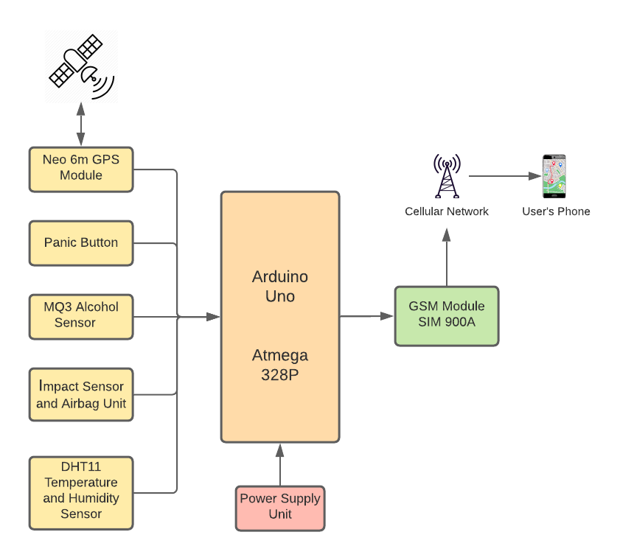

Fig. 2.1 Block Diagram

1. **Brief Description**

The Global Positioning System (GPS) is a popular technology which was developed by American Department of Defense (DoD) for military use. Later on it was available for civilian use. It is utilized for wide range of applications such as location, direction, speed, timing, surveying, logistics, traffic management, security etc. Nowadays, it has become an integral part of a vehicle system for tracking and navigation system. It can provide accurate time, location coordinate and speed.

On the other hand, Global System for Mobile communications (GSM) is a digital mobile telephony system that is widely used. More than 690 mobile networks provide GSM services across 213 countries and GSM represents 82.4% of all global mobile connections. Besides the voice communication it also offers Short Message Service (SMS) and General packet radio service (GPRS) to transfer data.

This can eliminate the need for an operator. When the vehicle is in an accident it communicates directly with emergency services and family members giving the severity of the accident, GPS location, and the car ID. Ambulances are currently capable of sending patient information to the hospital. The uniqueness of this project is that sensors detect an accident and information is sent immediately to the hospital, thus eliminating the need for an intermediary step. In our proposed system, we send the live location of victim, if somewhere accident occurs, then the same is detected using sensors, and it will be sent to the microcontroller. Further the GPS modem continuously receives the co-ordinates and gives the data to microcontroller after that information obtained from GPS module sends to the hospital, which can be further sent to the ambulance and also to family members and nearby police station. Also an alarm is rung after the accidents so that ambulance, police, and family member easily locate the place. From this module we can also detect the theft vehicle through GPS modem and microcontroller and easily locate the theft vehicle. From this project we can save many lives everyday by providing timely aid to the victims if accidents has happened.

A panic button can also be placed such that whenever a passenger / driver feels terror and discomfort (health emergencies) due to certain reasons, an alert message is raised by sending an SMS on pressing the button. There can be multiple panic buttons placed at different spots in the vehicle and connected to the Arduino.

In the intended system of Drink and Drive prevention, an MQ-3 Ethanol Sensor will be placed on the steering of the car or seat belt of the driver seat, such that it can monitor the percentage of alcohol in the breath of driver. If it is found to be higher than set limits, then the arduino signals the GSM to send an alert for the same to the driver’s predefined safety number (such as a home number). Measures can also include not to start the car engine unless the alcohol percentage reduces.

In the intended system of Cabin Monitoring, on sending a pre-designated string such as a “hello” to the SIM card in the GSM module, the real-time parameters such as temperature and humidity are read by the sensors in the car (eg. DHT-11) and sent via an SMS to the user.

1. **Input / Output**

Input to the accident detection system is obtained through the sensor, which is triggered due an accident.

The output of the accident detection system is the GPS coordinates sent to the hospital, police station, predefined number.

The Alert signal along with the Location can be sent using either of the three techniques:

1. GSM
2. Non-navigational information using one-way communication(OWS) in GPS
3. Satellite communication using Satellite Phone
4. Emergency Calling features
5. **Applications**
6. Accident detection
7. Vehicle Theft detection / tracking
8. Real time monitoring of car
9. **Project Outcome:**
10. After the completion of the project, we will demonstrate the working of prototype model using hardware components
11. A technical report will be prepared and submitted.
12. Throughout this project we intend to work with an aim of writing (publishing) a paper.
13. **Schedule / Pert Chart**

|  |  |
| --- | --- |
| **Week / Date** | **Work** |
| 1st and 2nd / 10.03.2021 – 23.03.2021 | Literature Survey |
| 3rd / 24.03.2021 - 30.03.2021 | Topic finalization and Synopsis |
| 4th – 7th / 01.04.2021 – 20.04.2021 | Design and Component Specification |
| 8th - 11th / 23.04.2021 – 18.05.2021 | Implementation / Working Verification |
| 12th - 14th / 24.05.2021 - 10.06.2021 | Changes / Corrections / Final Submission / Report |

1. **References**

[1] C. Xi-jun, X. Jiang-ning, C. Ke-jin and Z. Ying-bin, "Analysis on the One-Way Communication Capability of GPS Satellites in Orbit Transmitting Non-navigational Information," 2009 International Conference on Computer Technology, Malaysia, 2009, pp. 24-29, doi: 10.1109/ICCTD.2009.135.

[2] Technical Report Emergency Communications (EMTEL); Basis of requirements for communication of individuals with authorities/organizations in case of distress (Emergency call handling)

[3] Min-Te Sun, Wu-Chi Feng, Ten-Hwang Lai, K. Yamada, H. Okada and K. Fujimura, "GPS-based message broadcasting for inter-vehicle communication," Proceedings 2000 International Conference on Parallel Processing, Toronto, ON, Canada, 2000, pp. 279-286, doi: 10.1109/ICPP.2000.876143.

[4] Caveat utilitor: Satellite phones can always be tracked By Frank Smyth/CPJ Senior Adviser for Journalist Security on February 24, 2012 6:03 PM EST

[5] Fernandez Savari, George & Palanisamy, R. & Krishnasamy, Vijayakumar. (2018). GPS & GSM based accident detection and auto intimation. Indonesian Journal of Electrical Engineering and Computer Science. 11. 356-361. 10.11591/ijeecs.v11.i1.pp356-361.

|  |  |  |
| --- | --- | --- |
| **Event** | **On time (s)** | **Off time (s)** |
| *Initial Boot Display* | 7.9 | 13.2 |
| *Temperature and Humidity Display* | 14 | NA |
| *Gas Sensor Trigger* | 21 | NA |
| *Buzzer / LCD Display* | 28 | 53.7 |
| *Vibration Sensor Trigger* | 59.6 | NA |
| *LCD Display* | 1:08.6 | 1:13.9 |

|  |  |
| --- | --- |
| **Event** | **On Time after Trigger (s)** |
| *Booting (Display)* | 7.9 |
| *Gas Sensor output* | 8 |
| *Vibration Sensor Output* | 9 |