Event 1 Assignments

Following problems are to be solved using any appropriate s/w tools for hardware implementation.

1. Interface Keyboard and LCD to 8051 and develop an assembly language program to read the key closure and display the key code on LCD. In the keyboard there are digit keys from 0 to 9 , alphabets from A to Z and special character keys like @,#,$,%,^,&,\*,<,>,?,/,{.
2. Interface 5 digit multiplexed 7 segment displays in common cathode mode to 8051 and develop an ALP to display the message ‘HELLO’ in rolling method.
3. Develop an ALP to generate following waveform using DAC

i) Sine wave

ii) Ramp

iii) Pattern shown below

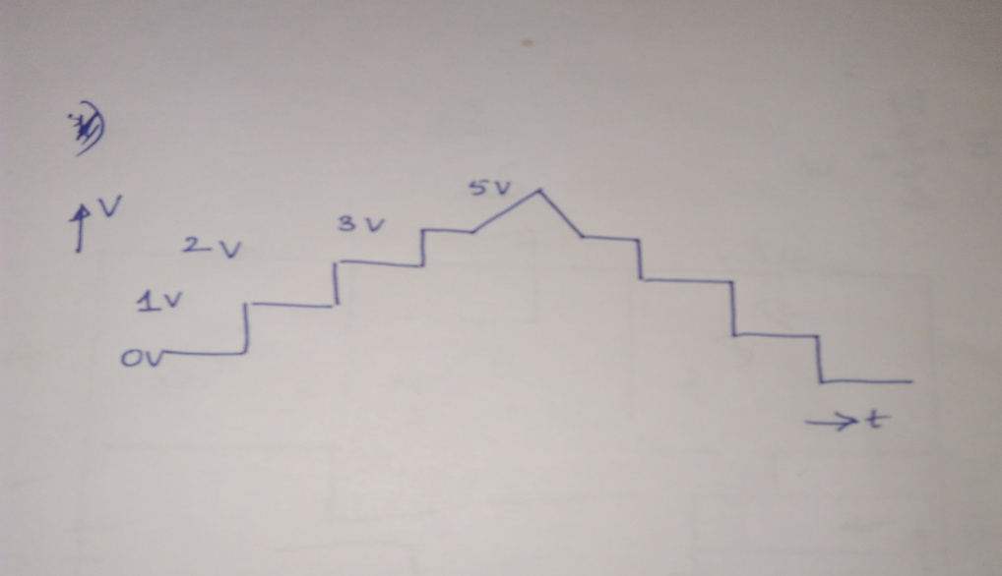

4.Write a program (ALP and Embedded C) to send the message HELLO serially at the baud rate of 4800 with XTAL=11.0592 MHz

5. Assume that a switch is connected to P2.0, Write a program (ALP and Embedded C) to read the switch and if switch =0 send the message HELLO to serial port else send the message WELCOME. Assume baudrate is 9600

6. Write a ALP and Embedded C program to do the following

a) Read the data from P1 and send it to P2 continuously

b) Also the data read from P1 is transmitted serially via Txd pin

c) Data received from Rxd pin is displayed at P0

Program serial port in interrupt mode and assume baudrate of 9600.

7. Write a program to generate a square wave on P1.5 with Ton=Toff. Calculate frequency of the wave generated. Use timer 0 in mode 1.

8. Generate the square with ON period of 4msec and OFF period of 3msec on P1.5.Assume crystal freq=22Mhz.Use timer0 in mode0.

9. Develop an 8051 ALP& embedded C program to toggle P1.5 every 1 second. Use timer1 in mode 1.

10. Write a ALP & embedded C program to generate a square wave of freq 10 KHz on p1.4.Use timer0 in mode2 with crystal freq=22MHz.

11. Write an ALP& embedded C program to toggle all the bits of p2 continuously every 50ms.Use timer 1 in mode2 configuration with XTAL=11.0592MHz.

12. Write a ALP and embedded C program to generate a square wave of 10 KHz with timer0 in mode2 at p1.3 using interrupt mode. Also display a value ‘A’ at P2 and ‘B’ at P0. Assume XTAL=22MHz.