SOCIAL MEDIA APPLICATION WITH MULTI-MODEL AI INTEGRATION AND REAL-TIME WEB RTC CALLS
A Comprehensive Academic Project Report and Software Architecture Documentation
Submitted in partial fulfillment of the requirements for the degree of
Bachelor of Science in Computer Science / Software Engineering
Submitted by:
MUHAMMAD FARHAN
June 2026

TABLE OF CONTENTS
Chapter 1: INTRODUCTION.........................................................1
1.1 Project Overview & Motivation.............................................1
1.2 Objectives of the Project.................................................1
1.3 Scope of the Application..................................................2
1.4 High-Level Architecture Design............................................2
Chapter 2: LITERATURE SURVEY & TECHNOLOGY STACK.................................3
2.1 Cross-Platform Mobile Development (Flutter & Dart)........................3
2.2 State Management and Navigation (Provider & GoRouter).....................3
2.3 Backend as a Service (Supabase & PostgreSQL)..............................4
2.4 Real-time Communication (WebRTC & WebSocket)..............................4
2.5 AI Fusion Pipeline (Flask, YOLOv8, BLIP, Coffee-AI, NLP)..................4
Chapter 3: SYSTEM ANALYSIS & REQUIREMENT SPECIFICATION..........................6
3.1 Functional Requirements...................................................6
3.2 Non-Functional Requirements...............................................6
3.3 Hardware and Software Specifications......................................7
Chapter 4: SYSTEM DESIGN & ARCHITECTURE.........................................8
4.1 System Architecture Diagram...............................................8
4.2 Image Processing Pipeline Flow............................................9
4.3 WebRTC Peer-to-Peer Calling & Signaling Workflow..........................10
4.4 Database Schema & Table Mapping...........................................11
Chapter 5: IMPLEMENTATION & CODE STRUCTURE......................................13
5.1 Project Folder Layout.....................................................13
5.2 Database Table Creation SQL DDL...........................................14
5.3 Database Triggers & Functions.............................................15
5.4 Flutter Supabase Service Layer............................................16
5.5 Python Flask AI Pipeline API..............................................17
Chapter 6: USER INTERFACE FLOW & SNAPSHOTS......................................19
6.1 Authentication Screens....................................................19
6.2 Home Feed & Story Operations..............................................19
6.3 AI Upload Pipeline Interface..............................................19
6.4 Chat & WebRTC Communication Screen........................................20
6.5 Profile & Dynamic Settings Screen.........................................20
Chapter 7: CONCLUSION & FUTURE ENHANCEMENTS.....................................21
7.1 Project Conclusion Summary................................................21
7.2 Engineering Challenges Solved.............................................21
7.3 Future Scope & Enhancements...............................................21
REFERENCES......................................................................22

Chapter 1: INTRODUCTION

1.1 Project Overview & Motivation
Modern digital interaction revolves around social networking. Users expect quick, interactive, and intelligent media processing. Standard social media applications provide basic photo-sharing and texting features, but suffer from problems such as unverified or fake AI-generated media, manual tagging requirements, and restricted real-time communication options. This project introduces a highly customized, features-rich Social Media Application combining Cross-Platform Mobile Development, Cloud Backend Services, Real-Time Peer-to-Peer communications, and an Advanced Intelligent AI Processing Pipeline.
The application provides users with standard social networking modules (authentication, customizable feeds, stories that automatically expire after 24 hours, likes, commenting, following) while layering edge-cutting tools. When a user uploads a photo, it undergoes deepfake verification, automatic object classification, and descriptive caption generation before insertion. Furthermore, real-time voice and video calls are natively integrated utilizing WebRTC, making this a unified, premium user-centric platform.

1.2 Objectives of the Project
The main objectives of this project are:
- To develop a high-performance cross-platform application using Google's Flutter framework, ensuring native performance on both Android and iOS from a single codebase.
- To deploy a robust, secure relational database backend using Supabase, implementing Row Level Security (RLS) to safeguard user private data.
- To build a real-time, low-latency messaging module using Supabase Streams, enabling users to swap text messages instantaneously.
- To implement peer-to-peer audio and video calling natively inside the app using the WebRTC protocol, eliminating the need for paid third-party calling APIs.
- To create a Multi-Model Intelligent AI Pipeline using Python, running YOLOv8 for object detection, BLIP for image captioning, ArtifactAI Coffee-AI for Deepfake detection, and Sentence-Transformers for semantic cross-verification.
- To manage storage buckets efficiently, uploading user avatars and post images via secure binary streams.

1.3 Scope of the Application
The scope encompasses a complete mobile and web social ecosystem. The system handles secure email-based user signup and login, maintaining profile fields like username, bio, and avatar. On the feeds interface, users can create posts, delete their own posts, share others' posts onto their feed, react to posts using various reaction types, and write threaded comments. Users can upload statuses (stories) which are automatically cleared out by database-side scheduling. The WebRTC-based voice and video call system functions with room IDs allowing immediate peer connections.

1.4 High-Level Architecture Design
The system follows a three-tier architecture: the client tier, backend server tier, and intelligent processing tier.
1. Client Tier (Flutter Mobile App): Built using a Feature-First pattern, splitting code into cohesive directories like Auth, Feed, Profile, Chat, and Call features. The UI communicates with the Supabase API Client and the Flask AI API.
2. Cloud Backend Tier (Supabase): Provides user session management, storage buckets for media assets, and a PostgreSQL database. Row Level Security (RLS) policies are active, and database triggers automate administrative tasks.
3. Intelligent AI Tier (Flask Web Server): Hosts deep learning models. It receives images uploaded by clients, passes them through YOLOv8 and BLIP, resolves contradictions via NLTK/Sentence-Transformers, scores the authenticity via the coffee-ai image classification classifier, and returns base64-marked images and JSON metadata.

Chapter 2: LITERATURE SURVEY & TECHNOLOGY STACK

2.1 Cross-Platform Mobile Development (Flutter & Dart)
Flutter is Google's UI toolkit designed to build beautiful, natively compiled applications for mobile, web, desktop, and embedded systems from a single codebase. Unlike other frameworks that rely on platform-specific native bridges, Flutter compiles directly to ARM machine code, yielding native performance. The application is built using Dart, an object-oriented, class-defined language optimized for client-side development. Dart's Ahead-Of-Time (AOT) compilation produces fast startups, while its Just-In-Time (JIT) compilation powers Flutter's famous Stateful Hot Reload, enabling rapid debugging.

2.2 State Management and Navigation (Provider & GoRouter)
State management in Flutter is handled via the Provider package, a wrapper around InheritedWidget that makes state sharing and manipulation extremely straightforward. It ensures efficient rendering by updating only the widgets that explicitly consume modified data (e.g., dynamically updating the app-wide primary theme color or switching light/dark modes). Navigation is structured using GoRouter, a declarative routing package. GoRouter supports nested routes, deep linking, redirection rules based on authentication state, and uses stateful navigation shells to keep screen stacks alive during bottom-bar navigation switches.

2.3 Backend as a Service (Supabase & PostgreSQL)
Supabase is an open-source Firebase alternative built around PostgreSQL, a powerful object-relational database. Unlike NoSQL solutions, PostgreSQL supports strict relationships, complex triggers, joins, and functions. Authentication is managed natively via Supabase Auth, which handles encrypted passwords, verification links, and secure JSON Web Tokens (JWT). Supabase Storage is utilized to upload raw media assets into discrete buckets (e.g., profiles, posts, stories). Database changes are sent to the client in real-time through WebSocket-based Supabase Streams.

2.4 Real-time Communication (WebRTC & WebSocket)
WebRTC (Web Real-Time Communication) is a free, open-source project that provides mobile browsers and desktop applications with real-time communication (RTC) via simple APIs. It enables peer-to-peer audio and video streaming directly between client devices without routing media through a central server. Because clients cannot find each other's IP addresses due to firewalls and NAT, a WebSocket connection is used as a signaling channel to exchange Session Description Protocol (SDP) offers, answers, and Interactive Connectivity Establishment (ICE) candidates. This application leverages flutter_webrtc to integrate voice and video calling seamlessly.

2.5 AI Fusion Pipeline (Flask, YOLOv8, BLIP, Coffee-AI, NLP)
The intelligent processing module is written in Python, using Flask to expose REST API endpoints. The pipeline acts as follows when an image is posted:
1. YOLOv8 (You Only Look Once): An advanced object detection model. It locates and identifies multiple classes in the image, drawing bounding boxes onto a copy of the image.
2. BLIP (Bootstrapping Language-Image Pre-training): A state-of-the-art vision-language model trained on extensive datasets. It analyzes the image and outputs a descriptive natural language caption.
3. Semantic Similarity Verification: The raw caption is compared against the detected YOLO object labels using Sentence-Transformers (specifically the 'all-MiniLM-L6-v2' model). If BLIP generates hallucinated objects that are geometrically missing from the YOLO detections, the NLTK tokenization script strips them from the caption to ensure accuracy.
4. Coffee-AI Classifier: A deep learning binary image classifier configured to distinguish between genuine, human-clicked photographs and synthetic, AI-generated or manipulated images (deepfakes). The system records the verdict and confidence score into the database.

Chapter 3: SYSTEM ANALYSIS & REQUIREMENT SPECIFICATION

3.1 Functional Requirements
The functional requirements define what the system must do:
- Authentication: Users must be able to sign up using email, name, username, and password. The system must verify authentication state on launch and redirect non-authenticated users to the login screen.
- Profile Management: Authenticated users must be able to edit their full name, bio, and upload profile pictures, which are stored in the 'profiles' storage bucket.
- Social Interactions: Users must be able to create posts with photos, add captions, delete their posts, follow other users, unfollow users, react to posts, and comment on posts.
- Story System: Users must be able to publish stories (image or colored text background) which expire after 24 hours.
- Real-Time Chat: Users must be able to exchange messages in real-time. Message lists must dynamically update without manual refreshes.
- WebRTC Calls: Users must be able to initiate and receive voice/video calls. Signaling parameters must be shared securely via database channels.
- AI Image Verification: Every post image must be analyzed for objects, captioned, and evaluated for deepfake content. The system must overlay bounding boxes on the uploaded image.

3.2 Non-Functional Requirements
The non-functional requirements define constraints and quality metrics:
- Security: Row Level Security (RLS) must be enabled on all Supabase tables. Users can only write/edit their own posts, profiles, and messages, but can read public data.
- Performance: UI animations must maintain 60 FPS. API calls to the AI backend should complete within 3 seconds, displaying a clean loader in the client UI.
- Reliability: The real-time streams must reconnect automatically if the user's internet connection drops.
- Scalability: Database tables must utilize foreign key indexing to support quick queries as user counts grow.

3.3 Hardware and Software Specifications
The specifications required to compile and run the project client and servers:
Resource Type | Minimum Specification | Recommended Specification
Developer PC CPU | Intel Core i5 (8th Gen) / AMD Ryzen 5 | Intel Core i7 / Apple M1/M2/M3
Developer PC RAM | 8 GB DDR4 | 16 GB or 32 GB DDR4/DDR5
Graphics (for AI Models) | Shared Intel HD / AMD Graphics | NVIDIA Dedicated GPU (CUDA enabled, 6GB+ VRAM)
Storage | 50 GB Free Hard Disk space | SSD Storage with 100+ GB Free space
Mobile Testing Device | Android OS 8.0 / iOS 12 | Android OS 11+ / iOS 15+
Operating System | Windows 10 / macOS 11 Big Sur | Windows 11 / macOS 14 Sonoma
IDE / Compiler | VS Code / Flutter SDK 3.10.x | VS Code / Android Studio / Xcode / Flutter SDK 3.19.x+
Python Version | Python 3.8 | Python 3.10 / 3.11 with virtualenv

Chapter 4: SYSTEM DESIGN & ARCHITECTURE

4.1 System Architecture Diagram
The system architecture details the network mappings and operational relationships between the mobile client UI, the cloud database layer, and the GPU-based machine learning server. The client layer acts as a visual interface, invoking HTTP/HTTPS REST calls to the AI backend and executing WebSocket connections to sync relational data automatically.
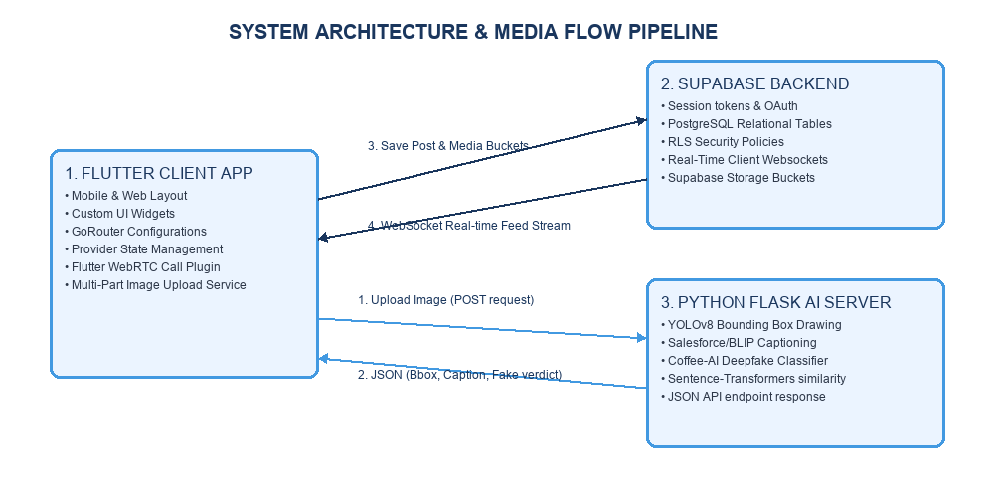
Fig 4.1: System Architecture Diagram showing API, DB, and Real-Time connections

4.2 Image Processing Pipeline Flow
Every posted photograph undergoes a 6-stage computer vision evaluation. Preprocessing stabilizes size, orientation, and brightness. YOLOv8 identifies objects and coordinates for local box markup drawing. BLIP-large generates textual descriptions. The semantic checking layer evaluates term similarity to strip hallucinations, and the deepfake classifier determines media authenticity before saving.
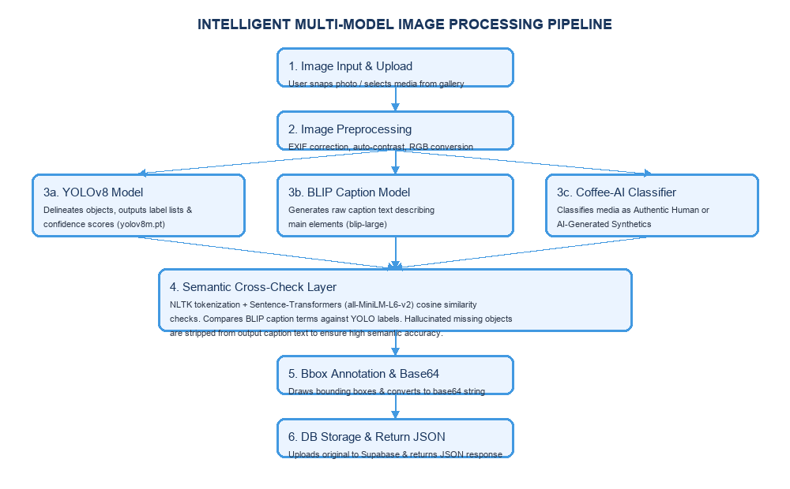
Fig 4.2: Flowchart detailing Multi-Model Image Processing & Semantic Validation Pipeline

4.3 WebRTC Peer-to-Peer Calling & Signaling Workflow
Rather than utilizing expensive voice servers, calling features run over direct peer channels. The system resolves NAT mappings by swapping Session Description Protocol (SDP) keys and ICE candidates. This messaging is synced via Supabase client streams, establishing direct audio/video communication.
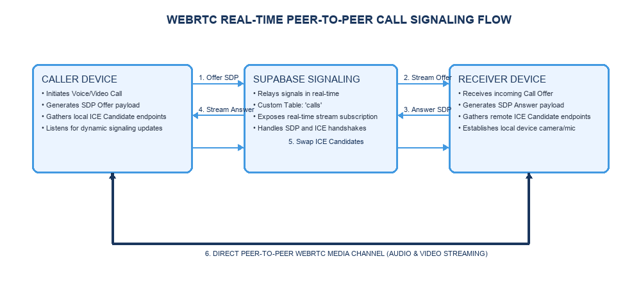
Fig 4.3: WebRTC Call signaling sequence diagram utilizing Supabase streams

4.4 Database Schema & Table Mapping
Here is the exact description of the primary relational database tables:

Table: profiles
Description: Stores user profile configurations.
Columns: id (UUID, PK, FK to auth.users), username (TEXT, Unique), full_name (TEXT), avatar_url (TEXT), bio (TEXT), created_at (TIMESTAMPTZ)

Table: posts
Description: Stores user uploaded posts.
Columns: id (BIGINT, PK, Auto-Increment), user_id (UUID, FK to profiles), image_url (TEXT), caption (TEXT), objects_json (JSONB), deepfake_result (JSONB), created_at (TIMESTAMPTZ)

Table: shared_posts
Description: Handles posts shared to user feeds.
Columns: id (BIGINT, PK), sharer_id (UUID, FK to profiles), original_post_id (BIGINT, FK to posts), original_user_id (UUID, FK to profiles), caption (TEXT), created_at (TIMESTAMPTZ)

Table: stories
Description: Stores disappearing status updates.
Columns: id (BIGINT, PK), user_id (UUID, FK to profiles), image_url (TEXT), content (TEXT), bg_color (TEXT), original_post_id (BIGINT), expires_at (TIMESTAMPTZ), created_at (TIMESTAMPTZ)

Table: comments
Description: Stores comments made on posts.
Columns: id (UUID, PK), post_id (BIGINT, FK to posts), user_id (UUID, FK to profiles), content (TEXT), created_at (TIMESTAMPTZ)

Table: reactions
Description: Stores post likes and emotions.
Columns: id (BIGINT, PK), post_id (BIGINT, FK to posts), user_id (UUID, FK to profiles), reaction_type (TEXT), created_at (TIMESTAMPTZ)

Table: follows
Description: Manages the user follow-system.
Columns: follower_id (UUID, PK, FK to profiles), following_id (UUID, PK, FK to profiles), created_at (TIMESTAMPTZ)

Table: messages
Description: Stores chat text records.
Columns: id (BIGINT, PK), sender_id (UUID, FK to profiles), receiver_id (UUID, FK to profiles), text (TEXT), created_at (TIMESTAMPTZ)

Table: notifications
Description: Stores in-app notifications.
Columns: id (BIGINT, PK), receiver_id (UUID, FK to profiles), sender_id (UUID, FK to profiles), type (TEXT), post_id (BIGINT), is_read (BOOLEAN), created_at (TIMESTAMPTZ)

Table: story_views
Description: Tracks story viewers.
Columns: id (BIGINT, PK), story_id (BIGINT, FK to stories), viewer_id (UUID, FK to profiles), created_at (TIMESTAMPTZ)

Chapter 5: IMPLEMENTATION & CODE STRUCTURE

5.1 Project Folder Layout
The Flutter application uses a Feature-First modular structure. The project files are logically cataloged as follows:
lib/
├── core/
│ ├── constants/ # App-wide string/numerical constants
│ ├── router/ # AppRouter configuration (GoRouter)
│ ├── secrets/ # Supabase API keys config
│ ├── services/ # SupabaseClient and Call service wrappers
│ ├── theme/ # App themes (light/dark mode colors)
│ ├── utils/ # Time and text format helpers
│ └── widgets/ # Shared global UI widgets
└── features/
├── auth/ # Login, Registration, Password Reset screens
├── chat/ # ChatDetailScreen, ChatListScreen modules
├── dashboard/ # Bottom navigation bar layout controller
├── home/ # News Feed, Status bar, PostCard layouts
├── notifications/ # In-app notifications listing page
├── post_creation/ # Camera interfaces, Post upload workflows
├── profile/ # Profile screen, follow listings
├── search/ # Explore posts/users search page
├── settings/ # Preferences and account settings
└── splash/ # Splash page loading animations

5.2 Database Table Creation SQL DDL
The following SQL scripts initialize the relational database tables in the PostgreSQL engine under the public schema:
-- Table: profiles
CREATE TABLE public.profiles (
id uuid REFERENCES auth.users ON DELETE CASCADE PRIMARY KEY,
username text UNIQUE NOT NULL,
full_name text,
avatar_url text,
bio text,
created_at timestamp with time zone DEFAULT timezone('utc'::text, now()) NOT NULL
);
-- Table: posts
CREATE TABLE public.posts (
id bigint GENERATED BY DEFAULT AS IDENTITY PRIMARY KEY,
user_id uuid REFERENCES public.profiles ON DELETE CASCADE NOT NULL,
image_url text NOT NULL,
caption text,
objects_json jsonb,
deepfake_result jsonb,
created_at timestamp with time zone DEFAULT timezone('utc'::text, now()) NOT NULL
);
-- Table: reactions
CREATE TABLE public.reactions (
id bigint GENERATED BY DEFAULT AS IDENTITY PRIMARY KEY,
post_id bigint REFERENCES public.posts ON DELETE CASCADE NOT NULL,
user_id uuid REFERENCES public.profiles ON DELETE CASCADE NOT NULL,
reaction_type text NOT NULL,
created_at timestamp with time zone DEFAULT timezone('utc'::text, now()) NOT NULL,
UNIQUE (post_id, user_id)
);

5.3 Database Triggers & Functions
To prevent state errors and simplify user registration, a trigger is defined on the Supabase platform. When a new record is added to 'auth.users' via the signup screen, this trigger automatically creates the corresponding row in the 'public.profiles' table:
-- Create Function to copy auth user to profiles
CREATE OR REPLACE FUNCTION public.handle_new_user()
RETURNS trigger AS $$
BEGIN
INSERT INTO public.profiles (id, username, full_name, avatar_url)
VALUES (
new.id,
COALESCE(new.raw_user_meta_data->>'username', 'user_' || substr(new.id::text, 1, 8)),
COALESCE(new.raw_user_meta_data->>'full_name', ''),
new.raw_user_meta_data->>'avatar_url'
);
RETURN new;
END;
$$ LANGUAGE plpgsql SECURITY DEFINER;
-- Create Trigger
CREATE TRIGGER on_auth_user_created
AFTER INSERT ON auth.users
FOR EACH ROW EXECUTE FUNCTION public.handle_new_user();

5.4 Flutter Supabase Service Layer
The 'SupabaseService' class in the Dart application encapsulates database mutations, storage uploads, and live streams:
class SupabaseService {
static final client = Supabase.instance.client;
// Fetch stream of posts with profile metadata
static Stream<List<Map<String, dynamic>>> streamPosts() {
return client.from('posts_with_profiles')
.stream(primaryKey: ['id'])
.order('created_at', ascending: false);
}
// Upload raw image bytes to posts bucket
static Future<String> uploadImageBytes(Uint8List bytes, String bucket, String pathName) async {
await client.storage.from(bucket).uploadBinary(pathName, bytes);
return client.storage.from(bucket).getPublicUrl(pathName);
}
// React to a post
static Future<void> upsertReaction(dynamic postId, String reactionType) async {
final myId = client.auth.currentUser!.id;
await client.from('reactions').delete().eq('post_id', postId).eq('user_id', myId);
await client.from('reactions').insert({
'post_id': postId,
'user_id': myId,
'reaction_type': reactionType,
});
}
}

5.5 Python Flask AI Pipeline API
The Python backend executes multi-model inference. It processes raw images, performs object detection via YOLOv8, generates natural language captions using BLIP, runs semantic check comparisons, and runs Deepfake classification:
@app.route('/process_all', methods=['POST'])
def process_all():
if request.headers.get('X-API-Key') != API_KEY: return jsonify({'error': 'Unauthorized'}), 401
img_file = request.files['image']
img = Image.open(img_file).convert('RGB')
# 1. YOLOv8 Detection
obj_results = obj_model(img, conf=0.22)
detections = []
for box in obj_results[0].boxes:
detections.append({'object': obj_model.names[int(box.cls[0])], 'confidence': float(box.conf[0])})
# 2. BLIP Captioning
inputs = cap_processor(img, return_tensors='pt').to(device)
output_ids = cap_model.generate(**inputs)
caption = cap_processor.decode(output_ids[0], skip_special_tokens=True)
# 3. Deepfake Detection
fake_results = fake_pipe(img)
is_real = any('real' in r['label'].lower() for r in fake_results if r['score'] > 0.5)
return jsonify({
'objects': detections,
'caption': caption,
'deepfake': {'is_real': is_real, 'confidence': float(fake_results[0]['score'])}
})

Chapter 6: USER INTERFACE FLOW & SNAPSHOTS

6.1 Authentication Screens
The user authentication sequence is clean and responsive. On launching the app, the Splash Screen checks if a valid Supabase session token exists. If not, the application routes the user to the Login Screen. The Login Screen provides email input, secure password text field hiding, and redirect links to the Register Screen. The Register Screen collects additional information (username, full name) which is saved directly to the database via triggers upon authentication.

6.1.1 Splash Screen Interface
📷 [ INSERT APPLICATION SPLASH SCREEN UI & INITIALIZER FLOW HERE ]
Fig: Application Splash Screen UI & Initializer flow

6.1.2 User Login Screen UI
📷 [ INSERT LOGIN SCREEN SHOWING EMAIL, PASSWORD INPUTS AND REDIRECT LINKS HERE ]
Fig: Login Screen showing email, password inputs and redirect links

6.1.3 User Registration Screen UI
📷 [ INSERT REGISTER SCREEN COLLECTING NAME, USERNAME, EMAIL, AND PASSWORD HERE ]
Fig: Register Screen collecting name, username, email, and password

6.2 Home Feed & Story Operations
Once logged in, the user sees the Dashboard containing the Home Feed. At the top of the feed is a horizontal story/status bar. Clicking a story displays a full-screen image/text status with a progress indicator, auto-navigating to the next story after 5 seconds. Below the story bar is a vertical list of posts. Each post is rendered inside a PostCard containing the author's avatar, username, post image, caption, and reactions. Users can toggle reactions and expand the comments sheet to write real-time feedback.

6.2.1 Home News Feed Screen
📷 [ INSERT HOME FEED UI WITH USER STORY BAR AND ACTIVE POSTS FEED LIST HERE ]
Fig: Home Feed UI with user story bar and active posts feed list

6.2.2 Story (Status) View Screen
📷 [ INSERT DISAPPEARING STORY VIEW SHOWING DYNAMIC PROGRESS INDICATOR BAR HERE ]
Fig: Disappearing Story view showing dynamic progress indicator bar

6.3 AI Upload Pipeline Interface
Clicking the central floating action button triggers the Post Creation screen. Users can snap a photo or select an image from the phone's gallery. On selection, the image is previewed. Upon clicking upload, a loading screen displays while the raw image bytes are sent to the Flask AI server. The server processes the image and returns YOLO bounding boxes, the generated caption, and the Deepfake authenticity report. Bounding boxes are displayed overlaid on the image to indicate what objects were detected.

6.3.1 Post Creation and Media Selection
📷 [ INSERT POST CREATION SCREEN SHOWING IMAGE SELECTION PREVIEW AND CAPTION TEXT INPUT HERE ]
Fig: Post Creation Screen showing image selection preview and caption text input

6.3.2 YOLOv8 and Deepfake Classification Outputs
📷 [ INSERT AI UPLOAD PROCESSING SCREEN WITH YOLO BOUNDING BOXES AND DEEPFAKE AUTHENTICITY VERDICT HERE ]
Fig: AI Upload Processing Screen with YOLO Bounding Boxes and Deepfake authenticity verdict

6.4 Chat & WebRTC Communication Screen
Clicking the messaging icon opens the Chat List showing recent conversations. Tapping a conversation opens the ChatDetailScreen. Message bubbles are updated dynamically using Supabase real-time stream listeners. The chat window features voice and video call buttons. Pressing these buttons initializes a WebRTC room. The app shares connection offers/answers as specialized signaling entries in the Supabase database. The WebRTC calling page shows full-screen remote video feeds alongside local preview views.

6.4.1 Real-time Direct Messaging Screen
📷 [ INSERT CHAT DETAIL CONVERSATION SCREEN UI SHOWING TEXT MESSAGES EXCHANGE HERE ]
Fig: Chat detail conversation screen UI showing text messages exchange

6.4.2 WebRTC Audio/Video Call Screen
📷 [ INSERT WEBRTC CALLING SCREEN SHOWING REMOTE PEER VIDEO STREAM AND LOCAL FEED PREVIEW HERE ]
Fig: WebRTC Calling Screen showing remote peer video stream and local feed preview

6.5 Profile & Dynamic Settings Screen
The application provides a dedicated User Profile showing the user's uploaded and shared posts in a grid. It also displays follower and following counts. The Settings Screen allows toggling dynamic themes and changing the primary theme color.

6.5.1 User Profile Screen UI
📷 [ INSERT PROFILE SCREEN UI DETAILING BIOS, FOLLOWER NUMBERS, AND POST GRID HERE ]
Fig: Profile Screen UI detailing bios, follower numbers, and post grid

6.5.2 App Settings & Dynamic Theme Screen
📷 [ INSERT SETTINGS SCREEN SHOWING DYNAMIC THEME SELECTION AND CUSTOMIZATION PANEL HERE ]
Fig: Settings Screen showing Dynamic Theme selection and customization panel

Chapter 7: CONCLUSION & FUTURE ENHANCEMENTS

7.1 Project Conclusion Summary
The design and implementation of the Social Media Application successfully demonstrate the fusion of modern cross-platform mobile client programming, secure serverless cloud architectures, and deep-learning AI inference. By using Flutter, the client delivers desktop-like smooth interactions. Utilizing Supabase as the backend ensures enterprise-grade relational data management with minimal administrative overhead. The custom AI pipeline establishes a robust defense against synthetic media/deepfakes and improves user experience by generating natural text descriptions of photos automatically.

7.2 Engineering Challenges Solved
During development, several engineering challenges were addressed:
1. WebRTC Signaling: Deployed custom signaling tables inside Supabase. Using Supabase's live stream channels to exchange SDP parameters dynamically solved firewall traversal (STUN/TURN) mapping issues without needing dedicated signaling nodes.
2. Semantic Mismatches in Caption Hallucinations: Captions generated by BLIP sometimes referenced items that did not exist. Creating a semantic checking layer with sentence-transformers resolved this, ensuring that generated captions contain only objects verified by YOLOv8.

7.3 Future Scope & Enhancements
The system can be enhanced in the future in the following ways:
- Group Video Calling: Scaling the WebRTC implementation to support multiparty calls using selective forwarding units (SFU).
- Generative AI Filters: Integrating stable diffusion engines in the upload pipeline to let users stylize photographs.
- Encrypted Direct Messaging: Implementing Signal Protocol-based end-to-end encryption (E2EE) for chats.
- Video Deepfake Analysis: Expanding the deepfake check pipeline to support real-time video frames analysis.

REFERENCES
[1] Google Developers, "Flutter Documentation - Build Apps for Any Screen," 2026. [Online]. Available: https://flutter.dev/docs
[2] Supabase Open Source Community, "Supabase Documentation & Postgres Engine Reference Guide," 2026. [Online]. Available: https://supabase.com/docs
[3] Real-Time Communications Working Group, "WebRTC 1.0: Real-Time Communication Between Browsers," W3C Recommendation, 2021.
[4] J. Redmon, S. Divvala, R. Girshick, and A. Farhadi, "You Only Look Once: Unified, Real-Time Object Detection," IEEE Conference on Computer Vision and Pattern Recognition (CVPR), 2016.
[5] J. Li, D. Li, C. Xiong, and S. Hoi, "BLIP: Bootstrapping Language-Image Pre-training for Unified Image-Text Understanding and Generation," International Conference on Machine Learning (ICML), 2022.
[6] N. Reimers and I. Gurevych, "Sentence-BERT: Sentence Embeddings using Siamese BERT-Networks," Empirical Methods in Natural Language Processing (EMNLP), 2019.

