

Motor power calculation for Suzuki Bolan

By

Muhammad Saad

CEO, CST EV

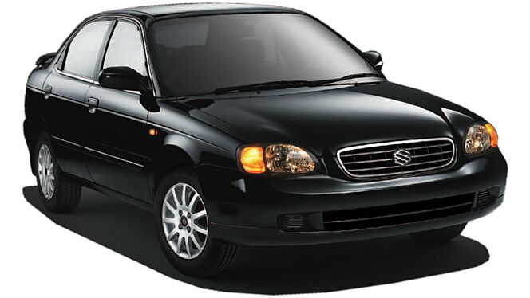

# **OVERVIEW**

While Suzuki was already known for its small offroad vehicles sold globally under different badges and nameplates, the Maruti Suzuki Baleno was less famous. It was built for the Indian market to be an affordable lineup in three body shapes: sedan, hatchback and station wagon. Maruti Suzuki made the three-box version with four doors for most families. It was introduced in 1995 and, in 1998, it went through a facelift which was applied for the Indian version from 2000.

# **Parameters**

# Weight of the vehicle after EV conversion

<https://www.autoevolution.com/cars/maruti-suzuki-baleno-2000.html#aeng_maruti-udyog-baleno-2001-16>

kerb Weight 975 kg

Gross Weight 1510 kg

Passenger Weight: 500 kg

Fuel tank with full fuel = 60 kg

Battery Weight = 170kg

Motor kit estimated weight = 30kg

Engine Weight = The engine weight of a Suzuki Baleno with a 1300cc engine is usually around 110 kg

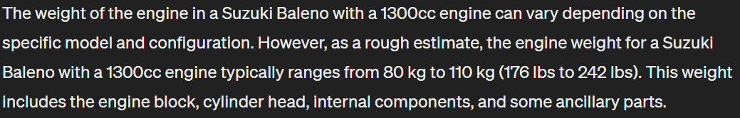

**Weight without engine:**

Kerb weight 975 kg - Engine Weight 110 kg - Fuel tank with full fuel 60 kg= 805 kg

Weight without engine:805 kg

**Weight of Bolan after EV conversion:**

Weight without engine (805 kg) + battery weight (170) + Passenger Weight (500 kg) + Motor kit estimated weight (30kg) = 1505 KG

Weight of Bolan after EV conversion: 1505 KG

# Dimensions:

<https://www.autoevolution.com/cars/maruti-suzuki-baleno-2000.html#aeng_maruti-udyog-baleno-2001-16>

**Length:**  166.3 in (4224 mm)

**Width:** 66.5 in (1689 mm)

**Height:** 54.7 in (1389 mm)

**Front/rear Track:** 56.7/56.5 in (1,440/1,435 mm)

**Wheelbase:** 97.6 in (2479 mm)

# Total Power usage

**Total Power usage** = Power usage due to air drag force + Power usage due to rolling resistance + Power usage due to the inclination angle of the road

We assume Power usage due to the inclination angle of the road = 0, this will result in a speed decrease on inclined roads but it is normal and also occurs with fuel vehicles.

So the final formula is

**Total Power usage** = Power usage due to air drag force + Power usage due to rolling resistance

Now we discuss the calculation of each of the above resistance forces

# Air drag calculation

Density of the air ρ = 1.225 kg/m3  (at around 15 degrees Celsius, it increase in colder weathers)

<https://en.wikipedia.org/wiki/Density_of_air#:~:text=At%20101.325%20kPa%20(abs)%20and%2015%20%C2%B0C%20(59,62%20lb%2Fcu%20ft)>

**Given the dimensions of the Suzuki Baleno/Maruti Suzuki Baleno:**

Length: 166.3 inches (4224 mm)

Width: 66.5 inches (1689 mm)

Now, calculate the frontal area (A):

A = Length * Width

A = 4.224 m * 1.689 m

A ≈ 7.13 square meters

For the drag coefficient (Cd) let's assume a typical value for a passenger car, which falls in the range of 0.3 to 0.35. For this estimation, let's take Cd = 0.32

Frontal area A estimated by a-c: A = 7.13 m2

Drag coefficient, Cd = 0.32

Drag Force = ½ (pCdAV2)

Force constant c for Boleno = ½ (pCdA) => ½ (1.225 x 0.32 x 7.13) = 1.397

The air resistance formula can be mathematically stated as:

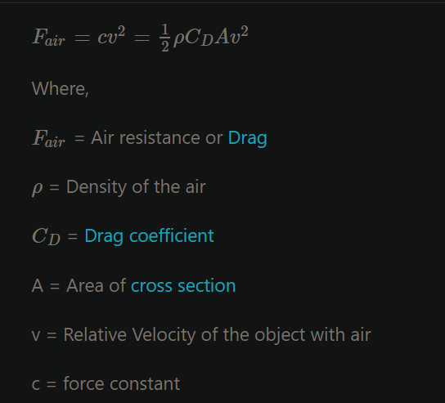

<https://testbook.com/physics-formulas/air-resistance-formula>

We have the formula and data to calculate the drag force acting on the vehicle but we use an online calculator to fill up the table below:

<https://www.omnicalculator.com/physics/drag-equation>

|  |  |  |
| --- | --- | --- |
| **Speed** | **Fair = Drag Force measure in Newtons** | **Power usage due to drag force = Fair x Velocity** |
| 40 km/h (11.11 m/s) | 172.5 N | 1916.47 W |
| 60 km/h (16.67 m/s) | 388.34 N | 6450.32 KW |
| 70 km/h (19.44 m/s) | 528.1 N | 10266.26 KW |
| 80 km/h (22.22 m/s) | 690 N | 15331.8 KW |
| 90 km/h (25 m/s) | 873.4 N | 21835 KW |
| 100 km/h (27.78 m/s) | 1078.5 N | 29960.7KW |
| 120 km/h (33.33 m/s) | 1552.4 N | 51741.49 KW |

## Example of drag force calculation at 120 km/h (33.33 m/s) using the online calculator

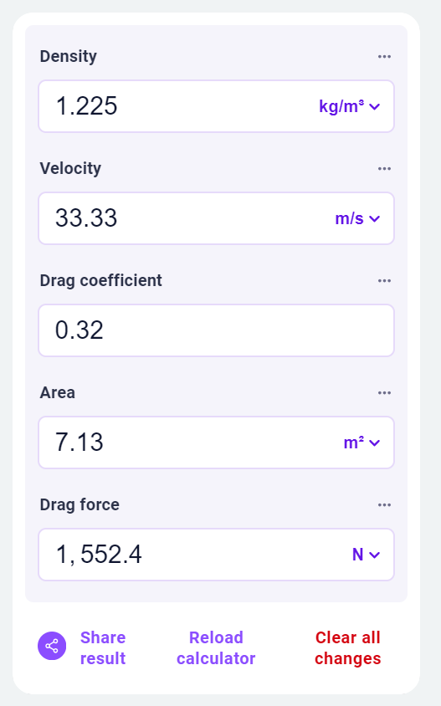

**Power usage due to drag force** = Drag force x the velocity of the vehicle = ½ (pCAV2) x V = ½ pCAV3

For example, the Power usage due to drag force at 60 km/h (16.67 m/s) = 0.5 x 1.225 x 0.32 x 7.13x 33.333  = 51741.49Watts

Please note that the power usage due to the drag force acting on the vehicle increases as cube of the current velocity/speed so the higher the speed the higher the power usage. The power usage increases exponentially with speed so therefore we limit the EV top speed to 120 km/h.

# Rolling Resistance

This is the resistance to the motion of the car's tires as they roll on the road. It's influenced by factors like weight of the vehicle, tire type, road surface, and tire pressure.

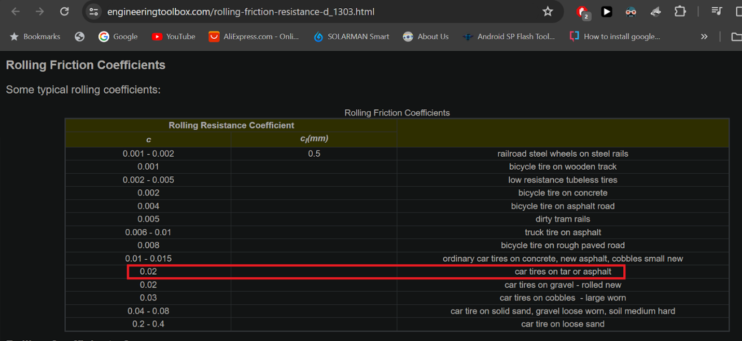

Table taken from <https://www.engineeringtoolbox.com/rolling-friction-resistance-d_1303.html>

Here is an online calculator for calculating the rolling resistance force

<https://www.omnicalculator.com/physics/rolling-resistance#rolling-resistance-basics>

Weight of Bolan after EV conversion = 1485 kg

Rolling resistance = 295.3 N

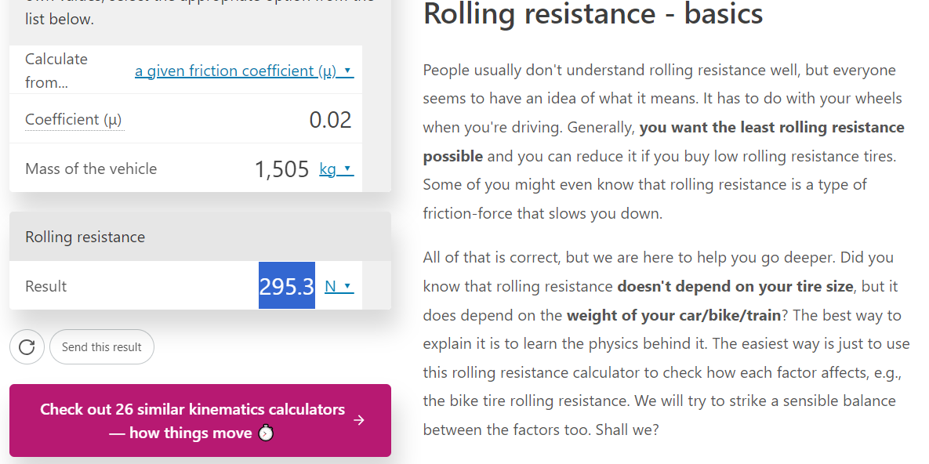

|  |  |  |
| --- | --- | --- |
| **Speed** | **Rolling Resistance Force** | **Power usage due to rolling resistance = RR x Velocity** |
| 40 km/h (11.11 m/s) | 295.3 N | 3280.78 W |
| 60 km/h (16.67 m/s) | 295.3 N | 4922.65 W |
| 70 km/h (19.44 m/s) | 295.3 N | 5740.63 W |
| 80 km/h (22.22 m/s) | 295.3 N | 6561.56W |
| 90 km/h (25 m/s) | 295.3 N | 7382.5 W |
| 100 km/h (27.78 m/s) | 295.3 N | 8203.43 W |
| 120 km/h (33.33 m/s) | 295.3 N | 9842.34 W |

# Suzuki Boleno calculation for motor power vs speed

|  |  |  |  |  |  |
| --- | --- | --- | --- | --- | --- |
| **Speed** | **Drag Force** | **Power usage** | **Rolling Resistance Force** | **Power usage** | **Total Power usage** |
| 40 km/h (11.11 m/s) | 172.5 N | 1916.47 W | 295.3 N | 3280.78 W | 5197.25 W |
| 60 km/h (16.67 m/s) | 388.34 N | 6450.32 W | 295.3 N | 4922.65 W | 11372.97W |
| 70 km/h (19.44 m/s) | 528.1 N | 10266.26 W | 295.3 N | 5740.63 W | 16006.89W |
| 80 km/h (22.22 m/s) | 690 N | 15331.8 W | 295.3 N | 6561.56 W | 21893.36 W |
| 90 km/h (25 m/s) | 873.4 N | 21835 W | 295.3 N | 7382.5 W | 29217.5 W |
| 100 km/h (27.78 m/s) | 1078.5 N | 29960.7 W | 295.3 N | 8203.43 W | 3164.13 W |
| 120 km/h (33.33 m/s) | 1552.4 N | 51741.49 W | 295.3 N | 9842.34 W | 61583.83 W |

There are 20-25% losses in transmission, clutch disk, ball bearings, motor inefficiency etc. so we adjust the motor power to be 20% higher than the power usage.

|  |  |  |  |  |
| --- | --- | --- | --- | --- |
| **Speed** | **Total Power usage** | **Motor power needed = 20% higher than power usage** | **Energy usage per km** | **Mileage per charge on a 24.19 kWh battery** |
| 40 km/h (11.11 m/s) | 5197.25 W | 6236.7 W | 155.91 Wh/km | 155 km |
| 60 km/h (16.67 m/s) | 11372.97 W | 13647.56 W | 227.45 Wh/km | 106 km |
| 70 km/h (19.44 m/s) | 16006.89 W | 19208.26 W | 274.40 Wh/km | 88 km |
| 80 km/h (22.22 m/s) | 21893.36 W | 26272.03 W | 328.40 Wh/km | 73 km |
| 90 km/h (25 m/s) | 29217.5 W | 35061 W | 389.56 Wh/km | 62 km |
| 100 km/h (27.78 m/s) | 3164.13 W | 3796.95 W | 37.96 Wh/km | 63 km |
| 120 km/h (33.33 m/s) | 61583.83 W | 73900.59 W | 615.83 Wh/km | 39 km |

The higher the speed, the higher the power usage and thus lower the range.

# Conclusion

A PMSM motor rated for 15kW should be enough to run the baleno

# Power consumption and hence motor power requirement increases with speed

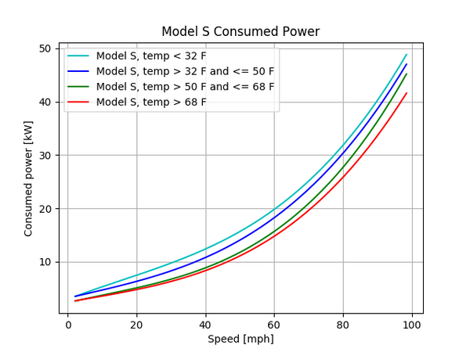

# The range decreases at higher speeds

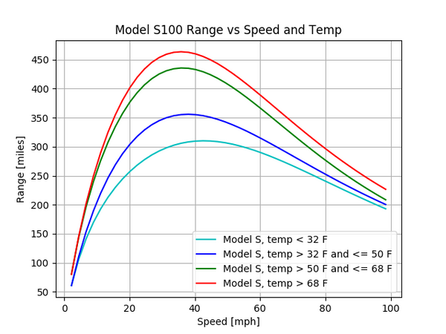

Graphs taken from <https://cleantechnica.com/2018/07/15/tesla-range-plotted-relative-to-speed-temperature-graphs/>