Fazals Assignment_1
Q.1 Create a database named university and a collection named students. Insert multiple student document with field: name, age, department, and grades.
Query-(i):- use university
Query-(ii):- db.createCollection("students")
Query-(iii):- db.stdnt.insertMany([
{name:"Alice",age:20,department:"Computer Science", grades:{"math":85,"english":92}},
{name:"Bob",age:21,department:"Physics",grades:{"math":88,"physic s":90}},
{name:"Charlie",age:22,department:"Mathematics",grades:{"math":95,"statistics":89}}])
Output:- {
acknowledged: true,
insertedIds: {
'0': ObjectId('69be6b561990fb7bdd63b112'),
'1': ObjectId('69be6b561990fb7bdd63b113'),
'2': ObjectId('69be6b561990fb7bdd63b114')
}
Check Query:- db.students.find()
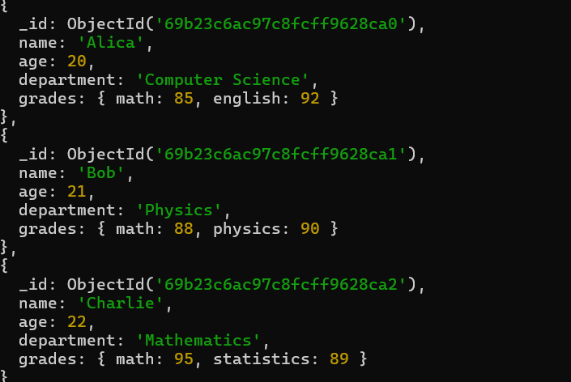

Q.2 Write a query to display all students who are in the Computer Science department.
Query :- db.students.find({department:"Computer Science"})
Output:-
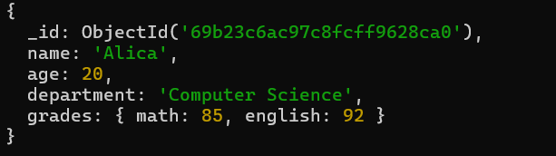
Q.3 Write a query to upadate the grades of a stdents named Alica by adding a new subject programming with a grade of 93.
Query:- db.students.updateOne({name:"Alica"},{$set:{"grades.programming":93}})
Output:- {
acknowledged: true,
insertedId: null,
matchedCount: 1,
modifiedCount: 1,
upsertedCount: 0
}
Check Query:- db.students.find()
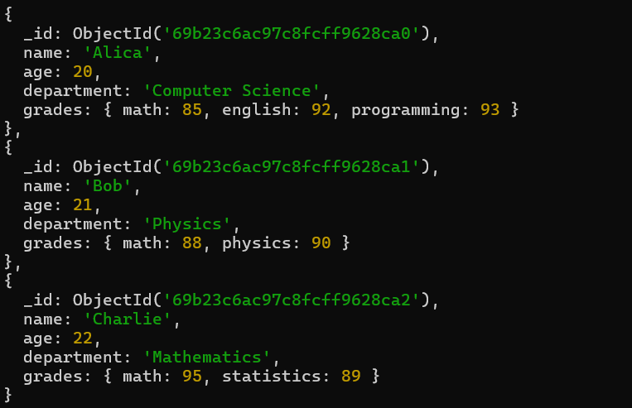

Q.4 Write a query to increment the age of all students by 1.
Query:- db.students.updateMany({},{$inc:{age:1}})
Output:- {
acknowledged: true,
insertedId: null,
matchedCount: 3,
modifiedCount: 3,
upsertedCount: 0
}
Check Query:- db.students.find()
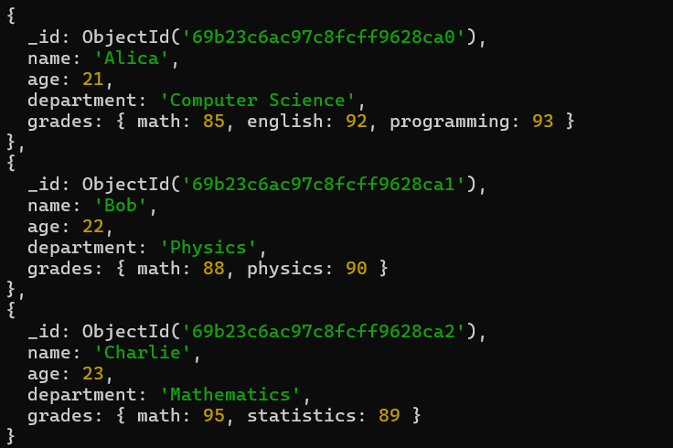
Q.5 Write a query to delete all students who are 23 years old.
Query:- db.students.deleteMany({age:23})
Output:- { acknowledged: true, deletedCount: 1 }
Check Query:- db.students.find()
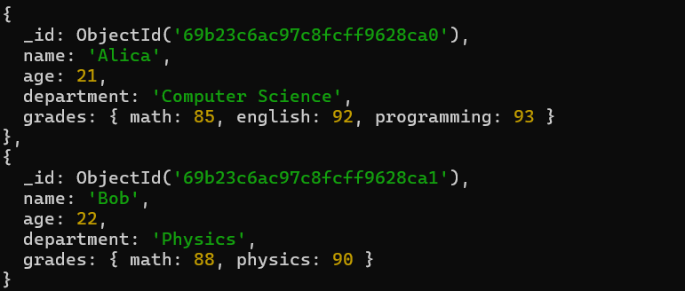

Q.6 Write a query to create an index on the name field of the students collection.
Query:- db.students.createIndex({name:1})
Check Query:- db.students.find()
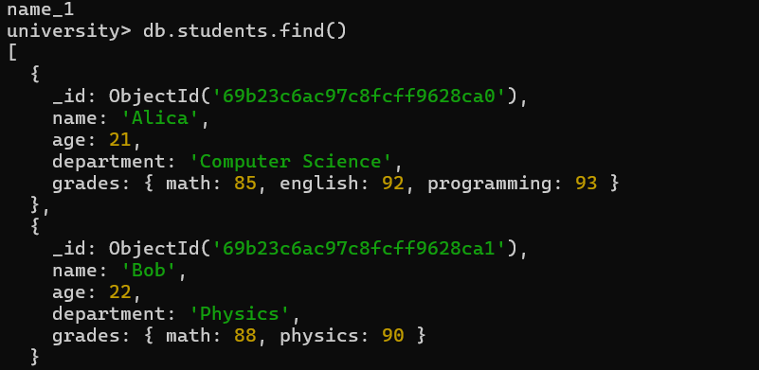

Q.7 Write an aggregation query to group students by their department and calculate the average age in each department.
Query:- db.students.aggregate([{$group:{"_id":"$department",average:{$avg:"$age"}}}])
Output:-

Q.8 Write a query to find all students who have scored more than 90 in any subject.
Query:- db.students.find({$or:[{"grades.math":{$gt:90}},{"grades.english":{$gt:90}},{"grades.programming":
{$gt:90}},{"grades.physics":{$gt:90}}]})
Qutput:-
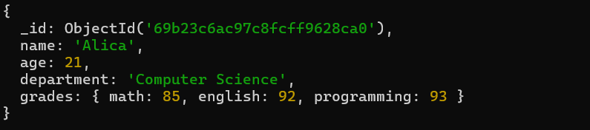

Q.9 Write a query to add a new field graduated set to false for all students who are in the Mathematics department.
Query:- db.students.updateMany({"grades.math":{$exists:true}},{$set:{"graduated":false}})
Output:- {
acknowledged: true,
insertedId: null,
matchedCount: 2,
modifiedCount: 2,
upsertedCount: 0
Check Query:-
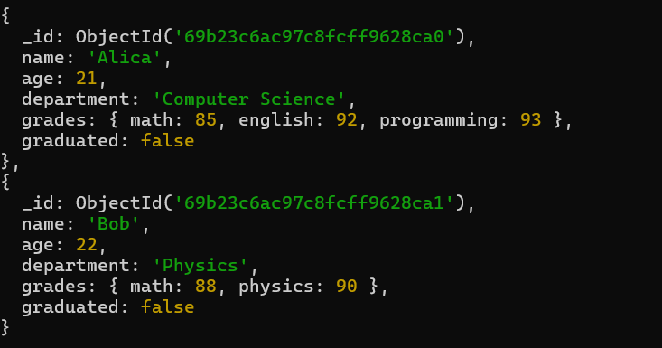

Q.10 How can you retrieve only the name and department fields for all students, excluding the _id field?
Query:- db.students.find({},{name:1,department:1,_id:0})
Qutput:-
