Fazals Assignment_3
1. Find students with marks greater than 80.
db.students.find({ marks: { $gt: 80 } })
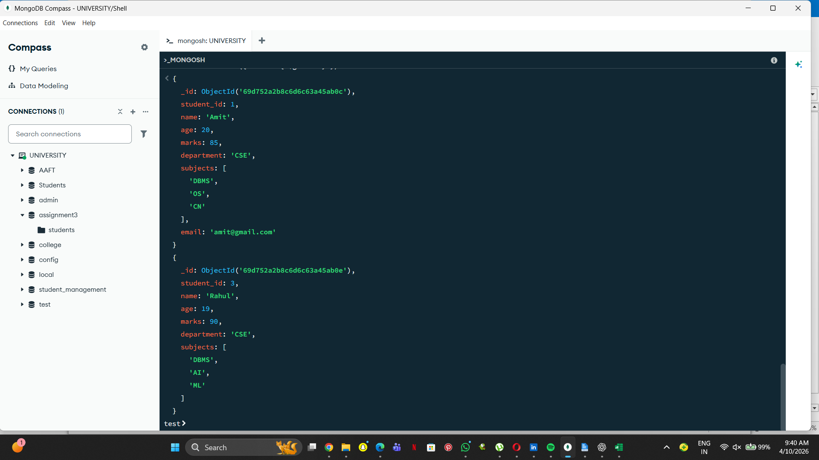

2. Find students aged less than or equal to 20.
db.students.find({ age: { $lte: 20 } })
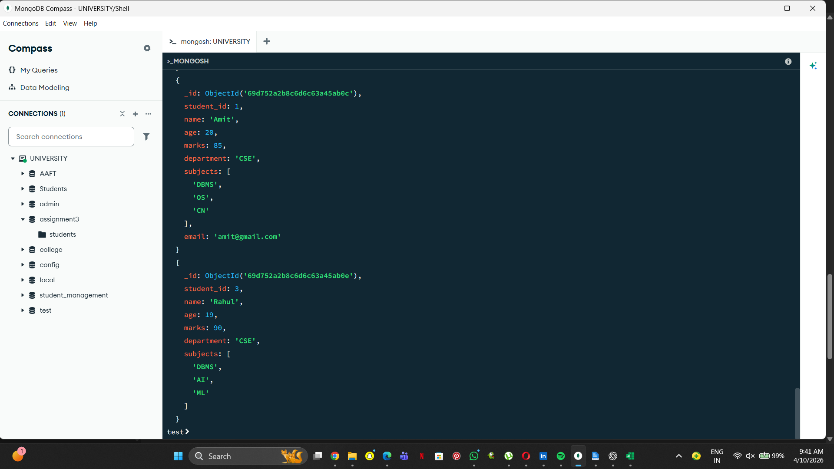

3. Find students with marks between 70 and 85.
db.students.find({ marks: { $gte: 70, $lte: 85 } })
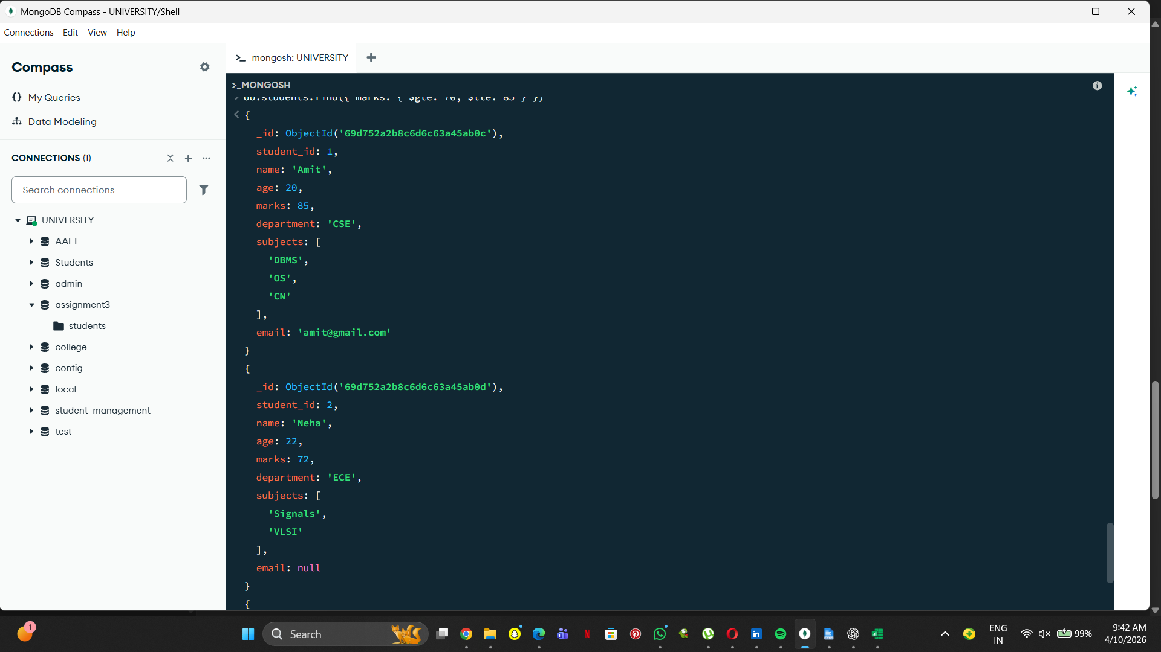
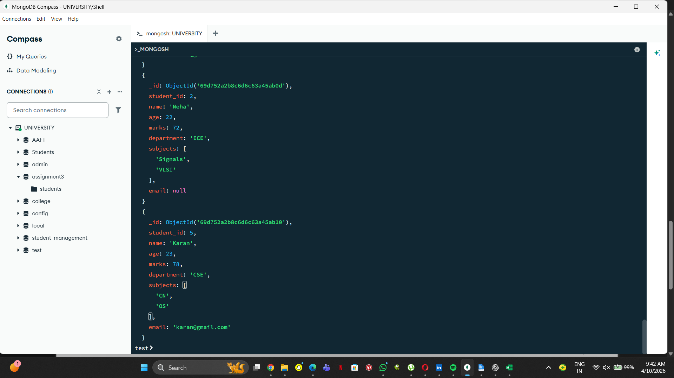

4. Find students not belonging to CSE department.
db.students.find({ department: { $ne: "CSE" } })
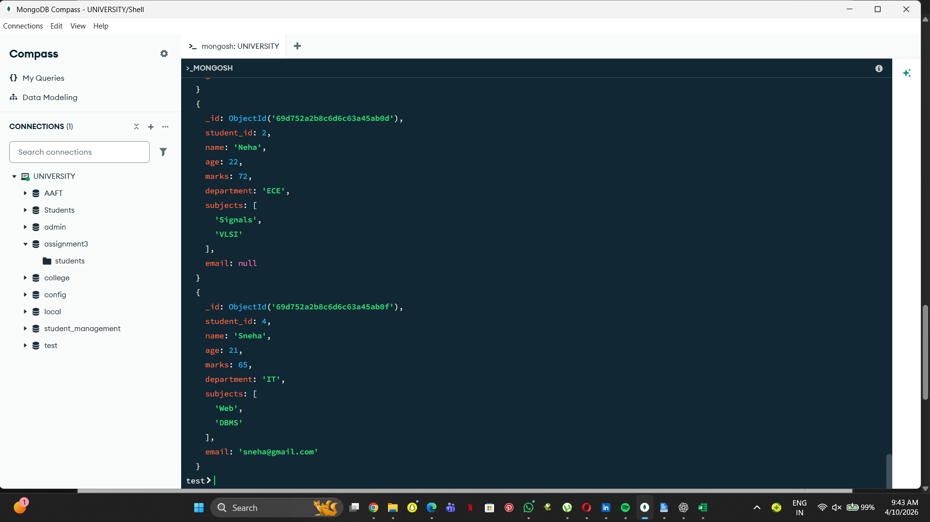
5. Find students whose age is exactly 21.
db.students.find({ age: 21 })
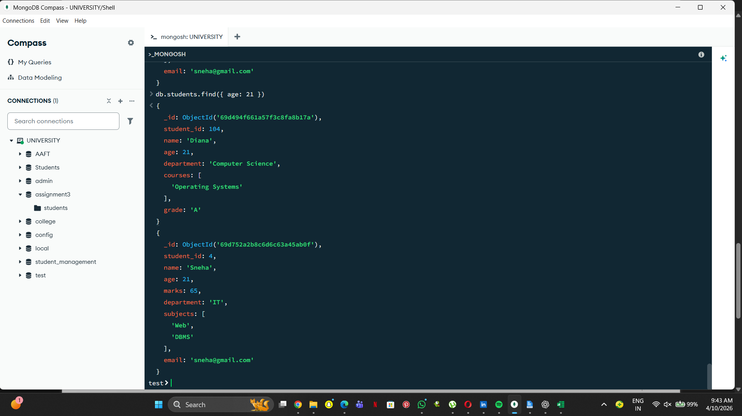
6. Find students with marks less than 75.
db.students.find({ marks: { $lt: 75 } })
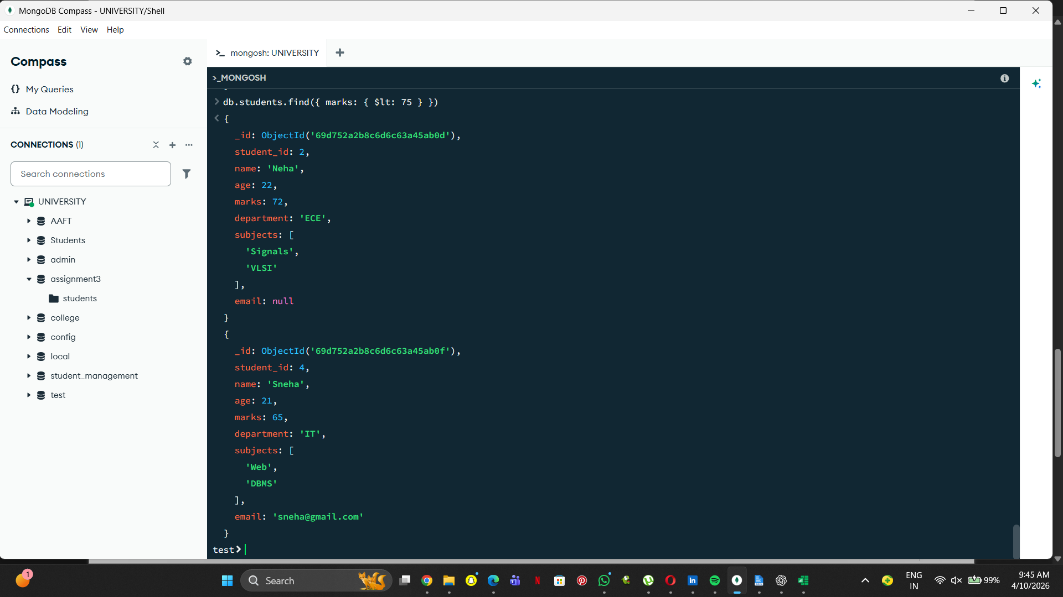
7. Find students whose department is either CSE or IT.
db.students.find({ department: { $in: ["CSE", "IT"] } })
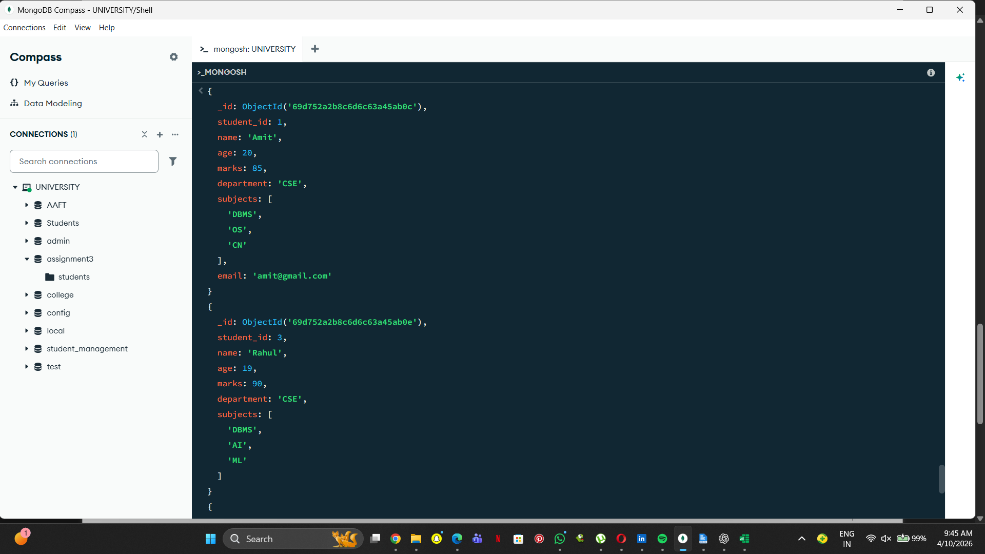
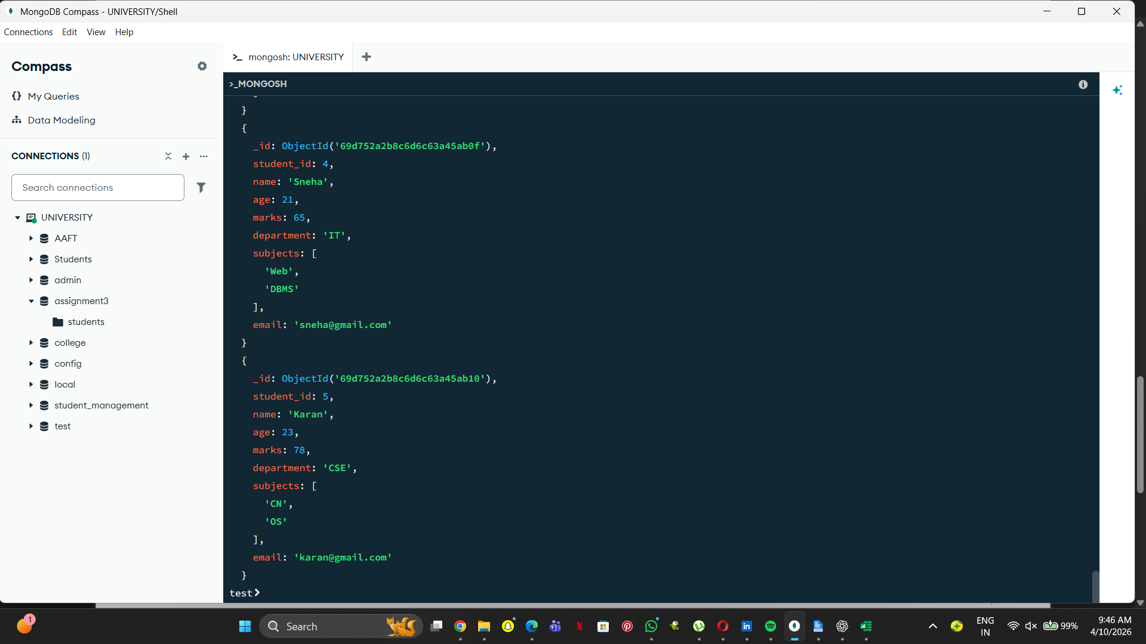
8. Find CSE students with marks above 80.
db.students.find({ department: "CSE", marks: { $gt: 80 } })
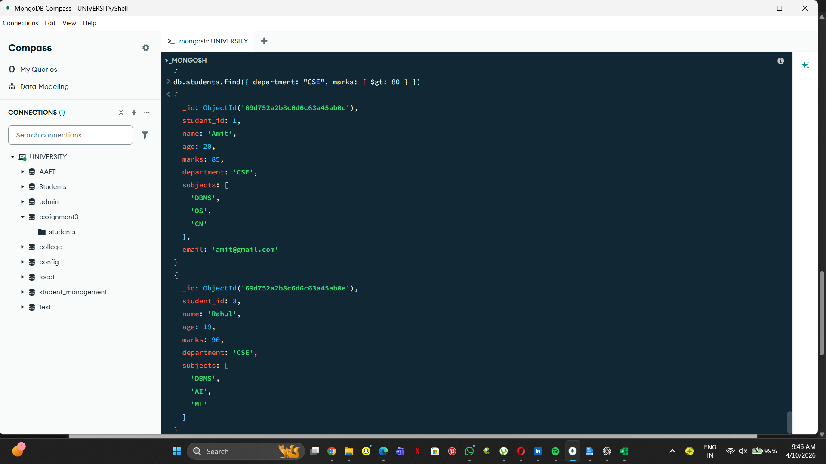
9. Find students who are in CSE or have marks above 85.
db.students.find({ $or: [{ department: "CSE" }, { marks: { $gt: 85 } }] })
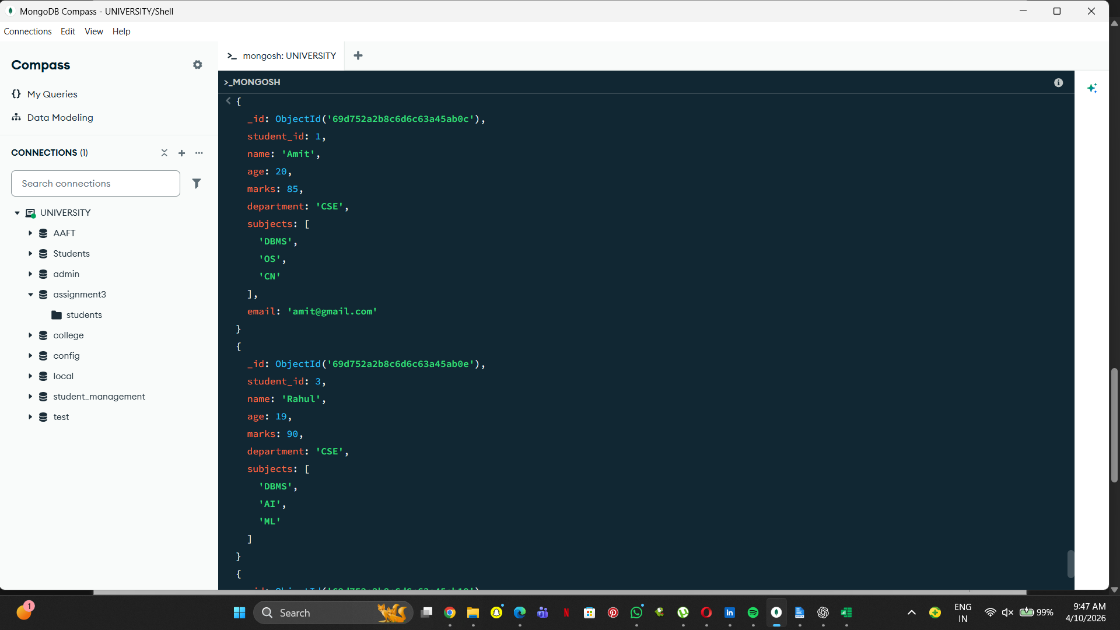
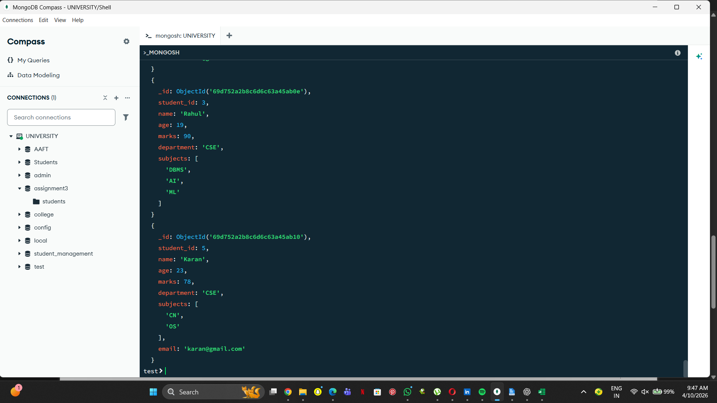
10. Find students who are NOT in IT department.
db.students.find({ department: { $ne: "IT" } })
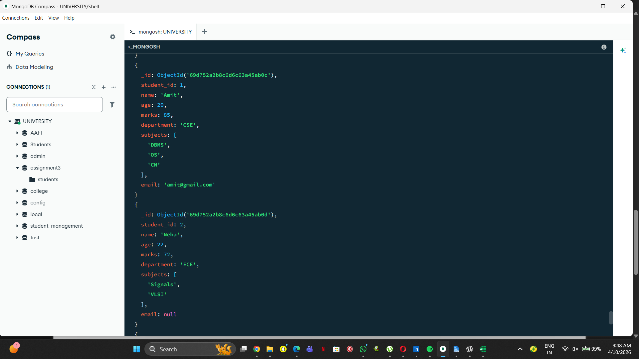
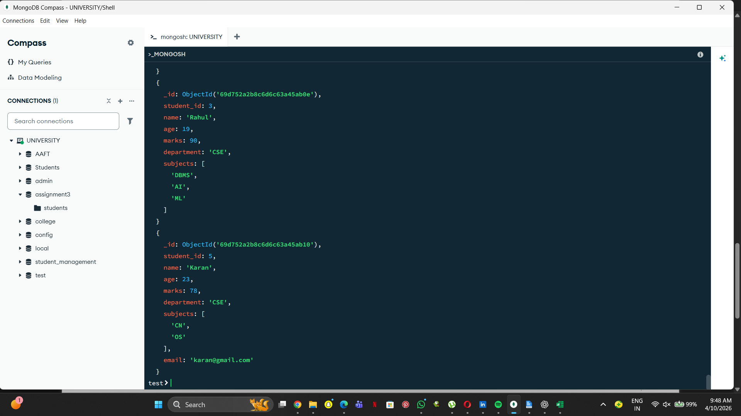
11. Find students with marks not between 70 and 85.
db.students.find({ $or: [{ marks: { $lt: 70 } }, { marks: { $gt: 85 } }] })
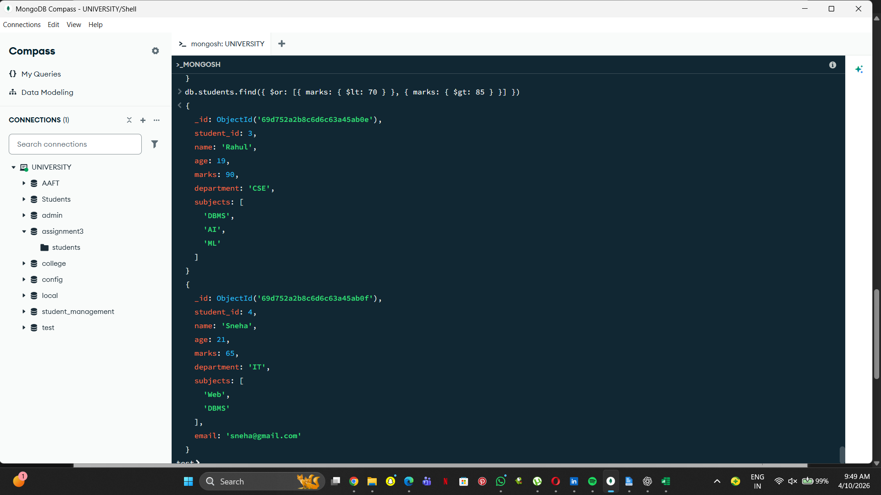
12. Find students aged above 20 and not in ECE.
db.students.find({ age: { $gt: 20 }, department: { $ne: "ECE" } })
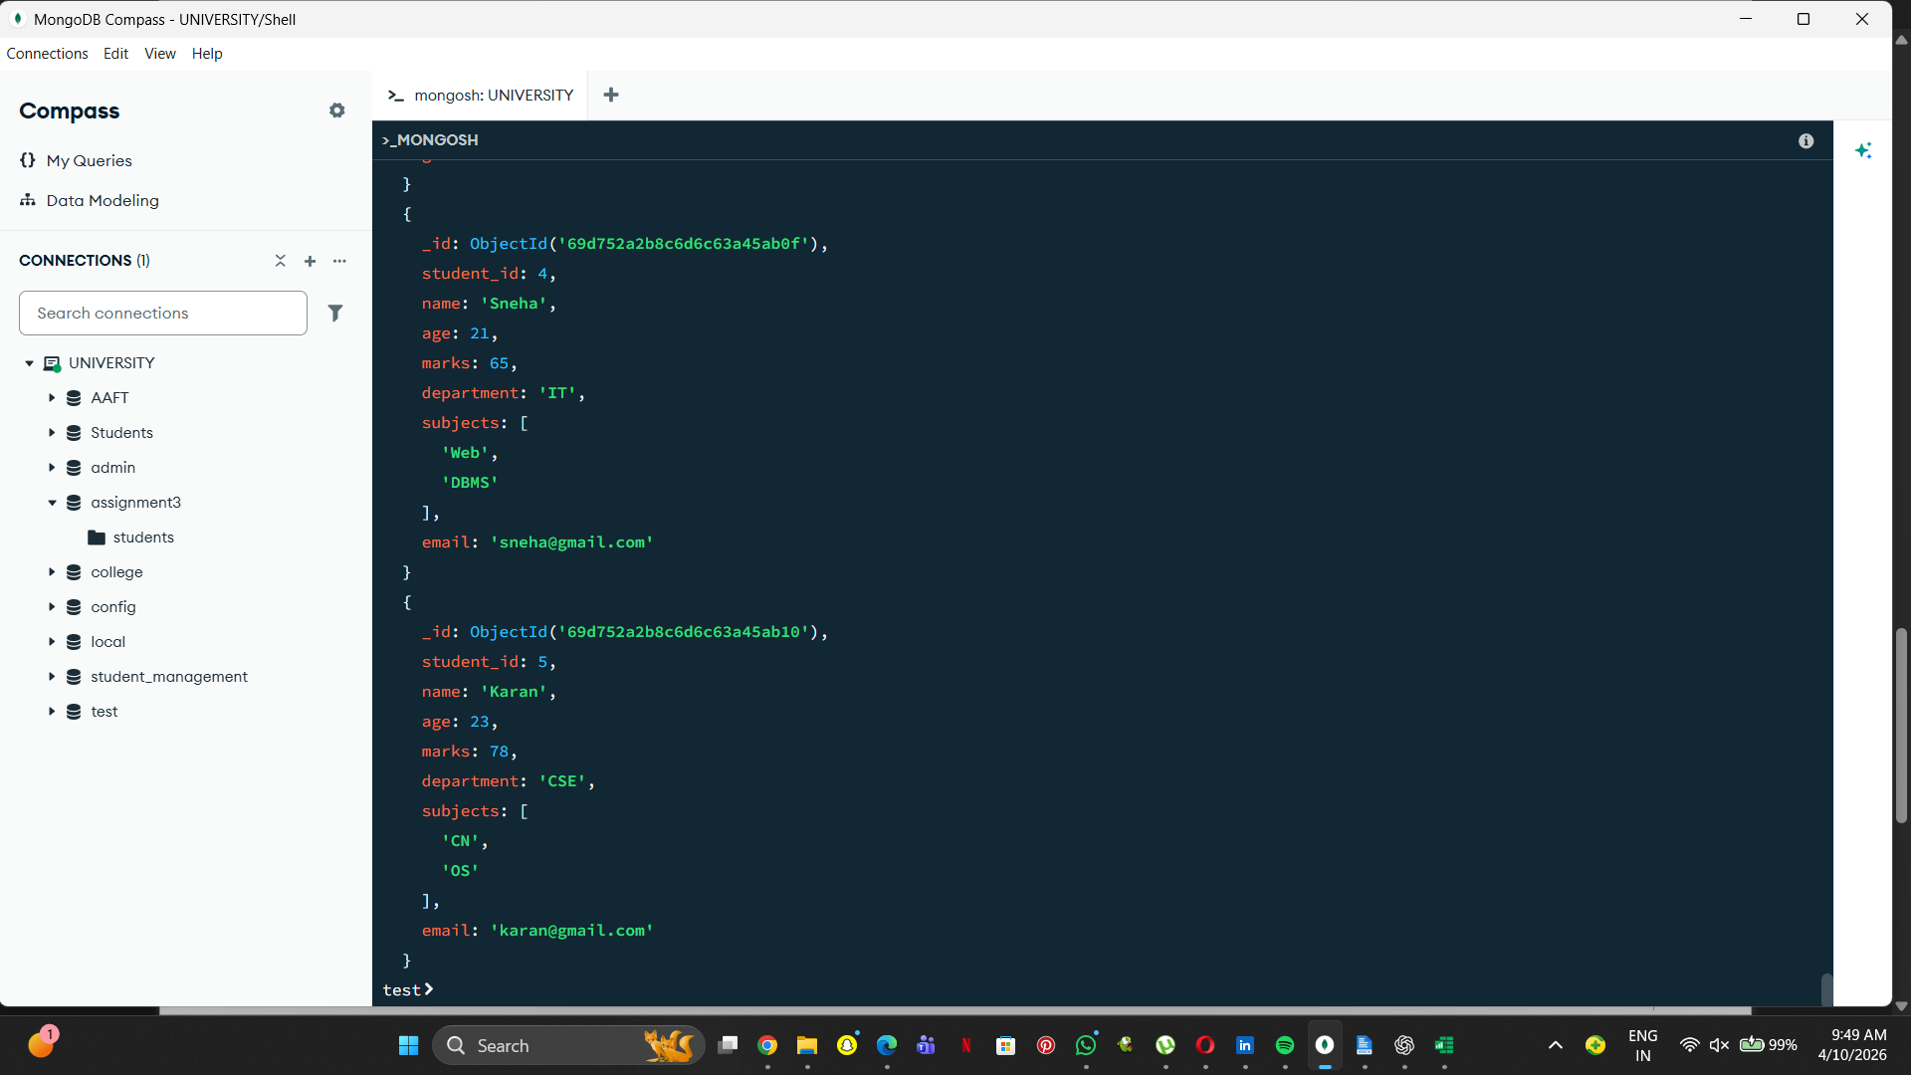
13. Find students who are either IT students or have marks less than 70.
db.students.find({ $or: [{ department: "IT" }, { marks: { $lt: 70 } }] })
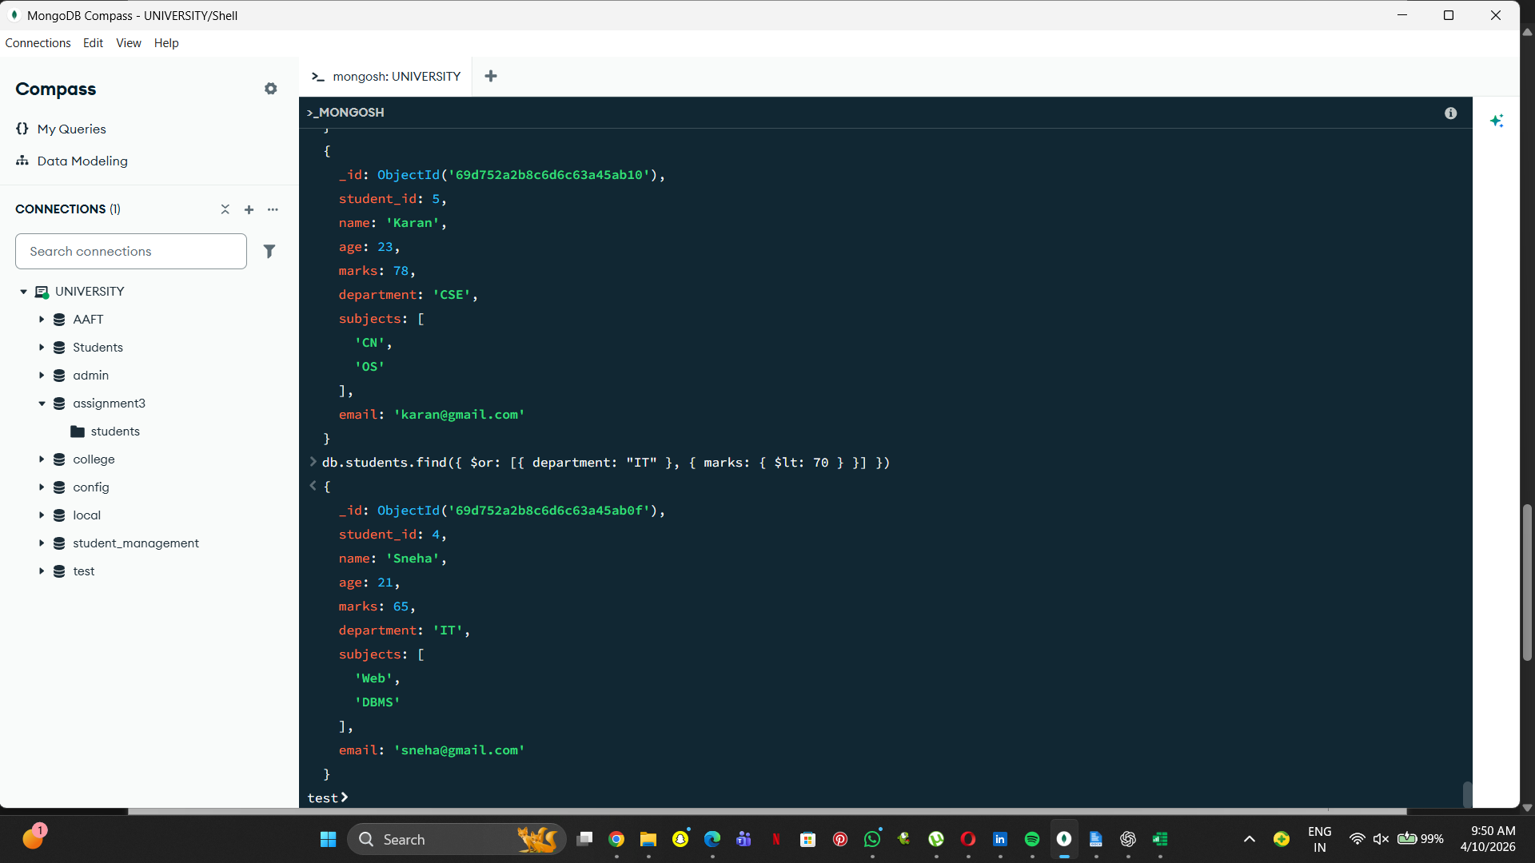
14. Find students who are not CSE and not IT.
db.students.find({ department: { $nin: ["CSE", "IT"] } })
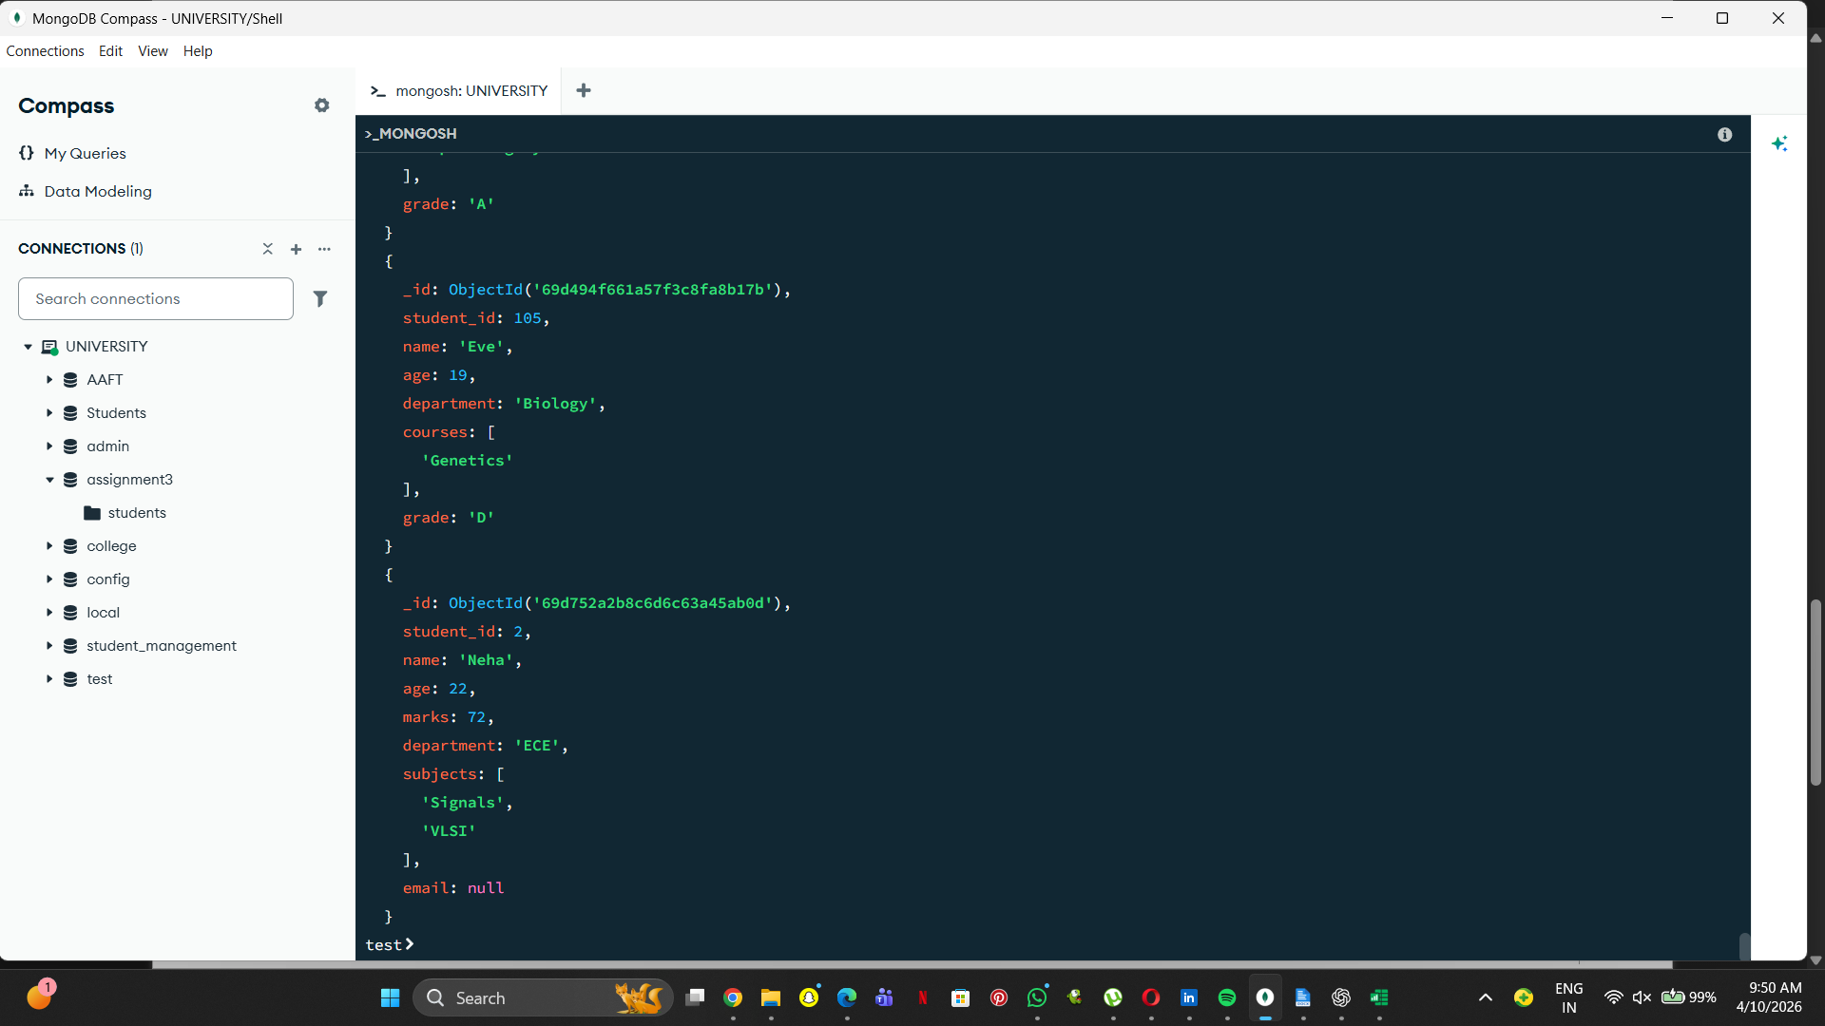
15. Find students who have an email field.
db.students.find({ email: { $exists: true } })
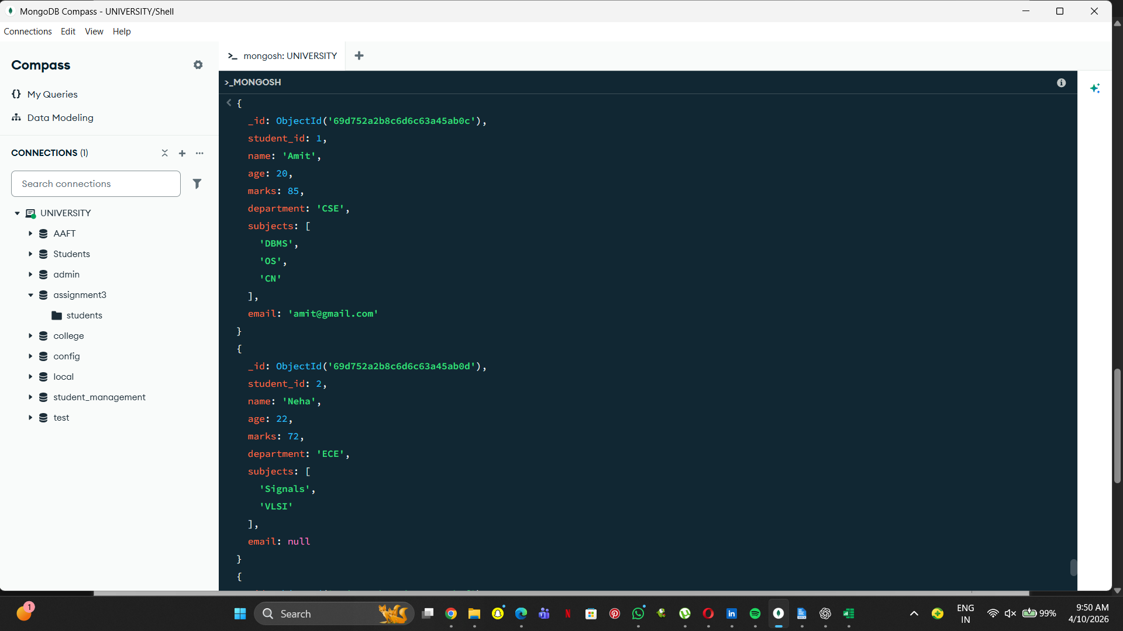
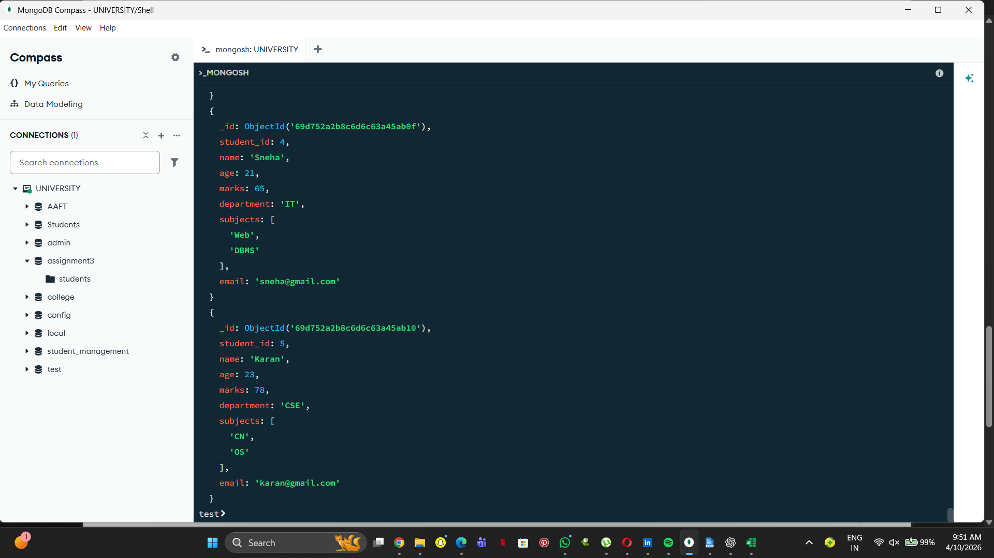
16. Find students who do not have an email field.
db.students.find({ email: { $exists: false } })
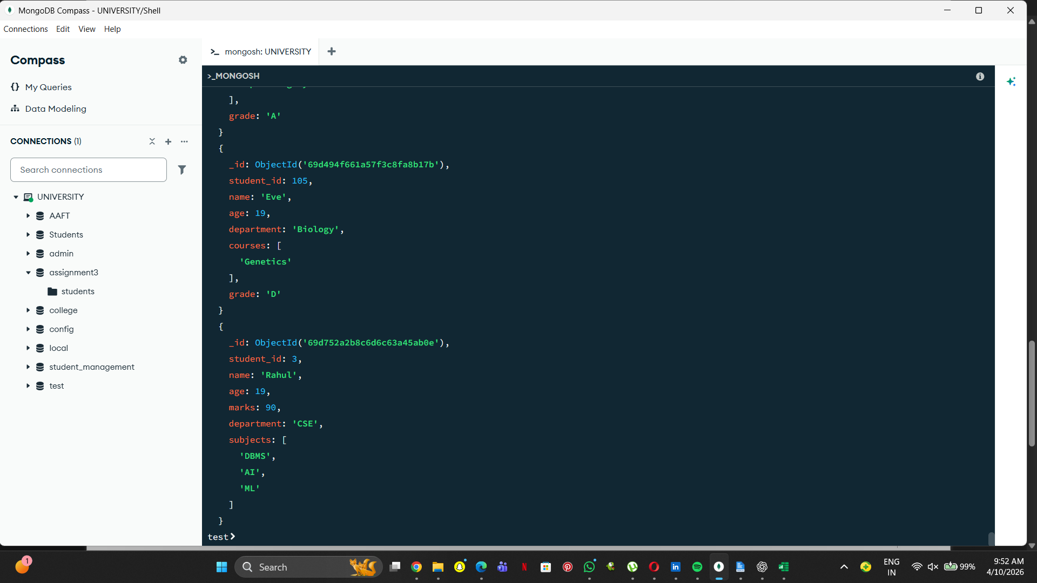
17. Find students whose email value is null.
db.students.find({ email: null })
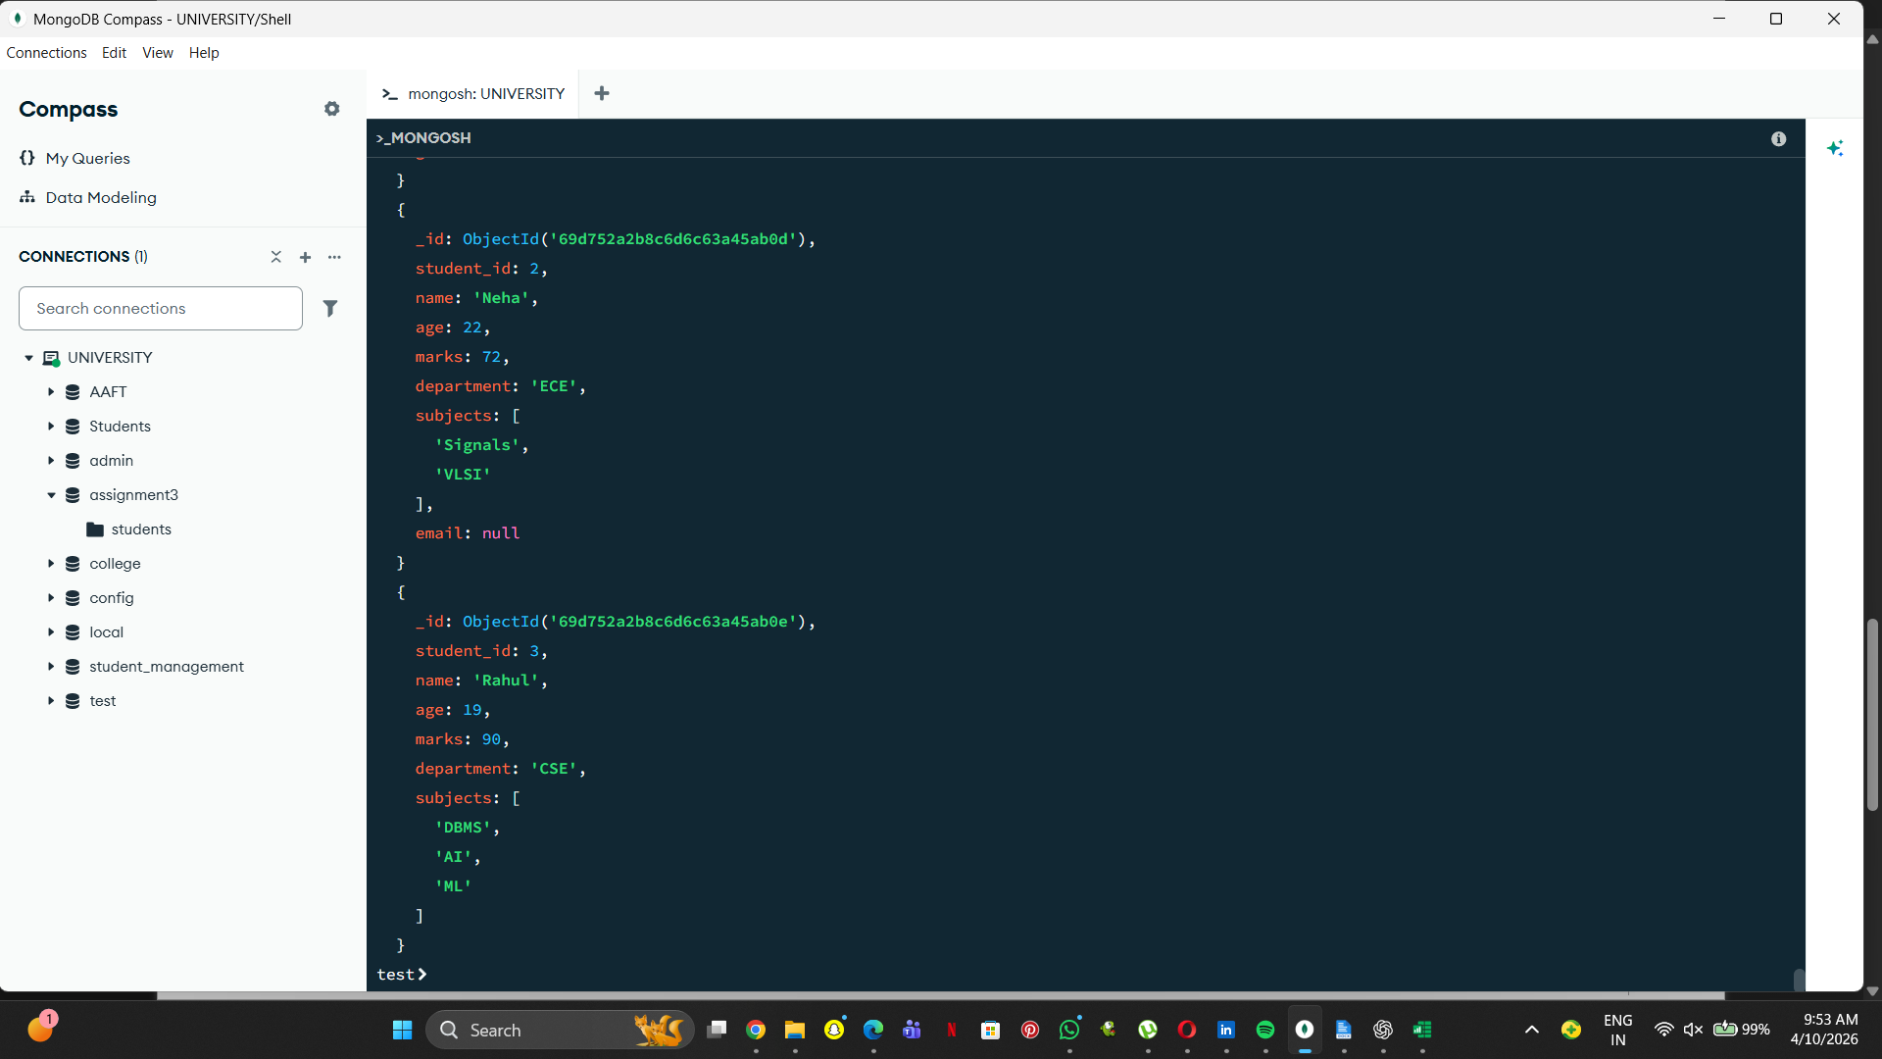
18. Find students whose marks field is of type integer.
db.students.find({ marks: { $type: "int" } })
db.students.find({ marks: { $type: "int" } })

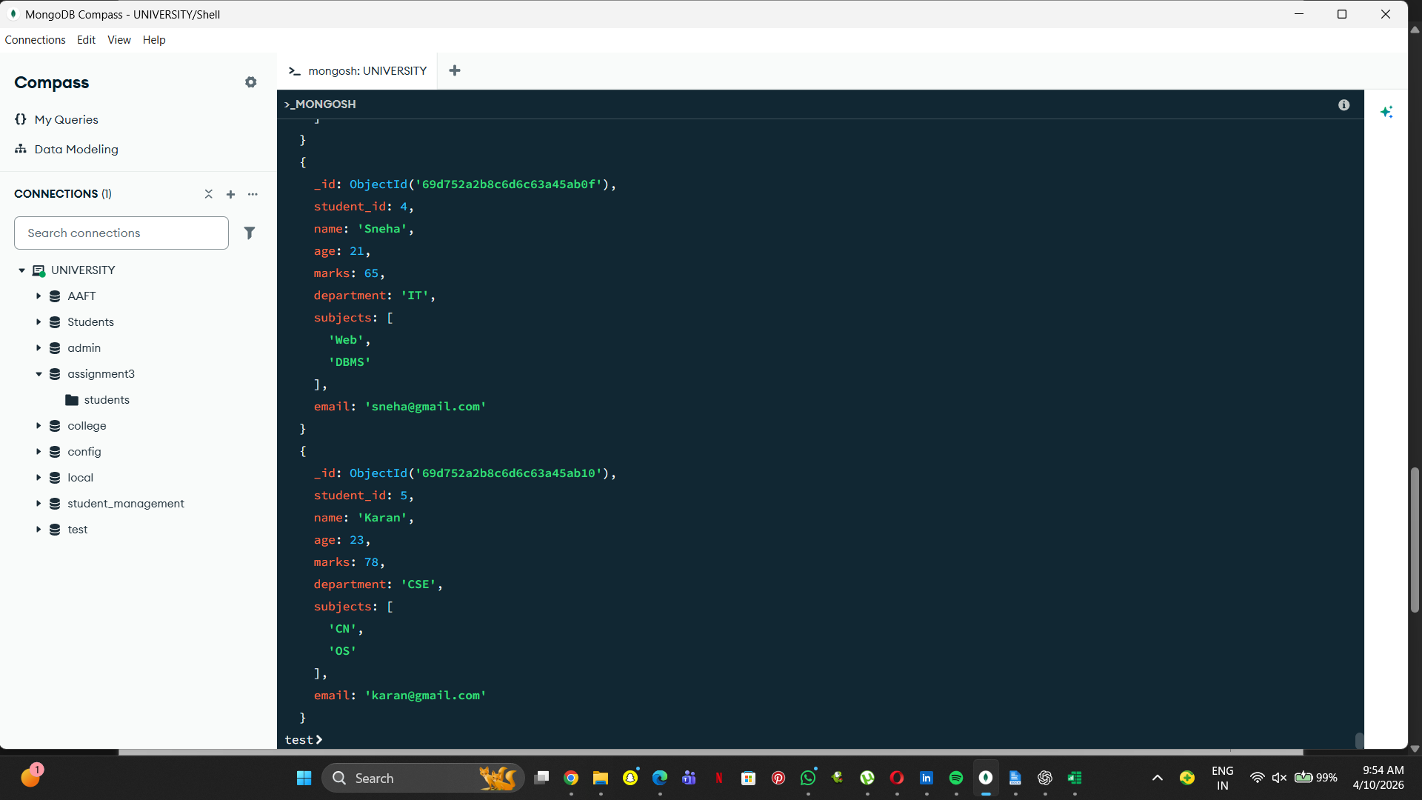
19. Find students who have subjects field.
db.students.find({ subjects: { $exists: true } })
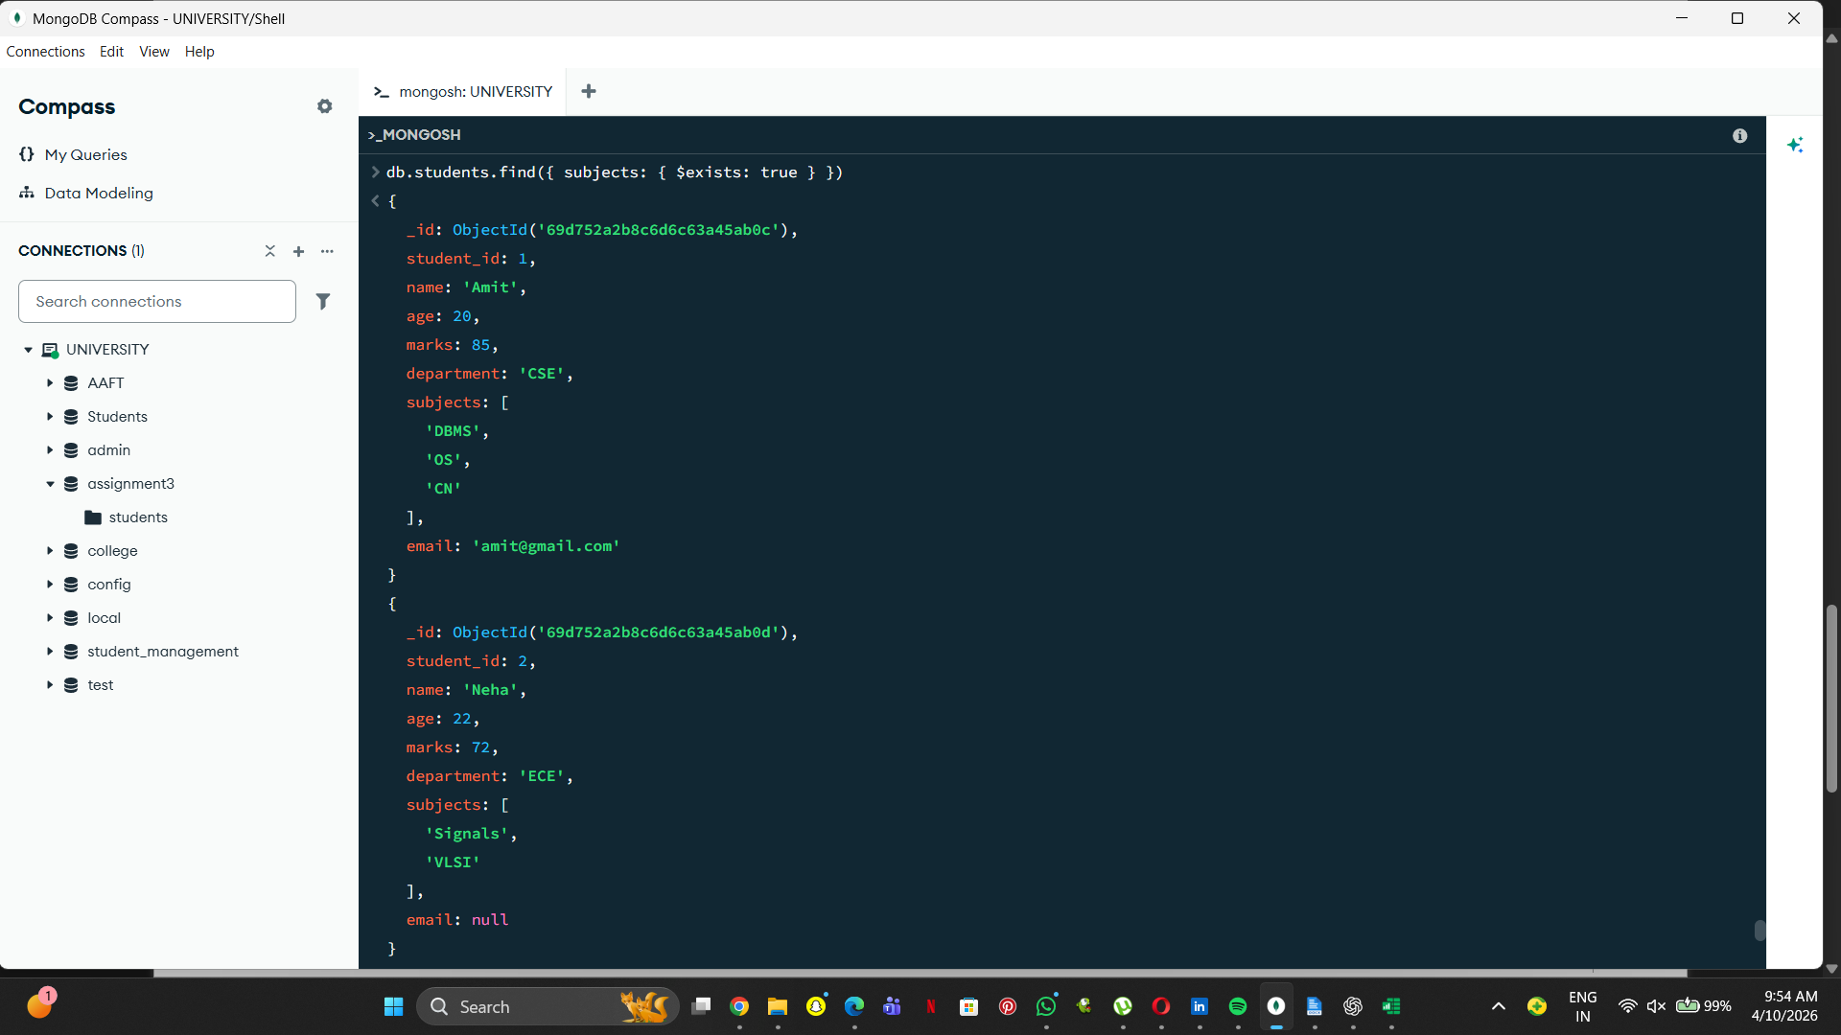

20. Find students whose age field is missing.
db.students.find({ age: { $exists: false } })

21. Find students where marks modulo 5 equals 0.
db.students.find({ marks: { $mod: [5, 0] } })
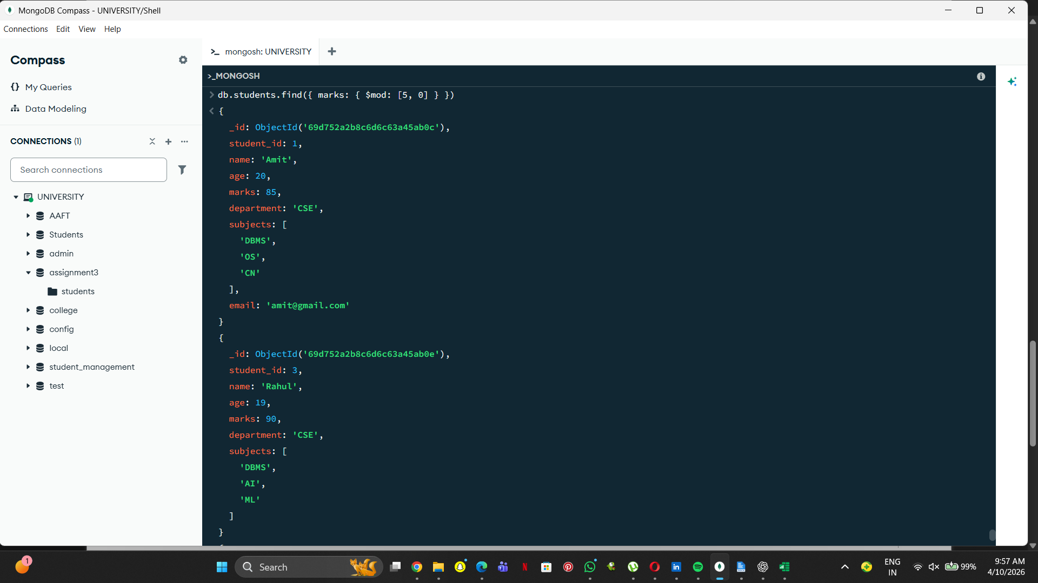
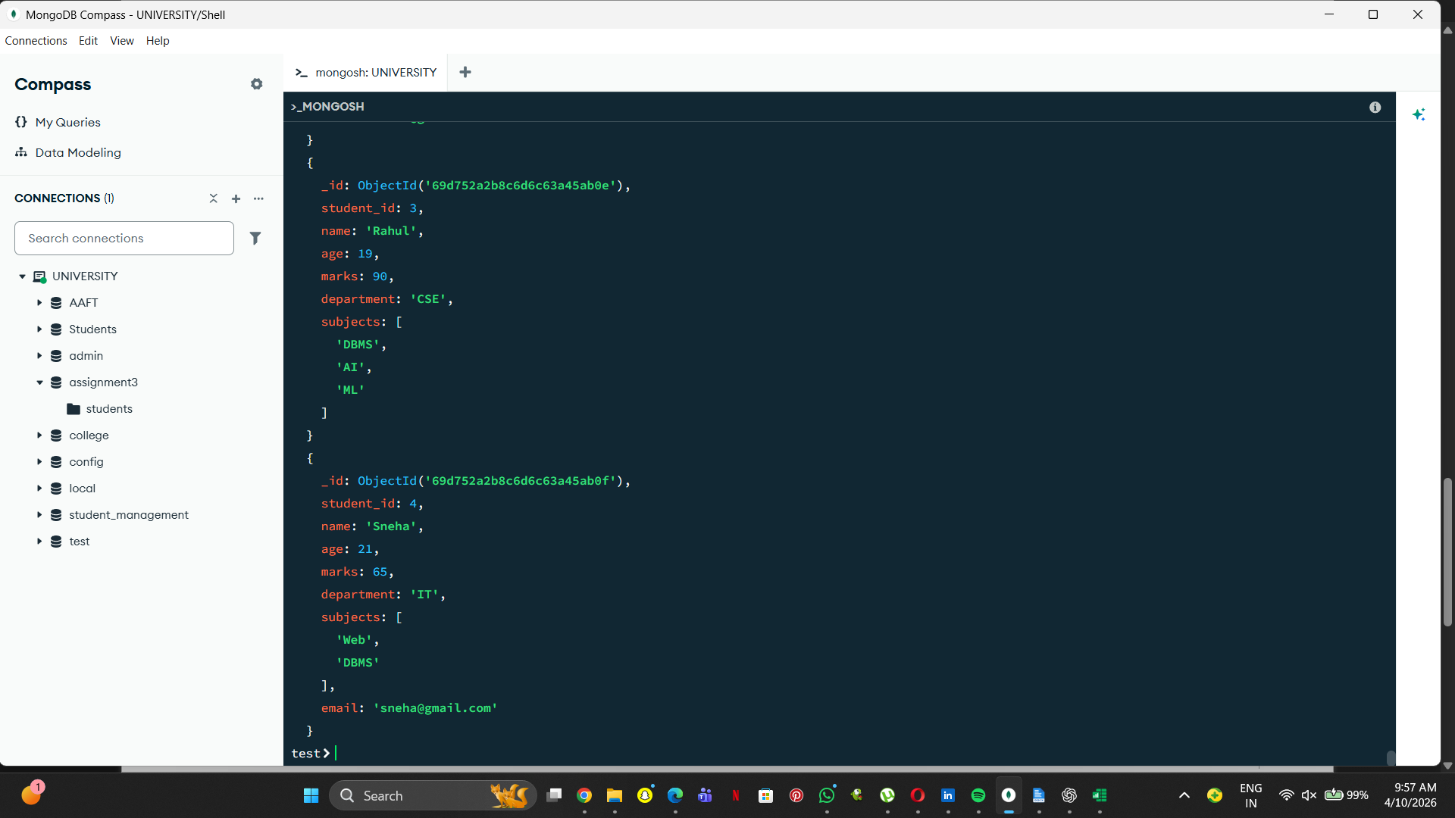
22. Find students whose name starts with letter 'A'.
db.students.find({ name: /^A/ })
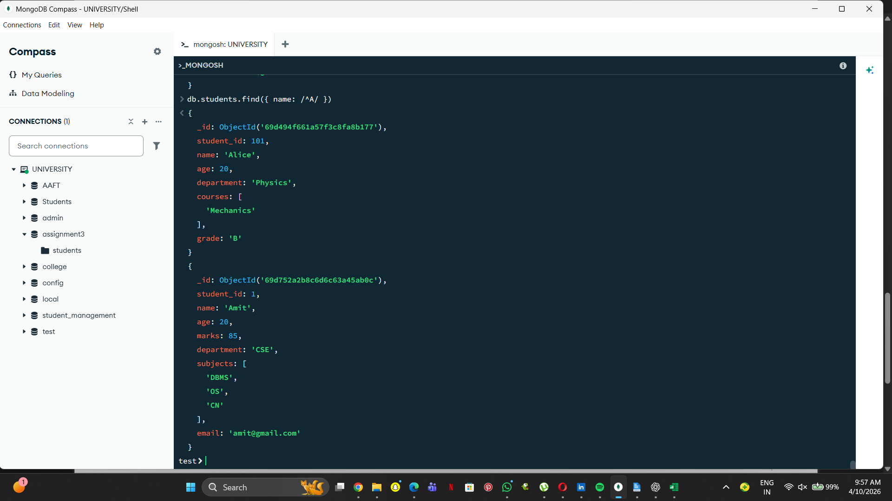

23. Find students whose email ends with gmail.com.
db.students.find({ email: /gmail\.com$/ })
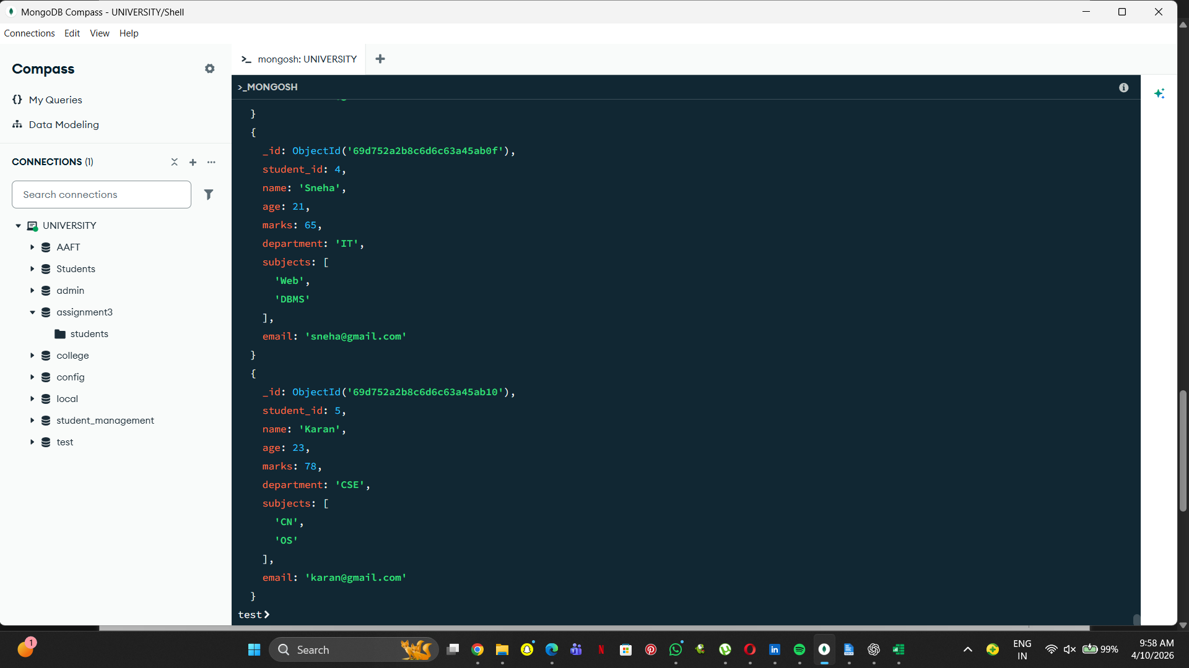
24. Find students who have more than 2 subjects.
db.students.find({ $expr: { $gt: [{ $size: "$subjects" }, 2] } })

25. Find students whose marks are greater than their age × 3.
db.students.find({ $expr: { $gt: ["$marks", { $multiply: ["$age", 3] }] } })
