## Solar Irradiance - Togo - Dapaong

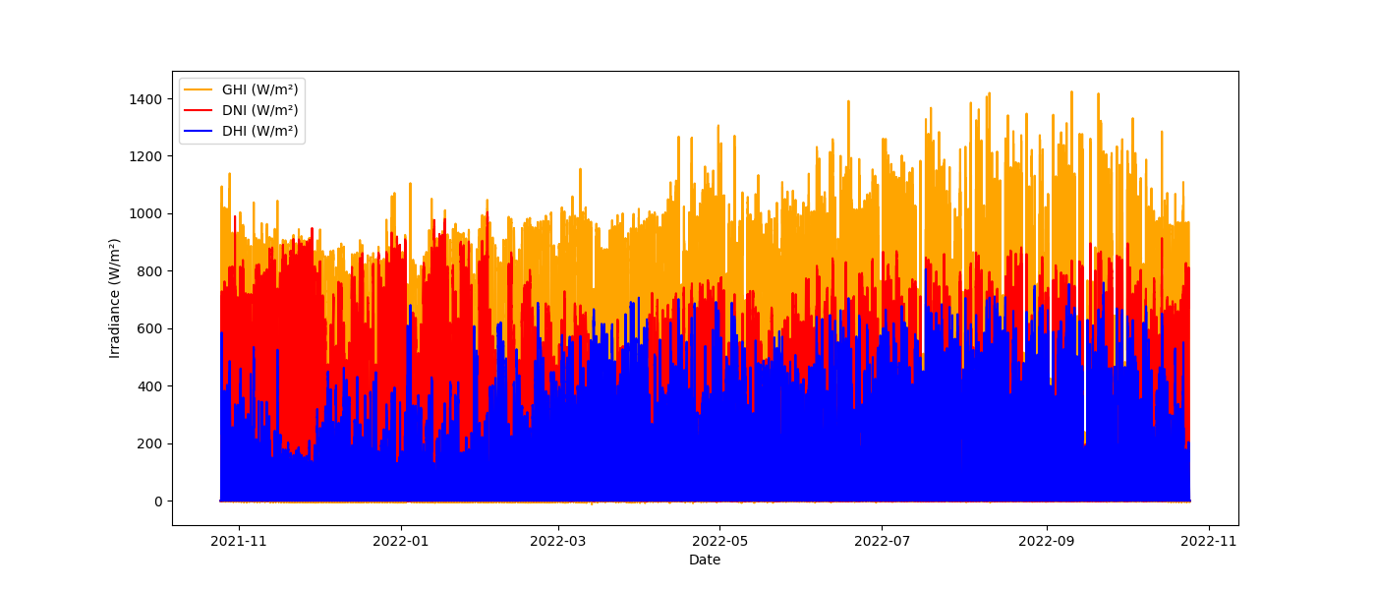

## Solar Irradiance - Sierra Leone - Bumbuna

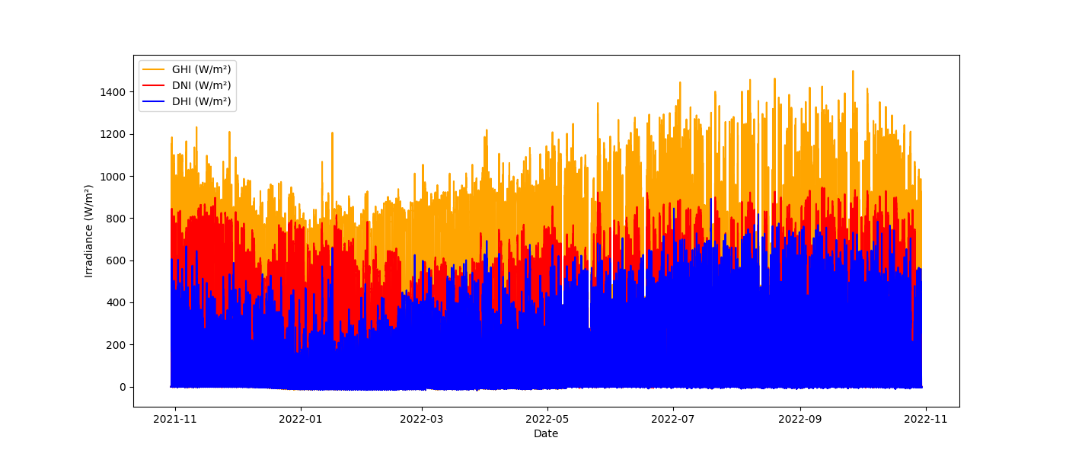

## Solar Irradiance - Benin - Malanville

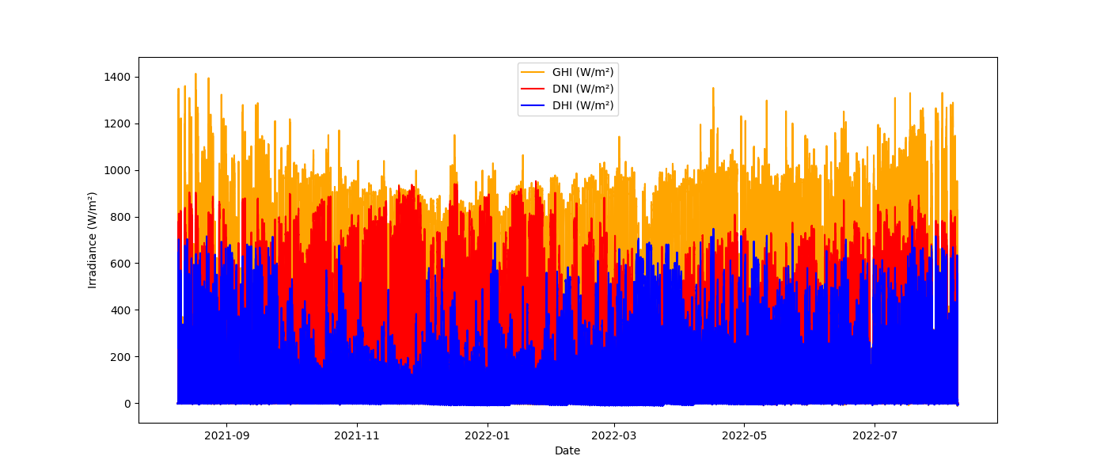

## Temperature and Humidity - Togo - Dapaong

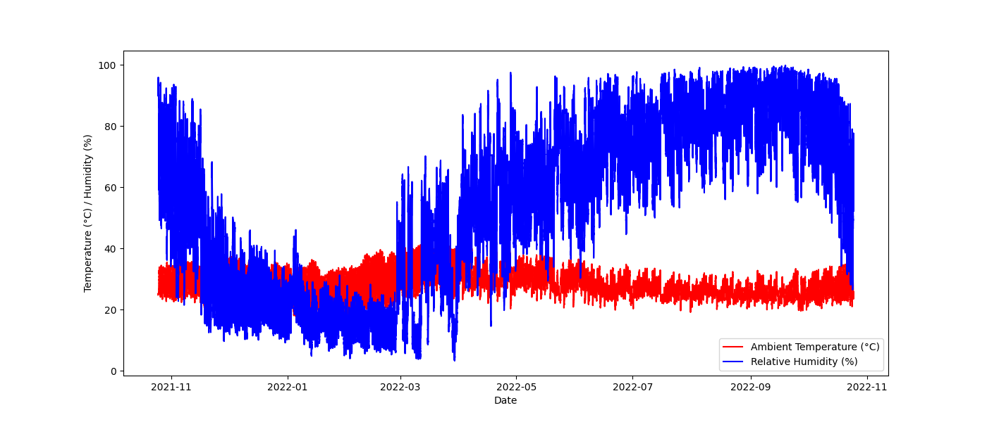

## Temperature and Humidity - Sierra Leone - Bumbuna

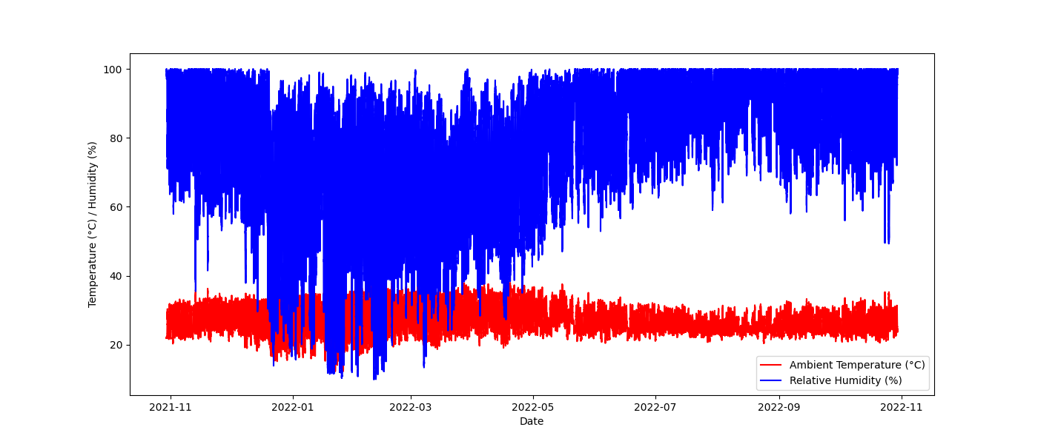

## Temperature and Humidity - Benin - Malanville

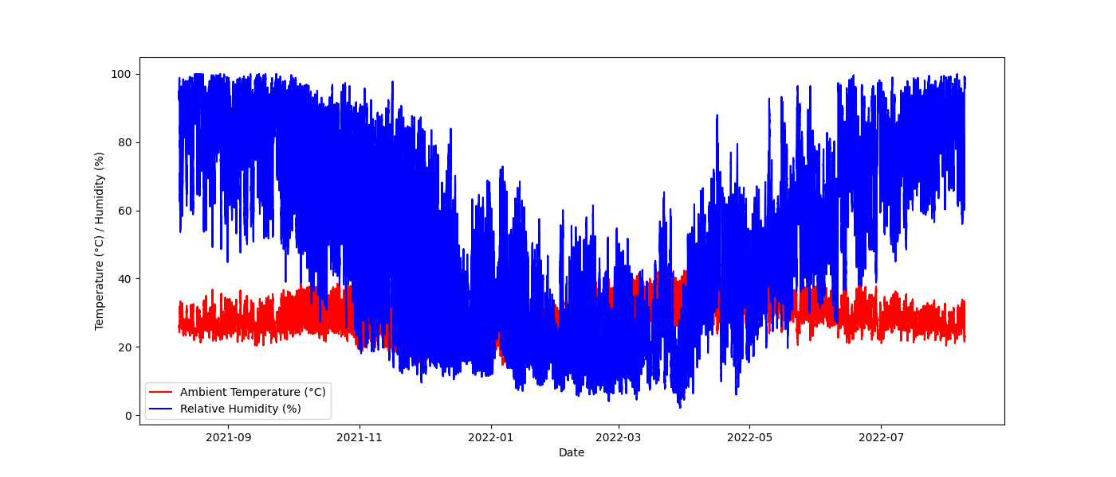

## Wind Conditions - Togo - Dapaong

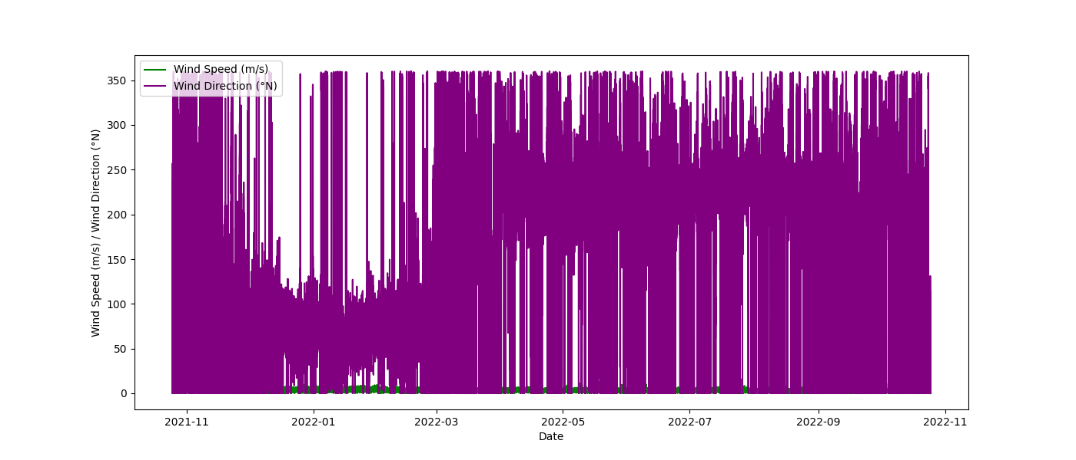

## Wind Conditions - Sierra Leone - Bumbuna

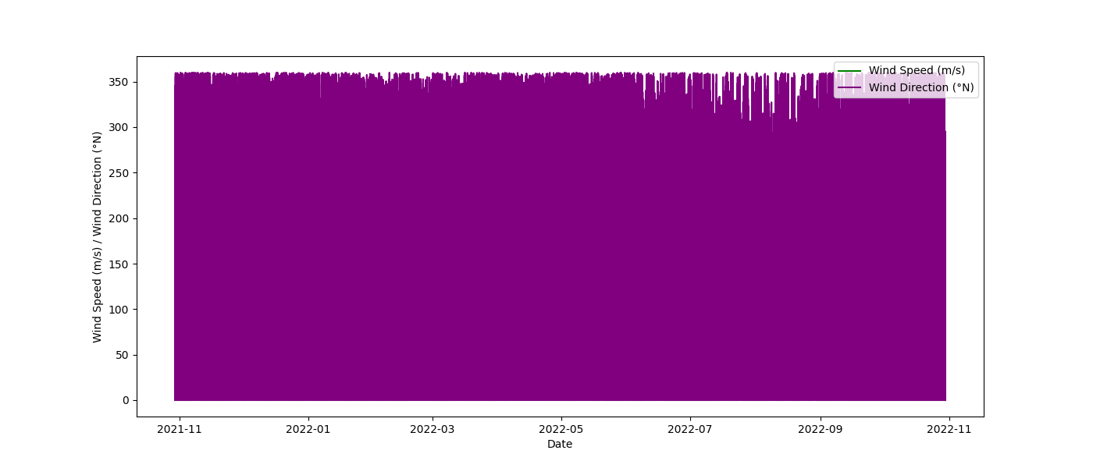

## Wind Conditions - Benin - Malanville

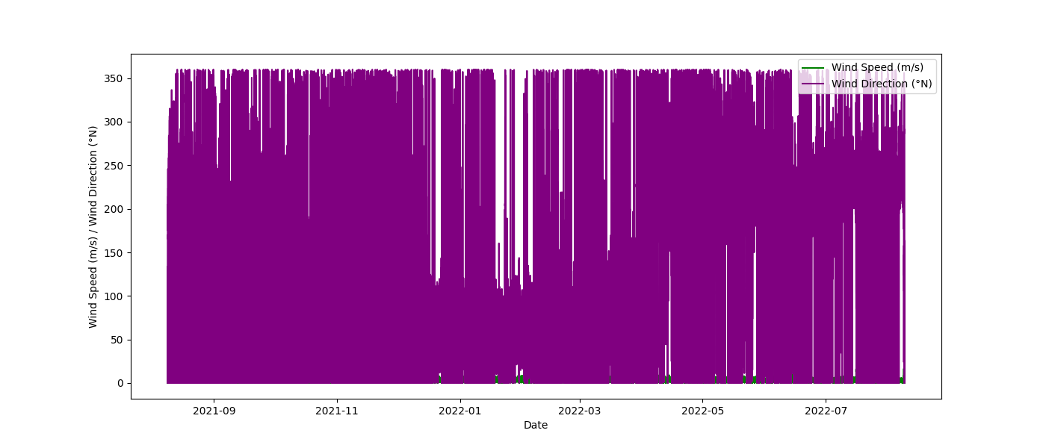

## Correlation Matrix - Togo - Dapaong

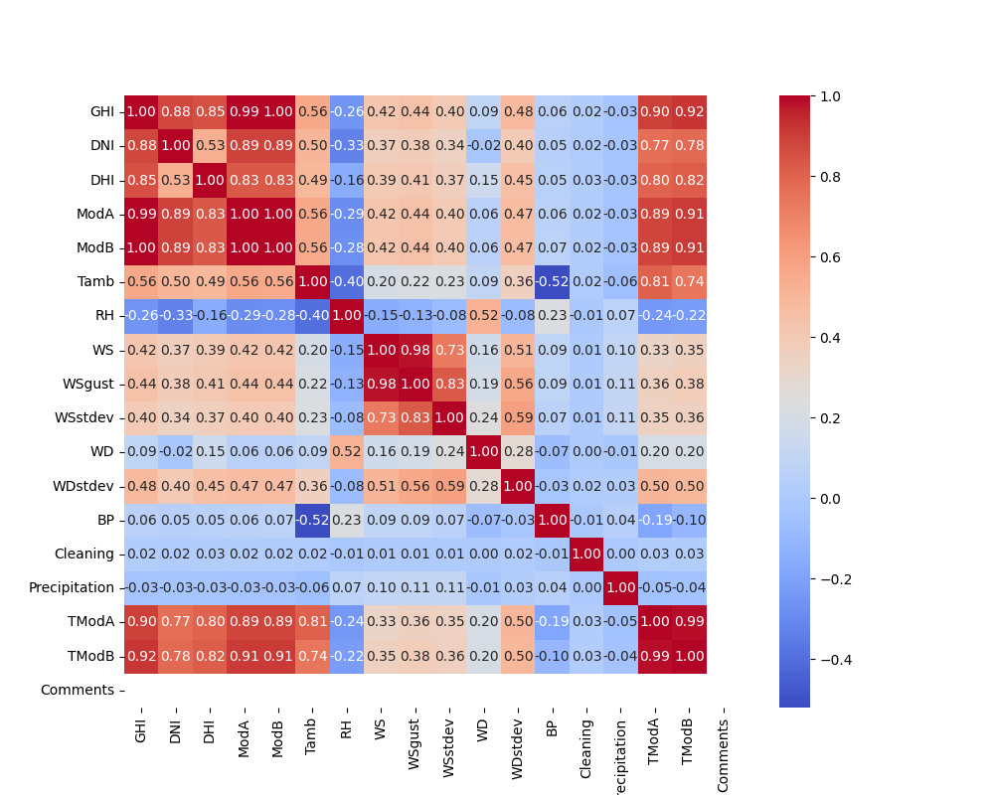

## Correlation Matrix - Sierra Leone - Bumbuna

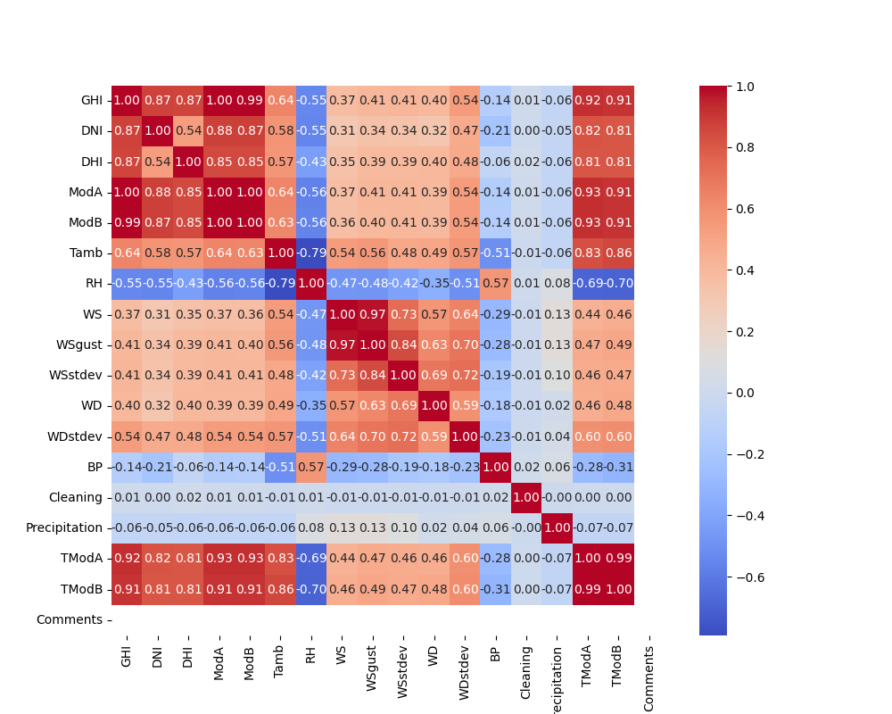

## Correlation Matrix - Benin - Malanville

