

**DATABASE PROJECT:**

**RAILWAY TICKET RESERVATION SYSTEM**

**SUBMITTED BY:**

**FAZEEL ABBAS FA20-BCE-041**

**MOIZ USMAN FA20-BCE-025**

**SUBMITTED TO:**

**MAHRUKH SALEEM**

**DELIVERABLE 2:**

**Project ERD:**

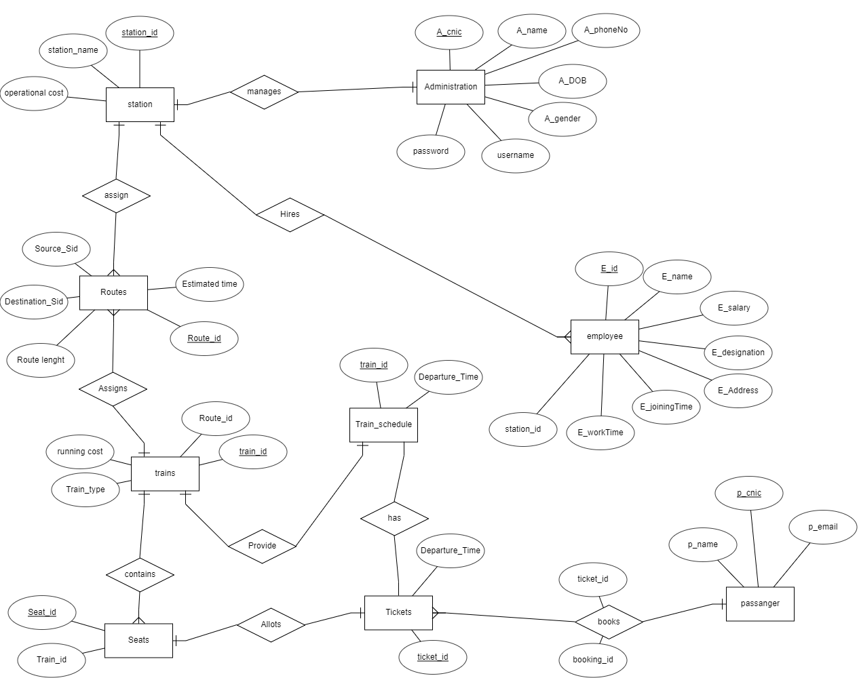

**Standardize ERD:**

