TASDEEQ – DIGITAL VERIFICATION PLATFORM
TASDEEQ-V1
Project Management Plan

Contents
1. Background and References 3
1.2 The Client 3
1.3 Expected Goals 3
1.3.1 Technical Goals 3
1.3.2 Economical Goals 3
1.3.3 Strategic Goals 3
1.4 Project Classification 3
1.5 Reference Contract Documents 4
2. Project Structuring 4
2.1 OBS (Organizational Breakdown Structure) 4
2.2 ABS (Activity Breakdown Structure) 5
2.3 PBS (Product Breakdown Structure) 5
2.4 WBS (Work Breakdown Structure) 6
2.5 Procurement Plan 7
2.6 Measurement and Control Methodologies 7
2.7 Reporting 7
3. Supporting Managerial Activities 7
3.1 Risk Management 7
3.2 Quality Management 8
3.3 Development 8
3.4 Configuration Management 8
3.5 Acceptance Criteria / Testing 8
3.6 Phase Reviews 8
4. Master Plan 8
4.1 Contract Plan 8
4.2 Master Plan and Associated Milestones 8
5. Technical Budget 9
5.1 Costs / Revenues / Margins 9
5.2 Business Plan 9
5.3 External Costs Plan 9
5.4 Billing and Collections 9
5.5 EVA Analysis 10

1. Background and References

1.1 Objective
The objective of the Tasdeeq Digital Verification Platform project is to design and deploy a secure, scalable digital verification system for the Italian and European market.
The platform will enable organizations to perform identity, credential, and background verification in a compliant, efficient, and reliable manner, fully aligned with GDPR and Italian data protection regulations.

1.2 The Client
The client is Tasdeeq, a digital verification service provider operating in the Italy / EU region, focusing on delivering secure and compliant verification solutions to enterprises such as banks, fintech companies, employers, telecom operators, and public institutions.

1.3 Expected Goals

1.3.1 Technical Goals
The technical goal is to develop a highly secure, scalable, and API-driven verification platform, ensuring:
- High system availability
- Strong data security and encryption
- Seamless integration with third-party systems
- High performance and reliability

1.3.2 Economical Goals
The economic goal is to optimize development and operational costs while maintaining quality, and to achieve a positive return on investment through enterprise contracts and service-based revenue within the initial operational period.

1.3.3 Strategic Goals
The strategic goal is to strengthen Tasdeeq’s position in the digital identity and verification market by offering a compliant, trusted, and enterprise-grade solution, increasing adoption across Italian and EU-based organizations.

1.4 Project Classification
The project is classified as the development and deployment of an enterprise IT system.
The scope of the project is regional (Italy / EU), with a focus on regulated industries requiring secure digital verification services.

1.5 Reference Contract Documents
The reference documents for the project include:
- Statement of Work (SOW)
- Project Proposal
- Project Management Plan
- Contract Agreement
- Non-Disclosure Agreement (NDA)
- Technical Specifications
- User and System Documentation

2. Project Structuring

2.1 OBS (Organizational Breakdown Structure)
The OBS defines the organizational structure and responsibilities involved in the Tasdeeq project, including:
- Project Manager
- Backend Development Team
- Frontend Development Team
- Quality Assurance Team
- Support Team
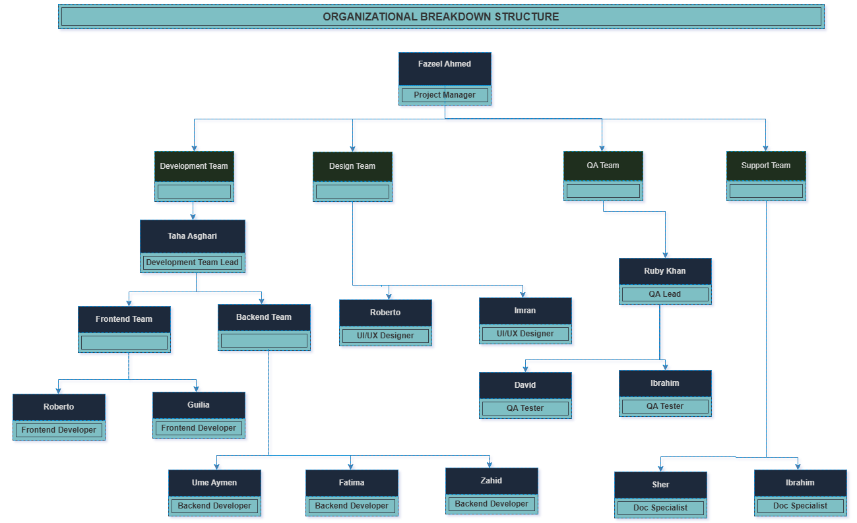

2.2 ABS (Activity Breakdown Structure)
The ABS identifies and organizes all activities required to complete the project, covering planning, analysis, design, development, testing, deployment, and documentation.
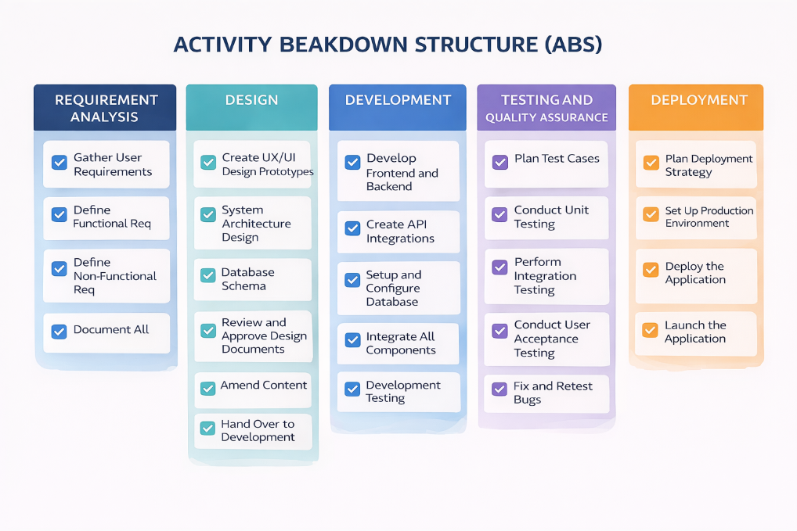

2.3 PBS (Product Breakdown Structure)
The PBS defines the main components of the product, including:
- Identity Verification Module
- Credential & Background Verification Module
- API Gateway
- Audit and Logging Module
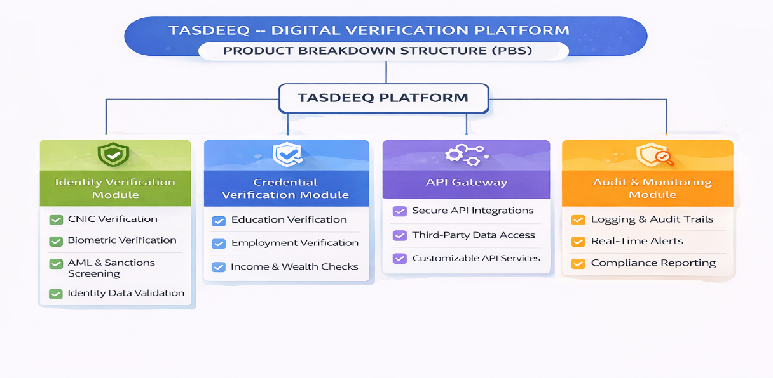

2.4 WBS (Work Breakdown Structure)
The project is divided into the following work packages:
WBS (Task) | Name
TASDEEQ_V1 | Tasdeeq Digital Verification Platform
WP1 | Project Management
WP1.1 | Project Planning
WP1.2 | Project Monitoring & Control
WP1.3 | Project Closure
WP2 | Requirements Analysis
WP2.1 | Requirements Gathering
WP2.2 | Functional Requirements Definition
WP2.3 | Non-Functional Requirements Definition
WP2.4 | Requirements Documentation
WP3 | Design
WP3.1 | System Architecture Design
WP3.2 | API Design
WP3.3 | Database Design
WP3.4 | Security & Compliance Design
WP3.5 | Design Review and Approval
WP4 | Development
WP4.1 | Backend Development
WP4.2 | API Development
WP4.3 | Integration
WP4.4 | Development Testing
WP5 | Quality Assurance
WP5.1 | Test Planning
WP5.2 | Unit Testing
WP5.3 | Integration Testing
WP5.4 | User Acceptance Testing
WP5.5 | Bug Fixing
WP6 | Deployment
WP6.1 | Deployment Planning
WP6.2 | Production Environment Setup
WP6.3 | Platform Deployment
WP6.4 | Post-Deployment Testing
WP7 | Documentation
WP7.1 | Technical and User Documentation

2.5 Procurement Plan
No major procurement activities are required for the Tasdeeq project, as development tools, licenses, and infrastructure are primarily available internally. External services may be used selectively for compliance audits or security assessments if required.

2.6 Measurement and Control Methodologies
The following tools and metrics will be used:
- Microsoft Project for scheduling (Gantt charts)
- Bug tracking tools for issue management
- Git for version control
Key performance indicators include:
- Defect density
- Verification success rate
- API availability
- Sprint velocity

2.7 Reporting
Weekly project status reports will be shared with stakeholders, covering progress, upcoming activities, risks, and issues, ensuring transparency and effective communication throughout the project lifecycle.

3. Supporting Managerial Activities

3.1 Risk Management
The project team will identify, assess, and mitigate project risks throughout the project life-cycle. Below table specifies the risk types along with the impact and exposure
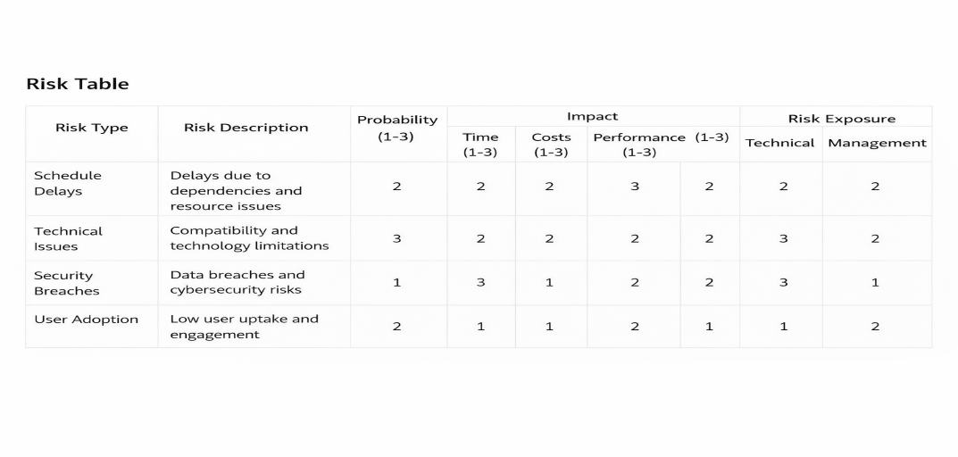

3.2 Quality Management
A structured quality plan will ensure that all deliverables meet defined standards. Rigorous testing will be conducted before acceptance and deployment.

3.3 Development
The development process will follow a structured and iterative approach, ensuring alignment with requirements and timely delivery of functional components.

3.4 Configuration Management
All system configurations, code versions, and deployment environments will be managed using standardized configuration management practices.

3.5 Acceptance Criteria / Testing
Clear acceptance criteria will be defined, and comprehensive testing will be conducted to ensure system reliability, security, and compliance.

3.6 Phase Reviews
Formal phase reviews will be conducted at the end of each major phase to validate deliverables before proceeding.

4. Master Plan

4.1 Contract Plan
A formal contract will be signed between the client and the project team, defining scope, responsibilities, timeline, and financial terms.

4.2 Master Plan and Associated Milestones
The Tasdeeq Project Plan defines the overall timeline and interdependencies of key project phases, from system design through deployment, ensuring a coordinated and controlled development process. The plan identifies critical milestones such as the completion of requirements analysis, system development, integration, testing, and final deployment, providing a structured framework to successfully achieve the project objectives within the approved schedule.
The Tasdeeq project is planned for the 2026–2027 period, with major milestones including:
- Requirements & Planning Completion: April 2026
- Design Phase Completion: August 2026
- Development Phase Completion: January 2027
- Integration & Testing Completion: March 2027
- Deployment & Launch: May 2027
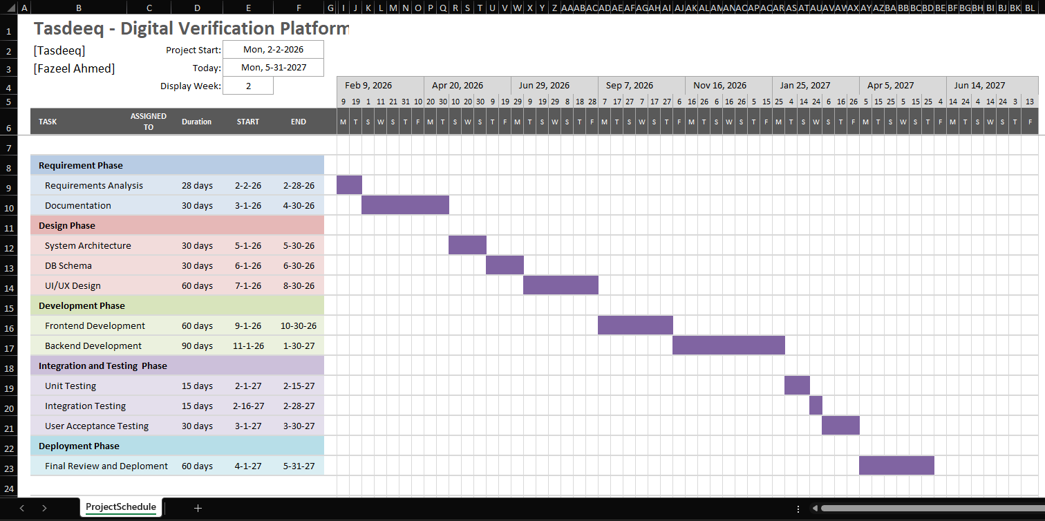

5. Technical Budget

5.1 Costs / Revenues / Margins
- Development Cost: €130,000
- Total Project Value: €180,000

5.2 Business Plan
The project aims to deliver a high-quality verification platform within the approved budget while monitoring CPI and SPI to ensure cost and schedule control.

5.3 External Costs Plan
External costs may include legal, compliance, and security audit services. All external expenses will be closely monitored to ensure budget adherence.

5.4 Billing and Collections
Payments are divided into four stages:
- 20% upon contract signing.
- 20% upon completion of design phase
- 30% upon completion of development phase
- 30% upon final deployment and launch

5.5 EVA Analysis
Revenue / Total Cost | = €180,000
Development Cost | = €130,000
EBIT | = €50,000
Estimated Tax | = €12,500
Net Income | = €37,500

