DSA LAB # 1
By Sir Shafique Rehman
Muhammad Fazeel
24K-0919

Task # 1:

// 24k-0919
#include<iostream>
using namespace std;

class Bankaccount{
private:
double balance;
public:
Bankaccount(){
balance = 0.0;
}

Bankaccount(double balance) {
this->balance = balance;
}

void addBalance( double newbalance){
balance += newbalance;
}

Bankaccount (const Bankaccount& other)
{
balance = other.balance;
}
double getBalance() {
return balance;
}

void withDraw( double amount){
if(this->balance - amount >= 0){
this->balance = this->balance - amount;
}
else{
cout << "\nNot enough balance: ";
}
}

void printBalance (){
cout << "Balance is $ " << balance <<endl;
}
};

int main()
{
Bankaccount account1;
account1.printBalance();

Bankaccount account2(1000);
account2.printBalance();

Bankaccount account3(account2);
account3.withDraw(200);

account2.printBalance();
account3.printBalance();
}

OUTPUT:

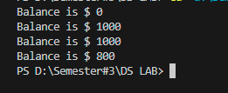

Task # 2:

#include<iostream>
#include<cstring>
using namespace std;

class Exam{
private:
char *name;
char *date;
int score;

public:

Exam () {
name = nullptr;
date = nullptr;
score = 0;
}

Exam(const char *newname ,const char *newdate, int score){
name = new char [strlen(newname)+1];
strcpy(name,newname);
date = new char [strlen(newdate)+1];
strcpy(date,newdate);
this->score = score;
}

// Copy constructor (commented out to demonstrate shallow copy issues)

// Exam (const Exam& other){
// name = new char[strlen(other.name)+1];
// strcpy (name, other.name);
// date = new char[strlen(other.date)+1];
// strcpy (date, other.date);
// }

// Exam& operator=(const Exam& other) {
// if (this != &other) {
// delete[] name;
// name = new char[strlen(other.name) + 1];
// strcpy(name, other.name);
// delete[] date;
// date = new char[strlen(other.date)+1];
// strcpy(date,other.date);
// }
// return *this;
// }

void setName(char *newname){
delete[] name;
name = new char[strlen(newname)+1];
strcpy(name,newname);
}

void setDate(char *newdate){
delete[] date;
date = new char[strlen(newdate)+1];
strcpy(date,newdate);
}

void setScore (int score){
this->score = score;
}

void displayDetails(){
cout << "\nExam name: "<<name;
cout << "\nExam Date: "<<date;
cout << "\nExam score: "<<score;
cout << "\n";
}

~Exam() {
delete[] date;
delete[] name;
}
};

int main()
{
Exam exam1 ("DSA","19-09-2020",100);
Exam exam2 ("TOA","1-3-2025",100);
Exam exam3 ("OOP","30-05-2024",100);

cout << "\nExam # 1 Details: ";
exam1.displayDetails();
cout << "\nExam # 2 Details: ";
exam2.displayDetails();
cout << "\nExam # 3 Details: ";
exam3.displayDetails();

// If we use the assignment operator here (exam2 = exam3),
// both objects will share the same memory (shallow copy).
// Changing one object will also change the other.
// This happens because the copy constructor and assignment operator
// are not defined (default shallow copy is used).

Exam exam4 = exam1; // Shallow copy happens here
exam4.displayDetails();

// it will change names of both Exam1 and Exam4.
exam1.setName("PF");
exam4.displayDetails();
}

OUTPUT:

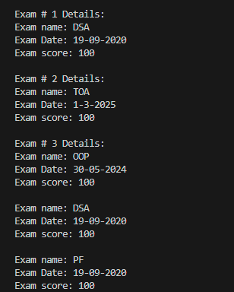
TASK # 3:
#include<iostream>
using namespace std;

class Box{
private:
int *data;
public:

Box(){
data = nullptr;
}

Box(int data){
this->data = new int(data);
}

// commented out due to show behaviour of shallow and deep copy

Box (const Box &other){
data = new int(*other.data);
}

Box& operator=(const Box &other) {
if (this != &other) {
delete data;
data = new int(*other.data);
}
return *this;
}

void setvalue (int value){
delete data;
data = new int(value);
}

void print(string boxname) const {
cout << boxname << " Data: "<< *data <<endl;
}
~Box (){
delete data;
}
};
int main()
{
cout << "===Rule of Three Demonstration ===\n";

Box box1(200);
Box box2(400);

box1.print("Box1");
box2.print("Box2");

// Copy constructor
Box box3 = box1;
box3.print("Box3 (copy of Box1)");

// Copy assignment
box2 = box1;
box2.print("Box2 after assignment from Box1");

// Change value in Box1
box1.setvalue(9999);

cout << "\nAfter modifying Box1:\n";
box1.print("Box1");
box2.print("Box2 (remains unchanged)");
box3.print("Box3 (remains unchanged)");
}

OUTPUT:

- Deep Copy Example :

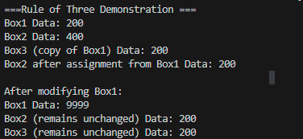

- Shallow Copy Example:

// Copy constructor and assignment operator commented
// change in both objects.

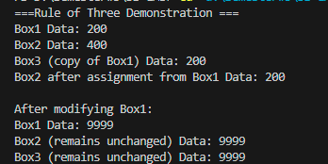

TASK # 4:

#include <iostream>
#include <cstring>
using namespace std;

class Product{
private:
char *name;
double price;
int stockquanity;
double discount = 0.0;
public:

Product(){
name = nullptr;
price = 0.0;
stockquanity = 0;
}

Product (const char* newname, double price, int stockquantity){
name = new char [strlen(newname) + 1];
strcpy (name, newname);
this->price = price;
this->stockquanity = stockquantity;
}

Product(const Product& other) {
name = new char[strlen(other.name) + 1];
strcpy(name,other.name);
price = other.price;
stockquanity = other.stockquanity;
}

void applyDiscount(double discount) {
this->discount = discount;
price=price-(price*discount/100.0);
}

Product& operator=(const Product& other) {
if (this != &other){
delete[] name;
name = new char[strlen(other.name)+1];
strcpy(name,other.name);
price = other.price;
stockquanity = other.stockquanity;
}
return *this;
}

void setPrice( double price) {
this->price = price;
}

void displayDetails(){
cout << "\nProduct name: "<<name;
cout << "\nProduct price: "<<price;
cout << "\nProduct stock: "<<stockquanity;
cout << "\nProduct discount: "<<discount << " %";
cout << endl;
}

~Product(){
delete[] name;
}

};

class Bundle{
private:
Product *products;
int size;
int productcount = 0;
bool istakingmemory;
public:

Bundle (int s, Product arr[]){
size = s;
productcount = s;
products = new Product[size];
for (int i = 0; i < size; i++)
{
products[i]=arr[i];
}
istakingmemory = true;
}

Bundle(const Bundle& other,bool shallow) {
if (shallow) {
products = other.products;
productcount = other.productcount;
istakingmemory = false;
}
else {
productcount=other.productcount;
products = new Product[productcount];

for (int i=0;i<productcount;i++){
products[i]=other.products[i];
}
istakingmemory=true;
}
}

void addProduct(Product& p) {
Product* temp = new Product[productcount + 1];
for (int i = 0; i < productcount; i++) {
temp[i] = products[i];
}
temp[productcount] = p;
delete[] products;
products = temp;
productcount++;
}

void displayDetails() const {
cout << "\nProduct Details: ";
for (int i = 0; i < productcount; i++)
{
cout << "Product " << i + 1 << ": ";
products[i].displayDetails();
}
}

void applyDiscount(double discount){
for (int i = 0; i < productcount; i++)
{
products[i].applyDiscount(discount);
}
}

void setAllProductsprice(double price){
for (int i = 0; i < productcount; i++)
{
products[i].setPrice(price);
}
cout << "\nPrice has been set for all products: ";
}

~Bundle() {
if(istakingmemory)
delete[] products;
}

};
int main()
{
Product products[3];
products[0] = Product("TV", 2000, 15);
products[1] = Product("Mobile-Phone", 3000, 20);
products[2] = Product("Laptop", 60000, 25);

Bundle bundle (3,products);

Product newproduct ("PC",100000,30);
bundle.addProduct(newproduct);

cout << "\nBefore Applying Discount:\n";
bundle.displayDetails();

bundle.applyDiscount(20);

cout << "\nAfter Applying Discount:\n";
bundle.displayDetails();

// Shallow and Deep Copy

// making shallow copy.
Bundle newbundle(bundle,true);
newbundle.displayDetails();

// changing price of new-bundle
newbundle.setAllProductsprice(1000);

// displaying original bundle. Also change price in old bundle due to shallow copy.
bundle.displayDetails();

// making deep copy.
Product p[1];
p[0] = Product("Hair-Brush",100,23);
Bundle b1(1,p);

Bundle b2(b1,false);
// changing price in bundle 2.
b2.setAllProductsprice(416983);

// displaying bundle 1 price. It won't be changed due to deep copy.

b1.displayDetails();

return 0;
}

Output:
