DS_LAB_11
Muhammad Fazeel
24k-0919

Task # 1:
#include<bits/stdc++.h>
using namespace std;

const int TABLESIZE = 10;

class Node {
public:
string key;
Node *next;
string value;

Node (string k, string value) {
key = k;
this->value = value;
next = NULL;
}

};
class HashTable {
private:
Node *hashtable[TABLESIZE];

int hashfunction (string key) {
int hashvalue = 0;
for (int i = 0; i < key.length(); i++) {
hashvalue += key[i];
}
return hashvalue % TABLESIZE;
}

public:
HashTable () {
for (int i = 0; i < TABLESIZE ;i++) {
hashtable[i] = nullptr;
}
}

void insert (string key, string value) {
int index = hashfunction (key);

Node *current = hashtable[index];

while (current)
{
if (current->key == key) {
current->key = value;
return;
}
current = current->next;
}

Node *newNode = new Node (key,value);
newNode->next = hashtable [index];
hashtable[index] = newNode;
}

string search (string key) {
int index = hashfunction(key);
Node *temp = hashtable[index];

while (temp)
{
if (temp->key == key) {
return temp->value;
}
temp = temp->next;
}
return "Key not found";
}

void remove (string key) {
int idx = hashfunction (key);
Node *temp = hashtable[idx];
Node *prev = NULL;

while (temp)
{
prev = temp;
if (temp->key == key)
break;

temp = temp->next;
}
if (temp == NULL) {
cout << "\nKey not found: ";
return;
}
if (prev == NULL) {
hashtable[idx] = temp->next;
}
else {
prev->next = temp->next;
}
delete temp;
cout << "Key "<< key << " deleted: \n";
}

void display () {
for (int i = 0; i < TABLESIZE; i++){
cout << "Index " << i << " : ";
Node *temp = hashtable[i];

if (!temp) {
cout << "\nEmpty: ";
}

while (temp)
{
cout << " -> [Key: " << temp->key << ", Name " << temp->value << " ]";
temp = temp->next;
}
cout << endl;
}
}

~HashTable() {
for (int i = 0; i < TABLESIZE; i++)
{
Node *temp = hashtable[i];
while (temp)
{
Node *cur = temp;
temp = temp->next;
delete cur;
}
}
}

};
int main()
{
HashTable myhash;
myhash.insert ("A","aaaaa");
myhash.insert ("B","bbbbb");
myhash.insert ("C","ccccc");
myhash.insert ("A","zzzzz");

myhash.display ();
return 0;
}

Output:
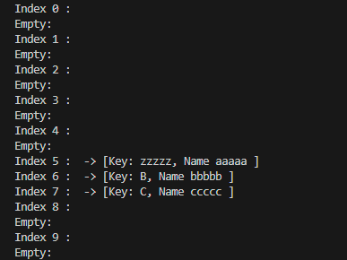

Task # 2:
#include<bits/stdc++.h>
using namespace std;

const int TABLESIZE = 100;

class Node {
public:
string key;
Node *next;

Node (string k) {
key = k;
next = NULL;
}

};

class HashTable {
private:
Node *hashtable[TABLESIZE];

int hashfunction (string key) {
int hashvalue = 0;
for (int i = 0; i < key.length(); i++) {
hashvalue += key[i];
}
return hashvalue % TABLESIZE;
}

public:
HashTable () {
for (int i = 0; i < TABLESIZE ;i++) {
hashtable[i] = nullptr;
}
}

void AddRecord (string word) {
int idx = hashfunction (word);

Node *temp = hashtable[idx];

while (temp)
{
if (temp->key == word) {
return;
}
temp = temp->next;
}
Node *newNode = new Node (word);
newNode->next = hashtable[idx];
hashtable[idx] = newNode;
}

string wordsearch (string key) {
int index = hashfunction(key);
Node *temp = hashtable[index];

while (temp)
{
if (temp->key == key) {
return temp->key ;
}
temp = temp->next;
}
return "Key not found";
}

void display () {
for (int i = 0; i < TABLESIZE; i++){
cout << "Index " << i << " : ";
Node *temp = hashtable[i];

if (!temp) {
cout << "\nEmpty: ";
}

while (temp)
{
cout << " -> [Value: " << temp->key << " ]";
temp = temp->next;
}
cout << endl;
}
}

~HashTable() {
for (int i = 0; i < TABLESIZE; i++)
{
Node *temp = hashtable[i];
while (temp)
{
Node *cur = temp;
temp = temp->next;
delete cur;
}
}
}

};
int main()
{
HashTable myhash;
myhash.AddRecord ("fazeel");
myhash.AddRecord("Aiman");
myhash.AddRecord ("Ahmad");
myhash.AddRecord ("Ali");
myhash.AddRecord ("Adnan");
myhash.AddRecord ("Babar");
myhash.AddRecord ("Saim");
myhash.AddRecord ("Virat");
myhash.AddRecord("lazeef");

cout << " Key found: " << myhash.wordsearch ("fazeel") <<"\n" ;

myhash.display ();

return 0;
}

Output
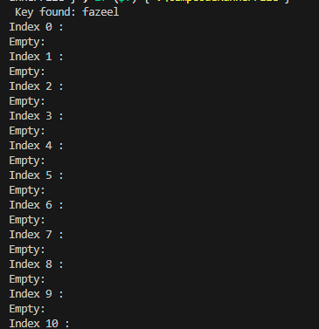
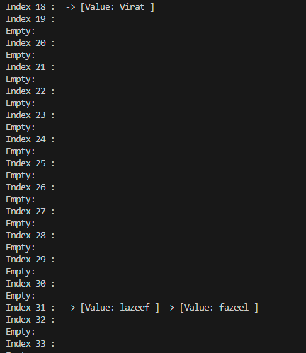
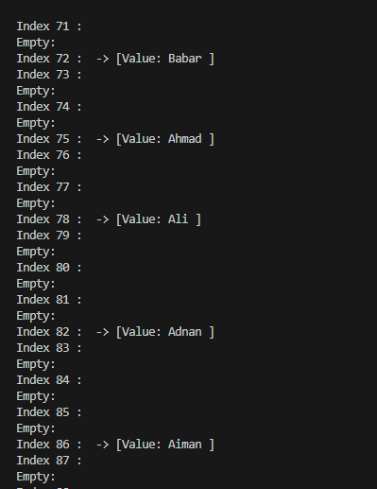

Task # 3:
#include<iostream>
#include<list>
using namespace std;

const int TABLESIZE = 10;

class Node {
public:
int key;
int value;
};

class HashTable {
private:
list<Node> table[TABLESIZE];

int hashfunction (int key) {
return key % TABLESIZE;
}

public:
HashTable () {

}

void insert (int key, int value) {
int index = hashfunction (key);

list<Node> &current = table[index];

for (auto &it: current) {
if (it.key == key) {
it.value = value;
return;
}
}

current.push_front ({key,value});
}

int search (int key) {
int index = hashfunction(key);
list<Node> &cur = table[index];

for (auto &it: cur) {
if (it.key == key) {
return it.value;
}
}
return -1;
}

void remove(int key) {
int idx = hashfunction(key);
list<Node> &cur = table[idx];

for (auto it = cur.begin(); it != cur.end(); it++) {
if (it->key == key) {
cur.erase(it);
cout << "Key " << key << " deleted\n";
return;
}
}
cout << "Key not found\n";
}

void display() {
for (int i = 0; i < TABLESIZE; i++) {
cout << "Index " << i << ": ";

list<Node> &temp = table[i];

if (temp.empty()) {
cout << "EMPTY";
}

for (auto &it : temp) {
cout << " -> [Key: " << it.key << ", Value: " << it.value << "]";
}
cout << endl;
}
}

};
int main()
{
HashTable myhash;
myhash.insert (1,100);
myhash.insert (2,200);
myhash.insert (3,300);
myhash.insert (4,400);
myhash.insert (5,500);

cout << "Search key \n";
cout << "Key found: " << myhash.search (300);
myhash.display ();
myhash.remove (100);
myhash.display();
return 0;
}

Output:
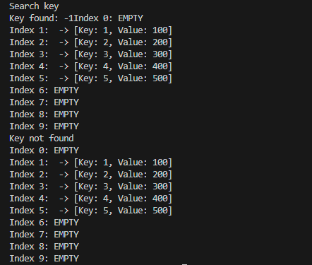

Task # 4:
#include<iostream>
#include<unordered_map>
using namespace std;

const int TABLESIZE = 10;

class Node {
public:
int key;
int value;
};

class HashTable {
private:
list<Node> table[TABLESIZE];

int hashfunction (int key) {
return key % TABLESIZE;
}

public:
HashTable () {

}

void insert (int key, int value) {
int index = hashfunction (key);

list<Node> &current = table[index];

for (auto &it: current) {
if (it.key == key) {
it.value = value;
return;
}
}

current.push_front ({key,value});
}

int search (int key) {
int index = hashfunction(key);
list<Node> &cur = table[index];

for (auto &it: cur) {
if (it.key == key) {
return it.value;
}
}
return -1;
}

void remove(int key) {
int idx = hashfunction(key);
list<Node> &cur = table[idx];

for (auto it = cur.begin(); it != cur.end(); it++) {
if (it->key == key) {
cur.erase(it);
cout << "Key " << key << " deleted\n";
return;
}
}
cout << "Key not found\n";
}

void display() {
for (int i = 0; i < TABLESIZE; i++) {
cout << "Index " << i << ": ";

list<Node> &temp = table[i];

if (temp.empty()) {
cout << "EMPTY";
}

for (auto &it : temp) {
cout << " -> [Key: " << it.key << ", Value: " << it.value << "]";
}
cout << endl;
}
};

int main()
{
unordered_map<int,int> mapi;
int arr[] = {3, 4, 7, 1, 12, 9};
int size = 6;

for (int i = 0; i < size; i++) {
mapi[arr[i]] = i;
}
for (int i = 0; i < size; i++)
{
int a = arr[i];
for (int j = i+1; j < size; j++)
{
int b = arr[j];
for (int k = j+1; k < size; k++)
{
int c = arr[k];

int target = a + b - c;

if (mapi.find(target) != mapi.end()) {
auto it = mapi.find(target);

if (it->second != i && it->second != j && it->second != k) {
cout << "(" << a << "," << b << ")"
<< " && "
<< "(" << c << "," << target << ")"
<< "\n";
}
}
}
}
}

return 0;
}

Output:
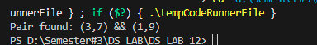

Task # 5:
#include <iostream>
#include <string>
using namespace std;

const int TABLE_SIZE = 15;

class StudentHashTable {
private:
int rollNo[TABLE_SIZE];
string Name[TABLE_SIZE];
bool occupied[TABLE_SIZE];

int hashFunction(int key) {
return key % TABLE_SIZE;
}
public:
StudentHashTable() {
for (int i = 0; i < TABLE_SIZE; i++) {
rollNo[i] = 0;
Name[i] = "";
occupied[i] = false;
}
}
void InsertRecord(int key, const string& name) {
int hash = hashFunction(key);
int index;
int i = 0;

while (i < TABLE_SIZE) {
index = (hash + i * i) % TABLE_SIZE;

if (!occupied[index] || rollNo[index] == key) {
rollNo[index] = key;
Name[index] = name;
occupied[index] = true;
return;
}
i++;
}

cout << "Hash table full, cannot insert key " << key << endl;
}

void SearchRecord(int key) {
int hash = hashFunction(key);
int index;
int i = 0;

while (i < TABLE_SIZE) {
index = (hash + i * i) % TABLE_SIZE;

if (!occupied[index]) {
cout << "Record not found\n";
return;
}

if (rollNo[index] == key) {
cout << "Record found: " << Name[index] << endl;
return;
}

i++;
}
cout << "Record not found\n";
}

void Display() {
cout << "Index\tRollNo\tName\n";
for (int i = 0; i < TABLE_SIZE; i++) {
if (occupied[i])
cout << i << "\t" << rollNo[i] << "\t" << Name[i] << "\n";
else
cout << i << "\t-\t-\n";
}
}
};

int main() {
StudentHashTable h;

h.InsertRecord(1, "Ali");
h.InsertRecord(11, "Sara");
h.InsertRecord(21, "Raza");
h.InsertRecord(2, "Taha");

h.SearchRecord(11);
h.SearchRecord(21);
h.SearchRecord(5);

cout << "\nHash table:\n";
h.Display();
return 0;
}
Output:
