DSA LAB # 2
By Sir Shafique Rehman
Muhammad Fazeel
24K-0919

Task # 1:
#include<bits/stdc++.h>
using namespace std;

class DynamicMatrix{
private:
int **arr;
int rows;
int cols;
public:
DynamicMatrix(int rows, int cols, int initialvalue = 0){
this->rows = rows;
this->cols = cols;
arr = new int*[rows];
for (int i = 0; i < rows; i++)
{
arr[i] = new int[cols];
}

for (int i = 0; i < rows; i++)
{
for (int j = 0; j < cols; j++)
{
arr[i][j] = initialvalue;
}
}
}

~DynamicMatrix(){
for (int i = 0; i < rows; i++)
{
delete[] arr[i];
}
delete[] arr;
}

void resizeMatrix(int newRows, int newCols, int defaultvalue = 0){
if(newRows == rows && newCols == cols){
return ;
}
else if(newRows <= 0 || newCols <= 0){
cout << "\nError Invalid size ! Returning the old array: ";
return ;
}

int** newArray = new int*[newRows];

for (int i = 0; i < newRows; i++) {
newArray[i] = new int[newCols];
for (int j = 0; j < newCols; j++)
{
newArray[i][j] = defaultvalue;
}
}

// copy elements:
int rowsLimit = rows < newRows ? rows : newRows;
int colsLimit = cols < newCols ? cols : newCols;

for (int i = 0; i < rowsLimit; i++)
{
for (int j = 0; j < colsLimit; j++)
{
newArray[i][j] = arr[i][j];
}
}

// deleting old array
for (int i = 0; i < rows; i++)
{
delete[] arr[i];
}
delete[] arr;
arr = newArray;
rows = newRows;
cols = newCols;
cout << "\nMatrix has been resized: \n";
}

void transposeMatrix() {
cout << "\nTransposing Matrix: ";

if (rows == cols) {

for (int i = 0; i < rows; i++) {
for (int j = i + 1; j < cols; j++) {
swap(arr[i][j], arr[j][i]);
}
}
return;
}

int** transpose = new int*[cols];
for (int i = 0; i < cols; i++) {
transpose[i] = new int[rows];
}

for (int i = 0; i < rows; i++) {
for (int j = 0; j < cols; j++) {
transpose[j][i] = arr[i][j];
}
}

for (int i = 0; i < rows; i++) {
delete[] arr[i];
}
delete[] arr;

arr = transpose;

swap(rows, cols);

}

void print(){
cout << "\nPrinting elements: \n";
int index = 0;
for (int i = 0; i < rows; i++)
{
for (int j = 0; j < cols; j++)
{
if (index % 2 == 1){
arr[i][j] += 2;
}
cout<< arr[i][j] << " ";
index++;
}
cout << endl;
}
}

};
int main()
{
// created a matrix with 3 rows and 3 cols with intial value 1.
cout << "\n---------- MATRIX-1 -----------\n";
DynamicMatrix matrix1 (3,3,1);
matrix1.print();

// resizing matrix and intializing defalut values in matrix.
// if new matrix size is bigger than old matrix .. then
//I have initialize the remaining matrix with default values.

int newrows = 4, newcols = 4;
matrix1.resizeMatrix(newrows,newcols);

matrix1.print();

// transpose of matrix # 1
matrix1.transposeMatrix();

matrix1.print();

// creating new matrix with initial value 12
cout << "\n---------- MATRIX-2 -----------\n";
DynamicMatrix matrix2 (3,3,12);
matrix2.print();

// now resizing matrix and making it small.
matrix2.resizeMatrix(2,2);
matrix2.print();

return 0;
}

OUTPUT :
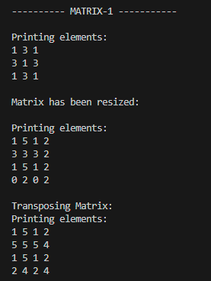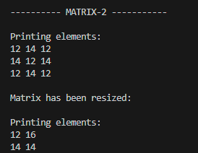

TASK # 2:
#include <bits/stdc++.h>
using namespace std;

int main()
{
int rows = 5, cols = 4;
int** studentData = new int*[rows];
int totalmarks[5] = {0,0,0,0,0};

int highestMarks = INT_MIN;
int studentno = -1;

for (int i = 0; i < rows; i++) {
studentData[i] = new int[cols];
}

cout << "\n---------- Enter the Student Details ------------\n";

for (int i = 0; i < rows; i++) {
for (int j = 0; j < cols; j++) {

cout <<"\nEnter Student "<<i + 1<<" subject "<<j+1<<" marks: ";

cin >> studentData[i][j];
totalmarks[i] += studentData[i][j];
}
if (totalmarks[i] > highestMarks) {
highestMarks = totalmarks[i];
studentno = i;
}
}
cout << "\nDisplaying the total marks of each student:\n";
for (int i = 0; i < rows; i++) {
cout<< "Student "<< i+1 << " total marks: "<<totalmarks[i]<<endl;
}

cout << "\nDisplaying the Average marks of each student:\n";

for (int i = 0; i < rows; i++) {
cout << "Student "<< i+1 <<" average marks: "<< totalmarks[i]/4.0<< endl;
}

cout << "\nStudent " << studentno + 1 << " has highest marks = " <<highestMarks << endl;

for (int i = 0;i < rows; i++) {
delete[] studentData[i];
}
delete[] studentData;

return 0;
}

OUTPUT:
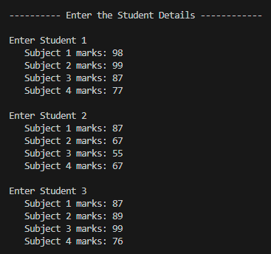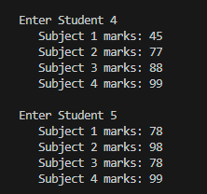

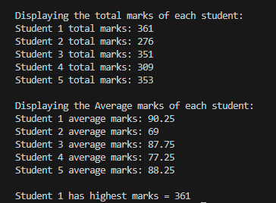

Task # 3:
#include <bits/stdc++.h>
using namespace std;

class Student
{
public:
int marks[5];
Student()
{
for (int i = 0; i < 5; i++)
{
marks[i] = 0;
}
}
};

int main()
{
int noofDepartments;
cout << "\nEnter no of Departments: ";
cin >> noofDepartments;

int *noofStudents = new int[noofDepartments];
Student **students = new Student *[noofDepartments];

for (int i = 0; i < noofDepartments; i++)
{
cout << "\nEnter the No of students in Department " << i + 1 << ": ";
cin >> noofStudents[i];
students[i] = new Student[noofStudents[i]];
}

cout << "\nEnter the marks for Students of each Department:\n";

for (int i = 0; i < noofDepartments; i++)
{
cout << "\n-------- Department " << i + 1 << " ----------\n";
for (int j = 0; j < noofStudents[i]; j++)
{
cout << "Enter marks for Student " << j + 1 << " (5 subjects): ";
for (int k = 0; k < 5; k++)
{
cin >> students[i][j].marks[k];
}
}
}

cout << "\n----------- Marks Record --------------\n";

for (int i = 0; i < noofDepartments; i++)
{
cout << "Department " << i + 1 << ":\n";
for (int j = 0; j < noofStudents[i]; j++)
{
cout << " Student " << j + 1 << ": ";
for (int k = 0; k < 5; k++)
{
cout << students[i][j].marks[k] << " ";
}
cout << endl;
}
}
cout << "\n---------- Department-wise Statistics -------------\n";
for (int i = 0; i < noofDepartments; i++)
{
int highest = INT_MIN;
int lowest = INT_MAX;
double sum = 0;
int totalmarks = 0;

cout << "\n----------Department-" << i + 1 << " Statistics--------- \n";

for (int j = 0; j < noofStudents[i]; j++)
{
for (int k = 0; k < 5; k++)
{
int mark = students[i][j].marks[k];
highest = max(highest, mark);
lowest = min(lowest, mark);
sum += mark;
totalmarks++;
}
}
double avg = sum / totalmarks;

cout << "\nDepartment " << i + 1 << " Results:";
cout << "\n Highest Mark = " << highest;
cout << "\n Lowest Mark = " << lowest;
cout << "\n Average Mark = " << fixed << setprecision(2) << avg << endl;
}

for (int i = 0; i < noofDepartments; i++)
{
delete[] students[i];
}
delete[] students;
delete[] noofStudents;

return 0;
}

OUTPUT:
- Jagged Array implemented. Every department has different no of students.
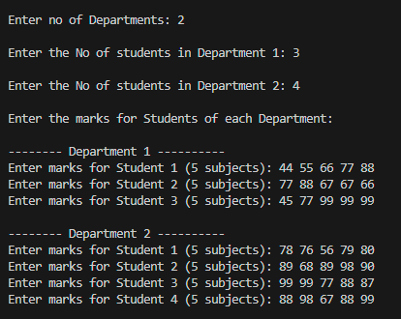
- Marks record
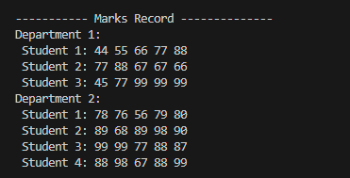

- Statictics of each Department:

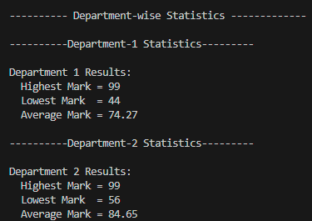

Task # 4:
#include <bits/stdc++.h>
using namespace std;

bool haveCommonfriend(bool friends[5][5], int i , int j){
for (int k = 0; k < 5; k++)
{
if (k != i && k != j) {
if (friends[i][k] && friends[j][k]) {
return true;
}
}
}
return false;
}

int main() {
bool friends[5][5] = {
{ false, true, true, false, true },
{ true,false, true, true, false},
{ true, true, false, true, true },
{ false, true, true,false,true },
{ true, false, true, true, false}
};

cout << "\nDisplaying Common Freinds for each Person : \n\n";

for (int i = 0; i < 5; i++) {
for (int j = i + 1; j < 5; j++) {
if (haveCommonfriend(friends, i, j)) {
cout << "Persons " << i << " and " << j << " have a common friend.\n";
} else {
cout << "Persons " << i << " and " << j << " do NOT have a common friend.\n";
}
}
}

return 0;
}

Output:
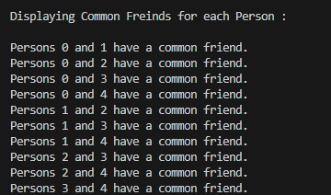
TASK # 5:
#include<bits/stdc++.h>
using namespace std;

int main()
{
int rows = 4;
int courses[4]={3,4,2,1};

double** gpas = new double*[rows];

for (int i = 0; i < rows; i++) {
gpas[i] = new double[courses[i]];
}
string deptNames[4] = {"SE","AI","CS","DS"};
cout << "\n---------- Enter Each Core GPA -----------\n";

for (int i = 0; i < rows; i++) {
cout << deptNames[i] << " Department:\n";
for (int j = 0; j < courses[i]; j++) {
cout<<" Enter GPA for Course "<<j+1<<": ";
cin>>gpas[i][j];
}
}

cout << "\n---------- GPA Records -----------\n";
for (int i=0;i<rows;i++) {
cout << deptNames[i] << ": ";

for (int j = 0; j < courses[i]; j++){

cout<< fixed <<setprecision(2)<<gpas[i][j] << " ";
}
cout << endl;
}

for (int i = 0; i < rows; i++) {
delete[] gpas[i];
}
delete[] gpas;

return 0;
}

OUTPUT:
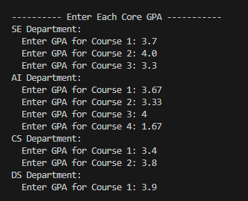
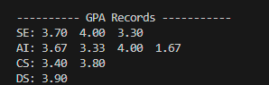
TASK # 6:
#include <bits/stdc++.h>
using namespace std;

int main(){
int rows;
cout << "Enter number of rows: ";
cin >> rows;

int *noofseats = new int[rows];
string **seats = new string*[rows];

cout << "Enter seats in each row:\n";

for(int i = 0; i < rows; i++){
cout << "Row " << i+1 << ": ";
cin >> noofseats[i];
seats[i]=new string[noofseats[i]];
}

cout<<"\nEnter names for seats:\n";

for(int i = 0; i < rows; i++){
cout << "\n-- Row " << i+1 <<" --\n";
for(int j = 0; j < noofseats[i]; j++){

cout << "Seat " << j+1 <<": ";
cin >> seats[i][j];
}
}

cout<<"\n--------- Seating Chart --------\n";

for(int i = 0; i < rows; i++){
cout << "Row " << i+1 <<": ";

for(int j = 0; j < noofseats[i]; j++){
cout << seats[i][j] << " ";
}
cout<<"\n";
}

for(int i = 0; i < rows; i++)
delete[] seats[i];

delete[] seats;
delete[] noofseats;

return 0;
}

OUTPUT:
