DSA_LAB_06_
Sir Shafique Rehman
Muhammad Fazeel
24k-0919

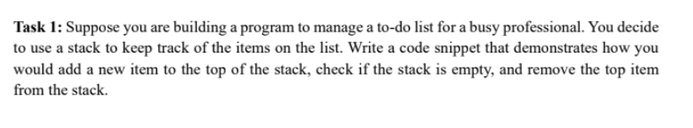

Code:
#include <iostream>
using namespace std;

class Node {
public:
int data;
Node* next;
Node (int val) {
data = val;
next = NULL;
}
};

class TodoList {
private:
Node* top;
public:
TodoList() {
top = nullptr;
}
void push(int value) {
Node* newNode = new Node(value);
if(top == NULL) {
top = newNode;
return;
}
newNode->next = top;
top = newNode;
}
void pop() {
if (isEmpty()) {
cout << "TodoList is empty! No item \n";
return ;
}
Node* temp = top;
top = top->next;
temp->next = NULL;
delete temp;
temp = NULL;
}

bool isEmpty() {
return top == NULL;
}

int top_element() {
if (isEmpty()) {
cout << "TodoList is empty\n";
return -1;
}
return top->data;
}

void display() {
if (isEmpty()) {
cout<<"TodoList is empty\n";
return;
}
Node* temp = top;
cout << "TodoList elements: ";
while (temp != nullptr) {
cout << temp->data << " ";
temp = temp->next;
}
cout << "\n";
}
};

int main ()
{
TodoList list;

// add new tasks
list.push(101);
list.push(102);
list.push(103);
list.push(104);

list.display();

// topmost task is:
cout << "The top element is: " << list.top_element() << endl;

// poping the tasks:
list.pop();
list.pop();
list.display();
}

Output:
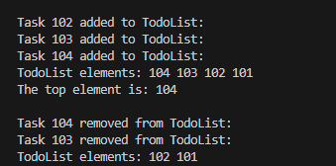

Task # 2:
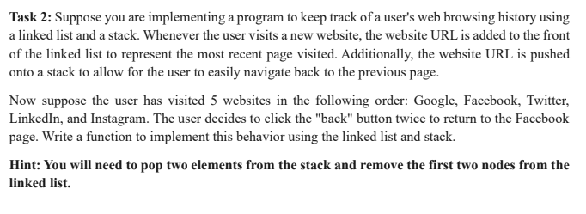
Code:
#include <iostream>
using namespace std;

class Node {
public:
string URL;
Node* next;
Node (string val) {
URL = val;
next = NULL;
}
};

class Stack {
private:
Node* top;
public:
Stack() {
top = nullptr;
}
void push(string value) {
Node* newNode = new Node(value);
if(top == NULL) {
top = newNode;
return;
}
cout << "\nWebiste: " << value << " added to Stack: ";
newNode->next = top;
top = newNode;
}
void pop() {
if (isEmpty()) {
cout << "Stack is underFlow \n";
return ;
}
cout << "\nWebsite " << top->URL << " removed from Stack: ";
Node* temp = top;
top = top->next;
temp->next = NULL;
delete temp;
temp = NULL;
}

bool isEmpty() {
return top == NULL;
}

string top_element() {
if (isEmpty()) {
cout << "Stack is empty\n";
return " ";
}
return top->URL;
}

void display() {
if (isEmpty()) {
cout<<"Stack is empty\n";
return;
}
Node* temp = top;
cout << "Stack elements: ";
while (temp != nullptr) {
cout << temp->URL << " ";
temp = temp->next;
}
cout << "\n";
}
};

int main ()
{
Stack browserHistory;

// adding items to the linked list head
browserHistory.push("Google");
browserHistory.push("Facebook");
browserHistory.push("Twitter");
browserHistory.push("LinkedIn");
browserHistory.push("Instagram");
cout << endl;
browserHistory.display();

// going back two steps:
cout << "\nClick back twice:\n";
browserHistory.pop();
browserHistory.pop();

cout << "\nCurrent page: " << browserHistory.top_element() << endl;
cout << endl;
browserHistory.display();
}

Output:
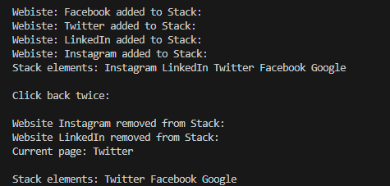

Task # 3:
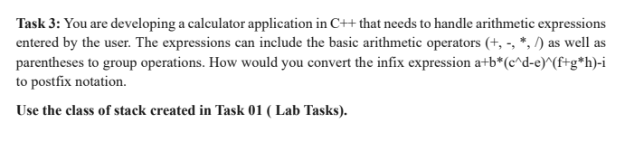
Code:

#include <bits/stdc++.h>
using namespace std;

class Node
{
public:
char data;
Node *next;
Node(char val)
{
data = val;
next = NULL;
}
};

class Stack
{
public:
Node *top;
Stack()
{
top = nullptr;
}
void push(char value){
Node *newNode = new Node(value);
if (top == NULL){
top = newNode;
return;
}
newNode->next = top;
top = newNode;
}

void pop(){
if (empty()){
cout << "Stack underflow! No element: \n";
return;
}
Node *temp = top;
top = top->next;
temp->next = NULL;
delete temp;
temp = NULL;
}
bool empty(){
return top == NULL;
}
char peek(){
if (empty())
return ' ';
return top->data;
}
};

bool isoperator(char opera) {
return (opera == '+' || opera == '-' || opera == '*' || opera == '/' || opera == '^');
}

int precedence(char ch){
if (ch == '^')
return 3;
else if (ch=='*' || ch=='/')
return 2;
else if (ch =='+' || ch =='-')
return 1;
else
return 0;
}

string infixToPostfix(string infix)
{
string ans;
Stack s;

for (int i = 0; i < infix.length(); i++)
{
char ch = infix[i];

if ((ch >= 'A' && ch <= 'Z') || (ch >= 'a' && ch <= 'z') || (ch >= '0' && ch <= '9')){
ans += ch;
}
else if (ch == '(')
{
s.push(ch);
}

else if (ch == ')')
{
while (!s.empty() && s.peek() != '('){
ans += s.peek();
s.pop();
}
if (!s.empty())
s.pop();
}

else if (isoperator(ch))
{
while (!s.empty() && precedence(ch) <= precedence(s.peek()))
{
ans += s.peek();
s.pop();
}
s.push(ch);
}
}

while (!s.empty())
{
ans += s.peek();
s.pop();
}

return ans;
}

int main()
{
string infix = "a+b*(c^d-e)^(f+g*h)-i";
string postfix = infixToPostfix(infix);
cout << "Postfix: " << postfix << endl;
return 0;
}

Output:

Task # 4:
#include <bits/stdc++.h>
using namespace std;

class Node{
public:
char data;
Node *next;
Node(char val){
data = val;
next = NULL;
}
};

class Stack{
public:
Node *top;
Stack(){
top = nullptr;
}
void push(char value){
Node *newNode = new Node(value);
if (top == NULL){
top = newNode;
return;
}
newNode->next = top;
top = newNode;
}

void pop(){
if (empty()) {
cout << "Stack underflow! No element: \n";
return;
}
Node *temp = top;
top = top->next;
temp->next = NULL;
delete temp;
temp = NULL;
}
bool empty(){
return top == NULL;
}
char peek(){
if (empty())
return ' ';
return top->data;
}
};

double op(double a, double b, char c){
if (c == '+')
return a + b;
if (c == '-')
return a - b;
if (c == '*')
return a * b;
if (c == '/')
return a / b;
return 0;
}

int pr(char c){
if (c == '+' || c == '-')
return 1;
if (c == '*' || c == '/')
return 2;
return 0;
}

double eval(string s) {
stack<double> val;
stack<char> st;
for (int i = 0; i < s.size(); i++){
if (s[i] == ' ')
continue;
if (isdigit(s[i]) || s[i] == '.') {
string tmp;
while (i < s.size() && (isdigit(s[i]) || s[i] == '.')) {
tmp += s[i];
i++;
}
val.push(stod(tmp));
i--;
}
else if (s[i] == '(') {
st.push('(');
}

else if (s[i] == ')') {
while (!st.empty() && st.top() != '('){
double y = val.top();
val.pop();
double x = val.top();
val.pop();
char c = st.top();
st.pop();
val.push(op(x, y, c));
}
if (!st.empty())
st.pop();
}

else if (s[i] == '+' || s[i] == '-' || s[i] == '*' || s[i] == '/'){

while (!st.empty() && pr(st.top()) >= pr(s[i])){
double y = val.top();
val.pop();
double x = val.top();
val.pop();
char c = st.top();
st.pop();
val.push(op(x, y, c));
}
st.push(s[i]);
}
}
while (!st.empty()){
double y = val.top();
val.pop();
double x = val.top();
val.pop();
char c = st.top();
st.pop();
val.push(op(x, y, c));
}
return val.top();
}

int main()
{

string exp = "12+13-5*(0.5+0.5)";
double result = eval(exp);

Stack s;
s.push('x');
s.push('=');

string resStr = to_string((int)result);
for (char c : resStr)
s.push(c);

cout << endl;
cout << "Result: " << result << endl;
cout << endl;
return 0;
}

Output:
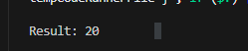

Task # 5:
#include <bits/stdc++.h>
using namespace std;

class Queue {
private:
int front;
int rear;
int capacity;
int* arr;
public:
Queue(int size) {
front=0;
rear=-1;
capacity=size;
arr=new int[size];
}
void enqueue(int val) {
if (rear == capacity - 1) {
cout << "Queue Overflow! Cannot add more customer " << val << "\n";
return;
}
arr[++rear] = val;
cout << "Customer " << val << " entered the queue." << "\n";
}

void dequeue() {
if (front > rear) {
cout << "Queue Underflow! No customers." << "\n";
return;
}
cout << "Customer " << arr[front] << " has been processed." << "\n";
front++;
}

void display() {
if (front > rear) {
cout << "No customers present in the queue!" << endl;
return;
}
cout << "Current queue is: ";
for (int i = front;i <= rear; i++) {

cout << arr[i] << " ";
}
cout << endl;
}

~Queue() {
delete[] arr;
}
};

int main() {
Queue q(7);

int customers[] = {13, 7, 4, 1, 6, 8, 10};
for (int i = 0; i < 7; i++) {
q.enqueue(customers[i]);
}

cout << "\nQueue\n";
q.display();

cout << "\n Managing Customers: \n";
q.dequeue();
q.display();

q.dequeue();
q.display();

q.dequeue();
q.display();

return 0;
}

Output:
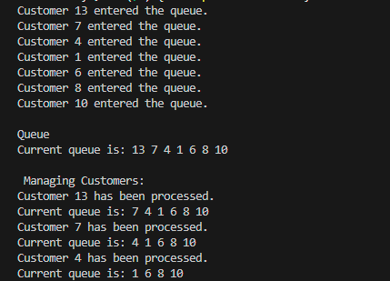

Task # 6:
#include <iostream>
using namespace std;

class Message {
public:
int time;
Message() {}
Message(int t) {
time = t;
}
};
class Queue {
private:
int front;
int rear;
int capacity;
Message* arr;

public:
Queue(int size) {
front = 0;
rear = -1;
capacity = size;
arr = new Message[size];
}
void enqueue(Message val) {
if (rear==capacity-1) {
cout<<"Queue Overflow! Cannot add more messages.\n";
return;
}
arr[++rear]=val;
cout<<"Message " << val.time<<" added to queue.\n";
}
void dequeue() {
if (front>rear) {

cout <<"Queue Underflow! No messages to process.\n";
return;
}

cout<< "Message " <<arr[front].time<<" processed successfully.\n";
front++;
}
void display(){
if (front>rear) {
cout<<"No messages currently in the queue.\n";
return;
}
cout<<"Current queue: ";
for(int i = front; i <= rear; i++) {
cout<<arr[i].time<<" ";
}
cout<<endl;
}
~Queue(){
delete[] arr;
}
};

int main() {
cout << "=== Messaging Queue System ===\n";

Queue q(5);

// adding messages to the queue
q.enqueue(Message(3));
q.enqueue(Message(5));
q.enqueue(Message(8));

q.display();
// prcoess first message
q.dequeue();

q.display();

// adding more to the queue
q.enqueue(Message(10));
q.enqueue(Message(12));

q.display();
// Process remaining messages
q.dequeue();
q.dequeue();
q.dequeue();
q.dequeue();

return 0;
}

Output:
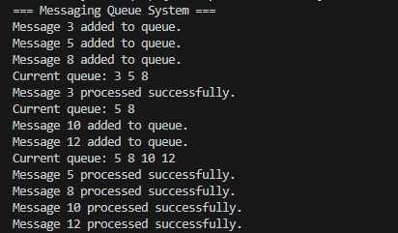

Task # 7:
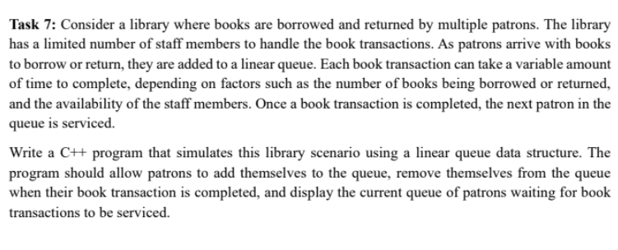

Code:
#include <iostream>
using namespace std;

class Library {
public:
string patron;
int books;
Library() {}

Library(string name, int n) {
patron = name;
books = n;
}

void showInfo() {
cout << patron << " (" << books << " books)";
}
};
class Node {
public:
Library data;
Node* next;

Node(Library val) {
data = val;
next = NULL;
}
};

class LibraryQueue {
private:
Node* front;
Node* rear;

public:
LibraryQueue() {
front = rear = NULL;
}

void enqueue(Library val) {
Node* newNode = new Node(val);
if (rear == NULL) {
front = rear = newNode;
return;
}
else {
rear->next = newNode;
rear = newNode;
}
cout<<"Patron "<<val.patron<<" added to the queue with " << val.books << " book\n";
}

void dequeue() {
if (isEmpty()) {
cout << "No patrons in queue. All transactions completed.\n";
return;
}
cout << "Patron # ";
front->data.showInfo();
cout << " has completed transation.\n";

Node* temp = front;
front = front->next;
if (front == NULL) {
rear = NULL;
}
delete temp;
}

bool isEmpty() {
return front == NULL;
}

void display() {
if (isEmpty()) {
cout << "No patrons are there waiting in the queue.\n";
return;
}
cout << "\nCurrent patrons are waiting:\n";
Node* temp = front;
while (temp != NULL) {
cout << " - ";
temp->data.showInfo();
cout << endl;
temp = temp->next;
}
cout << endl;
}
};
int main() {

cout << "\n--Library Management System:--\n";
LibraryQueue libraryQueue;

libraryQueue.enqueue(Library("Aliza", 3));
libraryQueue.enqueue(Library("Sahil", 2));
libraryQueue.enqueue(Library("Fazeel", 4));

libraryQueue.display();

libraryQueue.dequeue();
libraryQueue.display();

libraryQueue.dequeue();
libraryQueue.display();

libraryQueue.enqueue(Library("Aiman", 1));
libraryQueue.display();

libraryQueue.dequeue();
libraryQueue.dequeue();
return 0;
}

Output:
