DS_LAB_04
Instructor: Sir Shafique Rehman
Muhammad Fazeel
24k-0919

Task # 1:
Write a Program that ask user to enter 10 elements and finds the 4 minimum elements from given array using selection Sort.
Code:
#include<iostream>
#include <climits>
using namespace std;

void selectionsort(int arr[], int size) {
for (int i = 0; i < size-1; i++)
{
int minIndex = i;
for (int j = i; j < size; j++)
{
if (arr[j] < arr[minIndex])
{
minIndex = j;
}
}
swap (arr[i], arr[minIndex]);
}
}

int main()
{
int size = 10;
int arr[10];
cout << "\nEnter 10 elements of array:";

for (int i = 0; i < size; i++)
{
cin >> arr[i];
}

selectionsort(arr,size);

cout << "\n4 minimum elements in array are:\n";
for (int i = 0; i < 4; i++)
{
cout << "Minimum # " << i+1 << " : " << arr[i] << "\n";
}

return 0;
}

Output:
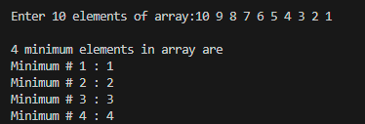
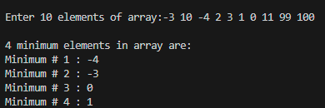

Task # 2:
Let arr[9] = { 20, 12, 15, 2, 10, 1, 13, 9, 5} now sort the array in such a way that
maximum element must be at middle of the array and rest of array must be sorted in ascending order do this using insertion sort.
Code:
#include<iostream>
#include <climits>
using namespace std;

void insertionsort(int arr[], int size) {
for (int i = 1; i < size; i++)
{
int pivot = arr[i];
int j = i-1;

while (arr[j] > pivot && j >= 0)
{
arr[j+1] = arr[j];
j--;
}
arr[j+1] = pivot;
}
}

int main()
{
int size = 9;
int arr[9] = { 20, 12, 15, 2, 10, 1, 13, 9, 5};
// int arr[9] = { 10, 3, 6, -1, 5, 20, 100, 4, 1};

cout << "\nOriginal array: ";
for (int i = 0; i < 9; i++)
{
cout << arr[i] << " ";
}

insertionsort(arr,size);

int mid = size/2;
int maximum = arr[size-1];

for (int i = size-1; i >= mid; i--)
{
arr[i] = arr[i-1];
}

arr[mid] = maximum;

cout << "\nAfter sorting the array: ";

for (int i = 0; i < size; i++)
{
cout << arr[i] << " ";
}

return 0;
}

Output:

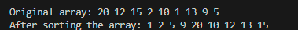

Task # 3:
Given an array of strings arr[]. Sort given strings using Bubble Sort and display the sorted array.
Input: string arr[] = {"banana", "apple", "cherry", "date", "grape"};
Output: apple banana cherry date grape.

Code:
#include <iostream>
using namespace std;
int main()
{
string arr[] = {"banana", "apple", "cherry", "date", "grape"};
int n = 5;

cout << "\nBefore sorting:\n[ ";
for (int i = 0; i < n; i++)
{
cout << arr[i];
if (i != n - 1) cout << ", ";
}
cout << " ]\n";

for (int i = 0; i < n; i++)
{
for (int j = 0; j < n - 1; j++)
{
if (arr[j] > arr[j+1]) {
string temp = arr[j];
arr[j] = arr[j+1];
arr[j+1] = temp;
}
}
}

cout << "\nAfter sorting the array of strings:\n[ ";
for (int i = 0; i < n; i++)
{
cout << arr[i];
if (i != n-1) cout << ", ";
}
cout << " ]\n";

return 0;
}

Output:
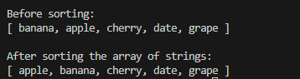

Task # 4:
Given an unsorted array that may contain duplicates. Write a function that returns true if the array contains duplicates.
Code:
#include<iostream>
using namespace std;

bool containsDuplicates (int arr[], int size) {
for (int i = 1; i < size; i++)
{
int pivot = arr[i];
int j = i-1;

while (arr[j] > pivot && j >= 0)
{
arr[j+1] = arr[j];
j--;
}
arr[j+1] = pivot;
}
for (int i = 0; i < size-1; i++)
{
if (arr[i] == arr[i+1]) {
return true;
}
}
return false;
}

int main()
{
int n = 10;
int arr[10];

cout << "\nEnter the elements of the array: \n";
for (int i = 0; i < n; i++)
{
cin >> arr[i];
}

if(containsDuplicates(arr,n)) {
cout << "\nArray contains Duplicates.\n";
}
else {
cout << "\nArray does not contains Duplicates.\n";
}
return 0;
}

Output:
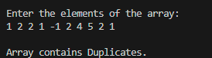
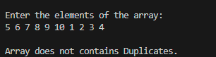

Task # 5:
Given an array with birth years of children born in 2022, 2023, and 2024, the task is to sort the array so that all children born in 2022 come first, followed by those born in 2023, and finally those born in 2024.
Code:
#include<iostream>
using namespace std;

void sort(int arr[], int size) {
for (int i = 1; i < size; i++)
{
int pivot = arr[i];
int j = i-1;

while (arr[j] > pivot && j >= 0)
{
arr[j+1] = arr[j];
j--;
}
arr[j+1] = pivot;
}
}

int main()
{
int n = 6;
int arr[6] = {2022, 2023, 2024, 2022, 2023, 2024};
// int arr[6] = {2023, 2024, 2022, 2020, 2021, 2025};

cout << "\nBefore sorting the array:\n";
cout << "[";
for (int i = 0; i < n; i++)
{
cout << arr[i] ;
if (i!=n-1) cout <<", ";
}
cout << "]\n";

sort(arr,n);

cout << "\nAfter sorting the array:\n";
cout << "[";
for (int i = 0; i < n; i++)
{
cout << arr[i] ;
if (i!=n-1) cout <<", ";
}
cout << "]";

return 0;
}

Output:
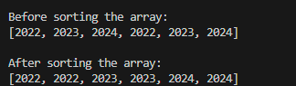
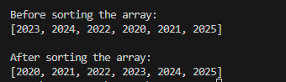
Task # 6:
A university admissions office has received thousands of student applications, each identified by a unique 6-digit application ID (e.g., 452913, 100234, 987654).
The office needs to sort all application IDs in ascending order to generate a merit list quickly.
Since the IDs are integers with a fixed number of digits, Write a program to sort the application IDs using appropriate and efficient sorting algorithm.

Code:
#include<iostream>
using namespace std;

int getMax(int arr[], int n) {
int maxVal = arr[0];
for (int i = 1; i < n; i++) {
if (arr[i] > maxVal)
maxVal = arr[i];
}
return maxVal;
}

void counting_sort(int arr[], int n , int exp) {
int output[n];
int count[10] = {0};

for (int i = 0; i < n; i++)
{
int digit = (arr[i]/exp)%10;
count[digit]++;
}
// prefix sum
for (int i = 1; i < 10; i++)
{
count[i] += count[i-1];
}
for (int i = n-1; i >= 0; i--)
{
int digit = (arr[i]/exp)%10;
output[count[digit]-1] = arr[i];
count[digit]--;
}
for (int i = 0; i < n; i++) {
arr[i] = output[i];
}
}

void radix_sort(int arr[], int n) {
int maxi = getMax(arr,n);

for (int exp = 1; maxi/exp > 0; exp*=10)
{
counting_sort(arr,n,exp);
}

}

int main()
{
int n = 10;
int arr[10] = {240990, 215364, 236762, 243454, 252143,
223444, 212321, 232311, 245655, 243333};

cout << "\nBefore sorting the IDs:\n";
for (int i = 0; i < n; i++) {
cout << "ID " << i + 1 << ": " << arr[i] << "\n";
}

radix_sort(arr, n);

cout << "\nAfter sorting the IDs (Merit Lists) :\n";
for (int i = 0; i < n; i++) {
cout << "ID " << i + 1 << ": " << arr[i] << "\n";
}

return 0;
}

Output:
