DS_LAB_05
Muhammad Fazeel
24k-0919

Remaining Tasks:

Task # 6:
Imagine you are working on a scientific application that involves processing a multi-dimensional array. You need to implement a function to calculate the sum of all elements in the array, which may contain nested arrays (creating a multi-dimensional structure using a jagged array).
Write a C++ function int recursiveArraySum(int* arr[], int sizes[], int dim) that calculates the sum of all elements in a multi-dimensional array represented by a jagged array. The function should work for arrays containing nested arrays, and sizes is an array that contains the sizes of each dimension, and dim is the current dimension being processed.

Code :
#include<bits/stdc++.h>
using namespace std;

int recursiveArraySum(int* arr[], int sizes[], int rows, int i , int j){
if(i == rows) return 0;

if(j == sizes[i]) {
return recursiveArraySum(arr, sizes, rows, i + 1, 0);
}

return arr[i][j] + recursiveArraySum(arr,sizes,rows,i,j+1);

}

int main()
{

int **arr = new int*[5];
int size[5] = {4,3,5,6,2};
for (int i = 0; i < 5; i++)
{
arr[i] = new int[size[i]];
}
cout << "\nEnter the values of Jagged Array: ";

for (int i = 0; i < 5; i++){
cout << "\nEnter " << size[i] << " elements for row " << i+1 << ": \n";
for (int j = 0; j < size[i]; j++){
cin >> arr[i][j];
}
}
cout << "\nThe jagged array is: ";
for (int i = 0; i < 5; i++){
for (int j = 0; j < size[i]; j++){
cout << arr[i][j] << " ";
}
cout << "\n";
}

int sum = recursiveArraySum(arr,size,5,0,0);
cout << "\nThe sum of jagged array is : "<< sum;

for (int i = 0; i < 5; i++) {
delete[] arr[i];
}
delete[] arr;

return 0;
}

Output:
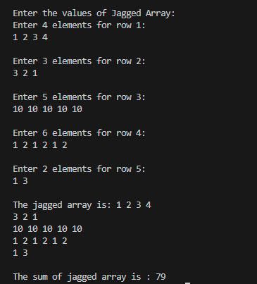

Task # 8:
#include <iostream>
using namespace std;

const int N = 4; // created a global variable

// safe function for checking if a flag can be placed.
bool issafe(int board[N][N], int row, int col, int solution[N][N]) {

for (int i = 0; i < row; i++) {
if (board[i][col]==1)
return false;
}
for (int i = row, j = col; i >= 0 && j >= 0; i--, j--) {
if (board[i][j]==1)
return false;
}
for (int i = row, j=col; i>=0 && j<N; i--, j++) {
if (board[i][j]==1)
return false;
}
return true;
}

void backtrack(int board[N][N], int row, int &maximumFlags, int solution[N][N]) {
if (row == N) {
maximumFlags = N;
for (int i = 0; i < N; i++)
for (int j = 0; j < N; j++)
solution[i][j] = board[i][j];
return;
}

for (int col = 0; col < N; col++) {

if (issafe(board, row, col, solution)) {

board[row][col] = 1;

backtrack(board, row + 1, maximumFlags, solution);

board[row][col] = 0;

}
}
}

int main() {
int board[N][N] = {0};
int maximumFlags = 0;
int solution[N][N] = {0};

backtrack(board, 0, maximumFlags, solution);

cout << "\nThe maximum flags that can be placed on " << N << " x " << N << " matrix is " << maximumFlags <<endl;

for (int i = 0; i < 4; i++)
{
for (int j = 0; j < 4; j++)
{
cout << solution[i][j] << " ";
}
cout << "\n";
}

return 0;
}

Output:
