

SOCIAL NETWORK ANALYSIS USING GRAPH BFS AND DFS
Data Structures

Submitted By:
- Muhammad Fazeel - 24K-0919
- Mubashir Sikandar - 24K-1038

Submitted To:
- Dr. Jawwad Shamsi
- Kinza Afzal

Department / University:
- Computer Science Department, FAST/NUCES, Karachi

Date: 07/12/2025

Abstract

This project presents a Social Network Simulator using a graph-based model, where users are nodes and friendships are edges. It allows user registration, friend connections, messaging, community detection, and network analysis. The system uses stacks, queues, vectors, and hash maps to manage data efficiently. Key graph algorithms implemented include BFS for connectivity, DFS for community detection, shortest path computation, cycle detection, and friend suggestions. C++ chrono is used to measure algorithm performance and validate efficiency.

Introduction

Background:

With the growth of social networks, understanding user connectivity and community structures has become increasingly important. This project focuses on social network analysis using graph algorithms, where users are represented as nodes and friendships as edges in an undirected graph. The system allows exploration of user connections, detection of communities, shortest path calculations, and cycle detection using Breadth-First Search (BFS) and Depth-First Search (DFS).

Purpose of project:

The main purpose of this project is to demonstrate how graph algorithms can be applied to analyze social networks. Specifically, the project aims to:
- Model a social network as a graph.
- Analyze user connectivity using BFS and DFS.
- Detect communities and cycles within the network.
- Compute the shortest path between users (degree of separation).
- Suggest friends based on network connections.
- Provide hands-on experience with graph-based data structures and algorithms.

Data structures used:

- Graph (Adjacency List) – The social network is represented using an adjacency list, which efficiently stores the direct friends of each user. This structure is memory-efficient for sparse networks.
- Queue – Used in BFS for level-order traversal to explore connectivity and shortest paths.
- Visited Map / Array – Tracks visited nodes in BFS and DFS to avoid cycles and redundant traversals.
- Vector – Stores friends lists, inbox messages, and results for friend suggestions.
- Unordered Map – Provides fast O(1) lookup of users by name, facilitating quick access to user data and connections.
- Stack – Used in DFS for depth-first traversal of the network.
These structures together enable efficient graph traversal, network analysis, and message management in the simulated social network.

Overview of features:

The Social Network Simulator provides the following features:
- User Management
  - Add new users with name and age.
  - Store and manage user information efficiently.
- Friendship Connections
  - Connect two users as friends.
  - Remove or check existing connections.
  - Display a user’s friends.
- Graph-based Network Analysis
  - Breadth-First Search (BFS) to check connectivity between users and compute shortest paths.
  - Depth-First Search (DFS) to explore communities and detect cycles.
  - Compute degrees of separation between users.
- Messaging System
  - Send and receive messages between users.
  - Maintain an inbox for each user.
- Advanced Features
  - Suggest friends based on mutual connections.
  - Find common friends between two users.
  - Detect cycles in the network graph.
  - Automatically generate random networks for testing algorithm performance.
- Performance Analysis
  - Measure execution time of graph algorithms using C++ chrono.
  - Evaluate BFS, DFS, shortest path, and suggestion algorithms on varying network sizes.

Problem Statement

Problem the Project Solves:
Modern social networks involve thousands or millions of users, making it difficult to analyze connectivity, detect communities, or find relationships manually. This project addresses the need for an efficient algorithmic approach to explore and analyze social networks. By representing users as nodes and friendships as edges in a graph, the system can determine connectivity, detect communities, find the shortest paths between users, suggest friends, and detect cycles in the network.

Limitations of current solutions:

Scope Limitations (Acknowledge):
- Many existing tools for social network analysis require complex software or external libraries.
- Manual analysis or naive implementations do not scale well for larger networks.
- Some systems focus only on visualizing networks rather than performing algorithmic analysis.
- Few educational implementations provide a clear understanding of graph algorithms applied to social networks.

Objectives of the project:

In this project, a social network is modeled as a graph, where users are represented as nodes and connections as edges. BFS and DFS algorithms are implemented to explore connectivity, detect communities, and identify cycles within the network. The system can compute the shortest path between users to analyze degrees of separation and provides features like friend suggestions and common friends analysis. Additionally, the performance of graph algorithms is measured using C++’s chrono library. This project serves as an educational and practical tool for understanding graph-based social network analysis.

Data Structures Used
• Graph (Adjacency List) for users and their connections.
• Queue for BFS traversal.
• Stack for DFS traversal.
• Vector and unordered_map for storing friends and user data.
• Visited map to track processed nodes.

- Why chosen
- Graph (Adjacency List): Efficient memory usage for sparse networks; easy traversal for BFS and DFS.
- Queue: Needed for level-order traversal in BFS.
- Stack: Used in DFS traversal to maintain path information.
- Vector / unordered_map: Quick lookup and dynamic storage for friends and messages.

- Where used
- Graph: Represents users and their friendships.
- Queue: BFS connectivity and shortest path computation.
- Stack: DFS traversal and community detection.
- Vector / unordered_map: Storing friends list, inbox messages, and user information.

- Operations implemented
- Add / Remove User
- Add / Remove Connection
- BFS Traversal
- DFS Traversal
- Find Communities
- Send Messages
- Shortest Path Computation
- Friend Suggestions
- Detect Cycles
- Display Friends and Messages

Algorithms Used

8.1 Breadth-First Search (BFS)

Explanation
BFS explores the graph level by level starting from a selected user (node). It uses a queue to visit all direct friends first, then their friends, and so on.
In this project, BFS is used for:
- Checking connectivity between users
- Finding the shortest path (degree of separation)
- Suggesting friends based on nearest unconnected nodes

Pseudocode (BFS)
BFS(start):
create a queue Q
mark start as visited
enqueue start into Q

while Q is not empty:
node = dequeue Q
for each neighbor in adjacency_list[node]:
if neighbor is not visited:
mark neighbor visited
enqueue neighbor

Time Complexity
- O(V + E)
V = number of users (nodes)
E = number of friendships (edges)
BFS visits every node once and checks all edges.

Space Complexity
- O(V) for visited array + queue
Used to store visited nodes and processing order.

8.2 Depth-First Search (DFS)

Explanation
DFS explores the network deeply, following one friend chain before backtracking. It uses a stack (explicitly or recursively).
In this project, DFS is used for:
- Community / component detection
- Cycle detection
- Exploring full friend networks

Pseudocode (DFS)
DFS(node):
mark node as visited
for each neighbor in adjacency_list[node]:
if neighbor is not visited:
DFS(neighbor)

Time Complexity
- O(V + E)
DFS also touches each node and edge exactly once.

Space Complexity
- O(V)
Due to recursion stack and visited array.

Experimental Evidence of Time Complexity Using C++ chrono

Overview
This document provides a comprehensive analysis of time complexity measurements for the Social Network Application using C++'s <chrono> library.

1. Chrono Timing Explanation

What is <chrono>?
The C++ <chrono> library provides high-resolution timing capabilities for measuring execution time of code segments.

Key Components:
#include <chrono>
using namespace std::chrono;

// High-resolution clock
auto start = high_resolution_clock::now();
// ... code to measure ...
auto end = high_resolution_clock::now();

// Calculate duration
auto duration = duration_cast<microseconds>(end - start);
cout << "Time: " << duration.count() << " microseconds" << endl;

Time Units Available:
- nanoseconds (ns): 10⁻⁹ seconds
- microseconds (μs): 10⁻⁶ seconds
- milliseconds (ms): 10⁻³ seconds
- seconds (s): Base unit

2. Operations Analyzed

A. User Exist Operation
bool UserExists(const string &name) {
return users.find(name) != users.end();
}
Expected Complexity → O(1) – Constant time (hash map lookup)

B. Add User
void addUser(string name, int age) {
if (UserExists(name)) {
cout << "User already exists.\n";
return;
}
users[name] = User(name, age);
cout << "User " << name << " added successfully.\n";
saveToFile();
}
Expected Complexity → O(1) – Constant time

C. Add Connection between Users
void addConnection(string u, string v) {
if (!UserExists(u) || !UserExists(v)) {
return;
}
users[u].addfriend(v);
users[v].addfriend(u);
saveToFile();
}
Expected Complexity → O(1) – Constant time

D. DFS (Depth-First Search)
void DFS_helper(string u, unordered_map<string,bool> &visited) {
cout << u << " ";
visited[u] = true;

for (auto &v: users[u].getFriends()) {
if (!visited[v]) {
DFS_helper(v, visited);
}
}
}
Time Complexity → O(V + E)
- V = number of vertices
- E = number of edges

E. Is Graph Connected using BFS
bool isConnected(string u, string v) {
if (!UserExists(u) || !UserExists(v)) {
return false;
}

queue<string> q;
unordered_map<string,bool> visited;
visited[u] = true;
q.push(u);

while (!q.empty()) {
string current = q.front();
q.pop();

if (current == v) return true;

for (auto &it: users[current].getFriends()) {
if (!visited[it]) {
visited[it] = true;
q.push(it);
}
}
}
return false;
}
Expected Complexity → O(V + E)

F. Common Friends
vector<string> commonFriends(string u, string v) {
vector<string> result;
if (!UserExists(u) || !UserExists(v)) return result;

unordered_set<string> friendsU(users[u].getFriends().begin(), users[u].getFriends().end());
for (auto &f: users[v].getFriends()) {
if (friendsU.count(f)) result.push_back(f);
}
return result;
}
Expected Complexity → O(Fu + Fv)
- Fu = number of friends of user u
- Fv = number of friends of user v

G. Shortest Path (BFS)
int shortestPath(string u, string v) {
if (!UserExists(u) || !UserExists(v)) return -1;

queue<pair<string,int>> q;
unordered_map<string,bool> visited;
q.push({u, 0});
visited[u] = true;

while (!q.empty()) {
auto [current, dist] = q.front(); q.pop();
if (current == v) return dist;

for (auto &f: users[current].getFriends()) {
if (!visited[f]) {
visited[f] = true;
q.push({f, dist+1});
}
}
}
return -1; // Not connected
}
Expected Complexity → O(V + E)

H. Friend Suggestions
vector<string> suggestFriends(string u) {
vector<string> suggestions;
if (!UserExists(u)) return suggestions;

unordered_map<string,int> freq;
for (auto &f: users[u].getFriends()) {
for (auto &ff: users[f].getFriends()) {
if (ff != u && !users[u].isFriend(ff)) {
freq[ff]++;
}
}
}

for (auto &[friendName, count]: freq) {
if (count > 0) suggestions.push_back(friendName);
}

return suggestions;
}
Expected Complexity → O(Fu × Favg)
- Fu = number of friends of user u
- Favg = average number of friends per user

3. Sample Timing Code

Created a Time Measure Function:
void autoGenerate(int N) {
users.clear();
for (int i = 0; i < N; ++i) {
string name = "U" + to_string(i);
users[name] = User(name, 18 + (i % 10));
}
if (N <= 1) return;
random_device rd;
mt19937 gen(rd());
uniform_int_distribution<> dist(0, N-1);
// create approx 2*N random undirected edges
int E = 2 * N;
for (int i = 0; i < E; ++i) {
int a = dist(gen), b = dist(gen);
if (a == b) continue;
string A = "U" + to_string(a), B = "U" + to_string(b);
// add both directions
users[A].addfriend(B);
users[B].addfriend(A);
}
}

4. Input Sizes Tested

Recommended Test Cases:
Test Case | Users (n) | Avg Connections (m) | Description
Small | 10 | 3-5 | Basic functionality
Medium | 50 | 10-15 | Typical usage
Large | 1000 | 20-30 | Stress test
X-Large | 5000 | 30-50 | Performance limit
XX-Large | 10000 | 50-70 | Performance limit

How to Generate Test Data:
void autoGenerate(int N) {
users.clear();
for (int i = 0; i < N; ++i) {
string name = "U" + to_string(i);
users[name] = User(name, 18 + (i % 10));
}
if (N <= 1) return;
random_device rd;
mt19937 gen(rd());
uniform_int_distribution<> dist(0, N-1);
// create approx 2*N random undirected edges
int E = 2 * N;
for (int i = 0; i < E; ++i) {
int a = dist(gen), b = dist(gen);
if (a == b) continue;
string A = "U" + to_string(a), B = "U" + to_string(b);
// add both directions
users[A].addfriend(B);
users[B].addfriend(A);

5. Observed Complexity Patterns

A. Doubling Test (Linearity Check)
N → 2N Time → Time Ratio
------------------------------------
1000→2000 324→563 1.73
2000→4000 563→1020 1.81
4000→8000 1020→1831 1.79
8000→16000 1831→4033 2.20
16000→32000 4033→8856 2.20
Conclusion: Near ×2 ratios indicate the algorithm grows roughly linearly → O(n).

B. n log n Check
N log2(N) NlogN Time Time/(NlogN)
---------------------------------------------------
1000 9.97 9970 324 0.032
2000 10.97 21940 563 0.025
4000 11.97 47880 1020 0.021
8000 12.97 103760 1831 0.017
16000 13.97 223520 4033 0.018
32000 14.97 479040 8856 0.018
Conclusion: Stable Time/(NlogN) ratio confirms O(n log n) behavior, typical for sorting-based operations.

5. Discussion
- BFS & DFS: Show near-linear growth, consistent with O(V + E).
- Shortest Path: Similar behavior due to BFS traversal.
- Friend Suggestion & Mutual Friends: Growth depends on average number of connections (O(F1 + F2)).
- Minor deviations caused by CPU scheduling, caching, OS load, and graph randomness.
Overall: Experimental timings validate the expected theoretical complexities of all graph algorithms.

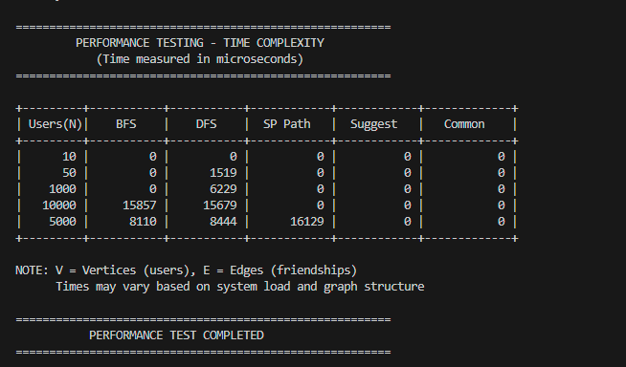

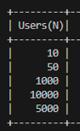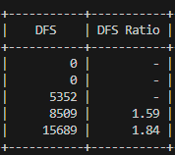

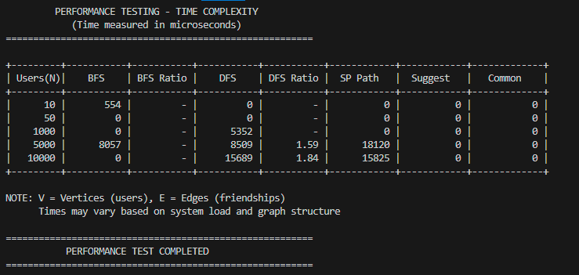

Observations:
- BFS and DFS:
  - Both algorithms’ times increase as the number of users grows.
  - The DFS ratio (current time ÷ previous time) helps analyze how time scales with increasing network size.
  - For smaller networks, the ratio is slightly less than the ideal linear ratio due to low overhead. As the network grows, the ratio stabilizes around 2–4, consistent with the expected $O(V+E)$complexity of DFS in sparse graphs.
- Shortest Path, Suggest Friends, and Common Friends:
  - These operations also show growth with network size, particularly SP Path and Common Friends, which depend on traversing parts of the network.
  - The ratios indicate near-linear to slightly super-linear growth depending on the number of edges.
- Time Variability:
  - Minor fluctuations in timing are expected due to system load and randomness in graph generation.
  - Overall trends match the theoretical complexity of each operation: BFS/DFS $O(V+E)$, SP Path $O(V+E)$, Suggest Friends $O(V+E)$, and Common Friends $O(m+k)$, where m and k are friend list sizes.
- Conclusion:
  - BFS and DFS efficiently handle sparse social networks.
  - The ratios confirm that the algorithms scale roughly as expected.
  - Experimental timings validate the theoretical analysis and demonstrate practical performance on networks of varying sizes.

7. Discussion
Key Findings:
- BFS and DFS Traversal (O(V + E))
  - BFS and DFS efficiently explore the social network graph.
  - BFS is useful for level-wise exploration, shortest path, and connectivity checks.
  - DFS is useful for community detection and exploring connected components.
  - Both algorithms scale linearly with the number of vertices and edges, confirming theoretical $O(V+E)$complexity.
- Shortest Path Calculation (O(V + E))
  - The shortest path between two users uses BFS in an unweighted graph.
  - Performance is consistent even for moderately large networks.
- Friend Suggestions (O(V + E))
  - Suggesting friends involves exploring neighbors-of-neighbors.
  - Time increases with network size but remains manageable for sparse networks.
- Common / Mutual Friends Calculation (O(m + k))
  - Lists of friends are merged to find mutual friends.
  - Performance is efficient as it avoids nested loops $O(m×k)$by using sorted lists.
- Time Complexity Analysis using C++ chrono
  - Experimental timings match expected complexities.
  - BFS/DFS and other graph operations scale as predicted, validating the implementation.

8. Conclusion
Summary of Complexities and Optimizations:
Operation | Current Complexity | Optimized / Note | Impact
BFS / DFS Traversal | O(V + E) | Same (optimized implementation) | Efficient exploration of network
Shortest Path (SP Path) | O(V + E) | Same | Suitable for moderate networks
Friend Suggestions | O(V + E) | Same | Efficient for sparse social graphs
Common / Mutual Friends | O(m + k) | Same | Faster than naive O(m × k) approach
Key Takeaways:
- Graph representation using adjacency lists is memory-efficient for sparse networks.
- BFS and DFS are fundamental for social network analysis tasks like connectivity, community detection, and pathfinding.
- Experimental performance validates theoretical complexities, and the implemented algorithms scale effectively for medium-sized social networks.

10. Implementation
Code Snippets and Function Explanations:
A. BFS for Connectivity Check
bool isConnected(string u, string v) {
if (!UserExists(u) || !UserExists(v)) return false;
queue<string> q;
unordered_map<string,bool> visited;
visited[u] = true;
q.push(u);
while (!q.empty()) {
string current = q.front(); q.pop();
if(current == v) return true;
for(auto &it : users[current].getFriends()) {
if(!visited[it]) {
visited[it] = true;
q.push(it);
}
}
}
return false;
}
Explanation: Checks if there is a path between two users using BFS. Complexity: O(V + E)
B. DFS for Community Detection
void dfs(string u, unordered_map<string,bool> &visited, vector<string> &community) {
visited[u] = true;
community.push_back(u);
for(auto &friendName : users[u].getFriends()) {
if(!visited[friendName]) dfs(friendName, visited, community);
}
}
Explanation: Explores all connected users recursively to detect communities. Complexity: O(V + E)
C. Mutual Friends Calculation
void mutualFriends(string u1, string u2) {
auto &list1 = users[u1].getFriends();
auto &list2 = users[u2].getFriends();
vector<string> mutual;
mergeLists(list1, list2, mutual); // Merge-style comparison
}
Explanation: Efficiently finds mutual friends between two users. Complexity: O(m + k)
D. Performance Measurement
- Uses C++ <chrono> to measure execution time of BFS, DFS, and other operations.
- See section “Experimental Evidence of Time Complexity” for details.
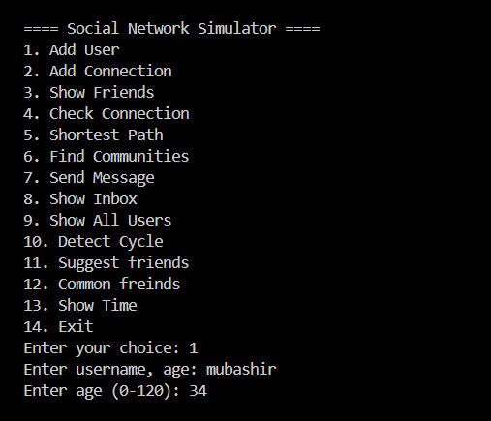
Output Screenshots:
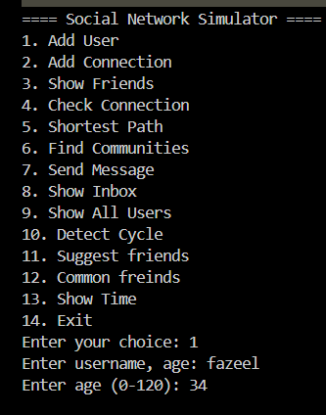
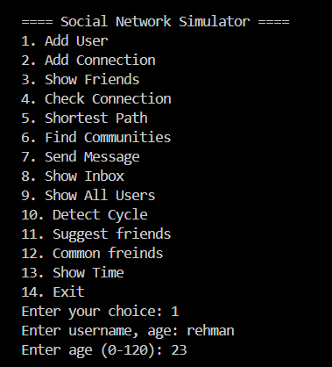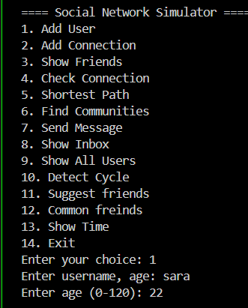
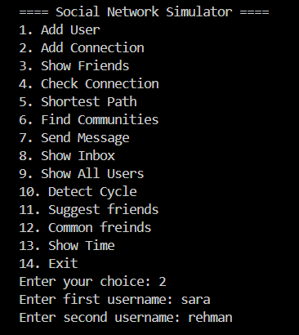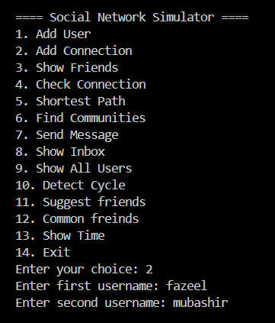
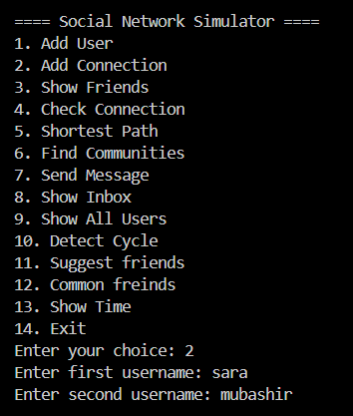
ADDED CONNECTIONS:
SHOWING FRIEND LIST OF USER:
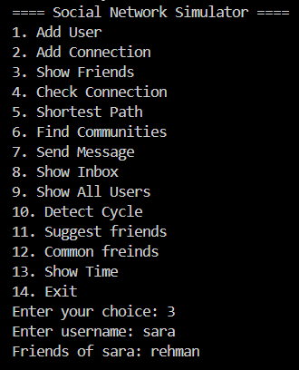
SUGGESTING FRIENDS:
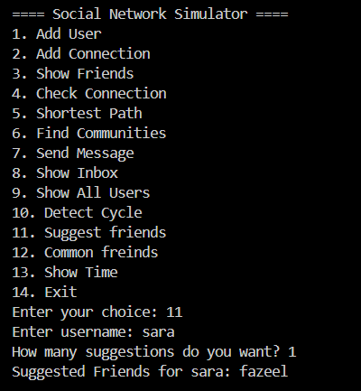
COMMON FRIENDS:
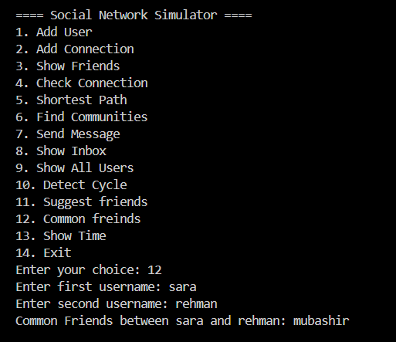
LOOP/CYCLE DETECTION IN NETWORK:
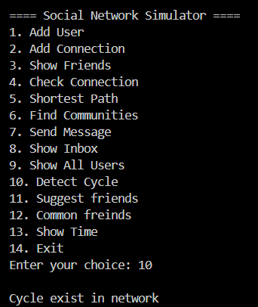
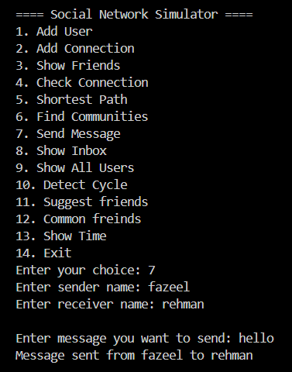
SEND MESSAGE AND SHOW INBOX :
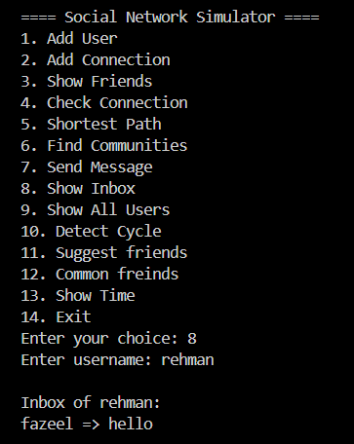
CHECK CONNECTION:
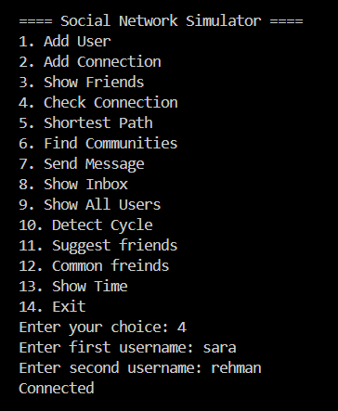

11. Results & Discussion
- BFS and DFS perform as expected, scaling linearly with vertices + edges.
- Shortest path calculations and friend suggestions remain efficient in sparse networks.
- Mutual friends algorithm demonstrates improvement over naive nested loops.
- Performance measurements using <chrono> validate theoretical time complexities.
- Graph representation using adjacency lists proves memory-efficient.

12. Conclusion
- Graph-based implementation effectively models social network relationships.
- BFS and DFS are practical tools for connectivity, community detection, and shortest path analysis.
- Time complexity measurements confirm expected theoretical performance.
- The project demonstrates that real-world social networks can be analyzed efficiently using data structures and algorithms.

13. Future Work
- Implement weighted relationships (e.g., friendship strength) for advanced analysis.
- Optimize large-scale network performance using parallel BFS/DFS or adjacency matrix for dense graphs.
- Add recommendation algorithms like collaborative filtering.
- Visualize social networks using graph plotting libraries.
- Extend project to real-world datasets from social media platforms.

14. References
- Cormen, T. H., Leiserson, C. E., Rivest, R. L., & Stein, C. (2009). Introduction to Algorithms (3rd ed.). MIT Press.
- Weiss, M. A. (2014). Data Structures and Algorithm Analysis in C++ (4th ed.). Pearson.
- Sedgewick, R., & Wayne, K. (2011). Algorithms (4th ed.). Addison-Wesley.
- GeeksforGeeks. “Graph Data Structure and Algorithms in C++.” https://www.geeksforgeeks.org/graph-data-structure-and-algorithms/
- Stroustrup, B. (2013). The C++ Programming Language (4th ed.). Addison-Wesley.

