Project13-Edge AI Anomaly Detection: Deploy TinyML Model in Arduino to ESP32 | Digi-Key Electronics
In this tutorial series, Shawn introduces the concept of Tiny Machine Learning (TinyML), which consists of running machine learning algorithms on microcontrollers and single board computers. In the previous episode ( • Edge AI Anomaly Detection Part 3: Dep... ), we deployed our Mahalanobis Distance model and Autoencoder neural network to a Raspberry Pi, which was used to detect anomalies in a ceiling fan in real time. Code and example dataset for this video series can be found here: https://github.com/ShawnHymel/tinyml-... For this episode, we retrain the model using a slightly more robust method: we move the fan around during training to account for various possible states of the accelerometer. While the Mahalanobis Distance does not work well with this new model, the neural network is able to adapt and performs brilliantly. We then convert the Mahalanobis Distance model and calculations to C code by generating a constant array in a header file for the mean and inverse covariance matrices of the training data. Next, we create a number of C functions that can calculate the Mahalanobis Distance. This is uploaded to our ESP32 using Arduino. A piezo buzzer is connected to the ESP32, which will alert the user of an anomaly in real time. The ESP32 reads from the accelerometer, computes the median absolute deviation (MAD), and then calculates the Mahalanobis Distance (MD) between the new sample and the model’s mean. If the MD is over a set threshold, we sound the buzzer (alerting the user of a possible anomaly). Similarly, we convert the autoencoder to a TensorFlow Lite model and create a C header file out of the FlatBuffer. The ESP32 reads data from the accelerometer, computes the MAD, and then runs the MAD values through the trained Autoencoder. The mean squared error (MSE) is computed between the input and output of the autoencoder. If the MSE is above a particular threshold, we sound the buzzer. Before starting, we recommend you watch the following videos: What is Edge AI - • Intro to Edge AI: Machine Learning + ... Getting Started with Machine Learning Using TensorFlow and Keras - • Getting Started with TensorFlow and K... Product Links: Adafruit Feather Huzzah32 - https://www.digikey.com/product-detai... Adafruit MSA301 Triple Axis Accelerometer - https://www.digikey.com/product-detai... Piezo Buzzer - https://www.digikey.com/product-detai...
Related Project Links: Edge AI Anomaly Detection Part 4: Machine Learning on Arduino - https://www.digikey.com/en/maker/proj...
Related Articles: What is Edge AI? https://www.digikey.com/en/maker/proj... Getting Started with Machine Learning Using TensorFlow and Keras https://www.digikey.com/en/maker/proj... TensorFlow Lite Tutorials: https://www.digikey.com/en/maker/sear... Low-Cost Data Acquisition (DAQ) with Arduino and Binho for ML https://www.digikey.com/en/maker/proj... Intro to TinyML: https://www.digikey.com/en/maker/sear... Edge AI Anomaly Detection: https://www.digikey.com/en/maker/sear...

TinyML Example: Anomaly Detection
This project is an example demonstrating how to use Python to train two different machine learning models to detect anomalies in an electric motor. The first model relies on the classic machine learning technique of Mahalanobis distance. The second model is an autoencoder neural network created with TensorFlow and Keras.
Data was captured using an ESP32 and MSA301 3-axis accelerometer taped to a ceiling fan. Each sample is about 200 samples of all 3 axes captured over the course of 1 second. Fan was run at multiple speeds (off, low, medium, high) with and without a weight. 1 "weight" is one US quarter taped to one of the fan's blades to create an offset motion. All raw data is stored in the ceiling-fan-dataset directory.
Note that if you create a "robust" model by moving the fan around during data collection, the Autoencoder works much better than the Mahalanobis Distance method.
The full articles that explain how these programs work and how to use them can be found here:
- Edge AI Anomaly Detection Part 1 - Data Collection
- Edge AI Anomaly Detection Part 2 - Feature Extraction and Model Training
- Edge AI Anomaly Detection Part 3 - Machine Learning on Raspberry Pi
- Edge AI Anomaly Detection Part 4 - Machine Learning Models on Arduino
Here are the accompanying YouTube videos that explain how to use these programs and some of the theory behind them:
- Edge AI Anomaly Detection Part 1: Data Collection
- Edge AI Anomaly Detection Part 2: Feature Extraction and Model Training
- Edge AI Anomaly Detection Part 3: Deploy Machine Learning Models to Raspberry Pi
- Edge AI Anomaly Detection Part 4: Deploy TinyML Model in Arduino to ESP32
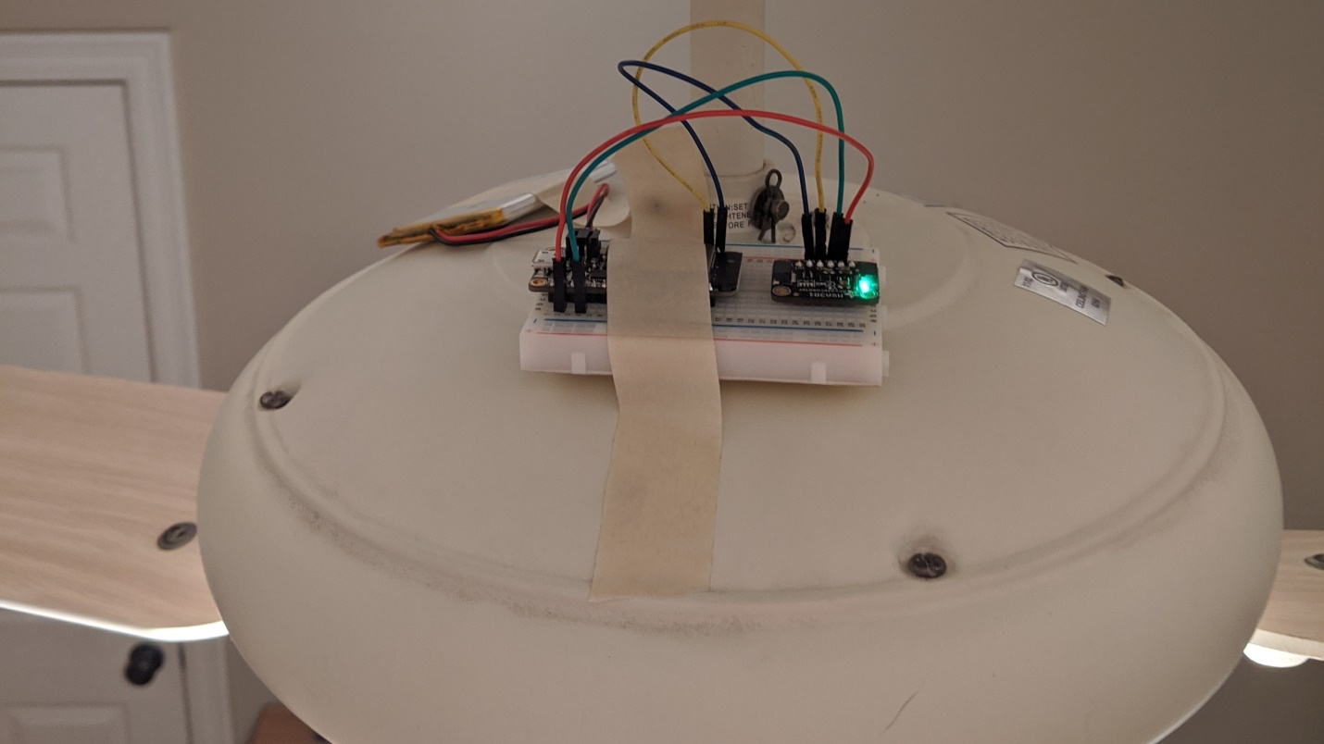
Prerequisites
You will need to install TensorFlow, Keras, and Jupyter Notebook on your desktop or laptop. This guide will walk you through that process.
Alternatively, you can use Google Colab to run a Jupyter Notebook instance in the cloud, however, loading files (e.g. training samples) will require you to upload them to Google Drive and write different code to import them into your program. This guide offers some tips on how to do that.
If you plan to collect data yourself, you will need an Adafruit Feather Huzzah32, Adafruit MSA301 accelerometer breakout board, battery, breadboard, and jumper wires.
For deployment, you will want to install TensorFlow Lite on your Raspberry Pi by following these instructions. For Arduino, you will want to install the TensorFlow Lite for Microcontrollers Arduino library.
Hardware
For this project, you will need the following:
- Adafruit Feather ESP32
- Adafruit MSA301 accelerometer
- Raspberry Pi 3B+ (optional)
- Piezo buzzer
You can use whatever breadboard, jumper wires, and battery you want to connect everything together.
Getting Started
Please read the tutorials above for full documentation on how to use the scripts found in this project.
In general, you will want to perform the following steps:
- Collect data samples
- Analyze data for good features
- Train one or more machine learning models
- Convert models for deployment
- Deploy machine learning model to end system
Collect Data
Download this repository. Connect an MSA301 accelerometer breakout board to the ESP32 Feather. Open the data_collection/esp32_accel_post/esp32_accel_post.ino Arduino sketch and change the WiFi SSID, password, and server IP address. Upload to your ESP32. Place your ESP32 and accelerometer on the system you wish to monitor (e.g. ceiling fan).
Run data_collection/http_accel_server.py on your server computer to collect data. Repeat this process for however many normal and anomaly states you wish to collect data from. I recommend at least 200 sample files per state.
See the Collecting Your Own Data section below for more information on how to use the server script.
Analyze Data
Open data_collection/anomaly-detection-feature-analysis in Jupyter Notebook and run it. Change the dataset_path to point to wherever you collected your sample files. Change the op_lists to be the names of the directories in that dataset path. Note that by default, the dataset path is set to datasets/ in this repository. You are welcome to use my collected data (although it might not be indicative of your particular system).
Carefully look at the various plots to determine which features can be used to best discriminate between normal and anomalous operation.
Train Machine Learning Models
You have two options for detecting anomalies: Mahalanobis Distance, which is a more classical machine learning method, and Autoencoder, which is a neural network.
Open mahalanobis_distance/anomaly-detection-training-mahalanobis-distance.ipynb with Jupyter Notebook to train the Mahalanobis Distance model. Change the datasets variables to point to your normal and anomaly samples. The model is the mean and covariance matrix of the normal dataset's median absolute deviation (MAD). It should be saved as a .npz file (you can find mine stored in mahalanobis_distance/models).
For the Autoencoder, open autoencoder/anomaly-detection-training-autoencoder.ipynb. Change the datasets variables to point to your normal and anomaly samples. The model is a trained neural network. Note that you might need to create and train the model several times (initialized parameters are random) to get a good separation between normal and anomaly mean squared errors (MSEs). The model is saved as a .h5 Keras file (you can find my models in autonecoder/models).
Convert Models
If you are deploying the model(s) to a Raspberry Pi (or other single board computer), you can use the generated .npz file for the Mahalanobis Distance. For the Autoencoder, you will want to convert the .h5 file to a TensorFlow Lite (.tflite) file. The functions for converting the .h5 file to a .tflite file can be found in autoencoder/anomaly-detection-tflite-conversion.ipynb.
For use on a microcontroller, you will want to develop a set of C functions to calculate the MAD and Mahalanobis Distance or use TensorFlow Lite for Microcontrollers.
To generate constant arrays in C and header files, use the functions in utils/c_writer.py.
Converting the Mahalanobis Distance model to C can be done with mahalanobis_distance/anomaly-detection-md-conversion.ipynb. Note that this Notebook also saves a normal and anomaly sample as a C header file for use in testing.
Converting the Autoencoder model to C can be done with autoencoder/anomaly-detection-tflite-conversion.ipynb. This will generate a .tflite model file and then convert that file to a constant C array (inside of a .h header file).
You will need to copy the generated .h files (model, test samples, etc.) to your microcontroller project (i.e. in your Arduino sketch directory).
Deploy Models
If you wish to use your ESP32 remotely (i.e. it sends raw accelerometer data back to a server that performs inference), run the original data collection sketch on it. For your server, run mahalanobis_distance/http_server_anomaly_detection_md.py or autoencoder/http_server_anomaly_detection_tflite.py, depending on which model you want to use. Note that for the Autoencoder, you will want to install TensorFlow Lite on your server.
To use the model locally on your microcontroller (ESP32), you will want to use mahalanobis_distance/esp32_deploy_md for the Mahalanobis Distance or autoencoder/esp32_deploy_tflite for the Autoencoder. You will need to copy the respective model .h file generated in the previous step to the Arduino sketch's folder. Note that utils.h and utils.c (found in the utils directory) are also required, as they contain necessary C functions for computing MAD, matrix multiplication, etc.
By default, a piezo buzzer is to be connected to pin A1 of the ESP32 Feather board, which buzzes any time an anomaly is detected. Feel free to change this to whatever action you want to take to alert the user.
If you are curious, mahalanobis_distance/esp_test_md and autoencoder/esp32_test_tflite are used to test inference using the normal and anomaly samples generated earlier. You would want to use these files to check your C implementation against known good outputs in Python.
Collecting Your Own Data
If you wish to collect your own data, you will need to connect an MSA301 accelerometer to an ESP32 (I used the Adafruit Feather Huzzah32) via I2C. Open the data_collection/esp32_accel_post/esp32_accel_post.ino sketch and change the WiFi credentials and server IP address to match your computer's IP address. Upload the sketch to the ESP32.
Attach a battery to the ESP32 and secure it (using something like tape) to your electric motor (I used a ceiling fan).
Start data_collection/http_accel_server.py with the following arguments:
python http-accel-server.py -d <output directory where samples are stored> -p <port, such as 1337> -t <time to run server; something like 2400 seconds seems to work well>
You'll want to run the collection process for each operating mode of your motor. For a ceiling fan, that's off, low, medium, and high. It can also help to collect some "anomaly" data in a separate folder. For example, tape a coin to a ceiling fan blade and run the collection process again with all operating modes (except for "off").
To create a more "robust" model, I recommend slightly moving the fan's base around every minute or so during "normal" sample collection. See the 4th YouTube episode for more details.
License
All code in this repository, unless otherwise specified, is for demonstration purposes and licensed under Beerware.
Distributed as-is; no warranty is given.

Conclusion
The TinyML project on anomaly detection effectively illustrates the use of machine learning techniques to monitor and identify anomalies in electric motor operation. By employing two distinct models—Mahalanobis distance and an autoencoder neural network—the project demonstrates a comprehensive approach to anomaly detection using real-time data collected from an accelerometer.
Key Outcomes:
- Data Acquisition: The project successfully utilized an ESP32 and MSA301 accelerometer to collect relevant data from a ceiling fan under various operating conditions. This hands-on data collection process is crucial for building effective models.
- Model Performance: The comparison between the Mahalanobis distance method and the autoencoder revealed that the autoencoder generally outperformed the classical method, particularly when a more diverse dataset was used. This underscores the importance of robust data collection practices in enhancing model accuracy.
- Flexible Deployment: The project outlines clear steps for converting and deploying trained models across different platforms, including Raspberry Pi and microcontrollers. This flexibility allows for scalable applications in real-world monitoring scenarios.
- Practical Applications: The integration of a feedback mechanism, such as a piezo buzzer for alerting users to detected anomalies, demonstrates the practical utility of the models in preventive maintenance and operational safety.
Future Directions:
To further enhance the system, future work could focus on optimizing the autoencoder's architecture and exploring additional features from the data that may improve anomaly detection. Additionally, implementing a more extensive testing phase with varied operational environments could provide deeper insights into the model's robustness.
Overall, this project not only serves as a practical example of anomaly detection using TinyML but also provides a valuable framework for similar applications in industrial and consumer domains.
نتیجه گیری
پروژه TinyML در تشخیص ناهنجاری به طور موثر استفاده از تکنیک های یادگیری ماشین را برای نظارت و شناسایی ناهنجاری ها در عملکرد موتور الکتریکی نشان می دهد. با به کارگیری دو مدل مجزا - فاصله Mahalanobis و یک شبکه عصبی رمزگذار خودکار - این پروژه یک رویکرد جامع برای تشخیص ناهنجاری با استفاده از داده های زمان واقعی جمع آوری شده از یک شتاب سنج را نشان می دهد.

نتایج کلیدی:
جمع‌آوری داده‌ها: این پروژه با موفقیت از شتاب‌سنج ESP32 و MSA301 برای جمع‌آوری داده‌های مربوطه از یک پنکه سقفی تحت شرایط مختلف عملیاتی استفاده کرد. این فرآیند جمع‌آوری داده‌ها برای ساخت مدل‌های مؤثر بسیار مهم است.
عملکرد مدل: مقایسه بین روش فاصله ماهالانوبیس و رمزگذار خودکار نشان داد که رمزگذار خودکار عموماً از روش کلاسیک بهتر عمل می کند، به ویژه زمانی که از مجموعه داده های متنوع تری استفاده می شود. این امر بر اهمیت شیوه های جمع آوری داده های قوی در افزایش دقت مدل تاکید می کند.
استقرار انعطاف پذیر: این پروژه مراحل روشنی را برای تبدیل و استقرار مدل های آموزش دیده در پلتفرم های مختلف، از جمله Raspberry Pi و میکروکنترلرها، تشریح می کند. این انعطاف‌پذیری به برنامه‌های مقیاس‌پذیر در سناریوهای نظارتی در دنیای واقعی اجازه می‌دهد.
کاربردهای عملی: ادغام یک مکانیسم بازخورد، مانند زنگ پیزو برای هشدار به کاربران در مورد ناهنجاری های شناسایی شده، کاربرد عملی مدل ها را در نگهداری پیشگیرانه و ایمنی عملیاتی نشان می دهد.
مسیرهای آینده:
برای بهبود بیشتر سیستم، کار آینده می‌تواند بر بهینه‌سازی معماری رمزگذار خودکار و کاوش ویژگی‌های اضافی از داده‌ها تمرکز کند که ممکن است تشخیص ناهنجاری را بهبود بخشد. علاوه بر این، اجرای یک مرحله آزمایشی گسترده تر با محیط های عملیاتی متنوع می تواند بینش عمیق تری در مورد استحکام مدل ارائه دهد.

به طور کلی، این پروژه نه تنها به عنوان یک نمونه عملی از تشخیص ناهنجاری با استفاده از TinyML عمل می کند، بلکه یک چارچوب ارزشمند برای برنامه های کاربردی مشابه در حوزه های صنعتی و مصرف کننده ارائه می دهد.

https://github.com/fazelelham32/Projects---MASTER-PROJECTS-/tree/Proj.13-Edge-AI-Anomaly-Detection-Deploy-TinyML-Model-in-Arduino-to-ESP32-%7C-Digi-Key-Electronics

