**Hamza Zia**

**Assignment 1**

**Test Report**

The objective of the test is functional testing of the 5 functions.

Test cases, test coverage and execution details.

Test Cases 🧪

add takes two numbers x,y as input and returns the addition of the two numbers.

sub takes two numbers x,y as input and returns the subtraction of the two numbers.

square takes a number x as input and returns the square of that number.

findArea takes two numbers x,y and applies the l * b formula and returns the area of a rectangle.

findPerimeter takes two numbers x,y and applies the 2 * ( l + b ) formula and returns the perimeter of a rectangle.

Test Coverage 🛠️

add we have three edge case tests adding positive numbers, negative nubers and postive and negative numbers together.

sub we have three edge case tests subtracting positive numbers, negative numbers and postive and negative numbers from each other.

squarewe have two edge case tests squaring positive number and negative numbers.

find Area and findPerimeter tests cover similar cases using positive numbers, negative nubers and positive and negative numbers.

Defects counts 🔎

Add unit test cases: All Passed ✅

[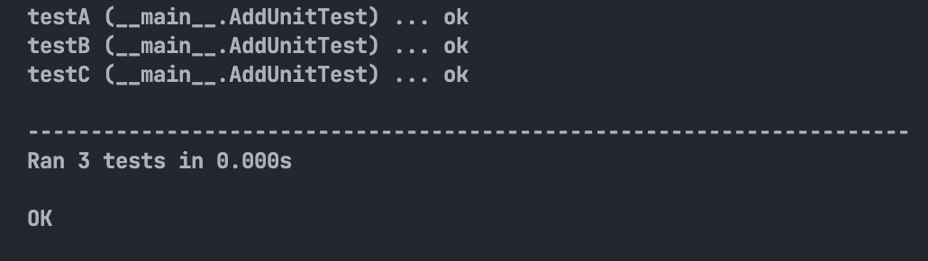](https://user-images.githubusercontent.com/66818162/182040935-e54605d2-693c-41a7-a8b9-34d04c9cc335.png)

Sub unit test cases: All Passed ✅

[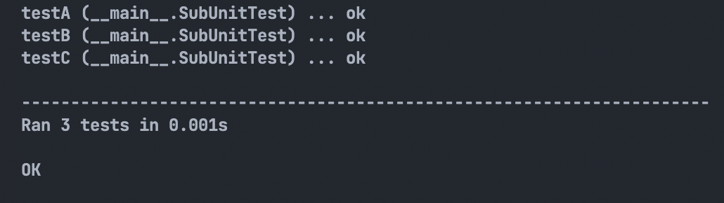](https://user-images.githubusercontent.com/66818162/182040939-d3f7df60-bfab-49d7-a80a-8bcfece62501.png)

Square unit test cases: All Passed ✅

[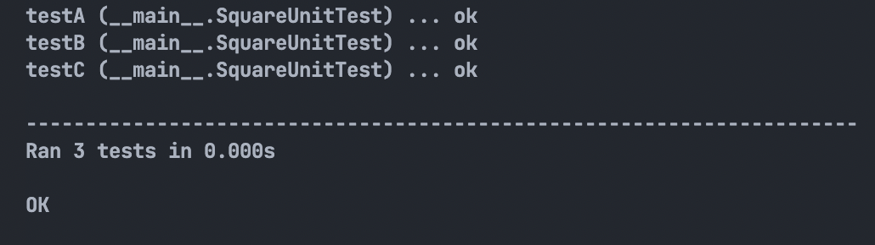](https://user-images.githubusercontent.com/66818162/182040953-e88d608b-c512-43b5-b32a-3fcbe9f4227c.png)

Rectangular Area test cases: All Passed ✅

[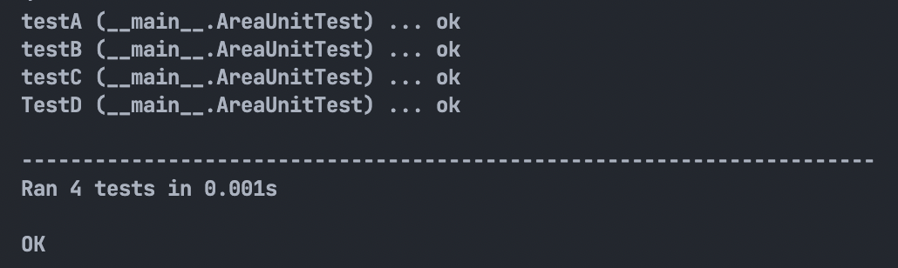](https://user-images.githubusercontent.com/66818162/182040955-ee9f1afb-66b5-4a1a-9fe0-56e5dfd7ce4c.png)

Rectangular Perimeter test cases: All Passed ✅

[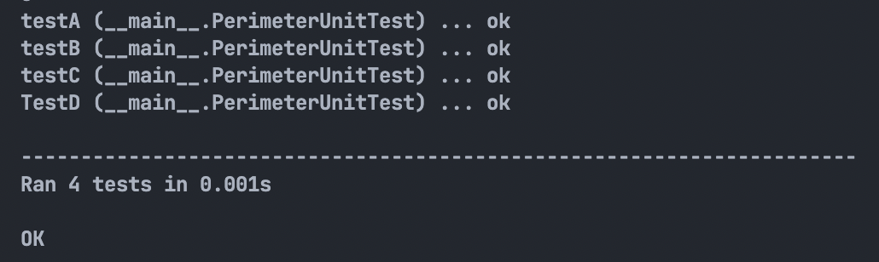](https://user-images.githubusercontent.com/66818162/182040957-25f60fad-a2bc-436e-979d-12492b2a96d8.png)

Entire Test Suite: All Passed ✅

[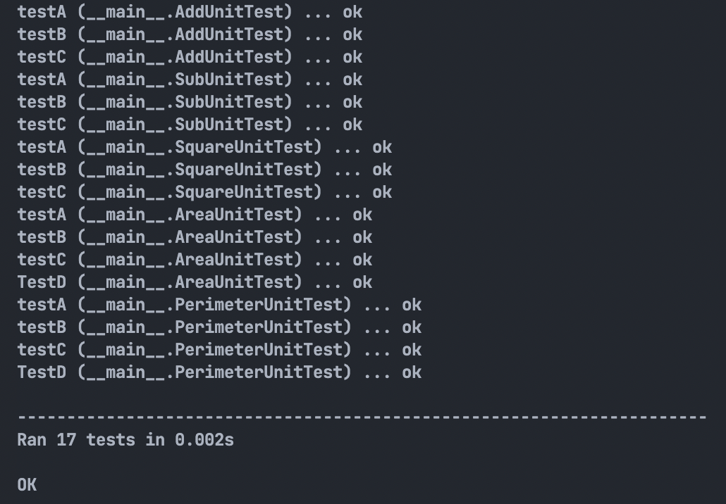](https://user-images.githubusercontent.com/66818162/182040962-ed670d18-18e8-41e0-b234-b11bdee21ffc.png)

No defects were found in any function.