EMPLOYEE_TABLE

CREATE TABLE EMPLOYEE
(
EMP_ID NUMBER PRIMARY KEY,
EMP_NAME VARCHAR2(30),
GENDER VARCHAR2(6),
DOB DATE,
HIRE_DATE DATE,
SALARY NUMBER(10,2),
COMMISSION NUMBER(10,2),
DEPT_ID NUMBER,
MANAGER_ID NUMBER,
JOB_TITLE VARCHAR2(30),
EMAIL VARCHAR2(30),
PHONE VARCHAR2(15),
STATUS VARCHAR2(10),

CONSTRAINT DEPT_001
FOREIGN KEY (DEPT_ID)
REFERENCES DEPARTMENT(DEPT_ID),

CONSTRAINT MAG_001
FOREIGN KEY (MANAGER_ID)
REFERENCES EMPLOYEE(EMP_ID)
);

SELECT * FROM EMPLOYEE;

INSERT ALL

INTO EMPLOYEE VALUES
(101,'Arun','M',DATE '2002-09-20',DATE '2023-04-29',10000,3000,10,NULL,'HR Manager','arun@gmail.com','9090909001','ACTIVE')

INTO EMPLOYEE VALUES
(102,'Bala','M',DATE '2001-06-15',DATE '2023-05-10',8000,NULL,20,NULL,'Finance Manager','bala@gmail.com','9090909002','ACTIVE')

INTO EMPLOYEE VALUES
(103,'Kiran','M',DATE '2000-12-08',DATE '2023-06-12',12000,2000,30,NULL,'IT Manager','kiran@gmail.com','9090909003','ACTIVE')

INTO EMPLOYEE VALUES
(104,'Devi','F',DATE '2002-03-18',DATE '2024-01-10',5000,NULL,10,101,'HR Executive','devi@gmail.com','9090909004','ACTIVE')

INTO EMPLOYEE VALUES
(105,'Esha','F',DATE '2001-11-25',DATE '2024-02-20',4500,NULL,20,102,'Accountant','esha@gmail.com','9090909005','ACTIVE')

INTO EMPLOYEE VALUES
(106,'Farhan','M',DATE '2000-08-05',DATE '2024-03-15',7000,1000,30,103,'Software Developer','farhan@gmail.com','9090909006','ACTIVE')

INTO EMPLOYEE VALUES
(107,'Gokul','M',DATE '1999-04-11',DATE '2024-04-08',6500,NULL,30,103,'Database Developer','gokul@gmail.com','9090909007','ACTIVE')

INTO EMPLOYEE VALUES
(108,'Harini','F',DATE '2002-07-22',DATE '2024-05-18',6000,500,40,NULL,'Sales Manager','harini@gmail.com','9090909008','ACTIVE')

INTO EMPLOYEE VALUES
(109,'Irfan','M',DATE '2001-09-30',DATE '2024-06-12',4500,1500,40,108,'Sales Executive','irfan@gmail.com','9090909009','ACTIVE')

INTO EMPLOYEE VALUES
(110,'Jaya','F',DATE '2003-01-14',DATE '2024-07-01',5500,NULL,50,NULL,'Marketing Manager','jaya@gmail.com','9090909010','ACTIVE')

SELECT * FROM DUAL;
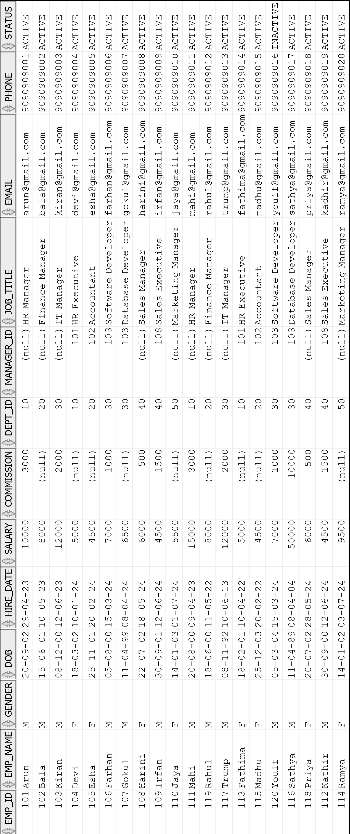
COMMIT;

DEPARTMENT_TABLE

CREATE TABLE DEPARTMENT (
DEPT_ID NUMBER PRIMARY KEY,
DEPT_NAME VARCHAR2(30),
LOCATION VARCHAR2(20)
);

INSERT ALL
INTO DEPARTMENT VALUES (10,'Human Resource','Chennai')
INTO DEPARTMENT VALUES (20,'Finance','Madurai')
INTO DEPARTMENT VALUES (30,'Information Technology','Karaikudi')
INTO DEPARTMENT VALUES (40,'Sales','Trichy')
INTO DEPARTMENT VALUES (50,'Marketing','Coimbatore')
SELECT * FROM DUAL;

COMMIT;

SELECT * FROM DEPARTMENT;

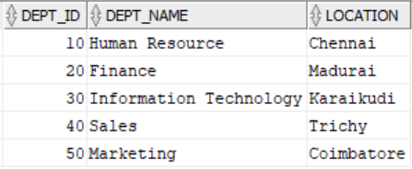

PROJECT_TABLE

CREATE TABLE PROJECT (
PROJECT_ID NUMBER PRIMARY KEY,
PROJECT_NAME VARCHAR2(30) NOT NULL,
START_DATE DATE,
END_DATE DATE,
BUDGET NUMBER(1,2)
);

INSERT ALL

INTO PROJECT VALUES (1001,'Payroll System',DATE '2025-06-20',DATE '2025-12-10',15000)
INTO PROJECT VALUES (1002,'Inventory Management',DATE '2024-02-20',DATE '2024-10-10',25000)
INTO PROJECT VALUES (1003,'Customer Portal',DATE '2025-01-20',DATE '2025-05-10',5000)
INTO PROJECT VALUES (1004,'HR Automation',DATE '2023-06-02',DATE '2023-11-02',10000)
INTO PROJECT VALUES (1005,'Sales Dashboard',DATE '2022-01-20',DATE '2023-06-10',20000)

SELECT * FROM DUAL;

COMMIT;
SELECT * FROM PROJECT;

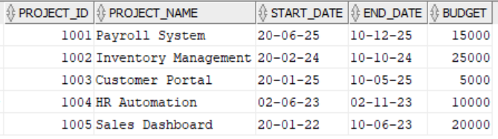

EMPLOYEE_PROJECT_TABLE

CREATE TABLE EMPLOYEE_PROJECT (
EMP_ID NUMBER,
PROJECT_ID NUMBER,
HOURS_WORKED NUMBER,

CONSTRAINT PK_EMP_PROJECT
PRIMARY KEY (EMP_ID, PROJECT_ID),

CONSTRAINT FK_EP_EMP
FOREIGN KEY (EMP_ID)
REFERENCES EMPLOYEE(EMP_ID),

CONSTRAINT FK_EP_PROJECT
FOREIGN KEY (PROJECT_ID)
REFERENCES PROJECT(PROJECT_ID)
);

INSERT ALL
INTO EMPLOYEE_PROJECT VALUES (101,1001,120)
INTO EMPLOYEE_PROJECT VALUES (101,1002,80)
INTO EMPLOYEE_PROJECT VALUES (102,1002,150)
INTO EMPLOYEE_PROJECT VALUES (103,1003,100)
INTO EMPLOYEE_PROJECT VALUES (104,1004,90)
INTO EMPLOYEE_PROJECT VALUES (105,1005,110)
INTO EMPLOYEE_PROJECT VALUES (106,1001,75)
INTO EMPLOYEE_PROJECT VALUES (107,1003,130)
INTO EMPLOYEE_PROJECT VALUES (108,1004,95)
INTO EMPLOYEE_PROJECT VALUES (109,1005,140)
INTO EMPLOYEE_PROJECT VALUES (110,1002,60)
SELECT * FROM DUAL;

COMMIT;

SELECT * FROM EMPLOYEE_PROJECT;

