SMART AGRICULTURE MONITORING SYSTEM

(IoT + HADOOP + DJANGO)

A CASE STUDY REPORT

Submitted by

DEOGAR A(RA2411003011740)

MOHAMED FAZIL A (RA2411003011760)


for the course
21CSC302J – COMPUTER NETWORKS
in partial fulfillment of the requirements for the degree of

BACHELOR OF TECHNOLOGY

DEPARTMENT OF DATA SCIENCE AND BUSINESS SYSTEMS
SCHOOL OF COMPUTING
FACULTY OF ENGINEERING AND TECHNOLOGY
SRM INSTITUTE OF SCIENCE AND TECHNOLOGY KATTANKULATHUR - 603 203.

ABSTRACT

The Smart Agriculture Monitoring System is designed to enhance agricultural productivity by integrating Internet of Things (IoT), Big Data technologies, and web-based applications. Agriculture depends heavily on environmental conditions such as soil moisture, temperature, and humidity. Traditional farming methods rely on manual monitoring, which often leads to inefficient resource utilization and reduced crop yield.
This project proposes an automated system that continuously monitors environmental parameters using IoT sensors. The collected data is transmitted through microcontrollers such as Arduino or NodeMCU to a Raspberry Pi gateway. The gateway processes and forwards the data to the Hadoop Distributed File System (HDFS), which provides scalable and fault-tolerant storage.
Apache Hive is used to analyze the stored data and generate meaningful insights such as irrigation recommendations and environmental trends. Django is used to develop an interactive dashboard that displays real-time and historical data using graphs and alerts.

TABLE OF CONTENTS
- Abstract
- Introduction
2.1 Background
2.2 Problem Statement
2.3 Objectives
- System Architecture
3.1 Overview
3.2 IoT Layer
3.3 Edge Layer
3.4 Big Data Layer
3.5 Application Layer
- Hardware Components
- Software Components
- Data Flow
- Database Design
- Implementation
8.1 IoT Implementation
8.2 Hadoop Implementation
8.3 Django Implementation
- Security Measures
- Quality of Service
- Monitoring and Management
- Testing and Validation
- Results
- Performance Analysis
- Applications
- Limitations
- Future Enhancements
- Conclusion
- References

1.INTRODUCTION

  - Background

Agriculture plays a vital role in economic development. However, traditional farming lacks automation and real-time monitoring. Environmental factors such as soil moisture and temperature directly impact crop growth.
IoT enables continuous monitoring using sensors, while Hadoop manages large datasets efficiently. Django provides a user-friendly interface for visualization.

  - Problem Statement

Traditional agriculture faces several issues:
- Lack of real-time monitoring
- Inefficient water usage
- Manual decision-making
- Lack of data analysis
- Reduced crop yield

  - Objectives

- Monitor soil moisture, temperature, and humidity
- Store large data using Hadoop
- Analyze data using Hive
- Develop a Django dashboard
- Provide irrigation suggestions

2. SYSTEM ARCHITECTURE

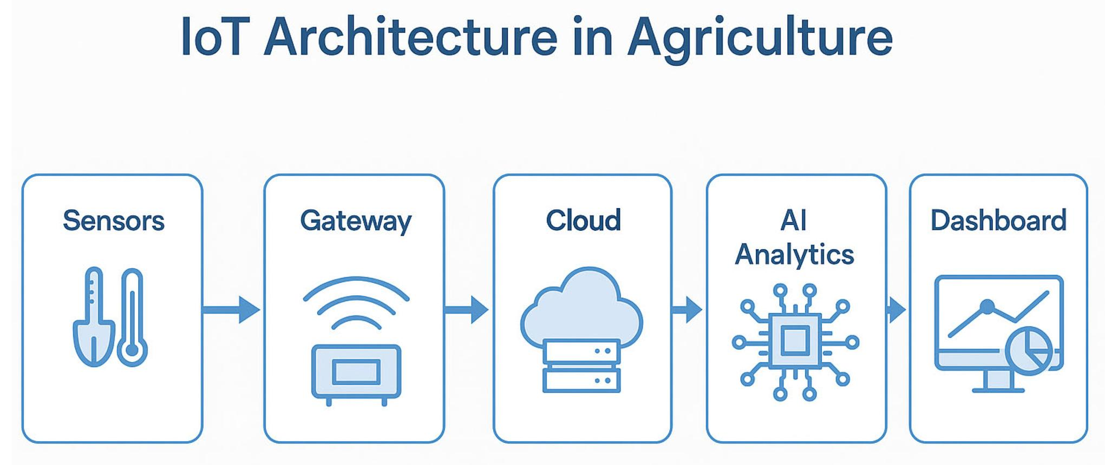
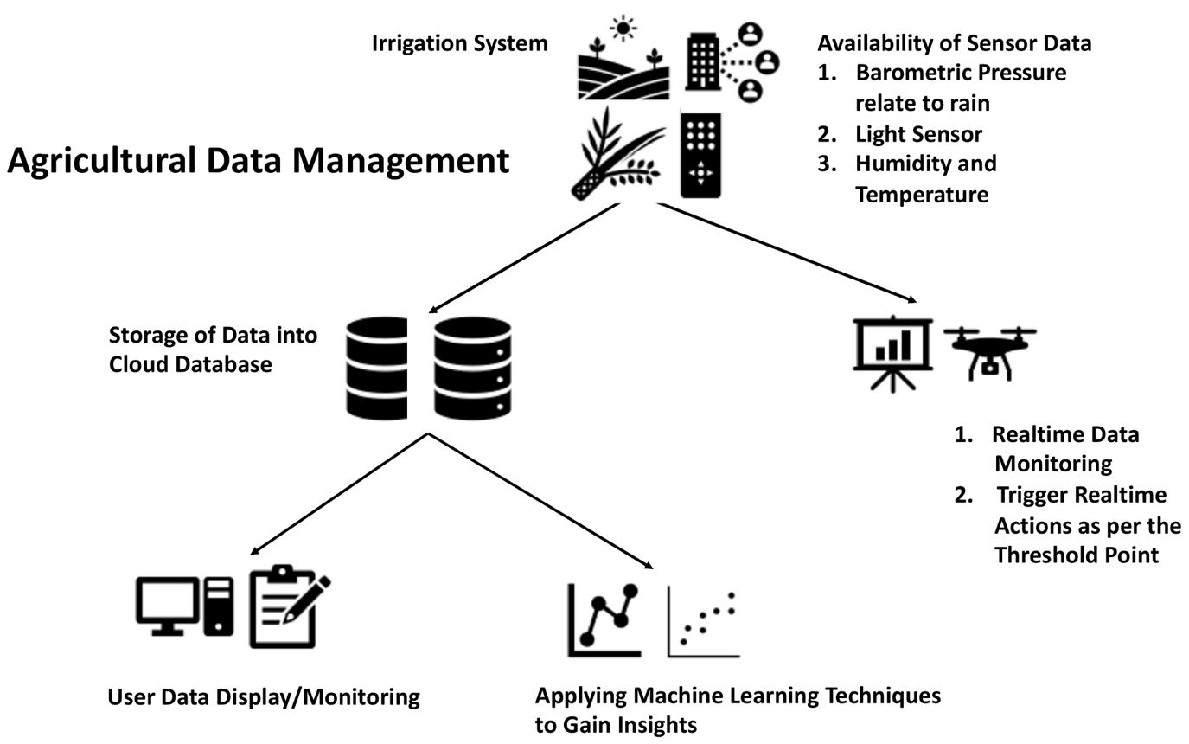
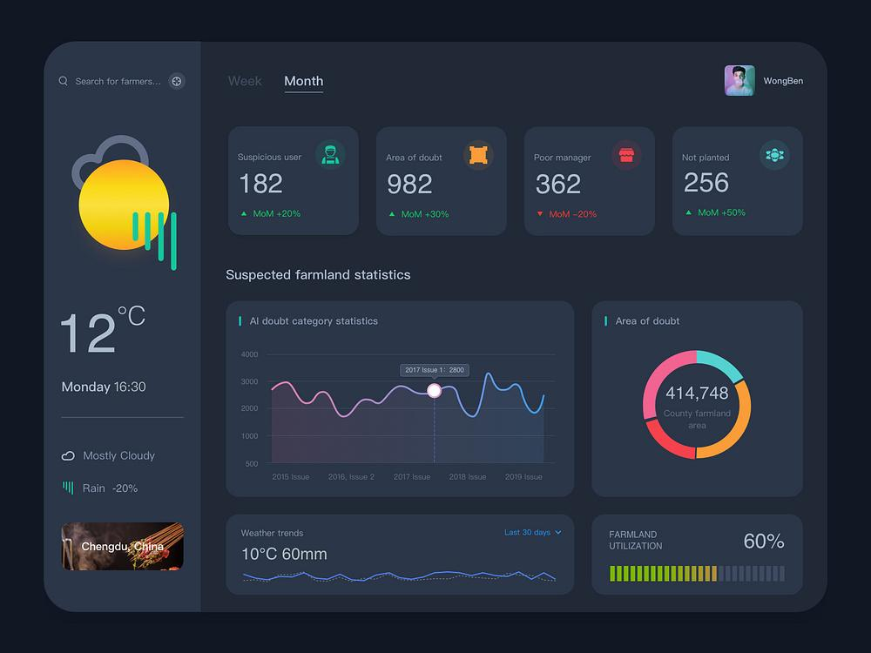

2.1 Overview

The system is divided into four layers:
- IoT Layer
- Edge Layer
- Big Data Layer
- Application Layer

2.2 IoT Layer

This layer includes sensors that collect environmental data such as soil moisture, temperature, and humidity.

2.3 Edge Layer

Raspberry Pi acts as a gateway:
- Collects sensor data
- Processes and filters data
- Sends data to Hadoop

2.4 Big Data Layer

Hadoop is used for distributed storage and processing. Hive enables SQL-like analysis of agricultural data.

2.5 Application Layer

Django is used to create a dashboard that displays real-time data and alerts.

3. HARDWARE COMPONENTS

- Arduino / NodeMCU
- Soil Moisture Sensor
- DHT11 Sensor
- Raspberry Pi

4. SOFTWARE COMPONENTS

- Apache Hadoop
- Apache Hive
- Django Framework
- Python

- DATA FLOW

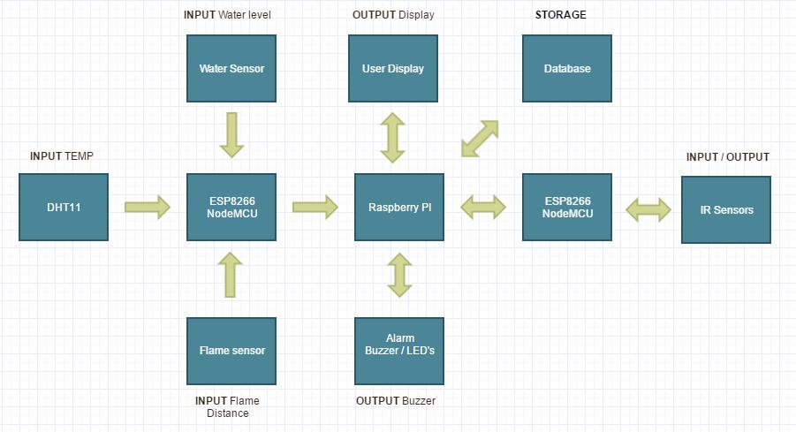
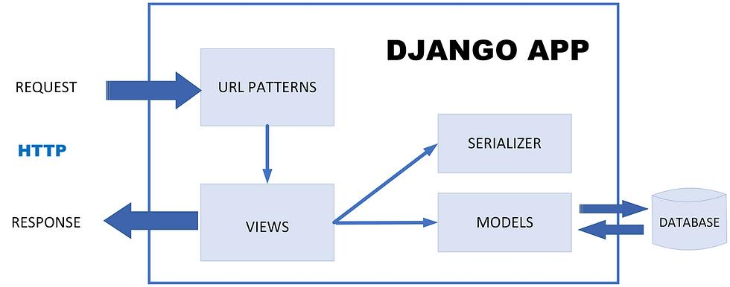
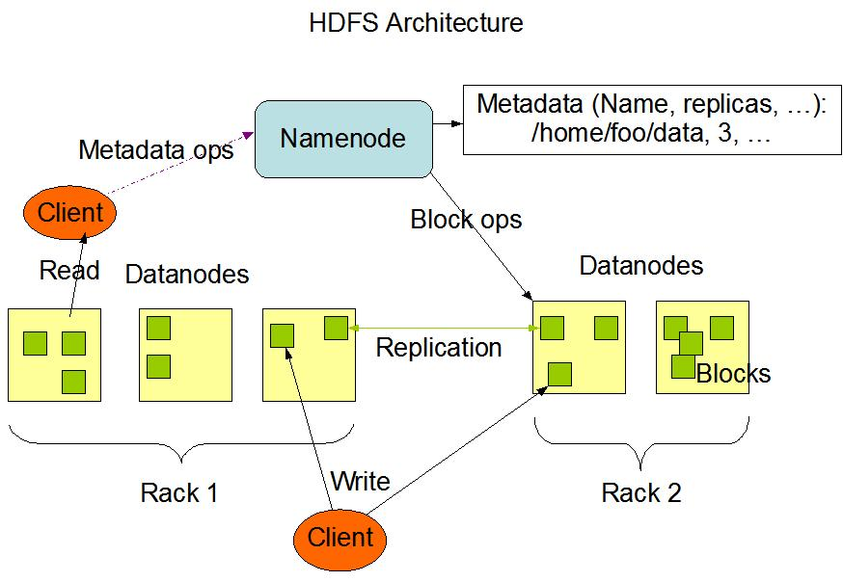

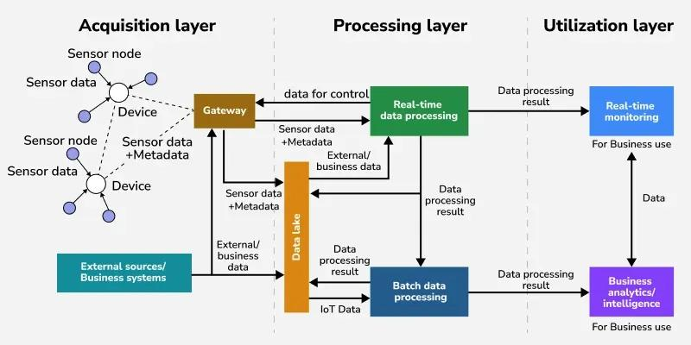

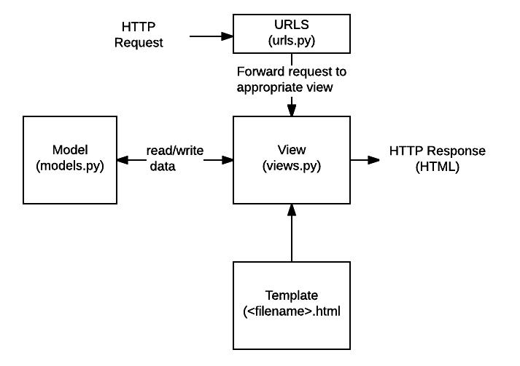

Steps:
- Sensors collect data
- Data sent to Raspberry Pi
- Data uploaded to HDFS
- Hive processes data
- Django displays results

- DATABASE DESIGN

Table: SensorData
Fields:
- ID
- Temperature
- Humidity
- Moisture
- Timestamp

7.IMPLEMENTATION

7.1 IoT Implementation
Sensors collect data continuously.

7.2 Hadoop Implementation
Data stored in HDFS and analyzed using Hive.

7.3 Django Implementation
Dashboard displays real-time data and alerts.

8. SECURITY MEASURES

- Authentication
- Secure APIs
- Access control
- Data protection

9. QUALITY OF SERVICE

- Low latency
- Reliable communication
- Efficient processing

10. DJANGO MODEL (Database)
Add this under Implementation / Coding Section

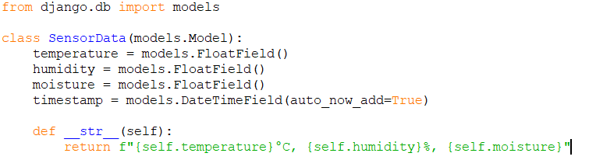

DJANGO API (Receive IoT Data)

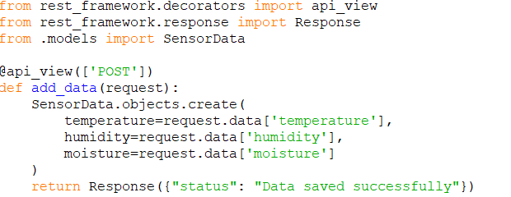

SIMULATED IOT DATA

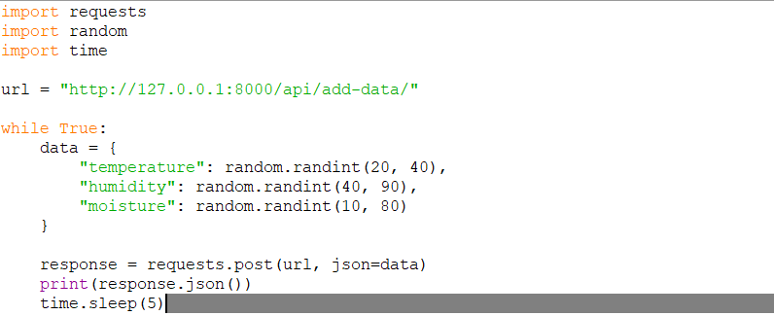

DJANGO VIEW FOR DASHBOARD

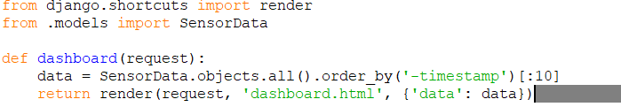

HADOOP

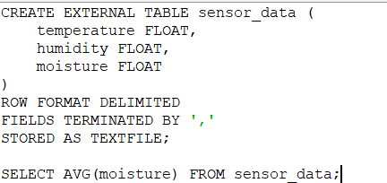

IRRIGATION LOGIC

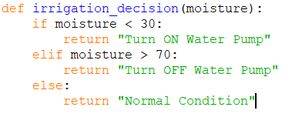

11. MONITORING AND MANAGEMENT

- System logs
- Error detection
- Alerts

12. TESTING AND VALIDATION

- Sensor testing
- API testing
- Dashboard testing

13. RESULTS

- Real-time monitoring achieved
- Accurate data collection
- Efficient processing

14. PERFORMANCE ANALYSIS

- High scalability
- Fast response time
- Reliable system

15. APPLICATIONS

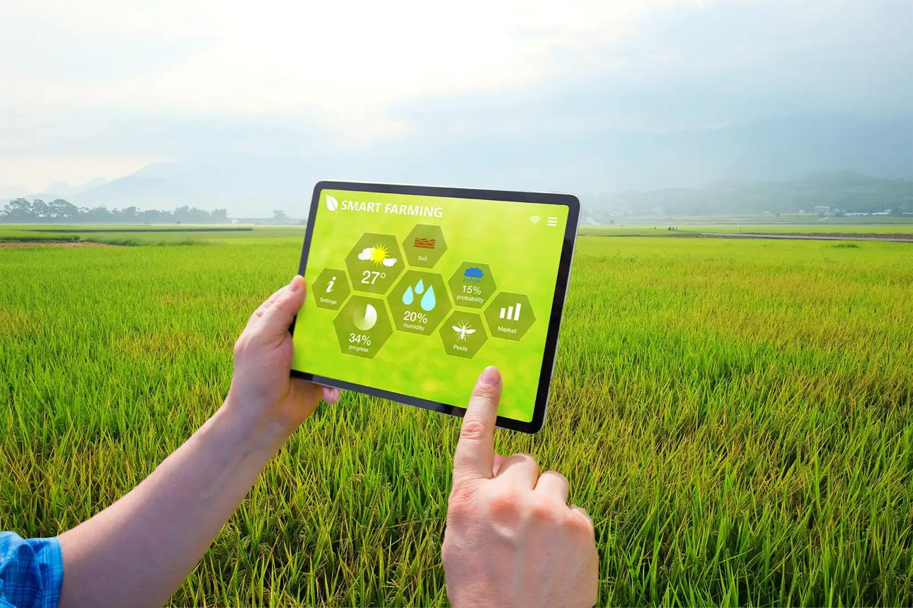

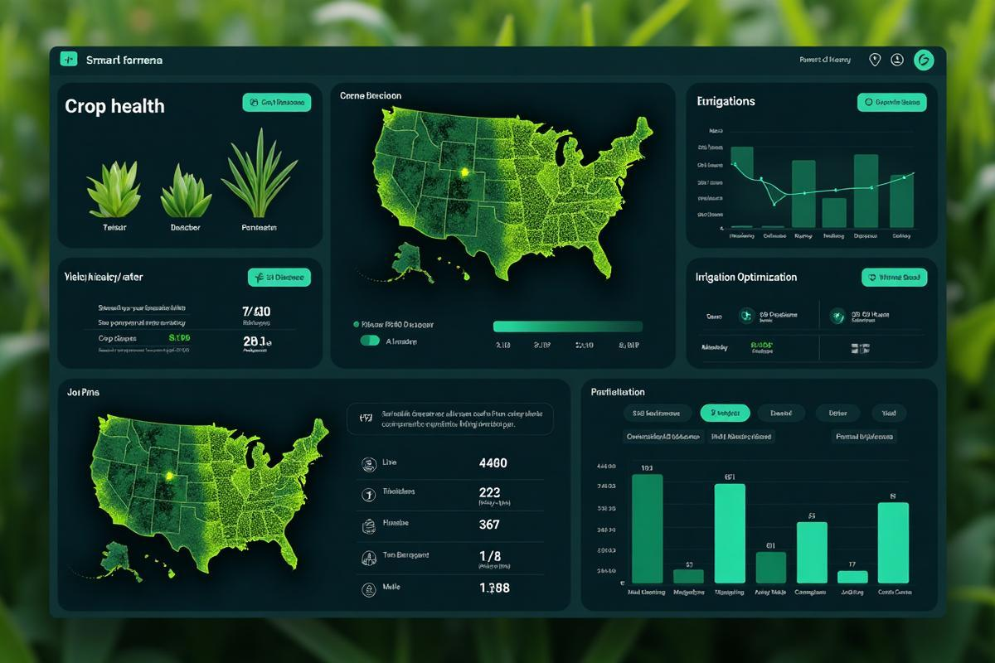

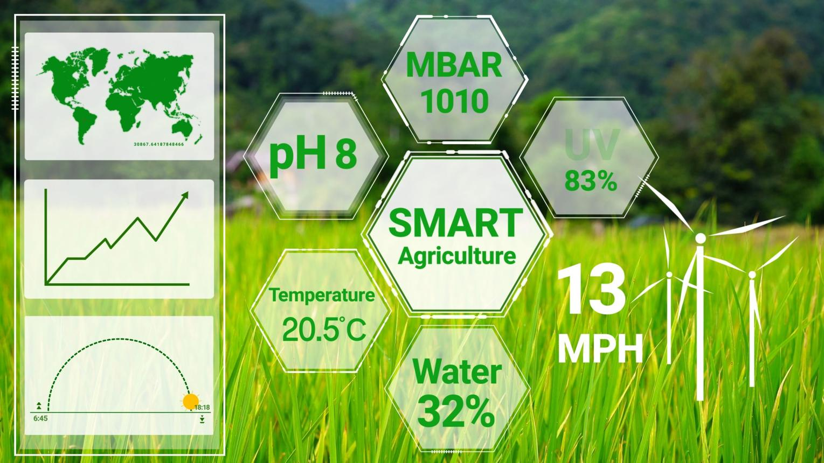

- Precision farming
- Water management
- Greenhouse monitoring

16. LIMITATIONS

- Internet dependency
- Hardware cost
- Maintenance

17. FUTURE ENHANCEMENTS

- Machine learning
- Mobile app
- Weather integration
- Automated irrigation

18.Advantages

- Saves water
- Improves crop yield
- Reduces manual work
- Real-time monitoring

19.Disadvantages

- Initial setup cost
- Requires maintenance
- Internet dependency

20.Assumptions

- Sensors are accurate
- Network is stable
- Data is continuously available

21.Algorithms
Step-by-step:
- Start
- Read sensor values
- Send data to server
- Store in database
- Analyze data
- Display results
- End

SAMPLE OUTPUT

- Temperature: 28°C
- Humidity: 65%
- Moisture: 25%
- Status: Water Pump ON

22. Literature Survey

Smart agriculture systems using IoT sensors help monitor environmental conditions in real time. Hadoop is used to store large data efficiently, and Django helps in visualizing the data. This project combines all three technologies for better farming decisions.

23. Existing System

- Manual monitoring
- No real-time data
- Water wastage
- Low efficiency

24.Proposed System

- Uses sensors to collect data
- Stores data in Hadoop
- Displays data using Django
- Provides irrigation suggestions

25.Modules

- Data Collection – Sensors
- Data Storage – Hadoop
- Processing – Hive
- Dashboard – Django

26.Future Scope

- Mobile app
- AI prediction
- Weather integration
- Auto irrigation

27.Applications

- Smart farming
- Water management
- Greenhouse monitoring

28. CONCLUSION

This system provides an efficient and scalable solution for smart agriculture by integrating IoT, Hadoop, and Django. It improves productivity and supports data-driven farming.

REFERENCES

- Hadoop Documentation
- Django Documentation
- Arduino Documentation
- Raspberry Pi Documentation

