**ETL Pipeline Testing screenshot**

Contents

Setup Hadoop Environment 1

Run instructions 1

https://github.com/fazilaijaz/msd.git 2

Run Data ingestion in hadoop and hive 2

Run loading script 2

Verify table and data 2

Run spark data aggregation and store result in hive 2

Run spark app 2

Verify tables and data 2

Run Data Visualization 3

# Setup Hadoop Environment

Follow the “Setup_hadoop_environment.docx” guide to setup the hortonworks sandbox using VM Player on windows.

# Run instructions

1. Run Sandbox Hortonworks Sandbox through VM Player Open SSH connection to VM in Browser.

192.168.122.128:4200

1. Login using **maria_**dev
2. Clone or download

# <https://github.com/fazilaijaz/msd.git>

# Run Data ingestion in hadoop and hive

## Run loading script

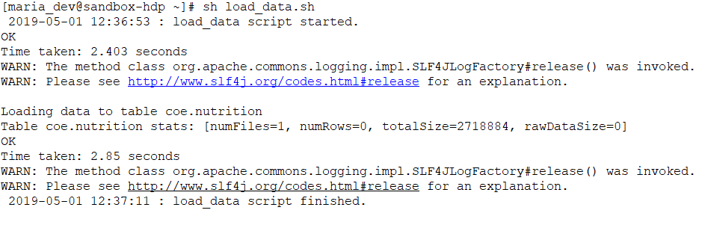

## Verify table and data

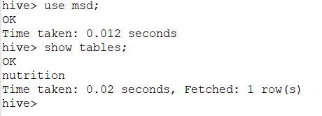

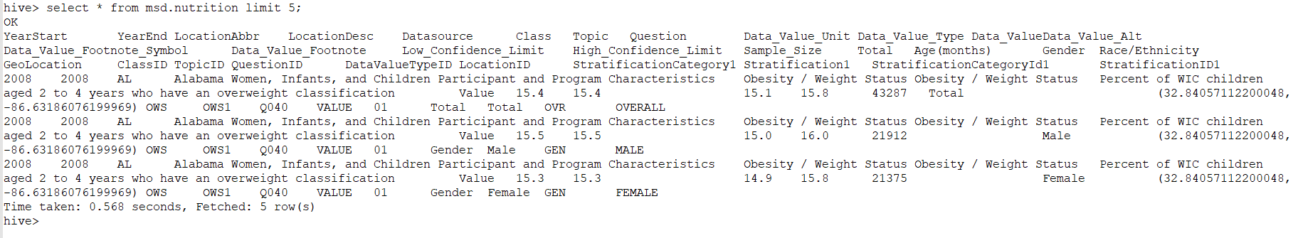

# Run spark data aggregation and store result in hive

## Run spark app

sh run_spark.sh

## Verify tables and data

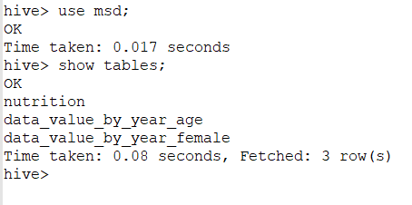

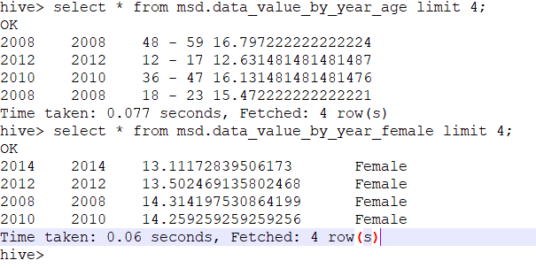

# Run Data Visualization

Open Visualization directory in windows.

Open **index.html** with **Firefox**

**Click on the button to display required data.**

