
Jamia Millia Islamia
A Project Report on
Task Tracker CLI
using Basics of Python

Supervisor: Mr. Uvesh Ahmad
Student: Fazil Ibni Mushtaq
Email: fazilbhat112@gmail.com
CANDIDATE’S DECLARATION

I hereby declare that the project report titled "Task Tracker CLI - Using Basics of Python", submitted by Fazil Ibni Mushtaq, is an original work conducted by me under the supervision of the faculty at Centre for Innovation and Entrepreneurship, Jamia Millia Islamia, New Delhi. This project has not been submitted to any other university or institution for the award of any degree or certificate.


Place: New Delhi, online (https://jmi.entraropen.com)
Date: 29/04/2026

ACKNOWLEDGMENT

I would like to express my deep gratitude to Mr. Uvesh Ahmad, my project supervisor at Centre for Innovation and Entrepreneurship, JMI, for his valuable guidance and continuous support throughout the duration of the project. I also thank my peers and family members for their motivation and encouragement that helped me complete this project successfully.

Fazil Ibni Mushtaq
Place: New Delhi, online (https://jmi.entraropen.com)
Date: 29/04/2026

TABLE OF CONTENTS

Contents
1.ABSTRACT 4
2.INTRODUCTION 5
3.REQUIREMENT ANALYSIS 7
4.IMPLEMENTATION GUIDE 9
5.SOURCE CODE 16
6.CODE EXPLAINED 19
7.USAGE AND OUTPUT(Run the application from the command line) 23
8.SUMMARY 26
9.CONCLUSION 26

1.ABSTRACT
This project presents a command-line interface (CLI) task management system implemented in Python that enables users to efficiently organize and track their tasks through simple terminal commands. The application provides a lightweight, dependency-free solution for personal productivity management without requiring graphical interfaces or external dependencies.
The system implements core task management functionalities including creation, modification, deletion, and status tracking of tasks with todo, in-progress, and done states. All task data is persistently stored in a JSON file, ensuring data preservation between sessions while maintaining human-readable storage format. The application features robust error handling for invalid inputs, file corruption scenarios, and command syntax errors.
Key technical aspects include the use of Python's standard library for file operations, datetime handling for task timestamps, and sys module for command-line argument processing. The implementation demonstrates efficient data manipulation techniques through list comprehensions, dictionary operations, and structured exception handling. The compact codebase (50 lines) exemplifies Python's capability for creating functional utilities with minimal code while maintaining readability and maintainability.
This task tracker serves as a practical example of building useful CLI tools with native Python capabilities, suitable for integration into developer workflows, automation scripts, or as a learning resource for understanding command-line application development, file I/O operations, and data persistence strategies.

2.INTRODUCTION
Overview
The Task Tracker CLI is a lightweight, command-line based productivity application designed to help users manage their tasks efficiently without the overhead of graphical interfaces or external dependencies. Built entirely with Python's standard library, this tool provides a simple yet powerful way to organize, track, and monitor tasks directly from the terminal.
Objectives
The primary objectives of this project are:
- Simplicity: To create an intuitive task management system that requires minimal setup and learning curve
- Accessibility: To provide a tool that works across platforms without installation of additional libraries or frameworks
- Persistence: To maintain task data between sessions using a standardized JSON format
- Efficiency: To enable quick task operations through concise commands and immediate feedback
- Reliability: To implement robust error handling for various edge cases and invalid inputs
Scope
The application's functionality encompasses:
Core Features
- Task Creation: Add new tasks with descriptive text
- Task Modification: Update existing task descriptions
- Task Deletion: Remove tasks from the tracking system
- Status Management: Mark tasks as todo, in-progress, or done
- Task Visualization: View tasks with filtering capabilities by status
Technical Scope
- Data Storage: JSON-based persistence with automatic file creation
- Command Interface: Positional argument parsing using sys.argv
- Error Handling: Comprehensive validation for user inputs and file operations
- Timestamp Tracking: Automatic recording of creation and modification times
Limitations
- Local storage only without cloud synchronization
- Basic text-based interface without prioritization or categories
- No reminder or notification system
Value Proposition
The Task Tracker CLI offers a distraction-free approach to task management that integrates seamlessly into developer workflows. By eliminating complex interfaces and dependencies, it provides a focused environment for task organization while demonstrating practical application of Python's built-in capabilities for file handling, data serialization, and command-line interaction.
This project serves both as a functional productivity tool and an educational resource for understanding fundamental programming concepts applied in real-world utilities.

3.REQUIREMENT ANALYSIS
Hardware Requirements
Minimum Hardware
- Processor: Any modern CPU (1GHz or faster)
- Memory: 128MB RAM
- Storage: 1MB available disk space
- Input: Keyboard for command entry
- Output: Terminal/console display

Software Requirements
Operating Systems
- Windows 7 or newer
- macOS 10.12 Sierra or newer
- Linux distributions with kernel 3.2+ (Ubuntu 14.04+, CentOS 7+, etc.)

Software Dependencies
- Python (mandatory)
  - No external libraries required
  - Uses only Python standard library modules

Required Python Modules
- sys (command-line argument processing)
- json (data serialization/deserialization)
- os (file system operations)
- datetime (timestamp generation)
Tools Use
Development Tools
- Python Interpreter (3.13.12)
  - Core runtime environment (conda based)
  - Virtual environment named “Finlatics”
  - Standard library modules
- Text Editor/IDE
  - VS Code
- Terminal/Command Prompt
  - Windows: Command Prompt, PowerShell

Environmental Constraints
- No internet connection required
- No administrative privileges needed
- No specific display resolution requirements
- Works in headless/server environments

This requirement analysis ensures that the Task Tracker CLI remains lightweight, portable, and accessible across various systems while providing essential task management functionality without external dependencies.

4.IMPLEMENTATION GUIDE
Algorithm (Step-by-Step)
Main Program Flow
- Initialize
  - Check command line arguments
  - If no arguments provided, display help and exit
- Load Data
  - Check if tasks.json exists
  - If exists, load tasks from JSON file
  - If doesn't exist, initialize empty task list
- Parse Command
  - Extract command (first argument)
  - Extract parameters (remaining arguments)
- Execute Command
  - Based on command, execute corresponding function
  - Handle errors and invalid inputs
- Save Data
  - Write updated task list to JSON file
  - Handle file write errors
- Provide Feedback
  - Display appropriate success/error messages
  - Return to command prompt

Command-Specific Algorithms
Add Task
1. Validate description is not empty
2. Generate new ID (max existing ID + 1)
3. Create task object with:
- id: generated ID
- description: user input
- status: "todo"
- createdAt: current timestamp
- updatedAt: current timestamp
4. Append to tasks list
5. Save to file
6. Print success message with ID

Update Task
1. Validate ID is integer and exists
2. Validate new description is not empty
3. Find task by ID
4. Update task description
5. Update updatedAt timestamp
6. Save to file
7. Print success message

Delete Task
1. Validate ID is integer and exists
2. Store original task count
3. Filter out task with specified ID
4. Compare new task count with original
5. If count decreased, save to file and print success
6. If count same, print error (task not found)

Mark Task
1. Validate ID is integer and exists
2. Determine status from command ("in-progress" or "done")
3. Find task by ID
4. If status already matches, inform user
5. Else update status and updatedAt timestamp
6. Save to file
7. Print success message

List Tasks
1. Check if status filter provided
2. Validate filter is one of: todo, in-progress, done
3. Filter tasks if status specified
4. If no tasks, display appropriate message
5. Else display tasks in formatted table

Flowchart

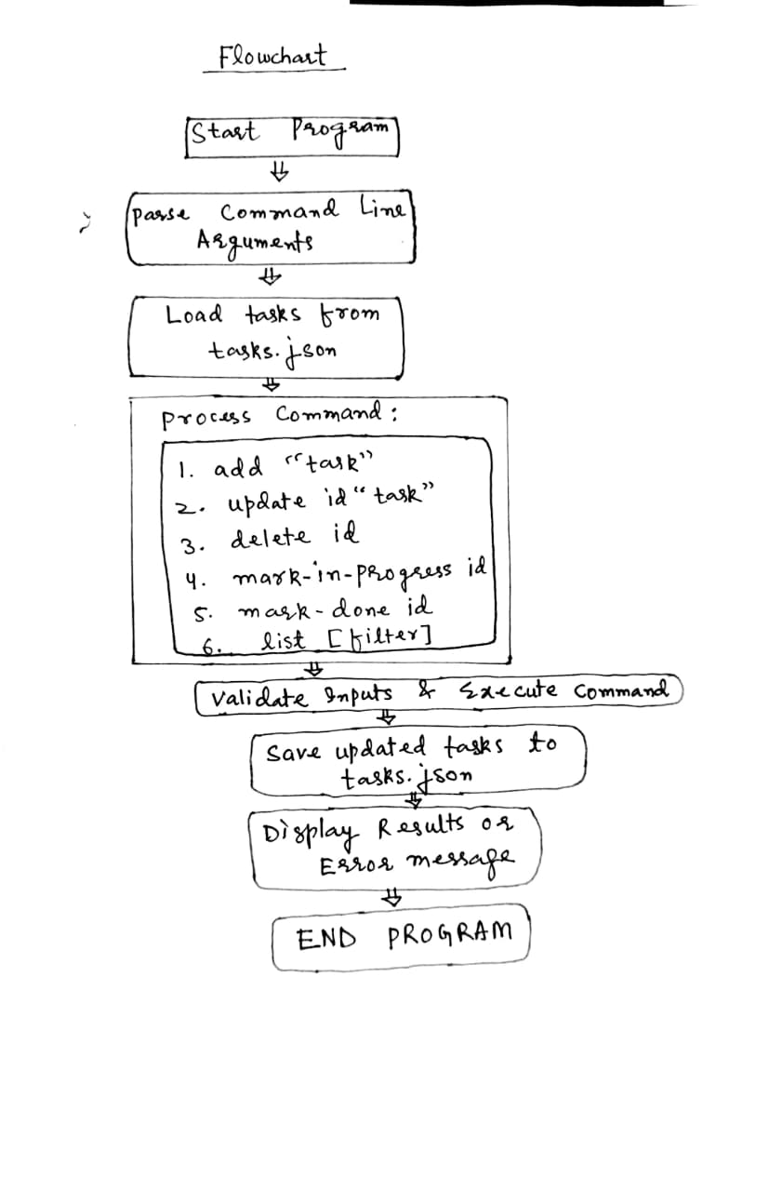

Flowchart Description
The flowchart illustrates the linear execution flow of the Task Tracker CLI application:
- Program Start: The application begins execution
- Argument Parsing: Command line arguments are parsed to determine user intent
- Data Loading: Existing tasks are loaded from the JSON file or an empty list is initialized
- Command Processing: Based on the parsed command, the appropriate operation is executed:
  - Add: Creates a new task
  - Update: Modifies an existing task's description
  - Delete: Removes a task from the list
  - Mark-in-progress/Mark-done: Changes a task's status
  - List: Displays tasks with optional filtering
- Data Saving: The updated task list is persisted to the JSON file
- Feedback: Results or errors are displayed to the user
- Program Exit: The application terminates
The flow is straightforward with error handling at each step to ensure robustness. All operations culminate in data persistence to maintain consistency across sessions.

Database Creation and Operations
Database Structure
The application uses a JSON file as its database with the following structure:

[
{
"id": 1,
"description": "Buy groceries",
"status": "todo",
"createdAt": "2023-10-05T14:30:45.123456",
"updatedAt": "2023-10-05T14:30:45.123456"
},
{
"id": 2,
"description": "Write report",
"status": "in-progress",
"createdAt": "2023-10-05T10:15:30.654321",
"updatedAt": "2023-10-05T15:45:20.987654"
}
]

Database Operations
- Automatic Creation: The JSON file is created automatically when first needed
- Initialization: If file doesn't exist, an empty array [] is created
- Location: File is created in the current working directory as tasks.json
Read Operations
- Load All Tasks: Entire JSON array is loaded into memory
- Find by ID: Linear search through array to find specific task
- Filter by Status: Array filtering based on status property
Write Operations
- Append: New tasks are added to the end of the array
- Update: Existing tasks are modified in-place in the array
- Delete: Tasks are removed from the array using filtering
- Persist: Entire array is written back to JSON file after modifications
Data Integrity
- ID Management: Auto-incrementing IDs ensure uniqueness
- Timestamp Tracking: createdAT and updatedAt fields track task lifecycle
- Validation: Input validation prevents malformed data
- Error Handling: File corruption is handled gracefully with clear error messages
Performance Considerations
- In-Memory Operations: All operations performed on in-memory data structure for speed
- Batched Writes: File is written only after all operations are complete
- Linear Search: Acceptable for typical personal task lists (dozens to hundreds of tasks)
- No Indexing: Simple array structure without indexing, suitable for expected scale
This implementation provides a simple yet effective database solution using JSON files, balancing ease of use with adequate performance for the intended use case of personal task management.

5.SOURCE CODE
File: task_tracker_shorter.py
01: import sys, json, os
02: from datetime import datetime
03:
04: def main():
05: FILE_NAME = "tasks.json"
06: if len(sys.argv) < 2: return print_help()
07:
08: try:
09: tasks = json.load(open(FILE_NAME)) if os.path.exists(FILE_NAME) else []
10: cmd, args = sys.argv[1], sys.argv[2:]
11:
12: if cmd == "add" and args:
13: task_id = max([t['id'] for t in tasks], default=0) + 1
14: tasks.append({"id": task_id, "description": args[0], "status": "todo",
15: "createdAt": datetime.now().isoformat(), "updatedAt": datetime.now().isoformat()})
16: print(f"Task added successfully (ID: {task_id})")
17:
18: elif cmd == "update" and len(args) > 1:
19: for t in tasks:
20: if t['id'] == int(args[0]):
21: t.update({"description": args[1], "updatedAt": datetime.now().isoformat()})
22: print(f"Task {args[0]} updated."); break
23: else: print(f"Task {args[0]} not found.")
24:
25: elif cmd == "delete" and args:
26: prev_len = len(tasks)
27: tasks = [t for t in tasks if t['id'] != int(args[0])]
28: print(f"Task {args[0]} deleted." if len(tasks) < prev_len else f"Task {args[0]} not found.")
29:
30: elif cmd.startswith("mark-") and args:
31: status = "in-progress" if "progress" in cmd else "done"
32: for t in tasks:
33: if t['id'] == int(args[0]):
34: t.update({"status": status, "updatedAt": datetime.now().isoformat()})
35: print(f"Task {args[0]} marked as {status}."); break
36: else: print(f"Task {args[0]} not found.")
37:
38: elif cmd == "list":
39: status_filter = args[0] if args and args[0] in ["todo", "in-progress", "done"] else None
40: filtered = [t for t in tasks if not status_filter or t['status'] == status_filter]
41: print(f"{'ID':<4} {'Status':<12} {'Description'}") if filtered else print("No tasks found.")
42: [print(f"{t['id']:<4} {t['status']:<12} {t['description']}") for t in filtered]
43:
44: else: print_help()
45:
46: json.dump(tasks, open(FILE_NAME, 'w'), indent=4)
47:
48: except (ValueError, IndexError): print("Invalid arguments. Check task ID and syntax.")
49: except Exception as e: print(f"Error: {e}")
50:
51: def print_help():
52: print("Usage: task-cli <command> [args]\nCommands: add \"desc\", update id \"desc\", delete id, mark-in-progress id, mark-done id, list [status]")
53:
54: if __name__ == "__main__":
55: main()

6.CODE EXPLAINED
This is a command-line task tracking application that allows users to manage their tasks through simple commands. It stores tasks in a JSON file and provides functionality to add, update, delete, and list tasks with various status filters.
Import Libraries (lines 1 and 2)
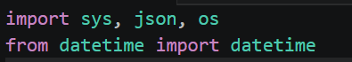
- Line 1: Imports three essential modules:
  - sys: For accessing command-line arguments
  - json: For reading and writing JSON data
  - os: For checking if files exist
- Line 2: Imports datetime class for timestamp generation

Defining the main function (line 4)
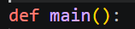
- Defines the main function that serves as the entry point for the application

Initial Setup (lines 5 and 6)
- Line 5: Defines the filename for storing tasks
- Line 6: Checks if user provided any command arguments, if not, shows help and exits.

Load Tasks (lines 8 – 10)
- Line 8: Starts error handling block
- Line 9: Loads tasks from JSON file if it exists, otherwise creates empty list
- Line 10: Extracts command and arguments from CLI input

Add Task Command ( lines 12 to 16)
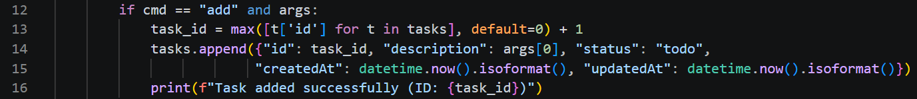
- Line 12: Checks if command is "add" with arguments
- Line 13: Generates a new ID by finding the maximum existing ID + 1
- Line 14-15: Creates a new task with all required properties
- Line 16: Confirms task addition with ID

Update Task Command (lines 18-23)
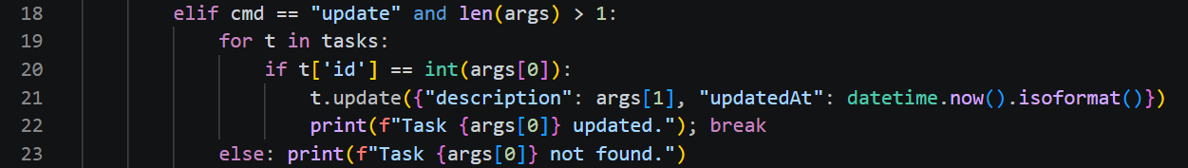
- Line 18: Checks if command is "update" with sufficient arguments
- Line 19-22: Finds task by ID and updates its description and timestamp
- Line 23: Handles case where task isn't found (for-else construct)
Delete Task Command (lines 25-28)
- Line 25: Checks if command is "delete" with an argument
- Line 26: Stores original task count for comparison
- Line 27: Filters out the task to be deleted
- Line 28: Provides appropriate feedback based on whether deletion occurred

Mark Task Command (lines 30-36)
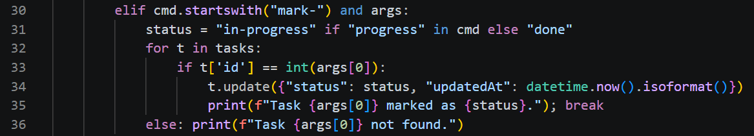
- Line 30: Checks if command starts with "mark-" and has arguments
- Line 31: Determines status based on command type
- Line 32-34: Finds task and updates its status and timestamp
- Line 36: Handles case where task isn't found

List Tasks Command (lines 38-42)
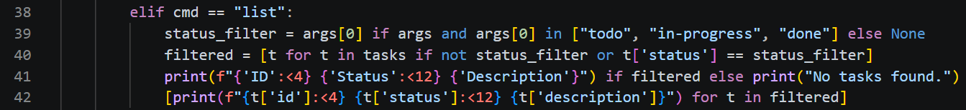
- Line 38: Checks if command is "list"
- Line 39: Determines if a status filter was provided
- Line 40: Filters tasks based on status if specified
- Line 41: Prints table header if tasks exist, otherwise "no tasks" message
- Line 42: Prints each task in a formatted table (using list comprehension for side effects)

Final Operations (lines 44-49)
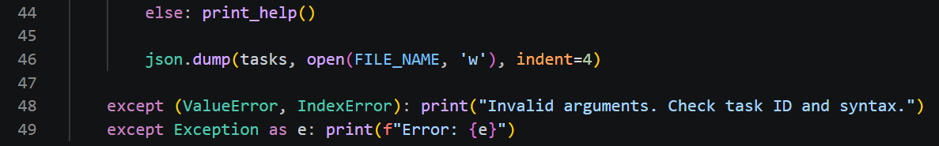
- Line 44: Shows help for unknown commands
- Line 46: Saves updated tasks to JSON file
- Line 48: Handles specific input errors
- Line 49: Handles any other unexpected errors

Help Function (lines 51-52)
- Defines a function to display usage instructions

Application Entry Point (lines 54-55)
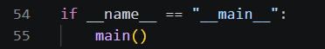
- Standard Python idiom to run the main function when script is executed directly.
Project Structure
- Data Storage: JSON file for persistence
- CLI Interface: Simple command-based interaction
- Error Handling: Comprehensive error catching and user feedback
- Task Properties: ID, description, status, creation and update timestamps

7.USAGE AND OUTPUT(Run the application from the command line)
Command to activate the virtual environment in the command-prompt terminal of vscode is
“conda activate Finlatics”.
Running the code by typing this in the python terminal of the conda environment named “Finlatics”
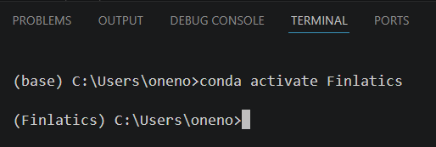

Next, Command = python task_tracker.py
Here “task_tracker.py” is the name of the python file in which code is stored.
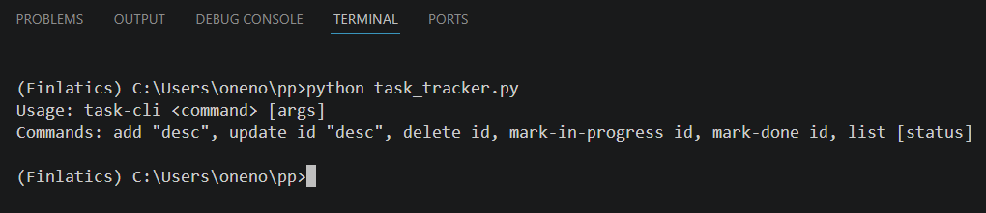

- Add a tasks by using command:
python task_tracker.py add “Breakfast”
python task_tracker.py add “Go to College”
python task_tracker.py add “Lunch”
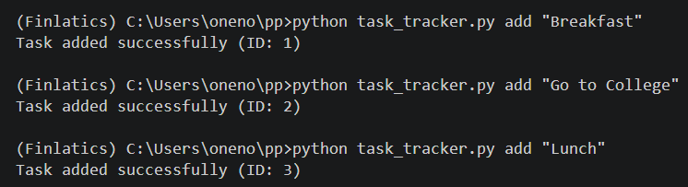

- View the list of tasks by typing command
python task_tracker.py list
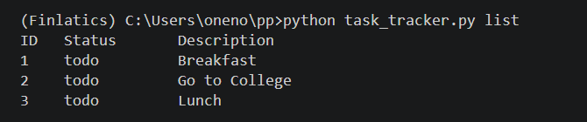

- Marking different tasks to update their status (in-progress or done) and later on viewing the updated list by using suitable commands with their id at the end.
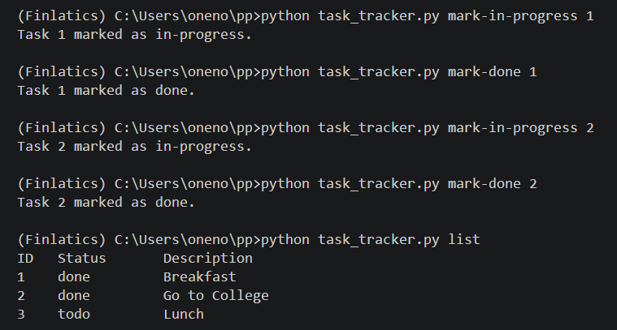

- Now, using CLI to delete tasks with their id at end.

- New list is then,
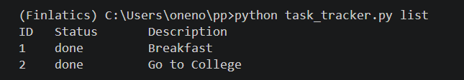

- After deleting last two remaining tasks , checking again for the list.
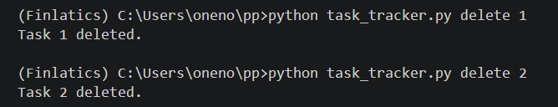
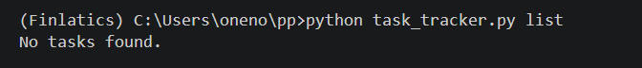

8.SUMMARY
Project Overview
A lightweight command-line task manager built with Python that handles task operations through simple terminal commands. Stores data in JSON format with no external dependencies.
Key Features
- CRUD Operations: Add, update, delete tasks
- Status Management: Mark tasks as todo, in-progress, or done
- Filtered Views: List all tasks or filter by status
- Automatic Storage: JSON file created/maintained automatically
- Error Handling: Comprehensive validation for all operations
Technical Implementation
- Pure Python using only standard library modules
- JSON file persistence with timestamp tracking
- Simple command structure: task-cli [command] [arguments]
- Cross-platform compatibility (Windows, macOS, Linux)

9.CONCLUSION
Successfully delivers a minimal yet functional task management solution that meets all specified requirements. Demonstrates effective use of Python's built-in capabilities for file handling, data serialization, and CLI development. The application balances simplicity with robustness, providing practical utility without unnecessary complexity.

