**Tamim IQbal**

**Plotting Time Series:**

> tamimVector<- c(0,0,0,0,0,4,0,0,118,0,0,137,10,0,0,112,0,65,0,0,0,0,63,0,0,0,0,253,0,0,0,0,0,0,0,58,36,0,114,43,99,0,0,0,157,0,60,0,4,138,196,30,0,107,143,0,0,0,0,162,108,0,0,0,0,0,0,59,300,0,11,24,0,0,0,278,147,0,160,26,21,63,47,65,0,0,57,62,111,52,0,68,0,0,0,0,93)

> print(tamimVector)

[1] 0 0 0 0 0 4 0 0 118 0 0 137 10 0 0 112 0 65 0 0 0 0 63

[24] 0 0 0 0 253 0 0 0 0 0 0 0 58 36 0 114 43 99 0 0 0 157 0

[47] 60 0 4 138 196 30 0 107 143 0 0 0 0 162 108 0 0 0 0 0 0 59 300

[70] 0 11 24 0 0 0 278 147 0 160 26 21 63 47 65 0 0 57 62 111 52 0 68

[93] 0 0 0 0 93

> plot(tamimVector)

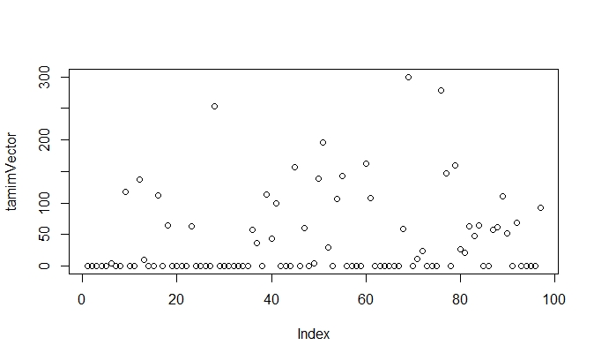

> tamimTS<- ts(tamimVector,start=c(2007,1),frequency = 12)

> print(tamimTS)

Jan Feb Mar Apr May Jun Jul Aug Sep Oct Nov Dec

2007 0 0 0 0 0 4 0 0 118 0 0 137

2008 10 0 0 112 0 65 0 0 0 0 63 0

2009 0 0 0 253 0 0 0 0 0 0 0 58

2010 36 0 114 43 99 0 0 0 157 0 60 0

2011 4 138 196 30 0 107 143 0 0 0 0 162

2012 108 0 0 0 0 0 0 59 300 0 11 24

2013 0 0 0 278 147 0 160 26 21 63 47 65

2014 0 0 57 62 111 52 0 68 0 0 0 0

2015 93

> plot.ts(tamimTS)

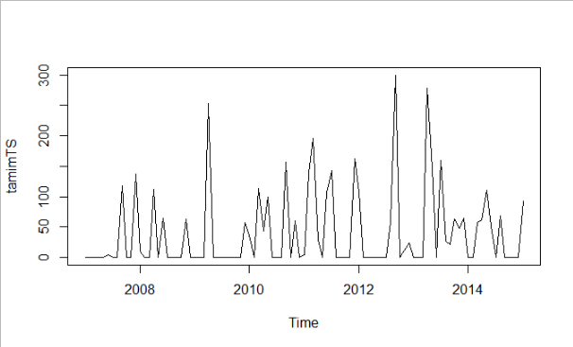

## Decomposing Time Series

### Decomposing Non-Seasonal Data

>library(TTR)

> TamimtimeseriesSMA3 <- SMA(tamimTS,n=3)

> plot(TamimtimeseriesSMA3)

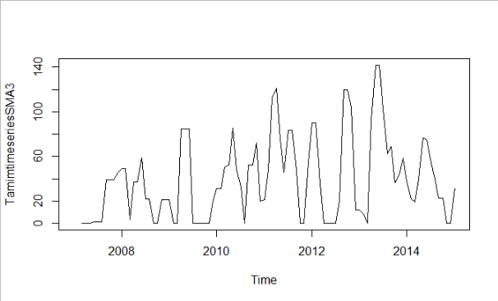

> tamimTSLog<- log(tamimTS)

> plot.ts(tamimTSLog)

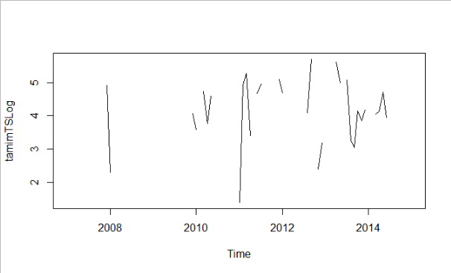

### Decomposing Seasonal Data

> Tamimtimeseriescomponents <- decompose(tamimTS)

> plot(Tamimtimeseriescomponents)

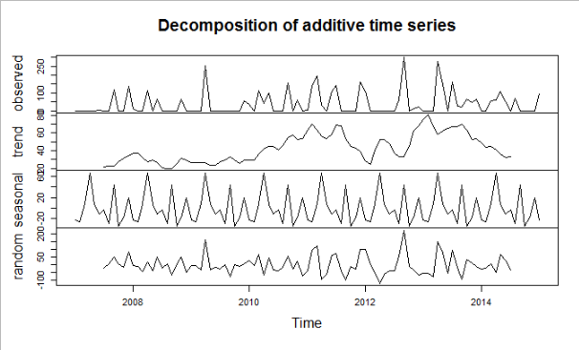

## Forecasts using Exponential Smoothing

### Simple Exponential Smoothing

> tamimTSforecasts <- HoltWinters(tamimTS, beta=FALSE, gamma=FALSE)

> tamimTSforecasts

Holt-Winters exponential smoothing without trend and without seasonal component.

Call:

HoltWinters(x = tamimTS, beta = FALSE, gamma = FALSE)

Smoothing parameters:

alpha: 0.05201359

beta : FALSE

gamma: FALSE

Coefficients:

[,1]

a 44.52762

> tamimTSforecasts$fitted

xhat level

Feb 2007 0.0000000 0.0000000

Mar 2007 0.0000000 0.0000000

Apr 2007 0.0000000 0.0000000

May 2007 0.0000000 0.0000000

Jun 2007 0.0000000 0.0000000

Jul 2007 0.2080544 0.2080544

Aug 2007 0.1972327 0.1972327

Sep 2007 0.1869739 0.1869739

Oct 2007 6.3148522 6.3148522

Nov 2007 5.9863940 5.9863940

Dec 2007 5.6750202 5.6750202

Jan 2008 12.5057036 12.5057036

Feb 2008 12.3753730 12.3753730

Mar 2008 11.7316855 11.7316855

Apr 2008 11.1214784 11.1214784

May 2008 16.3685323 16.3685323

Jun 2008 15.5171462 15.5171462

Jul 2008 18.0909270 18.0909270

Aug 2008 17.1499530 17.1499530

Sep 2008 16.2579224 16.2579224

Oct 2008 15.4122895 15.4122895

Nov 2008 14.6106410 14.6106410

Dec 2008 17.1275452 17.1275452

Jan 2009 16.2366801 16.2366801

Feb 2009 15.3921521 15.3921521

Mar 2009 14.5915511 14.5915511

Apr 2009 13.8325921 13.8325921

May 2009 26.2725472 26.2725472

Jun 2009 24.9060178 24.9060178

Jul 2009 23.6105664 23.6105664

Aug 2009 22.3824961 22.3824961

Sep 2009 21.2183022 21.2183022

Oct 2009 20.1146622 20.1146622

Nov 2009 19.0684264 19.0684264

Dec 2009 18.0766091 18.0766091

Jan 2010 20.1531679 20.1531679

Feb 2010 20.9774185 20.9774185

Mar 2010 19.8863077 19.8863077

Apr 2010 24.7814986 24.7814986

May 2010 25.7291082 25.7291082

Jun 2010 29.5401902 29.5401902

Jul 2010 28.0036989 28.0036989

Aug 2010 26.5471261 26.5471261

Sep 2010 25.1663148 25.1663148

Oct 2010 32.0234578 32.0234578

Nov 2010 30.3578028 30.3578028

Dec 2010 31.8995999 31.8995999

Jan 2011 30.2403872 30.2403872

Feb 2011 28.8755305 28.8755305

Mar 2011 34.5514858 34.5514858

Apr 2011 42.9490023 42.9490023

May 2011 42.2754783 42.2754783

Jun 2011 40.0765789 40.0765789

Jul 2011 43.5575062 43.5575062

Aug 2011 48.7298671 48.7298671

Sep 2011 46.1952519 46.1952519

Oct 2011 43.7924711 43.7924711

Nov 2011 41.5146675 41.5146675

Dec 2011 39.3553407 39.3553407

Jan 2012 45.7345295 45.7345295

Feb 2012 48.9731801 48.9731801

Mar 2012 46.4259092 46.4259092

Apr 2012 44.0111311 44.0111311

May 2012 41.7219542 41.7219542

Jun 2012 39.5518457 39.5518457

Jul 2012 37.4946123 37.4946123

Aug 2012 35.5443829 35.5443829

Sep 2012 36.7643938 36.7643938

Oct 2012 50.4562222 50.4562222

Nov 2012 47.8318130 47.8318130

Dec 2012 45.9160583 45.9160583

Jan 2013 44.7761254 44.7761254

Feb 2013 42.4471585 42.4471585

Mar 2013 40.2393295 40.2393295

Apr 2013 38.1463375 38.1463375

May 2013 50.6219872 50.6219872

Jun 2013 55.6349535 55.6349535

Jul 2013 52.7411799 52.7411799

Aug 2013 58.3200960 58.3200960

Sep 2013 56.6390119 56.6390119

Oct 2013 54.7852990 54.7852990

Nov 2013 55.2125751 55.2125751

Dec 2013 54.7854096 54.7854096

Jan 2014 55.3167071 55.3167071

Feb 2014 52.4394866 52.4394866

Mar 2014 49.7119208 49.7119208

Apr 2014 50.0909999 50.0909999

May 2014 50.7104297 50.7104297

Jun 2014 53.8463066 53.8463066

Jul 2014 53.7502736 53.7502736

Aug 2014 50.9545290 50.9545290

Sep 2014 51.8411251 51.8411251

Oct 2014 49.1446822 49.1446822

Nov 2014 46.5884909 46.5884909

Dec 2014 44.1652563 44.1652563

Jan 2015 41.8680628 41.8680628

> plot(tamimTSforecasts)

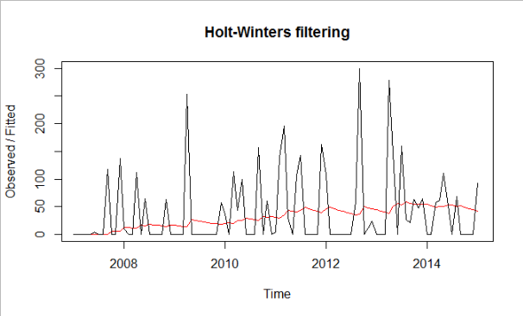

> tamimTSforecasts$SSE

[1] 430714.3

> model$coef

intercept

39.80412

> acf(model$residuals,main="Coorlogram")

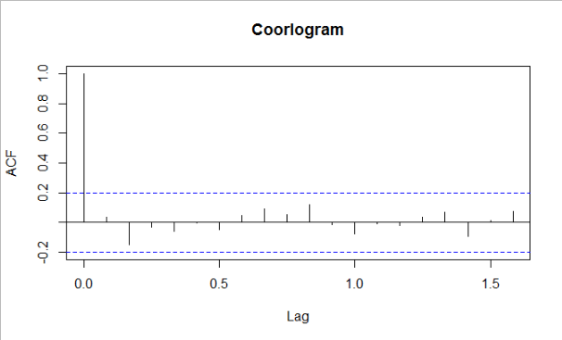

> pacf(model$residuals, main="Partial corrlogram")

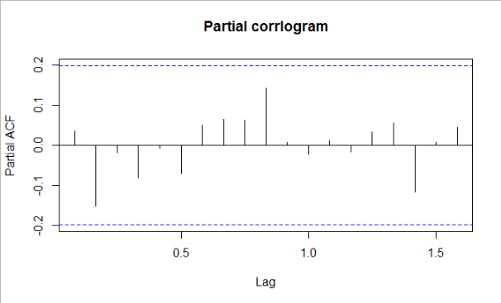

> Box.test(model$residuals, lag = 1, type = c("Box-Pierce", "Ljung-Box"), fitdf = 0)

Box-Pierce test

data: model$residuals

X-squared = 0.11653, df = 1, p-value = 0.7328

> plot.ts(model$residuals)

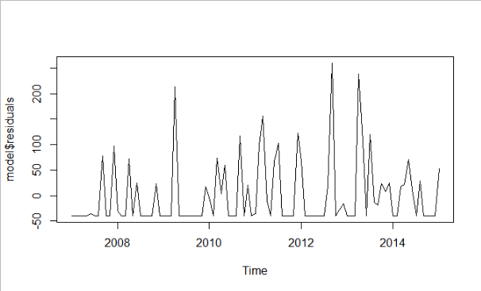

#Residual plot

hist(model$residuals)

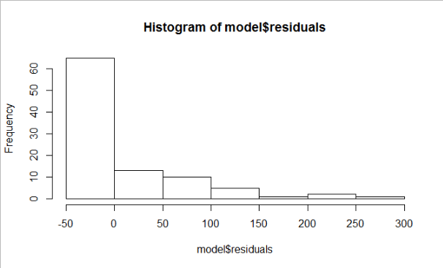

**Staitionary:**

> adf.test(tamimTS)

Augmented Dickey-Fuller Test

data: tamimTS

Dickey-Fuller = -5.2313, Lag order = 4, p-value = 0.01

alternative hypothesis: stationary

**forecast**

> r<- forecast(model)

> library(ggplot2)

> accuracy(r)

ME RMSE MAE MPE MAPE MASE ACF1

Training set -2.965644e-11 65.42417 49.92305 -Inf Inf 0.7331478 0.03466039

> autoplot(r)

