**QUESTIONS BANK**

**PHYSICS**

**CHAPTER – 1 ELECTROSTATICS**

**SESSION – 1**

**1.1 - ELECTRIC CHARGE & ITS PROPERTIES AND CONDUCTION, FRICTION & INDUCTION**

**LEVEL-1**

6. The velocity of an electron at point A1, where cross sectional area is A, *v*0. The velocity of electron just the end of contraction at point B, where cross sectional area is 2A, is *v*1. Find the correct option.

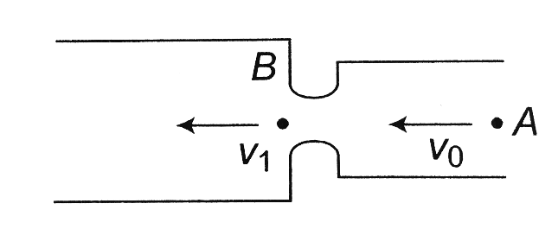

a) v1 < *v*0 b) *v*1 = *v*0 c) *v*1 > *v*0 d)

**Key:** c

**Hint:** As the electrons comes near the throat, positive charges are induced on the throat. The induced charges attract the electron and velocity increases. So *v*1 > *v*0.

17. The charge on 500 cc of water due to protons will be

a) 6.0 × 1027C b) 2.67 × 107C c) 6 × 1023C d) 1.67 × 1023C

**Key:** b

**Hint:** Q = ne, where n = number of moles × 6.02 × 1023 × 10

= 2.67 × 107C

18. **Assertion:** Vehicle carrying highly inflammable materials have hanging chains, slightly touching the ground.

**Reason:** The body of a vehicle gets charged when moving through air at high speed.

a) Both (A) and (R) are correct and (R) is not the correct explanation of (A)

b) (A) is correct but (R) is not correct

c) (A) is not correct but (R) is correct

d) Both (A) and (R) are correct and (R) is the correct explanation of (A)

**Key:** d

**Hint:** It is true that body of vehicle is charged, when the vehicle is moving through air at high speed. Because of this, the vehicles, which are carrying highly inflammable material, have hanging chains, which touch slightly the ground. This chain transfers the charge to the ground (earth). Hence there is no harm to the vehicle.