6. The velocity of an electron at point A1, where cross sectional area is A, *v*0. The velocity of electron just the end of contraction at point B, where cross sectional area is 2A, is *v*1. Find the correct option.

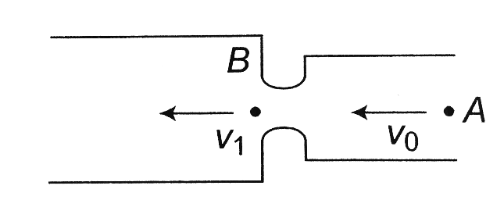

a) v1 < *v*0 b) *v*1 = *v*0 c) *v*1 > *v*0 d) 

**Key:** c

**Hint:** As the electrons comes near the throat, positive charges are induced on the throat. The induced charges attract the electron and velocity increases. So *v*1 > *v*0.