**QUESTIONS BANK**

**PHYSICS**

**CHAPTER – 1 ELECTROSTATICS**

**SESSION – 1**

**1.1 - ELECTRIC CHARGE & ITS PROPERTIES AND CONDUCTION, FRICTION & INDUCTION**

**LEVEL-1**

1. If a body is charged by rubbing, its weight

a) Always decrease slightly  
b) Always increases slightly  
c) May increase slightly or may decrease slightly  
d) Remains precisely the same

**Key:** c

**Hint:** Weight may increase or decrease depending upon whether the body is charged negatively or positively.

2. In general, metallic ropes are suspended on the carriers which take inflammable material. The reason is

a) There speed is controlled  
b) To keep the centre of gravity of the carrier nearer to the earth

c) To keep the body of the carrier in contact with the earth

d) Nothing should be placed under the carrier

**Key:** c

**Hint:** For providing path to charges induced on the surface of the carriers which take inflammable material.

3. When a body is connected to earth, electrons from the earth flow into the body. This means the body is

a) Unchanged b) Charged positively

c) Charged negatively d) An insulator

**Key:** b

**Hint:** When a positively charged body is connected to earth, electrons flow earth to body and body becomes neutral

4. An uncharged metal object M is insulated from its surroundings. A positively charged metal sphere S is then brought near to M. Which diagram best illustrates the resultant distributions of charge on S and M?

a) 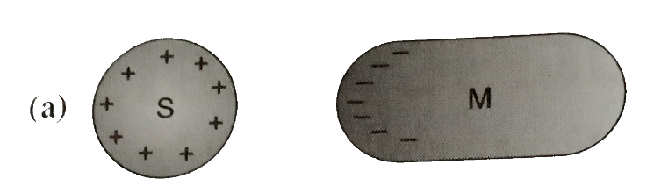 b) 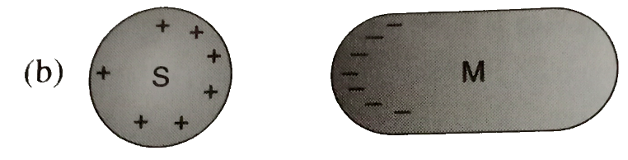

c) 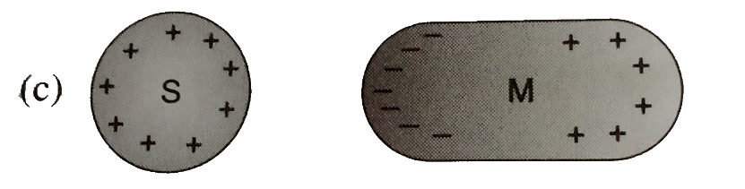 d) 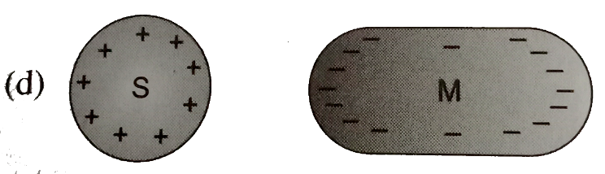

**Key:** b

**Hint:** Negative charge are attracted to surface of M near S by electrostatic induction and positive charges are repelled to surface of M away from S such that entire M still remain neutral (uncharged) Charge on S is also redistributed to have more charge on surface near to M due to the field set up by negative charges on M Diagram b thus best illustrates the charge distribution on both S and M.

5. The diagram shows the arrangement of three small uniformly charged spheres A, B and C. The arrows indicate the direction of the electrostatic forces acting between the spheres (for example, the left arrow on sphere A indicates the electrostatic force on sphere A due to sphere B) At least two of the spheres are positively charged. Which sphere, if any, could be negatively charged?

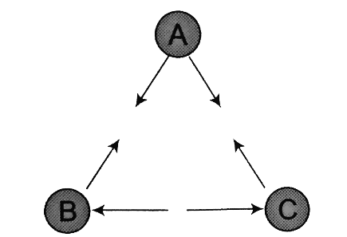

a) Sphere A b) sphere B c) sphere C d) none of the spheres

**Key:** a

**Hint:** It can be seen from the diagram that only the sphere B and sphere C repel. Hence they both must be the same type. According to the fact that at least two spheres are positively charged. Since attraction occurs for two remaining pairs it can be concluded that the sphere A is negatively charged.

6. The velocity of an electron at point A1, where cross sectional area is A, *v*0. The velocity of electron just the end of contraction at point B, where cross sectional area is 2A, is *v*1. Find the correct option.

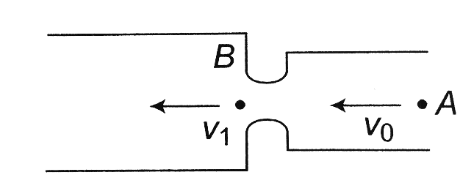

a) v1 < *v*0 b) *v*1 = *v*0 c) *v*1 > *v*0 d) 

**Key:** c

**Hint:** As the electrons comes near the throat, positive charges are induced on the throat. The induced charges attract the electron and velocity increases. So *v*1 > *v*0.

7. A glass rod rubbed with silk is used to charge a gold leaf electroscope and the leaves are observed to diverge. The electroscope thus charged is exposed to X-rays for a short period. Then

a) The divergence of leaves will not be affected b) The leaves will diverge further

c) The leaves will collapse d) The leaves will melt

**Key:** b

**Hint:** Charge on glass rod is positive, so charge on gold leaves will also be positive. Due to X-rays, more electrons from leaves will be emitted, so leaves becomes more positive and diverge further.

8. One metallic sphere A is given positive charge whereas another identical metallic sphere B of exactly same mass as of A is given equal amount of negative charge. Then

a) Mass of A and mass of B still remain equal b) Mass of A increases

c) Mass of B decreases d) Mass of B increases

**Key:** d

**Hint:** Negative charge means excess of electron which increases the mass of sphere B.

9. A charged metallic ball is lowered into an insulated metal can.

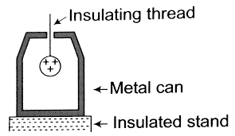

The ball is made to touch the bottom of the can. Then it is placed on the disc of electroscope shown below. Final observation must be that

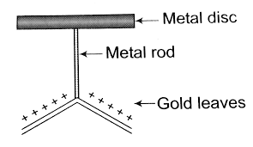

a) Leaves of electroscope diverge b) Leaves of electroscope converge

c) Leaves of electroscope remain unaffected d) Leaves of electroscope oscillate

**Key:** b

**Hint:** When charged metallic ball touches the bottom of can, all of its charge goes to the outer surface of the can. (Net charge on a conductor lies only on its surface).  
When ball is withdrawn from the can, it is uncharged. When ball is placed on the disc of electroscope .Final charge on the leaves is reduced so leaves electroscope converges.

10. An electroscope is given a positive charge, causing its foil leaves to separate. When an object is brought near the top plate of the electroscope, the foils separate even further. We conclude

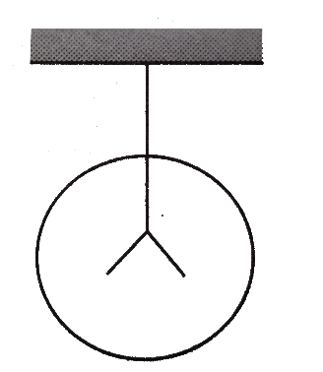

a) That the object is positively charged b) that the object is electrically neutral

c) That the object is negatively charged d) none of these

**Key:** a

**Hint:** The object should be positively charged. Being positively charged, it repels positive charge from top plate towards leaves causing to separate more.

11. Four metal conductors having different shapes such that of

1. a sphere 2. a cylinder

3. a pear 4. a lightning conductor

are mounted on insulating stands and charged. The one which is best suited to retain the charges for a longer time is

a) 1 b) 2 c) 3 d) 4

**Key:** a

**Hint:** In case of spherical metal conductor the charge quickly spreads uniformly over the entire surface because of which charges stay for longer time on the spherical surface. While in case of non-spherical surface, the charge concentration is different at different points due to which the charges do not stay on the surface for longer time.

12. If there are two metallic spheres of same radii but one is solid and the other is hollow, then

a) Solid sphere can be given more charge

b) Hollow sphere can be given more charge

c) They can be charged equally (maximum)

d) None of the above

**Key:** c

**Hint:** In case of metallic sphere either solid or hollow, the charge will reside on the surface of the sphere. Since both spheres have same surface area, so they can hold equal maximum charge.

13. A point charge + q is placed at a distance d from an isolated conducting plane. The field at a point P on the other side of the plane is

a) Directed perpendicular to the plane and away from the plane

b) Directed perpendicular to the plane but towards the plane

c) Directed radially away from the point charge

d) Directed radially towards the point charge

**Key:** a

**Hint:** When a point positive charge is brought near an isolated conducting plane, some negative charge develops on the surface of the plane towards the charge and an equal positive charge develops on opposite side of the plane. This process is called charging by induction. So, the field at a point P on the other side of the plane is away from the plane and field lines are always perpendicular to the surface of conductor.

14. An electrically isolated hollow (initially uncharged), conducting sphere has a small positively charged ball suspended by an insulating rod from its inside surface, (see diagram).

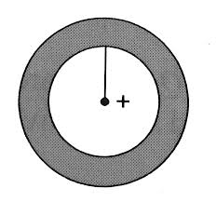

This causes the inner surface of the sphere to become negatively charged. When the ball is centred in the sphere the electric field outside the conducting sphere is

a) Zero

b) The same as if the sphere wasn’t there

c) Twice what it would be if the sphere wasn’t there

d) Equal in magnitude but opposite in direction to what it would be if the sphere wasn’t there

**Key:** b

**Hint:** Let the charge on the ball at centre is *q*, then −*q* charge will be induced on the inner surface and +*q* on the outer surface. Field at any point outside the sphere due to inner charges *q* and −*q* will jointly be zero.

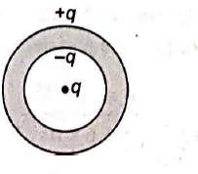

Outer charge *q* will produce the electric field at outside points as it would be produced by a charge at the centre. Hence, presence of sphere does not affect the electric field outside the sphere.

15. A thin metallic spherical shell contains a charge Q on it. A point charge q is placed at the centre of the shell and another charge q1 is placed outside it as shown in figure. All the three charges are positive.

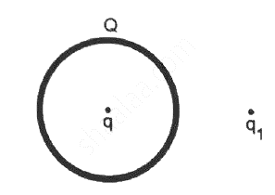

The force on the charge at the centre is  
a) to wards left b) towards right

c) Upward d) zero

**Key:** d

**Hint:** Note that there is no field inside the metallic shell and hence no force is experienced by the charge at the centre.

16. Two isolated object A and B are charged either by friction, conduction or induction. Initially, object A is charged and B is uncharged. If qA and qB are the magnitude of final charge on A and B, respectively, then match column I and column II and select the correct option from the codes given below.

|  |  |  |  |
| --- | --- | --- | --- |
| **Column-I** | | **Column-II** | |
| **i)** | qA = qB | **p)** | Charge transfer by conduction |
| **ii)** | qA ≥ qB | **q)** | Charging by friction |
| **iii)** |  | **r)** | Charging by induction |

A) (a)-(p), (b)-(r), (c)-(q) B) (a)-(q), (b)-(p), (c)-(r)

C) (a)-(q), (b)-(r), (c)-(p) D) (a)-(r), (b)-(q), (c)-(p)

**Key:** b

**Hint:** (i) When two objects are charged by rubbing them against each they acquire equal and opposite charge.

|qA| = |qB|

or qA = qB, hence (q).

(ii) If two objects say two identical conducting spheres are take and let 1st having charge (q = qA) is touched with 2nd (Initially uncharged), then hence (p).

(iii) When two objects are charged by induction, then magnitude of induced charge may be equal if objects are conducting. If one object is conducting say A and other is non-conducting say B, then induced charge on B may be less than charge on A, hence (r).

17. The charge on 500 cc of water due to protons will be

a) 6.0 × 1027C b) 2.67 × 107C c) 6 × 1023C d) 1.67 × 1023C

**Key:** b

**Hint:** Q = ne, where n = number of moles × 6.02 × 1023 × 10



= 2.67 × 107C

18. **Assertion:** Vehicle carrying highly inflammable materials have hanging chains, slightly touching the ground.

**Reason:** The body of a vehicle gets charged when moving through air at high speed.

a) Both (A) and (R) are correct and (R) is not the correct explanation of (A)

b) (A) is correct but (R) is not correct

c) (A) is not correct but (R) is correct

d) Both (A) and (R) are correct and (R) is the correct explanation of (A)

**Key:** d

**Hint:** It is true that body of vehicle is charged, when the vehicle is moving through air at high speed. Because of this, the vehicles, which are carrying highly inflammable material, have hanging chains, which touch slightly the ground. This chain transfers the charge to the ground (earth). Hence there is no harm to the vehicle.

19. **Assertion:** When charges are shared between any two bodies, no charge is really lost, but some loss of energy does occur.

**Reason:** Energy disappear in the form of heat. Sparking, etc.

a) Both (A) and (R) are correct and (R) is not the correct explanation of (A)

b) (A) is correct but (R) is not correct

c) (A) is not correct but (R) is correct

d) Both (A) and (R) are correct and (R) is the correct explanation of (A)

**Key:** d

**Hint:** Charge is always conserved but energy is lost in the terms of heat. But it does not mean energy conservation is violated.

20. **Assertion:** The whole charge of a conductor cannot be transferred to another isolated conductor.

**Reason:** The total transfer of charge from one conductor to another is possible.

a) Both (A) and (R) are correct and (R) is not the correct explanation of (A)

b) (A) is correct but (R) is not correct

c) (A) is not correct but (R) is correct

d) Both (A) and (R) are correct and (R) is the correct explanation of (A)

**Key:** c

**Hint:** The whole charge of a conductor can be transferred to another isolated conductor, if it is placed inside the hollow insulated conductor and connected with it.

21. Assertion: The tyres of aircrafts are slightly conducting.

Reason: If a conductor is connected to ground, the extra charge induced on conductor will flow to ground.

a) Both (A) and (R) are correct and (R) is not the correct explanation of (A)

b) (A) is correct but (R) is not correct

c) (A) is not correct but (R) is correct

d) Both (A) and (R) are correct and (R) is the correct explanation of (A)

**Key:** d

**Hint:** During take-off and landing, the friction between tyres and the run way may cause electrification of tyres. Due to conducting nature of tyre, the charge so collected is conducted to a ground and electrical sparking is avoided.

22. A comb run through one’s dry hair attracts small bits of paper. This is due to

a) Comb is a good conductor

b) Paper is a good conductor

c) The atoms in the paper get polarized by the charged comb

d) The comb possesses magnetic properties

**Key:** c

**Hint:** The atoms in the paper get polarized by the charged comb

23. When 1019 electrons are removed from a neutral metal plate through some process, the charge on it becomes

a) -1.6C b) +1.6C c) 1019C d) 10-19C

**Key:** b

**Hint:** b

24. Consider a neutral conducting sphere. A positive point charge is placed outside the sphere. The net charge on the sphere is then

a) Negative and distributed uniformly over the surface of the sphere

b) Negative and appears only at the point on the sphere closest to the point charge

c) Negative and distributed non-uniformly over the entire surface of the sphere

d) Zero

**Key:** d

**Hint:** d

25. When a body is earth connected, electrons from the earth flow into the body. This means the body is

a) Unchanged b) Charged positively

c) Charged negatively d) an insulator

**Key:** b

**Hint:** When a positively charged body connected to earth, electrons flows from earth to body and body becomes neutral.

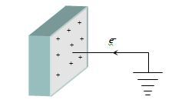

26. A ball with charge -50 e is placed at the centre of a hollow spherical shell which has a net charge of -50 e. What is the charge on the shell’s outer surface

a) -50e b) zero c) -100e d) +100e

**Key:** c

**Hint:** 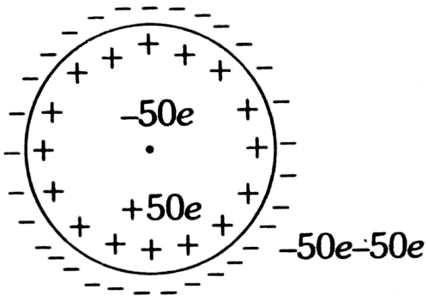

Charge on outer surface = -50e – 50e = -100e.

27. When a person combs his hair, static electricity is sometimes generated by what process?

a) Contact between the comb and hair results in a charge

b) Friction between the comb and hair results in the transfer of electrons

c) Conduction between the comb and hair

d) Induction between the comb and hair

**Key:** b

**Hint:** while combing hair, friction between the comb and the hair results is the transfer of electrons.

28. There are two types of electric charges-positive charges and negative charges. The property which differentiates the two types of charges is

a) Field of charge b) amount of charge

c) Strength of charge d) Polarity of charge

**Key:** d

**Hint:** The property which differentiates the two types of charges is called the polarity of charge.

29. What will happen when we rub a glass rod with silk cloth?

a) Some of the electrons from the glass rod are transferred to the silk cloth.

b) The glass rod gets positive charge and silk cloth gets negative charge.

c) New charges are created in the process of rubbing.

d) Both (a) and (b) are correct.

**Key:** d

**Hint:** When a glass rod is rubbed with silk cloth then some of the electrons from the glass rod get transferred to silk cloth and thus the glass rod gets positive charge and the silk gets negative charge. No new charge is created in the process of rubbing.

30. When two bodies are rubbed against each other, they acquire

a) Equal and similar charges b) Equal and opposite charges

c) Unequal and similar charges d) unequal and opposite charges

**Key:** b

**Hint:** It is the property of some materials to acquire equal and opposite charge when rubbed against each other.

31. Object may acquire an excess or deficiency of charge by

a) Hammering b) heating c) shaking d) rubbing

**Key:** d

**Hint:** Object can be charged by rubbing. During rubbing some of the free electrons may get transferred from one object to other.

32. An object is charged when it has a charge imbalance, which means the

a) Object contains no protons

b) Object contains no electrons

c) Object contains equal number of electrons and protons

d) Object contains unequal number of electrons and protons

**Key:** d

**Hint:** An object is said to be charged, if it has a deficiency of electron or excess of electrons. That means it contains and unequal number of protons and electrons.

33. Which of the following materials is the best conductor of electricity?

a) Platinum b) Gold

c) Silicon d) Copper

**Key:** d

**Hint:** Among the gives material, copper is the best conductor of electricity.

34. Which of the following is not conductor?

a) Dry air b) diamond c) Ebonite d) Human body

**Key:** b

**Hint:** diamond is a non-conductor

35. A method for charging a conductor without bringing a charged body in contact with it is called

a) Magnetization b) electrification

c) Electrostatic induction d) electromagnetic induction

**Key:** c

**Hint:**

36. A conducting sphere is negatively charged. Which of the following statements is true?

a) The charge is uniformly distributed throughout the entire volume

b) The charge is located at the center of the sphere

c) The charge is located at the bottom of the sphere because of gravity

d) The charge is uniformly distributed on the surface of the sphere.

**Key:** d

**Hint:** When a conducting sphere get charged, the charge is uniformly distributed on the surface of the sphere.

37. If 109 electrons move out of a body to another body every second, then the time required to get a total charge of 1 C on the other body is (in years)

a) 250 b) 100 c) 198 d) 150

**Key:** c

**Hint:** The charge given out in one second

= 1.6 × 10-19 C × 109 = 1.6 × 10-10C

Time required to accumulate a charge of 1C



= 198 years

38. The number of electrons that must be removed from an electrically neutral silver dollar to give it a charge of +2.4 C is

a) 2.5 × 1019 b) 1.5 × 1019  c) 1.5 × 10-19  d) 2.5 × 10-19

**Key:** b

**Hint:** Total charge, q = + 2.4C

Then by quantization of charge, q = ne

∴ Number of electrons, 

39. An object of mass 1 kg contains 4 × 1020 atoms. If one electron is removed from every atom of the solid, the charge gained by the solid in 1 g is

a) 2.8C b) 6.4 × 10-2C c) 3.6 × 10-3 C d) 9.2 × 10-4C

**Key:** b

**Hint:** Here,

Number of electrons removed = number of atoms in 1 g

or 

∴ Charge, q = ne = 4 × 1017 × 1.6 × 10-19 C

= 6.4 × 10-2C

40. **Assertion:** When bodies are charged through friction, there is a transfer of electric charge from one body to another, but no creation or destruction of charge.

**Reason:** This follows from conservation of electric charges.

a) If both assertion and reason are true and reason is the correct explanation of assertion

b) If both assertion and reason are true but reason is not the correct explanation of assertion

c) If assertion is true but reason is false

d) If both assertion and reason are false

**Key:** a

**Hint:** Conservation of electric charges states that the total charge of an isolated system remains unchanged with time.

41. **Assertion:** The charge on body can be increased or decreased in terms of electronic charge e.

**Reason:** Quantisation of charge means that the charge on a body is the integral multiple of electronic

charge e.

a) If both assertion and reason are true and reason is the correct explanation of assertion

b) If both assertion and reason are true but reason is not the correct explanation of assertion

c) If assertion is true but reason is false

d) If both assertion and reason are false

**Key:** a

**Hint:** All the observable charges have to be integral multiple of e. Thus if a body contains n1 electrons and n2 protons, the total amount of charge on the body is n2e + n1(-e) = (n2 – n1) e. Since n1 and n2 are integers, their difference is also an integer. Thus the charge on anybody is always an integral multiple of e and can be increased or decreased in terms of e.

42. When 1014 electrons are removed from a neutral metal sphere, the charge on the sphere becomes:

a) 16 μC b) 32 μC c) –32 μC d) –16 μC

**Key:** a

**Hint:** As we know that,

q = ne

= 1014 × 1.6 × 10-19

∴ q = 1.6 × 10-5C = 16 μC

Electrons are removed, so charge will be positive.

43. Quantization of charge implies:

a) Charge cannot be destroyed

b) Charge exists on particles

c) There is a minimum permissible charge on a par-ticle

d) Charge, which is a fraction of a coulomb is not possible

**Key:** d

**Hint:** Charge quantization means that charge cannot take any arbitrary values, but only values that are integral multiples of the fundamental charge.

44. In figure, two positive charges, q2 and q3 fixed along the y axis, exert a net electric force in the

+x-direction on a charge fixed along the x-axis. If a positive charge Q is added at (x, 0), the force on q1:

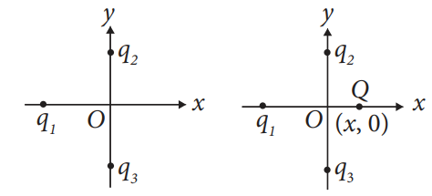

a) Shall increase along the positive x-axis.

b) Shall decrease along the positive x-axis.

c) Shall point along the negative x-axis.

d) Shall increase but the direction changes because of the intersection of Q with q2 and q3.

**Key:** a

**Hint:** As shown in the figure, since positive charge q2 and q3 exert a net force in the +X-direction on the charge q1 fixed along the x-axis, the charge q1 is negative. Obviously, due to addition of positive charge Q at (x, 0), the force on −q shall increase along the positive x-axis.

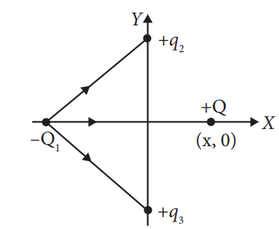

45. In nature, the electric charge of any system is always equal to:

a) Half integral multiple of the least amount of charge

b) Zero

c) Square of the least amount of charge

d) Integral multiple of the least amount of charge

**Key:** d

**Hint:** charge is quantized it always present in integral multiple of elementry charge.

46. Two conductors are of same shape and size. One of copper and the other of aluminium (less conducting) are placed in an uniform electric field. The charge induced in aluminium:-

a) Will be less than that in copper b) Will be more than that in copper

c) Will be equal to that in copper d) cannot be compared with that of copper

**Key:** c

**Hint:** Same charge induced in both spheres. (εr →same)

47. A charge given to any conductor resides on its outer surface, because:-

a) The free charge tends to be in its minimum potential energy state.

b) The free charge tends to be in its minimum kinetic energy state.

c) The free charge tends to be in its maximum potential energy state.

d) The free charge tends to be in its maximum kinetic energy state

**Key:** a

**Hint:** Minimum PE → more stability

48. One metallic sphere A is given positive charge whereas another identical metallic sphere B of exactly same mass as of A is given equal amount of negative charge. Then,

a) Mass of A and mass of B still remain equal b) Mass of A increases

c) Mass of B decreases d) Mass of B increases

**Key:** d

**Hint:** Negative charge means excess of electron which increases the mass of sphere B.

49. A conductor has 14.4 ×10-19 C positive charge. The conductor has (charge on electron = 1.6×10-19C)

a) 9 electrons in excess b) 27 electrons in short

c) 27 electrons in excess d) 9 electrons in short

**Key:** d

**Hint:** A conductor has positive charge. So, there is a deficiency of electrons.

50. Which of the following is correct regarding electric charge?

(i) If a body is having positive charge, then there is shortage of electrons.

(ii) If a body is having negative charge, then there is excess of electrons.

(iii) Minimum possible charge = ± 1.6 × 10-19C.

(iv) Charge is quantised, i.e. Q = ± ne, where n = 1, 2, 3, 4,…

a) Both (i) and (ii) b) both (ii) and (iii)

c) (i), (ii), (iii) d) all of these

**Key:** d

**Hint:**

51. A ball with charge − 50e is placed at the centre of a hollow spherical shell having a charge of − 50e. What is the charge on the shell’s outer surface?

a) − 50e b) Zero c) − 100e d) + 100e

**Key:** c

**Hint:** Let the induced charge on inner surface and outer surface is q1 and q2 respectively, then

q1+ q2 = −50e. Here, charge q1 induced due to ball is + 50e.

So, +50e + q2 = -50e

⇒ q2 = -100e

52. Match Column I and Column II.

|  |  |  |  |
| --- | --- | --- | --- |
| **Column-I** | | **Column-II** | |
| **A)** | Additivity of charge | **1)** |  |
| **B)** | Conservation of charge | **2)** | -5μC + 15μC = 10μC |
| **C)** | Quantisation of charge | **3)** | Gold nucleus repels alpha particle. |
| **D)** | Attraction and repulsion | **4)** | q = ne |

a) (A) → (3), (B) → (2), (C) → (4), (D) → (1) b) (A) → (2), (B) → (4), (C) → (1), (D) → (3)

c) (A) → (2), (B) → (1), (C) → (4), (D) → (3) d) (A) → (1), (B) → (2), (C) → (3), (D) → (4)

**Key:** c

**Hint:** (A) → (2); (B) →(1) because total charge on L.H.S. is equal to total charge on R.H.S. (C) → (4) charge q is integer times the charge on an electron (D) → (3) because both are positively charged.

53. Match the entries of column I with that of Column II.

|  |  |  |  |
| --- | --- | --- | --- |
| **Column-I** | | **Column-II** | |
| **A)** | Coulomb’s law | **1)** | Total electric flux through a closed surface. |
| **B)** | Gauss’s law | **2)** | Vector sum of forces. |
| **C)** | Principle of superposition | **3)** | Force is inversely proportional to square of distance |
| **D)** | Quantisation of charge | **4)** | Discrete nature of charge |

a) (A) → (2), (B) → (3), (C) → (1), (D) → (4) b) (A) → (3), (B) → (1), (C) → (2), (D) → (4)

c) (A) → (1), (B) → (4), (C) → (3), (D) → (2) d) (A) → (1), (B) → (2), (C) → (3), (D) → (4)

**Key:** b

**Hint:**

54. The metal knob of a gold leaf electroscope is touched with a positively charged rod. When it is taken away the leaves stay separated. Now the metal knob is touched by negatively charged rod. The separation between the leaves

a) Increases b) Decreases

c) remains same d) First increases then decreases.

**Key:** b

**Hint:** On touching the metal knob with a positively charged rod some electrons from the gold leaves get transferred to the rod making gold leaves positively charged and they get separated. When a negatively charged rod is touched with metal knob some negative charge flows to the gold leaves lessening the positive charge there and the separation between the leaves decreases.

55. The vehicles carrying inflammable fluids usually have metallic chains touching the ground:

a) To protect tyres from catching dirt from ground

b) To alert other vehicles

c) It is a custom

d) To conduct excess charge due to air friction to ground and prevent sparking

**Key:** d

**Hint:** Static charge is developed due to air friction. This can result in combustion. So, metallic chains is used to discharge excess charge.

**LEVEL-2**

56. Estimate the total negative charge in 1g of water. Given that Avogadro number = 6.02 × 1023 and molecular weight of water = 18.

a) 6.25 × 104C b) 5.35 × 104C

c) 1.76 × 104C d) 1.25 × 104C

**Key:** b

**Hint:** One molecule of water (H2O) contains 2 + 8 i.e.,

10 electrons, Number of molecules in 1 g of water,



Therefore, number of electrons in 1g of water,

n`= n × 10 = 3.344 × 1022 × 10 = 3.334 × 1023

The negative charge possessed by 1 g of water,

q = n` e = 3.344 × 1023 × 1.6 × 10-19

= 5.35 × 104C

57. A cup contains 250 g of water. Find the total positive charge present in the cup of water.

a) 1.34 × 1019C b) 1.34 × 107C

c) 2.43 × 1019C d) 2.43 × 107C

**Key:** b

**Hint:** Mass of water = 250 g

Molecular mass of water = 18 g

Number of molecules in 18 g of water = 6.02 × 1023

Number of molecules in one cup of water = 

Each molecule of water contains two hydrogen atoms and one oxygen atom, i.e., 10 electrons and 10 protons.

∴ Total positive charge present in one cup of water



= 1.34 × 107C

58. A coin is made up of aluminium and weighs 0.75 g. It has a square shape and its diagonal measures 17 mm. It is electrically neutral and contains equal amounts of positive and negative charges. The magnitude of these charges is (Atomic mass of Al = 26.98 g)

a) 3.47 × 104 C b) 3.47 × 102C

c) 1.67 × 1020C d) 1.67 × 1022C

**Key:** a

**Hint:** Mass of the coin = 0.75g,

Atomic mass of aluminium = 26.98 g

Number of Al atoms in the coin,



As atomic number (Z) of Al is 13, each atom of Al contain 13 protons and 13 electrons. Magnitude of positive and negative charges in one paisa coin

= NZe = 1.67 × 1022 × 13 × 1.6 × 10-19 C = 3.47 × 104C

59. Which of the following charges cannot be present on an oil drop in Millikan's experiment:–

a) 4.0 × 10–19 C b) 6.0 × 10–19 C

c) 10.0 × 10–19 C d) all of them

**Key:** d

**Hint:** if N is not an integer then Q is not possible.

60. A conductor has been given a charge – 3 × 10-7C by transferring electron. Increase in mass (in kg) of the conductor and the number of electrons added to the conductor are respectively

a) 2 × 10-16 and 2 × 1031 b) 5 × 10-31 and 5 × 1019

c) 3 × 10-19 and 9 × 1016 d) 2 × 10-18 and 2 × 1012

**Key:** d

**Hint:** Here, q = -3 × 10-7C

Number of electrons transferred to the conductor is



Mass of one electron, me = 9.1 × 10-31 kg

Increase mass of the conductor = me × n

= 9.1 × 10-31 × 2 × 1012

= 18.2 × 10-19 kg ≈ 2 × 10-18kg

61. Two identical conducting balls A and B have positive charges q1 and q2 respectively but q1 ≠ q2. The balls are brought together so that they touch each other and then kept in their original positions. The force between them is

a) less than that before the balls touched

b) Greater than that before the balls touched

c) Same as that before the balls touched

d) Zero

**Key:** b

**Hint:** According to Coulomb’s law, the force of repulsion

Between two conducting balls is given by 

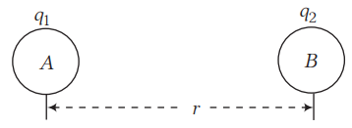

When the charged balls A and B are brought in contact, each sphere will attain equal charge q′



Now, the force of repulsion between them at the same distance r is



As, 

∴ F` > F

62. A metal sphere is being charged by induction using a charged rod, but the sequence of diagrams showing the process misplaced.

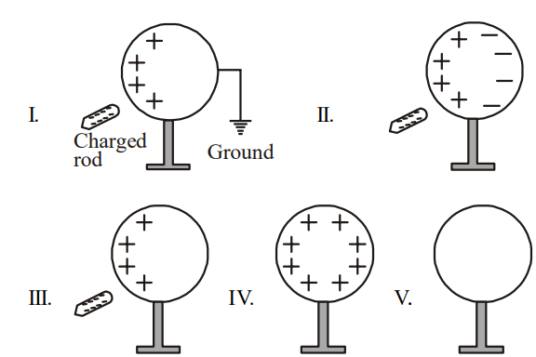

Correct order of charging is

a) I → II → III → IV → V b) V → II → III → I → IV

c) V → II → I → III → IV d) IV → II → III → I → V

**Key:** c

**Hint:** When charged rod is brought near uncharged conductor near end of conductor has opposite charge. When for end of this conductor is connected is ground (i.e., earthed), charge of far end flows down to ground when for end connection and rod are removed charge on conductor spreads uniformly on surface.

**LEVEL-3**

63. A sphere of lead of mass 10 g has net charge -2.5 nC. How many excess electrons are per lead atom? [ZPb = 82; its atomic mass is 207 g/mol]

a) 0.563 nano unit b) 0.635 pico unit c) 0.536 pico unit d) 0.753 nano unit

**Key:** c

**Hint:** Net charge on sphere = -2.5 nC

No. of excess electrons = -2.5 x10-9/-1.6x10-19 = 1.56 ×1010 electrons

10 g of lead will have  = 2.91×1021 atoms

The no. of excess electrons per lead atom is =5.36 ×10-13 electrons

No. excess electrons/atom in lead = 0.536 pico units

64. Estimate the total negative charges in 1 g of ammonia. (Given: NA = 6.023x1023, Molecular weight of NH3 is 17 g).

a) 56.6 kC b) 566 mC c) 655 nC d) 655 mC

**Key:** a

**Hint:** One molecule of Ammonia contains (7+3) =10 electrons.

No. molecules in 1 g of NH3,

N = NA/molecular weight

N = 6.023 x 1023/17 x =3.54 x 1022

No. electrons in 1 g of ammonia =3.54 x 1022 x 10=3.54 x 1023

The negative charge possessed by 1 g of ammonia,

Q = ne = 3.54 x1023 x 1.6 x 10-19

Q = 5.66 x 104C