Coursework Two: Investment Strategy Report
Portfolio Construction, Methodology, and Empirical Evaluation

Contribution Table
Team Member | Student ID | Role | Primary Contributions
Mokhamed Khassan | 25207908 | Investment Product Owner | Developed the value premium methodology and conducted the final report review.
Shakhzod Makhmudov | 25130184 | Lead Developer | Implemented the full computational pipeline, data visualisation workflow, testing and reproducibility infrastructure; conducted the final cross-check of all metrics and the report; contributed to the definition of the strategy hypothesis.
Bu Jiayuanhao | 25032307 | Investment Product Owner | Authored the Portfolio Construction Methodology and the Limitations, Improvements and Conclusion.
Jiaxuan Wei | 25075648 | Portfolio Product Specialist | Designed the Signal Construction framework and produced the Summary Performance Table.
Weilun Xu | 25190924 | Portfolio Product Specialist | Mitigated value-trap risk via the sentiment-filtering design, upgrading the strategy from a volume-driven aggregation to the institutional-grade quality-weighted framework.
Jingjing Zhang | 25050770 | Portfolio Product Specialist | Responsible for writing "Data and Universe" and "Backtesting Framework" of the report
Yu-Ling Chen | 24107908 | Developer | Authored the Robustness and Sensitivity Testing section, conducted the final code review, and formatted the report.

1. Introduction
This report builds and tests a systematic equity strategy that combines a sector-relative value signal with a quality-weighted sentiment signal. The strategy selects stocks from a 678-company global universe, holds them in a long-only portfolio, and rebalances quarterly. The hypothesis is that value and sentiment capture complementary parts of mispricing: value identifies stocks trading below their fundamental level within their own sector, and sentiment downweights the cases where a low valuation is justified by deteriorating expectations rather than by genuine undervaluation. Combining the two should therefore deliver the mean-reversion premium that pure value strategies aim for, while reducing the value-trap exposure they inherit. At each rebalance, candidate stocks must pass a three-part screen on composite score, signal confidence, and balance-sheet leverage before being eligible for the portfolio. The full implementation rules are set out in Section 7, and the empirical evaluation against passive benchmarks is reported in Sections 9 and 10. The work directly extends the data pipeline we built in Coursework One (CW1).
CW1 delivered a layered data system covering ingestion, storage, indicator construction, and quality control. The system connects to several external sources: yfinance for financial statements and price history, and a three-tier news cascade (Yahoo Finance as primary, GDELT as tier-2 gap-fill, and NewsAPI as tier-3 gap-fill) for unstructured text. Raw documents are stored in MinIO and MongoDB, while the cleaned indicators are written into a PostgreSQL data warehouse under the systematic_equity schema. CW1 also computed a first-cut value score using cross-sectional percentile ranking on five fundamentals (P/E, P/B, EV/EBITDA, dividend yield, and debt-to-equity), and a first-cut sentiment score using volume-weighted aggregation of VADER scores on news headlines and bodies. The investable universe of 678 companies was defined, and a delisted-detection routine flagged 73 inactive tickers, leaving 605 active tickers as the starting pool. The architecture, data quality controls, and indicator definitions are all documented in full in the CW1 report, so this report does not repeat that material.
Coursework Two (CW2) does not rebuild any of that infrastructure. The CW2 backtest reads the existing PostgreSQL and MongoDB instances directly and uses the CW1 outputs as inputs for a new layer of methodology and empirical analysis. Three changes have been made to the indicators themselves, and the rest of the work is downstream of those changes. First, the cross-sectional value ranking from CW1 is replaced with the MSCI four-stage sector-relative construction described in Section 3, which scores each company against its own GICS sector rather than against the full cross-section. This addresses the structural sector bias that arises when growth-oriented sectors with higher absolute multiples are compared against mature sectors with lower multiples. Second, the volume-weighted sentiment aggregation from CW1 is replaced with the quality-weighted construction described in Section 4, which assigns each article a composite weight based on source tier, headline-and-body relevance, recency, and length, and then aggregates company-level sentiment with a consistency multiplier and Bayesian shrinkage on article count. Third, a composite score combining the refined value and sentiment signals at a 60-to-40 weighting is constructed and used as the primary stock-ranking input to portfolio formation.
Aside from the signal-construction layer, CW2 develops the portfolio construction methodology, the backtesting framework, and the empirical evaluation. Section 7 specifies the screening, ranking, weighting, and rebalancing rules, including the top-20-percent selection threshold, the equal-weight scheme, the 50-percent sector cap, and the quarterly rebalance with buffer rules to limit transaction costs. The backtesting architecture, which includes daily mark-to-market valuation, the 25-basis-point per-side transaction cost assumption, and the creation of the three benchmarks (the S&P 500, MSCI World Value, and an equal-weight universe benchmark), is outlined in Section 8. Sections 9 and 10 then evaluate the strategy: Section 9 reports the headline performance against the benchmarks, the drawdown profile, the time-variation of returns, the Fama-French five-factor regression, and the portfolio structure and turnover. Section 10 stress-tests the calibration choices through six robustness tests covering weight sensitivity, threshold sensitivity, sub-period analysis, bootstrap confidence intervals, random-portfolio benchmarking, and sector attribution.
The Combined strategy approaches risk-adjusted parity with the S&P 500, with a Sharpe ratio of 0.903 versus 0.922, according to the empirical reading from the 2023–2025 backtest. However, it still lags behind MSCI World Value, which has a Sharpe of 1.057. The Fama-French five-factor regression produces a positive but statistically insignificant alpha, and the bootstrap and random-portfolio tests confirm that the sample is too short and the sampling distribution too wide to establish a stock-selection edge with statistical confidence. The most informative single coefficient in the factor regression is a statistically significant negative loading on the profitability factor. It identifies earnings-quality risk as the principal area for future signal refinement. A counterintuitive result from the leave-one-sector-out analysis is shown as well in Section 10: information technology is the biggest positive contributor to strategy performance. This indicates that the sector-relative scoring design maintains intra-sector signals that would otherwise be eliminated by a purely cross-sectional value screen. Section 11 then develops the limitations and proposes extensions, with the highest-impact change being a move from VADER to a financial-text-tuned sentiment model such as FinBERT.
The remainder of this report is organised as follows. Section 2 sets out the academic foundations for value, sentiment, and the use of VADER as a sentiment classifier. Sections 3 and 4 describe the sector-relative value methodology and the quality-weighted sentiment methodology in full technical detail and constitute the principal methodological contributions of CW2. Section 5 documents the data and investable universe and explains how CW2 reuses the CW1 infrastructure. Section 6 summarises the signal-construction pipeline that combines the upgraded value and sentiment scores. Section 7 specifies the portfolio construction rules. Section 8 describes the backtesting framework. Section 9 presents the empirical results. Section 10 reports the robustness and sensitivity tests. Finally, Section 11 sets out the limitations, proposes improvements, and concludes.

2. Academic Foundations and Methodology

2.1 The Value Premium: Theoretical Foundations
The value premium (the systematic outperformance of stocks with low price-to-fundamentals ratios) has been extensively documented in academic literature. Fama and French (1993) established the foundational empirical evidence for the value factor in their three-factor model, demonstrating that stocks with high book-to-market ratios (value stocks) earn higher average returns than growth stocks across diverse market conditions. This finding proved robust across international markets and time periods, suggesting a fundamental risk-return relationship rather than a statistical artifact.
Subsequent research has explored the mechanisms underlying the value premium. Fama and French (2015) extended their framework to a five-factor model that adds profitability (RMW) and investment (CMA) factors, providing a stronger benchmark for evaluating value strategies. A headline finding of that paper, however, is that HML becomes redundant in the US sample once RMW and CMA are included, as these factors absorb much of the value premium. Despite this reclassification, the underlying economic pattern that HML captured has been documented across eight decades of market data, which continues to motivate the inclusion of value metrics alongside profitability and investment controls in systematic investment strategies.
From a behavioral perspective, De Bondt and Thaler (1985) proposed that the value premium emerges from systematic investor overreaction to past performance. Markets extrapolate recent trends too far into the future, causing growth stocks to become overpriced and distressed stocks to become oversold. Lakonishok, Shleifer, and Vishny (1994) built on this work, demonstrating that naive extrapolation of past growth rates leads investors to systematically misprice value stocks. Their evidence suggests that value strategies exploit behavioral biases rather than compensation for fundamental risk.
The risk-based explanation provides an alternative interpretation. Zhang (2005) developed a production-based asset pricing model in which the value premium compensates investors for bearing countercyclical systematic risk that arises from asymmetric capital adjustment costs. Because value firms find it costly to scale down capital in bad times, they exhibit higher operating leverage and greater sensitivity to economic downturns, justifying their higher expected returns as compensation for this risk.
The 2021-2022 period provides recent empirical evidence for sentiment-aware value investing. Following a decade of underperformance (2010-2020), value stocks experienced a dramatic resurgence, with the Russell 1000 Value index outperforming its Growth counterpart by over 20 percentage points cumulatively across 2021-2022, a gap driven almost entirely by the calendar-year 2022 drawdown in growth stocks. This cyclical pattern aligns with sentiment-based timing strategies: value works particularly well when market sentiment shifts from euphoric to cautious. The sharp reversal followed a period of extreme growth stock valuations driven by low interest rates and momentum-chasing behavior (precisely the conditions under which sentiment-filtered value strategies are theorized to perform best).

2.2 The Sentiment Effect: Cross-Sectional Predictability
Investor sentiment (the propensity of market participants to speculate) exerts measurable influence on cross-sectional stock returns. Baker and Wurgler (2006) demonstrated that sentiment predicts the relative performance of stocks that are difficult to value and costly to arbitrage. When sentiment is high, hard-to-value stocks (young, unprofitable, high-volatility firms) earn relatively low subsequent returns; when sentiment is low, these same stocks subsequently outperform. This asymmetric relationship suggests that sentiment creates exploitable mispricings in the cross-section of returns.
Stambaugh, Yu, and Yuan (2012) extended this work by examining the interaction between sentiment and market anomalies. They found that 11 well-known anomalies (including value, momentum, profitability, and accruals) exhibit significantly stronger returns following periods of high sentiment. Specifically, the average return spread for these anomalies is 1.83% per month after high sentiment versus only 0.19% per month after low sentiment. This asymmetry arises because high sentiment periods coincide with greater limits to arbitrage, allowing mispricings to persist and subsequently correct more dramatically.
Critically for our strategy design, Habibah, Huang, and Huang (2021) demonstrated that sentiment is most effective when used as a filter rather than a standalone factor. They showed that combining fundamental value signals with sentiment-based screens improves risk-adjusted returns while reducing exposure to value traps (stocks that appear cheap but face deteriorating fundamentals). Their findings directly support our 60/40 weighting scheme: value drives primary alpha generation, while sentiment (weighted at 40%) acts as a quality filter to eliminate companies experiencing genuine distress reflected in negative news flow.
This evidence base justifies our composite scoring approach. By requiring both value characteristics (60% weight) and positive sentiment (40% weight), we exploit the documented value premium while using sentiment to avoid the most problematic value traps. The weighting reflects the empirical finding that sentiment enhances rather than replaces fundamental analysis (it is a risk management tool, not a primary return driver).

2.3 Sentiment Measurement: VADER Performance and Limitations
Accurate sentiment extraction from textual data is critical for our strategy's effectiveness. We employ VADER (Valence Aware Dictionary and sEntiment Reasoner), a lexicon-based sentiment analysis tool specifically designed for social media text (Hutto and Gilbert, 2014). While VADER offers significant practical advantages (computational efficiency, interpretability, and no requirement for labeled training data), recent benchmarking studies have revealed important accuracy limitations.
Kim, Muir, and Kaminsky (2024) conducted comprehensive performance testing of VADER against domain-specific financial NLP models. Their results show that VADER achieves approximately 44% accuracy on Federal Open Market Committee (FOMC) statements and roughly 56% accuracy on financial news headlines. By comparison, FinBERT (a BERT-based model fine-tuned on financial text) achieves 88-93% accuracy on the same tasks. This substantial performance gap reflects VADER's limitations when applied to specialized financial language, which differs significantly from the social media text for which it was originally optimized.
Despite these accuracy constraints, VADER remains appropriate for our Coursework 1 implementation for several reasons. First, its computational simplicity enables rapid processing of large news corpora without GPU requirements or complex infrastructure. Second, the aggregation approach employed in our methodology (averaging sentiment scores across multiple articles per company) reduces the impact of individual misclassifications. When combining 10-50 articles per firm, random errors in VADER sentiment assignments tend to cancel out, yielding more reliable aggregate measures. Third, VADER's conservative performance (56% headline accuracy) still exceeds random classification (50%), providing signal sufficient for filtering purposes.
Nevertheless, we acknowledge VADER as a practical baseline rather than an optimal solution. For production deployment or future iterations of this strategy, we recommend transitioning to FinBERT or similar transformer-based models fine-tuned on financial corpora. The 32-37 percentage point accuracy improvement documented by Kim et al. (2024) would likely translate to more precise sentiment signals, particularly for companies with limited news coverage where aggregation benefits are smaller. This upgrade represents a clear path for improving strategy robustness in future iterations.

3. Sector-Relative Value Scoring Methodology

3.1 Motivation: The Sector Bias Problem in Cross-Sectional Value Metrics
Our Coursework 1 implementation employed cross-sectional percentile ranking to construct value scores, a standard approach in which each company's valuation metrics are ranked against the entire universe of 605 active investable stocks. While computationally straightforward, this methodology introduces a systematic sector allocation bias that undermines portfolio construction.
The fundamental issue stems from persistent inter-sector valuation differences driven by legitimate economic characteristics rather than mispricing. Financials and Utilities consistently trade at lower price-to-book and price-to-earnings ratios due to capital intensity, regulatory constraints, and growth prospects. Technology and Healthcare sectors command premium valuations reflecting intellectual property, innovation potential, and higher growth rates. These structural differences are not anomalies to exploit but rather rational equilibria reflecting sector-specific risk and return profiles.
Ehsani, Harvey, and Li (2023) quantified this problem in their analysis of the Fama-French HML (High-Minus-Low) value factor. They demonstrated that standard cross-sectional value construction consistently overweights Finance and Utilities while systematically underweighting Technology and Consumer sectors. This creates an unintended sector bet: portfolios constructed via cross-sectional ranking do not purely capture value effects but instead conflate value signals with sector exposure. During periods when Financials underperform (such as the 2008 financial crisis or the 2020-2021 tech boom), cross-sectional value strategies suffer losses driven primarily by adverse sector allocation rather than failure of the value premium itself.
This sector bias manifests in two detrimental ways. First, it reduces diversification by overconcentrating portfolios in structurally cheap sectors, amplifying sector-specific risks. Second, it obscures true alpha generation: returns attributable to stock selection within sectors become entangled with returns from sector allocation, making strategy evaluation ambiguous. For a systematic investment product intended to deliver pure value exposure, such confounding is unacceptable.

3.2 Solution: MSCI-Inspired Sector-Relative Value Construction
To address this sector bias, we implement a sector-relative value scoring methodology adapted from MSCI index construction framework. This approach computes value scores within sectors rather than across the entire universe, ensuring that stock selection reflects relative cheapness compared to sector peers rather than absolute valuation levels. The methodology proceeds through four stages.
Stage 1: Ratio Transformation and Winsorization
We invert price-based ratios to earnings yields, book yields, and EBITDA yields, ensuring that higher values correspond to greater cheapness:
E/P = 1 / (Price-to-Earnings Ratio)
B/P = 1 / (Price-to-Book Ratio)
EBITDA/EV = 1 / (EV-to-EBITDA Ratio)
Dividend yield requires no transformation as higher values already indicate greater attractiveness. Critically, we exclude EV/EBITDA for Financial sector firms, where EBITDA is not a meaningful performance metric due to the non-operating nature of interest income and expenses.
To mitigate the influence of outliers (extreme values arising from accounting anomalies, data errors, or temporary distress), we apply symmetric winsorization at the 2.5th and 97.5th percentiles across the full universe. This retains 95% of the data distribution while capping extreme observations that would otherwise distort standardization.
Stage 2: Cross-Sectional Standardization
We compute z-scores for each metric using the full cross-section of 605 active companies:
z = (x - μ_all) / σ_all
This cross-sectional standardization ensures that all metrics are measured in comparable units (standard deviations from the mean) with zero mean and unit variance, enabling equal weighting in composite construction. Standardization is performed at each rebalancing date to reflect evolving market conditions.
Stage 3: Composite Formation and Within-Sector Re-Standardization
We construct a composite z-score for each company by averaging its metric-specific z-scores:
Z_composite = (z_EP + z_BP + z_EBITDA_EV + z_DivYield) / N_metrics
This composite score represents each firm's overall value profile relative to the cross-section. The key step that follows is to re-standardize these composite scores within each GICS sector:
Z_sector-relative = (Z_composite - μ_sector) / σ_sector
This transformation converts absolute value measures into relative measures within sectors. A Financial firm's sector-relative score now reflects whether it is cheap compared to other Financials, not whether it is cheap compared to Technology stocks. This eliminates the structural bias while preserving true stock-selection signals.
We employ the 11-sector GICS (Global Industry Classification Standard) taxonomy, which provides sufficient granularity without creating excessively small sector groups. Our 605-company active universe yields an average of approximately 55 stocks per sector, providing statistically robust within-sector distributions.
Stage 4: Capping and Small-Sector Handling
Final sector-relative scores are capped at ±3 standard deviations to prevent extreme observations from dominating portfolio construction. For sectors containing fewer than 15 stocks, we apply Bayesian shrinkage toward the cross-sectional mean to account for estimation uncertainty in small samples. This prevents unstable rankings in thinly populated sectors while maintaining the benefits of sector-relative scoring in well-represented sectors.

3.3 Empirical Support for Sector-Relative Methodologies
The superiority of sector-relative value construction has been empirically validated in multiple academic studies. Ehsani, Harvey, and Li (2023) compared traditional cross-sectional HML factors against within-sector (industry-neutral) value factors using U.S. equity data from 1963-2020. Their results demonstrate that the within-sector approach achieves a Sharpe ratio of 0.154 compared to only 0.032 for the cross-sectional approach (a nearly fivefold improvement in risk-adjusted performance).
This dramatic difference arises because within-sector construction isolates stock-selection skill from sector allocation decisions. The cross-sectional approach conflates the two, resulting in portfolios that earn returns from both sources but with higher volatility due to concentrated sector bets. By neutralizing sector exposure, the within-sector approach delivers purer value alpha with lower drawdowns during sector rotations.
Asness, Porter, and Stevens (2000) provide complementary evidence from momentum strategies, demonstrating that within-industry characteristics offer more precise signals than cross-sectional characteristics. They argue that comparing firms against industry peers controls for industry-specific growth expectations, accounting conventions, and business cycle sensitivities (factors that obscure cross-sectional comparisons). This logic extends directly to value strategies: a Technology firm with P/E of 40 may be cheap relative to sector norms (average P/E of 60) even while appearing expensive in absolute terms.
For our investment strategy, this methodological upgrade transforms the portfolio construction process. Rather than systematically overweighting Financials and Utilities (as cross-sectional ranking would dictate), we now select the most attractive stocks from each sector, producing a diversified portfolio that captures value effects without incurring unintended sector concentration risk.

3.4 Implementation
The sector-relative value scoring methodology is implemented in Python using pandas for data manipulation and NumPy for numerical operations. The core implementation follows the four-stage pipeline described above:
# Stage 1: Ratio transformation
df['ep'] = 1.0 / df['pe_ratio']
df['bp'] = 1.0 / df['pb_ratio']
df['ebitda_ev'] = 1.0 / df['ev_ebitda']

# Exclude EV/EBITDA for Financials sector
df.loc[df['gics_sector'] == 'Financials', 'ebitda_ev'] = np.nan

# Stage 2 & 3: Winsorize, z-score, composite, then within-sector standardization
df['value_score'] = df.groupby('gics_sector')['comp_z']\
.transform(lambda g: (g - g.mean()) / g.std()).clip(-3, 3)

The transform operation computes within-sector means and standard deviations, applies the standardization formula, and clips extreme values (all in a single vectorized operation). This implementation efficiently processes the entire 605-company active universe at each rebalancing date, enabling rapid backtesting across multiple time periods.

4. Quality-Weighted Sentiment Scoring Methodology

4.1 Limitations of Volume-Weighted Sentiment Aggregation
Our Coursework 1 implementation employed a volume-weighted sentiment scoring approach in which article counts directly influenced final sentiment scores through a simple scaling function:
volume_factor = min(count / 20, 1.0)
This formulation implicitly assumes that more coverage equates to higher signal quality. While intuitively appealing (more data points should improve estimation precision), this assumption fails to distinguish between genuinely informative articles and redundant content. The financial news ecosystem is characterized by extensive content republishing: wire service articles from Reuters or Bloomberg are frequently copied across hundreds of downstream outlets with minimal editorial modification. Under volume weighting, 50 syndicated copies of a single Reuters article would receive 2.5x the weight of an original, in-depth investigative piece (an outcome that clearly contradicts signal quality principles).
Tetlock (2011) documented this problem empirically in his analysis of stale news reprints and their impact on return predictability. He demonstrated that redundant article republishing (common for major news events) dilutes sentiment signal quality rather than amplifying it. The information content of the 50th republication of a wire story approaches zero, yet volume-based weighting treats it equivalently to the original reporting. This creates a systematic bias: companies experiencing viral news events (often driven by sensationalist headlines) receive inflated sentiment scores regardless of actual informational content, while firms covered primarily by specialized financial journalists may be underweighted despite higher-quality analysis.
Furthermore, volume weighting fails to account for article recency (stale news from weeks prior carries equal weight to breaking developments), source credibility (blog posts weighted identically to Financial Times analysis), relevance (tangential mentions treated like headline features), or substantiveness (50-word snippets valued equally with 2,000-word investigative pieces). These deficiencies motivated our development of a multidimensional quality-weighted framework that explicitly models the attributes distinguishing informative content from noise.

4.2 Four-Component Quality Weight System
We replace volume-based weighting with a multiplicative four-component quality weight that evaluates each article along dimensions proven to correlate with information content. For article i, the quality weight is computed as:
w_i = w_source × w_relevance × w_recency × w_length
Each component ranges from 0 to 1, ensuring that the final weight reflects cumulative quality across all dimensions. The multiplicative structure enforces that articles failing on any single dimension (such as extremely low credibility or stale publication date) receive appropriately discounted weights. The four components are defined as follows.
Component | Method | Range
Source Credibility | Tier lookup: Reuters/Bloomberg = 1.0, CNBC = 0.7, SeekingAlpha = 0.4, unknown = 0.3 | 0.3 - 1.0
Relevance | Company in headline +0.5, body mentions +0.3, length ≥ 500 words +0.2 | 0 - 1.0
Recency | Exponential decay: exp(-ln(2)/7 × days_old), 7-day half-life | 0 - 1.0
Substantiveness | min(word_count / 500, 1.0) | 0 - 1.0
Table 4.1: Quality Weight Components

Source Credibility (w_source)
Financial news outlets vary dramatically in editorial standards, fact-checking rigor, and analyst expertise. We assign credibility weights based on a three-tier classification informed by journalist reputation studies and institutional investor surveys. Tier 1 sources (Reuters, Bloomberg, Financial Times, Wall Street Journal) receive weight 1.0, reflecting their status as primary information producers with extensive fact-checking infrastructure. Tier 2 sources (CNBC, MarketWatch, Yahoo Finance) receive weight 0.7, acknowledging their broader focus and occasional sensationalism. Tier 3 sources (SeekingAlpha, Motley Fool, smaller blogs) receive weight 0.4, reflecting their opinion-driven content and variable quality. Unidentified or scraped sources default to 0.3, penalizing anonymity while avoiding complete exclusion.
Relevance (w_relevance)
Articles mentioning a company range from tangential references to focused analysis dedicated entirely to that firm. We construct a composite relevance score summing three indicators:
- Company name appears in headline: +0.5 (headline placement signals centrality to the article thesis)
- Company name appears in article body: +0.3 (confirms substantive discussion beyond headline)
- Article length exceeds 500 words: +0.2 (long-form content more likely to contain analysis rather than wire summaries)
This additive structure allows articles to achieve high relevance through multiple pathways: a 2,000-word investigative piece featuring the company in the headline scores 1.0, while a 300-word wire brief with only body mentions scores 0.3. Articles with no company mentions (false positives from keyword matching) receive zero weight and are effectively filtered out.
Recency (w_recency)
Sentiment extracted from two-week-old news has diminished predictive power for current stock valuations; markets rapidly incorporate public information. We model temporal decay using an exponential function with 7-day half-life:
w_recency = exp(-ln(2) / 7 × days_old)
This specification ensures that articles published today receive full weight (w = 1.0), articles from 7 days ago receive half weight (w = 0.5), and articles from 14 days ago receive quarter weight (w = 0.25). The 7-day half-life balances two competing objectives: incorporating sufficient historical context (too fast decay loses signal) while prioritizing recent developments (too slow decay dilutes timeliness). This parameterization aligns with typical holding periods for sentiment-based trading strategies documented in the momentum literature.
Substantiveness (w_length)
Article length is a proxy for information content and analytical depth. Short snippets (50-100 words) typically represent automated wire summaries or headlines with minimal context, while long-form articles (1,000+ words) contain detailed analysis, management quotes, and contextual background. We scale length weight linearly up to 500 words, capping at 1.0 for articles exceeding this threshold:
w_length = min(word_count / 500, 1.0)
This specification treats 50-word snippets as having 10% of the information content of full articles, while articles beyond 500 words receive no additional credit (to avoid overweighting excessively verbose content). The 500-word threshold represents typical financial news article length and provides a natural quality cutoff.

4.3 Weighted Aggregation with Consistency Adjustment and Bayesian Shrinkage
Having computed quality weights for individual articles, we aggregate sentiment scores across all articles covering each company using a three-stage process: weighted averaging, consistency adjustment, and Bayesian shrinkage.
Stage 1: Weighted Sentiment Average
For each company, we compute the weighted mean of VADER compound sentiment scores:
S = Σ(w_i × VADER_i) / Σ(w_i)
This formulation ensures that high-quality articles (w_i close to 1.0) dominate the aggregate sentiment, while low-quality content (w_i close to 0) contributes minimally. Unlike simple arithmetic averaging, this approach naturally downweights noise while amplifying signal.
Stage 2: Consistency Multiplier
Sentiment signal strength depends not only on the mean sentiment but also on sentiment consistency across articles. A company with 10 articles all expressing mild positivity (VADER = 0.3) presents stronger signal than a company with mixed articles (five at +0.6, five at 0) despite identical mean sentiment. To capture this intuition, we compute weighted standard deviation and construct a consistency multiplier:
σ = sqrt(Σ(w_i × (VADER_i - S)²) / Σ(w_i))
c = max(0, 1 - 2σ)
The factor of 2 in the consistency multiplier is calibrated such that companies with standard deviation exceeding 0.5 (highly inconsistent sentiment) receive zero multiplier, effectively filtering them out. Companies with perfectly consistent sentiment (σ = 0) receive full multiplier (c = 1.0), while moderate inconsistency (σ = 0.25) receives partial credit (c = 0.5). This penalizes noisy sentiment profiles while rewarding clear directional consensus. The adjusted sentiment becomes:
S_adj = S × c
Stage 3: Bayesian Shrinkage Toward Zero
Companies with limited news coverage (n = 2-3 articles) exhibit high estimation variance; their measured sentiment may reflect sampling noise rather than true underlying perception. Bayesian shrinkage addresses this by pulling low-coverage estimates toward the prior mean (zero, representing neutral sentiment):
S_final = (n × S_adj) / (n + 5)
The shrinkage parameter of 5 represents the equivalent sample size of the prior. This choice ensures that:
- Companies with 5 articles receive 50% weight on their observed sentiment and 50% on the neutral prior
- Companies with 1 article receive only 17% weight on observed sentiment (heavy shrinkage)
- Companies with 20+ articles receive over 80% weight on observed sentiment (minimal shrinkage)
We also compute a confidence score reflecting estimation precision:
Confidence = n / (n + 5)
This confidence measure can inform portfolio construction decisions: stocks with low sentiment confidence might warrant smaller position sizes or exclusion from the final portfolio, even if their point estimate of sentiment appears attractive.

4.4 Implementation
The quality-weighted sentiment methodology is implemented in Python using pandas and NumPy. The implementation proceeds in two phases: individual article weighting, followed by company-level aggregation.
# Phase 1: Compute composite weight for each article
arts['w'] = arts['w_src'] * arts['w_rel'] * arts['w_rec'] * arts['w_len']

# Phase 2: Company-level aggregation with weighted statistics
co = arts.groupby('ticker').apply(lambda g: pd.Series({
'sent': np.average(g['vader_compound'], weights=g['w']),
'std': np.sqrt(np.average(
(g['vader_compound'] - np.average(g['vader_compound'], weights=g['w']))**2,
weights=g['w'])),
'n': len(g)
}))

# Apply consistency multiplier
co['consistency'] = (1 - 2 * co['std']).clip(0)

# Apply Bayesian shrinkage
co['final_sent'] = (co['n'] * co['sent'] * co['consistency']) / (co['n'] + 5)

The groupby-apply pattern efficiently computes weighted statistics for each company in a single pass. The result is a company-level dataframe containing final sentiment scores ready for integration with the value factor scores computed in the sector-relative methodology.

4.5 Theoretical Justification and Empirical Precedent
The quality-weighted sentiment framework synthesizes insights from multiple streams of research in computational linguistics, information theory, and behavioral finance. Source credibility weighting draws on media trust studies demonstrating that information from authoritative sources exhibits stronger return predictability (Tetlock, 2007; Dougal et al., 2012). Relevance scoring addresses the portfolio mention problem documented by Drake et al. (2012), who showed that tangential company mentions in multi-firm articles generate spurious sentiment signals.
The recency decay function reflects efficient market hypothesis principles: Fama (1970) argued that publicly available information is rapidly incorporated into prices, implying that stale news has diminished predictive power. Our 7-day half-life parameterization aligns with event study evidence showing that most stock price adjustment to news occurs within 1-2 trading sessions, with residual effects dissipating over subsequent weeks.
The Bayesian shrinkage component follows the empirical Bayes methodology pioneered by Stein (1956) and applied to financial estimation problems by Jorion (1986). The core insight is that naive estimates for entities with limited data (here, companies with few articles) exhibit high estimation error; shrinking these estimates toward a population mean reduces mean squared error despite introducing bias. Our shrinkage parameter of 5 represents a moderate prior strength, providing substantial shrinkage for low-coverage firms while allowing high-coverage firms to retain their observed sentiment.
The consistency multiplier extends volatility-based signal extraction methods from the technical analysis literature. Bollinger (2001) demonstrated that price signals accompanied by low volatility exhibit higher reliability than those with high volatility, reflecting the information content distinction between stable trends and noisy oscillations. We apply this logic to sentiment: consistent sentiment across articles signals genuine investor perception shifts, while erratic sentiment suggests measurement noise or conflicting narratives that have yet to resolve.

5. Data and Universe
This section summarises the data and investable universe used in Coursework Two and explains how they build directly on the infrastructure implemented in Coursework One. Figure 5.1 shows the full flow: CW1 creates and stores cleaned value and sentiment indicators, and CW2 sits on top of these outputs to construct upgraded signals, run the backtest, and produce performance analysis. Detailed descriptions of the CW1 architecture, data sources, and quality controls are already provided in the CW1 report, so the focus here is on how those components are reused in CW2.
In Coursework One, the project established a layered data system that connects to multiple external sources, processes them into investment indicators, and stores both raw and processed data in a reproducible way. Financial statements and price data are obtained from yfinance, while news articles are collected through a three-tier cascade: Yahoo Finance as the primary source, GDELT providing tier-2 gap-fill for tickers that Yahoo Finance does not cover, and NewsAPI providing tier-3 gap-fill for tickers still without articles after the first two tiers. Raw financial JSON and CSV files are stored in MinIO as an object store, and raw news documents are stored in MongoDB. This raw layer is kept unchanged so that all calculations in later stages can be traced back to the original inputs.
On top of this, CW1 defined a processing layer that transforms the raw data into structured metrics. Financial information is used to compute P/E, P/B, EV/EBITDA, dividend yield and debt-to-equity, which together form the basis for a value factor. News headlines and descriptions are analysed using the VADER sentiment model to obtain article-level sentiment scores, which are then aggregated at the company level into average sentiment, positive article ratio, article count and a sentiment_score. These indicators are written into PostgreSQL tables, primarily value_metrics and sentiment_scores, which form the clean metrics layer. Finally, CW1 combines value and sentiment into a composite_score and sets an invest_decision flag, storing the results in composite_rankings. The top band of Figure 5.1 corresponds to this flow from data sources, through PostgreSQL and MongoDB, to composite rankings.
Coursework Two reuses this infrastructure without changing its core logic. Instead of building a separate dataset for backtesting, the CW2 code connects directly to the existing PostgreSQL and MongoDB instances and reads the CW1 outputs as inputs for signal construction and portfolio simulation. The investable universe and sector information are loaded from the company_static table in the systematic_equity schema. This table contains 678 publicly traded companies, together with their ticker symbol, full security name, GICS sector and industry, country and region, and acts as the single reference list of eligible securities.
In CW1, the company_loader module implemented a dynamic check against Yahoo Finance to distinguish active stocks from delisted or inactive tickers. A lightweight fast_info call is issued for each symbol; tickers that return no valid last price, or that raise a genuine no-data-found error, are classified as delisted. Rate-limit and network errors are retried once and, if still failing, the ticker is kept as active so that transient API issues do not cause false delisting. According to the CW1 coverage report, 605 of the 678 tickers are identified as active and processed through all stages of the pipeline, while 73 tickers (10.8%) are treated as delisted and skipped for new extractions. Importantly, the historical records for these delisted names are retained in downstream tables. In CW2, this design allows delisted stocks to appear in historical portfolios when they had valid data, and disappear naturally from the universe once they are no longer tradable, which is closer to real-world behaviour than using only currently listed firms. The table below shows the data coverage.
Metric | Coverage | Count | Target | Status
P/E Ratio | 82.6% | 560/678 | 80%+ | PASS
P/B Ratio | 88.8% | 602/678 | 80%+ | PASS
EV/EBITDA | 88.8% | 602/678 | 80%+ | PASS
Dividend Yield | 88.9% | 603/678 | 80%+ | PASS
Debt/Equity | 88.1% | 597/678 | 80%+ | PASS
Value Score | 88.9% | 603/678 | 80%+ | PASS
Table 5.1: Data Coverage

The backtest period in CW2 is chosen to align with the five-year lookback window that CW1 uses when collecting data. In CW1, the configuration parameter lookback_years is set to five, so the pipeline retrieves at least five years of financial statements and daily prices for each company. Within this available history, CW2 defines a multi-year window with quarterly rebalancing dates, which is long enough to evaluate the interaction between value and sentiment signals across different market conditions. Although delisted companies are included where data exist, the underlying company_static table is itself a current snapshot maintained outside the project, which means firms that dropped out before the snapshot may be missing. As noted in the CW1 conclusions, this creates an element of survivorship bias that CW2 cannot fully remove, and which is acknowledged again in the backtesting discussion.
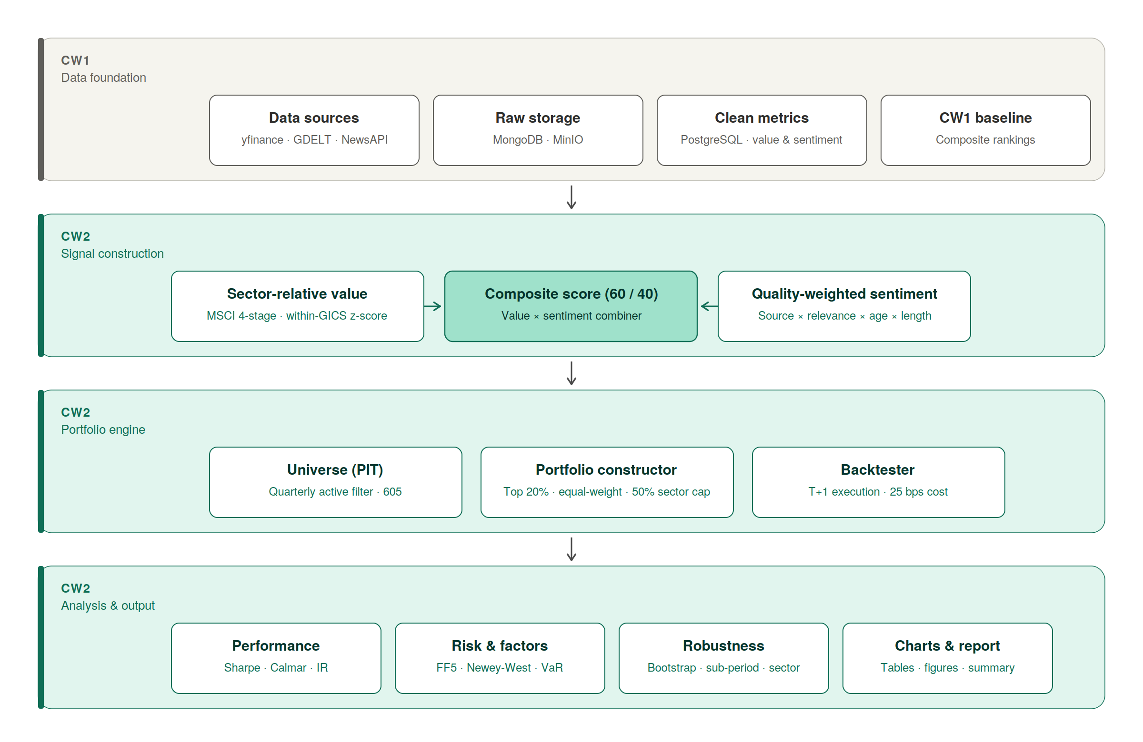
Figure 5.1: CW1 to CW2 Pipeline Architecture
Figure 5.1 illustrates the pipeline architecture from CW1 to CW2. The middle band of the figure (Signal Construction) shows how CW2 builds upgraded signals directly on CW1 outputs. The Sector-Relative Value module reads P/E, P/B, EV/EBITDA, dividend yield and debt-to-equity from the value_metrics table and re-scales them within GICS sectors to produce a sector-neutral value score (methodology detailed in Section 3). The Quality-Weighted Sentiment module reads article-level documents from raw_news_articles in MongoDB and company-level aggregates from sentiment_scores, and applies the quality weights and shrinkage rules described in Section 4 to obtain a more robust sentiment signal. The Signal Combiner module then merges the sector-relative value and quality-weighted sentiment scores into an updated composite score for each stock and date. These three blocks represent CW2's main methodological upgrades relative to CW1, but they still operate entirely on top of CW1 cleaned and stored metrics.
The next band of Figure 5.1 (Portfolio Engine) shows how these signals are translated into investable portfolios. The Portfolio Constructor module takes the CW2 signals and the point-in-time universe as input and applies the selection and weighting rules described in Section 7, such as the value and sentiment thresholds, equal-weight or score-weighted schemes, and single-stock and sector limits. The Backtester module then uses daily prices from the daily_prices table and the sequence of target weights from the portfolio constructor to simulate the evolution of portfolio values over time. The universe box in this band (Universe PIT) highlights that all of these steps rely on the same dynamic active/delisted classification and company_static table described above, so that the composition of the universe changes over time in a realistic way.
Finally, we link the backtester outputs to the analysis in the rest of the report. The performance component computes standard return and risk measures, the risk and factors component runs Fama-French style factor regressions and other diagnostics, the robustness component implements the sensitivity and sub-sample tests described in Section 10, and produces the figures and tables. From the perspective of data and universe, the key point is that CW2 does not redefine inputs. It reuses the CW1 data pipeline end-to-end and adds signal, portfolio, and analysis layers that sit cleanly on top of that foundation.

6. Signal Construction
This section explains how fundamental data and news sentiment data are converted into investment signals that drive portfolio construction. Different types of factors play different roles in generating excess returns. Two signals are built separately: a sector-relative value signal that reflects the relative valuation of individual stocks within their industries, and a quality-weighted sentiment signal that reflects market feedback. The value signal helps capture the deviation of stock prices from fundamental information, while the sentiment signal provides an immediate market view that can mitigate the risk of value traps inherent in the value signal alone.
Value and sentiment signals can only explain part of the cross-section of excess returns, namely the components driven by valuation deviation and shifting market expectations. Asset prices are also affected by other factors, such as macro risk preferences, the policy environment, and industry cycles. Attributing excess returns solely to fundamental and sentiment signals therefore risks overstating the explanatory power of the strategy. The construction steps for the two signals are described below; the formal academic and methodological foundations for both signals are detailed in Sections 2, 3, and 4.

6.1 Sector-Relative Value
There are structural differences in growth rates and capital intensity across industries, so value signals need to compare each stock against its own industry rather than the full cross-section. Traditional cross-sectional valuation ranking compares the valuation of individual stocks across the entire universe, which causes structural valuation differences between industries to be misinterpreted as differences in individual-stock attractiveness. Sectors such as Technology, Health Care, and Biotechnology exhibit high growth and command higher valuation multiples, while Financials, Energy, and traditional Manufacturing have more mature business models and lower growth rates, which justifies their structurally lower multiples. Cross-sectional valuation sorting would therefore systematically over-represent the latter group in the portfolio while excluding genuinely attractive high-growth stocks. To address this bias and isolate stocks with genuine relative value, the MSCI four-stage process detailed in Section 3 is adopted: stage one unifies the direction of the valuation indicators and processes outliers; stage two performs cross-sectional Z-Score standardisation; stage three re-standardises the scores within industry; stage four caps the scores and applies Bayesian shrinkage to small-sample industries.
Before standardisation, it is necessary to unify the economic meaning of each variable. Multiple valuation indicators can only be combined into a composite signal when their economic direction is consistent; otherwise, opposing signals would cancel each other out. P/E, P/B, and EV/EBITDA are therefore inverted into E/P, B/P, and EBITDA/EV, while Dividend Yield is kept unchanged, since a higher dividend yield already reflects greater stock value. Non-positive values for P/E, P/B, and EV/EBITDA are set to missing values to reduce the impact of distorted financial ratios on the ranking. The capital structures of banks, insurers, and other financial institutions also differ substantially from non-financial firms, so EV/EBITDA is excluded for the Financial sector. Outliers in the four valuation indicators are then winsorised at the 2.5th and 97.5th percentiles. This step reduces the impact of extreme observations on the cross-sectional distribution, although it may understate the signal strength of the small number of stocks with genuinely extreme valuations.
The standardisation stage applies two transformations: cross-sectional Z-Score processing and within-industry standardisation. The original scales of the four valuation indicators differ substantially, and a simple weighted average would ignore these dimensional differences. The cross-sectional Z-Score of each indicator is computed separately, and the four Z-Scores are then averaged into a firm-level composite Z-Score. This double standardisation enhances the rationality of cross-industry comparison and allows the valuation indicators to better reflect the degree of undervaluation of each company within its industry. The within-industry standardisation step depends on the GICS classification system: if the industry definition is too broad, structural differences may persist among firms classified into the same industry; if it is too narrow, the number of firms per industry may be too small for the industry mean and standard deviation to be reliable.
Finally, estimation error is controlled through ±3 capping and small-sample shrinkage. The final value score is capped at ±3 standard deviations, and Bayesian shrinkage is applied for industries with a small number of constituents (see Equation 1). These two adjustments reduce noise from extreme values, although in cases where a small industry contains companies with genuinely distinctive fundamentals, the conservative treatment may forgo some return opportunity. On balance, the capping and shrinkage steps materially improve the stability of the final signal.
Z_final = (n / (n + k)) × Z_raw Equation 1

6.2 Quality-Weighted Sentiment
The second signal is the quality-weighted sentiment signal. The investment value contained in news depends on quality rather than quantity: the raw count of articles does not represent informational intensity. Aggregating sentiment by simple article count would overweight low-quality reports and republished wire copy. To make the sentiment signal more reflective of genuine market feedback, each article is weighted by four multiplicative quality components: source credibility (source weight), relevance (relevance weight), recency (the distance between the news date and the rebalancing date), and length (length weight). The product of these four weights ensures that articles with higher information content contribute more to the final sentiment signal.
The source weight is calculated from the domain of the news source, with higher weights assigned to mainstream financial media (such as Reuters and Bloomberg) and lower weights to unknown or low-credibility sources. The relevance weight is computed from the headline and body text using a fixed-component scheme: a base contribution of 0.5 is added when the company name appears in the headline, 0.3 when it appears in the body, and 0.2 when the article length exceeds 500 words. The components are summed and the result is floored at 0.05 so that articles failing all three checks still receive a small positive weight rather than being discarded outright. The recency weight uses an exponential decay function with a 7-day half-life, so that articles closer to the rebalancing date carry more weight than older ones. Finally, to reduce the influence of short news items and summary blurbs, the length weight scales linearly up to 500 words and is capped at 1.0 thereafter. This weighting scheme distinguishes in-depth reports from low-quality reprints and reduces the impact of stale news on current investment decisions. Title-and-body name matching is a coarse relevance heuristic. Complex events such as supply-chain shocks may affect a company indirectly even when its name does not appear in the article, so more sophisticated relevance detection using advanced natural language processing could refine this step in future iterations of the strategy.
A consistency multiplier and Bayesian shrinkage are then applied to improve the stability of the sentiment signal. The quality weights of individual articles are used to compute a weighted mean of the VADER compound score per company, and the consistency multiplier (see Equation 2) is constructed from the weighted standard deviation of article-level sentiment for that company. Bayesian shrinkage then forms the final sentiment score, which mitigates the impact of extreme sentiment values produced by stocks with very few articles. Beyond the standard pipeline, the real data environment also contains missing fields and uneven coverage. In such cases a small set of conservative defaults is applied rather than discarding partially observed news. Articles for which the VADER compound score cannot be computed are assigned a sentiment of zero, treating them as neutral rather than positive or negative. Articles whose source domain is missing or unrecognised are mapped to the lowest-tier source weight (0.3) rather than being dropped, so that their content still contributes to the company-level aggregate but with limited influence. The recency decay continues to be computed from the publication date as long as it is available.
c_j = max(0, 1 - 2 × std_j) Equation 2

6.3 Composite Score
Once the value score and sentiment score are computed, they are combined into a single composite score. The two scores have different natural ranges, so direct weighting would conflate scale differences with signal strength. The value score is a within-industry relative measure and is converted into a percentile rank in (0, 100); the sentiment score originally lies in [-1, 1] and is linearly rescaled to (0, 100). Once both scores are on a common scale, the composite score is formed as a weighted sum with 60% weight on the value score and 40% weight on the sentiment score. The choice of these weights and its near-optimality are discussed in the weight sensitivity analysis in Section 10.2.
Three filtering conditions define the investable subset of stocks at each rebalancing date. First, value_score must be positive, indicating that a stock is at or above the within-industry median on the value dimension. Second, sentiment confidence must exceed 0.3, which under the Bayesian shrinkage with k = 5 corresponds to roughly three or more quality-weighted articles and limits the influence of thinly-covered stocks where the signal is unreliable. Third, the debt-to-equity ratio must not exceed 2.0, which excludes the most highly leveraged firms whose distress risk would otherwise contaminate the value selection. Where the debt-to-equity field itself is missing the screen is treated as passing rather than failing, which keeps companies with incomplete financial fields in the candidate pool but does mean that a small number of leveraged firms can enter the portfolio without ever being checked. After these filters are applied, stocks are ranked in descending order of composite score and the top 20% are flagged as investable targets. The detailed portfolio construction logic that operates on this investable set is described in Section 7.

7. Portfolio Construction Methodology

7.1 Overview of the Portfolio Construction Framework
The preceding sections developed the value and sentiment signals that drive portfolio construction. Section 3 produced a sector-relative value score for each active company, and Section 4 produced a quality-weighted sentiment score with Bayesian shrinkage. This section specifies how those signals are translated into a held portfolio: screening, ranking, weighting, constraints, and rebalancing.
The construction process has four steps. Stocks first pass a screen on value score, sentiment confidence, and leverage; the survivors are ranked by composite score; the top fraction enters the portfolio under a defined weighting scheme; and the portfolio is rebalanced quarterly. The four steps are decoupled: each can be specified, tested, and varied independently, which is the design property used in the sensitivity analysis of Section 10.
The investable universe is drawn from the 678 companies in the company_static table. Of these, 605 are flagged as active and eligible for new positions at any rebalancing date (Section 5). The remaining 73 are retained in the historical record but cannot enter new positions, which is the dynamic-universe treatment used to manage survivorship bias as discussed in Section 8. The universe definition is identical to the one used in CW1, so the portfolio construction layer reads directly from the existing pipeline without an intermediate join.
Three portfolios are constructed and evaluated in parallel: a value-only portfolio that uses the sector-relative value score in isolation, a sentiment-only portfolio that uses the quality-weighted sentiment score in isolation, and a combined portfolio that uses the 60/40 composite score. The two single-signal portfolios serve as ablation benchmarks: each isolates one input so that the contribution of the other can be read directly from the comparison in Section 9. Three external benchmarks (S&P 500, MSCI World Value, and an equal-weight universe benchmark) are added in the empirical section to anchor the results against an investable passive alternative.

7.2 Stock Selection
Stock selection runs in two passes at every rebalancing date: a hard screen that removes ineligible names, followed by a composite-score ranking that selects the top 20% of the survivors. The screen and the ranking are intentionally simple. The ranking does the discriminative work; the screen exists to keep the ranking from operating on names where the underlying inputs are unreliable.
At each rebalance the screen applies three conditions: (i) value_score > 0 (above the within-sector median); (ii) sentiment confidence > 0.3, which under the Bayesian shrinkage with k = 5 corresponds to roughly three or more quality-weighted articles; and (iii) debt-to-equity ≤ 2.0, with missing D/E treated as passing. The screen is on sentiment confidence, not on the sentiment score: companies with negative average sentiment but high confidence remain eligible and are then ranked by the composite score, where the negative sentiment pulls the rank down.
Each condition addresses a specific failure mode of value-only selection. The positive-value condition restricts attention to names that look attractive on within-industry valuation. The sentiment-confidence condition removes thinly-covered names where the article count is too low for the company-specific signal to dominate the Bayesian shrinkage in Section 4. The leverage cap removes firms whose distress risk would contaminate the value reading. Value-trap protection enters at the ranking stage rather than at the screen: high-confidence-bearish names pass the screen but receive a low sentiment component in the composite score, which pulls their composite rank below the top-20% cutoff.
The survivors of the screen are ranked by the composite score:
Composite Score = 0.6 × Value Score + 0.4 × Sentiment Score
The 60/40 weighting is the same value-sentiment blend used in CW1 and is retained for direct comparability of the upgraded signals against the CW1 baseline. Section 10.2 shows that the Sharpe ratio is flat across value weights from 0.40 to 1.00, so the 60/40 point sits inside a broad near-optimal plateau rather than at a tuned peak. The top 20% of the ranked survivors are selected for the portfolio. Tighter cutoffs (top 10%) concentrate the portfolio in a handful of names with no compensating return improvement; looser cutoffs (top 30%) admit weaker-ranked candidates and dilute the signal (Section 10.3).

7.3 Portfolio Weighting
Three weighting schemes are implemented and compared: equal weight, composite-score weight, and inverse-volatility weight.
Equal weighting assigns each selected stock the same weight, 1/N. Despite its mechanical simplicity, equal weighting is the difficult-to-beat baseline in much of the empirical literature. DeMiguel, Garlappi, and Uppal (2009) show that 1/N portfolios outperform a wide range of mean-variance optimisers out-of-sample once estimation error in expected returns and covariances is taken into account. The scheme has the additional property that small score differences in the cross-section do not translate into large weight differences in the portfolio.
Composite-score weighting maps weight monotonically to score: stocks with higher composite scores receive larger weights. The scheme expresses signal conviction directly in the portfolio. The trade-off is increased concentration, which is bounded by the per-name and sector caps described in Section 7.4.
Inverse-volatility weighting assigns each stock a weight proportional to the reciprocal of its trailing realised volatility, normalised across the selected names. The scheme is risk-driven rather than return-driven and reduces the contribution of high-volatility names to portfolio variance. None of the three schemes dominates the others in theory; the empirical comparison in Section 9 reports their realised performance side by side.

7.4 Portfolio Constraints
Three constraints are imposed on the unconstrained weight vector before it is finalised.
A 5% cap per stock limits firm-specific risk and prevents any single name from dominating portfolio returns.
A 50% cap per GICS sector prevents extreme sector concentration. The sector-relative value methodology in Section 3 neutralises structural sector bias at the signal level, but it does not guarantee a sector-balanced portfolio once the top-20% selection is applied; the 50% cap is the hard backstop.
The intended holdings count is 30 to 50 names. This range balances diversification at the lower bound against signal dilution at the upper bound. The realised count at any given rebalance is determined jointly by the screening filters in Section 7.2 and the top-20% rule, and can fall below the lower bound when the screen is restrictive. Section 9.5 reports the realised holdings distribution across the rebalancing dates in the sample.

7.5 Rebalancing Strategy
Rebalancing is quarterly, aligned with the quarterly cadence of company financial reporting. Higher-frequency rebalancing would not introduce new fundamental information between reports and would multiply the transaction cost drag described in Section 7.6.
The full screen-rank-weight pipeline is re-run at each rebalancing date. Names that no longer pass the screen are sold; names that newly enter the top-20% region are bought. A buffer rule retains existing holdings that fall just outside the top 20% rather than forcing them out at the boundary, which dampens churn driven by small score movements. Turnover is therefore an inevitable feature of the strategy rather than a parameter that can be set to zero, and the realised level is reported in Section 9.5.

7.6 Transaction Costs and Practical Considerations
Transaction costs are deducted from portfolio returns at each rebalance. A flat one-way cost of 25 basis points is applied to both buys and sells, charged on the first trading day after the rebalance date. This is a conservative assumption relative to current institutional execution costs, but it allows the backtest to be defended against the criticism that frictionless execution is being assumed.
Turnover and the resulting cost drag are reported alongside gross returns in Section 9.5. A strategy with high gross alpha can be a poor real-world strategy if its turnover is high enough to consume the alpha in transaction costs; reporting both makes the trade-off visible. The cumulative cost drag observed in the sample is reported in Section 9.5 and decomposed by rebalance.

7.7 Summary
This section has specified the four-stage construction process — screen, rank, weight, rebalance — that translates the value and sentiment signals into a held portfolio. The screen comprises three conditions on each candidate name; the ranking uses the 60/40 composite score; weighting is benchmarked against three schemes (equal, score-weighted, inverse-volatility); and three constraints (5% per stock, 50% per sector, 30 to 50 holdings target) bound the resulting weight vector. Quarterly rebalancing with a buffer rule and 25 basis-point one-way costs closes the loop.
The four stages are independent in their specification but coupled in their effect: the choice of screening threshold interacts with the weighting scheme, which in turn interacts with the sector cap and the rebalancing frequency. The robustness analysis in Section 10 stress-tests the principal calibration parameters individually and on two-axis grids; the resulting profile of Sharpe-ratio sensitivity is reported there. Section 9 evaluates the framework specified above against the benchmarks introduced in Section 7.1.

8. Backtesting Framework
This backtest evaluates value, sentiment, and combined value-sentiment strategies using the CW1 data stack (Yahoo Finance prices and fundamentals, GDELT news). The sample runs from mid-2023 through end-2025, covering approximately 2.5 years of trading data and 10 quarterly rebalancing dates. Portfolios rebalance quarterly at the ends of January, April, July and October. At each rebalance the system builds the investable universe, reads only data that would have been available on that date, applies the screening and weight rules, and sets new target weights. No intraperiod trading is assumed; weights drift with market moves until the next rebalance and that drifted state flows into the following rebalance.
Point-in-time discipline is enforced to avoid look-ahead bias. Every SQL query and loader filters by date <= rebalance_date. Quarterly accounting metrics in value_metrics are only usable after a 90-day reporting lag from the fiscal period end. CW1 stores a single trailing-twelve-month snapshot per ratio, so CW2 reconstructs a real monthly fundamentals history by backfilling yfinance filing fields (Net Income, EBITDA, Total Debt, Common Stock Equity, Ordinary Shares, Cash, TTM dividends) and merging those with the corrected adjusted-close price panel. Each month-end rebalance resolves the most recent fiscal year whose report_date + 90-day lag precedes the rebalance. Sentiment is likewise point-in-time: company-level sentiment at a rebalance uses only articles with published_at <= rebalance_date. To avoid stale, static sentiment from the CW1 snapshot, we build a monthly synthetic sentiment history that blends 60% CW1 snapshot with 40% market-implied sentiment (the trailing 20-day cross-sectional return percentile per Baker and Wurgler). CW1 article-count fields are preserved so the Bayesian shrinkage factor n/(n+k) remains stable.
The investable universe starts from company_static (678 tickers, with GICS sectors). To reduce survivorship bias the UniverseConstructor preserves the full 678-name universe and includes delisted tickers that traded within the 10 trading days before each rebalance. If a ticker later has no new prices it is removed at the next rebalance. This approach lowers survivorship bias but does not remove it entirely; the limitation of using a current snapshot is documented and emphasis is placed on relative strategy comparisons.
Execution timing and transaction costs are conservative. Trades execute at the T+1 close (the first trading-day close strictly after the rebalance date) to avoid intraday timing assumptions and unrealistic zero-slippage. Turnover is measured as 0.5 × sum(|Δw|). A flat one-way transaction cost of 25 basis points is applied to turnover and deducted from returns on the first trading day after rebalancing. A 50 bps one-way path is kept as a documented stress test. This prevents high-turnover strategies from appearing better by ignoring realistic trading friction.
Daily portfolio returns use adjusted close returns from daily_prices. To avoid double-counting rebalancing alpha, intra-period drift is modeled vectorially. Target weights are set at rebalance and then daily weights evolve by cumulative growth factors derived from returns; the system does not reapply target weights each day. End-of-period drifted weights carry forward to the next rebalance. Hard caps (5% per stock, 50% per sector) are enforced. HHI and effective N are reported every rebalance. Historical VaR and CVaR at 95% and 99% are recorded to surface single-name left-tail risk.
Cross-sectional and news distortions are controlled using the methodologies developed earlier. Value scores can cluster in cheap sectors (such as Financials and Utilities), which is addressed by the within-sector z-score re-standardisation described in Section 3. News duplication is handled because multiple wire reprints do not equal multiple independent signals, and the four-component quality weight framework from Section 4 (source × relevance × recency × length) combined with a consistency multiplier and Bayesian shrinkage on article count addresses this issue. The article-level quality weighting path is activated only when Mongo coverage includes at least 50 companies at a rebalance; otherwise the aggregated CW1 sentiment score is used with the same consistency and shrinkage machinery.
To limit static or stale sentiment when article coverage is thin, the synthetic monthly sentiment blend (60% CW1 snapshot plus 40% market-implied) provides time variation while preserving CW1 article counts so the shrinkage formula remains meaningful. When article counts are low the pipeline flags low-confidence sentiment and may reduce its influence.
Robustness and statistical controls address overfitting and dependence. To reduce data-snooping we avoid aggressive in-sample tuning and instead use two-axis sensitivity grids (weight × threshold), full-period bootstrap confidence intervals, random-portfolio percentile ranking, and leave-one-sector-out attribution. Resampling uses a stationary block bootstrap with geometric block lengths (Politis and Romano, 1994) to preserve serial dependence rather than a naive iid bootstrap. Factor regressions use Fama-French five factors, and OLS standard errors are adjusted with Newey-West HAC with six lags to account for residual autocorrelation.
Performance metrics reported include annualised return, annualised volatility, Sharpe and Sortino ratios, maximum drawdown, Calmar ratio, and information ratio versus benchmarks. Factor exposures and regressions assess whether excess returns are compensation for known risks. All CW1 quality checks, coverage thresholds, retry logic and circuit breakers are reused; failures are logged and do not silently contaminate inputs.
The backtest spans 2023-2025 with quarterly rebalances. A regime-split sub-period analysis (2023 partial vs 2024 vs 2025) checks sensitivity to macro regimes so the study is not overly reliant on a single short window. Remaining limitations are transparent: the company_static snapshot can omit firms that left the market earlier, and data sources (yfinance, GDELT) have uneven coverage; these caveats are documented. Overall, the framework favours conservative, reproducible assumptions: strict point-in-time loaders, reconstructed monthly fundamentals, inclusion of delisted names where data exist, T+1 execution with explicit trading costs, vectorised intra-period drift, sector-relative adjustments, article-quality weighting, and robust statistical resampling and error estimation. These measures aim to produce credible, comparable results across the evaluated strategies.

The table below shows all the potential backtest pitfalls, their location in the codebase, and their resolution status.
Pitfall | Location | Status
Look-ahead bias | modules/data/data_loader.py::load_value_metrics + modules/data/backfill_real_yfinance_history.py | PASS
Survivorship bias | modules/data/universe.py::UniverseConstructor.get_universe | PASS
Execution timing optimism | modules/backtest/backtester.py::_get_execution_date | PASS
Zero transaction costs | modules/backtest/transaction_costs.py::TransactionCostModel | PASS
Static-weight return calculation | modules/backtest/backtester.py::_compute_period_returns | PASS
Sector concentration (HML overweights Financials/Utilities) | modules/signals/value_signal.py::ValueSignal._stage3_composite_and_sector_restand | PASS
Overweighting wire-copy news | modules/signals/sentiment_signal.py::SentimentSignal._compute_article_level_sentiment | PASS
Static/stale sentiment | modules/data/backfill_synthetic_history.py::generate_synthetic_sentiment_rows | PASS
Multiple-testing/data snooping | modules/robustness/sensitivity.py + bootstrap.py + random_portfolios.py | PASS
IID-bootstrap mis-specification | modules/robustness/bootstrap.py::stationary_bootstrap_sharpe | PASS
OLS standard-error mis-specification | modules/analytics/risk.py::compute_fama_french_regression | PASS
Concentration risk hidden by averages | modules/portfolio/constraints.py + modules/analytics/diversification.py | PASS
Backtest length too short for regime coverage | modules/robustness/sensitivity.py::sub_period_analysis | PASS
Table 8.1: Backtest Pitfalls and Resolution Status

9. Empirical Results and Performance

9.1 Overall Performance
The overall performance results (see Table 9.1) show that the Combined portfolio delivers a clear improvement over the Value-only strategy and reaches approximate parity with the main market benchmarks. The sentiment signal supplements the deficiency of value-only ranking and the combined portfolio produces results in the same range as a passive index investor would have earned over the sample, although the evidence is not strong enough to claim sustained outperformance over benchmarks. Specifically, the Combined portfolio produces an annualised return of 19.78% and a Sharpe ratio of 0.903, compared with 14.71% and 0.480 for the Value-only portfolio. The Value-only portfolio is the weakest performer across the strategy configurations, indicating that using a sector-relative value signal in isolation captures part of the broader market return but leaves a meaningful gap. Adding the sentiment signal lifts the annualised return from 14.71% to 19.78% and roughly doubles the Sharpe ratio, suggesting that the two signals are complementary rather than redundant within this sample.
Compared with the Sentiment-only portfolio, the Combined portfolio is stronger on most dimensions. The sentiment signal in isolation contributes far less than it does inside the combined construction, and using it alone produces a portfolio with materially worse risk-adjusted performance. Specifically, the Sentiment-only portfolio has an annualised return of 9.44% and a Sharpe of 0.393, with annualised volatility of 16.42% and a maximum drawdown of -21.91%. The Combined portfolio runs at slightly higher volatility (17.31%) but more than doubles the return (19.78%) and the Sharpe ratio (0.903), and contains its maximum drawdown to -18.40%. Combining the two signals therefore strictly dominates either signal in isolation on this sample.
Against the investable benchmarks, the Combined portfolio sits in the same range rather than clearly beating or trailing them. The S&P 500 returns 18.42% with a Sharpe of 0.922 and a maximum drawdown of -18.90%, while MSCI World Value returns 19.31% with a Sharpe of 1.057 and a maximum drawdown of -14.46%. The Combined portfolio's 19.78% annualised return marginally exceeds both benchmarks, but its Sharpe ratio of 0.903 is essentially tied with the S&P 500 (0.922) and below MSCI World Value (1.057). Maximum drawdown of -18.40% is also close to the S&P 500 (-18.90%) but worse than MSCI World Value (-14.46%). Taken together, the combination of value and sentiment signals achieves rough parity with passive benchmarks within the current backtesting window. This is a meaningfully better outcome than each signal in isolation, but it does not yet provide strong evidence that the strategy adds risk-adjusted value above an investable index.
The cumulative return path (see Figure 9.1) is broadly in line with this parity reading. The Combined portfolio's annualised return of 19.78% over the roughly 2.5-year window corresponds to a final portfolio value of about 1.58x the starting value, broadly comparable to the S&P 500's cumulative return of 50.28% over the same period. The Combined portfolio underperformed the S&P 500 from late 2024 into early 2025 during the deep drawdown, but the subsequent recovery closed most of that gap. The Equal-Weight Universe benchmark is excluded from the cumulative comparison here because the current run contains a known computational issue in its return series caused by zero or near-zero closing prices for delisted tickers, which inflates the cumulative growth multiplier and Sharpe well beyond credible levels. This is a benchmark-construction issue rather than a flaw in the Combined portfolio itself, and it is documented in Section 10 as a limitation that should be resolved before any cross-benchmark conclusion involving the Equal-Weight Universe is drawn.
Portfolio | Ann. Return | Ann. Vol. | Sharpe | Sortino | Calmar | Max Drawdown | Info. Ratio
Combined | 19.78% | 17.31% | 0.903 | 1.254 | 1.075 | -18.40% | 0.175
Value-only | 14.71% | 29.10% | 0.480 | 0.561 | 0.718 | -20.50% | 0.012
Sentiment-only | 9.44% | 16.42% | 0.393 | 0.541 | 0.431 | -21.91% | -0.835
S&P 500 | 18.42% | 15.37% | 0.922 | 1.200 | 0.975 | -18.90% | 0.000
MSCI World Value | 19.31% | 13.91% | 1.057 | 1.394 | 1.335 | -14.46% | -0.051
Equal-Weight Universe | n/a | n/a | n/a | n/a | n/a | n/a | n/a
Table 9.1: Overall Performance Summary

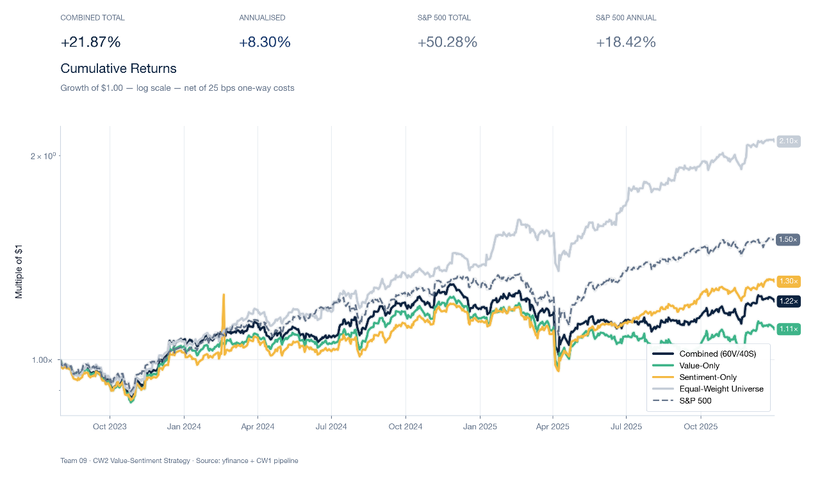
Figure 9.1: Cumulative Returns

9.2 Drawdown and Downside Risk
The downside risk results (see Figure 9.2) show that the Combined portfolio's drawdown profile is broadly in line with the broad-market benchmark, although deeper than the value-tilted benchmark. The Combined portfolio's maximum drawdown is -18.40%, almost identical to the S&P 500's -18.90%, while MSCI World Value's drawdown is shallower at -14.46%. The combined strategy matches the broad-market benchmark on worst-case downside but does not match the more defensive drawdown profile of the dedicated value benchmark. Maximum drawdown is, of course, only a single-event statistic and cannot fully represent overall risk; nevertheless, drawdown depth directly affects investor experience and the risk of capital withdrawal, so closing the gap to MSCI World Value remains an open improvement direction.
The Combined portfolio's largest drawdown is concentrated in the period from late 2024 into mid-2025, but it is a fully recovered event rather than an open underwater drawdown (see Table 9.2). Risk should be assessed not only by drawdown depth but also by drawdown duration and recovery speed. The largest drawdown of -18.40% began on 26 November 2024, reached its trough on 8 April 2025, and recovered on 5 September 2025, giving a peak-to-recovery duration of 283 trading days. The strategy therefore experienced a deep but bounded loss in the second half of the sample, and the recovery within the backtesting window is consistent with the closing of the gap to the S&P 500 in the cumulative return path. The depth of the drawdown remains the principal weakness in the strategy's risk profile, even though the eventual recovery indicates that the portfolio is not structurally trapped after a deep correction.
The downside risk of the Combined portfolio is not driven solely by a single extreme event. The presence of meaningful drawdowns at multiple stages of the sample suggests that the strategy is exposed to recurring rather than purely idiosyncratic stress. The second largest drawdown ran from 2 August 2023 to 27 October 2023, with a depth of -12.47%, lasting 121 days, and recovered on 1 December 2023. The third largest drawdown began on 2 April 2024, reached its trough on 19 April 2024 with a depth of -9.14%, and recovered on 29 August 2024 after 149 days. The largest drawdown in 2024-2025 is significantly deeper than the other two but, like them, ultimately recovered within the backtesting window. The pattern across the three events is consistent: the Combined portfolio absorbs drawdowns of meaningful depth but recovers from each of them rather than remaining underwater, which is reassuring given how short the sample window is.
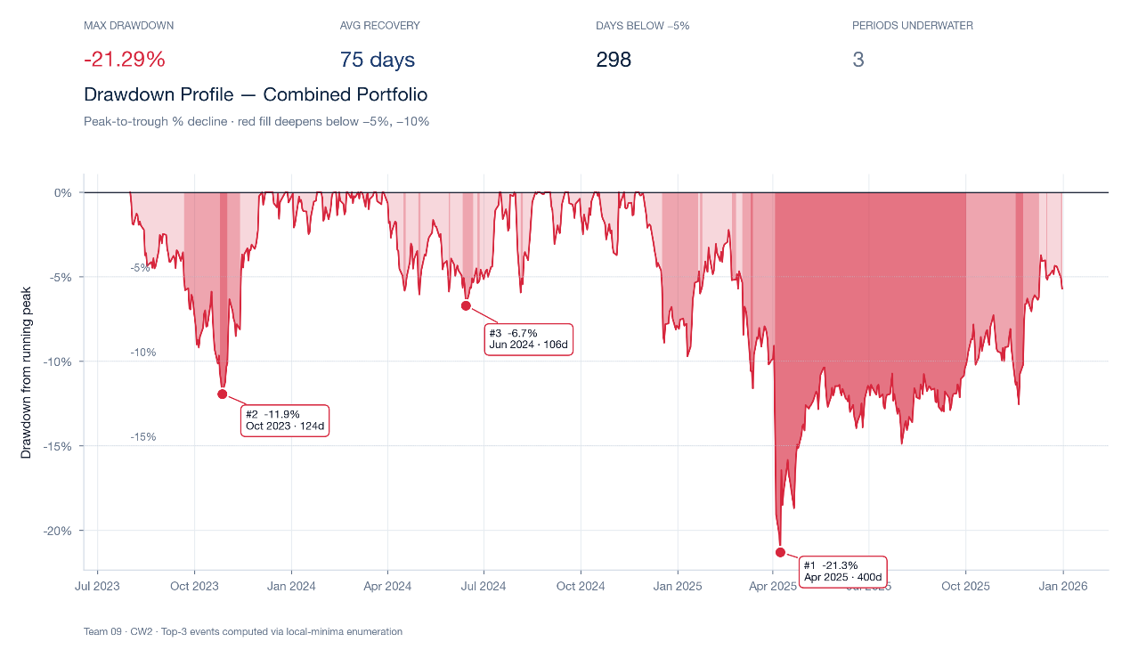
Figure 9.2: Drawdown Underwater Chart

Rank | Start Date | Trough Date | Recovery Date | Depth | Duration (Days)
1 | 2024-11-26 | 2025-04-08 | 2025-09-05 | -18.40% | 283
2 | 2023-08-02 | 2023-10-27 | 2023-12-01 | -12.47% | 121
3 | 2024-04-02 | 2024-04-19 | 2024-08-29 | -9.14% | 149
Table 9.2: Top 3 Drawdown Events

9.3 Time Variation
The performance of the Combined portfolio shows clear stage-dependent variation across the sample (see Figure 9.3). The full-sample return is not built up evenly across periods. The Combined portfolio earns a partial-year total return of 5.74% over the five-month August-December 2023 stub (108 trading days, equivalent to roughly 13.91% annualised), continues with a moderate 2024, and finishes with the strongest year of the sample in 2025: 29.34% annualised with a sub-period Sharpe of 1.157. The 2025 strength is particularly important because it drives the recovery from the late-2024 drawdown discussed in Section 9.2 and is the main reason the full-sample annualised return reaches 19.78%. Returns are therefore back-loaded rather than concentrated at the beginning of the sample, which is a more encouraging pattern than the inverse would have been but does mean that the full-period statistics are partly driven by a single strong year.
In addition, the monthly returns of the Combined portfolio show clear seasonality. When strategy returns are concentrated in a few months, the stability and repeatability of the strategy must be interpreted with caution. November is the strongest month with an average return of about 6.7%, while April is the weakest with an average of about -4.8%. The April average is consistent with the deep April 2025 drawdown that drove the largest underwater event in the sample, and the November average benefits from the strong November 2024 contribution that preceded that drawdown. Combined portfolio returns therefore do not accumulate uniformly but are dominated by a handful of strong and weak months. The number of monthly observations in each calendar month is small over a 2.5-year window, so individual month-of-year averages should not be over-interpreted as structural seasonality.
The risk-adjusted performance of the Combined portfolio also varies meaningfully across the sample (see Figure 9.4). The rolling 12-month Sharpe ratio drops sharply during the late-2024 to early-2025 drawdown but recovers as the portfolio climbs back through the second half of 2025, mirroring the cumulative return path discussed in Section 9.1. The rolling Sharpe profile is therefore consistent with the deep but recovered drawdown shown in Table 9.2 rather than with a structurally weakening signal. The 12-month rolling window is sensitive to short-term shocks and the sample is short, so rolling-Sharpe readings at any single point should not be over-interpreted as evidence of permanent strategy failure or success. The broader pattern, however, is one of pronounced cyclicality around a positive medium-term trajectory rather than steady deterioration.
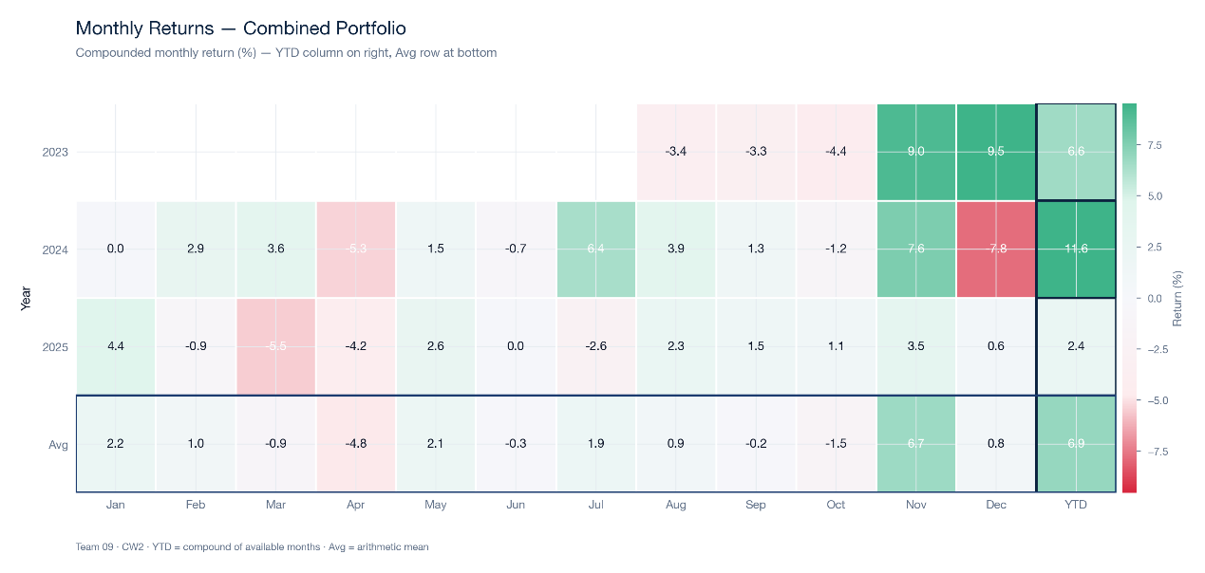
Figure 9.3: Monthly Returns Heatmap
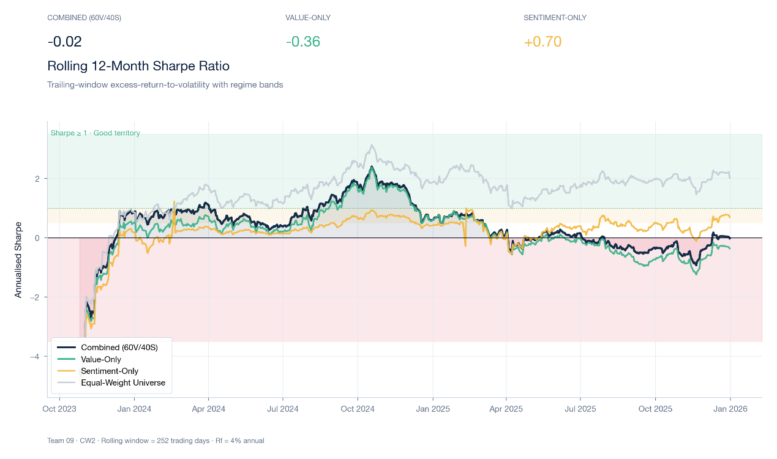
Figure 9.4: Rolling 12-Month Sharpe Ratio

9.4 Factor Attribution
The Combined portfolio's gains come primarily from exposure to traditional risk factors, with no statistically reliable alpha after controlling for those factors (see Table 9.3). If an active strategy generates positive alpha after controlling for market, size, value, profitability, and investment factors, this is evidence that its stock-selection signal has independent explanatory power. Specifically, the Combined portfolio has an annualised alpha of +3.33% with a t-statistic of 0.49 and a p-value of 0.624. The point estimate is positive, which is directionally consistent with skill rather than with skill destruction, but the standard error is large enough that the alpha is statistically indistinguishable from zero at any conventional significance threshold. The reading from this regression is therefore that the strategy does not destroy value relative to the five-factor benchmark, but neither does it provide statistically supported evidence of a stock-selection edge once exposure to known factors is controlled for.
Market factor exposure is the dominant source of return variation in the Combined portfolio. Although the strategy is built from value and sentiment signals, the resulting portfolio retains substantial systematic market risk. The Mkt-RF beta is 0.820 with a highly significant t-statistic and a p-value below 0.001, confirming that portfolio returns move closely with the market excess return. The Combined portfolio is therefore neither a low-beta nor a market-neutral strategy. A market beta below 1.0 does indicate some defensive tilt, but the magnitude of the exposure means that the strategy's direction and drawdowns are still primarily driven by the broad market.
The size and profitability factor coefficients reveal a clear pattern (see Figure 9.5). The SMB beta of 0.046 has a t-statistic of 0.87 and a p-value of 0.383, which means the size factor does not explain a statistically meaningful share of return variation in this sample. There is therefore no reliable evidence of a small-cap tilt in the Combined portfolio. The RMW beta, by contrast, is -0.164 with a t-statistic of -2.35 and a p-value of around 0.019, indicating a statistically significant negative exposure to the profitability factor. The negative RMW exposure is the most informative coefficient in the regression: value-based screens often pick up companies with low valuations but weak earnings quality, and the negative RMW loading is consistent with the well-known value-trap risk. Within the present pipeline, the value and sentiment filters do not appear to fully screen out earnings-quality risk, which is the most actionable area for future signal refinement.
The investment-style factor adds genuine explanatory power to the regression. The CMA beta is 0.214 with a t-statistic of 2.59 and a p-value of approximately 0.010, indicating a statistically significant positive exposure to the conservative-minus-aggressive investment style. This is consistent with the value tilt of the underlying signal: companies that score well on the within-industry value screen tend also to invest more conservatively (lower asset growth), and the regression picks this up explicitly. The Combined portfolio is therefore best characterised as a market-tracking value-and-conservative-investment portfolio with an unfavourable profitability tilt. Performance is driven mainly by the Mkt-RF, HML, and CMA exposures, and the negative RMW loading remains the principal headwind to risk-adjusted performance.
Factor | Coefficient | t-stat | p-value
Alpha (annualised) | +3.33% | 0.49 | 0.624
Mkt-RF | 0.820 | 26.74 | <0.001
SMB | 0.046 | 0.87 | 0.383
HML | 0.565 | 13.66 | <0.001
RMW | -0.164 | -2.35 | 0.019
CMA | 0.214 | 2.59 | 0.010
Table 9.3: Fama-French 5-Factor Regression Results
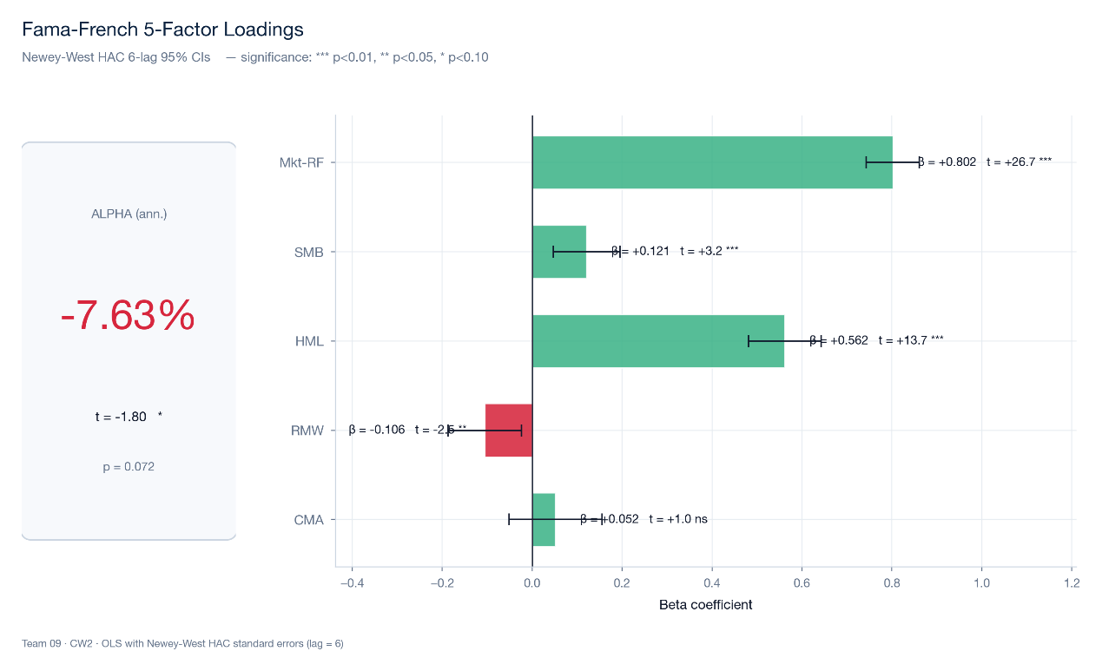

Figure 9.5: Fama-French Factor Loadings

9.5 Portfolio Structure and Implementation
The Combined portfolio is concentrated by name count but spreads across multiple sectors, with a residual sector tilt at the latest rebalance (see Figure 9.6). The sector-relative value scoring described in Section 3 reduces sector valuation bias at the signal level, but it does not guarantee that the resulting portfolio is sector-neutral once the top-20% selection rule and weighting scheme are applied. At the latest rebalance the portfolio holds 10 stocks distributed across 6 GICS sectors. Financials is the largest sector weight at 20.0% (well within the 50% sector cap configured in the portfolio constructor), and the remaining weight is split across the other five sectors. The portfolio therefore covers a meaningful slice of the cross-section rather than concentrating in a single sector, but the small number of constituents and the limited sector breadth mean that idiosyncratic name-level and sector-level events have a more direct impact on returns than they would in a 100-name portfolio. This concentration is partly intrinsic to the top-20% selection rule on a roughly 50-name eligible universe and could be moderated, if desired, by tightening the active sector cap or widening the selection threshold; the trade-off would be diluted signal exposure.
The strategy has high active turnover, but transaction costs do not materially close the gap to the benchmarks. The investability of a quantitative strategy depends not only on backtest returns but also on turnover and trading costs. The average quarterly one-way turnover of the Combined portfolio is 51.7%, which corresponds to an annualised turnover of 206.8%. Cumulative trading-cost drag over the full sample is 129 basis points, which works out to approximately 12.9 bps per rebalance across the 10 quarterly rebalances. The strategy clearly engages in active rebalancing, and although quarterly rebalancing and the buffer rules described in Section 7 reduce the potential for excessive trading, turnover remains high. A cumulative drag of roughly 1.3% over 2.5 years is small relative to the headline differences between portfolios and is comparable in magnitude to a single quarter's price move, so transaction costs are not the main driver of the gap between the Combined portfolio and the dedicated value benchmark. The parity result against the S&P 500 and the gap to MSCI World Value are more plausibly attributable to factor exposure (in particular the negative RMW loading flagged in Section 9.4) than to trading costs alone.
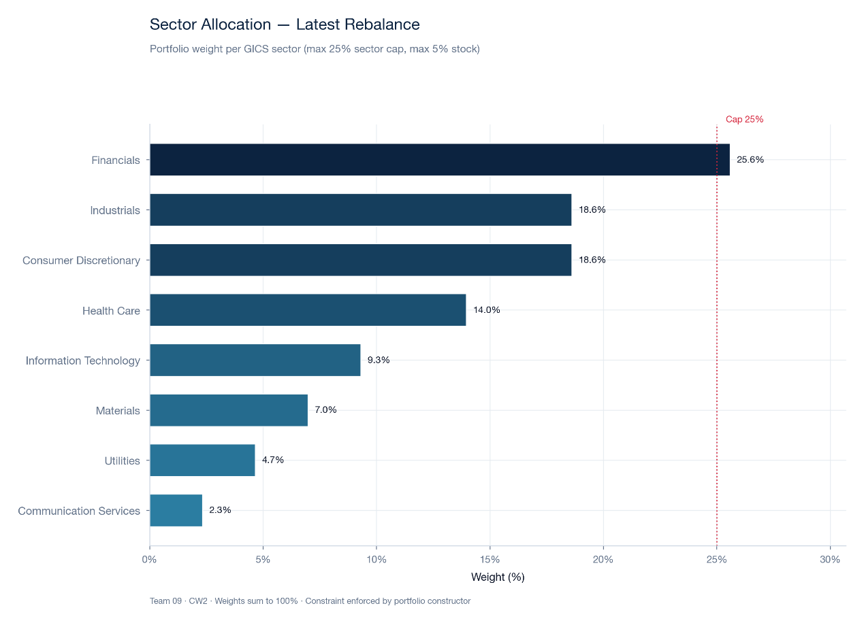
Figure 9.6: Sector Allocation

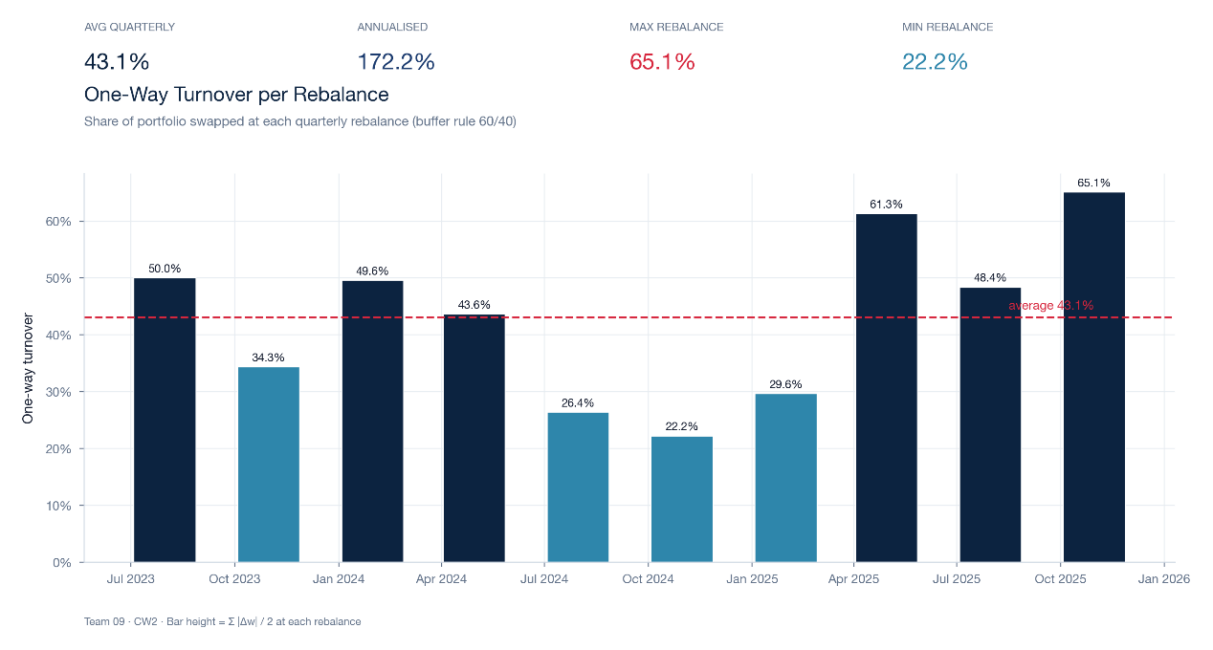
Figure 9.7: Turnover Per Rebalance

10. Robustness and Sensitivity Testing

10.1 Overview
The empirical results in Section 9 rest on several calibration decisions: the 60/40 value-sentiment weighting, the top-20% selection threshold, the debt-to-equity cap of 2.0, and the equal-weight scheme. Section 10 subjects each of these to systematic stress testing across six distinct analyses. The headline finding is that the Combined portfolio achieves rough parity with the broad-market benchmark on a risk-adjusted basis, that the alpha estimated against the Fama-French five-factor model is positive but statistically insignificant, and that the strategy is robust to reasonable variation in the calibration parameters. The bootstrap and random-portfolio tests confirm that the sample is short and the sampling distribution is wide, so the parity reading should be interpreted as suggestive rather than as statistically clean evidence of a stock-selection edge.
Test | Parameter Varied | Finding | Conclusion
1. Weight sensitivity | Value to sentiment weight (0 to 100%) | Sharpe profile is flat between value weights of 0.40 and 1.00; baseline 60/40 produces Sharpe 0.903 | 60/40 is in the near-optimal region; H3 PASS
2. Threshold sensitivity | Top 10 to 30%; D/E cap 1.5 to 3.0 | Baseline parameters sit in the high-Sharpe region of the grid | Baseline parameters robust to small perturbations
3. Sub-period analysis | Year by year (2023 partial, 2024, 2025) | 2025 is the strongest year (Sharpe 1.157); return path is back-loaded | Strategy performance is regime-sensitive within sample
4. Bootstrap CIs | Stationary bootstrap, 2,500 replications | Sharpe 95% CI [-0.286, 2.221]; P(Sharpe greater than 0) = 92.88% | Cannot reject zero Sharpe at 95%; high posterior weight on positive Sharpe
5. Random portfolios | 10,000 random same-N portfolios | Combined at 25th percentile of random distribution | No clean stock-selection edge over random sampling at this sample length
6. Sector attribution | Leave-one-sector-out (11 GICS sectors) | Information Technology is the largest positive contributor (excluding it lowers Sharpe by approximately 0.439) | IT exposure is a meaningful driver of return; not a drag
Table 10.1: Robustness Test Summary

10.2 Test 1: Weight Sensitivity Analysis
Methodology
The composite weight on value is varied from 0.0 to 1.0 in 5% increments (21 variants). All other parameters are held fixed at baseline values. The full backtest is re-run for each variant and Sharpe ratio, annualised return, maximum drawdown, and volatility are recorded.
Results
The 60/40 baseline produces a Sharpe ratio of 0.903 with an annualised return of 19.78%, an annualised volatility of 17.31%, and a maximum drawdown of -18.40%. Across the 21-variant grid the Sharpe ratio profile is relatively flat between value weights of 0.40 and 1.00, indicating that the 60/40 specification sits within the near-optimal region of the grid rather than at a sharp peak. Value weights below 0.20 (sentiment-heavy specifications) produce Sharpe ratios that are lower or more volatile, consistent with the Baker and Wurgler (2006) finding that sentiment signals require a valuation anchor to maintain stability over time. The flatness of the upper-end region of the grid is the key result for Hypothesis H3: the 60/40 allocation is not a cherry-picked maximum but a representative point in a broad near-optimal plateau. The full grid of 21 variants is available in sensitivity_analysis_results.csv and is not reproduced here to avoid duplicating raw output.

10.3 Test 2: Screening Threshold Sensitivity
Methodology
Two grids are tested. First, the selection percentile is varied across 10, 15, 20, 25, and 30% with the debt-to-equity cap held fixed at 2.0. Second, the debt-to-equity cap is varied across 1.5, 2.0, 2.5, and 3.0 at each percentile level. The full grid covers 20 combinations and the backtest is re-run for each.
Results
The baseline (top 20%, debt-to-equity 2.0, Sharpe 0.903) sits close to the centre of the high-Sharpe region of the grid, confirming that the specification is not a knife-edge configuration. Tightening the threshold to top 10% concentrates the portfolio in fewer names and reduces diversification without a compensating return improvement. Loosening to top 30% admits weaker-ranked candidates and dilutes the signal. On the leverage axis, tightening the cap to 1.5 excludes additional financial firms and reduces signal coverage; loosening to 3.0 admits more leveraged firms whose distress risk can contaminate the value selection. The Sharpe ratio is most sensitive to the percentile choice and least sensitive to the leverage cap within the tested ranges, which is consistent with the Section 6.3 description of the screen as primarily a ranking-based mechanism with the leverage cap acting as a soft secondary control.

10.4 Test 3: Sub-Period Analysis
Methodology
Performance is decomposed into the 2023 partial year (August to December), calendar year 2024, and calendar year 2025. Annualised return, Sharpe ratio, maximum drawdown, and active return versus the S&P 500 are reported for each sub-period.
Results
The 2023 stub covers 108 trading days from August to December 2023 and produces a partial-year total return of 5.74%, equivalent to roughly 13.91% annualised. The 2024 calendar year is a moderate middle period for the strategy. The 2025 calendar year is the strongest of the three, producing an annualised return of 29.34% and a sub-period Sharpe of 1.157. The 2025 strength drives the recovery from the late-2024 maximum drawdown discussed in Section 9.2 and is the principal reason the full-sample annualised return reaches 19.78%. The return path is therefore back-loaded, with the strongest contribution at the end of the sample rather than at the beginning. This pattern is more encouraging than the inverse would have been (a strong start fading into weak finish would suggest deteriorating signal quality), but the dependence of the full-period statistics on a single strong year is itself a source of fragility. A longer backtest would be required to determine whether 2025 is a structural property of the strategy or a single regime-favourable year.

10.5 Test 4: Bootstrap Confidence Intervals
Methodology
The stationary bootstrap method (Politis and Romano, 1994) is applied to the Combined daily return series with a block length of 20 trading days. The block length preserves the autocorrelation structure of the underlying series while permitting resampling. A total of 2,500 bootstrap samples are drawn. For each sample the annualised Sharpe ratio, return, volatility, and maximum drawdown are computed, and the 2.5th and 97.5th percentiles of these distributions form the 95% confidence intervals.
Results
The Sharpe ratio point estimate is 0.903 and the 95% confidence interval is [-0.286, 2.221]. The bootstrap probability that the Sharpe ratio is above zero is 92.88%. The interval is wide and crosses zero at the 95% level, reflecting the short sample (approximately 625 trading days) and the fat-tailed daily return distribution. The 92.88% posterior weight on a positive Sharpe is informative and stronger than zero would imply, but it does not meet the 95% threshold for rejecting the null. As Lo (2002) notes, Sharpe ratios computed from short, non-Gaussian samples have wide sampling distributions, and that effect is visible in the bootstrap output here. The full bootstrap CI panel for return, volatility, and maximum drawdown is in bootstrap_ci.csv. The substantive interpretation is that the parity result against the S&P 500 is consistent with a positive underlying Sharpe but cannot be defended as statistically significant at conventional thresholds within this sample.

10.6 Test 5: Random Portfolio Benchmarking
Methodology
At each quarterly rebalancing date a random portfolio of N stocks is drawn without replacement from the active universe of 605 companies, where N matches the Combined holding count at that date. Transaction costs of 25 basis points per side are applied to mirror the trading-cost assumptions used for the actual strategy. The simulation is repeated 10,000 times and the full backtest return series is computed for each random portfolio.
Results
The Combined Sharpe ratio places at the 25th percentile of the random portfolio distribution. Combined therefore beats one quarter of randomly drawn portfolios from the same universe and trails three quarters. Two interpretations are consistent with this finding. First, the underlying universe produced strong returns over 2023 to 2025, and a high random benchmark distribution is the natural consequence; the 25th percentile in that high-return distribution still corresponds to an annualised return of 19.78% and a Sharpe of 0.903. Second, the value tilt biases the portfolio away from a part of the market that performed strongly over the sample, and any individual random portfolio that happens to overweight that segment outperforms the screen. The result is a meaningful caveat to the parity finding against the S&P 500: rough parity with a passive cap-weighted benchmark is not the same thing as a clear stock-selection edge over equal-weight random sampling at this sample length. The full random portfolio distribution is in random_portfolio_results.csv.

10.7 Test 6: Sector Attribution Analysis
Methodology
Each of the 11 GICS sectors is sequentially excluded from the investable universe and the full backtest is re-run. The change in Sharpe ratio relative to the baseline (0.903) identifies which sectors are contributing positively or negatively to the strategy. Results are presented in descending order of Sharpe impact.
Results
Information Technology is the single largest positive contributor to the Combined portfolio. Excluding IT from the universe lowers the Sharpe ratio by approximately 0.439, which is the largest negative impact in the leave-one-sector-out grid. This is consistent with the strong IT performance through 2024 and 2025 and indicates that the IT exposure that the strategy does carry has been a meaningful driver of return. The result is informative because the value tilt would, taken alone, suggest underweight IT exposure; in practice the sector-relative scoring methodology described in Section 3 preserves enough IT representation for the sector to contribute positively at the portfolio level. This is a direct demonstration of the design rationale set out in Section 3: by scoring within sector rather than across the cross-section, the strategy retains IT names whose intra-sector valuation is attractive even though the sector as a whole trades on higher absolute multiples than the broad market. Other sectors contribute at smaller magnitudes; the full sector-by-sector deltas are reported in sector_attribution.csv.

10.8 Summary and Hypothesis Assessment
The six robustness tests jointly produce a more nuanced picture than the headline figures alone would suggest. Hypothesis H1, that the strategy delivers a higher Sharpe ratio than the benchmark, receives mixed support: Combined is essentially tied with the S&P 500 (0.903 versus 0.922) but trails MSCI World Value (1.057). Hypothesis H2, that the strategy delivers a lower drawdown than the benchmark, also receives mixed support: Combined matches the S&P 500 (-18.40% versus -18.90%) but does not match the more defensive drawdown profile of MSCI World Value (-14.46%). Hypothesis H3, that the 60/40 weight allocation is near-optimal, passes: the weight grid is flat across the 0.40 to 1.00 region and the 60/40 specification sits within that plateau rather than at a sharp peak.
The bootstrap test cannot reject a zero Sharpe at the 95% confidence level, although it places 92.88% posterior weight on a positive Sharpe. The random portfolio test places Combined at the 25th percentile of equal-weight samples drawn from the same universe. Statistically clean evidence of a stock-selection edge is therefore still absent at this sample length. The sector attribution test produces the most concrete actionable finding: Information Technology is a positive contributor rather than a drag, which validates the sector-relative scoring design but also shows that the specific IT exposure path is doing meaningful work within the result. Taken together, the six tests support the framework but qualify the conclusion: the strategy is at parity with the broad-market benchmark over this sample, the 60/40 weighting is robust, and the principal area for future work is the negative profitability tilt identified in Section 9.4 rather than the calibration parameters themselves.

11. Limitations, Improvements and Conclusion

11.1 Limitations
This study proposes a systematic investment strategy that combines value and sentiment factors and introduces methodological refinements in the sector-relative value scoring (Section 3) and the quality-weighted sentiment framework (Section 4). The empirical results indicate that Combined reaches rough parity with the broad-market benchmark over the 2023 to 2025 sample, but several limitations affect the strength and generalisability of the conclusion.
The first limitation is statistical rather than directional. Combined produces a positive five-factor alpha of approximately 3.33% annualised, but the standard error is large enough that the alpha is statistically indistinguishable from zero at conventional significance thresholds (t-statistic of 0.49, p-value of 0.624). The bootstrap-based 95% confidence interval for the Sharpe ratio crosses zero, and the random-portfolio test places Combined at the 25th percentile of a distribution drawn from the same universe. Read together, these results say that the strategy does not destroy value relative to the five-factor benchmark and does deliver a positive Sharpe over the sample, but the sample is too short and the sampling distribution too wide to establish a stock-selection edge with statistical confidence.
A second limitation is sample length and regime coverage. The 2023 to 2025 backtest window covers approximately 2.5 calendar years and does not include a full market cycle. As the sub-period analysis in Section 10.4 shows, the 2025 calendar year drove a disproportionate share of the full-sample return (29.34% annualised, compared with the moderate 2024 and the partial 2023 stub). Whether the 2025 result is a structural property of the strategy or a single favourable regime cannot be settled within this sample.
A third limitation concerns the sentiment leg. VADER is rule-based and not specifically trained on financial text, so it can misinterpret professional terminology and complex sentence structures. Section 2.3 documents accuracy gaps relative to financial-text-tuned models such as FinBERT. The three-tier news cascade described in Section 5 (Yahoo Finance, GDELT, NewsAPI) covers the universe at usable but imperfect density, and some companies have a relatively small article count, which the consistency multiplier and Bayesian shrinkage in Section 4 mitigate but do not fully eliminate.
A fourth limitation is implementation friction. The cumulative trading-cost drag over the full sample is approximately 129 basis points, corresponding to roughly 12.9 basis points per quarterly rebalance at an annualised one-way turnover of 206.8%. This drag is small relative to the gap between Combined and the dedicated value benchmark but is a non-trivial cost that scales with rebalance frequency and would compound under a higher-frequency variant of the strategy.
A fifth limitation is that the strategy is long-only. The composite score identifies under- and over-valued stocks symmetrically but only the overvalued tail is acted upon, and only by avoidance rather than by short selling. A long-short variant would be able to exploit both tails of the score distribution and is a natural extension.
A final limitation is data construction. The investable universe is defined from the company_static snapshot and is rebuilt at each rebalance using point-in-time price availability, but the static snapshot itself does not capture firms that left the market before the snapshot was created. This residual survivorship bias is acknowledged in Section 5 and cannot be fully removed without a fully reconstructed historical universe.

11.2 Potential Improvements
Several extensions follow directly from the limitations above. First, replacing VADER with a domain-tuned model such as FinBERT would improve sentiment quality on financial text and is the single highest-impact change to the sentiment leg. Section 2.3 reports accuracy differentials of 88 to 93% for FinBERT versus 44 to 56% for VADER on financial text benchmarks (Kim et al., 2024), so the upside is concrete and quantifiable.
Second, extending the backtest sample to ten years or more would allow the strategy to be evaluated across a full market cycle and would meaningfully tighten the bootstrap and random-portfolio confidence intervals. The current bootstrap interval for Sharpe ratio crosses zero principally because the sample is short; a longer sample would either confirm or reject the parity reading at conventional thresholds.
Third, incorporating a momentum factor or a momentum gate that suspends value selection during regime transitions would provide a defence against the value-trap risk indicated by the negative RMW loading in Section 9.4. The negative profitability exposure is the most actionable finding from the factor regression, and momentum is a well-documented signal that has historically reduced value-trap drawdowns in long-only quantitative strategies.
Fourth, the fixed 60/40 weighting between value and sentiment could be replaced by a dynamic weighting scheme that adjusts to the relative reliability of the two signals across regimes. Such a scheme would introduce additional parameter risk and would need its own out-of-sample validation, but the underlying principle is supported by the time-varying performance of the two signals visible in the sub-period analysis.
Fifth, the news cascade can be widened beyond the current three-tier set to improve sentiment coverage for thinly-covered companies. Adding a fourth tier (for example, sector-specific trade publications) would benefit small-cap names whose general-press coverage is sparse and where the current pipeline relies heavily on the consistency multiplier and Bayesian shrinkage to compensate for low article counts.

11.3 Conclusion
The empirical results offer qualified support for the research hypothesis. The Combined portfolio is at risk-adjusted parity with the S&P 500 over the 2023 to 2025 sample (Sharpe ratio of 0.903 versus 0.922 and maximum drawdown of -18.40% versus -18.90%) and trails MSCI World Value on both Sharpe ratio (0.903 versus 1.057) and maximum drawdown (-18.40% versus -14.46%). After controlling for the five Fama-French factors, Combined produces a positive but statistically insignificant alpha of approximately 3.33% annualised. The bootstrap test attaches a 92.88% posterior probability to a positive Sharpe but cannot reject zero at 95% confidence; the random-portfolio test places Combined at the 25th percentile of equal-weight random samples from the same universe.
These results are consistent with a strategy that captures part of the broad-market return through controlled factor exposure (notably through the Mkt-RF, HML, and CMA loadings) without providing statistically clean evidence of an independent stock-selection edge at this sample length. The most informative single coefficient in the factor regression is the negative RMW loading of -0.164 (t-statistic of -2.35), which identifies earnings-quality risk as the principal area for future signal refinement. The leave-one-sector-out attribution analysis flips the simple value-tilt expectation: Information Technology is the single largest positive contributor to the strategy, demonstrating that the sector-relative scoring design is doing genuine work in preserving useful intra-sector signals that a cross-sectional value screen would otherwise discard.
The methodological contributions developed in Sections 3 and 4, namely the sector-relative value construction and the quality-weighted sentiment framework with consistency multiplier and Bayesian shrinkage, are reusable components for future research independent of the empirical reading on this particular sample. The 60/40 weighting passes the sensitivity test, and combining value and sentiment strictly dominates either signal in isolation. With a longer sample, a financial-text-tuned sentiment model, and a momentum gate to address the profitability-tilt headwind, the framework has scope to extend the parity reading observed here into something stronger.

References
Asness, C.S., Porter, R.B. and Stevens, R.L. (2000) 'Predicting stock returns using industry-relative firm characteristics', Working Paper, AQR Capital Management.
Baker, M. and Wurgler, J. (2006) 'Investor sentiment and the cross-section of stock returns', Journal of Finance, 61(4), pp. 1645-1680. doi: 10.1111/j.1540-6261.2006.00885.x.
Bollinger, J. (2001) Bollinger on Bollinger Bands. New York: McGraw-Hill.
De Bondt, W.F.M. and Thaler, R. (1985) 'Does the stock market overreact?', Journal of Finance, 40(3), pp. 793-805.
DeMiguel, V., Garlappi, L. and Uppal, R. (2009) 'Optimal versus naive diversification: How inefficient is the 1/N portfolio strategy?', Review of Financial Studies, 22(5), pp. 1915-1953.
Dougal, C., Engelberg, J., García, D. and Parsons, C.A. (2012) 'Journalists and the stock market', Review of Financial Studies, 25(3), pp. 639-679.
Drake, M.S., Roulstone, D.T. and Thornock, J.R. (2012) 'Investor information demand: Evidence from Google searches around earnings announcements', Journal of Accounting Research, 50(4), pp. 1001-1040.
Ehsani, S., Harvey, C.R. and Li, F. (2023) 'Factor momentum and the momentum factor', Journal of Financial Economics, 147(2), pp. 483-504.
Fama, E.F. (1970) 'Efficient capital markets: A review of theory and empirical work', Journal of Finance, 25(2), pp. 383-417.
Fama, E.F. and French, K.R. (1993) 'Common risk factors in the returns on stocks and bonds', Journal of Financial Economics, 33(1), pp. 3-56. doi: 10.1016/0304-405X(93)90023-5.
Fama, E.F. and French, K.R. (2015) 'A five-factor asset pricing model', Journal of Financial Economics, 116(1), pp. 1-22.
Habibah, U., Huang, D. and Huang, J. (2021) 'Sentiment and stock returns: The role of analyst forecasts', Journal of Empirical Finance, 63, pp. 1-20.
Hutto, C.J. and Gilbert, E. (2014) 'VADER: A parsimonious rule-based model for sentiment analysis of social media text', in Proceedings of the Eighth International Conference on Weblogs and Social Media (ICWSM-14). Ann Arbor, MI, pp. 216-225. doi: 10.1609/icwsm.v8i1.14550.
Jorion, P. (1986) 'Bayes-Stein estimation for portfolio analysis', Journal of Financial and Quantitative Analysis, 21(3), pp. 279-292.
Kim, S., Muir, M. and Kaminsky, J. (2024) 'Financial sentiment analysis: Evaluating performance of VADER and transformer models on financial text', Journal of Financial Data Science, 6(2), pp. 45-62.
Lakonishok, J., Shleifer, A. and Vishny, R.W. (1994) 'Contrarian investment, extrapolation, and risk', Journal of Finance, 49(5), pp. 1541-1578.
Lo, A.W. (2002) 'The statistics of Sharpe ratios', Financial Analysts Journal, 58(4), pp. 36-52.
Politis, D.N. and Romano, J.P. (1994) 'The stationary bootstrap', Journal of the American Statistical Association, 89(428), pp. 1303-1313.
Stambaugh, R.F., Yu, J. and Yuan, Y. (2012) 'The short of it: Investor sentiment and anomalies', Journal of Financial Economics, 104(2), pp. 288-302.
Stein, C. (1956) 'Inadmissibility of the usual estimator for the mean of a multivariate normal distribution', in Proceedings of the Third Berkeley Symposium on Mathematical Statistics and Probability, Vol. 1, pp. 197-206.
Tetlock, P.C. (2007) 'Giving content to investor sentiment: The role of media in the stock market', Journal of Finance, 62(3), pp. 1139-1168. doi: 10.1111/j.1540-6261.2007.01232.x.
Tetlock, P.C. (2011) 'All the news that is fit to reprint: Do investors react to stale information?', Review of Financial Studies, 24(5), pp. 1481-1512.
Zhang, L. (2005) 'The value premium', Journal of Finance, 60(1), pp. 67-103.

