Preliminary analysis of the Icelandic Gyrfalcon CMR dataset

Frederic Barraquand, Olafur Nielsen

November 6, 2017

Here I attempt to explore the CMR dataset, before we go to inferential models to estimate survival and perhaps link this to an integrated pop. model.

## Basic statistics

How many birds have been ringed?

dringed<-read.csv("Gyrs_ringed.csv")  
head(dringed) # What's in the data table

## Program RingNo Species ColourRing RingerCode Ringer  
## 1 REYK 14499 Fálki 32 Finnur Guðmundsson  
## 2 REYK 2451 Fálki 62 Helgi Þórarinsson (eldri)  
## 3 REYK 2452 Fálki 62 Helgi Þórarinsson (eldri)  
## 4 REYK 2453 Fálki 62 Helgi Þórarinsson (eldri)  
## 5 REYK 32671 Fálki 88 Hallgrímur Sæmundsson  
## 6 REYK 21602 Fálki 97 Tryggvi Eyjólfsson  
## RingingDate SiteID AgeCode Age SEX  
## 1 7/31/1954 3376 202 Eldisungi 0  
## 2 7/8/1940 703 101 Ófleygur ungi í hreiðri 0  
## 3 7/8/1940 703 101 Ófleygur ungi í hreiðri 0  
## 4 7/8/1940 703 101 Ófleygur ungi í hreiðri 0  
## 5 9/28/1943 3437 460 Fullvaxinn (1. árs+) 0  
## 6 9/12/1958 1743 100 Ófleygur ungi 0  
## Notes  
## 1 Tekinn úr hr. alinn til útflutnings á Ystafelli, S-Þing.  
## 2   
## 3   
## 4   
## 5   
## 6

length(unique(dringed$RingNo)) #How many unique bird IDs

## [1] 1738

OK, so we have a little more than 1700 unique IDs. Isn't this much compared to the total population?

Let's compare to how many gyrs have been recovered.

drecov<-read.csv("Gyrs_recovered.csv")  
length(unique(drecov$RingNo)) #How many unique bird IDs in Gyrs_recovered.csv

## [1] 274

Let's now analyse the number of birds that have been ringed as a function of the year

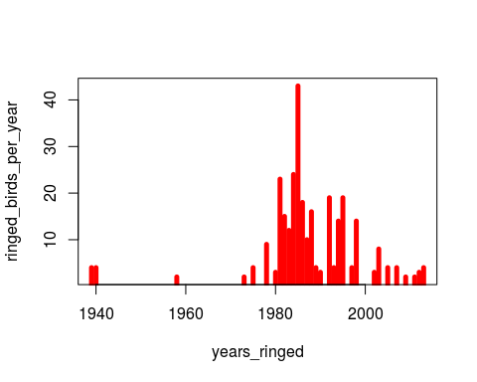

We now analyse the patterns of recovery (and resighting)

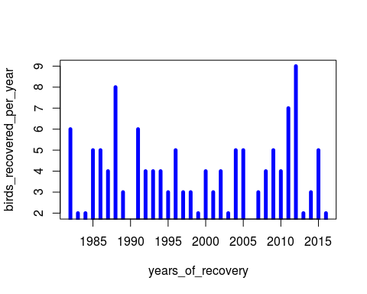

Now how many birds have been seen several times? We see below that very few birds have been recovered more than once (also this tends to be recent?).

|  |
| --- |
| **Question: when did the change from recovery of dead birds to resighting of live birds occur?** |

I can infer the earliest date at which a bird has been resighted a second time, but given few birds have been resighted, but it might be preferable to allow later for a change in protocol (in the CMR models) using a predefined time (we can use several if unsure). I have noted 2006 earlier but I am unsure.

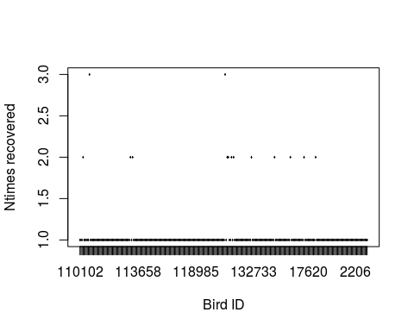

## ntimes_recovered  
## 1 2 3   
## 260 12 2

Thus for all practical purposes, we can consider that such data consists mainly of individual that are either recovered or not recovered/resighted. We'll now turn to whether the individuals have been found live or dead, and how this varies in time.

Also whether the recoveries of dead birds are of young vs. adult birds (which may provide quick and dirty estimates of survival rates, at least for the youngs...)

table(drecov$RecoveryCode) ## these are all the recovery codes that we have (top row), and how many of those we have in the dataset (bottom row). For instance, we can see 15 read colourmarks. We need to simplify this complexity to some extent by aggregating some values.

##   
## 0 100 110 115 116 117 118 119 120 121 122 123 124 125 130   
## 3 23 7 8 3 5 4 17 26 4 1 7 2 2 4   
## 131 146 190 210 216 226 291 292 296 352 605 620 621 622 625   
## 2 21 6 1 1 2 5 1 1 1 1 4 10 3 2   
## 626 630 631 632 633 635 641 643 644 650 651 680 761 805 810   
## 2 4 3 2 1 1 1 1 1 1 1 1 1 1 1   
## 820 852 870 981 982 995 996 1030 1031 1035 1080 1085 1086 4500 4800   
## 1 5 1 2 6 4 6 3 2 2 1 2 1 2 1   
## 4820 5600 5601 5621 5700 6000 6220 6280 6281 6400 6500 6510 6800 6810 6815   
## 1 3 1 2 15 3 5 1 6 1 2 1 1 2 2   
## 6860 6871 6872 6873   
## 2 1 1 2

*Now we need some more info on the codes, I'm attempting below to fill this gap but may need some help*

|  |  |
| --- | --- |
| AGE Code | Meaning |
| 100 | unfledged young |
| 101 | unfledged young at the nest |
| 501 | adult at the nest |

|  |  |
| --- | --- |
| RECOVERY Code | Meaning |
| 100 | found dead |
| 120 | found dead for a long time |
| 121 | found dead with one tag only? |
| 146 | found dead just outside the nest |
| 5700 | read colourmark |
| 981,996 | found injured and had to kill it |