*Contract Details*

**RFQ System Development (WebApp)**

Language :                C#.NET (Visual [Studio.NET](http://studio.net/) 2008)

Data Base (Back End):                 Microsoft SQL Server (2008 or higher)

**Scope**

The scope of an RFQ System defines which needs it addresses, including requester entry form, managers approval form, purchasing review form, collation of quotations and other functionalities. The value of the system at the end of successful transactions provides a collection of quotations from different suppliers indicate which is best based on price and delivery lead time. Measuring the change in RFQS allows the company to determine the cost of items per quotation. Together, system values and level changes allow the company to plan for future RFQS needs.

**Scope Details Per Transaction**

|  |  |
| --- | --- |
| **Transaction Name** | **Scope** |
| Requester Entry | User can create, update or edit request but doesn't have capability to delete the created request. User can also retrieve previous request to eliminate re-entry but with a new request number. This entry is an auto-generate request number based on the last record plus one . |
| Requester Inquiry | User can view all his/her request by entering RFQ Number, Creation Date (From - To). This is used to monitor the status of the request hence transaction update involved. (For viewing purposes only) |
| Manager Approval | Manager can view all the submitted requests in order to check all the items and has the responsibility to approve and disapprove the request/s. Approved request will be submitted to Purchasing Department for approval. If disapproved, the Manager will put remarks then the request entry will be automatically go back to the requester for review. |
| Purchasing Approval | Purchasing Personnel can view all the request entries created by the requesters and even the status made by the Managers whether approved or disapproved. He/she has also the responsibility to approve or disapprove any request from the Managers. If disapproved, he/she will put remarks then the request entry will be automatically go back to the Manager for review. If approved, request entry will become a quotation. The quotation will be sent to different possible suppliers through *system email functionality.* |
| Supplier RFQS Response | This will allow the supplier to review the quotation. As a response, supplier must input the price, lead time and remarks then send it back to Purchasing for collation. ***(Note: Still thinking for the separate page or form of supplier response entry)*** |
| Purchasing Collation | Reply emails or responses to the quotation from the possible suppliers will be received through *system email functionality.* This will be transferred to *RFQS Database.* Purchasing Personnel can now view the responses of possible suppliers regarding the quotation.  He/She may now differentiate all the responses and finally select a supplier for the specific quotation. Send back the quotation to supplier being selected. Unselected suppliers will receive *Thank You!* reply. |
| Department Maintenance | This must be an appointed Admin. Admin can create and update department table, and view list of all departments. |
| Division Maintenance | User can create and update division table. User can also view list of all division. This can be done only by appointed admin or personnel. User must have an admin account in Login Account Maintenance. Delete is allowed only if no existing record in other tables or this division is never been used. |
| Section Maintenance | User can create and update section table. User can also view list of all section. This can be done only by appointed admin or personnel. User must have an admin account in Login Account Maintenance. Delete is allowed only if no existing record in other tables or this section is never been used. |
| Login Account Maintenance | User can create, delete and update login table. User can also view list of all logins except the password. This can be done only by appointed admin or personnel. User must have an admin account in Login Account Maintenance. |
| Admin Email Account Maintenance | User can update the account credentials of dedicated email for sending and receiving quotation/s from Purchasing to suppliers and vice versa. Only the MIS Section has the access on this one. |

**Process Model**

For this project, I plan to use waterfall as a process model. The waterfall model is a sequential design process, often used in software development processes, where the progress is seen as flowing steadily downwards (like a waterfall) through the phases of Conception, Initiation, Analysis, Design, Construction, Testing and Maintenance.

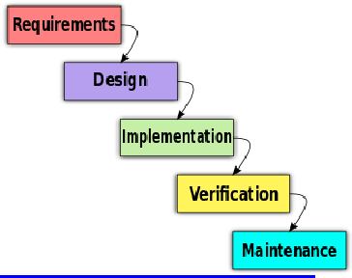

**Milestone**

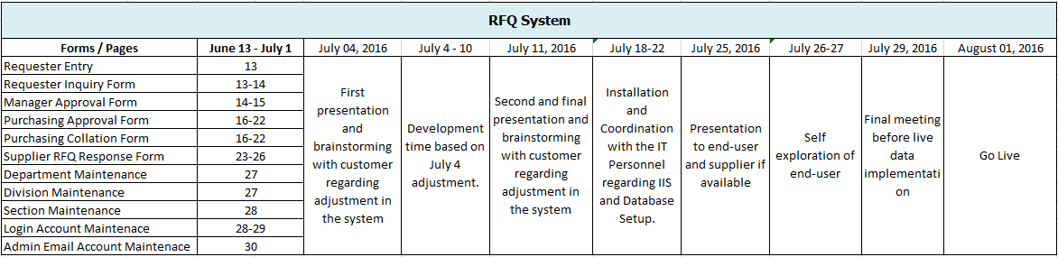

**Terms of Payment**

Contract Price:         **Php 150,000**

**50 %( 75,000)**             **Down payment**

                                    Starting System Development

  Analyzing Requirements and coordination with product owner

**50% (75,000)**            **Final Payment**

                                    After system installation and implementation including 10 working days pilot testing w/ live data.

Note :

* *2 months maintenance free of charge considering all routines satisfying client requirements based on system scope.*
* ***Monthly technical support is optional for Php 10,000 per month (1 year initial contract)***

We’re looking forward for this project.

Thank you very much for your trust!

**Additional Note / Request**

Due to some problem that we encountered like sending/receiving email via intranet, internet connection and volume of request we forced to move the go live implementations of this project. I am requesting in your good office for payment adjustment of **Php 100,000** for this project. Please refer to attached payment adjustment letter for details.

Prepared by : Approved By:

**FERDIE R. MANGALIMAN Name**

Consultant Position

**ROHM Philippines**