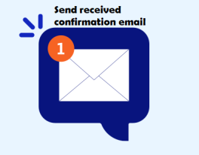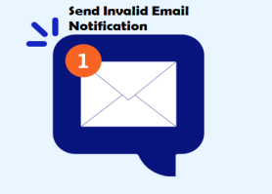

3

**Update Response to DB**

YES

**Is buyer approved?**

NO

**Do Nothing**

NO

YES

3

**Store Reponses to Database**

**Is New Response?**

2

NO

**Get csv response**

YES

**Is VALID?**

**Check Email Subject and csv attachment**

YES

**Check if csv is for URF,DRF,CRF OR ERFO**

**Is CSV?**

NO

1

NO

**Get pdf response**

YES

2

NO

**Is VALID?**

**Check Email Subject and pdf attachment**

YES

**Is PDF?**

NO

3

**Store Reponses to Database**

NO

**Do Nothing**

YES

**Is buyer approved?**

NO

1

2

3

AZURE (RFQS Email)

**Store Reponses to Database**

YES

3

**Get xml response**

**Is New Response?**

2

NO

YES

**Is VALID?**

**Check Email Subject and xml attachment**

YES

**Is XML?**