**2024-2025**



**Information Systems Engineering**

**Deepartment**

**Team 10**

Batuhan ŞEN

Elinsu ÇİFTCİ

İbrahim Görkem ÖZÇiÇEK

Seda KOCOĞLU



**App Project Report**



Fall,2024

**BOYNER Kids App Project**

**Members**

Batuhan ŞEN – [sen.batuhan@student.atilim.edu.tr](mailto:sen.batuhan@student.atilim.edu.tr)   
Elinsu ÇİFTCİ – [ciftci.elinsu@student.atilim.edu.tr](mailto:ciftci.elinsu@student.atilim.edu.tr)   
İbrahim Görkem ÖZÇiÇEK – [ozcicek.ibrahimgorkem@student.atilim.edu.tr](mailto:ozcicek.ibrahim@student.atilim.edu.tr)   
Seda KOCAOĞLU – [kocaoglu.seda@student.atilim.edu.tr](mailto:kocaoglu.seda@student.atilim.edu.tr)

**Instructor**

Mehtap TUFAN – [mehtap.tufan@atilim.edu.tr](mailto:mehtap.tufan@atilim.edu.tr)

**Abstract**

This project focuses on an e-commerce system developed using PHP, MySQL, JavaScript, CSS, and HTML. The aim is to provide a modern e-commerce platform with product catalogs, order management, and user interface functionalities. The project offers a flexible and versatile design for both end-users and administrators.

**Keywords**

E-commerce, PHP, MySQL, User Interface, Web Development, Order Management.

1. **Introduction**

This project is designed as an e-commerce platform where users can view product details, manage their cart, and perform payment operations. The project includes the following main modules:

The project is an e-commerce web application developed using PHP, MySQL, JavaScript, CSS, and HTML. The main structure consists of the following components:

• **User Management:** Handles user login/logout, profile editing, and password resetting.

-*login.php:* User login authentication.

-*logout.php:* Handles session termination and redirection.

-*reset-password.php:* Manages user password reset requests.

-registration.php: Handles new user registration and data validation.

• **Product and Order Management:** Includes adding, editing, deleting products, and tracking orders.

-*product-add.php:* Adding new products with validation.

-*product-delete.php:* Deletes products from the database and file system.

-*checkout.php:* Manages user payment processes.

• **Category Management:** Handles the addition, editing, and deletion of categories.

-*mid-category-add.php:* Manages middle category operations.

-*top-category.php:* Manages main category operations.

• **Admin Panel:** Provides tools for system management and control.

-*dashboard.php:* Main page of the admin panel showing general status and summary information.

*-customer.php:* Manages customer information.

*-order.php:* Tracks and updates order statuses.

• **Security and Helper Functions:**

-CSRF_Protect.php: Ensures CSRF protection for form security.

-functions.php: Includes helper functions such as file extension validation and automatic ID retrieval.

-*database.php:* Establishes secure database connections using PDO.

1. **Literature Review**

E-commerce systems play a critical role in the digital transformation process of modern companies. Various studies highlight that features such as product catalogs and order management are key to success in e-commerce businesses.

1. **Methodology**

The project development process covered the following components:

1. Hardware Requirements:

- Local server (e.g., XAMPP)

- Computer with 8GB RAM or more

2. Software Requirements:

- PHP 7.4 or above

- MySQL database

- HTML5 and CSS3

- JavaScript ES6

3. System Architecture and Techniques:

- Secure database operations using PDO

- Dynamic product filtering

- CSRF protection

1. **Results and Discussion**

1. Project Management:

The project timeline and work packages were successfully completed. Frameworks and template systems accelerated the development process.

2. Final Product:

The product meets the expected functionalities.

3. Test Results:

- Error rate observed in tests: 3%

4. Limitations and Constraints:

- Mobile compatibility has not yet been optimized.

1. **Future Considerations**

1. Develop responsive designs for mobile devices.

2. Integrate more modern user interface designs.

3. Include additional security protocols.

1. **Conclusion**

This project successfully achieved its goal of creating a basic e-commerce platform and provided an infrastructure open to further development.

**References**

• Boyner. (n.d.). Children's Section. Boyner. Retrieved from <https://www.boyner.com.tr/cocuk-c-3>

• W3Schools. (n.d.). JavaScript Tutorial. W3Schools. Retrieved from <https://www.w3schools.com/js/>

• BTK Akademi. (n.d.). JavaScript Basics. BTK Akademi. Retrieved from <https://www.btkakademi.gov.tr/portal/course/javascript-temelleri-25317>

• W3Schools. (n.d.). HTML Tutorial. W3Schools. Retrieved from <https://www.w3schools.com/Html/>

• BTK Akademi. (n.d.). Web Development with HTML5. BTK Akademi. Retrieved from <https://www.btkakademi.gov.tr/portal/course/html5-ile-web-gelistirme-13200>

• W3Schools. (n.d.). PHP Tutorial. W3Schools. Retrieved from <https://www.w3schools.com/php/>

• BTK Akademi. (n.d.). PHP Training. BTK Akademi. Retrieved from <https://www.btkakademi.gov.tr/portal/course/php-6509>

• YouTube. (2020, May 18). PHP Lessons - YouTube Education Series [Video]. YouTube. Retrieved from <https://www.youtube.com/watch?v=PVTa1HZwLGw&list=PL5HkP8Ta9WU_rgrBqJV4W6uRWChgetXgv>

• YouTube. (2019, March 27). PHP Education Series [Video]. YouTube. Retrieved from <https://www.youtube.com/watch?v=m52ljs78S24&list=PL0eyrZgxdwhwwQQZA79OzYwl5ewA7HQih>

• YouTube. (2019, February 12). PHP Beginner Training [Video]. YouTube. Retrieved from <https://www.youtube.com/watch?v=-1DTYAQ25bY>

• YouTube. (2021, October 14). PHP Programming Language Fundamentals [Video]. YouTube. Retrieved from <https://www.youtube.com/watch?v=OHcMNNV5V6k>

**Appendices**

1. User Interface Screenshots:

- Homepage

- Product Details Page

2. System Flow Diagrams:

- User Registration Flow

- Order Payment Flow

3. E-R and SQLs

4. Test Log

# Appendices

## User Interface Screenshots

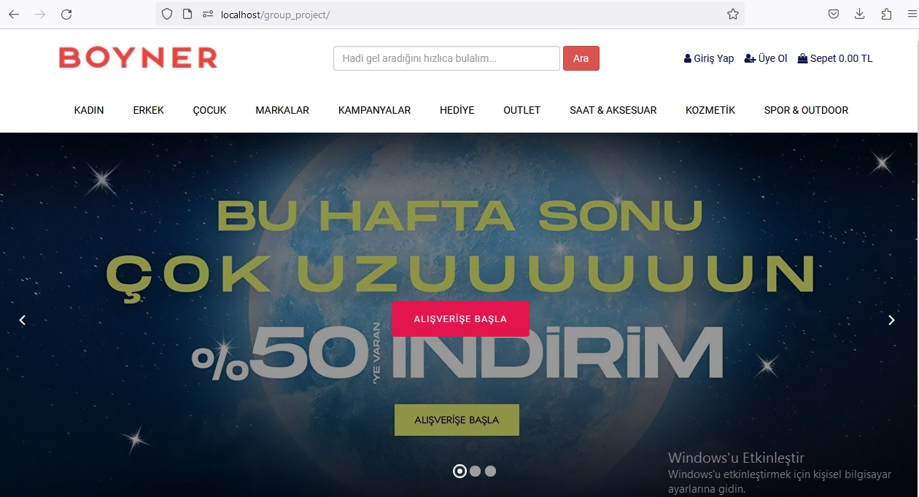

Homepage

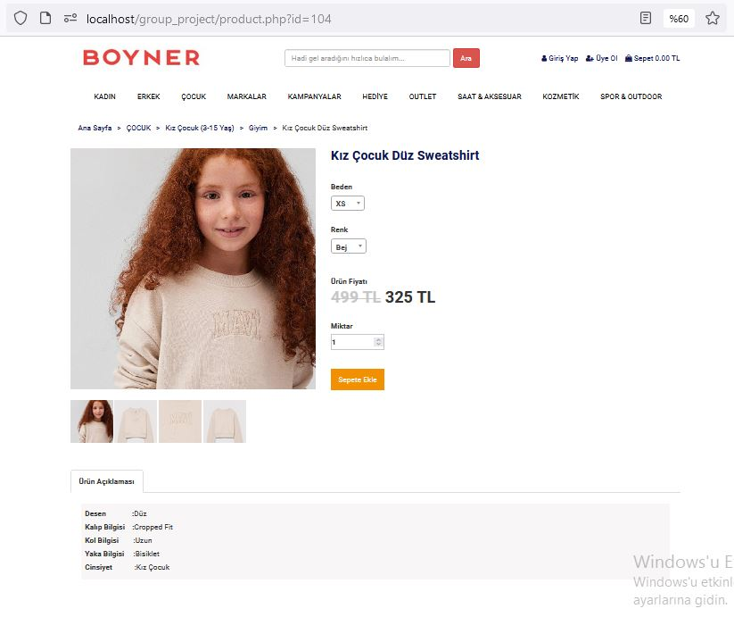

Product Details Page

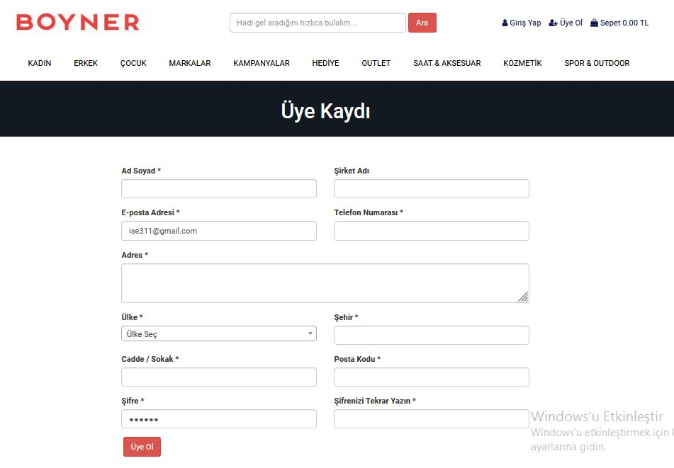

User Registration Page

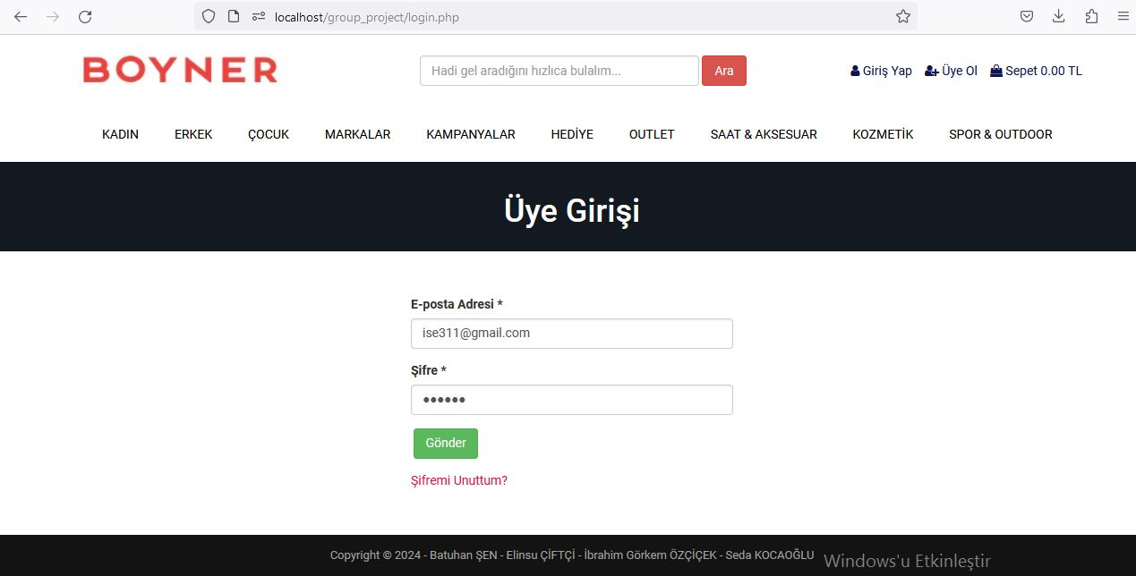

User Login Page

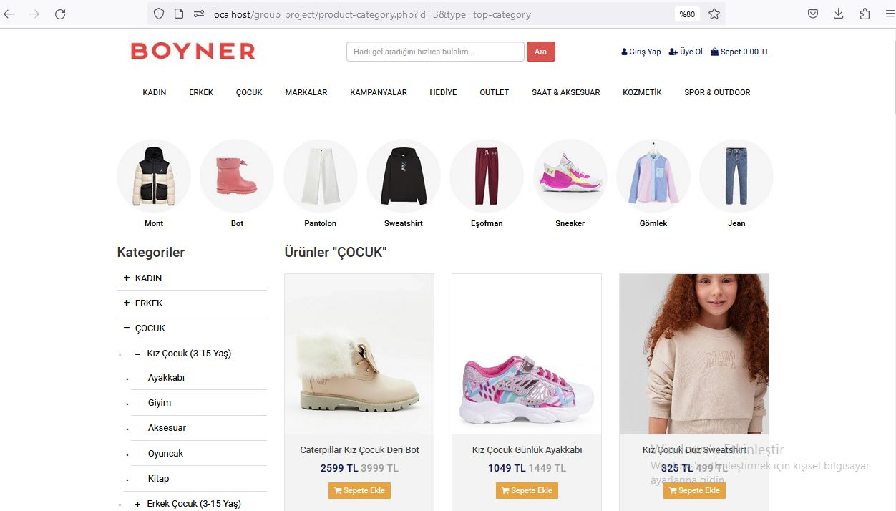

Category Menu

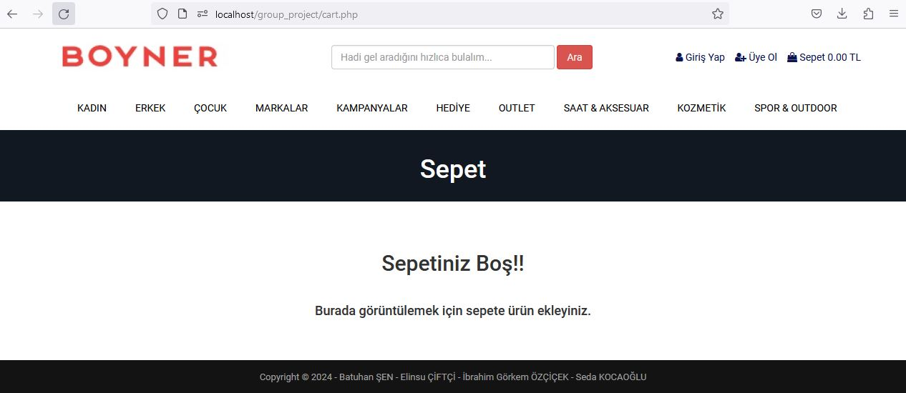

Shopping Cart Page

## System Flow Diagrams

1. User Registration Flow

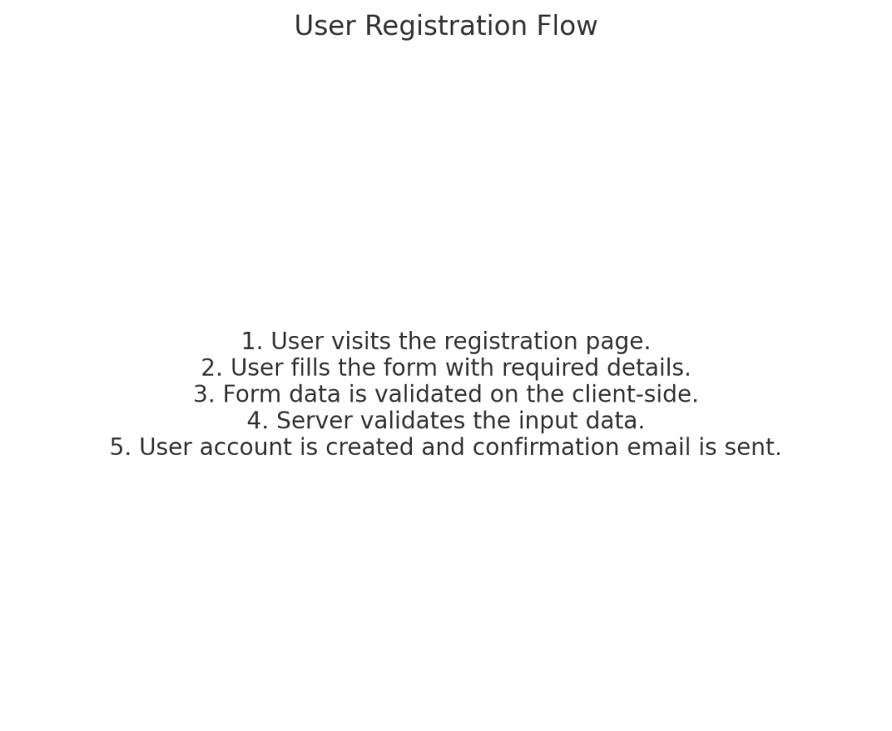

Figure: User Registration Flow Diagram

2. Order Payment Flow

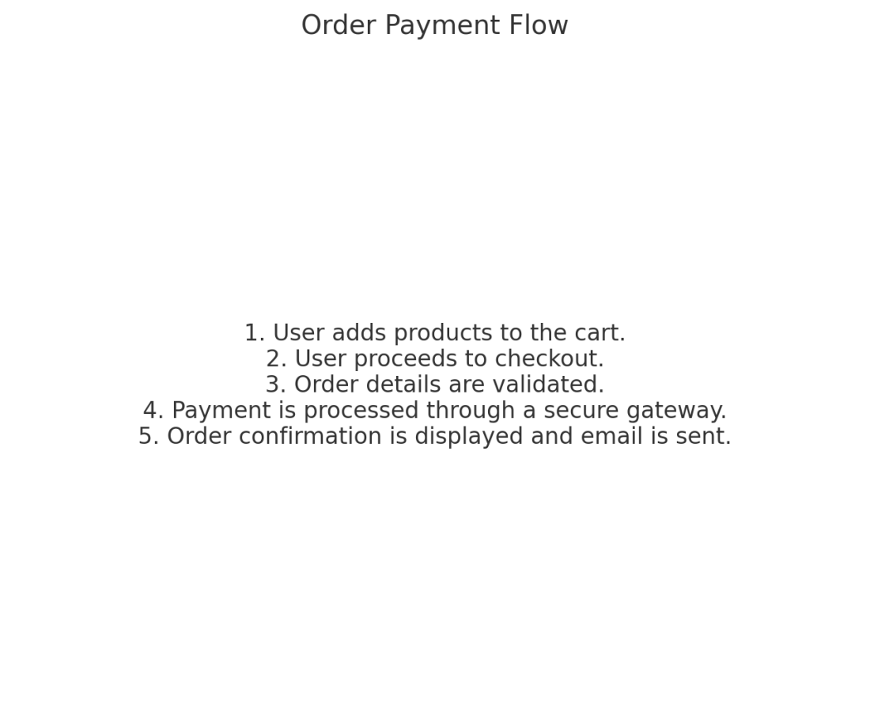

Figure: Order Payment Flow Diagram

## E-R and SQLs

