Virtual reality

The introduction of virtual reality

[https://www.youtube.com/watch?v=gWLHIusLWOc](https://wx.qq.com/cgi-bin/mmwebwx-bin/webwxcheckurl?requrl=https%3A%2F%2Fwww.youtube.com%2Fwatch%3Fv%3DgWLHIusLWOc&skey=%40crypt_ef3ff6be_b5fdc21b8244c3f93626a5b63e3cf8f7&deviceid=e963770217262208&pass_ticket=%252Bhhfg8bpSBwgw4ct2cQjvFufAnx%252Bd8QUS%252Bbte8R56wEW5Trgo9D%252BZCUbTTxZCidQ&opcode=2&scene=1&username=@f0fd995fa000f1344f59de3785e18eea771583ece0c77c9be1e85d61873c6ff3)

<http://www.vrs.org.uk/virtual-reality/history.html>

History Of Virtual Reality

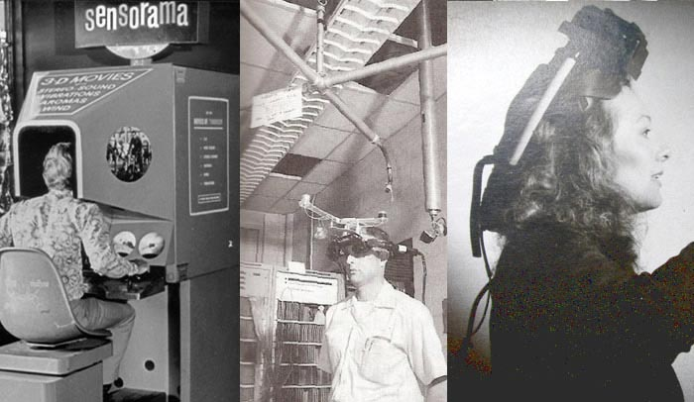

Virtual reality has beginnings that preceded the time that the concept was coined and formalised. In this detailed history of virtual reality we look at how technology has evolved and how key pioneers have paved the path for virtual reality as we know it today.

Early attempts at virtual reality

Panoramic paintings

If we focus more strictly on the scope of virtual reality as a means of creating the illusion that we are present somewhere we are not, then the earliest attempt at virtual reality is surely the 360-degree murals (or panoramic paintings) from the nineteenth century. These paintings were intended to fill the viewer’s entire field of vision, making them feel present at some historical event or scene.



Battle of Borodino, 181

1838 – Stereoscopic photos & viewers

In 1838 Charles Wheatstone’s research demonstrated that the brain processes the different two-dimensional images from each eye into a single object of three dimensions. Viewing two side by side stereoscopic images or photos through a stereoscope gave the user a sense of depth and immersion. The later development of the popular View-Master stereoscope (patented 1939), was used for “virtual tourism”. The design principles of the Stereoscope is used today for the popular Google Cardboard and low budget VR head mounted displays for mobile phones.

* 1838 : The stereoscope (Charles Wheatstone)
* 1849 : The lenticular stereoscope (David Brewster)
* 1939 : The View-Master (William Gruber)

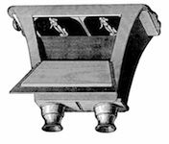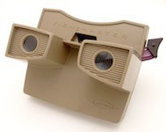

Over time mankind has been slowly but surely creating ever richer ways to stimulate our senses. Things really began to take off in the 20th century, with advent of electronics and computer technology.

1929 – Link Trainer The First Flight Simulator

In 1929 Edward Link created the “Link trainer” (patented 1931) probably the first example of a commercial flight simulator, which was entirely electromechanical. It was controlled by motors that linked to the rudder and steering column to modify the pitch and roll. A small motor-driven device mimicked turbulence and disturbances. Such was the need for safer ways to train pilots that the US military bought six of these devices for $3500. In 2015 money this was just shy of $50 000. During World War II over 10,000 “blue box” Link Trainers were used by over 500,000 pilots for initial training and improving their skills.

 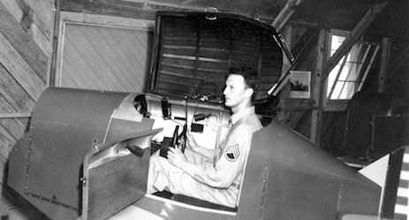  
*Left: Edward Link, Right: The Link Trainer*

1930s – Science fiction story predicted VR

In the 1930s a story by science fiction writer Stanley G. Weinbaum (Pygmalion’s Spectacles) contains the idea of a pair of goggles that let the wearer experience a fictional world through holographics, smell, taste and touch. In hindsight the experience Weinbaum describes for those wearing the goggles are uncannily like the modern and emerging experience of virtual reality, making him a true visionary of the field.

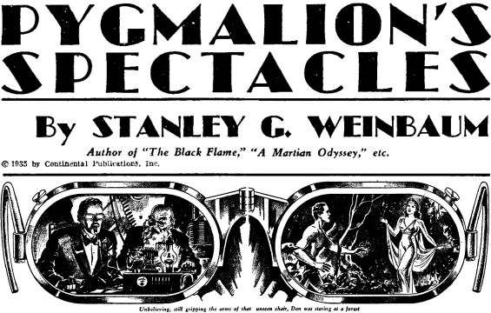 *Image source: sffaudio.com*

1950s – Morton Heilig’s Sensorama

In the mid 1950s cinematographer Morton Heilig developed the Sensorama (patented 1962) which was an arcade-style theatre cabinet that would stimulate all the senses, not just sight and sound. It featured stereo speakers, a stereoscopic 3D display, fans, smell generators and a vibrating chair. The Sensorama was intended to fully immerse the individual in the film. He also created six short films for his invention all of which he shot, produced and edited himself. The Sensorama films were titled, Motorcycle, Belly Dancer, Dune Buggy, helicopter, A date with Sabina and I’m a coca cola bottle!  
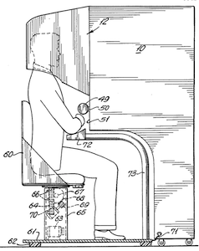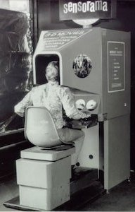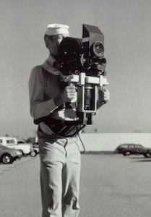  
*Image source: mortonheilig.com*

The video below is an interview with Morton about the Sensorama.

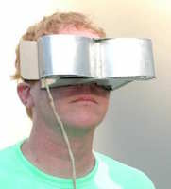

1960 – The first VR Head Mounted Display

Morton Heilig’s next invention was the Telesphere Mask (patented 1960) and was the first example of a head-mounted display (HMD), albeit for the non-interactive film medium without any motion tracking. The headset provided stereoscopic 3D and wide vision with stereo sound.

1961 Headsight – First motion tracking HMD

In 1961, two Philco Corporation engineers (Comeau & Bryan) developed the first precursor to the HMD as we know it today – the Headsight. It incorporated a video screen for each eye and a magnetic motion tracking system, which was linked to a closed circuit camera. The Headsight was not actually developed for virtual reality applications (the term didn’t exist then), but to allow for immersive remote viewing of dangerous situations by the military. Head movements would move a remote camera, allowing the user to naturally look around the environment. Headsight was the first step in the evolution of the VR head mounted display but it lacked the integration of computer and image generation.

1965 – The Ultimate display by Ivan Sutherland

Ivan Sutherland described the “Ultimate Display” concept that could simulate reality to the point where one could not tell the difference from actual reality. His concept included:

* A virtual world viewed through a HMD and appeared realistic through augmented 3D sound and tactile feedback.
* Computer hardware to create the virtual word and maintain it in real time.
* The ability users to interact with objects in the virtual world in a realistic way

*“The ultimate display would, of course, be a room within which the computer can control the existence of matter. A chair displayed in such a room would be good enough to sit in. Handcuffs displayed in such a room would be confining, and a bullet displayed in such a room would be fatal. With appropriate programming such a display could literally be the Wonderland into which Alice walked.” –****Ivan Sutherland***

This paper would become a core blueprint for the concepts that encompass virtual reality today.

1968 – Sword of Damocles

In 1968 Ivan Sutherland and his student Bob Sproull created the first VR / AR head mounted display (Sword of Damocles) that was connected to a computer and not a camera. It was a large and scary looking contraption that was too heavy for any user to comfortably wear and was suspended from the ceiling (hence its name). The user would also need to be strapped into the device. The computer generated graphics were very primitive wireframe rooms and objects.

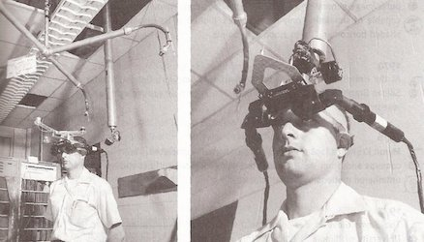

1969 – Artificial Reality

In 1969 Myron Kruegere a virtual reality computer artist developed a series of experiences which he termed “artificial reality” in which he developed computer-generated environments that responded to the people in it. The projects named GLOWFLOW, METAPLAY, and PSYCHIC SPACE were progressions in his research which ultimately let to the development of VIDEOPLACE technology. This technology enabled people to communicate with each other in a responsive computer generated environment despite being miles apart.

1987 – Virtual reality the name was born

Even after all of this development in virtual reality, there still wasn’t an all-encompassing term to describe the field. This all changed in 1987 when Jaron Lanier, founder of the visual programming lab (VPL), coined (or according to some popularised) the term “virtual reality”. The research area now had a name. Through his company VPL research Jaron developed a range of virtual reality gear including the Dataglove (along with Tom Zimmerman) and the EyePhone head mounted display. They were the first company to sell Virtual Reality goggles (EyePhone 1 $9400; EyePhone HRX $49,000) and gloves ($9000). A major development in the area of [virtual reality *haptics*](http://www.vrs.org.uk/virtual-reality-gear/haptic/).

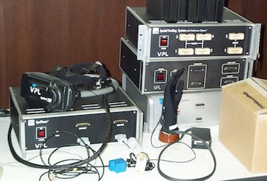

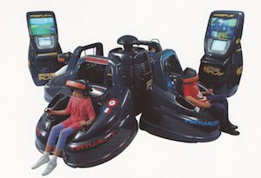

1991 – Virtuality Group Arcade Machines

We began to see virtual reality devices to which the public had access, although household ownership of cutting edge virtual reality was still far out of reach. The Virtuality Group launched a range of arcade games and machines. Players would wear a set of VR goggles and play on gaming machines with realtime (less than 50ms latency) immersive stereoscopic 3D visuals. Some units were also networked together for a multi-player gaming experience.

1992 – The Lawnmower Man

The Lawnmower Man movie introduced the concept of virtual reality to a wider audience. It was in part based on the founder of Virtual Reality Jaron Lanier and his early laboratory days. Jaron was played by Pierce Brosnan, a scientist who used virtual reality therapy on a mentally disabled patient. Real virtual reality equipment from VPL research labs was used in the film and the director Brett Leonard, admited to drawing inspiration from companies like VPL.

1993 – SEGA announce new VR glasses

Sega announced the Sega VR headset for the Sega Genesis console in 1993 at the Consumer Electronics Show in 1993. The wrap-around protoype glasses had head tracking, stereo sound and LCD screens in the visor. Sega fully intended to release the product at a price point of about $200 at the time, or about $322 in 2015 money. However, technical development difficulties meant that the device would forever remain in the prototype phase despite having developed 4 games for this product. This was a huge flop for Sega.

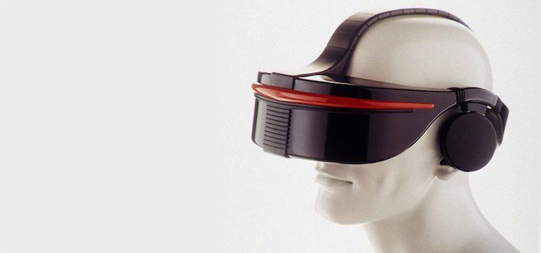

1995 – Nintendo Virtual Boy

The Nintendo Virtual Boy (originally known as VR-32) was a 3D gaming console that was hyped to be the first ever portable console that could display true 3D graphics. It was first released in Japan and North America at a price of $180 but it was a commercial failure despite price drops. The reported reasons for this failure were a lack of colour in graphics (games were in red and black), there was a lack of software support and it was difficult to use the console in a comfortable position. The following year they discontinued its production and sale.

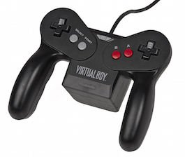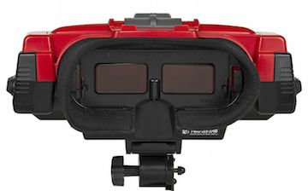

1999 – The Matrix

In 1999 the Wachowski siblings’ film *The Matrix*hits theatres. The film features characters that are living in a fully simulated world, with many completely unaware that they do not live in the real world. Although some previous films had dabbled in depicting virtual reality, such as Tron in 1982 and *Lawnmower Man*in 1992, The Matrix has a major cultural impact and brought the topic of simulated reality into the mainstream.

Virtual reality in the 21st century

The first fifteen years of the 21st century has seen major, rapid advancement in the development of virtual reality. Computer technology, especially small and powerful mobile technologies, have exploded while prices are constantly driven down. The rise of smartphones with high-density displays and 3D graphics capabilities has enabled a generation of lightweight and practical virtual reality devices. The video game industry has continued to drive the development of consumer virtual reality unabated. Depth sensing cameras sensor suites, motion controllers and natural human interfaces are already a part of daily human computing tasks.

Recently companies like Google have released interim virtual reality products such as the Google Cardboard, a DIY headset that uses a smartphone to drive it. Companies like Samsung have taken this concept further with products such as the Galaxy Gear, which is mass produced and contains “smart” features such as gesture control.

Developer versions of final consumer products have also been available for a few years, so there has been a steady stream of software projects creating content for the immanent market entrance of modern virtual reality.

It seems clear that 2016 will be a key year in the virtual reality industry. Multiple consumer devices that seem to finally answer the unfulfilled  promises made by virtual reality in the 1990s will come to market at that time. These include the pioneering Oculus Rift, which was purchased by social media giant Facebook in 2014 for the staggering sum of $2BN. An incredible vote of confidence in where the industry is set to go. When the Oculus Rift releases in 2016 it will be competing with products from Valve corporation and HTC, Microsoft as well as Sony Computer Entertainment. These heavyweights are sure to be followed by many other enterprises, should the market take off as expected.

* Virtual Reality in the Military
* Virtual Reality in Education
* Virtual Reality in Entertainment
* Virtual Reality in Sport
* Virtual Reality in Media
* Virtual Reality in Film

<http://www.vrs.org.uk/virtual-reality-military/>

# Virtual Reality in the Military

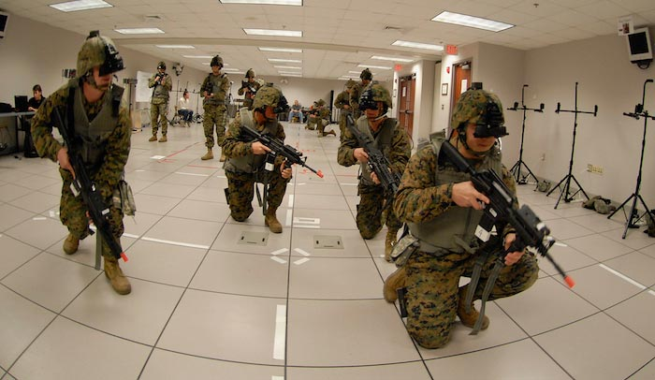

[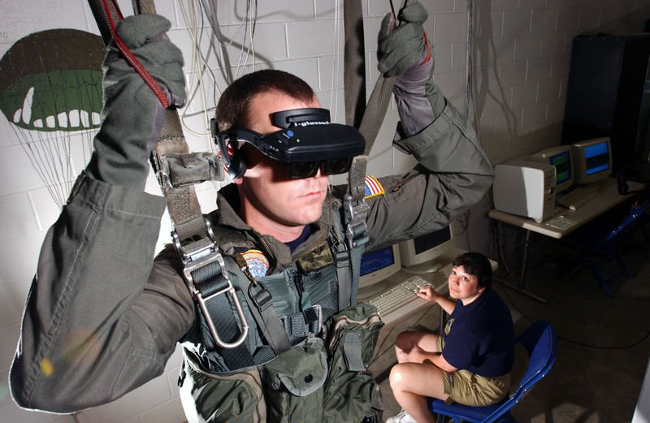](http://www.vrs.org.uk/images/us-military.jpg)

Virtual reality parachuting simulation

Virtual reality has been adopted by the military – this includes all three services (army, navy and air force) – where it is used for training purposes. This is particularly useful for training soldiers for combat situations or other dangerous settings where they have to learn how to react in an appropriate manner.

A virtual reality simulation enables them to do so but without the risk of death or a serious injury. They can re-enact a particular scenario, for example engagement with an enemy in an environment in which they experience this but without the real world risks. This has proven to be safer and less costly than traditional training methods.

## Military uses of virtual reality

These include:

* Flight simulation
* Battlefield simulation
* Medic training (battlefield)
* Vehicle simulation
* Virtual boot camp

Virtual reality is also used to treat post-traumatic stress disorder. Soldiers suffering from battlefield trauma and other psychological conditions can learn how to deal with their symptoms in a ‘safe’ environment. The idea is for them to be exposed to the triggers for their condition which they gradually adjust to. This has the effect of decreasing their symptoms and enabling them to cope to new or unexpected situations.

This is discussed further in the virtual reality treatment for PTSD (post traumatic stress disorder) article.

## VR equipment and the military

Virtual reality training is conducted using head mounted displays (HMD) with an inbuilt tracking system and data gloves to enable interaction within the virtual environment.

Another use is combat visualisation in which soldiers and other related personnel are given virtual reality glasses to wear which create a 3D depth of illusion. The results of this can be shared amongst large numbers of personnel.

Find out more about individual uses of virtual reality by the different services, e.g. virtual reality navy training in the separate virtual reality and the military section.

This section discusses the various military applications of virtual reality and the ramifications from using this form of technology. The military may not be an obvious candidate for virtual reality but it has been adopted by all branches – army, navy and air force.

What the military stress is that virtual reality is designed to be used as an additional aid and will not replace real life training.

This section discusses all aspects of how virtual reality is used by military, from training through to combat situations. It is arranged as follows:

* Virtual reality war
* Virtual reality and the Army
* Virtual reality and the Navy
* Virtual reality and the Air force
* Virtual reality army training
* Virtual reality army exercises
* Virtual reality air force training
* Virtual reality navy training
* Virtual reality combat training
* Virtual reality combat simulation
* Virtual reality military weapons
* Virtual reality military history

Each of these subjects is discussed as a separate article.

What is apparent is that virtual environments are ideal set ups for military training in that they enable the participants, i.e. soldiers, to experience a particular situation within a controlled area. For example, a battlefield scenario in which they can interact with events but without any personal danger to themselves.

The main advantages of this are time and cost: military training is prohibitively expensive especially airborne training so it is more cost-effective to use flight simulators than actual aircraft. Plus it is possible to introduce an element of danger into these scenarios but without causing actual physical harm to the trainees.

Flight simulators are a popular theme in military VR training but there are others which include: medical training (battlefield), combat training, vehicle training and ‘boot camp’.

But another use and one which is not immediately thought of is virtual reality and post traumatic stress disorder (PTSD). PTSD or ‘combat stress’ has only recently been acknowledged as a medical condition but it causes very real damage to the person concerned and their family. Virtual reality is used to help the sufferer adjust to their symptoms and develop coping strategies whenever they are placed in a new situation.

This is discussed at greater length in our virtual reality treatment for PTSD article.

Generally, virtual reality training involves the use of head mounted displays (HMD) and data gloves to enable military personnel to interact with objects within a virtual environment. Alternately, they may be given virtual reality glasses to wear which display a 3D image.

<http://www.vrs.org.uk/virtual-reality-education/>

# Virtual Reality and Education

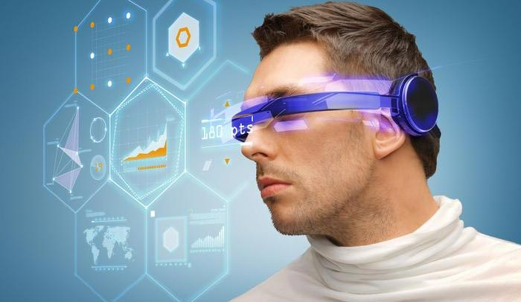

Education is another area which has adopted [virtual reality](http://www.vrs.org.uk/) for teaching and learning situations. The advantage of this is that it enables large groups of students to interact with each other as well as within a three dimensional environment.

It is able to present complex data in an accessible way to students which is both fun and easy to learn. Plus these students can interact with the objects in that environment in order to discover more about them.

## Virtual reality astronomy

For example, astronomy students can learn about the solar system and how it works by physical engagement with the objects within. They can move planets, see around stars and track the progress of a comet. This also enables them to see how abstract concepts work in a three dimensional environment which makes them easier to understand and retain.

This is useful for students who have a particular learning style, e.g. creative or those who find it easier to learn using symbols, colours and textures.

One ideal learning scenario is medicine: virtual reality can be used to develop [surgery simulations](http://www.vrs.org.uk/virtual-reality-education/training-for-surgery.html) or three dimensional images of the human body which the students can explore. This has been used in medical schools both in the UK and abroad.

The use of virtual reality in medicine is discussed in a series of separate articles in the [virtual reality and healthcare](http://www.vrs.org.uk/virtual-reality-healthcare/)section.

## Virtual reality and tech-savvy children

Then there is the fact that children today are familiar with all forms of technology and use these at school as well as at home. They have grown up with technology from a very early age and unlike adults, do not have any fear or hesitation in using it.

Plus we live in a technological society. So it makes sense to implement virtual reality as one of several forms of technology in order to educate tomorrow‘s technological elite. Education has moved on from books, pencils and pens to the use of interactive technologies to help impart knowledge and understanding.

<http://www.vrs.org.uk/virtual-reality-applications/entertainment.html>

# Virtual Reality in Entertainment

The entertainment industry is one of the most enthusiastic advocates of virtual reality, most noticeably in games and virtual worlds. But other equally popular areas include:

* [Virtual Museums](http://www.vrs.org.uk/virtual-reality-applications/heritage.html), e.g. interactive exhibitions
* Galleries
* Theatre, e.g. interactive performances
* Virtual theme parks
* Discovery centres

Many of these areas fall into the category ‘edutainment’ in which the aim is to educate as well as entertain.

## Audience engagement

These environments enable members of the public to engage with the exhibits in ways which were previously forbidden or unknown. They wear [virtual reality glasses](http://www.vrs.org.uk/virtual-reality-gear/glasses/) with stereoscopic lenses which allow them to see 3D objects and at different angles. And in some cases they can interact with the exhibits by means of an input device such as a data glove.

An example of this is a historical building which the member of the public can view at different angles. Plus they are able to walk through this building, visiting different rooms to find out more about how people lived at that particular time in history.

They are able to do this by means of a tracking system (built into the glasses) which tracks their movements and feeds this information back to a computer. The computer responds by changing the images in front of the person to match their change in perception and maintain a sense of realism.

There are a range of virtual reality systems available for audience entertainment which includes [CAVE systems](http://www.vrs.org.uk/virtual-reality-environments/cave.html), augmented reality systems, simulators and 3D display platforms.

Virtual reality gaming is a very popular form of entertainment which is discussed in more detail in a separate section. Visit the virtual reality games section which contains a set of individual articles discussing VR games for Xbox, PC and PS3 as well as virtual worlds.

<http://www.vrs.org.uk/virtual-reality-applications/sport.html>

# Virtual Reality in Sport

[Virtual reality](http://www.vrs.org.uk/) is used as a training aid in many sports such as golf, athletics, skiing, cycling etc. It is used as an aid to measuring athletic performance as well as analysing technique and is designed to help with both of these. It also used in clothing/equipment design and as part of the drive to improve the audience’s experience.

## Virtual reality performance

The athlete uses this technology to fine tune certain aspects of their performance, for example, a golfer looking to improve their swing or a track cyclist wanting to go faster in the individual pursuit. Three dimensional systems can pinpoint aspects of an athlete’s performance which require changing, for example, their biomechanics or technique.

## Driving equipment design and innovation

Another popular use is sports manufacture: virtual reality is used in the design of sporting clothes and equipment, e.g. running shoe design. Innovation is a key factor in this industry as the bar is raised higher and higher in terms of sporting achievement.

Sportspeople are constantly looking at ways of gaining them that edge which can mean being faster, stronger, better endurance etc. They are constantly pushing boundaries as regards what their bodies can do which drives the sports clothing and equipment industry. This industry has to keep pace with this constant drive for sporting perfection and uses the very latest technology to do so.

## Bringing the sporting event closer to the audience

Virtual reality has also been used to improve the audience’s experience of a sporting event. Some systems allow the audience to walkthrough a stadium or other sporting location, which helps them when purchasing a ticket to an event.

And then there are virtual reality games with a sports theme which allow the player to become part of the competition. One example is an interactive football game which projects this match onto a real world surface.

<http://www.vrs.org.uk/virtual-reality-applications/media.html>

# Virtual Reality in Media

This article discusses the various ways virtual reality is used in the media. This includes radio, television, music and film as well as books and the arts.

## Virtual reality in film and TV

Virtual reality has featured in several film and television programmes. It is often used to illustrate the concept of being trapped within the machine (or in this case, cyberspace), or as a form of advanced technology.

Examples of VR inspired films include:

* The Lawnmower Man
* The Matrix
* Tron (1982 version)
* The Thirteenth Floor
* eXistenZ
* Vanilla Sky

And then there are television programmes such as selected episodes of Doctor Who, Red Dwarf and Star Trek: The Next Generation which utilise virtual reality technology. One example is the holodeck as seen in Star Trek which enables the person to experience any situation they so wish.

## Virtual reality music

This technology has formed part of experimental sound displays and sound installations. Another use is virtual reality musical instruments which the person can interact with these instruments as a new type of performance or to create new compositions.

## Virtual reality books

Virtual reality has been a staple theme of many fictional stories such as William Gibson’s Neuromancer and Mona Lisa Overdrive as well as Orson Scott Card’s Enders Game.

## Virtual reality art

There are artists who use virtual reality to explore certain ideas or concepts. They create a three dimensional environment as a form of communication with the audience. One example is the work of Kenneth Rinaldo who uses robotics and augmented reality to explore ideas related to the human-technology boundary.

<http://www.vrs.org.uk/virtual-reality-applications/film.html>

# Virtual Reality in Film

[Virtual reality](http://www.vrs.org.uk/) is a very common theme in science fiction movies, where it is often used a way to turn the fantastical into something that seems totally real.

TRON, for instance, was one of the first movies to use virtual reality as a plot element. The main characters were taken from reality and transported into a virtual world inside a computer. This is not 100% like the virtual reality we know today but the concept of another reality inside of a computer reminds the same.

Some of the most popular movies of our time use [concepts of virtual reality](http://www.vrs.org.uk/virtual-reality/concepts.html). Some of these movies, which you’ve probably heard of, include:

* TRON & TRON Legacy
* The Matrix series
* Vanilla Sky

The list continues indefinitely. We can certainly expect such a list to continue growing in the future as the ideas behind virtual reality are fully explored in film.

## Second Life’s Film Festival

Second Life, at one time, partnered with the 48 Hour Film Project to produce the first film festival to take place in a virtual world.

The participants of the festival had to create a film set totally within the world of Second Life. In true 48HFP style, they were given a genre, a character, a proper and a piece of dialogue, which must be incorporated into their films, and went away to write and edit a Second Life film within 48 hours.

The winners of the ‘virtual film festival’ were given the opportunity to have their films shown at the real-life 48 Hour Film Project event.

Term

In 1938, Antonin Artaud described the illusory nature of characters and objects in the theatre as "la réalité virtuelle" in a collection of essays, Le Théâtre et son double. The English translation of this book, published in 1958 as The Theater and its Double, is the earliest published use of the term "virtual reality". The term "artificial reality", coined by Myron Krueger, has been in use since the 1970s. The term "virtual reality" was used in The Judas Mandala, a 1982 science fiction novel by Damien Broderick. The Oxford English Dictionary cites a 1987 article titled "Virtual reality" but the article is not about VR technology. "Virtual" has had the meaning "being something in essence or effect, though not actually or in fact" since the mid-1400s, "...probably via sense of "capable of producing a certain effect" (early 1400s)". The term "virtual" was used in the "computer sense of "not physically existing but made to appear by software" since 1959.[3] The term "reality" has been used in English since the 1540s, to mean "quality of being real," from "French réalité and directly Medieval Latin realitatem (nominative realitas), from Late Latin realis".

Virtual reality is also called "virtual realities", "immersive multimedia", "augmented reality" (or AR), "artificial reality" or "computer-simulated reality".

# Explained: How does VR actually work?

Mind blown by VR headsets? Here's how the tech tricks your brains

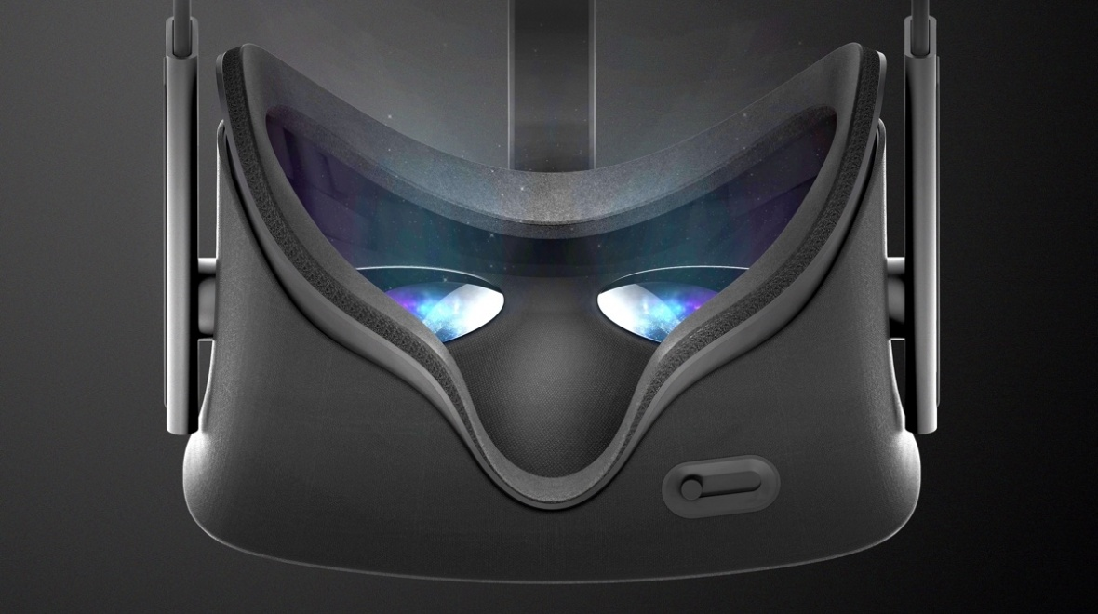

**Monday**

**June 20, 2016**

**By**[**Sophie Charara**](http://www.wareable.com/author/s.charara)

[@sophiecharara](https://twitter.com/sophiecharara)

How does VR work? How does wearable tech make you think you're standing on Mars when you're actually about to bump into the kitchen counter? We'll be explaining how [virtual reality headsets](http://www.wareable.com/headgear/the-best-ar-and-vr-headsets) work here.

Let's start with some basics.

The headset set-up is being used by Oculus, Sony, HTC, Samsung and Google and usually requires three things. A PC, console or smartphone to run the app or game, a headset which secures a display in front of your eyes (which could be the phone's display) and some kind of input - head tracking, controllers, hand tracking, voice, on-device buttons or trackpads.

Total immersion is what everyone making a VR headset, game or app is aiming towards - making the virtual reality experience so real that we forget the computer, headgear and accessories and act exactly as we would in the real world. So how do we get there?

## The basics

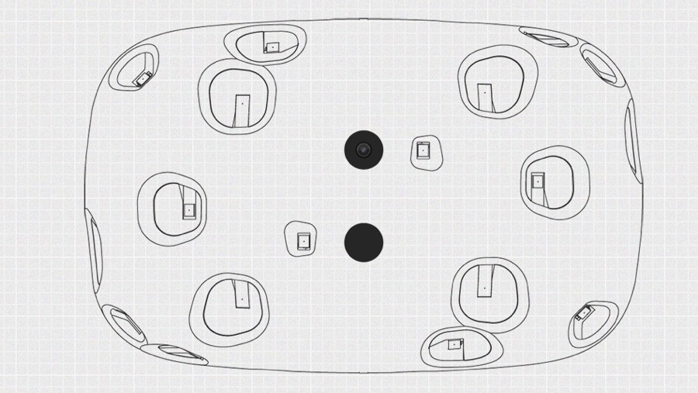

VR headsets like [Oculus Rift](http://www.wareable.com/oculus-rift/how-oculus-rift-works) and [PlayStation VR](http://www.wareable.com/sony/sony-project-morpheus-review) are often referred to as HMDs and all that means is that they are head mounted displays. Even with no audio or hand tracking, holding up Google Cardboard to place your smartphone's display in front of your face can be enough to get you half-immersed in a virtual world.

The goal of the hardware is to create what appears to be a life size, 3D virtual environment without the boundaries we usually associate with TV or computer screens. So whichever way you look, the screen mounted to your face follows you. This is unlike AR which overlays graphics onto your view of the real world.

***The future:***[*Virtual reality versus augmented reality*](http://www.wareable.com/vr/virtual-reality-vs-augmented-reality-which-is-the-future)

Video is sent from the console or computer to the headset via a HDMI cable in the case of headsets such as [HTC's Vive](http://www.wareable.com/vr/htc-vive-review) and the Rift. For Google Cardboard,[Google's upcoming Daydream headsets](http://www.wareable.com/google/google-daydream-specs-price-release-date) and the [Samsung Gear VR](http://www.wareable.com/samsung/samsung-gear-vr-review), it's already on the smartphone slotted into the headset.

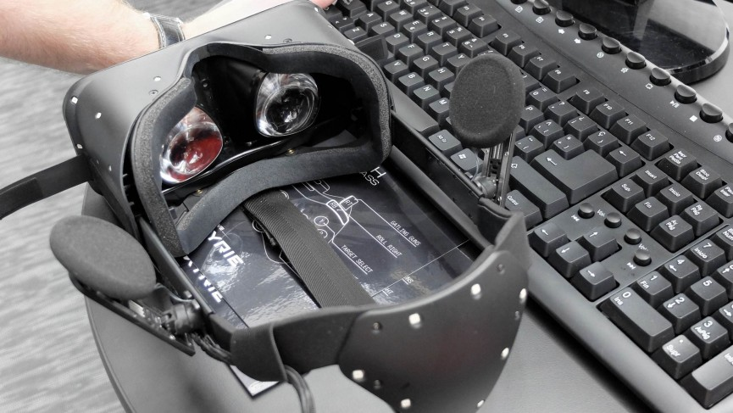

VR headsets use either two feeds sent to one display or two LCD displays, one per eye. There are also lenses which are placed between your eyes and the pixels which is why the devices are often called goggles. In some instances, these can be adjusted to match the distance between your eyes which varies from person to person.

These lenses focus and reshape the picture for each eye and create a stereoscopic 3D image by angling the two 2D images to mimic how each of our two eyes views the world ever-so-slightly differently. Try closing one eye then the other to see individual objects dance about from side to side and you get the idea behind this.

* [[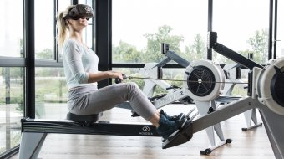](http://www.wareable.com/vr/vr-fitness-holodia-one-big-problem)](http://www.wareable.com/vr/vr-fitness-holodia-one-big-problem)

[VR fitness looks amazing but it has a big problem](http://www.wareable.com/vr/vr-fitness-holodia-one-big-problem)

[Trying to break the great gym boredom problem comes with a few hurdles](http://www.wareable.com/vr/vr-fitness-holodia-one-big-problem)

* [[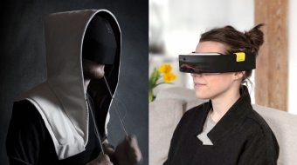](http://www.wareable.com/vr/social-ar-lonely-places)](http://www.wareable.com/vr/social-ar-lonely-places)

[VR needs to get social right](http://www.wareable.com/vr/social-ar-lonely-places)

[Let's all have a panic party](http://www.wareable.com/vr/social-ar-lonely-places)

* [[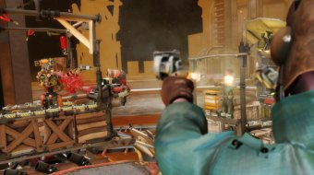](http://www.wareable.com/vr/how-to-start-vr-games-on-htc-vive-and-oculus-rift)](http://www.wareable.com/vr/how-to-start-vr-games-on-htc-vive-and-oculus-rift)

[How to start playing VR games on Vive and Rift](http://www.wareable.com/vr/how-to-start-vr-games-on-htc-vive-and-oculus-rift)

[VR games shouldn't be this confusing but we can help](http://www.wareable.com/vr/how-to-start-vr-games-on-htc-vive-and-oculus-rift)

* [[](http://www.wareable.com/vr/positive-ways-virtual-reality-is-used-beyond-gaming)](http://www.wareable.com/vr/positive-ways-virtual-reality-is-used-beyond-gaming)

[VR beyond gaming](http://www.wareable.com/vr/positive-ways-virtual-reality-is-used-beyond-gaming)

[We take a look at how virtual reality is being used to help people](http://www.wareable.com/vr/positive-ways-virtual-reality-is-used-beyond-gaming)

* [[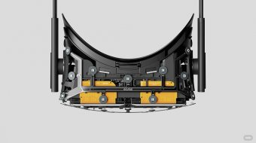](http://www.wareable.com/oculus-rift/how-oculus-rift-works)](http://www.wareable.com/oculus-rift/how-oculus-rift-works)

[How Oculus Rift works](http://www.wareable.com/oculus-rift/how-oculus-rift-works)

[From your PC to your eyeballs and the bits in between](http://www.wareable.com/oculus-rift/how-oculus-rift-works)

One important way VR headsets can increase immersion is to increase the field of view i.e. how wide the picture is. A 360 degree display would be too expensive and unnecessary. Most high-end headsets make do with 100 or 110 degree field of view which is wide enough to do the trick.

And for the resulting picture to be at all convincing, a minimum frame rate of around 60 frames per second is needed to avoid stuttering or users feeling sick. The current crop of VR headsets go way beyond this - Oculus is capable of 90fps, for instance, Sony's PlayStation VR manages 120fps.

## Head tracking

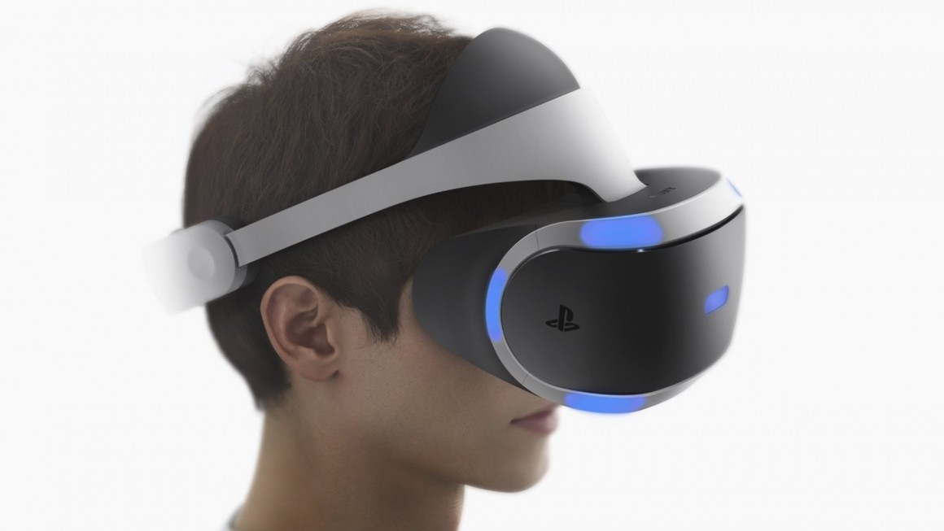

Head tracking means that when you wear a VR headset, the picture in front of you shifts as you look up, down and side to side or angle your head. A system called 6DoF (six degrees of freedom) plots your head in terms of your x, y and z axis to measure head movements forward and backwards, side to side and shoulder to shoulder, otherwise known as pitch, yaw and roll.

***Read this***:[All you need to know about Google's Daydream VR](http://www.wareable.com/google/google-daydream-specs-price-release-date)

There's a few different internal components which can be used in a head-tracking system such as a gyroscope, accelerometer and a magnetometer. Sony's PSVR also uses nine LEDs dotted around the headset to provide 360 degree head tracking thanks to an external PS4 camera monitoring these signals, Oculus has 20 lights but they are not as bright.

Head-tracking tech needs low latency to be effective - we're talking 50ms or less or we will detect the lag between when we turn our head and when the VR environment changes. The Oculus Rift has an impressively minimised lag of just 30 milliseconds. Lag can also be a problem for any motion tracking inputs such as PS Move-style controllers that measure our hand and arm movements.

Finally, headphones can be used to increase the sense of immersion. Binaural or 3D audio can be used by app and game developers to tap into VR headsets' head-tracking technology to take advantage of this and give the wearer the sense that sound is coming from behind, to the side of them or in the distance.

## Motion tracking

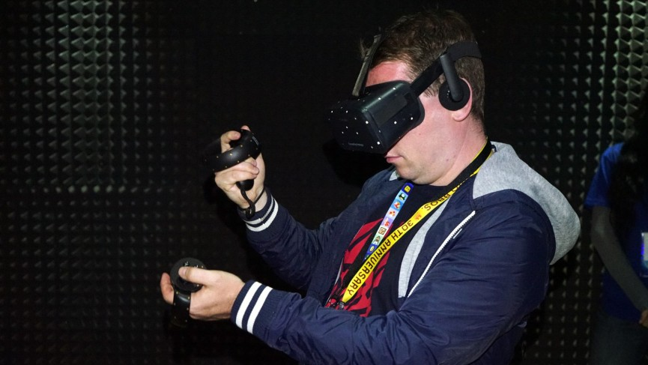

Head tracking is one big advantage the as-yet unreleased premium headsets have over the likes of Cardboard. But the big VR players are still working out motion tracking. When you look down with a VR headset on the first thing you want to do is see your hands in a virtual space.

For a while, we've seen the Leap Motion accessory - which uses an infrared sensor to track hand movements - strapped to the front of Oculus dev kits. We've also tried a few experiments with Kinect 2 cameras tracking our flailing bodies. But now we have exciting input options from Oculus, Valve and Sony.

[Oculus Touch](http://www.wareable.com/vr/oculus-touch-e3-2015-hands-on-review-445) is a set of wireless controllers, designed to make you feel like you're using your own hands in VR. You grab each controller and use buttons, thumbsticks and triggers during VR games. So for instance, to shoot a gun you squeeze on the hand trigger. There is also a matrix of sensors on each controller to detect gestures such as pointing and waving.

**Headset head-to-head:**[HTC Vive versus Oculus Rift](http://www.wareable.com/vr/oculus-rift-vs-htc-vive-887)

It's a pretty similar set-up to Valve's Lighthouse positional tracking system and HTC's controllers for its Vive headset. It involves two base stations around the room which sweep the area with lasers. These can detect the precise position of your head and both hands based on the timing of when they hit each photocell sensor on both the headset and around each handheld controller. Like Oculus Touch, these also feature physical buttons too and incredibly you can have two Lighthouse systems in the same space to track multiple users.

Other input methods can include anything from hooking an Xbox controller or joystick up to your PC, voice controls, smart gloves and treadmills such as the Virtuix Omni, which allow you to simulate walking around a VR environment with clever in-game redirections.

## Eye tracking

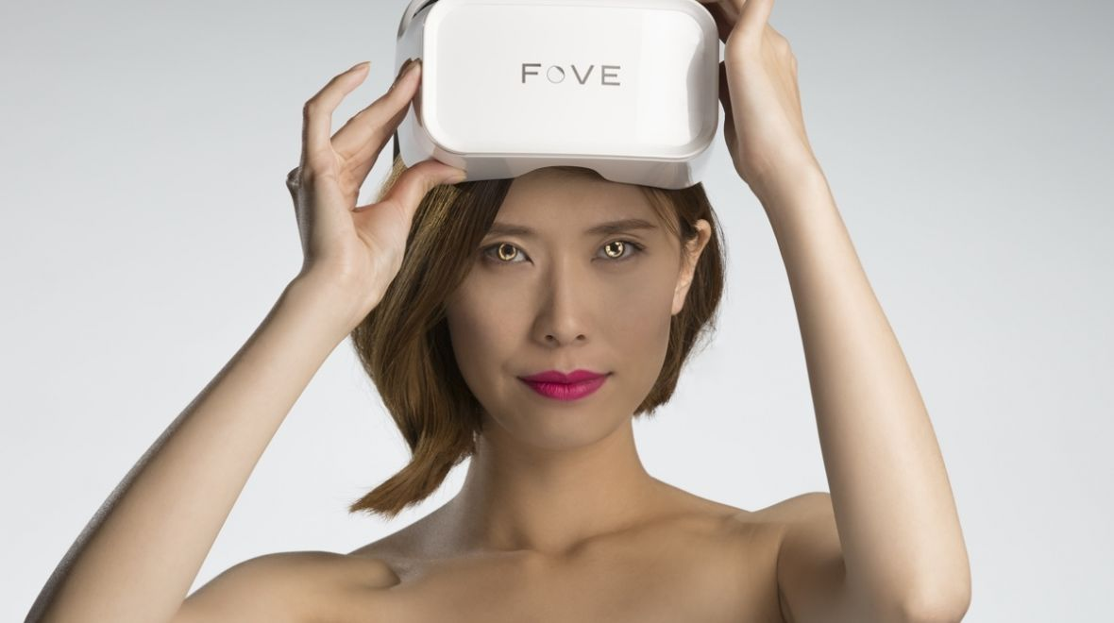

Eye tracking is possibly the final piece of the VR puzzle. It's not available on the Rift, Vive or PS VR but it will feature in [FOVE's very promising VR headset](http://www.wareable.com/vr/fove-eye-tracking-vr-headset-price-specs-release-date-1157). So how does it work?

Well, an infrared sensor monitor's your eyes inside the headset so FOVE knows where your eyes are looking in virtual reality. The main advantage of this - apart from allowing in-game characters to more precisely react to where you're looking - is to make depth of field more realistic.

In standard VR headsets, everything is in pin-sharp focus which isn't how we're used to experiencing the world. If our eyes look at an object in the distance, for instance, the foreground blurs and vice versa. By tracking our eyes, FOVE's graphics engine can simulate this in a 3D space in VR. That's right, blur can be good.

Headsets still need hi-res displays to avoid the effect of looking through a grid. Also what our eyes focus on needs to look as life-like as possible. Without eye tracking, with everything in focus as you move your eyes - but not your head - around a scene, simulation sickness is more likely. Your brain knows that something doesn't match up.