**1. WEBSITE OBJECTIVES AND GOALSa. Objective:**The objective of this website is to be a one-stop for all things Warner Bros. Studios. It should serve as a platform to:Showcase upcoming and past Warner Bros. movies across various genres (action, animation, comedy, etc.)Provide trailers, clips, and behind-the-scenes content to generate excitement.Allow users to purchase movie tickets directly or link to authorized ticketing platforms.Sell merchandise related to popular Warner Bros. franchises and movies.Share news and updates about Warner Bros. productions and talent.Foster a community for fans to connect and discuss their favorite Warner Bros. movies.

**b. Target Audience:**Demographics: Movie enthusiasts of all ages and backgrounds, with a particular focus on fans of action, superhero, and animation genres.Technical Aptitude: Generally, tech-savvy and comfortable navigating websites. May use the website across various devices (desktop, mobile, tablets).

**c. Website Type:**This website will be a combination of a content portal and an e

-commerce store.2. **INFORMATION DESIGN AND TAXONOMYa. Information Architecture:**The website will be organized into the following main sections:

**b. Site Map:**This shows the hierarchy of pages and their navigation paths.]

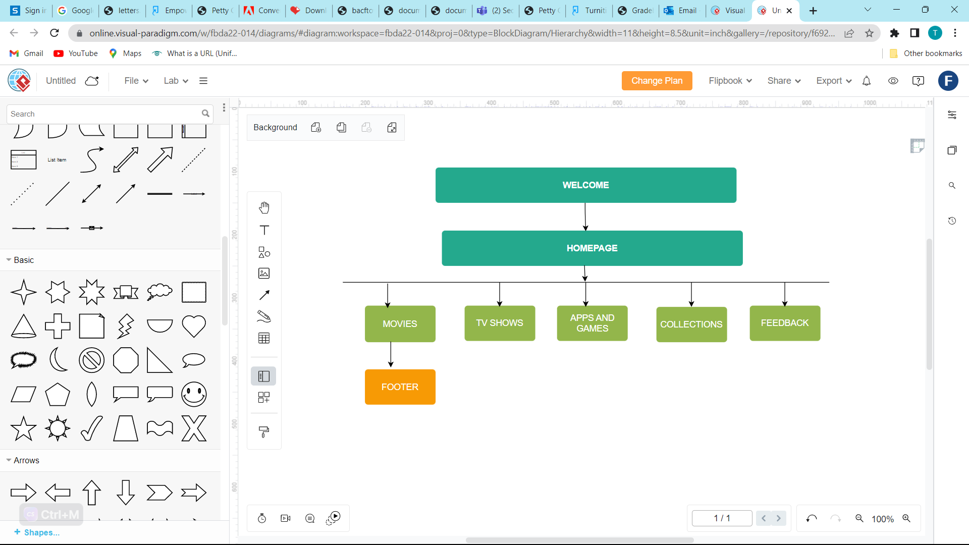**c. Storyboard Flowchart:**3**. PAGE TEMPLATE DESIGN**Wireframe

Above is a sketch to illustrate the basic layout and structure of mywebsite's pages.**General Design Considerations:**Responsiveness: The website will be responsive and adapt to different screen sizes (desktop, tablet, mobile).User Interface (UI): The website will have a clean, user-friendly interface with clear navigation, Visual Design: The website will have a visually appealing design that leverages high-quality image content to showcase movies . It should also incorporate Warner Bros. branding elements for a cohesive look and feel.

4**. TECHNICAL BRIEF**

a. **Technologies:**Front-End: HTML, CSS, JavaScript (or a front-end framework Bootstrap)

Content Management System (CMS): A CMS like WordPress can simplify content management for movie listings, news articles, and blog posts.

**b. Software Tools:**Code editor (Notepad)Design tools (e.g., Figma, Adobe XD)Version control system (eGit)

Microsoft word-for documenting my wor

Miro-for creating wireframes and flowchartsk

5**. Quality Assurance**a. **Testing:**The website was thoroughly tested across different browsers (Chrome, Firefox, Safari, Edge) to ensure proper functionality, responsiveness, and user experience.

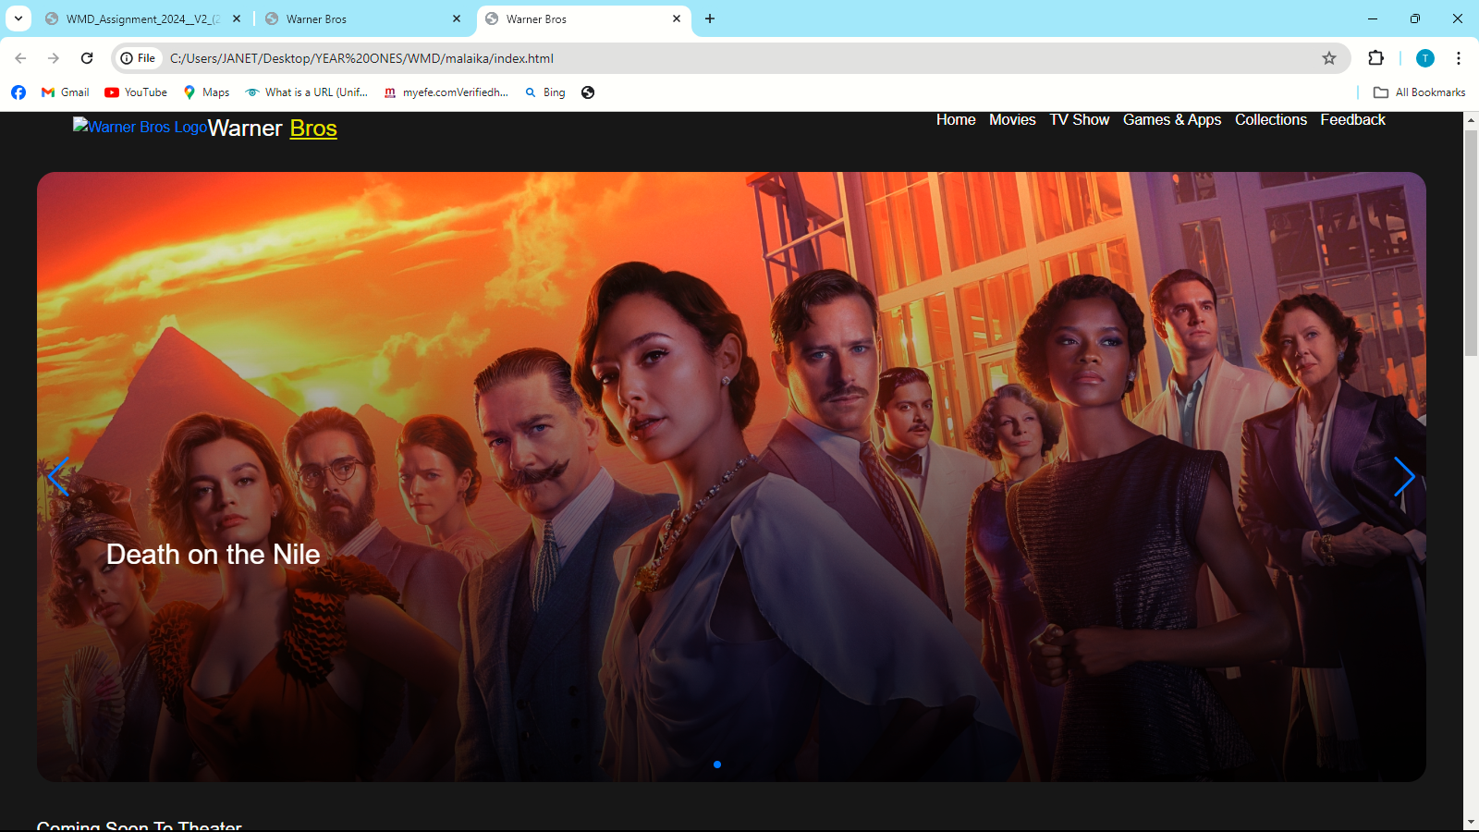

This is the website being tested on chrome

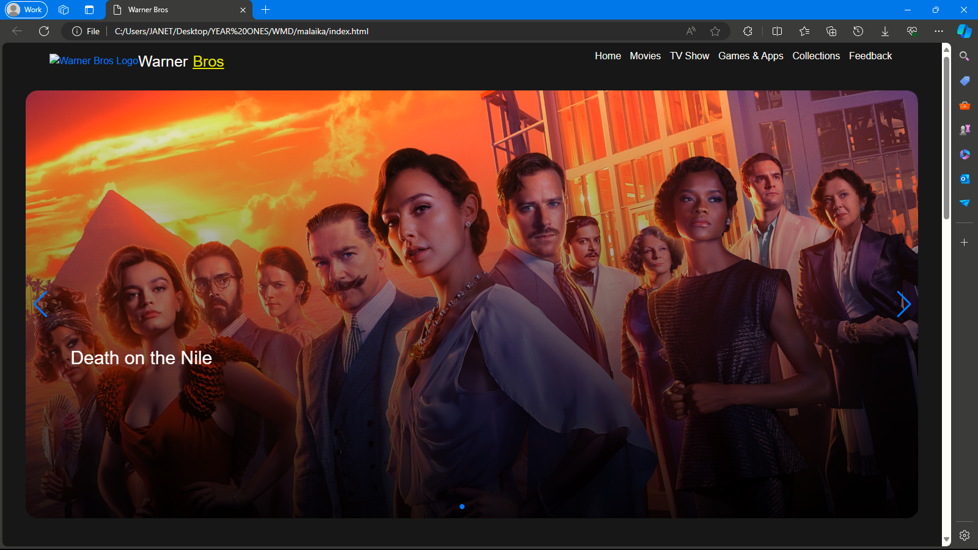

This was the website being tested on Microsoft edge

a**. Hosting Options:**

GitHub was used to host my website

GitHub Pages can be a suitable option for a smaller, more promotional one-pager showcasing upcoming releases or trailers.

**b. Uploading to GitHub Pages**

**The following are the steps I followed to be able to upload on github**

Choose the github-pages branch as the deployment source.

Website Link ():

c. **Promotion Strategies:**

Social Media Marketing: Leverage Warner Bros.' existing social media presence to promote the website and new content.

Search Engine Optimization (SEO): Implement SEO best practices to improve website ranking in search engine results for relevant movie-related keywords.

Online Advertising: Consider targeted online advertising campaigns to reach potential moviegoers interested in Warner Bros. releases.

Influencer Marketing: Partner with movie reviewers, bloggers, and social media influencers to promote the website and Warner Bros. content.

**7. Future Developments & Recommendations**

Personalized User Experience: Implement features like user accounts and watchlists to personalize the movie browsing experience and recommend content based on user preferences.

Interactive Features: Integrate interactive elements like quizzes, polls, and games to engage users and promote movies.

Virtual Reality (VR) Integration: Explore incorporating VR experiences to showcase movie trailers or behind-the-scenes content in an immersive format.

Multilingual Support: Expand the website's reach by offering content and translations in multiple languages to cater to a global audience.

Streaming Service Integration: If Warner Bros. offers a streaming service, integrate it with the website for users to easily access it