Did typhoon tracks change in the past 3 years?
Alrescha Mikaela D. Gabriana

Introduction

Background of the Study
Typhoons are known to be unpredictable, and each year the patterns they show are different. Long-term trends can be observed, however, by comparing many years. Particularly, the past 3 years were pandemic years, and changes in external factors such as a lowering of pollution levels may have affected trends in typhoons. The study will look at the tracks and other properties of typhoons over the last 3 years and will be comparing them to previous long-term averages.
The climate or long-term weather pattern of an area is typically averaged over 30 years, taken as a mean and variability of meteorological variables over time. For this study, a base climate defined from the 1990 to 2019 averages is used as comparison data to which the values of the same variables over the past 3 years from 2020 to 2022 will be compared. From here we hope to determine if typhoon tracks have changed over the past 3 years.

Objectives of the Study

General Objective
- Find out if the properties of typhoons have changed in the last 3 years.

Specific Objectives
- Determine the trends in the tracks, lateral speed, wind speed, and pressure of typhoons
- Compare the trends in the last 3 years against the trends in the last 30 years.

Significance of the Study
The Philippines is a typhoon-prone country—each year several typhoons enter the Philippine Area of Responsibility (PAR). The passage of typhoons has a substantial impact on the country's agriculture, economy, and public safety. Yet despite its importance, there are limited studies regarding the nature of typhoons being done in the Philippines.
To minimize its effects, it is crucial to properly monitor a typhoon’s track and make accurate forecasts about its path. This will help citizens prepare in advance and reduce actual damage.
PAGASA has studied the trends of typhoons’ tracks, lateral speed, wind speed, and pressure from 1990 to 2019. However, the trends in the past 3 years haven’t been analyzed yet and this research aims to provide insights in our current understanding of typhoons. Furthermore, the models mostly used in the institution are Physics-based and the researcher would like to explore empirical analysis of the same dataset.

Scope and Delimitations
This study looks at tropical cyclones that form in the Western Pacific region, whether or not they enter the Philippine Area of Responsibility, regardless of their category or classification. It will focus on data from 1990 to 2022, although older data from 1951 onward may be consulted to provide additional context. The study shall be limited to the paths, central pressure, and maximum wind speed of tropical cyclones; rainfall and other properties are excluded from the study.

Review of Related Literature
Climate is commonly understood as the “average” weather for a particular location over some period of time. The World Meteorological Organization (WMO) defines it mathematically, as the statistical mean and variability of relevant variables over a fixed period of 30 years (WMO, 2022). Although there have been discussions over the use of 30 years as a standard (Arguez and Vose, 2011), the current consensus is to follow the WMO convention, as evidenced by its use in international and local institutions such as NASA (2015), PAGASA (2022) and intergovernmental organizations such as the IPCC (2021).
The WMO further specifies a common 30-year reference period over which a baseline climate should be measured (WMO, 1989), to be updated every decade, and has recently updated the reference to be based on the 1991-2020 period (WMO, 2021). A 30-year average of a weather variable is called a climatological normal (IGI, n.d.), which is usually specified in terms of a monthly average (WMO, 2017). The climatological normal of a set of relevant weather variables is called a baseline climate or a climatological baseline, commonly used to calculate measurable changes in the climate (Climate Council, 2018).
The climate of the Philippines is described as tropical and maritime. It is characterized by relatively high temperatures, high humidity, and abundant rainfall. Temperature, humidity, and rainfall are the variables that most define the country’s climate. Based on these quantities, PAGASA has divided the Philippines into four climate types, as shown in the Philippine climate map on their website (PAGASA, 2022). Other people have proposed different ways of defining climate zones (Corporal-Lodangco, 2017). Furthermore, PAGASA has recently released climatological normals for rainfall, temperature (max, min, and mean), and wind (speed and direction) for the different provinces and cities in the Philippines (PAGASA, 2022), replacing their old baseline climate of 1971 to 2000 (ClimateGrid PH, n.d.).
One defining characteristic of the Philippine climate is the presence of typhoons, which appear during the annual Pacific typhoon season that usually lasts from April to November, with the most severe typhoons from August to September. The hardest-hit regions are Calabarzon, Bicol, and Central Luzon (WorldData, 2022). The Pacific itself is home to three tropical cyclone basins, namely, the North Eastern Pacific (NEP), North Western Pacific (NWP), and South Pacific (SP) typhoon regions (ThoughtCo, 2013) out of seven tropical cyclone basins in the world (NOAA, n.d.). The Philippine Area of Responsibility (PAR) is an area in the NWP where PAGASA monitors weather systems. Typhoons that develop in the NWP are assigned number IDs and international names from a list approved in 1998 by the NWP Typhoon Committee, while those developing or entering the PAR are given Philippine-specific names by PAGASA (2022).
Typhoons are known to produce considerable damage. The WMO calls tropical cyclones “one of the biggest threats to life and property even in the formative stages of their development” (WMO, 2021). This is why, to this day, the science of forecasting typhoon tracks remains of primary importance, especially for a country in a typhoon basin like the Philippines.
The study of typhoon tracking in the Philippines started in 1865, after a very destructive typhoon passed over the City of Manila. Father Federico Faura, S.J., thus began to study the nature of typhoons in order to forecast them (Doucette, 1933). Upon the initiative of Fr. Francisco Colina, SJ, they founded the Manila Observatory (Hennessey, 1960), the first meteorological observatory in Asia (Anduaga, 2014). The Tokyo Meteorological Observatory (TMO) founded on June 1, 1875, now known as the Japan Meteorological Agency (JMA) was the second (JMA, n.d.). It took time for Padre Faura to build a database large enough to predict typhoon tracks. It was only in 1879 that he was able to gain enough knowledge to warn the citizens of Manila that a typhoon would arrive in three days (Doucette, 1933). The Oxford Research Encyclopedias (OxfordRE) calls it “the world’s first typhoon forecast was made in 1879 by Fr. Federico Faura, who was a Jesuit scientist from the Manila Observatory'' (Anduaga, 2019). Faura has since designed his own aneroid barometer calibrated for use in the Philippines in 1886, which became known among antique collectors as the Faura barometer (Ocampo, 2022). An earthquake in 1880 caused him to expand his interest to other scientific domains. The MO opened a seismology section in 1887 and an astronomy section in 1899 (MO, n.d.).
The study of typhoon tracks in the Philippines has progressed beyond these early initiatives. The Spanish government converted the Manila Observatory into a government-funded institution while remaining under Jesuit control. It was only in 1972 when it went back to being a private organization when the Philippine government created the PAGASA, which today is under the DOST and partners with other key institutions for typhoon research.
Time Magazine calls the Philippines “the most storm-exposed country on earth” (2013). However, different areas of the country are affected by typhoons in varying degrees. A probabilistic study of storm surges by Project NOAH plotted every typhoon crossing PAR from 1951 to 2013, and clearly showed large areas of Mindanao which were crossed only 3 times during that period (Tablazon et. al., 2015). PAGASA itself has produced typhoon tracks of every typhoon from 2017 to the present, showing a pattern of typhoons moving from Bicol or Samar/Leyte areas to Northern Luzon or as low as the NCR/Calabarzon areas during the peak typhoon months of July to October, while mostly hitting Samar/Leyte crossing the Visayas and exiting north of Palawan during the cold November to January months, while Palawan itself is rarely hit (PAGASA, 2022). Thus, going back to Tablazon et. al., the Philippines can be subdivided into areas by the number of typhoons crossing them, with Bicol and Samar/Leyte the most frequently hit, followed respectively by Northern Luzon, Central Luzon and NCR/Calabarzon, Central and Western Visayas including Northern Mindanao, Palawan, and lastly Southern Mindanao which is rarely hit by typhoons.
Brand and Blelloch (1973) made a study on the changes in the characteristics of typhoons crossing the Philippines, which they followed up with a similar study of changes in the characteristics of typhoons crossing the island of Taiwan (1974) which demonstrate that the characteristics of storms in the NWP have always been slowly evolving. Closer to the present, Bohra-Mishra et. al. (2017) also shows that climatic variability continues to have an effect today. The pandemic was shown to have noticeable effects in other areas, as described by Jauregui (2020), Takane et. al. (2020), Harvard University (Bernstein, 2020) and NASA (Zhongming et. al., 2021). Whether the pandemic years had an effect on tropical cyclones in the Philippines has not yet been studied (R. Ordinario, personal communication, Nov 10, 2020), and has piqued my interest.

Materials and Methods

Research Design
The question this research is trying to answer is if there is a significant difference in the tracks, maximum speed, and wind pressure of the tropical cyclones that originated in the Western Pacific region in the past three years compared to those in base climate used from years 1990-2019.
The researcher’s proposed hypothesis is that there is a significant difference in the identified measures of typhoons in the past three years compared to those in the base climate.
To answer the stated problem and test the hypothesis, this study will do an empirical analysis of historic quantitative data of typhoons from the dataset provided by PAGASA. The results will be compared against existing trends in the base climate, checking for significant differences.
The analysis will be done by a program that the researcher will write using data analytic packages in Python. Furthermore, correlation and regression analyses and Student’s t-test will be applied.

Locale of the Study
This study will focus on the tropical cyclones that were formed in the North Western Pacific (NWP), regardless of their classification. These typhoons may or may not have entered the Philippine Area of Responsibility (PAR).
PAGASA has provided the researcher with a dataset of typhoons with position information every 6 hours. Other data included are pressure, and wind speed. The dataset also contains other measurements such as typhoon radius, however, these will not be included as these are beyond the scope of this study.
This research will apply data analysis on historic typhoon data. The main hardware to be used in this study is a Linux laptop with Intel Core i5 as processor and 8GB RAM, running Ubuntu 20.04 LTS (Focal Fossa) as its operating system. The choice of Linux is due to its compatibility with open-source research software. Its Python environment and data processing packages, as well as included development tools, are also well-maintained and easy to set up. On this system the researcher will develop Python-based software to examine and analyze the given dataset, incorporating data analysis and presentation libraries.

Procedural Flowchart
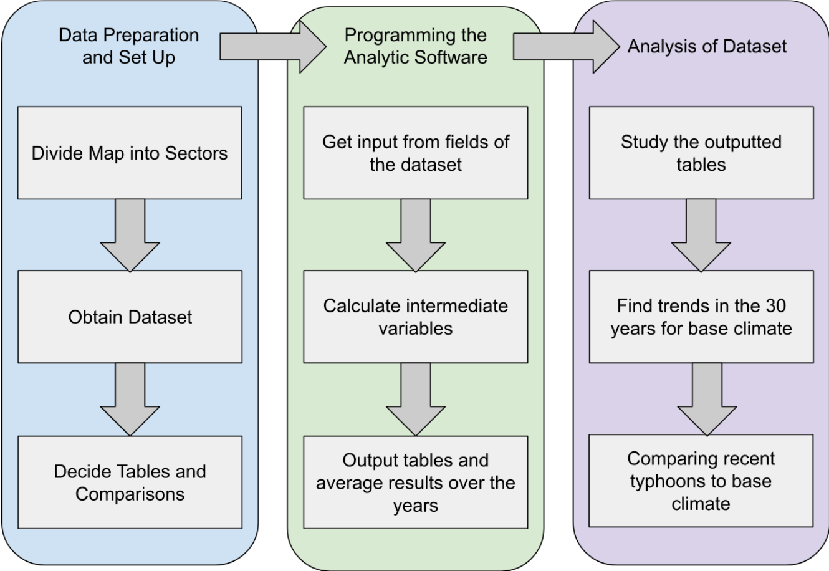

Materials and Procedures
This research will use data analysis on a dataset of typhoon measurements provided by PAGASA. Aside from the laptop, there are no other physical materials needed for this study.
There are three phases in this study: data preparation and set-up, programming the analytical software, and analysis of the dataset.
For the data preparation and setup, we first divide the Philippines into sectors that will be used in the analysis of typhoon tracks. The dataset and included scheme file will then be downloaded and saved in a plain text format. It will be stored in a location that can be accessed by the analytics program. The researcher will then have to design the tables needed for the analysis. This step concludes with the specific table formats that the software will have to follow.
The second phase is programming the software that will analyze the data and create the tables designed in the previous step. Using the Linux laptop, the researcher will write a program using Python 3.8, incorporating necessary packages for data analytics and statistics. The IDE that the researcher will use in developing the program is IDLE.
After the development is complete, the software is expected to perform the following process: It will identify the track of each typhoon, the regions it passed through, and the month of its activity. From this, it should also be able to calculate the lateral speed of the typhoons and the various statistics.
The final phase is analyzing the data, and it can be further divided into descriptive analysis and comparative analysis. The results of both types of analysis should provide the insights needed to answer the question and test the hypothesis of this research. The data will then be presented in visualizations that are accurate in representation and easily understandable.
The analysis of the data consists of two phases, a descriptive component where the trends found in the defined base climate period will be identified, and a comparative component wherein the more recent data shall be tested for divergence from the base climate. The results will then be presented in a way that is accurate in representation and easily understandable.

Treatment of Data
The treatment of data starts by dividing the Philippines into sections and seeing how many typhoons passed through there every month. For the purposes of this study, these areas shall be called sectors. The sectors to be used in this study are:
    - Northern Luzon
    - Central Luzon, NCR, and Southern Luzon
    - Bicol Region
    - Eastern Visayas
    - Central Visayas and Northern Mindanao
    - Western Visayas
    - Palawan
    - Rest of Mindanao
The preliminary selection of sectors are based on similarity to each other in terms of frequency and characteristics of tropical cyclones crossing them, according to currently known data. The research itself will clarify any patterns existing among them, if there are any. The groupings may be slightly tweaked during the course of the study as we learn more about the typhoon patterns revealed in the analysis of data.
From the position information (latitude and longitude) of typhoons given in 6-hour intervals, we can compute the average lateral speed for each interval. This calculation will be automated with the use of a program that will be written, into which the data will be fed.
The next step in the treatment of data is to generate tables mapping the various parameters of the typhoon to the defined sectors. The tables will be in comma-separated values (CSV) format that will again be generated by a program that will be developed for this purpose. The output tables will cover the entire duration of the dataset from 1951 to present.
From these tables, a set of monthly climatological norms will be calculated for the base climate reference period. Instead of 1991 to 2020, the 30-year reference period was chosen to be the years 1990 to 2019. This is to prevent overlap with the pandemic years covering the last three years which is the subject of this study. As before, a software program will be written to automate the calculation of these climatological norms.
All programs developed by the researcher will be written in the Python 3.8.x series.
Based on the output of these programs, the base climate as well as the mean of the last three years can be described. Comparisons will be done by computing a Pearson correlation coefficient and doing Linear Regression analysis followed by a Two-Sample Independent t-Test for comparison of means. If the regression does not turn out to be linear, other regressions such as tests for quadratic or exponential relationships will be applied.
From the results of these tests, it can be determined if data recorded in the past three years showed any changes to the patterns, and to what extent.

FAQs - Climate. (2022, January 18). World Meteorological Organization. https://public.wmo.int/en/about-us/frequently-asked-questions/climate
Arguez, A., & Vose, R. S. (2011). The definition of the standard WMO climate normal: The key to deriving alternative climate normals. Bulletin of the American Meteorological Society, 92(6), 699-704.
What's the difference between weather and climate? (2015, March 9). NASA. https://www.nasa.gov/mission_pages/noaa-n/climate/climate_weather.html
Climatological Normals. (2022, December 9). PAGASA. https://www.pagasa.dost.gov.ph/climate/climatological-normals
Matthews, J. B. R., Möller, V., Van Diemen, R., Fuglestvedt, J. S., Masson-Delmotte, V., Méndez, C., Semenov, S., & Reisinger, A. (Eds.) (2021). Annex VII: Glossary. IPCC — Intergovernmental Panel on Climate Change. https://www.ipcc.ch/report/ar6/wg1/downloads/report/IPCC_AR6_WGI_AnnexVII.pdf
World Meteorological Organization. (1989). Calculation of monthly and annual 30-year standard normals. WCDP 10, WMO-TD 341.
Updated 30-year reference period reflects changing climate. (2021, May 5). World Meteorological Organization. https://public.wmo.int/en/media/news/updated-30-year-reference-period-reflects-changing-climate
IGI. (n.d.). What is baseline climate. IGI Global: International Academic Publisher. https://www.igi-global.com/dictionary/climate-change-impact-on-the-water-resources-of-the-limpopo-basin/61469
WMO. (2017). WMO guidelines on the calculation of climate normals. https://library.wmo.int/doc_num.php?explnum_id=4166
Climate Council. (2018, May 8). What is a baseline year and why does it matter? https://www.climatecouncil.org.au/what-is-a-baseline-year-and-why-does-it-matter/
Climate of the Philippines. (2022, July 29). PAGASA. https://www.pagasa.dost.gov.ph/information/climate-philippines
Corporal-Lodangco, I. L., & Leslie, L. M. (2017). Defining Philippine climate zones using surface and high-resolution satellite data. Procedia Computer Science, 114, 324-332.
Climatological Normals. (2022, December 9). PAGASA. https://www.pagasa.dost.gov.ph/climate/climatological-normals
Observed climate trends and projected climate change in the Philippines. (n.d.). Climate Grid PH. https://climgridph.pagasa.dost.gov.ph/files/CLIRAM_intro_and_guide.pdf
Typhoons in the Philippines. (2022, September 28). Worlddata.info. https://www.worlddata.info/asia/philippines/typhoons.php
Climate variablity table. (n.d.). NOAA's Atlantic Oceanographic and Meteorological Laboratory. https://www.aoml.noaa.gov/hrd/Landsea/climvari/table.html
Northwest Pacific Basin Names. (2022). PAGASA. https://www.pagasa.dost.gov.ph/learning-tools/northwest-pacific-basin-names
Tropical cyclones. (2021, April 12). World Meteorological Organization. https://public.wmo.int/en/our-mandate/focus-areas/natural-hazards-and-disaster-risk-reduction/tropical-cyclones
Doucette, B. F. (1933). A brief history of the Manila Observatory. Bulletin of the American Meteorological Society, 14(2), 36-38.
Hennessey, J. J. (1960). The Manila Observatory. Philippine Studies, 8(1), 99-120.
Anduaga, A. (2014). Spanish Jesuits in the Philippines: Geophysical research and synergies between science, education and trade, 1865–1898. Annals of Science, 71(4), 497-521.
Japan Meteorological Agency: History. (n.d.). https://www.jma.go.jp/jma/en/Background/history.html
Doucette, B. F. (1933). A brief history of the Manila Observatory. Bulletin of the American Meteorological Society, 14(2), 36-38.
Anduaga, A. (2019). History of typhoon science. Oxford Research Encyclopedia of Climate Science. https://oxfordre.com/climatescience/display/10.1093/acrefore/9780190228620.001.0001/acrefore-9780190228620-e-721
Ocampo, A. R. (2022, November 2). Padre Faura’s barometer. Inquirer.net. https://opinion.inquirer.net/158366/padre-fauras-barometer
History | Manila observatory. (n.d.). Manila Observatory: Committed to a scientific culture for sustainable development. https://www.observatory.ph/about/
The Philippines is the most storm-exposed country on earth. (2013, November 11). TIME.com. https://world.time.com/2013/11/11/the-philippines-is-the-most-storm-exposed-country-on-earth/
Tablazon, J., Caro, C. V., Lagmay, A. M. F., Briones, J. B. L., Dasallas, L., Lapidez, J. P., ... & Malano, V. (2015). Probabilistic storm surge inundation maps for Metro Manila based on Philippine public storm warning signals. Natural Hazards and Earth System Sciences, 15(3), 557-570.
Annual Tropical Cyclone Tracks. (2022, December 10). PAGASA. https://www.pagasa.dost.gov.ph/information/annual-cyclone-track
Brand, S., & Blelloch, J. W. (1973). Changes in the characteristics of typhoons crossing the Philippines. Journal of Applied Meteorology and Climatology, 12(1), 104-109.
Brand, S., & Blelloch, J. W. (1974). Changes in the characteristics of typhoons crossing the island of Taiwan. Monthly Weather Review, 102(10), 708-713.
Bohra-Mishra, P., Oppenheimer, M., Cai, R., Feng, S., & Licker, R. (2017). Climate variability and migration in the Philippines. Population and environment, 38(3), 286-308.
Jauregui, J. P. (2020). What is the effect of COVID-19 on climate change.
Takane, Y., Nakajima, K., & Kikegawa, Y. (2022). Urban climate changes during the COVID-19 pandemic: integration of urban-building-energy model with social big data. npj Climate and Atmospheric Science, 5(1), 1-10.
Bernstein, A. (2020, July 6). Coronavirus and climate change. C-CHANGE | Harvard T.H. Chan School of Public Health. https://www.hsph.harvard.edu/c-change/subtopics/coronavirus-and-climate-change/
Zhongming, Z., Linong, L., Xiaona, Y., Wangqiang, Z., & Wei, L. (2021). Emission Reductions From Pandemic Had Unexpected Effects on Atmosphere.

