

**Fatih BİLDİRİCİ**

**Ankara University – Interdisciplinary Artificial Intelligence PhD Programme**

**23823406**

**Machine Learning with Python Course MiniLab 3**

Example 1:

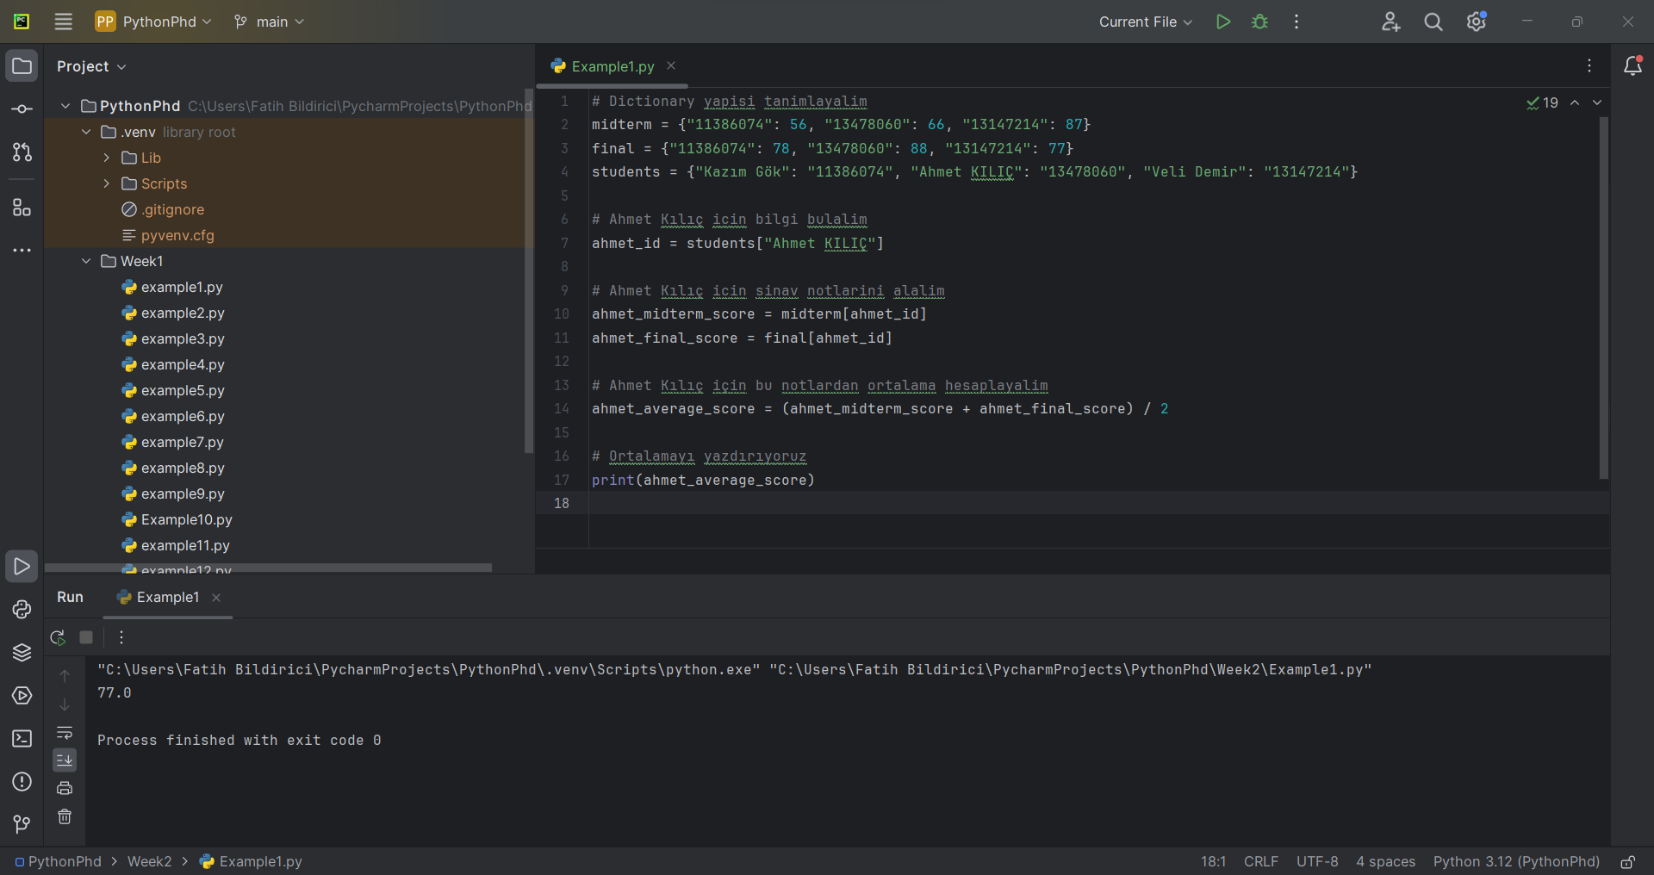

Example 2:

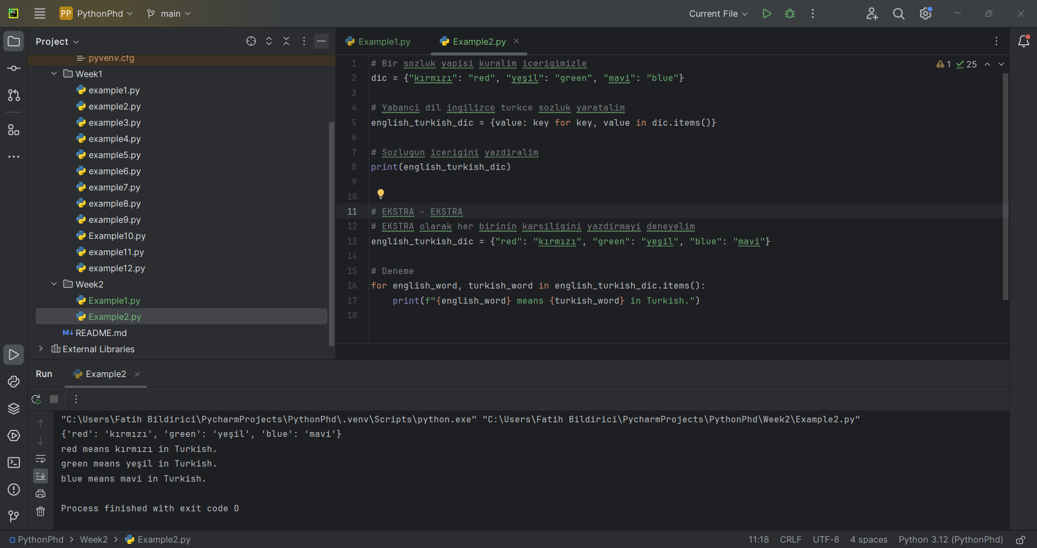

Example 3:

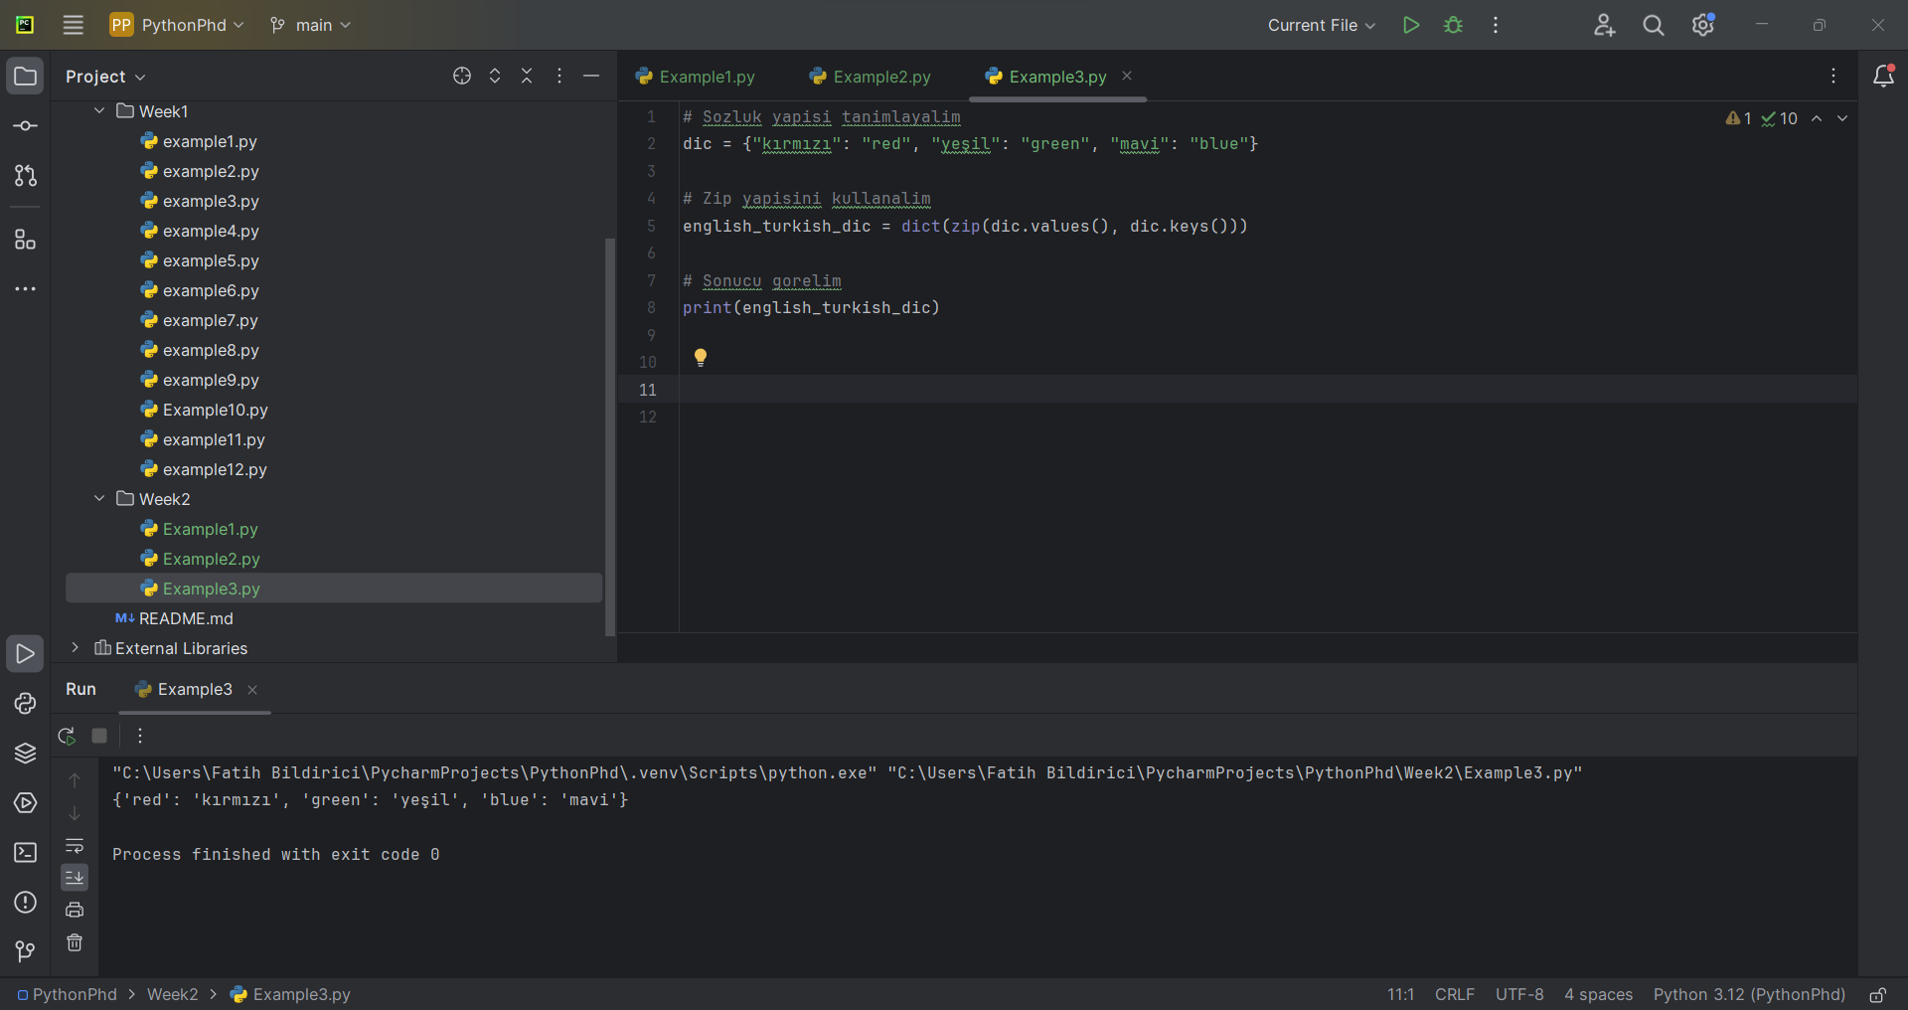

Example 4:

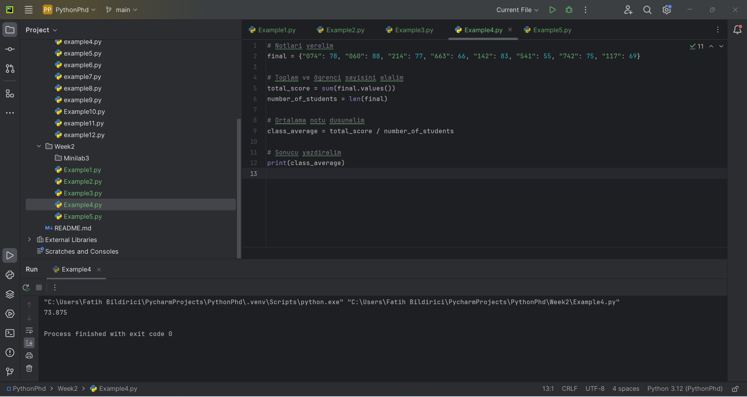

Example 5:

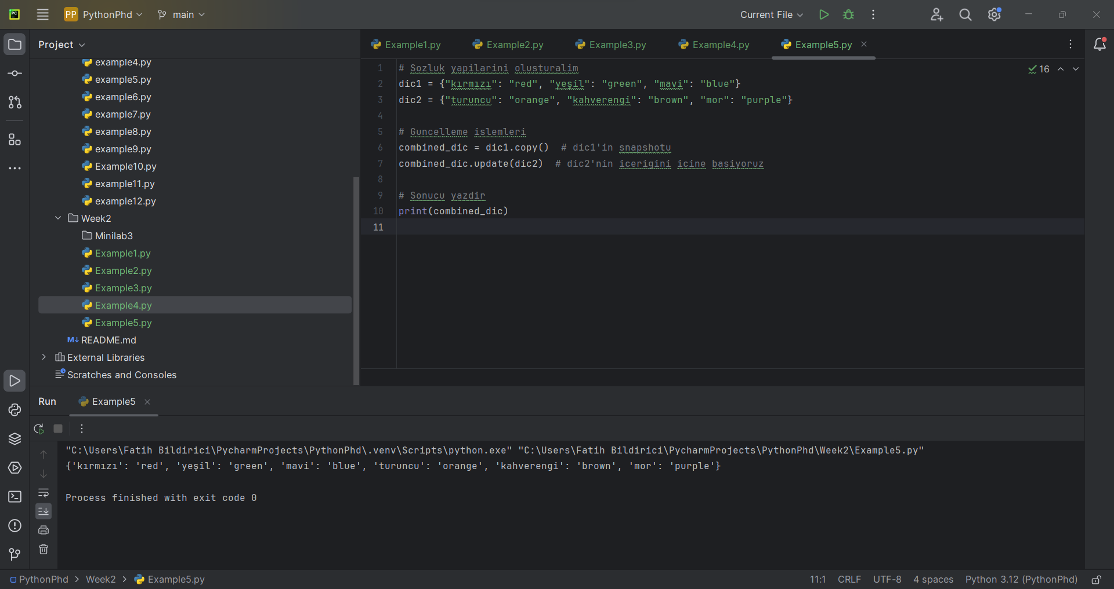

Example 6:

