

**Fatih BİLDİRİCİ**

**23823406**

**Minilab 5 – Week 3 / Machine Learning with Python Course**

Example 1:

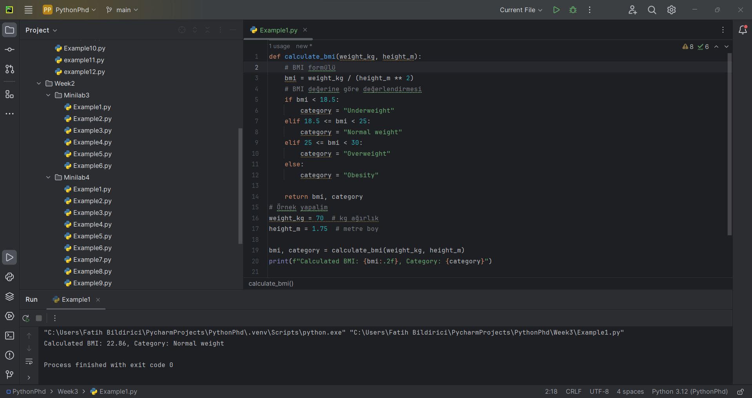

Example 2:

In this program, a function called compute does some math operations. The function has four parameters: a, c, b, and d. Each parameter except a has an initial value.

In the first example, the function is called compute (4,3,2,1). Here a=4, c=3, b=2, and d=1. The computation result is calculated as 4*2+3-1, and the result is 10.

In the second example, the function is called only for a and d: compute (4, d=5). a=4 and d=5, using the default values for b and c (b=4, c=5). The operation is 4*4+4+5-5, and the result is 16.

In the third example, a call is made for a and c: compute (4, c=5). a=4, c=5 and the default values for the other parameters (b=4, d=3) are used. When computing 4*4+4+5-3, the result is 18.

The results are 10, 16, and 18.

Example 3:

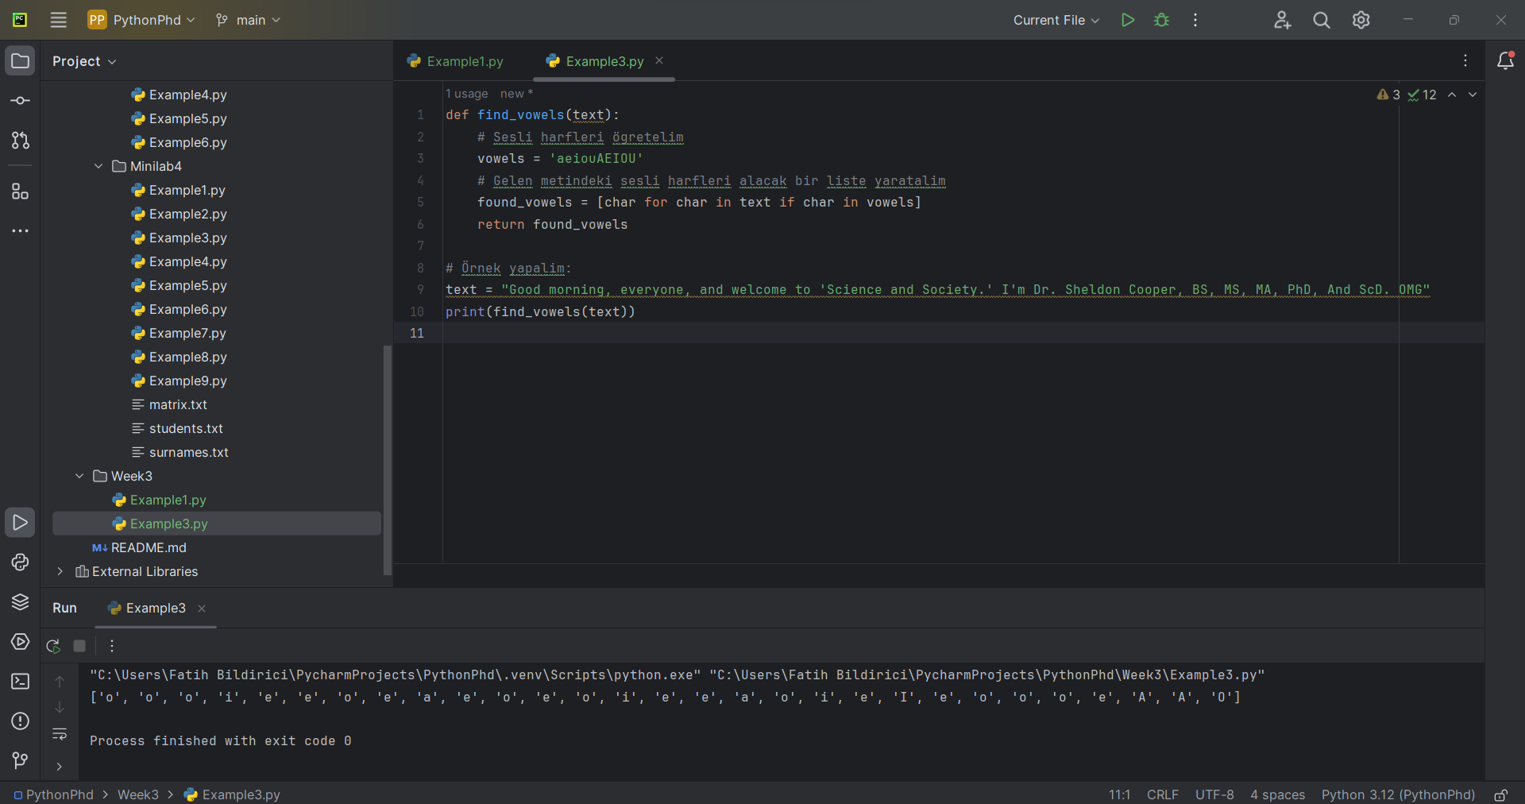

Example 4:

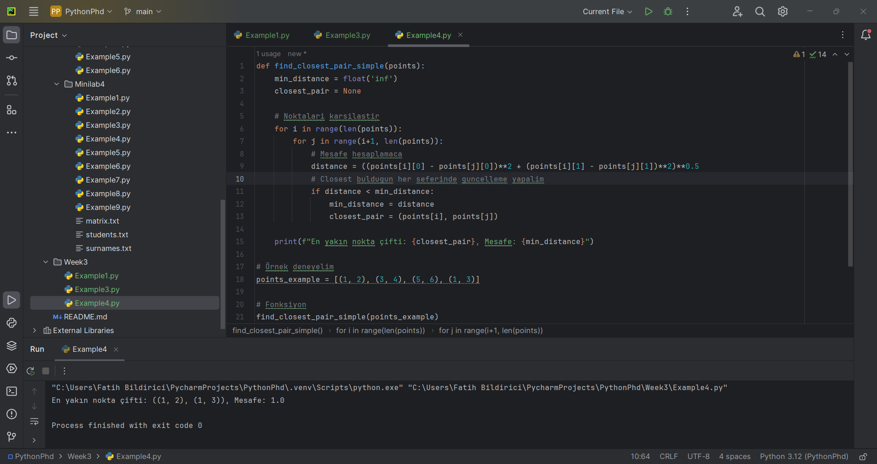

Example 5:

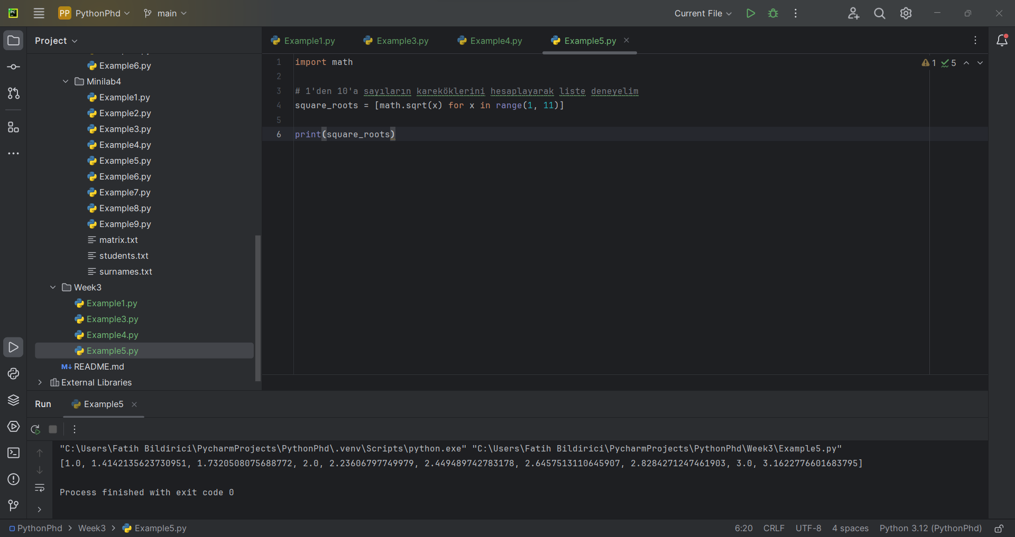

Example 6:

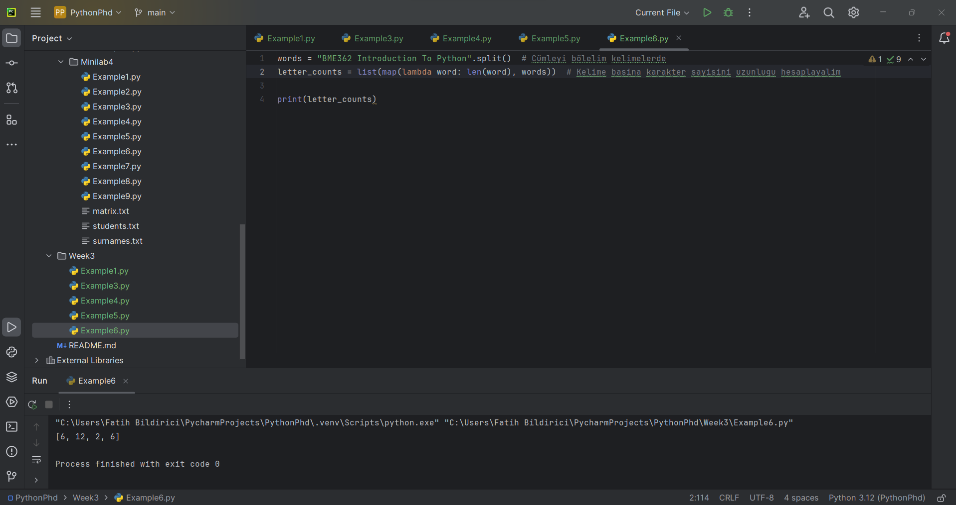

Example 7:

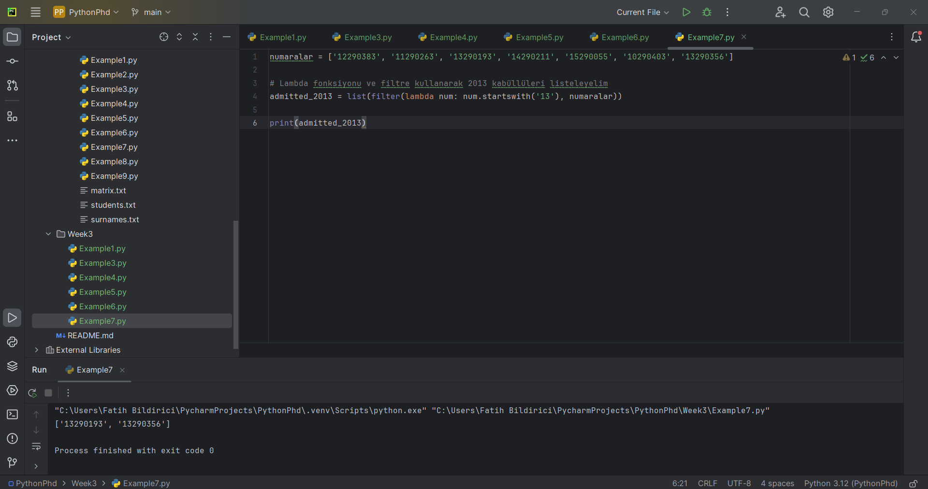

Example 8:

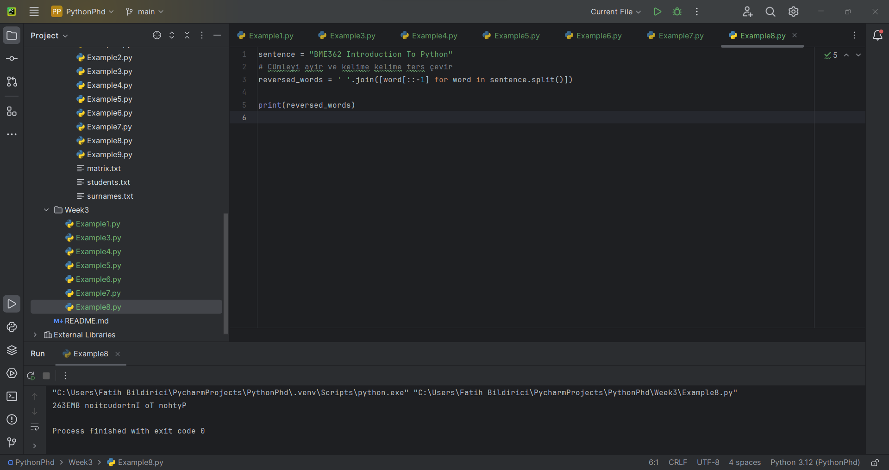

Example 9:

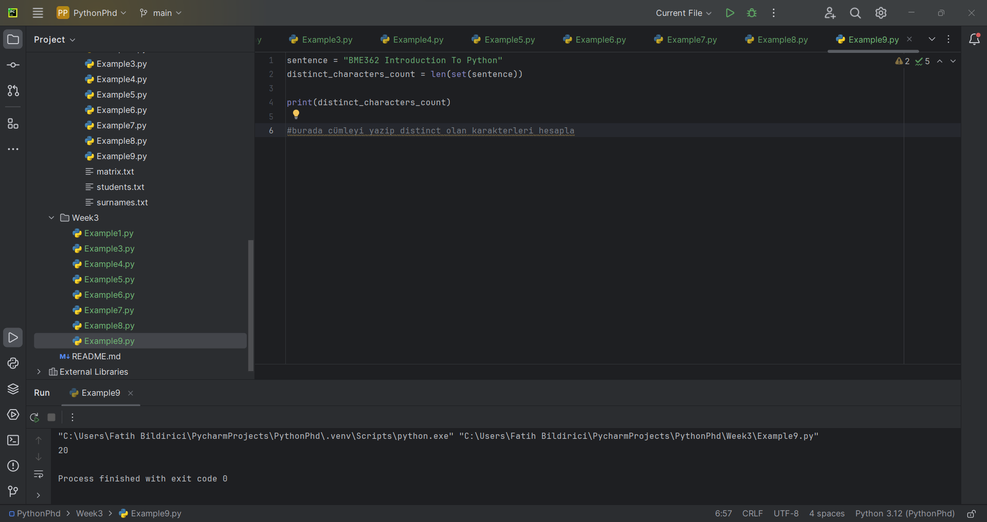

Example 10:

