amblem, simge, sembol, daire, ticari marka içeren bir resim

Açıklama otomatik olarak oluşturuldu

**Fatih Bildirici – 23823406**

**Ankara University Artificial Intelligence PhD Programme**

**Machine Learning with Python Course**

**Minilab 8 Answers**

Example 1:

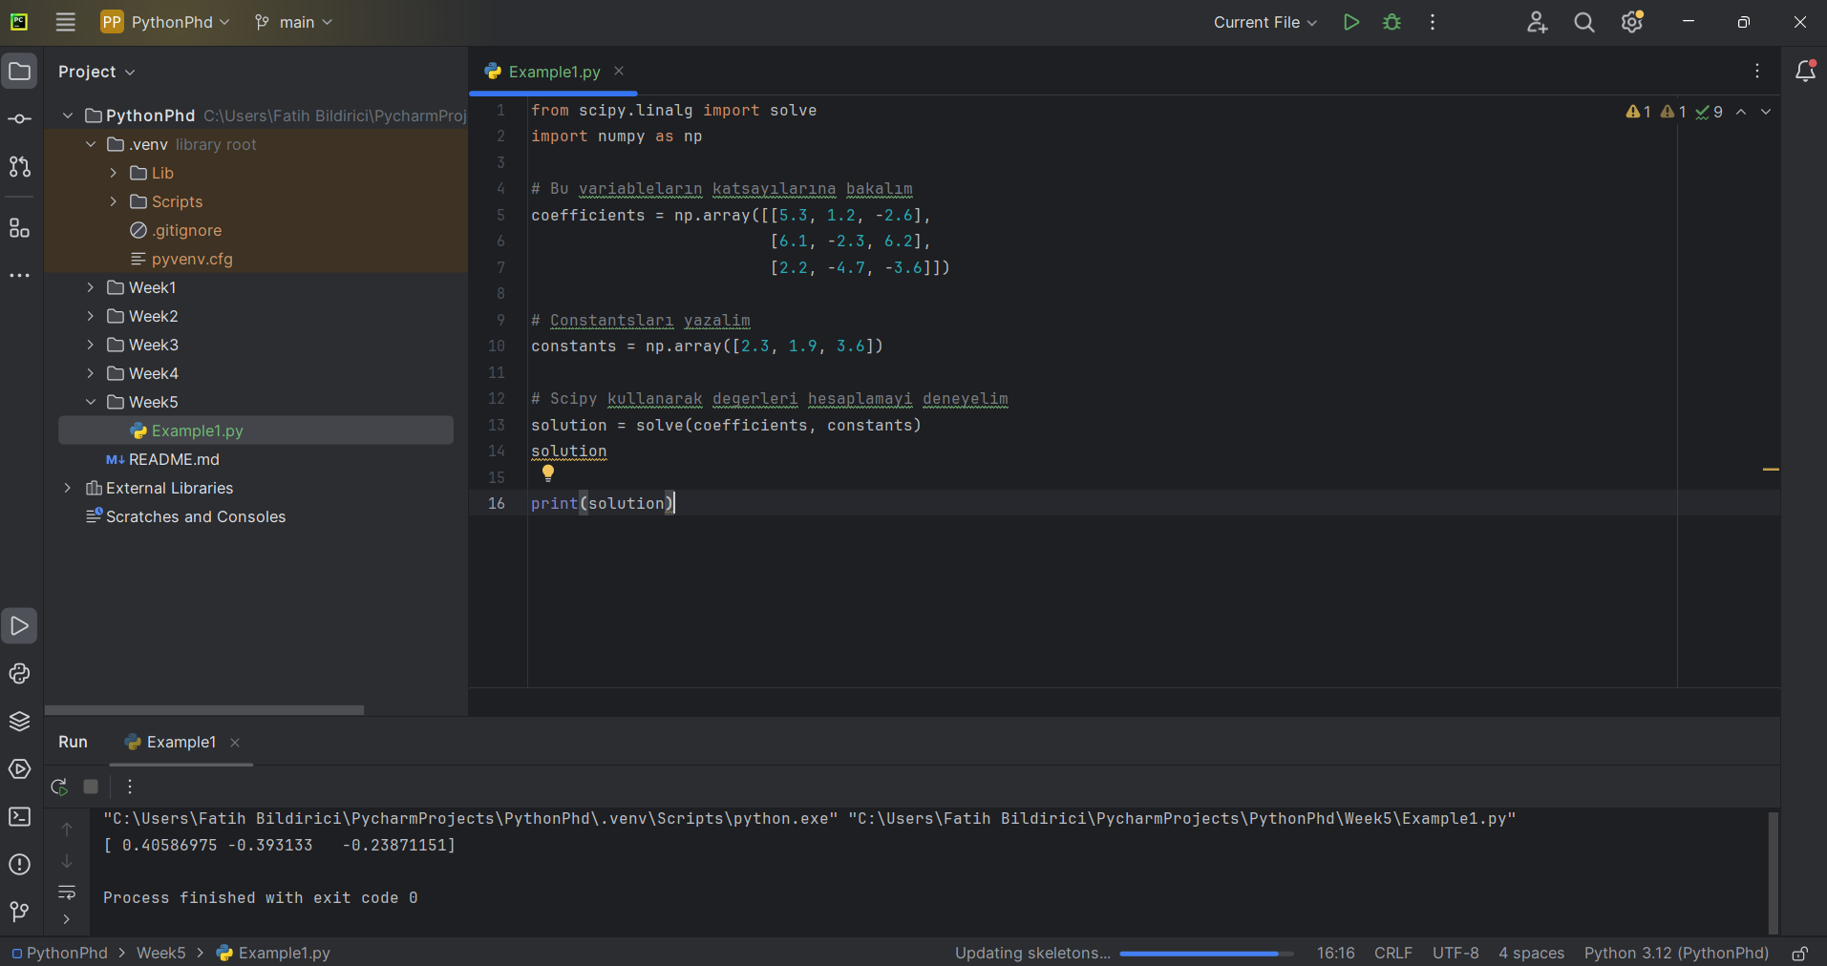

Example 2:

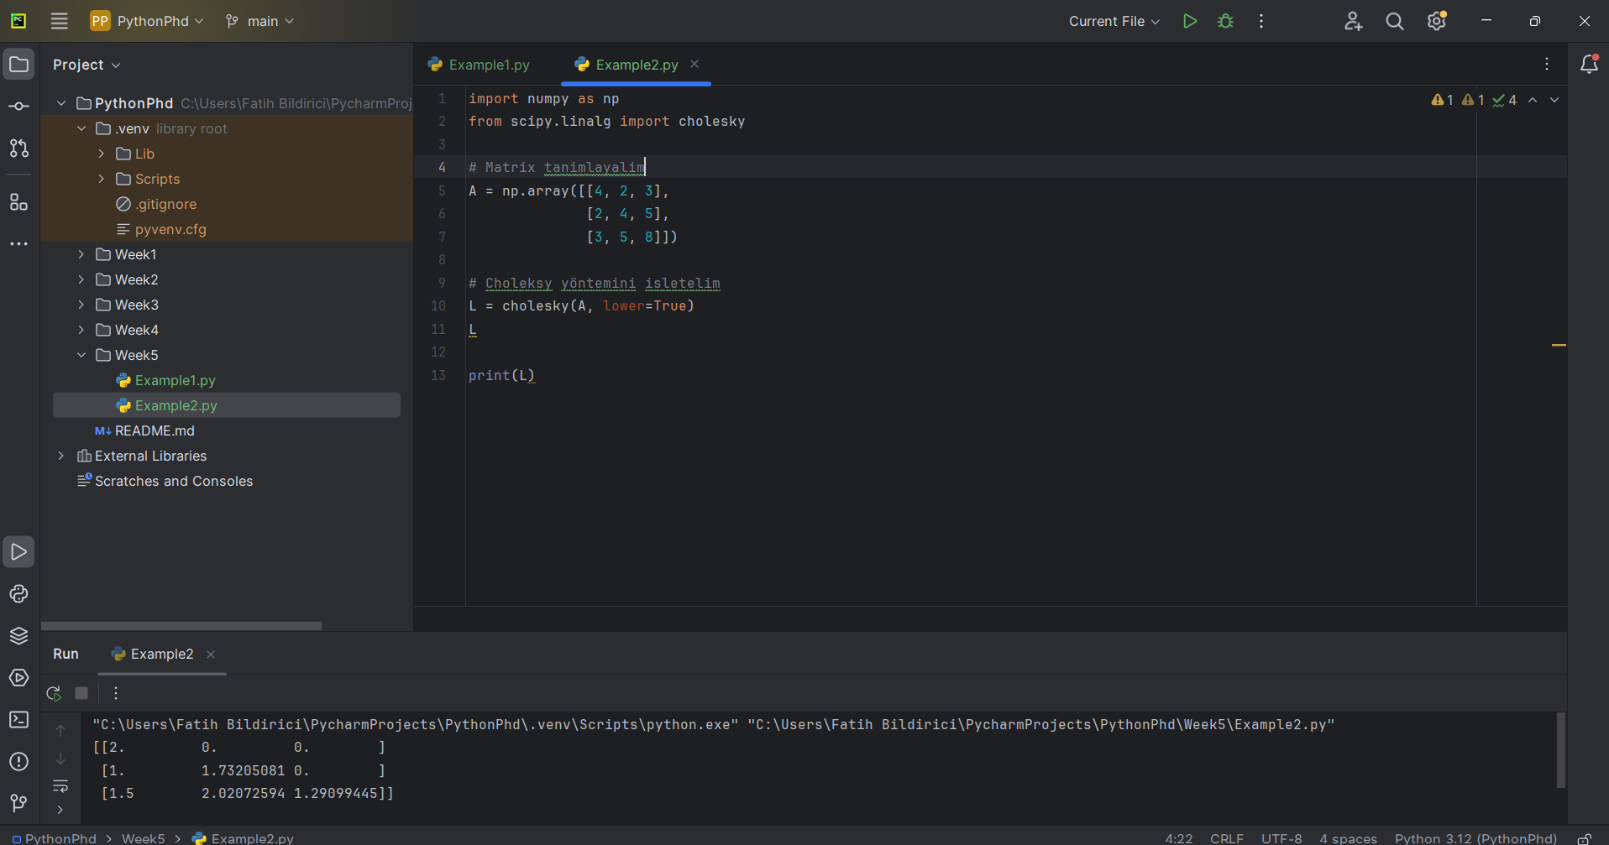

Example 3:

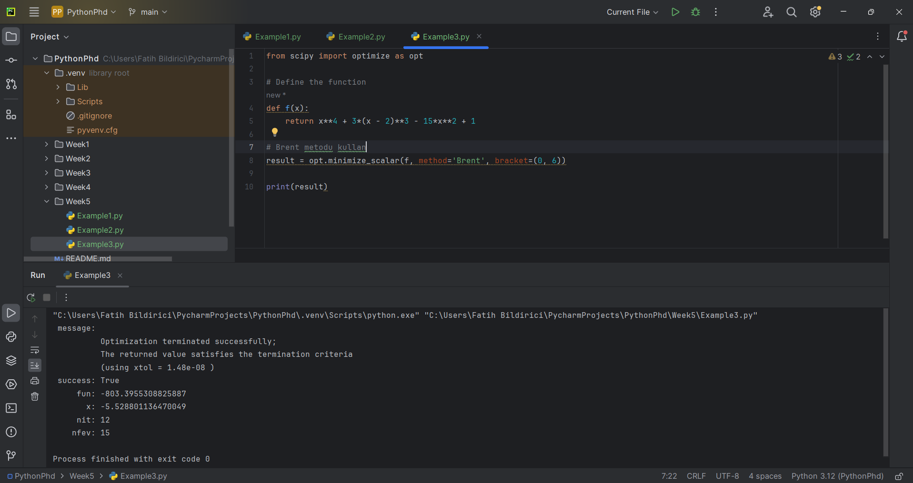

Example 4:

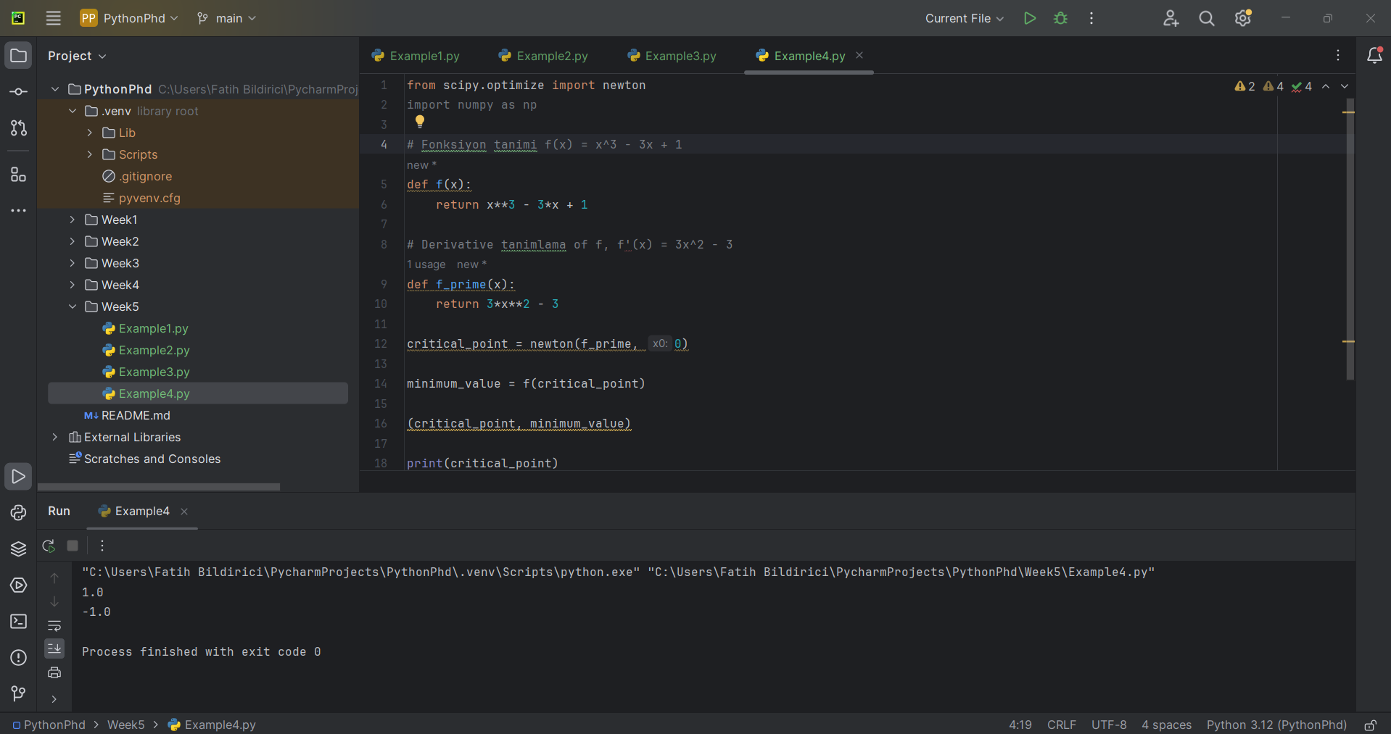

Example 5:

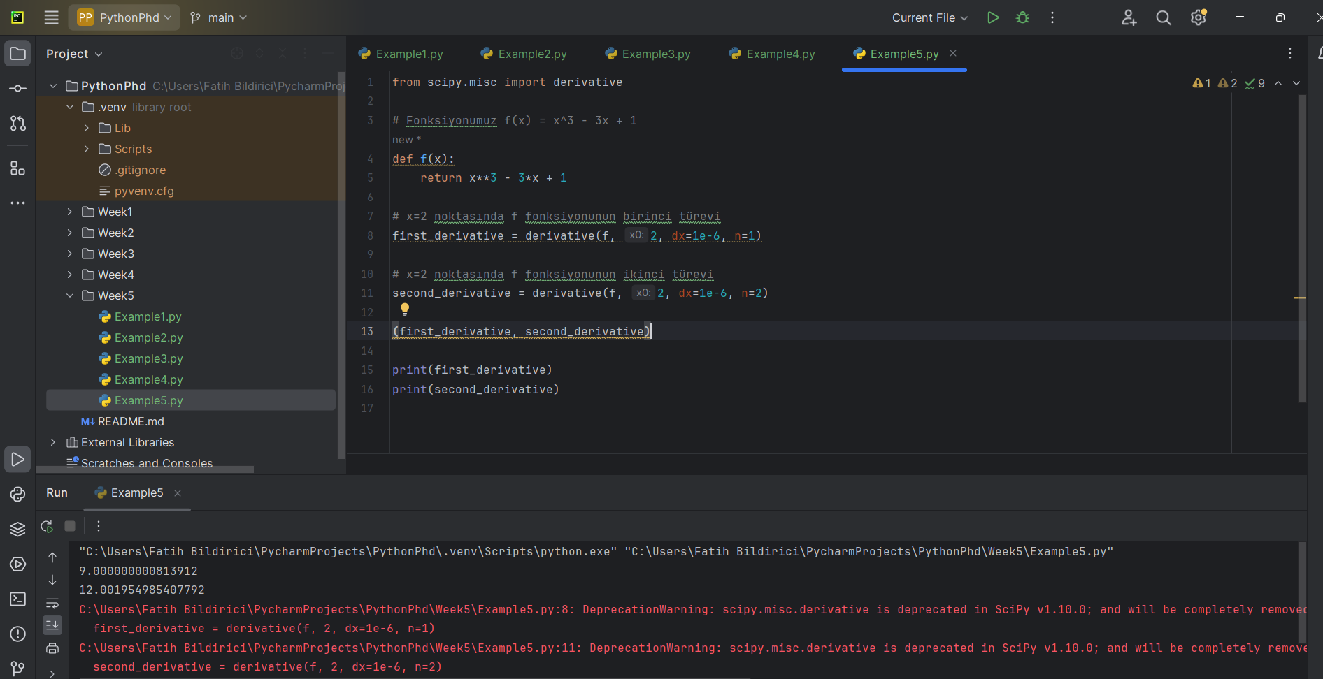

Note: Due to the deprecation of scipy.misc.derivative, it is necessary to use alternative methods maybe such as **numdifftools**

Issue: **https://github.com/pvlib/pvlib-python/issues/1644**