Writing Reports with R Markdown

Felicia Bisnath

2022-10-21

This report was prepared for the UN. It analyses the relationship between a country’s GDP, life expectancy, and CO2 emissions. Our goal was to determine to what degree a country’s economic strength or weakness may be related to its public health status and impact on climate pollution. We hypothesise that both life expectancy and CO2 emissions will increase with a country’s GDP.

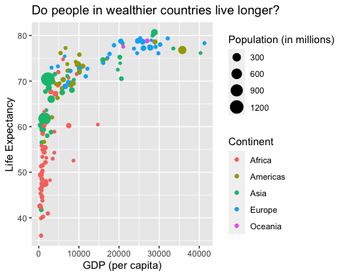

The above plot shows the relationship between the GDP per capita and life expectancy for a total of 142 countries. Economic wealth ranged from a minimum of $ 312 to a maximum of 4.1283^{4} per capita.

| Summary of Data |  |
| --- | --- |
| Number of countries | 142 |
| Minimum GDP per cap | 312 |
| Maximum GDP per cap | 4.1283^{4} |

# Lists

## Unordered lists

* **R**
* *geom*
* ***statistics in R***

## Ordered lists

1. **R**
2. *geom*
3. ***statistics in R***
4. [Cheatsheets](www.rstudio.com/resources/cheatsheets)
5. [Markdown cheatsheet](https://www.rstudio.com/wp-content/uploads/2015/03/rmarkdown-reference.pdf)
6. list1
   * one
   * two
7. list2

```