Falcon MFD Extractor v0.2.0.2 User Manual

Overview
Falcon MFD Extractor is a software utility for home F-16 cockpit builders, that allows exporting the MFDs (multi-function displays) and HUD (head-up display) graphics from Falcon 4, and sending those graphics to other monitors which are either attached to the same computer as Falcon is running on, or to monitors that are attached to other computers which are connected together via a local-area network.

Supported Falcon Versions
2D Cockpit Image Extraction Mode:
All Falcon 4 versions are supported in 2D Cockpit Image Extraction Mode, including:
- “Classic” Falcon 4.0 with at least the 108US patch applied
- Falcon 4: Allied Force,
- Any of the Benchmark Sims (BMS) Falcon variants
- FreeFalcon/RedViper
- OpenFalcon

3D Cockpit Image Extraction Mode:
- BMS 2.0 Falcon variants (including OpenFalcon 4.5 or later) are supported in 3D Cockpit Image Extraction Mode.

Networking Support
Falcon MFD Extractor can be used in a networked, multiple-computer configuration, where one instance of Falcon MFD Extractor acts as a “server”, providing graphics over a network to one or more “client” computers (also running Falcon MFD Extractor). This allows you to use Falcon MFD Extractor to send graphics to monitors which are not physically attached to the same computer that will be running Falcon itself.

Falcon MFD Extractor supports three different networking modes:

Standalone
In Standalone mode, Falcon MFD Extractor runs on a single computer, and all networking functionality in Falcon MFD Extractor is disabled. Use this mode when all of the monitors that you want to use for displaying MFDs and/or HUD graphics are physically attached to the same computer that you will be running Falcon on.

Client
Falcon MFD Extractor in Client mode runs on a computer that is not running Falcon. In Client mode, Falcon MFD Extractor receives MFD and/or HUD graphics over a network from the “Server” computer, which is also running a copy of Falcon MFD Extractor in Server mode.

Server
Falcon MFD Extractor in Server mode runs on the same computer as Falcon. In Server mode, Falcon MFD Extractor extracts MFD and/or HUD graphics from Falcon, and then makes these graphics available over a network, where they can be received by other computers on the network which are running Falcon MFD Extractor in Client mode.

When Falcon MFD Extractor is running in Server mode, it also has the ability to generate output on any displays that happen to be physically attached to the Server computer.

2D and 3D Cockpit Image Extraction Modes
Falcon MFD Extractor supports two image extraction modes: 2D cockpit mode and 3D cockpit mode.

2D Cockpit Image Extraction Mode
Falcon MFD Extractor supports 2D cockpit image extraction mode with all versions of Falcon.
2D cockpit image extraction mode is the default mode of operations when you first start up Falcon MFD Extractor, and is appropriate for flying using Falcon’s 2D cockpit out-the-window views.

In certain of Falcon’s 2D cockpit views, it is possible to have Falcon display the MFDs and/or HUD data on the screen at all times, in unchanging locations (e.g., in Falcon’s “#1” or “#5” 2D cockpit out-the-window views; or when panned to 12:00 in Falcon’s “#2” 2D cockpit out-the-window views).

In 2D cockpit image extraction mode, Falcon MFD Extractor captures graphics from specific areas of Falcon’s out-the-window view, and sends those graphics to the monitors of your choice.

As long as the appropriate graphics are visible on-screen in Falcon, at unchanging screen locations, you can use Falcon MFD Extractor in 2D mode to capture those graphics and send them to additional monitors, such as TFT/LCD screens in your cockpit.

3D Cockpit Mode
3D Cockpit Extraction mode is appropriate for flying Falcon using Falcon’s 3D cockpit views, such as the “#3” (“virtual cockpit”) view, or the various “Padlock” views).

In Falcon’s various 3D cockpit out-the-window views, there is no way to keep the MFD and/or HUD graphics visible on the screen at all times, in unchanging screen locations, as you pan around.

However, the BMS 2.0-based Falcon variants (such as OpenFalcon) provide a special “hidden” feature, which, when enabled, allows Falcon to export the graphics for certain cockpit instruments (such as the MFDs and the HUD) to a special shared memory file.

This feature allows third-party programs such as Falcon MFD Extractor to read these images, even when they are not visible on-screen.

NOTE: Non-BMS 2.0 Falcon variants (such as Allied Force, FreeFalcon/RedViper, and Falcon 4.0 “classic”) do not provide this special feature, and therefore cannot be used with Falcon MFD Extractor’s 3D cockpit image extraction mode.

You can switch Falcon MFD Extractor into 3D mode by pressing a user-defined hotkey. You can also switch back to 2D mode using a different user-defined hotkey. See the

Pre-Installation Requirements
Please pay careful attention to the following system requirements and pre-requisites. You MUST have the minimum required versions of DirectX, Windows Installer, and the .NET Framework installed, or Falcon MFD Extractor may not operate properly.

System Requirements
Any computer capable of running a modern Falcon 4 version
Operating System
Windows XP, Service Pack 2 (or later)
DirectX
DirectX 9.0c 4.09.0000.0904 (November 2007), or later

NOTE: All Falcon MFD Extractor users running on Windows XP should verify that they are have the latest version of DirectX, by running the Microsoft DirectX End-User Web Installer, available at:

http://www.microsoft.com/downloads/details.aspx?familyid=2da43d38-db71-4c1b-bc6a-9b6652cd92a3&displaylang=en

You will need to reboot your computer after upgrading your DirectX to the latest version, if the DirectX End-User Web Installer finds that you need to upgrade.
Windows Installer
Microsoft Windows Installer 3.1 SP2 [KB893803]

NOTE: All Falcon MFD Extractor users running on Windows XP must have the Microsoft Windows Installer 3.1 SP2 [KB893803] (or later), installed.
is available at:

http://www.microsoft.com/downloads/details.aspx?FamilyId=889482FC-5F56-4A38-B838-DE776FD4138C&displaylang=en
.NET Framework
Microsoft .NET Framework 3.5 (or later), available at:

http://www.microsoft.com/downloads/details.aspx?FamilyID=333325FD-AE52-4E35-B531-508D977D32A6&displaylang=en

NOTE: earlier versions of the Microsoft .NET Framework are not supported.

Downloading Falcon MFD Extractor
The latest version of Falcon MFD Extractor can be found at

www.assembla.com/spaces/lightningstools

As of the time of this writing, the current version of Falcon MFD Extractor is v0.2.0.2.

Caution: Some users have reported issues when downloading Falcon MFD Extractor installer using Internet Explorer. Several versions of Internet Explorer have a bug that corrupts certain downloads. Please use an alternative browser such as FireFox (available from www.firefox.com) or Opera (available from www.opera.com) to download Falcon MFD Extractor.

Installing Falcon MFD Extractor
- Download the latest version of Falcon MFD Extractor, as described in the Downloading Falcon MFD Extractor section in this document.
- Install/update all prerequisite software packages such as the Microsoft .NET Framework, DirectX, and Microsoft Windows Installer, as described in the Supported Falcon Versions section in this document.
- Important: Reboot your computer after installing all the prerequisites!
- To install Falcon MFD Extractor, simply double-click the .msi file that you downloaded in Step #1. Then, follow the on-screen prompts to complete the program installation.

Caution: During installation, If you receive an error message stating that “The cabinet file xxx required for this installation is corrupt and cannot be used”, you most likely did not observe the caution in the Downloading Falcon MFD Extractor section, above. This can happen if you have downloaded Falcon MFD Extractor using Internet Explorer. Simply re-download Falcon MFD Extractor using an alternative browser, and try again.

For networked, multiple-computer installations: If you plan on using Falcon MFD Extractor in a networked, multiple-computer configuration, repeat the above steps on each computer that Falcon MFD Extractor will be running on.

All computers running Falcon MFD Extractor must meet the minimum requirements and prerequisites described in the Supported Falcon Versions section of this document.

Launching Falcon MFD Extractor
During installation, Falcon MFD Extractor adds an icon on your Windows Start menu, under the Programs (or “All Programs”) submenu. This icon looks like a miniature MFD display:

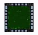
Figure 1: The Falcon MFD Extractor icon

Simply click this icon on your Windows Start menu to launch Falcon MFD Extractor.

At first, nothing interesting will appear to have happened. But, if you look down in the “system tray” (which is typically in the lower, right-hand corner of your Start menu bar), you should now see a miniature Falcon MFD Extractor icon sitting in the tray:

Figure 2: Falcon MFD Extractor running in the Windows system tray

When you see the Falcon MFD Extractor icon sitting in the system tray, it indicates that Falcon MFD Extractor is loaded (though not necessarily running).

Accessing Falcon MFD Extractor’s Menu

Right-clicking on the Falcon MFD Extractor icon in the system tray brings up the Falcon MFD Extractor menu:

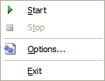
Figure 3: Falcon MFD Extractor's Menu

Starting and Stopping Falcon MFD Extractor
As you can see, you will use Falcon MFD Extractor’s menu to Start and Stop Falcon MFD Extractor, and to access Falcon MFD Extractor’s Options dialog.

You can easily determine from Falcon MFD Extractor’s system tray menu whether Falcon MFD Extractor is Started or Stopped.
- If Falcon MFD Extractor is Stopped, then the Stop menu item will be disabled.
- If Falcon MFD Extractor is Started, then the Start menu item will be disabled.

Initially, Falcon MFD Extractor will launch in the Stopped state. This means that Falcon MFD Extractor is loaded into memory, but it is currently not performing any work. After you have configured Falcon MFD Extractor’s Options, you will need to manually Start the Extractor in order for it to do anything useful. In the Options dialog, you can also configure Falcon MFD Extractor to Start itself automatically whenever you launch Falcon MFD Extractor. Additionally, you can configure Falcon MFD Extractor to launch automatically each time Windows starts up.

Falcon MFD Extractor’s Options dialog
All of Falcon MFD Extractor’s options can be set in the Options dialog.

To access the Options dialog, take the following steps:

- Launch Falcon MFD Extractor from your Windows Start menu, as described in the Launching Falcon MFD Extractor section in this document.
- Right-click on the Falcon MFD Extractor iconin the Windows system tray, to bring up Falcon MFD Extractor’s menu.
- On the menu, click the Options menu item, which will bring up the Falcon MFD Extractor Options dialog.

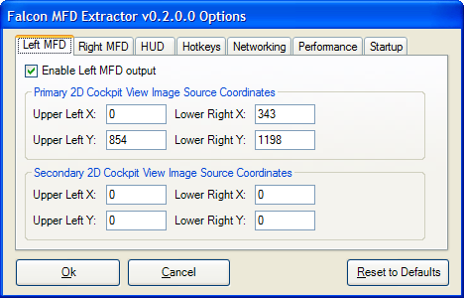
Figure 4: Falcon MFD Extractor’s Options dialog

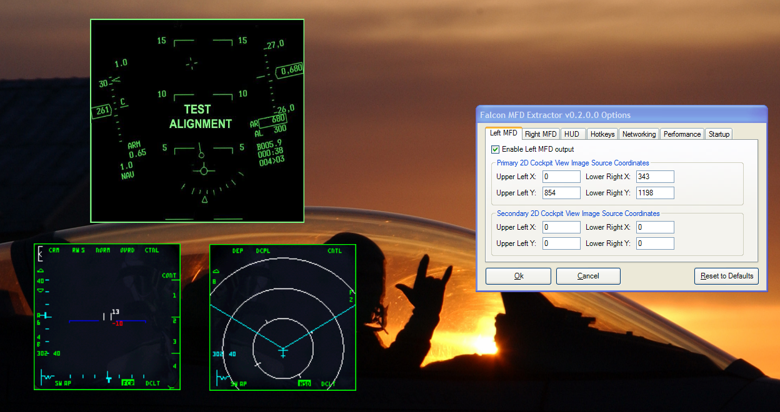
Figure 5: Falcon MFD Extractor's output windows and Options dialog

When you enter the Options dialog, you should see a Test/Alignment output window for each of the enabled instruments (Left MFD, Right MFD, and/or HUD). If you do not see one or more of these output windows, the most likely reason is that the output window for that instrument is not Enabled in the appropriate tab in the Options dialog. (By default, the HUD output window is disabled; you will need to manually enable the HUD via the HUD tab in the Options dialog before you will be able to adjust the HUD output window’s size/location/advanced properties

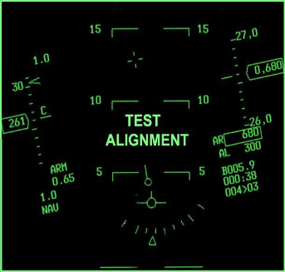

Figure 6: The HUD test/alignment image
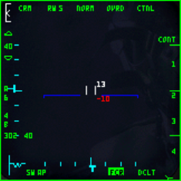
Figure 7: The Left MFD test/alignment image
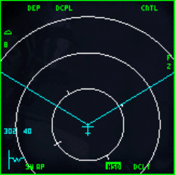

Figure 8: The Right MFD test/alignment image

Adjusting Output Window Sizes and Locations
To move an output window to a new location, simply click and drag the output window to the new location or monitor where you want the output window to appear while running Falcon MFD Extractor.

Each output window will remember its position, even after you stop or close Falcon MFD Extractor. When you restart Falcon MFD Extractor, each (enabled) output window will re-appear at the location it was previously located at.

To re-size any of the output windows, simply move your mouse over one of the edges or corners of the output window until the cursor changes to a resize-cursor. Then, click and drag the border of the window until you have achieved the appropriate size.

You can also move, re-size, or reconfigure advanced properties of output windows while Falcon MFD Extractor is running. These changes will take effect immediately and will be remembered even when Falcon MFD Extractor is stopped, restarted, closed, or re-launched.

Adjusting Advanced Properties of Output Windows
You can right-click on any output window to adjust advanced options specific to that window.

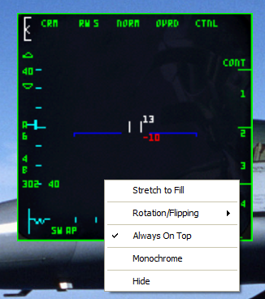
Figure 9: Advanced output window options

Stretch to Fill
If this option is checked, the output window will resize itself automatically to fill the monitor on which the output window is currently positioned. Also, when checked, if you drag the output window to another monitor, it will automatically resize itself again to fill the new monitor’s display entirely.

Rotation/Flipping
Under this submenu, you can select options for rotating and/or flipping the output image. This allows you to use TFT/LCD screens which are oriented sideways or upside-down, or even to use rear-screen projection techniques or mirrors as part of your home cockpit setup.

Note: Typically, if your output window will be configured to use full-screen mode, you will get better performance by using your video card driver’s output rotation feature instead of Falcon MFD Extractor’s rotation/flipping settings.

Always On Top
If this option is checked, then this output window will appear on top of any other windows which are not also set to use “Always On Top”.

Monochrome
When checked, this option will cause all output inside this output window to render in monochrome (actually 8-bit grayscale in the current release; future releases will support 1-bit [high contrast black-and-white] output).
Hide
Clicking the “Hide” menu option closes the selected output window and disables it in the Options dialog. To re-enable the output window after hiding it, you will need to re-enable it on the appropriate tab of the Options dialog.

Configuring MFD and HUD options
In the Options dialog, the first three tabs (the Left MFD tab, the Right MFD tab, and the HUD tab) allow you to configure Falcon MFD Extractor’s capturing and display behavior. All of these first three tabs contain identical options.

Enable xxx output
When this checkbox is checked, Falcon MFD Extractor will provide an output window for the instrument denoted by the current tab. When this checkbox is cleared, Falcon MFD Extractor will not output the instrument denoted by the current tab.

2D Cockpit View Image Source Coordinates
When Falcon MFD Extractor is running in 2D Cockpit Mode, Falcon MFD Extractor captures graphics from specific areas on the primary monitor. The actual screen areas that you will want to capture will depend on several factors, including which version of Falcon you are flying, which resolution you are flying Falcon under, which 2D cockpits you have installed in Falcon, which 2D cockpit views in Falcon that you tend to use while flying, and other such factors. In order to accommodate all of these factors, Falcon MFD Extractor provides you with the ability to configure the specific screen areas to capture.

Falcon MFD Extractor now allows you to configure TWO independent sets of 2D screen capture coordinates, per instrument that you wish to extract. Future releases of Falcon MFD Extractor may support more than two sets of 2D screen capture coordinates, per instrument. .

The current release of Falcon MFD Extractor (v0.2.0.2) designates one set of 2D screen capture coordinates as Primary. The other set of 2D coordinates are designated as Secondary.

A user-configurable hotkey switches Falcon MFD Extractor between Primary 2D Mode and Secondary 2D Mode. The mode you are in determines which set of screen capture coordinates are active at that time. Using multiple sets of screen capture coordinates provides the ability to configure, for example, one set of coordinates that you will activate when you are flying in the #1/#5 views in Falcon, and another set of coordinates that you will activate when you are in the #2 view in Falcon. Alternatively, if you mainly use the #2 view(s) when flying Falcon in the 2D cockpit, you may want to use the Primary coordinates for capturing from the standard 2D forward view, and use the Secondary coordinates for capturing from the wide 2D view or from the Ghost view.

The Primary 2D Cockpit View Image Source Coordinates sections in the Left MFD, Right MFD, and HUD tabs in the Options dialog allow you to specify the screen coordinates where Falcon MFD Extractor will extract graphics from when operating in Primary 2D Cockpit Image Extraction Mode.

The Secondary 2D Cockpit View Image Source Coordinates sections in the Left MFD, Right MFD, and HUD tabs in the Options dialog allow you to specify the screen coordinates where Falcon MFD Extractor will extract graphics from when operating in Secondary 2D Cockpit Image Extraction Mode.

For each instrument that you want to capture graphics for, you will need to configure Falcon MFD Extractor with the X/Y coordinates of the screen area containing the graphics you want to capture. Any graphics that are contained on-screen, within this rectangle, will be captured.

You will want to define these coordinates so that they match the screen locations where Falcon itself will be displaying the graphics that you want to capture.

X/Y coordinates, explained:
For the Primary/Secondary 2D Cockpit View Image Source Coordinates, each X/Y coordinate represents a single pixel on the primary monitor. The X value tells the number of pixels inward from the left edge of the primary monitor. The Y value tells the number of pixels downward from the top edge of the primary monitor.

For example, an X/Y coordinate value of X=50, Y=200 would indicate a pixel on the primary monitor 50 pixels in from the left edge of the screen (X=50), and 200 pixels down from the top edge of the screen (Y=200).

Any rectangular area on the primary monitor can be specified in terms of two X/Y coordinates -- the Upper Left X/Y coordinate, indicating the pixel at the upper left corner of the rectangle that you want to capture, and the Lower Right X/Y coordinate, indicating the pixel at the lower right corner of the rectangle that you want to capture.

Image Source Coordinates and Networking Modes
When Falcon MFD Extractor is running in standalone mode (on a single computer) or Server mode, you can adjust the X/Y coordinates of the screen areas to be captured in 2D mode.

When Falcon MFD Extractor is running in Client mode, these options are unavailable, because the source images will be coming from the Server computer, according to how the Server is configured.

Hotkeys Tab
The Hotkeys options allow you to assign the hotkeys that you will use to switch Falcon MFD Extractor between Primary 2D Mode, Secondary 2D mode, and 3D cockpit mode.

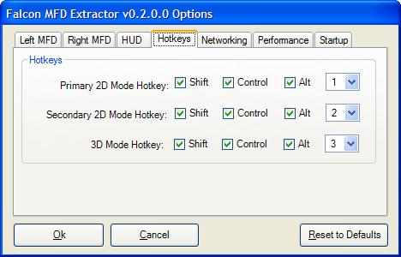
Figure 10: Hotkeys options tab

You should take care to assign hotkeys that are not being used by Falcon itself. If you use Falcon MFD Extractor in combination with a programmable joystick such as the HOTAS Cougar, you can program your joystick so that after it emits the appropriate keystrokes to switch to a particular view in Falcon, it then emits the appropriate Hotkey to cause the MFD Extractor to switch into a capture mode which matches the current Falcon view.

Networking Tab
Each computer running Falcon MFD Extractor can be configured to run in any of 3 different networking modes: Standalone, Client, and Server.

Standalone Mode

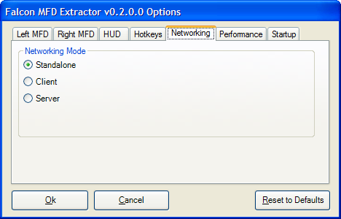
Figure 11: Networking tab (Standalone mode)

In Standalone mode, Falcon MFD Extractor does not send or receive graphics over the network at all. In Standalone mode, all output screens are attached to the computer that will be running Falcon itself.

Client Mode

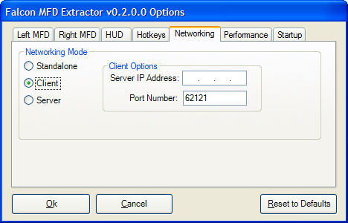
Figure 12: Networking tab (Client mode)

In Client mode, Falcon MFD Extractor receives graphics over the network from the Server computer (the computer which will be running Falcon itself, and which will also be running a copy of Falcon MFD Extractor in Server mode).

The Client computer does *not* run Falcon. The Client computer needs to know the IP (Internet Protocol) address of the Server computer to talk to, and the Port Number that the Server will be listening on.

Server Mode
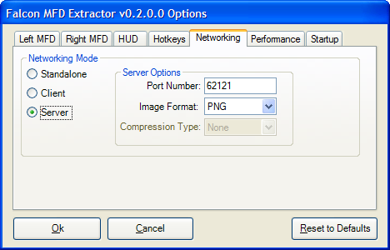
Figure 13: Networking tab (Server mode)

In Server mode, Falcon MFD Extractor captures images from Falcon, and makes them available over the network to any Clients that happen to request those images.

The Server computer needs to be assigned a Port Number to listen on. Clients can talk to the Server on this port number. The default Port Number is 62121, but you can change this, should you want/need to. The only requirement is that the Client and Server are both configured to use the same Port Number.

In Server Mode, you can configure the Image Format that Falcon MFD Extractor will use when publishing images over the network to remote Clients.

Supported image formats are:
- BMP (Windows Bitmap)
- GIF (Graphics Interchange Format)
- JPEG (Joint Photographic Experts Group Format)
- PNG (Portable Network Graphics Format)
- TIFF (Tagged Image File Format)

Depending on you choice of Image Format, you can also configure the Compression Type that Falcon MFD Extractor will use in order to compress images for transit across the network. Using image compression will allow images to traverse a low-bandwidth network more rapidly, at the expense of higher CPU utilization on both the Server and the Client computer (compressing and decompressing images requires more work than sending uncompressed images).

Supported compression formats depend on your choice of Image Format, and include:
- None
- RLE (lossless, simple, fast, low CPU overhead on client and server)
- LZW (lossless, more complex than RLE, higher CPU overhead on client and server, achieves smaller image sizes (lower network utilization/higher network throughput)
- JPEG (Lossy, about as fast as LZW, much smaller image sizes than either RLE or LZW, but images don’t look as good)

Performance Tab
The Performance tab settings let you fine-tune the performance-related aspects of Falcon MFD Extractor.

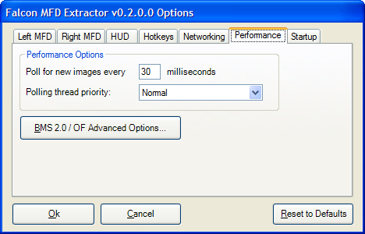
Figure 14: Performance options tab

Poll for new images every n milliseconds

In Standalone or Server mode, this option controls how often Falcon MFD Extractor performs image captures. Lower (shorter) values allow more frequent screen captures; Higher (longer) values result in less-frequent screen captures.

In Client mode, this option controls how often Falcon MFD Extractor requests new images over the network from the Server. It is obviously counter-productive to configure a Client to poll a Server more frequently than the Server is polling Falcon.

The tradeoff in all cases is CPU utilization versus image refresh rate: shorter polling intervals = higher CPU utilization; longer intervals = less CPU utilization. Lower CPU utilization on the part of Falcon MFD Extractor allows higher FPS rates within Falcon, and is a “Good Thing” ™.

Polling thread priority:

The Polling thread priority setting controls how Windows will allocate CPU time to Falcon MFD Extractor’s worker threads.

By default, most Windows programs execute with a base priority of Normal. The default setting of Normal is recommended for Falcon MFD Extractor as well. However, the Polling Thread Priority option is provided so that you can experiment in order to achieve the best possible MFD Extractor performance.

Setting the Polling thread priority to Lowest will only allow Falcon MFD Extractor’s polling threads to receive CPU time when no other program is using the CPU. This is also known as “Background mode”. A setting of Lowest is probably too low for practical use, because Falcon MFD Extractor typically requires more CPU time than would be allocated to it using a setting of Lowest.

BelowNormal is more aggressive than Lowest. At this priority level, Falcon MFD Extractor will receive less CPU time than it would receive under the Normal priority level, but all programs running at a higher priority level than BelowNormal can still pre-empt Falcon MFD Extractor.

AboveNormal is quite aggressive. Programs running at this priority level yield the CPU to other (lower-priority) programs rather infrequently; therefore, AboveNormal is not generally recommended except on stand-alone machines in Client Mode, and only then when no other running software needs to receive a great deal of CPU time in order to operate correctly.

Highest is the most aggressive setting. Essentially, a program running at Highest priority cannot be pre-empted by any other program on the system, except those which are also running at Highest priority (which, generally means, no other processes).

Be advised that setting the Polling thread priority to Highest may make it impossible to shut down Falcon MFD Extractor, because Windows Explorer (and the Task Manager) will not be running at a high enough priority to pre-empt Falcon MFD Extractor!

BMS 2.0 / OpenFalcon Advanced Options
In the BMS 2.0 / OpenFalcon Advanced Options dialog, you can configure advanced options of BMS 2.0 –based Falcon variants (including OpenFalcon). These include the ability to:

- Enable or disable Falcon’s ability to perform image exporting while flying in the 3D cockpit
- Control how often Falcon exports images while flying in the 3D cockpit
- Control the color depth of the images that Falcon exports while flying in the 3D cockpit.

CAUTION: Configuring Falcon to export instrument images from within the 3D cockpit will cause your Falcon FPS rates (video frames per second) to suffer.

Clicking on the BMS 2.0 / OF Advanced Options button in the Performance tab of the Options dialog, brings up the following dialog box:

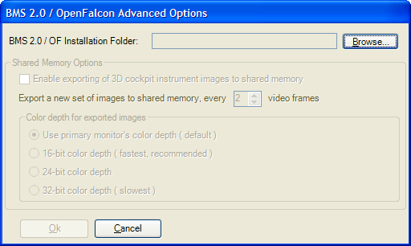
Figure 15: BMS 2.0 / OpenFalcon Advanced Options dialog

BMS 2.0 / OF Installation Folder:
The first time you enter the BMS 2.0 / OpenFalcon Advanced Options dialog, you must tell Falcon MFD Extractor where to find your BMS 2.0 or OpenFalcon installation folder.

Until you select your BMS 2.0 or OpenFalcon installation folder, all other options on the BMS 2.0 / OF Advanced Options dialog will be disabled (grayed out).

To select your BMS 2.0 or OpenFalcon installation folder, click the Browse... button. Then select a folder containing your BMS 2.0 or OpenFalcon installation, and click OK. Once you have performed this step, the remaining options on this dialog will become enabled (assuming you have selected a valid BMS 2.0 or OpenFalcon installation folder).

Enable exporting of 3D cockpit instrument images to shared memory
Checking this option configures Falcon to export specific cockpit instruments (including the MFDs and the HUD) to a special shared memory file, where Falcon MFD Extractor can read them.

Unchecking this option turns off Falcon’s 3D cockpit instrument images export feature.

This option MUST be enabled (checked) in order to use Falcon MFD Extractor in 3D Cockpit Mode.

Export a new set of images to shared memory, every n video frames
This option lets you specify how often Falcon exports new images to shared memory. Higher values result in better Falcon FPS rates, at the expense of “laggier” MFD and HUD images (as delivered by Falcon MFD Extractor).

Lower values will cause more responsive MFD and HUD images, but will cause Falcon’s FPS rates to drop off precipitously.

You can experiment with this setting in order to find the best compromise between MFD/HUD responsiveness and Falcon’s out-the-window FPS rates.

Color depth for exported images
This option lets you configure the color depth that Falcon will use when generating exported images in. The lower the color depth, the higher your Falcon FPS rates will be, all other things being equal. It is STRONGLY RECOMMENDED to set this value to use 16-bit color depth for exported images.

How to Monitor your Falcon FPS Rates

To monitor your out-the-window FPS rates in Falcon, try the following:

While running Falcon, press CTRL and Z together, then release, then press and release R. You should then see a little box in the upper right hand corner of Falcon’s out-the-window view that shows your current FPS rate.

Startup Tab

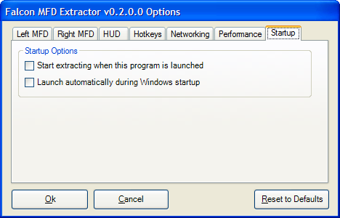
Figure 16: Startup options tab

The Startup Options group of settings let you define how Falcon MFD Extractor behaves during Windows startup and when Falcon MFD Extractor itself is launched.

Start extracting when this program is launched
You can configure Falcon MFD Extractor to automatically Start itself when you launch Falcon MFD Extractor, without having to use the right-click menu in the system tray to Start Falcon MFD Extractor’s capture process.

Launch automatically during Windows startup
You can configure Falcon MFD Extractor to launch itself automatically when Windows starts up. Use this setting in conjunction with the Start extracting when this program is launched setting, for a fully-automated Falcon MFD Extractor startup sequence. If both options are checked, then when Windows starts up, Falcon MFD Extractor will be launched; then when Falcon MFD Extractor is launched, it will Start itself running.

