Fiscal Discipline and Investment Outcomes: Panel Evidence and Machine-Learning Validation from India's Top Ten FDI-Recipient States, FY 2019-20 to FY 2023-24
R Vinay Kumar
Department of Advanced Computing, St. Joseph's University
Bengaluru, Karnataka, India
rvinaykumar6924@gmail.com

S. Dutta
Department of Advanced Computing, St. Joseph's University
Bengaluru, Karnataka, India
duttasanjay098@gmail.com

Abstract
Foreign direct investment in India concentrates in a handful of states, and fiscal discipline is widely assumed, though rarely tested, to be part of the reason. This study asks whether it is. We measure the fiscal discipline of India's ten largest FDI-recipient states through four indicators, each expressed as a share of gross state domestic product: fiscal deficit, public debt, own tax revenue and capital expenditure. The panel is balanced and covers five fiscal years, 2019-20 to 2023-24. It is built from audited state finance accounts published in the Sixteenth Finance Commission report, together with official investment and output data from the Department for Promotion of Industry and Internal Trade and the Ministry of Statistics and Programme Implementation. On that panel we estimate fixed-effects and pooled regressions of FDI and of GSDP growth on the four indicators. Five years is not many, and one of them is dominated by the COVID-19 shock, so the regression findings are cross-checked against a non-parametric rank correlation and against machine-learning methods drawn from two distinct families: regularised linear selection, in the form of LASSO with an Elastic Net cross-check, and SHAP-based random forest importance. The window is also, by necessity, the most COVID-adjacent five years for which audited state finance data exist, and the results should be read as describing that period rather than a COVID-free steady state. States carrying persistently lower public debt receive more FDI than their peers. The association is large and it survives every robustness check we apply, though at ten clusters the wild cluster bootstrap this paper defers to puts the pooled coefficient at p = 0.057, significant at ten per cent rather than five; the claim rests on the agreement of several methods rather than on that one p-value. The relationship holds between states rather than within a given state from year to year, a split confirmed inside a single Mundlak specification in which the two coefficients differ at a bootstrapped p = 0.017, and every validation method converges on debt as the dominant fiscal predictor of investment. The growth equation supports no such conclusion. Fiscal coefficients that appear significant when the pandemic is controlled for by a single dummy do not survive a full set of year fixed effects, and we report the second hypothesis as unsupported rather than retain a result that tracks the shape of the recovery. Two states depart from the general pattern for identifiable reasons, and Jharkhand and Uttar Pradesh are examined individually. The paper also documents in full every fiscal, investment and demographic series used in the analysis, along with the exact procedure behind its fiscal discipline ranking, so that the study can be independently reproduced and its ranking judged against an outcome rather than reported as an end in itself.
Keywords: fiscal discipline, foreign direct investment, sub-national public finance, panel data, India, LASSO, SHAP

1. Introduction
Ten states take almost all of India's foreign direct investment. The Department for Promotion of Industry and Internal Trade began reporting state-wise FDI equity figures in October 2019, and since then those ten have absorbed close to 97 per cent of the national total (DPIIT, 2024). Maharashtra, Karnataka and Gujarat between them take about half of it in a typical year. So what separates the states that receive capital from the two dozen that receive almost none? And is any part of that difference something a state finance department can actually act on?
Two research literatures speak to that question and rarely cite each other. One asks how state fiscal policy affects growth. Trivedi and Rajmal (2011), working with fourteen states and fixed-effects panel methods, report that fiscal deficits contract subsequent growth; Panda and Sahay (2022) repeat the exercise on seventeen states for 2004-05 to 2016-17, adding two-stage least squares, and reach the same verdict. Running alongside both is a debt-sustainability literature (Misra, Gupta and Trivedi, 2023; NIPFP, 2024) concerned with whether current borrowing paths are solvent, which stops before asking what those borrowing paths do to the investment a state subsequently receives. NITI Aayog's Fiscal Health Index (2025, 2026) ranks states on fiscal metrics and validates the ranking against nothing at all.
This paper closes that gap. We use a balanced panel of India's ten largest FDI-recipient states across five fiscal years, the most recent window for which audited, comparable state finance data exist, and one that happens to bracket the COVID-19 shock. The question is whether fiscal deficit, public debt, own tax revenue and capital expenditure, each measured against state GSDP, predict two things: the FDI a state receives, and the GSDP growth it records. Both relationships are estimated under two specifications. One is entity fixed effects with Driscoll-Kraay standard errors; the other is pooled OLS with time-invariant Census controls. Keeping both separates the within-state from the between-state dimension, and that distinction turns out to matter a great deal for how the results should be read.
Because the panel is short and one of its five years is an extreme common shock, we do not stop at the regression. The same prediction problem is run again through LASSO, Elastic Net, and SHAP values from a shallow random forest. These methods were chosen because they stay credible at forty-eight observations, where instrument-heavy panel GMM estimators do not (Roodman, 2009). If a regularised linear selector, a non-linear tree-based explainer and a fixed-effects panel regression all land on the same variable, that agreement is worth more than any one method's p-value. We also report a methodological pitfall we walked into and corrected. An early SHAP specification included the time-invariant Census literacy and urbanisation controls, which let the random forest use urbanisation as a disguised state identifier and inflated its apparent importance. Dropping both controls, and restricting the machine-learning stage to the same five time-varying regressors the fixed-effects model uses, removes the leakage. Diagnosis and corrected results are both reported in Section 6.
Inputs are reported in full. Every year-wise fiscal amount and ratio, the raw FDI and GSDP series each indicator was built from, the Census control variables, and the composite-ranking procedure all appear in Section 4. A reader can rebuild every table in Sections 6 and 7 from the raw numbers, without taking any intermediate step on faith.
Section 2 surveys the work this paper builds on and departs from. Section 3 sets out the channels through which a fiscal position could plausibly reach an investor, together with the rival agglomeration account, and states the two hypotheses. Section 4 is the data section, and it is intentionally long. It includes the sample, sources, every input series in both rupee and ratio form, the control variables, and the detailed ranking procedure with a worked example. Section 5 focuses on estimation. Its first two parts present the econometric and machine-learning specifications. Section 5.3 then outlines the entire analytical process, from the raw source files to the convergence test, which serves as the final validation step of the paper. Results are in Section 6. Section 7 interprets them, with particular attention to the between-state versus within-state contrast and to the Jharkhand and Uttar Pradesh cases. Section 8 closes with policy implications and limits.

2. Review of Literature
Five bodies of work bear on the question this paper asks, and each stops one step short of it. The macroeconomic case for expecting fiscal policy to matter at all comes first, followed by the Indian evidence on state deficits and growth, the separate Indian literature on sub-national debt sustainability, the largely agglomeration-driven work on what determines FDI, and the fiscal-federalism tradition that supplies the theoretical reason a state balance sheet might be visible to mobile capital. Two smaller literatures close the review: the ranking exercises this paper sets itself against, and the applied machine-learning practice it borrows its validation design from.
Barro (1990) formalised the point that public spending is neither uniformly good nor uniformly bad for growth: spending financed without highly distortionary taxation tends to support growth, while the same spending financed through heavy taxation need not. Fischer (1993) extended the argument to deficits directly, showing that large and persistent fiscal deficits slow growth and generate monetary and trade instability, largely because deficit-financed spending crowds out the investment that would otherwise drive growth. Read together, the two papers make the same point at different levels: what matters is not how much is spent but what it is spent on and how it is financed.
The Indian state-level evidence which arrives later is quite consistent. Trivedi and Rajmal (2011) estimate fixed-effects panels across fourteen major states and find that gross fiscal deficits reduce subsequent growth, attributing the effect to the crowding out of private investment and to the higher borrowing costs a deficit state faces. Panda and Sahay (2022) return to the question with seventeen states over 2004-05 to 2016-17. They add two-stage least squares to address the obvious reverse-causality worry, that weak growth widens deficits rather than the other way round, and the negative association survives it. Neither study extends the dependent variable beyond output. FDI is absent from both.
A second Indian literature takes debt rather than deficit as its object, and asks a solvency question rather than a growth question. Misra, Gupta and Trivedi (2023) examine whether state debt paths remain sustainable once off-budget borrowings and guarantees are counted, and conclude that the official on-budget figure understates exposure for several states. The NIPFP (2024) working paper approaches the same debt stock from a different angle, using threshold regression to estimate the debt-to-GSDP level beyond which further borrowing begins to reduce growth in the major states.
The Reserve Bank of India's (2024) annual study of state budgets supplies the background series: aggregate state debt rose after the pandemic, the increase was uneven across states, and the pace of subsequent consolidation has varied just as widely.
Misra, Gupta and Trivedi (2023) and the NIPFP (2024) between them establish that debt levels differ meaningfully across states and that the differences persist rather than converge over time, but neither asks what that debt means to an investor. The NIPFP threshold estimate and the Misra, Gupta and Trivedi sustainability analysis both assess debt against the state's own budget constraint, never against the state's ability to attract capital.
The FDI-determinants literature has a different intellectual ancestry altogether. Dunning's (1993) OLI framework organises location choice around ownership, location and internalisation advantages, and in the cross-country empirical work Blonigen (2005) surveys, the location leg is operationalised mostly through market size, factor costs, trade openness and institutional quality. Borensztein, De Gregorio and Lee (1998) run the causal arrow in the other direction, showing that FDI raises host-country growth conditional on sufficient absorptive capacity, which is a large part of why sub-national governments compete for it in the first place. Applied to Indian states, this literature is dominated by agglomeration. Existing industrial clusters, port and highway access, labour-market depth, and the size of a state's own consumer market do most of the explanatory work (Mahatekar, 2025). Mahatekar's own study of state-wise flows between 2019 and 2024 is descriptive rather than econometric: it documents the concentration without estimating it, and it carries no fiscal variable at all. Where fiscal instruments do appear in this literature they are usually incentives offered to the investor, such as tax holidays or subsidised land, rather than measures of the host government's own balance sheet. It is also published in JETIR, a venue without competitive peer review; it is cited here only for its descriptive concentration figures, which are consistent with the DPIIT data this paper uses directly, and not for any econometric claim.
The theoretical case for expecting a state's fiscal position to matter to mobile capital predates both of those literatures. Tiebout (1956) modelled households sorting across jurisdictions according to the fiscal package on offer; Oates (1972) extended the logic of assignment and inter-governmental competition to sub-national governments generally. Rao and Singh (2005) apply the framework to India, and their account of an asymmetric federation, in which states control expenditure composition and own tax effort but not currency, monetary policy or most trade regulation, is the institutional setting this paper takes as given. Feld, Köhler, Palhuca and Schaltegger (2024) provide the closest empirical antecedent. Across a panel of federal economies they find that fiscally healthier governments, at both the national and the sub-national level, attract more mobile capital. Their result has not been tested inside India, and that omission matters. The Indian case removes several of the levers that operate in a cross-country sample: states here share a currency, a central bank, a national tax framework and most of the regulatory environment. If a fiscal signal still shows up in that setting, it cannot be standing in for exchange-rate risk or for monetary credibility, which narrows considerably the set of channels capable of producing it.
Three such channels remain available. The first is a signalling channel, and it is informational. A state that runs small deficits and holds debt on a sustainable path is telling a prospective investor something about how it will behave in a downturn, namely that it is less likely to reach for distortionary taxation or to compress committed expenditure when revenues fall (Misra, Gupta and Trivedi, 2023). The second is the crowding-in argument, and it is weaker than it first looks. Capital expenditure lowers the cost of doing business only if it is genuinely spent on infrastructure, so a state that funds capex without borrowing heavily is demonstrating administrative capacity at least as much as fiscal restraint. The third is a competition channel. Mobile capital is finite, and honouring an incentive package, a land arrangement or a regulatory commitment across the fifteen-year life of a project requires fiscal headroom that a stressed state does not have (Feld et al., 2024). Against all three sits the agglomeration account, under which FDI simply goes where FDI already is and the host government's balance sheet is incidental. Section 3 develops that contrast and explains how the empirical design lets the two be told apart.
A further strand ranks rather than tests, and it is the strand this paper takes most direct issue with. NITI Aayog's Fiscal Health Index (2025, 2026) scores eighteen states on indicators broadly similar to the four used here and publishes the resulting league table. The index is outcome-agnostic by construction. No step in it asks whether a high-ranking state subsequently receives more investment, grows faster, borrows more cheaply, or differs on any other observable at all. The implicit claim, that fiscal health is worth ranking because it matters, is precisely the claim that goes unexamined. The criticism generalises to composite indices as a class: with no outcome to validate against, the choice of weights is unfalsifiable, and a reader has no way of telling a well-constructed index from an arbitrary one.
The last body of work this paper draws on is methodological rather than substantive. Using machine-learning methods alongside, rather than instead of, a structural specification is now ordinary practice in applied economics. Varian (2014) made the initial case for these tools as complements to regression. Mullainathan and Spiess (2017) drew the sharper distinction: prediction problems and parameter-estimation problems are different tasks with different success criteria, and treating a regularised model's variable selection as evidence about a coefficient requires care about which of the two is being attempted. Athey and Imbens (2019) survey which methods transfer usefully to economic questions and which do not. The specific tools used later in this paper are all well established. The LASSO (Tibshirani, 1996) shrinks and selects in a single step, so a variable that still carries weight after the penalty has been applied has cleared a criterion that owes nothing to a p-value. The Elastic Net (Zou and Hastie, 2005) modifies that penalty to handle correlated regressors differently, which matters here because deficit and debt are mechanically linked.
Random forests (Breiman, 2001) impose no functional form on the relationship between regressors and outcome. SHAP values (Lundberg and Lee, 2017) decompose an individual prediction into per-variable contributions, giving a measure of importance that is not specific to any one model class. Hastie, Tibshirani and Friedman (2009) set out how each of these methods trades bias against variance.
None of these methods has yet been applied to state finance in India, where the literature still rests on conventional panel estimation. That is unobjectionable on a long panel. It is a weakness on a short one, where the entire claim depends on the standard errors of a single specification. Across these bodies of work the pattern is a run of near-misses rather than one clean omission. Trivedi and Rajmal (2011) establish that fiscal deficits contract growth across fourteen states, but do not look at FDI. Panda and Sahay (2022) confirm the same growth result on seventeen states over a pre-2017 window, again with no FDI channel. Misra, Gupta and Trivedi (2023) study the sustainability of state debt, off-budget guarantees included, without linking that sustainability to an investment outcome. The NIPFP threshold regression (2024) estimates the debt level at which growth turns negative for the major states, once more without FDI. NITI Aayog (2025, 2026) produces a composite fiscal ranking of eighteen states and validates it against no outcome whatsoever. Mahatekar (2025) documents state-wise FDI descriptively, with neither econometrics nor fiscal variables. And Feld et al. (2024) establish the fiscal-federalism link to FDI across countries but not within one.
So far as we can establish, no study uses Indian state fiscal indicators as direct predictors of state-wise FDI, and none corroborates a sub-national fiscal-investment relationship with machine-learning methods, a robustness step that has become routine in applied economics (Athey and Imbens, 2019) but has not reached Indian state finance research. This paper addresses both omissions using the most recent audited data, over a window that additionally brackets the COVID-19 fiscal shock.

3. Theoretical Framework and Hypotheses
The signalling, crowding-in and competition channels of Section 2 give three separate reasons why a state's fiscal position could shape the FDI it attracts, even though all ten states in this sample share a currency, a central bank and most regulatory settings with one another. Against all three stands the agglomeration hypothesis: FDI goes where FDI already is, whatever the host government's balance sheet looks like. We address that rival account twice over. State fixed effects absorb any time-invariant structural advantage a state holds, whether an existing industrial base, a port, or a metropolitan market, so the within-state coefficient in Section 6 cannot simply be picking up fixed geography. The machine-learning stage of Section 6.6 then leaves a flexible non-linear model free to rank a structural or agglomeration-linked variable above the fiscal ones, if agglomeration is in fact doing all the work.
Two hypotheses follow from the problem statement, which asks whether the fiscal discipline of Indian state governments significantly influences FDI inflows and GSDP growth across India's top ten FDI-recipient states between FY 2019-20 and FY 2023-24, and whether any such relationship survives both traditional econometric and modern machine-learning treatment.

H1: Fiscal discipline and FDI
Null (H1₀): Fiscal discipline indicators have no significant effect on state-wise FDI inflows.
Alternative (H1): Lower deficit and debt, and higher own tax revenue and capital expenditure, are significantly associated with higher FDI inflows.

H2: Fiscal discipline and GSDP growth
Null (H2₀): Fiscal discipline indicators have no significant effect on GSDP growth.
Alternative (H2): Fiscal discipline indicators significantly affect GSDP growth.
Both hypotheses are tested twice in Section 6, within states over time and between states, because the two dimensions answer different questions. For H1 they also point in different directions, for a substantive and explicable reason set out in Section 7.1.

4. Data

4.1 Sample and scope
The sample is a balanced panel of ten states over five fiscal years, FY 2019-20 through FY 2023-24, giving fifty state-year cells. The ten are Maharashtra, Karnataka, Gujarat, Tamil Nadu, Haryana, Telangana, Jharkhand, Rajasthan, West Bengal and Uttar Pradesh, selected because they head DPIIT's state-wise table of FDI equity inflows. Forty-eight of the fifty cells carry a usable FDI observation. The two that do not belong to Uttar Pradesh, whose earliest years are missing rather than zero, because DPIIT's state-wise reporting for that state starts only in FY 2021-22. We treat this as left-censoring, not as an absence of investment, and test its influence directly in Section 6.5.
Every figure and every regression variable used anywhere in this paper is reproducible from the tables in this section: the four fiscal indicators, reported first as rupee amounts and then as the percent-of-GSDP ratios actually used as regressors (Sections 4.3-4.4), raw FDI and GSDP by state and year (Section 4.5), the two Census control variables (Section 4.6), and the exact fiscal discipline ranking procedure, with a worked example (Section 4.7).

4.2 Primary source and definitional notes
All four fiscal indicators are computed as a percentage of state GSDP from the Sixteenth Finance Commission's Report, Volume II, Chapter 5 annexures (Government of India, 2025), which in turn derive from CAG-audited States' Finance Accounts and MoSPI's comparable GSDP series (2011-12 base), adjusted for GST compensation loans. This single-vintage source was used throughout in preference to mixing in state-budget-document figures, which compute GSDP and debt slightly differently and are not always comparable across states. For example, Gujarat's FY 2023-24 debt ratio is 20.6 per cent of GSDP on the FC-16 basis used here, against roughly 15.3 per cent on a state-budget-document basis, a gap driven entirely by the GSDP denominator and the GST loan adjustment rather than by any disagreement over the rupee amount of debt itself.
Capital expenditure is not directly reported in the FC-16 annexures and is derived from the accounting identity gross fiscal deficit = revenue deficit + capital outlay + net lending, so the derived capex series used here is gross fiscal deficit minus revenue deficit and includes net lending alongside capital outlay. The capital expenditure table in Section 4.4 reports both the derived series and, for the two most recent years, a cross-check against exact capital outlay compiled from state budget documents. That cross-check does not behave the way a pure net-lending wedge would. The gap is neither small nor consistently signed: in the FY 2022-23 actuals Telangana is 3.0 per cent derived against 1.37 exact, a discrepancy of 1.63 percentage points and larger than the 1.01-point standard deviation of the regressor itself, while Karnataka and Rajasthan come out smaller than their exact outlay rather than larger; in the FY 2023-24 column five of the ten states run the other way, Uttar Pradesh at 4.6 derived against 6.19 exact. The derived series is therefore a noisy proxy for capital outlay rather than a uniformly inflated one, which is a stronger reason for the caution in Section 7.2 than net lending alone, and it should be kept in mind wherever capital expenditure enters, including as one of the four components of the ranking in Section 4.7. One consequence of the derivation is worth flagging in advance, because it concerns the state whose exclusion moves the estimates most. Jharkhand's gross fiscal deficit for FY 2021-22 is reported as 0.0 per cent of GSDP in the FC-16 annexure, a figure rounded to one decimal place rather than an exact zero, and because derived capital expenditure is gross fiscal deficit minus revenue deficit, that year's capital expenditure of 2.5 per cent is numerically identical to the state's revenue surplus. That cell also feeds the ranking, where Jharkhand places second of ten on capital expenditure across the five years and so sits sixth overall on the composite. Both values are carried through as the source reports them, and Section 6.5 tests the sensitivity of every estimate to dropping Jharkhand entirely.

4.3 Fiscal deficit and debt, year-wise
Gross fiscal deficit is the standard flow measure of a state's annual borrowing requirement; outstanding liabilities (debt) is the resulting stock. Both are reported below first as the underlying rupee amount and then as a percentage of that year's GSDP, which is the ratio form used as the regressor in every model in this paper.
Table 1. Gross fiscal deficit, Rupees crore, by state and fiscal year.
State | FY2019-20 | FY2020-21 | FY2021-22 | FY2022-23 | FY2023-24 | 5-yr Total
Maharashtra | 63763 | 49602 | 50301 | 69189 | 89229 | 322084
Uttar Pradesh | -11901 | 49347 | 31610 | 65482 | 84572 | 219110
Telangana | 32303 | 47155 | 42716 | 32795 | 49702 | 204671
Gujarat | 29108 | 37170 | 11525 | 19831 | 29110 | 126744
Karnataka | 38779 | 54170 | 47474 | 45400 | 63931 | 249754
Jharkhand | 8068 | 13352 | 0 | 4591 | 6519 | 32530
Tamil Nadu | 61008 | 94769 | 76682 | 86162 | 96803 | 415424
Haryana | 31000 | 25518 | 24329 | 32475 | 31480 | 144802
Rajasthan | 38000 | 54967 | 41825 | 50242 | 66946 | 251980
West Bengal | 37731 | 39963 | 43864 | 50549 | 54495 | 226602
Computed as (fiscal deficit % of GSDP / 100) x that year's GSDP; see the GSDP table in Section 4.5.
Table 2. Gross fiscal deficit, per cent of GSDP, by state and fiscal year. This is the ratio used as a regressor in Sections 5-6.
State | FY2019-20 | FY2020-21 | FY2021-22 | FY2022-23 | FY2023-24 | 5yr_Average
Maharashtra | 2.4 | 1.9 | 1.6 | 1.9 | 2.2 | 2.0
Uttar Pradesh | -0.7 | 3.0 | 1.6 | 2.9 | 3.2 | 2.0
Telangana | 3.4 | 5.0 | 3.8 | 2.5 | 3.4 | 3.62
Gujarat | 1.8 | 2.3 | 0.6 | 0.9 | 1.2 | 1.36
Karnataka | 2.4 | 3.3 | 2.4 | 2.0 | 2.5 | 2.52
Jharkhand | 2.6 | 4.5 | 0.0 | 1.1 | 1.4 | 1.92
Tamil Nadu | 3.5 | 5.3 | 3.7 | 3.6 | 3.6 | 3.94
Haryana | 4.2 | 3.5 | 2.8 | 3.3 | 2.9 | 3.34
Rajasthan | 3.8 | 5.4 | 3.5 | 3.7 | 4.4 | 4.16
West Bengal | 3.2 | 3.5 | 3.3 | 3.3 | 3.3 | 3.32
Source: FC-16 Report Vol II Annexure 5.1 (States' Finance Accounts - AUDITED ACTUALS).
The amount table gives the underlying rupee value of each state's annual deficit. The ratio table scales that amount by GSDP, so that a small state and a large one can be compared on a common footing, and that is why every regression in this paper uses the ratio rather than the amount as its regressor. The figure below plots the ratio year on year for all ten states, one coloured line each, so that a state's trajectory can be read directly instead of only its five-year average.
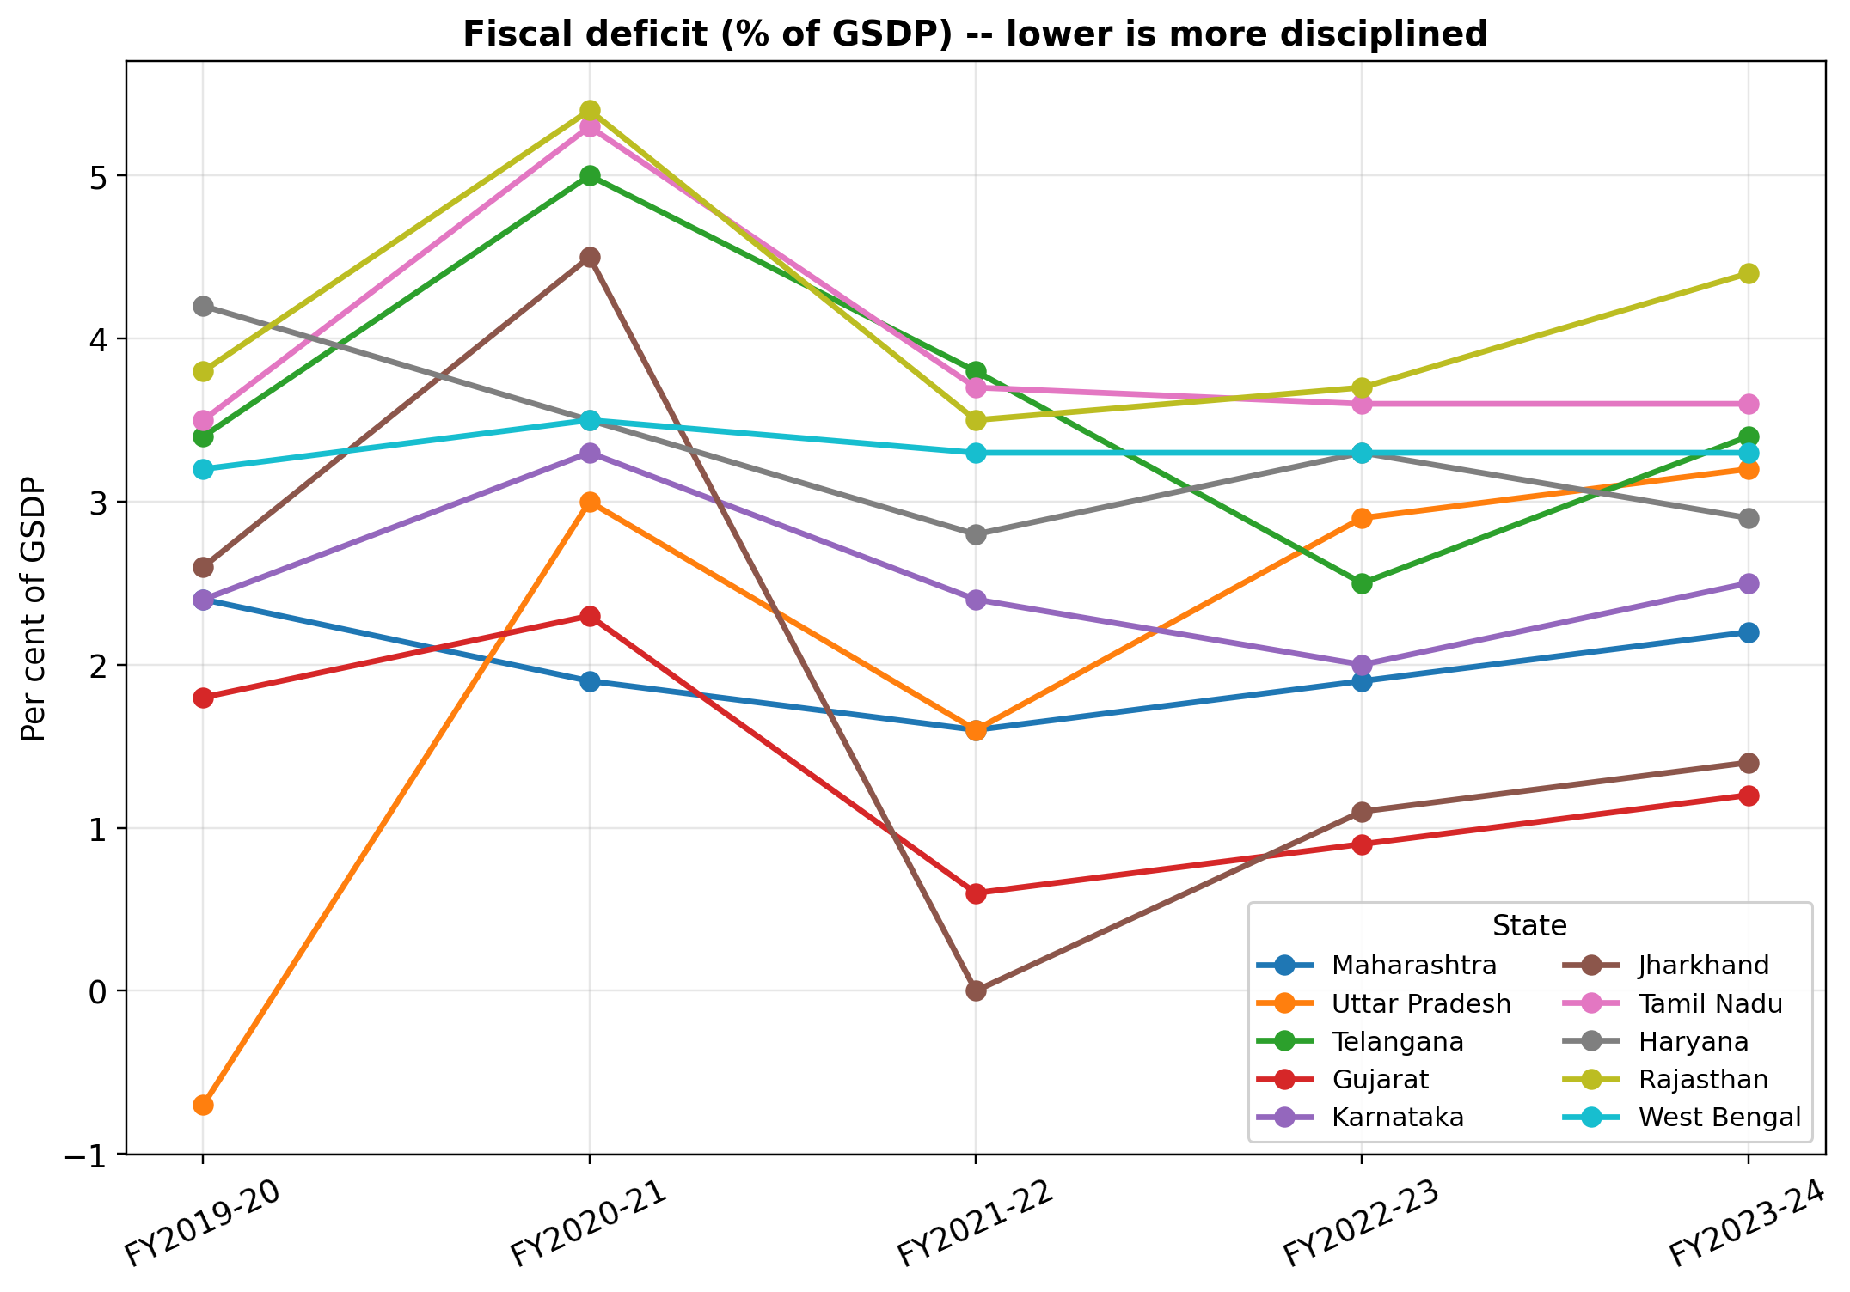
Figure 1. Fiscal deficit, per cent of GSDP, FY 2019-20 to FY 2023-24, one line per state as shown in the legend. States with the flattest, lowest lines are the same states that rank best on fiscal discipline in Section 4.7.
Table 3. Outstanding liabilities (debt), Rupees crore, by state and fiscal year.
State | FY2019-20 | FY2020-21 | FY2021-22 | FY2022-23 | FY2023-24 | 5-yr Total
Maharashtra | 486195 | 540405 | 584751 | 640912 | 730052 | 2982315
Uttar Pradesh | 503230 | 559266 | 614412 | 666110 | 784934 | 3127952
Telangana | 237525 | 281987 | 318120 | 354186 | 399081 | 1590899
Gujarat | 370316 | 416954 | 422598 | 471528 | 499716 | 2181112
Karnataka | 319928 | 385752 | 441116 | 494860 | 577936 | 2219592
Jharkhand | 94331 | 107405 | 109445 | 115202 | 123394 | 549777
Tamil Nadu | 430546 | 554311 | 623822 | 706053 | 804000 | 3118732
Haryana | 219216 | 244248 | 266752 | 303103 | 331081 | 1364400
Rajasthan | 358000 | 409196 | 456490 | 487486 | 576652 | 2287824
West Bengal | 437446 | 485265 | 523705 | 585148 | 632476 | 2664040
Computed as (debt % of GSDP / 100) x that year's GSDP.
Table 4. Outstanding liabilities (debt), per cent of GSDP, by state and fiscal year. This is the ratio used as a regressor in Sections 5-6.
State | FY2019-20 | FY2020-21 | FY2021-22 | FY2022-23 | FY2023-24 | 5yr_Average
Maharashtra | 18.3 | 20.7 | 18.6 | 17.6 | 18.0 | 18.64
Uttar Pradesh | 29.6 | 34.0 | 31.1 | 29.5 | 29.7 | 30.78
Telangana | 25.0 | 29.9 | 28.3 | 27.0 | 27.3 | 27.5
Gujarat | 22.9 | 25.8 | 22.0 | 21.4 | 20.6 | 22.54
Karnataka | 19.8 | 23.5 | 22.3 | 21.8 | 22.6 | 22.0
Jharkhand | 30.4 | 36.2 | 29.1 | 27.6 | 26.5 | 29.96
Tamil Nadu | 24.7 | 31.0 | 30.1 | 29.5 | 29.9 | 29.04
Haryana | 29.7 | 33.5 | 30.7 | 30.8 | 30.5 | 31.04
Rajasthan | 35.8 | 40.2 | 38.2 | 35.9 | 37.9 | 37.6
West Bengal | 37.1 | 42.5 | 39.4 | 38.2 | 38.3 | 39.1
Source: FC-16 Report Vol II Annexure 5.3 (States' Finance Accounts - AUDITED ACTUALS).
As with fiscal deficit, the figure below plots the debt ratio year-on-year for all ten states.
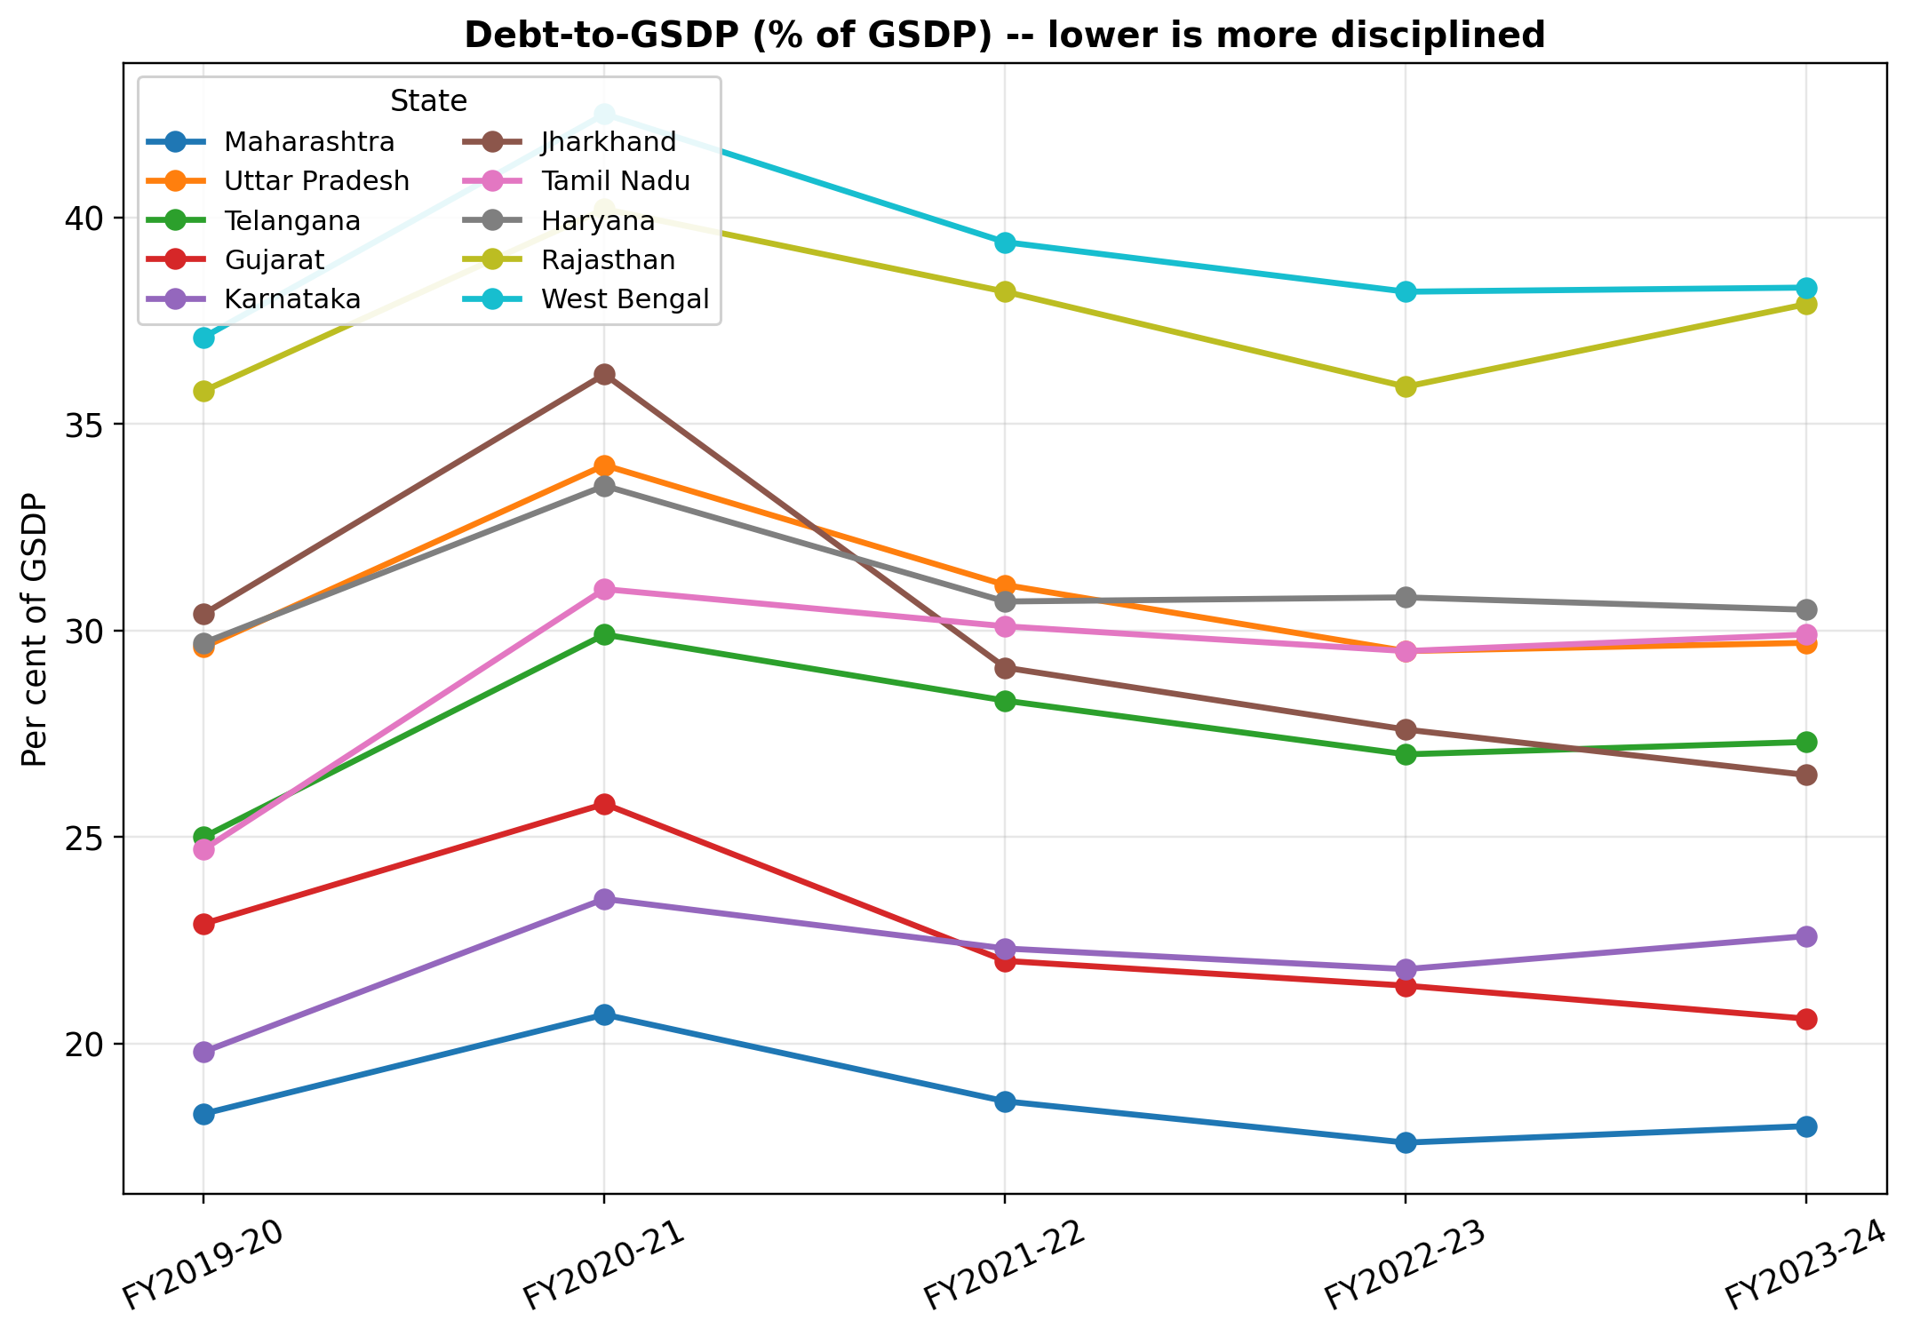
Figure 2. Debt-to-GSDP, per cent of GSDP, FY 2019-20 to FY 2023-24, one line per state as shown in the legend. Gujarat and Maharashtra hold the lowest, flattest lines throughout; West Bengal and Rajasthan the highest.
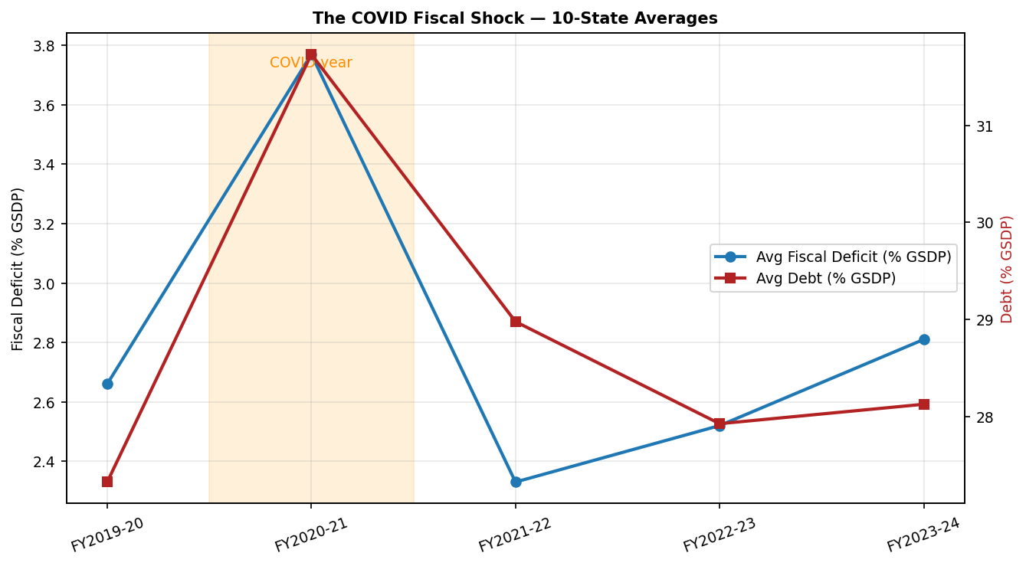
Figure 3. The COVID-19 fiscal shock: ten-state average fiscal deficit and debt, FY 2019-20 to FY 2023-24. Both indicators deteriorate sharply in FY 2020-21 and partially recover thereafter; this shared shock is the reason the within-state and between-state regression coefficients in Section 6.3 point in different directions.

4.4 Own tax revenue, capital expenditure and revenue deficit, year-wise
Own tax revenue captures how much a state raises on its own account rather than receiving from the centre. Capital expenditure captures spending that adds to the asset base. Revenue deficit, which is what remains when revenue expenditure runs ahead of revenue receipts, is carried here as an auxiliary series only, with a negative entry denoting a surplus; it is not one of the four regressors, but capital expenditure is derived from it. As in Section 4.3, each indicator appears first as a rupee amount and then as the percent-of-GSDP ratio the regressions use, followed by its year-wise trend chart.
Table 5. Own tax revenue, Rupees crore, by state and fiscal year.
State | FY2019-20 | FY2020-21 | FY2021-22 | FY2022-23 | FY2023-24 | 5-yr Total
Maharashtra | 191290 | 164471 | 223211 | 280399 | 300133 | 1159504
Uttar Pradesh | 122407 | 120078 | 152121 | 178382 | 200859 | 773847
Telangana | 68407 | 67903 | 92176 | 107568 | 112561 | 448615
Gujarat | 92175 | 84037 | 115254 | 149831 | 162529 | 603826
Karnataka | 101795 | 96848 | 120664 | 140740 | 161106 | 621153
Jharkhand | 16756 | 16912 | 21438 | 25461 | 27938 | 108505
Tamil Nadu | 109815 | 114438 | 128495 | 157964 | 177472 | 688184
Haryana | 43548 | 43017 | 53872 | 64951 | 73815 | 279203
Rajasthan | 60000 | 61074 | 75285 | 85548 | 97377 | 379284
West Bengal | 61313 | 60515 | 70448 | 85781 | 89174 | 367231

Table 6. Own tax revenue, per cent of GSDP, by state and fiscal year. This is the ratio used as a regressor in Sections 5-6.
State | FY2019-20 | FY2020-21 | FY2021-22 | FY2022-23 | FY2023-24 | 5yr_Average
Maharashtra | 7.2 | 6.3 | 7.1 | 7.7 | 7.4 | 7.14
Uttar Pradesh | 7.2 | 7.3 | 7.7 | 7.9 | 7.6 | 7.54
Telangana | 7.2 | 7.2 | 8.2 | 8.2 | 7.7 | 7.7
Gujarat | 5.7 | 5.2 | 6.0 | 6.8 | 6.7 | 6.08
Karnataka | 6.3 | 5.9 | 6.1 | 6.2 | 6.3 | 6.16
Jharkhand | 5.4 | 5.7 | 5.7 | 6.1 | 6.0 | 5.78
Tamil Nadu | 6.3 | 6.4 | 6.2 | 6.6 | 6.6 | 6.42
Haryana | 5.9 | 5.9 | 6.2 | 6.6 | 6.8 | 6.28
Rajasthan | 6.0 | 6.0 | 6.3 | 6.3 | 6.4 | 6.2
West Bengal | 5.2 | 5.3 | 5.3 | 5.6 | 5.4 | 5.36
Source: FC-16 Report Vol II Annexure 5.5 (States' Finance Accounts - AUDITED ACTUALS).
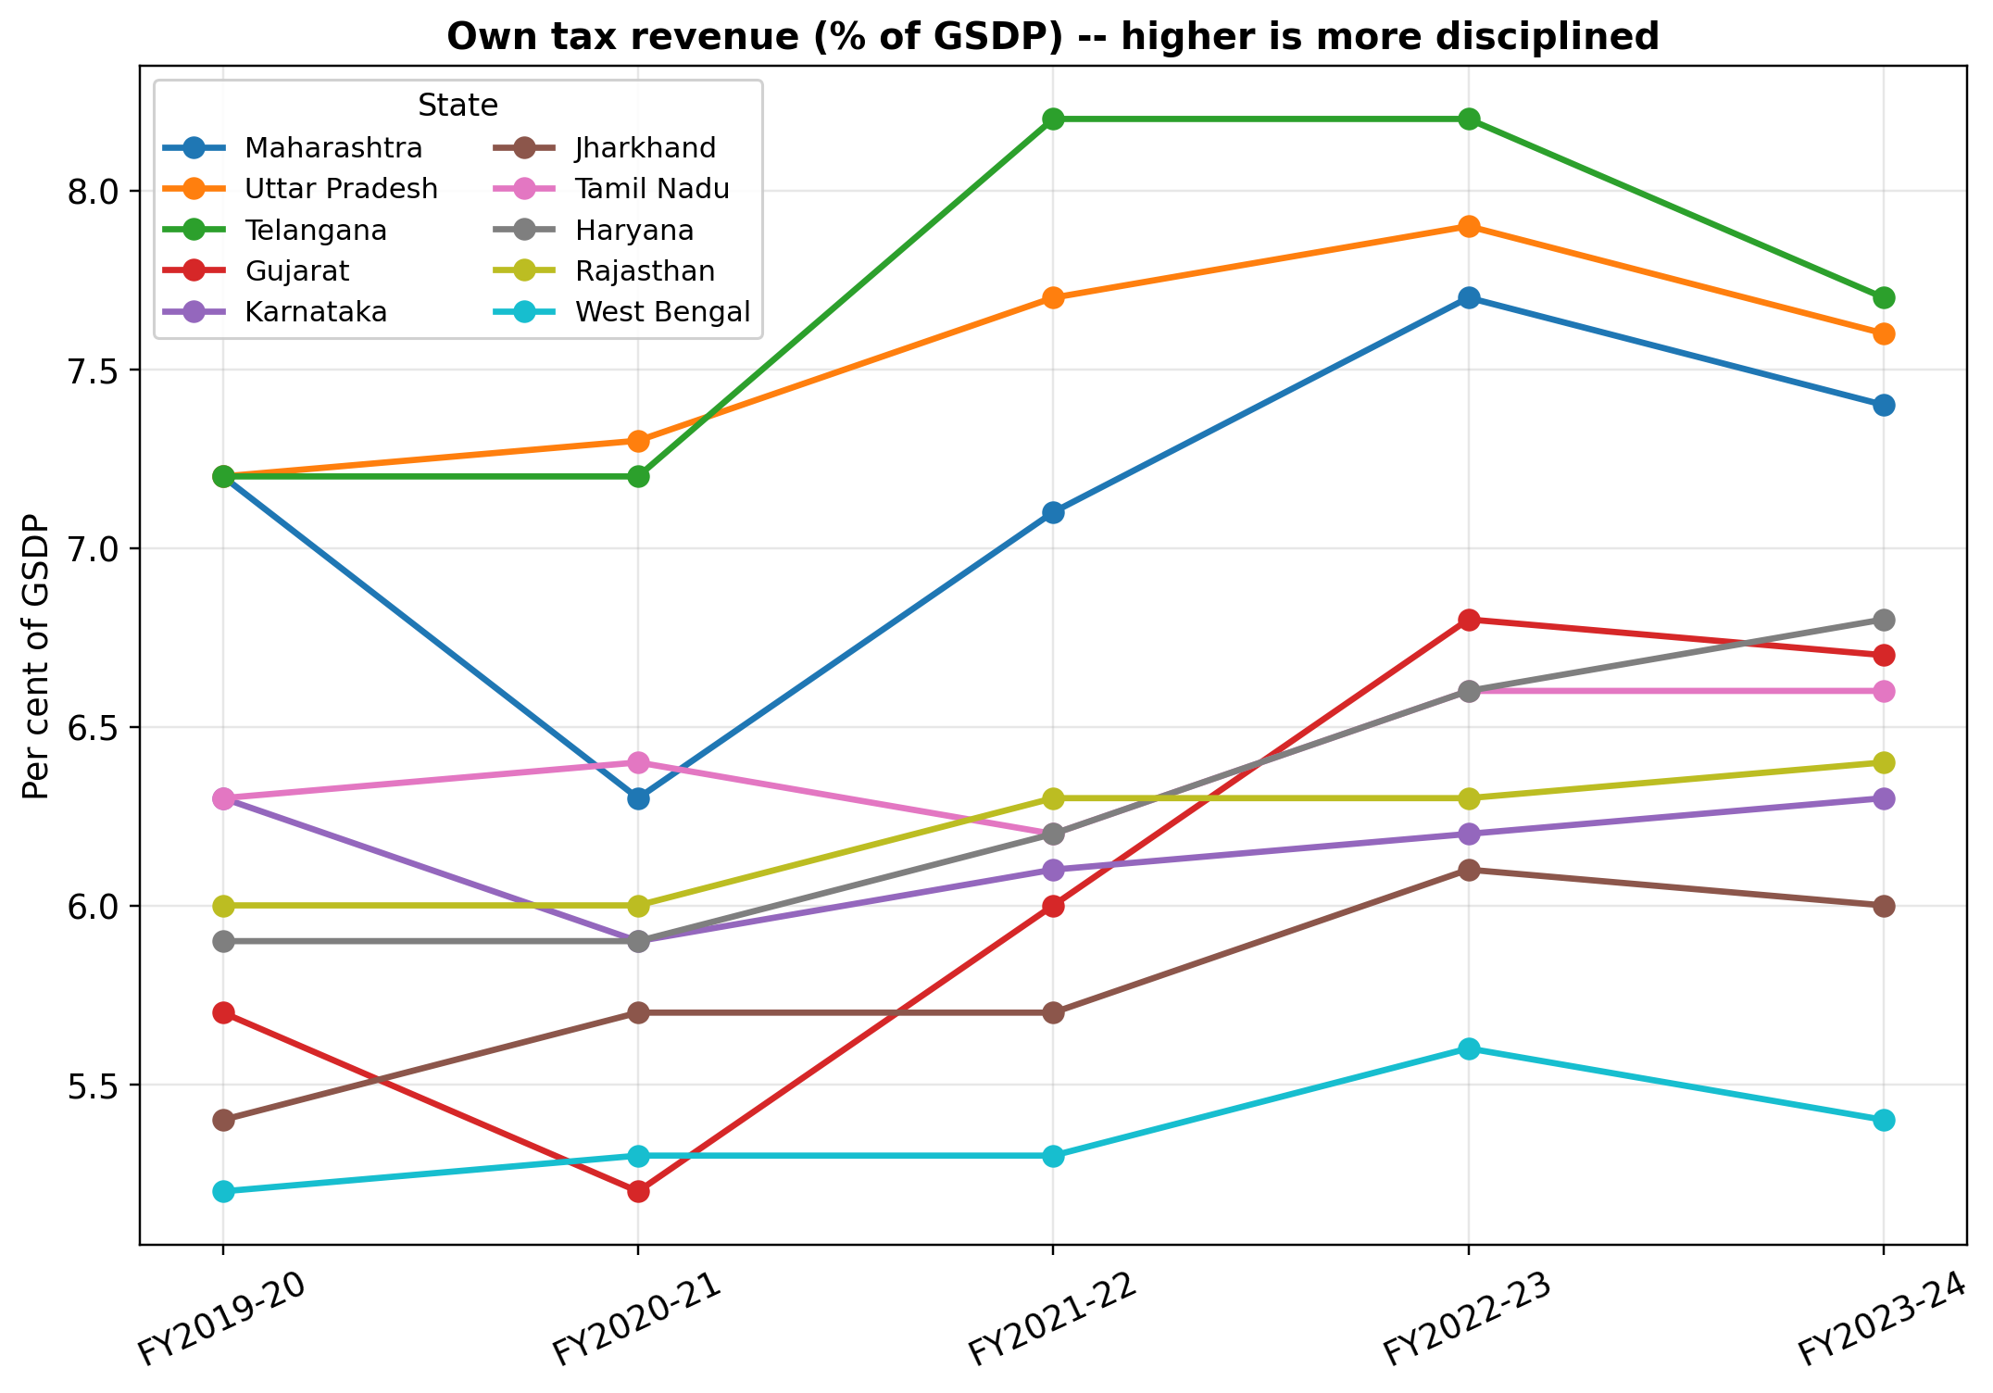
Figure 4. Own tax revenue, per cent of GSDP, FY 2019-20 to FY 2023-24, one line per state as shown in the legend.
Table 7. Capital expenditure (derived), Rupees crore, by state and fiscal year.
State | FY2019-20 | FY2020-21 | FY2021-22 | FY2022-23 | FY2023-24 | 5-yr Total
Maharashtra | 45166 | 20885 | 47157 | 65548 | 77061 | 255817
Uttar Pradesh | 56103 | 52637 | 75073 | 103868 | 121572 | 409253
Telangana | 25653 | 27350 | 38219 | 39354 | 51164 | 181740
Gujarat | 30725 | 21009 | 34576 | 44068 | 70348 | 200726
Karnataka | 40395 | 47604 | 51431 | 59020 | 53702 | 252152
Jharkhand | 9930 | 11868 | 9402 | 18366 | 17694 | 67260
Tamil Nadu | 24403 | 33974 | 37305 | 47868 | 48401 | 191951
Haryana | 14024 | 7291 | 11296 | 14762 | 19539 | 66912
Rajasthan | 1000 | 15268 | 22705 | 19011 | 27387 | 85371
West Bengal | 17686 | 14843 | 18609 | 22977 | 28073 | 102188

Table 8. Capital expenditure (derived), per cent of GSDP, by state and fiscal year, with cross-check capital-outlay figures for FY 2022-23 (actuals) and FY 2023-24 (revised estimates). This ratio is the regressor used in Sections 5-6.
State | FY2019-20 | FY2020-21 | FY2021-22 | FY2022-23 | FY2023-24 | 5yr_Average | CrossCheck_CapOutlay_FY2022-23_A | CrossCheck_CapOutlay_FY2023-24_RE
Maharashtra | 1.7 | 0.8 | 1.5 | 1.8 | 1.9 | 1.54 | 1.69 | 2.12
Uttar Pradesh | 3.3 | 3.2 | 3.8 | 4.6 | 4.6 | 3.9 | 4.12 | 6.19
Telangana | 2.7 | 2.9 | 3.4 | 3.0 | 3.5 | 3.1 | 1.37 | 3.02
Gujarat | 1.9 | 1.3 | 1.8 | 2.0 | 2.9 | 1.98 | 1.59 | 2.38
Karnataka | 2.5 | 2.9 | 2.6 | 2.6 | 2.1 | 2.54 | 2.63 | 2.0
Jharkhand | 3.2 | 4.0 | 2.5 | 4.4 | 3.8 | 3.58 | 3.56 | 5.06
Tamil Nadu | 1.4 | 1.9 | 1.8 | 2.0 | 1.8 | 1.78 | 1.67 | 1.56
Haryana | 1.9 | 1.0 | 1.3 | 1.5 | 1.8 | 1.5 | 1.19 | 1.32
Rajasthan | 0.1 | 1.5 | 1.9 | 1.4 | 1.8 | 1.34 | 1.46 | 2.28
West Bengal | 1.5 | 1.3 | 1.4 | 1.5 | 1.7 | 1.48 | 1.44 | 1.8
Derived: GFD minus RD (FC-16 Annex 5.1 - 5.2); includes net lending. Cross-check cols = exact capital outlay from state budget docs (Forum for State Studies) columns show exact capital outlay compiled from state budget documents, for comparison against the derived series.
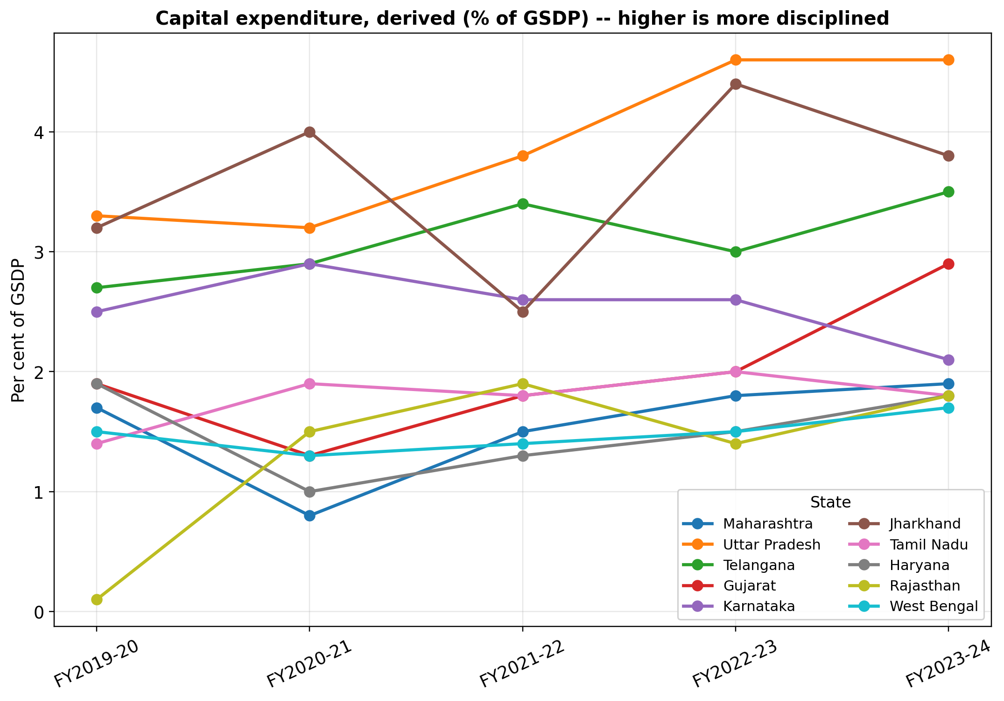
Figure 5. Capital expenditure (derived), per cent of GSDP, FY 2019-20 to FY 2023-24, one line per state as shown in the legend.

Table 9. Revenue deficit, Rupees crore, by state and fiscal year.
State | FY2019-20 | FY2020-21 | FY2021-22 | FY2022-23 | FY2023-24 | 5-yr Total
Maharashtra | 18598 | 28717 | 3144 | 3642 | 12168 | 66269
Uttar Pradesh | -68004 | -3290 | -43463 | -38386 | -37000 | -190143
Telangana | 6651 | 19805 | 4496 | -6559 | -1462 | 22931
Gujarat | -1617 | 16161 | -23051 | -24237 | -41239 | -73983
Karnataka | -1616 | 6566 | -3956 | -13620 | 10229 | -2397
Jharkhand | -1862 | 1484 | -9402 | -13774 | -11175 | -34729
Tamil Nadu | 36605 | 60795 | 39378 | 38294 | 48401 | 223473
Haryana | 16976 | 18228 | 13034 | 17714 | 11941 | 77893
Rajasthan | 37000 | 39698 | 19120 | 31232 | 39559 | 166609
West Bengal | 20045 | 25120 | 25255 | 27572 | 26422 | 124414

Table 10. Revenue deficit, per cent of GSDP, by state and fiscal year (negative = revenue surplus). Auxiliary variable; not used directly as a regressor, but is the series capital expenditure is derived from.
State | FY2019-20 | FY2020-21 | FY2021-22 | FY2022-23 | FY2023-24 | 5yr_Average
Maharashtra | 0.7 | 1.1 | 0.1 | 0.1 | 0.3 | 0.46
Uttar Pradesh | -4.0 | -0.2 | -2.2 | -1.7 | -1.4 | -1.9
Telangana | 0.7 | 2.1 | 0.4 | -0.5 | -0.1 | 0.52
Gujarat | -0.1 | 1.0 | -1.2 | -1.1 | -1.7 | -0.62
Karnataka | -0.1 | 0.4 | -0.2 | -0.6 | 0.4 | -0.02
Jharkhand | -0.6 | 0.5 | -2.5 | -3.3 | -2.4 | -1.66
Tamil Nadu | 2.1 | 3.4 | 1.9 | 1.6 | 1.8 | 2.16
Haryana | 2.3 | 2.5 | 1.5 | 1.8 | 1.1 | 1.84
Rajasthan | 3.7 | 3.9 | 1.6 | 2.3 | 2.6 | 2.82
West Bengal | 1.7 | 2.2 | 1.9 | 1.8 | 1.6 | 1.84
Source: FC-16 Report Vol II Annexure 5.2 (negative = revenue surplus).

4.5 FDI and GSDP, year-wise
FDI equity inflows by state are DPIIT's (2024) state-wise series, in Rupees crore, reported for the fiscal year in which the inflow was recorded. GSDP is the Ministry of Statistics and Programme Implementation's (MoSPI, 2024) state-wise series on the comparable 2011-12 base. GSDP growth is computed year-on-year from this series. The MoSPI series used here is at current prices, so the growth rates in Table 13 and the dependent variable of Model 2 are nominal rather than real. This matters for how the post-pandemic path is read: a large part of the roughly nineteen per cent recorded for FY 2021-22 is a deflator effect rather than real output, which is one reason Section 6.5 treats the common time path as something to absorb rather than to interpret. It also means the comparison with Trivedi and Rajmal (2011) and Panda and Sahay (2022) in Section 8 is not like for like, since both model real growth.
Table 11. FDI equity inflows by state and fiscal year, Rupees crore.
State | FY2019-20 (Oct-Mar) | FY2020-21 | FY2021-22 | FY2022-23 | FY2023-24 | Cumulative Oct2019-Mar2024
Maharashtra | 52073 | 119734 | 114964 | 118422 | 125101 | 532428.74
Uttar Pradesh | NA (combined with FY2020-21; see note) | NA (combined with FY2019-20; see note) | 1619 | 3373 | 2762 | 12615.44
Telangana | 4865 | 8618 | 11964 | 10319 | 25094 | 60860.43
Gujarat | 18964 | 162830 | 20169 | 37059 | 60600 | 299624.37
Karnataka | 30746 | 56884 | 163795 | 83628 | 54427 | 389483.39
Jharkhand | 13208 | 5993 | 48 | 44 | 90 | 19382.14
Tamil Nadu | 7230 | 17208 | 22396 | 17247 | 20157 | 84243.09
Haryana | 5198 | 12559 | 20971 | 20735 | 15797 | 75269.59
Rajasthan | 1347 | 2015 | 5277 | 7218 | 2195 | 18052.36
West Bengal | 1363 | 3115 | 3195 | 3217 | 1501 | 12398.46

Source: DPIIT (2024). Uttar Pradesh's DPIIT state-wise reporting begins only in FY 2021-22; its FY 2019-20 and FY 2020-21 cells are not available separately and are treated as missing, not zero, throughout this paper. The cumulative column as originally published by DPIIT includes an unattributed combined figure for Uttar Pradesh's first two years and should not be summed against the state-year columns. Maharashtra's published cumulative figure (532,428.74) likewise exceeds the sum of its five state-year cells (530,294) by 2,134.74 crore, a difference DPIIT does not explain and which is more than two hundred times the largest rounding gap in any other state. The analysis panel, Table 18 and every estimate reported in this paper use the summed state-year series, not the published cumulative column.
The first figure below totals this table by state; the second plots it year by year on a log scale so that both large states (Maharashtra, Karnataka) and small ones (Rajasthan, West Bengal) remain legible on the same axis.
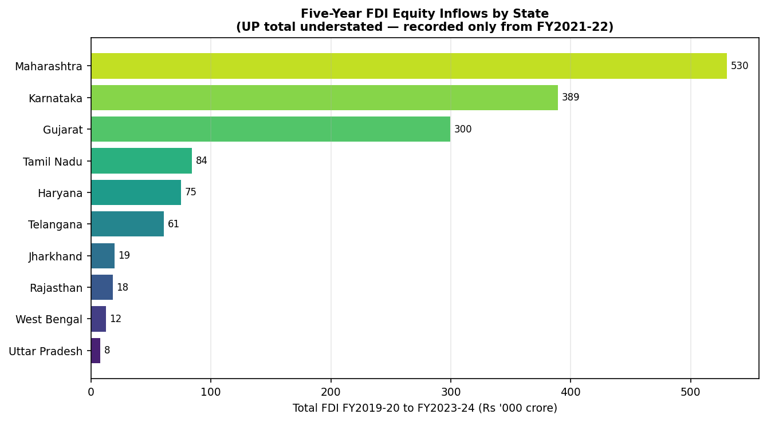
Figure 6. Five-year total FDI equity inflows by state, FY 2019-20 to FY 2023-24. Uttar Pradesh's bar understates the state. DPIIT records its series only from FY 2021-22, so that bar is a floor, not a five-year total.
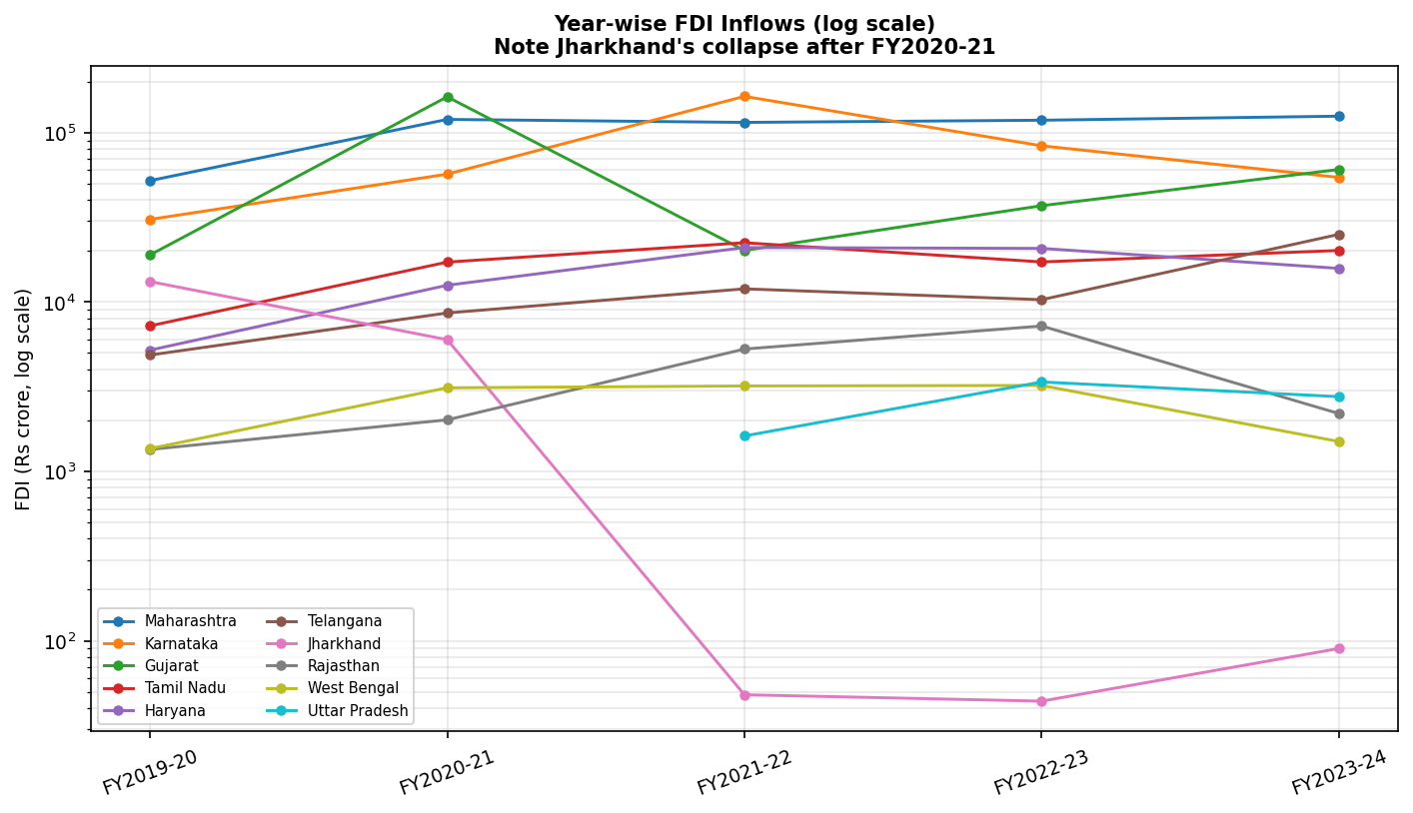
Figure 7. Year-wise FDI inflows by state, log scale. Jharkhand's collapse after FY 2020-21 and Uttar Pradesh's left-censored early years are both visible here; the log scale is used because Maharashtra's FDI is roughly three orders of magnitude larger than Jharkhand's by FY 2023-24, which would compress every other state's line to a flat line on a linear axis.
Table 12. GSDP by state and fiscal year, Rupees crore.
State | 2018-19 | 2019-20 | 2020-21 | 2021-22 | 2022-23 | 2023-24
Maharashtra | 2528854 | 2656806 | 2610651 | 3143821 | 3641543 | 4055847
Uttar Pradesh | 1582200 | 1700100 | 1644900 | 1975600 | 2258000 | 2642877
Telangana | 857400 | 950100 | 943100 | 1124100 | 1311800 | 1461836
Gujarat | 1492200 | 1617100 | 1616100 | 1920900 | 2203400 | 2425804
Karnataka | 1479400 | 1615800 | 1641500 | 1978100 | 2270000 | 2557241
Jharkhand | 305700 | 310300 | 296700 | 376100 | 417400 | 465638
Tamil Nadu | 1630200 | 1743100 | 1788100 | 2072500 | 2393400 | 2688963
Haryana | 698900 | 738100 | 729100 | 868900 | 984100 | 1085510
Rajasthan | 911500 | 1000000 | 1017900 | 1195000 | 1357900 | 1521510
West Bengal | 1102100 | 1179100 | 1141800 | 1329200 | 1531800 | 1651374
Source: MoSPI (2024), 2011-12 comparable series.
Table 13. GSDP growth, per cent per annum, by state and fiscal year, computed year-on-year from the GSDP table above. This is the dependent variable in Model 2 (Section 5.1).
State | FY2019-20 | FY2020-21 | FY2021-22 | FY2022-23 | FY2023-24 | 5-yr Avg
Maharashtra | 5.06 | -1.74 | 20.42 | 15.83 | 11.38 | 10.19
Uttar Pradesh | 7.45 | -3.25 | 20.10 | 14.29 | 17.05 | 11.13
Telangana | 10.81 | -0.74 | 19.19 | 16.70 | 11.44 | 11.48
Gujarat | 8.37 | -0.06 | 18.86 | 14.71 | 10.09 | 10.39
Karnataka | 9.22 | 1.59 | 20.51 | 14.76 | 12.65 | 11.75
Jharkhand | 1.50 | -4.38 | 26.76 | 10.98 | 11.56 | 9.28
Tamil Nadu | 6.93 | 2.58 | 15.91 | 15.48 | 12.35 | 10.65
Haryana | 5.61 | -1.22 | 19.17 | 13.26 | 10.30 | 9.42
Rajasthan | 9.71 | 1.79 | 17.40 | 13.63 | 12.05 | 10.92
West Bengal | 6.99 | -3.16 | 16.41 | 15.24 | 7.81 | 8.66

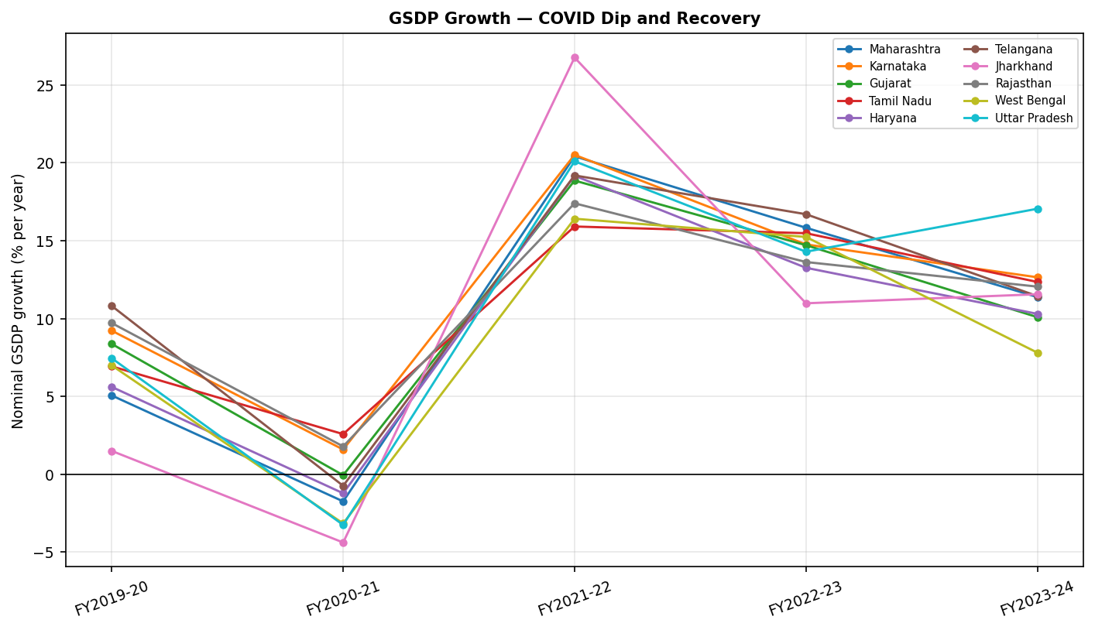
Figure 8. GSDP growth by state, FY 2019-20 to FY 2023-24, showing the COVID-19 dip in FY 2020-21, common to all ten states, and the subsequent recovery.

4.6 Control variables
Two controls enter only the pooled cross-state specification of Section 5.1, since the fixed-effects model already absorbs every time-invariant state characteristic by construction. They are the literacy rate and the urbanisation rate as recorded in the Primary Census Abstract of Census 2011 (Office of the Registrar General and Census Commissioner, India, 2011), which remains the latest full enumeration available.
Table 14. Literacy and urbanisation rate by state, Census 2011.
State | Literacy_2011_pct | Urbanization_2011_pct | Source
Maharashtra | 82.3 | 45.2 | Census 2011 PCA
Uttar Pradesh | 67.7 | 22.3 | Census 2011 PCA
Telangana | 66.5 | 38.9 | Census 2011 PCA
Gujarat | 78 | 42.6 | Census 2011 PCA
Karnataka | 75.4 | 38.6 | Census 2011 PCA
Jharkhand | 66.4 | 24.1 | Census 2011 PCA
Tamil Nadu | 80.1 | 48.4 | Census 2011 PCA
Haryana | 75.6 | 34.9 | Census 2011 PCA
Rajasthan | 66.1 | 24.9 | Census 2011 PCA
West Bengal | 76.3 | 31.9 | Census 2011 PCA

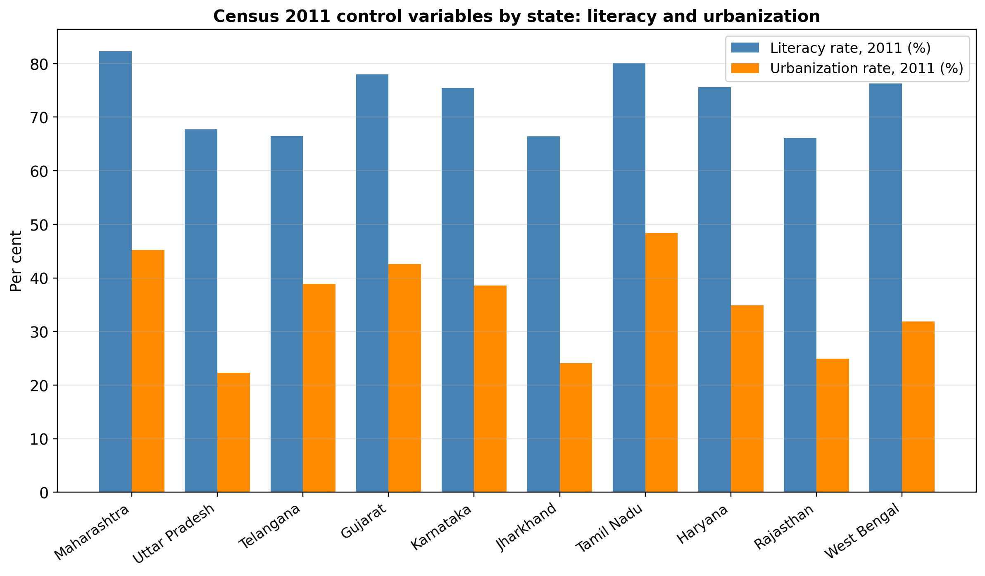
Figure 9. Literacy and urbanisation rate by state, Census 2011. States are listed in the same order as the fiscal tables above for ease of comparison.

4.7 Fiscal discipline ranking: construction and a worked example
The composite fiscal discipline ranking reported in Section 6.2 is built from the four fiscal regressors only (fiscal deficit, debt, own tax revenue and capital expenditure) and excludes the auxiliary revenue-deficit series. For a given year (or, for the five-year composite ranking, for each state's five-year average), each of the four indicators is separately ranked across the ten states from 1 (most disciplined on that indicator) to 10 (least disciplined): ascending rank on fiscal deficit and on debt, since lower is more disciplined for both, and descending rank on own tax revenue and on capital expenditure, since higher is more disciplined for both. Where two states are exactly tied on an indicator, both receive the average of the ranks they would otherwise have occupied. A state's composite score is the simple average of its four sub-indicator ranks, and states are then ranked 1 to 10 on that composite score, lower being more disciplined. The same averaging rule is applied at this second stage, so two states with an identical composite score share a half-rank rather than being separated arbitrarily; this is why both tables below contain entries such as 9.5. The two tables apply the procedure, first to the five-year state averages, then independently within each fiscal year; the year-wise version is the series plotted in the heatmap figure that follows the tables.
As a worked example, take Gujarat in FY 2022-23. Its fiscal deficit that year was 0.9 per cent of GSDP, the lowest of the ten states, giving it rank 1 on that indicator. Its debt was 21.4 per cent of GSDP, the second-lowest, giving rank 2. Its own tax revenue was 6.8 per cent of GSDP, the fourth-highest, giving rank 4. Its capital expenditure was 2.0 per cent of GSDP, tied for the fifth-highest with Tamil Nadu, giving both states a shared rank of 5.5. Gujarat's composite score for FY 2022-23 is therefore (1 + 2 + 4 + 5.5) / 4 = 3.125, the lowest (best) composite score of any state that year, which is why Gujarat is shown ranked first for FY 2022-23 in the year-wise ranking table and heatmap figure below.

Table 15. Composite fiscal discipline ranking, five-year state averages (1 = most disciplined). Each state's rank on each of the four indicators (Rank columns) is computed from its own five-year average of that indicator, then the four ranks are averaged into the Composite Score column, and states are ordered by that score.
Composite_Rank | State | Composite_Score(avg of 4 ranks; lower=more disciplined) | GFD_5yr_avg | GFD_rank | Debt_5yr_avg | Debt_rank | OTR_5yr_avg | OTR_rank | CapEx_5yr_avg | CapEx_rank
1.0 | Uttar Pradesh | 3.375 | 2.0 | 3.5 | 30.78 | 7.0 | 7.54 | 2.0 | 3.9 | 1.0
2.0 | Maharashtra | 3.625 | 2.0 | 3.5 | 18.64 | 1.0 | 7.14 | 3.0 | 1.54 | 7.0
3.0 | Telangana | 4.0 | 3.62 | 8.0 | 27.5 | 4.0 | 7.7 | 1.0 | 3.1 | 3.0
4.0 | Gujarat | 4.25 | 1.36 | 1.0 | 22.54 | 3.0 | 6.08 | 8.0 | 1.98 | 5.0
5.0 | Karnataka | 4.5 | 2.52 | 5.0 | 22.0 | 2.0 | 6.16 | 7.0 | 2.54 | 4.0
6.0 | Jharkhand | 4.75 | 1.92 | 2.0 | 29.96 | 6.0 | 5.78 | 9.0 | 3.58 | 2.0
7.0 | Tamil Nadu | 6.0 | 3.94 | 9.0 | 29.04 | 5.0 | 6.42 | 4.0 | 1.78 | 6.0
8.0 | Haryana | 7.0 | 3.34 | 7.0 | 31.04 | 8.0 | 6.28 | 5.0 | 1.5 | 8.0
9.5 | Rajasthan | 8.75 | 4.16 | 10.0 | 37.6 | 9.0 | 6.2 | 6.0 | 1.34 | 10.0
9.5 | West Bengal | 8.75 | 3.32 | 6.0 | 39.1 | 10.0 | 5.36 | 10.0 | 1.48 | 9.0
Composite score = simple average of the four sub-indicator ranks (fiscal deficit, debt, own tax revenue, capital expenditure); states are then ranked 1-10 on this score, with ties broken by the ranking algorithm and shown as shared rank numbers (e.g., Rajasthan and West Bengal both rank 9.5 on the underlying score, so both are listed at that position).
Table 16. Fiscal discipline rank by year (1 = most disciplined), computed independently for each fiscal year by the procedure worked through above, then averaged across the five years in the final column.
State | FY2019-20 | FY2020-21 | FY2021-22 | FY2022-23 | FY2023-24 | 5-yr Avg Rank
Maharashtra | 2 | 2.5 | 2 | 3 | 2 | 2.30
Uttar Pradesh | 1 | 1 | 1 | 4 | 3 | 2.00
Telangana | 4 | 4 | 3 | 2 | 4.5 | 3.50
Gujarat | 5 | 6 | 5 | 1 | 1 | 3.60
Karnataka | 3 | 2.5 | 4 | 6 | 6 | 4.30
Jharkhand | 6 | 7 | 6 | 5 | 4.5 | 5.70
Tamil Nadu | 7 | 5 | 8 | 7 | 8 | 7.00
Haryana | 8 | 8 | 9 | 8 | 7 | 8.00
Rajasthan | 9.5 | 9 | 7 | 9.5 | 9 | 8.80
West Bengal | 9.5 | 10 | 10 | 9.5 | 10 | 9.80

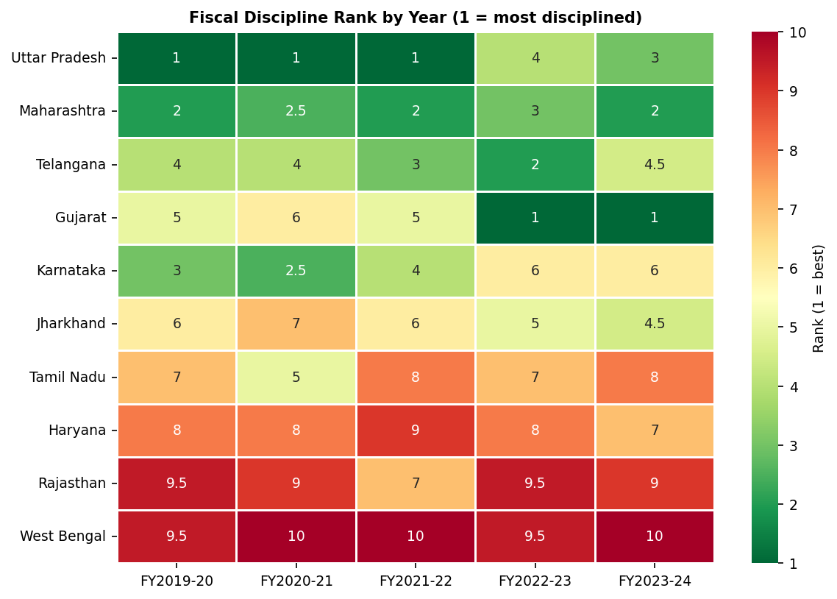
Figure 10. Fiscal discipline rank by state and year, 1 (green) = most disciplined, 10 (red) = least disciplined. Each cell is one state-year's rank from Table 16 above, with a half-rank such as 2.5 or 9.5 marking two states tied on that year's composite score; reading along a row shows whether a state's discipline improved, worsened, or stayed stable over the five years.
Uttar Pradesh holds the best five-year average of the yearly ranks in Table 16, at 2.0 against 2.3 for Maharashtra, and the two also take the first two places on the five-year-average composite score of Table 15, at 3.375 and 3.625 respectively. The two tables give slightly different numbers because Table 15 ranks the five-year mean of each indicator once, while Table 16 ranks each year separately and then averages the resulting yearly ranks. West Bengal is bottom or joint-bottom in every year of the panel, the only state never to place above ninth; it shares the last two places with Rajasthan in FY 2019-20 and FY 2022-23, where the two are exactly tied on the composite score.
The composite ranking above weights the four indicators equally, and that choice is not otherwise justified in the text. The table below checks how much the ranking, and its correlation with realised FDI, would change under two alternative weightings: a rank based on debt alone, and a composite that weights debt twice as heavily as the other three indicators. Debt is singled out because Section 6.6 independently identifies it as the dominant fiscal predictor. Reweighting toward debt does not simply reproduce the equal-weight ranking (rho = 0.68 and 0.86 against it, not 1.0), so the choice of weights is not inert; but every weighting scheme tested, including the two that favour debt most heavily, correlates with realised FDI in the same direction and more strongly than the equal-weight ranking does. Two things follow, and the second is uncomfortable for the composite. Equal weighting is the conservative choice among those tested, not one that happens to favour the paper's own conclusion. But on the paper's own criterion, that a ranking should be judged against an outcome, a single indicator beats the composite: debt alone correlates with realised FDI at rho = -0.917 (p = 0.0005) against -0.728 (p = 0.026) for the four-indicator average. The honest reading is not that the weights are defensible but that the composite is not earning its complexity, and that a reader who wants one verifiable number should use debt. The point is sharpened by which indicators carry Uttar Pradesh to first place: capital expenditure, where it ranks first, and own tax revenue, where it ranks second, are precisely the two indicators this paper later finds wrong-signed and indistinguishable from zero respectively, and unlike the NITI Aayog index this paper criticises in Section 2, the ranking here is checked against an outcome rather than asserted on its own terms.
Table 16a. Sensitivity of the composite fiscal discipline ranking to alternative indicator weightings. The two FDI columns correlate each weighting's discipline rank against the five-year FDI total in levels, so a negative rho means that better-ranked (lower-numbered) states received more investment. That is the same relationship as the positive rho = 0.728 reported in Section 6.2, which correlates discipline rank against FDI rank; only the sign convention differs.
Weighting scheme | vs. equal-weight rank (rho) | vs. equal-weight rank (p) | vs. 5-yr FDI excl. UP (rho) | vs. 5-yr FDI excl. UP (p)
Equal-weight (paper's ranking) | 1.000 | - | -0.728 | 0.026
Debt-only rank | 0.681 | 0.030 | -0.917 | 0.0005
Debt double-weighted composite | 0.862 | 0.0014 | -0.814 | 0.0076

5. Methodology

5.1 Econometric specification
Two models are estimated, using the fiscal ratios (not the amounts) from Section 4 as regressors:
Model 1: ln(FDI)_it = a_i + b1 FD_it + b2 DEBT_it + b3 OTR_it + b4 CAPEX_it + b5 COVID_t + e_it
Model 2: GROWTH_it = a_i + g1 FD_it + g2 DEBT_it + g3 OTR_it + g4 CAPEX_it + g5 COVID_t + v_it
with i denoting the state and t the fiscal year. Each model is estimated twice. The first fit is an entity fixed-effects panel with Driscoll-Kraay standard errors, which stay valid under cross-sectional dependence and serially correlated errors in a panel of this length (Driscoll and Kraay, 1998); it identifies the within-state relationship. The second is a pooled OLS with the two Census controls added and errors clustered by state. Strictly, a pooled coefficient is a variance-weighted mixture of within-state and between-state variation rather than a between estimator, and we describe it as identifying the between-state relationship only because, for the regressors that matter here, that mixture is overwhelmingly between: Section 6.1 shows that 91.5 per cent of the variation in debt is cross-sectional. Section 7.1 reports a true between estimator on the ten state means, and a Mundlak specification that separates the two dimensions inside a single equation, so that the claim does not rest on the pooled coefficient's interpretation. Standard errors from the panel routines used here carry that software's finite-sample cluster correction, which returns intervals roughly four per cent tighter than the correction applied by default in some other packages; the distinction changes no verdict in this paper but is noted so that a replication arriving at slightly different standard errors is not read as a discrepancy. Variance inflation factors are computed for the four fiscal regressors, interpreted against the cautions in O’Brien (2007), because deficit and debt are mechanically linked: a state's debt stock is the accumulation of its past deficits. Dynamic panel estimators of the Arellano-Bond family (1991) are deliberately avoided here. At N = 10 and T = 5 the instrument count in a standard difference or system GMM setup would approach or exceed the number of cross-sectional units, a configuration Roodman (2009) identifies as unreliable. As a descriptive complement to the two regressions, Spearman's rank correlation (Spearman, 1904) is computed between the composite discipline ranking of Section 4.7 and each state's five-year FDI total and per-capita GSDP. Unlike the regression coefficients, which exploit year-by-year variation, this compresses each state to a single point; it is reported in Section 6.2.

5.2 Machine-learning validation
A panel of ten states over five years leaves thirty-three to forty residual degrees of freedom, and the pandemic dominates one of those five years. One specification's p-value is thin support for a policy claim on that basis. Three further methods are used to check the debt-FDI result, each independent of the panel regression and each defensible at this sample size:
(a) LASSO regression (Tibshirani, 1996) with cross-validated regularisation strength, which asks which regressors survive shrinkage rather than which cross a p < 0.05 threshold;
(b) Elastic Net (Zou and Hastie, 2005) as a cross-check on the LASSO selection, since the two penalise correlated regressors differently;
(c) A shallow random forest (Breiman, 2001) with SHAP (SHapley Additive exPlanations; Lundberg and Lee, 2017) values, which ranks predictors by their average marginal contribution to each individual prediction and can, unlike a linear model, in principle detect a non-linear or threshold effect. The forest is grown to maximum depth 3 with minimum leaf size 4 throughout; the depth and leaf constraints were chosen specifically to prevent a forest with 48 training rows from memorising individual states. The number of trees varies with the cost of the exercise and is stated here rather than left implicit: 1,000 for the main SHAP fit reported in Section 6.6, 500 for the ten leave-one-state-out refits and for the out-of-sample comparison of Table 31, and 300 for the 500-draw permutation null. Tree count affects the stability of a SHAP estimate, not its expectation, and the leave-one-state-out ranking is unanimous at 500. Depth and leaf size were selected rather than only asserted. A grid over both, scored by pooled leave-one-state-out R-squared and reported in the repository's diagnostic output, puts depth 3 first, so the depth used here is the grid's own choice. On leaf size the grid prefers 3 to the 4 used here, at 0.128 against 0.085, and the out-of-bag R-squared runs the same way, 0.507 against 0.402. We report the more heavily regularised setting deliberately, because at 48 rows the smaller leaf is the one more likely to be fitting individual state-years, and because the choice does not change what the forest says: refitting at leaf size 3 still ranks debt-to-GSDP first on mean absolute SHAP, at 1.017 against 0.327 for the next variable, a first-to-second gap of 0.690 against the 0.810 reported in Section 6.6. The tuning is disclosed here so that a reader can see the paper did not select the setting that flatters it.
All three are restricted to the same five time-varying regressors the fixed-effects econometric model uses: fiscal deficit, debt, own tax revenue, capital expenditure and the COVID dummy. That restriction was not the original choice. An initial SHAP run that also carried the two time-invariant Census controls ranked urbanisation as the most important predictor by a wide margin, at mean |SHAP| = 1.30 against 0.25 for debt, the next variable down. On inspection this turned out to be a known failure mode of tree-based models rather than a real urbanisation effect. Urbanisation is fixed within a state across all five years, so the random forest could treat it as a near-unique fingerprint for which state an observation came from, re-learning the state fixed effect through the back door instead of any fiscal or structural relationship. We report it rather than quietly drop it, because it is a useful caution for anyone applying tree-based importance measures to short panels with few entities. Part B is rerun with literacy and urbanisation excluded, and the Section 6.6 results come from that corrected specification.
Four design choices follow from the shape of the panel. Each closes off a way in which these methods, applied without care, would overstate what forty-eight observations support.
The cross-validation folds are blocked by state. Under a leave-one-observation-out scheme, holding out Gujarat in FY 2021-22 leaves Gujarat's other four years in the training sample. A state's fiscal ratios and FDI level are persistent, so the held-out point is then partly predictable from its own state, and the resulting accuracy figure flatters the model. Every cross-validated quantity below (the LASSO penalty strength, and the out-of-sample fit of Section 6.6) uses the ten states as groups, so that no state appears in both folds. Out-of-sample fit is also reported under the row-wise scheme, and under a forward-chaining scheme that predicts each year from the years before it. How far apart those three columns sit measures how much of the apparent fit is state persistence.
Selection needs a probability attached to it. At this sample size the cross-validated penalty can be light enough that nothing is eliminated, and a table of selected variables then says nothing at all. Two further statistics fill that gap. The entry order along the regularisation path records the penalty at which each variable first takes a non-zero coefficient, identifying the one that survives hardest shrinkage. The stability-selection exercise, following Meinshausen and Bühlmann (2010), refits LASSO over a grid of penalties on 500 random subsamples of five states each, and records how often each variable is kept.
The machine-learning branch runs twice, pooled and within. Section 7.1 turns on the contrast between the pooled and fixed-effects estimates, which identify different parameters. Fitting the machine-learning methods to raw data alone would validate only the pooled half, and would leave an obvious objection open: a tree fitted to raw levels may be learning that West Bengal is a high-debt, low-FDI state and nothing more. LASSO and the random forest are also fitted to state-demeaned data, the algebra a fixed-effects estimator performs, so the branch has to reproduce the within-state result too.
Last, the importance ranking is tested against a null. Debt ranking first on mean absolute SHAP proves little on its own, since some variable must rank first, and tree ensembles favour high-variance continuous regressors even when the outcome is noise. We permute the outcome 500 times, refit the forest and recompute SHAP on each permutation, recording two things: how often debt ranks first, and how often the gap between first and second place matches the gap in the real data. The gap statistic is the one that carries weight. The rank is reported beside it because the two diverge sharply, and the divergence is worth seeing.
Out-of-sample R-squared is computed for ordinary least squares, LASSO, the random forest and a gradient-boosted alternative. Forty-eight observations cannot support a claim to predictive power. The figures are reported to show how much of it exists.

5.3 Analytical architecture: from the source data to final validation
The paper does not rely on a single model. The analysis runs in two parallel tracks, one econometric and one machine-learning, over eleven stages, and a result is accepted only once it appears in both tracks and each has passed its own diagnostic checks.
This design follows from the size of the panel. Fifty state-year observations are too few to rest a conclusion on any single specification's p-value, so agreement between two methodologically independent tracks is treated as the higher bar.
Figure 11 shows the steps we take and the text after it explains what each step is for.
The process begins with data assembly and the fiscal discipline ranking, then splits into two branches. The classical branch estimates fixed-effects and pooled OLS specifications and subjects them to a battery of robustness checks. The machine-learning branch applies LASSO, Elastic Net and a shallow random forest with SHAP importance, together with its own diagnostic check for the leakage problem described in Section 5.2.
The two branches are then compared directly: where they agree, that agreement is the paper's strongest evidence; where they do not, Section 7.2 sets out why. The same forty-eight to fifty observations underlie both branches throughout, including the convergence test and the state-level case discussion that follow.

Figure 11. Analytical architecture of the research study, from raw data to final validation. Boxes are numbered stages; the two vertical tracks are the classical and machine-learning estimation branches, which run in parallel on the same panel and meet at the Stage 9 convergence test.

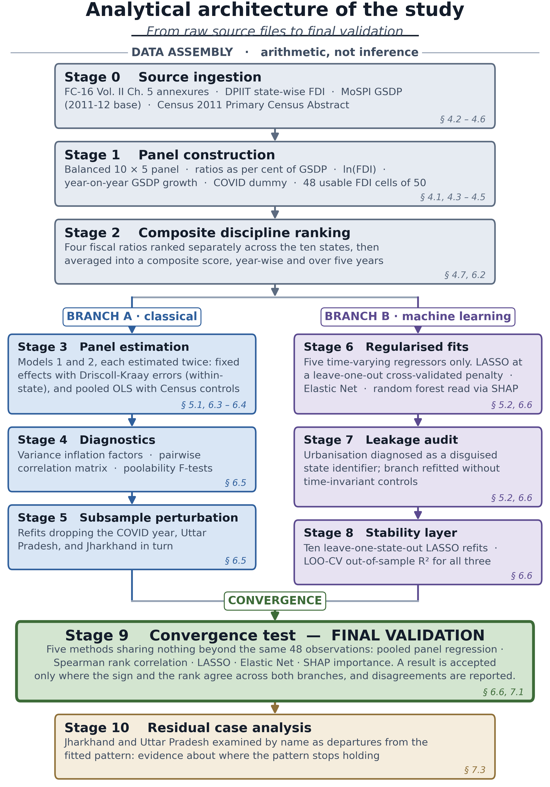

Stages 0 to 2 are assembly, and they are arithmetic rather than inference. Everything in them is reproducible from the tables in Section 4. Three choices there propagate through the rest of the chain. Ratios are used instead of rupee amounts, because a rupee of deficit in Maharashtra and a rupee of deficit in Jharkhand are not comparable quantities. FDI enters in logs, because the largest recipient in the panel takes roughly three orders of magnitude more than the smallest in the same year. And the COVID dummy is created at this stage rather than being handled later, because FY 2020-21 is a shock common to all ten states (International Monetary Fund, 2020); leaving it in the residual would contaminate every stage downstream of it.
Stages 3 to 5 are the classical branch. The two specifications are estimated in parallel, and neither is chosen over the other, because they identify different parameters. The fixed-effects fit uses only variation within a state across five years; the pooled fit is driven mostly by variation between states. Section 7.1 shows why keeping both was necessary, since they disagree on the sign of debt for a reason that is substantive rather than technical. Stages 4 and 5 are the branch auditing itself: whether the estimates depend on collinearity between deficit and debt, on the pandemic year, or on any one state.
Stages 6 to 8 are the machine-learning branch, and it is fed exactly the five time-varying regressors the fixed-effects model uses, no more. Stage 7 is where that restriction was decided rather than assumed, and it is reported because the failure it corrects is instructive. The first pass included the two Census controls and returned urbanisation as the dominant predictor by a factor of about five. Urbanisation is constant within a state across all five years, so the forest had found a near-unique fingerprint for state identity and was re-learning the fixed effect through the back door. Tree-based importance measures invite this on short panels with few entities, and a reader applying the same method elsewhere should expect it.
Stage 9 is the only stage that produces a conclusion, and it is what the whole architecture is built to reach. Five methods arrive at it: the pooled panel regression, the Spearman rank correlation, LASSO, Elastic Net, and SHAP importance from the random forest. They are not five mutually independent draws and we do not treat them as such. LASSO and Elastic Net differ only in the shape of the penalty and should be read as one regularised-linear verdict with an internal cross-check; the pooled regression and the Spearman correlation both exploit cross-state variation, though one is parametric and the other is not. What the design buys is agreement across three genuinely different method families, a parametric panel estimator, a regularised linear selector and a non-parametric tree ensemble, whose distributional assumptions and loss functions differ and two of which are not hypothesis tests at all. Agreement of that kind on the sign and the rank of debt is harder to obtain by chance than a single p-value below 0.05 would be, which is the point of the design given how short the panel is. Where the methods disagree, Section 7.2 sets out what they disagree on and why, rather than reporting only the consensus.
The tenth stage handles the two observations that do not fit the general pattern. Jharkhand and Uttar Pradesh are examined by name in Section 7.3 as cases where the pattern breaks down, rather than folded silently into the averages with everything else.

5.4 Specification testing strategy
Each estimator in Section 5.1 involves a choice: fixed or random effects, pooled or panel, one covariance estimator over another. In a conventional panel a short battery of specification tests would settle those choices (Baltagi, 2021). At N = 10 and T = 5 the battery is available but weak. The Hausman statistic often fails to compute at all, because the difference between the two covariance matrices is not positive definite. Pesaran's CD statistic is asymptotic in the number of entities, and there are ten. The Wooldridge and Driscoll-Kraay results are asymptotic in the number of periods, and there are five. Reporting only the tests that come back clean would misrepresent that position. Three things are done instead.
First, the formal tests are run and reported in full, including those that return no verdict. Estimator choice is examined with the Hausman test (Hausman, 1978), the Breusch-Pagan LM test and the F-test for poolability. For error structure we use Pesaran's CD test for cross-sectional dependence (Pesaran, 2015), the Wooldridge test for first-order serial correlation (Wooldridge, 2010), implemented as in Drukker (2003), and the modified Wald test for groupwise heteroskedasticity. Functional form is checked with Ramsey's RESET, and by comparing the logarithmic, inverse-hyperbolic-sine and level transformations of FDI.
Second, since those tests are weak, we report directly how far the inference depends on the covariance estimator. The same fixed-effects coefficient appears with Driscoll-Kraay, cluster-robust and unadjusted standard errors, and with a percentile interval from 2,000 bootstrap resamples drawn at the level of the state, so that the resampling respects the panel structure. Both the kernel and the cluster-robust estimators rest on asymptotics this panel does not supply, the first in the number of periods and the second in the number of clusters. A wild cluster bootstrap-t with the null imposed and Rademacher weights (Cameron, Gelbach and Miller, 2008) is therefore computed for every coefficient the paper relies on, and settles the cases where the two disagree. We checked it in both directions. The COVID dummy in the growth model, an effect of roughly fourteen percentage points, returns p = 0.003; eight pure-noise placebo regressors returned nothing below 0.05.
Third, the debt coefficient is estimated under every defensible combination of modelling choices instead of being defended in one: fixed effects or pooled, the pandemic year kept or dropped, Census controls in or out, FDI in logarithms or inverse hyperbolic sine, and each of the ten states excluded in turn. That gives 132 estimates, reported as a specification curve. A result holding across all of them makes the question of which single specification is correct much less pressing. The logic mirrors the convergence argument of Section 5.2, moved to the econometric side.

6. Results

6.1 Descriptive statistics
A range check was run before any regression, shown in the table below: the mean, spread, and minimum and maximum of every ratio and outcome variable across the state-year observations, so that any value that did not make sense would be visible before it entered a model. The table is a check, not a result. Observation counts differ slightly: the four fiscal variables and GSDP growth have all fifty cells filled, while FDI and log FDI have forty-eight, reflecting the two Uttar Pradesh gaps discussed in Section 4.5.

Table 17. Descriptive statistics for the panel (N = 50; FDI and log FDI, N = 48).
Unnamed: 0 | N | Mean | Std Dev | Min | Median | Max
Fiscal Deficit (% GSDP) | 50.0 | 2.82 | 1.26 | -0.7 | 3.1 | 5.4
Debt (% GSDP) | 50.0 | 28.82 | 6.55 | 17.6 | 29.55 | 42.5
Own Tax Revenue (% GSDP) | 50.0 | 6.47 | 0.8 | 5.2 | 6.3 | 8.2
Capital Expenditure (% GSDP) | 50.0 | 2.27 | 1.01 | 0.1 | 1.9 | 4.6
Revenue Deficit (% GSDP) | 50.0 | 0.54 | 1.77 | -4.0 | 0.6 | 3.9
FDI (Rs crore) | 48.0 | 31194.46 | 43932.66 | 44.0 | 12883.5 | 163795.0
GSDP Growth (%) | 50.0 | 10.39 | 7.35 | -4.38 | 11.41 | 26.76

One feature of the table anticipates a result developed later. Debt-to-GSDP ranges from 17.6 to 42.5 per cent, a spread of almost twenty-five percentage points across ten states that is not randomly distributed: West Bengal and Rajasthan carry the highest debt ratio in every year of the panel, and Gujarat and Maharashtra the lowest. That ordering recurs through the results that follow. That persistence is worth quantifying, because it governs how the two specifications of Section 5.1 behave. Decomposing each regressor's sum of squares into a between-state and a within-state component, debt is overwhelmingly a cross-sectional quantity: 91.5 per cent of its variation lies between states and 8.5 per cent within them, and the ranking of states by debt is close to fixed across the panel, with a mean pairwise rank correlation of 0.91 between any two years. Own tax revenue (81.9 per cent between) and capital expenditure (80.3 per cent) behave similarly; the fiscal deficit, at 55.1 per cent, is the most genuinely year-to-year of the four. GSDP growth runs the other way entirely, with 98.3 per cent of its variation within states and 1.7 per cent between them. Two consequences follow and both recur below: the within-state debt coefficient of Model 1 is identified off very little variation and should be expected to be fragile, and the pooled specification of Model 2 has almost no cross-state variation in the dependent variable to explain, which is the reason no fiscal variable reaches significance there rather than anything substantive about growth.

6.2 Fiscal discipline ranking and its relationship to outcomes
Table 18 shows each state's discipline rank, carried over from Section 4.7, next to its five-year total of foreign direct investment and its per-capita gross state domestic product for FY 2023-24. The Spearman procedure itself is described in Section 5.1; the correlations are reported in the note beneath the table. The question here is more specific than the one the regressions address. It is not whether a state's investment changes when its own financial position changes. It is whether the states that rank highest on discipline over the period are the same states that receive the most investment and record the highest incomes.
Table 18. Fiscal discipline composite rank against FDI and per-capita GSDP, with rank correlations.
State | Fiscal_Discipline_Composite_Rank | FDI_5yr_Total_INRcr | FDI_Rank | PerCapita_GSDP_2023-24_INR | PC_GSDP_Rank
Maharashtra | 2.0 | 530294.0 | 1.0 | 319474.0 | 6.0
Karnataka | 5.0 | 389480.0 | 2.0 | 376402.0 | 2.0
Gujarat | 4.0 | 299622.0 | 3.0 | 336875.0 | 5.0
Tamil Nadu | 7.0 | 84238.0 | 4.0 | 349248.0 | 4.0
Haryana | 8.0 | 75260.0 | 5.0 | 356829.0 | 3.0
Telangana | 3.0 | 60860.0 | 6.0 | 382870.0 | 1.0
Jharkhand | 6.0 | 19383.0 | 7.0 | 117124.0 | 9.0
Rajasthan | 9.5 | 18052.0 | 8.0 | 186610.0 | 7.0
West Bengal | 9.5 | 12391.0 | 9.0 | 166196.0 | 8.0
Uttar Pradesh | 1.0 | 7754.0 | 10.0 | 111475.0 | 10.0

Spearman rank correlations: Discipline vs FDI (n=10): rho=0.255 p=0.476; Discipline vs PerCapita GSDP (n=10): rho=0.012 p=0.973; Discipline vs FDI excluding UP (n=9; UP FDI left-censored from FY22): rho=0.728 p=0.026; Discipline vs PerCapita GSDP excluding UP (n=9): rho=0.393 p=0.295; Significance threshold n=10: |rho|>=0.648 at p=0.05 two-tailed.
Across all ten states the discipline-FDI correlation is positive but falls short of significance (rho = 0.255, p = 0.476). Uttar Pradesh is the reason. It ranks first on discipline and tenth on FDI, and the second of those ranks is an accounting artefact: two of its five years are unrecorded, not small. Drop it and the correlation is both large and significant (rho = 0.728, p = 0.026, n = 9), against a two-tailed critical value of 0.648. The income relationship behaves quite differently. Discipline against per-capita GSDP stays weak with Uttar Pradesh in (rho = 0.012) and with it out (rho = 0.393), significant in neither case. In this sample, then, fiscal discipline tracks investment far more closely than it tracks prosperity. A disciplined state is not necessarily a rich one, but it still draws more than its share of capital. The two figures below plot both relationships.
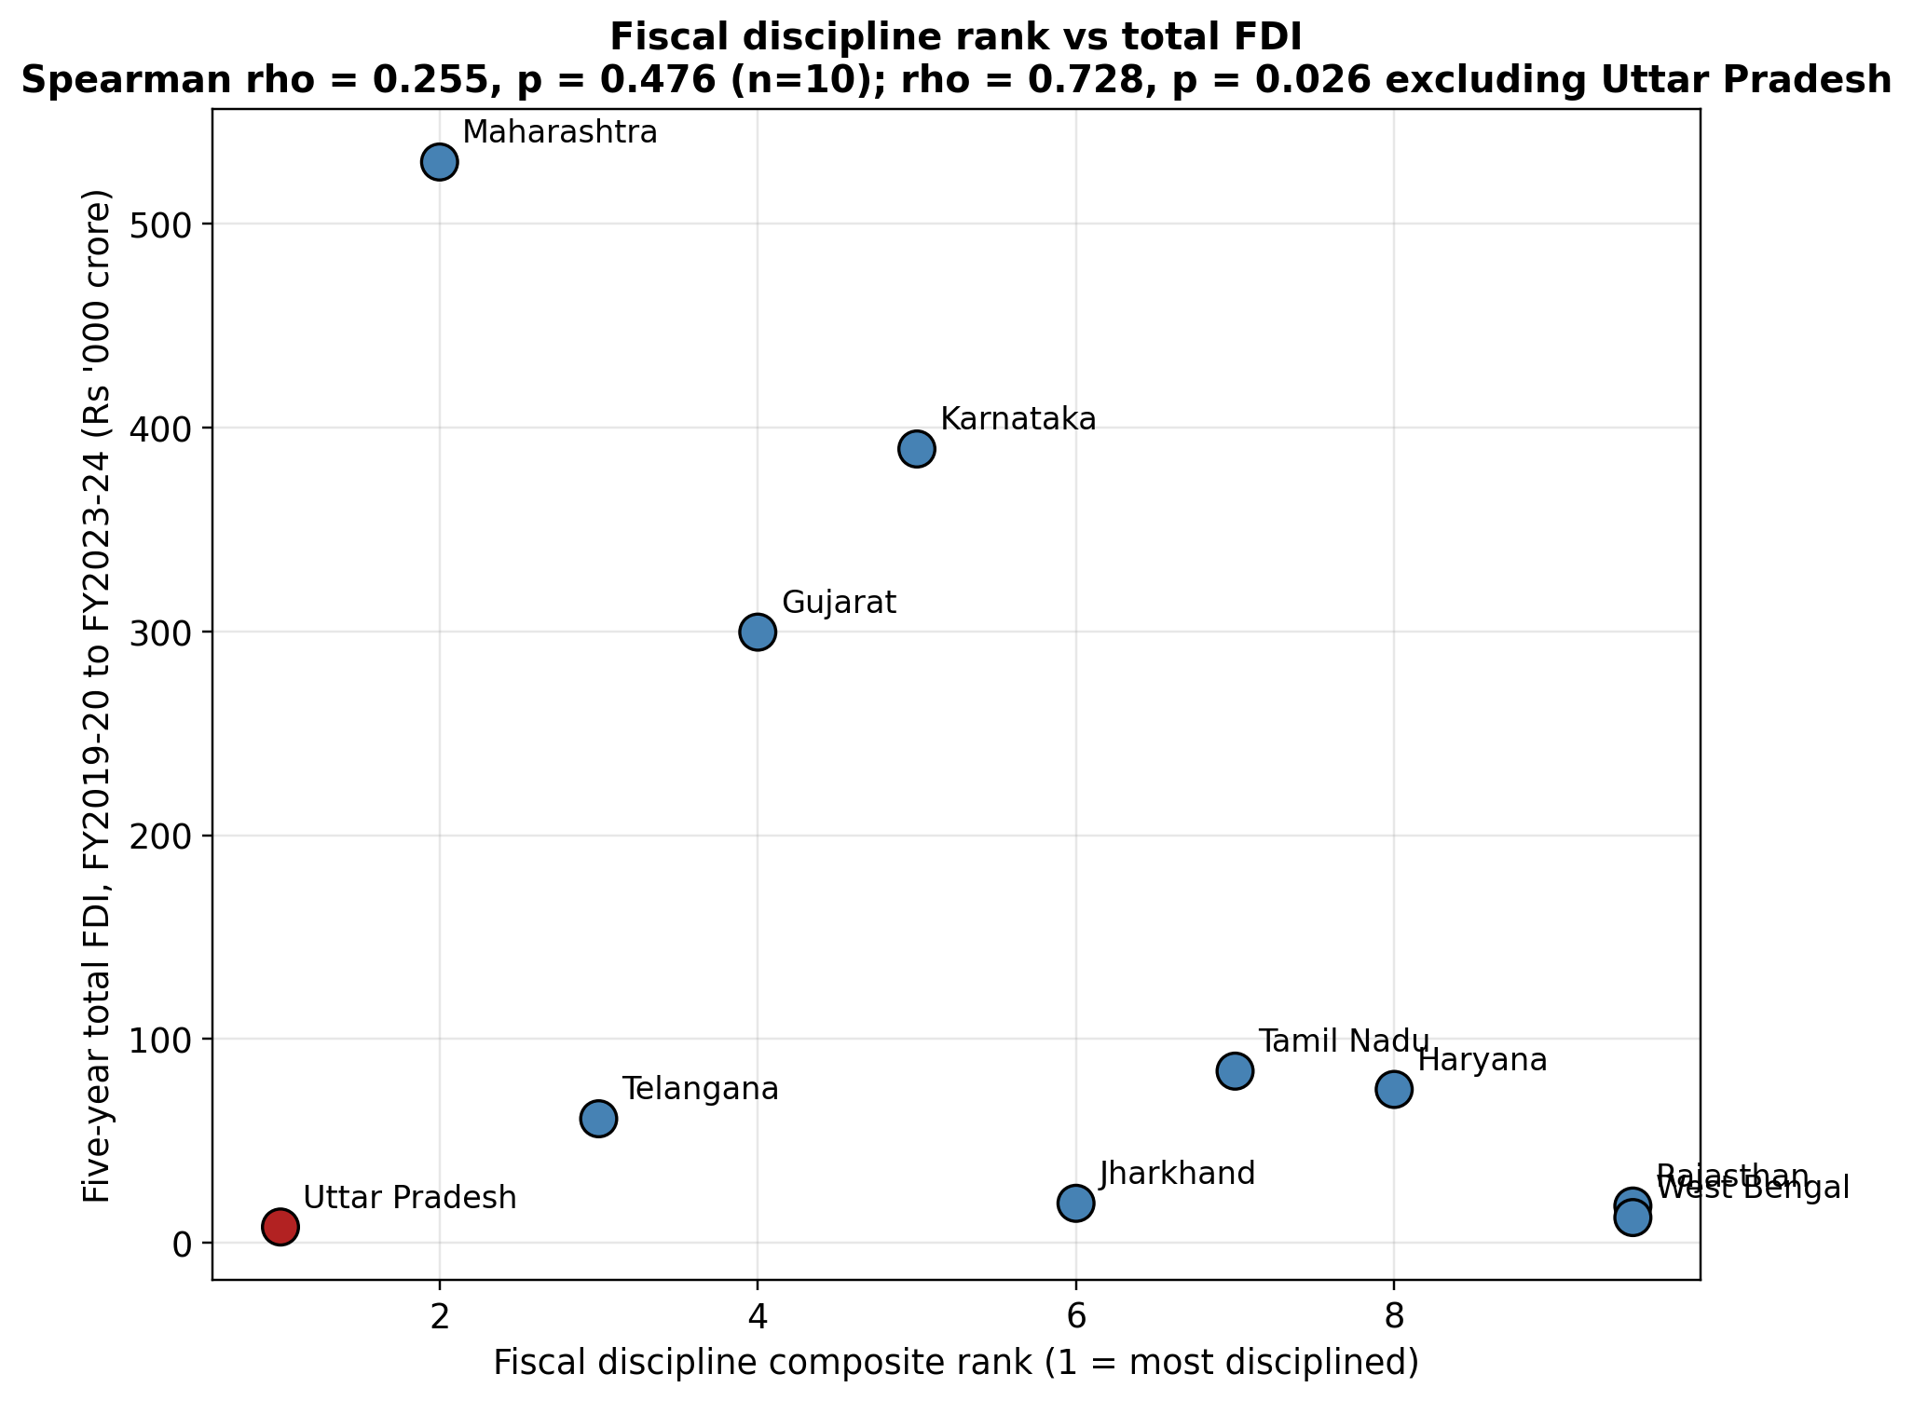
Figure 12. Fiscal discipline composite rank plotted against five-year total FDI. Uttar Pradesh, whose FDI series is left-censored before FY 2021-22 and is therefore not a genuine low-FDI outcome, is marked in red; every other state is marked in blue. Excluding Uttar Pradesh, the downward slope implied by the remaining nine points is the significant Spearman correlation (rho = 0.728, p = 0.026) reported above.
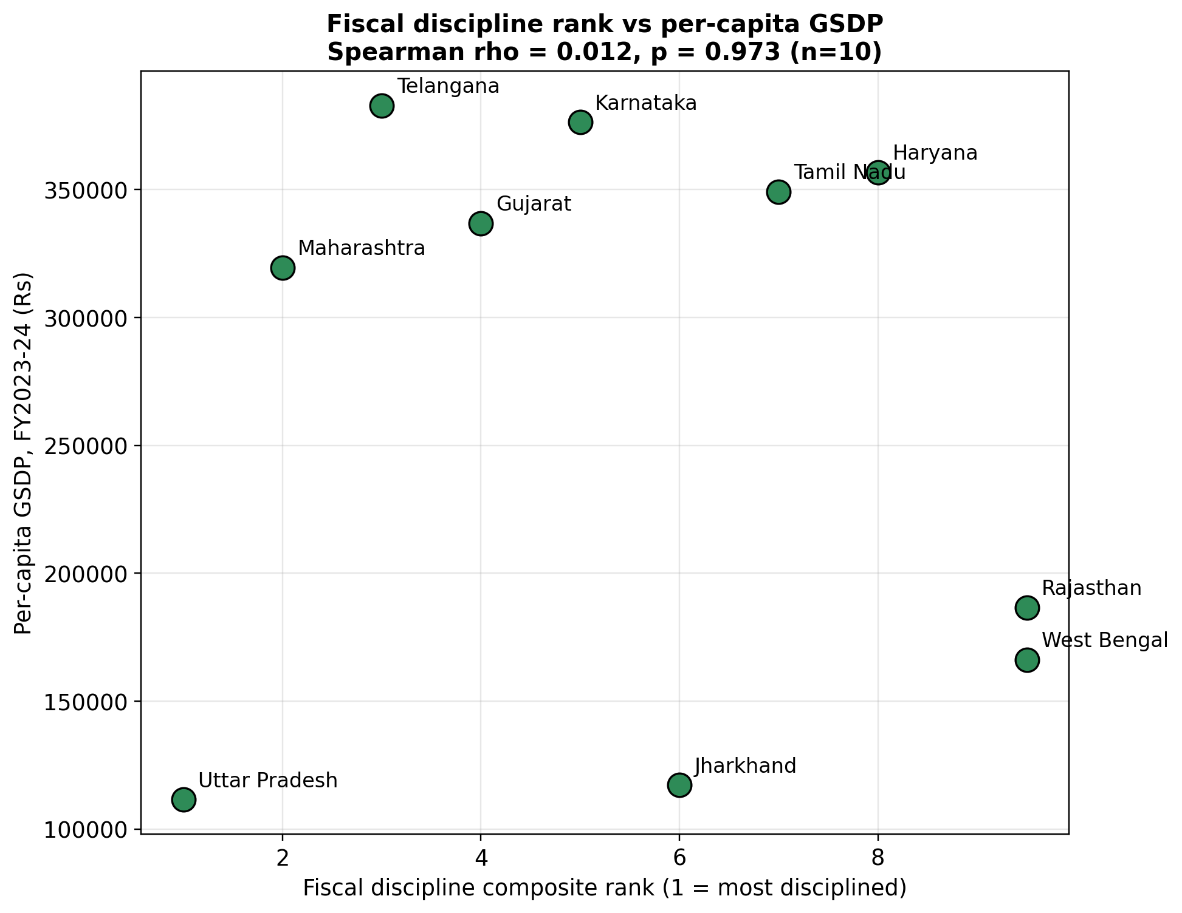
Figure 13. Fiscal discipline composite rank plotted against FY 2023-24 per-capita GSDP. Unlike the FDI relationship in Figure 12 above, no clear pattern is visible, consistent with the statistically insignificant Spearman correlation (rho = 0.012, p = 0.973) reported above.

6.3 Panel regression: FDI (Model 1)
The fixed-effects specification (n = 48, within R² = 0.429, F(5,33) = 4.96, p = 0.0017) explains within-state variation in log FDI. Fiscal deficit (coefficient 0.566, p < 0.001), debt (0.353, p < 0.001) and the COVID dummy (-1.406, p < 0.001) are all significant under Driscoll-Kraay; own tax revenue and capital expenditure are not. Two of those three survive stricter inference and one does not. Table 34 puts the within-state deficit coefficient at p = 0.264 under cluster-robust errors and p = 0.836 under the wild cluster bootstrap, so no deficit-FDI claim is made anywhere in this paper, and the Driscoll-Kraay p-value quoted here should be read against that. A poolability F-test strongly rejects the null of no entity effects (F(9,33) = 6.74, p < 0.001), confirming that state fixed effects are doing real work in this model and that pooling would be misspecified here.
The pooled specification with Census controls (n = 48, R² = 0.643, F(7,40) = 10.29, p < 0.001) tells a different, and for the paper's central claim more important, story. Its between R² of 0.874, the fit the same coefficients deliver against the ten state means, is reported alongside because it is the dimension the specification is meant to speak to. Debt is negative and precisely estimated (coefficient -0.176, standard error 0.062, t = -2.84, p = 0.0071 under cluster-robust inference): a one-percentage-point-lower debt-to-GSDP ratio is associated with roughly 19 per cent higher FDI, since exp(0.176) - 1 = 0.192, holding the other regressors and the Census controls fixed. Literacy (0.101) and capital expenditure (-0.366) also clear conventional significance under those same standard errors, at p = 0.035 and p = 0.008 respectively, while fiscal deficit, own tax revenue, the COVID dummy and urbanisation do not. Ten clusters is too few for the cluster-robust t-distribution to be reliable, however, so all of these p-values are re-computed by wild cluster bootstrap in Section 6.7. Debt is the only regressor that approaches conventional significance under that stricter standard (p = 0.057, significant at the 10 per cent level); literacy (p = 0.235) and capital expenditure (p = 0.095) do not survive it, and neither is relied upon in what follows.

Table 19. Model 1, log(FDI), fixed effects and pooled OLS. Each fiscal ratio is reported with its coefficient, standard error, t-statistic and p-value under each of the two specifications described in Section 5.1.
Variable | FE + Driscoll-Kraay (coef) | FE + Driscoll-Kraay (std_err) | FE + Driscoll-Kraay (t) | FE + Driscoll-Kraay (p) | Pooled OLS + controls (coef) | Pooled OLS + controls (std_err) | Pooled OLS + controls (t) | Pooled OLS + controls (p)
Intercept | -2.6202 | 0.9754 | -2.6864 | 0.0112 | 3.6472 | 4.5738 | 0.7974 | 0.4299
fd | 0.5660 | 0.0994 | 5.6926 | 0.0000 | 0.5665 | 0.5011 | 1.1304 | 0.2650
debt | 0.3533 | 0.0422 | 8.3728 | 0.0000 | -0.1760 | 0.0620 | -2.8388 | 0.0071
otr | 0.1068 | 0.2600 | 0.4108 | 0.6838 | 0.3251 | 0.2893 | 1.1237 | 0.2678
capex | -0.1730 | 0.3021 | -0.5725 | 0.5709 | -0.3659 | 0.1316 | -2.7796 | 0.0083
covid | -1.4059 | 0.2373 | -5.9246 | 0.0000 | 0.5467 | 0.3829 | 1.4281 | 0.1610
literacy | — | — | — | — | 0.1006 | 0.0461 | 2.1804 | 0.0352
urban | — | — | — | — | 0.0047 | 0.0410 | 0.1146 | 0.9093

The figure below plots the raw relationship the fixed-effects half of Table 19 summarises: average fiscal deficit against average log FDI for each state, with colour showing average debt.
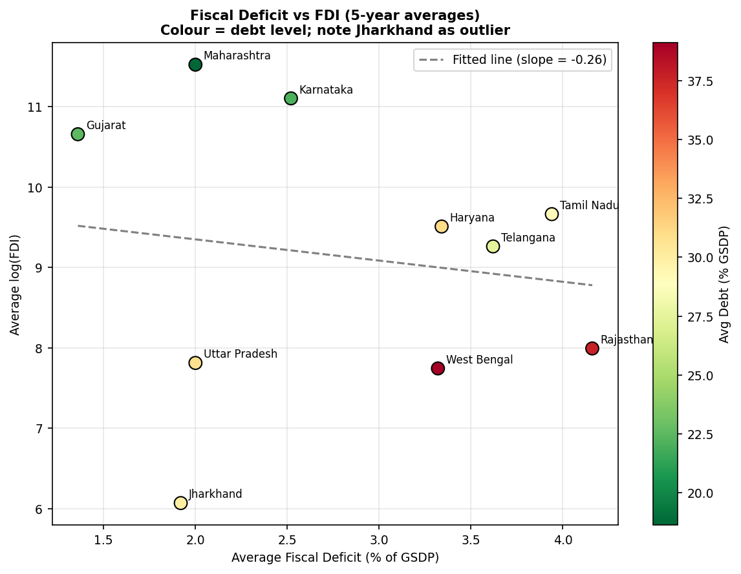
Figure 14. Average fiscal deficit against average log FDI, five-year state means, colour-coded by average debt-to-GSDP (red = high debt, green = low debt). Jharkhand sits well off the fitted line, foreshadowing the case discussion in Section 7.3.
The sign reversal on debt between the two specifications in Table 19 is the paper's central empirical fact and is addressed at length in Section 7.1; both coefficients are individually well estimated and neither is a coding artefact.

6.4 Panel regression: GSDP growth (Model 2)
For growth, the fixed-effects specification (n = 50, within R² = 0.689, F(5,35) = 15.53, p < 0.001) is dominated by the COVID dummy, which is large, negative and robust to every method of inference (-13.783; p = 0.003 under the wild cluster bootstrap), consistent with the roughly 14-percentage-point growth collapse the panel records in FY 2020-21. Among the fiscal variables the picture depends on how the standard errors are computed, and Section 6.7 sets the comparison out in full. Within this specification debt is positive and significant under every method (+1.097; cluster-robust p = 0.001, bootstrap p = 0.020), and own tax revenue under the two methods appropriate at ten clusters (+4.083; cluster-robust p = 0.045, bootstrap p = 0.028) though not under Driscoll-Kraay (p = 0.101). Both results depend on the COVID dummy being an adequate control for common time variation, and Table 23b shows that it is not: under full year fixed effects the own tax revenue coefficient disappears and the debt coefficient reverses sign. Neither is claimed as a finding of this paper, and the discussion in Sections 6.7 and 8 proceeds on that basis. The fiscal deficit coefficient is negative and sizeable (-2.172) and significant under Driscoll-Kraay (p = 0.031), but it does not survive either cluster-robust inference (p = 0.310) or the bootstrap (p = 0.448). Unlike Model 1, the poolability test for the growth equation does not reject pooling (F(9,35) = 0.82, p = 0.603), meaning the state fixed effects contribute comparatively little explanatory power once the fiscal variables and the COVID dummy are already in the equation.
Table 20. Model 2, GSDP growth, fixed effects and pooled OLS, in the same layout as Table 19.
Variable | FE + Driscoll-Kraay (coef) | FE + Driscoll-Kraay (std_err) | FE + Driscoll-Kraay (t) | FE + Driscoll-Kraay (p) | Pooled OLS + controls (coef) | Pooled OLS + controls (std_err) | Pooled OLS + controls (t) | Pooled OLS + controls (p)
Intercept | -37.9337 | 21.1480 | -1.7937 | 0.0815 | 5.3667 | 11.9457 | 0.4493 | 0.6556
fd | -2.1719 | 0.9663 | -2.2477 | 0.0310 | -1.4353 | 1.4861 | -0.9658 | 0.3397
debt | 1.0967 | 0.4771 | 2.2984 | 0.0276 | 0.2579 | 0.2196 | 1.1744 | 0.2468
otr | 4.0830 | 2.4238 | 1.6845 | 0.1010 | 1.6267 | 0.8780 | 1.8528 | 0.0709
capex | -0.3560 | 1.2357 | -0.2881 | 0.7750 | -0.3226 | 0.9018 | -0.3578 | 0.7223
covid | -13.7826 | 3.1731 | -4.3436 | 0.0001 | -12.6624 | 1.5744 | -8.0427 | 0.0000
literacy | — | — | — | — | -0.1720 | 0.1911 | -0.9004 | 0.3730
urban | — | — | — | — | 0.1994 | 0.1355 | 1.4710 | 0.1487

The pooled growth specification (n = 50, R² = 0.641, F(7,42) = 10.70, p < 0.001) is dominated by the COVID dummy (-12.662, p < 0.001); none of the four fiscal variables reach significance in this cross-state form, own tax revenue coming closest (1.627, p = 0.071). That null is what Section 6.1's variance decomposition predicts rather than a substantive result, since under two per cent of the variation in GSDP growth is between states at all, leaving the cross-state specification almost nothing to explain. H2 therefore had to rest on the within-state estimates, and Table 23b shows those do not survive a full set of year effects. We report H2 as unsupported by this panel: over a five-year window containing the pandemic, with ten states, the growth equation cannot separate a fiscal effect from the common time path every state shares.

6.5 Diagnostics and robustness
Variance inflation factors for the four fiscal regressors range from 1.33 (capital expenditure) to 1.69 (debt), all comfortably below the conventional concern threshold of five, despite the mechanical link between deficits and debt (pairwise correlation 0.533; see the correlation matrix below). Multicollinearity is not a threat to either model's coefficient estimates.
Table 21. Variance inflation factors, four fiscal regressors. A value near 1 means a regressor is close to uncorrelated with the others; values above 5 are the usual threshold for concern.
Variable | VIF
const | 140.14
fd | 1.52
debt | 1.69
otr | 1.51
capex | 1.33

Table 22. Pairwise correlation matrix, fiscal regressors and outcome variables. Each cell is the Pearson correlation between the row and column variable across all state-year observations; the diagonal is 1 by construction.
Unnamed: 0 | fd | debt | otr | capex | log_fdi | growth
fd | 1.0 | 0.533 | -0.085 | -0.2 | -0.005 | -0.373
debt | 0.533 | 1.0 | -0.371 | -0.125 | -0.557 | -0.198
otr | -0.085 | -0.371 | 1.0 | 0.444 | 0.215 | 0.294
capex | -0.2 | -0.125 | 0.444 | 1.0 | -0.288 | 0.102
log_fdi | -0.005 | -0.557 | 0.215 | -0.288 | 1.0 | -0.113
growth | -0.373 | -0.198 | 0.294 | 0.102 | -0.113 | 1.0

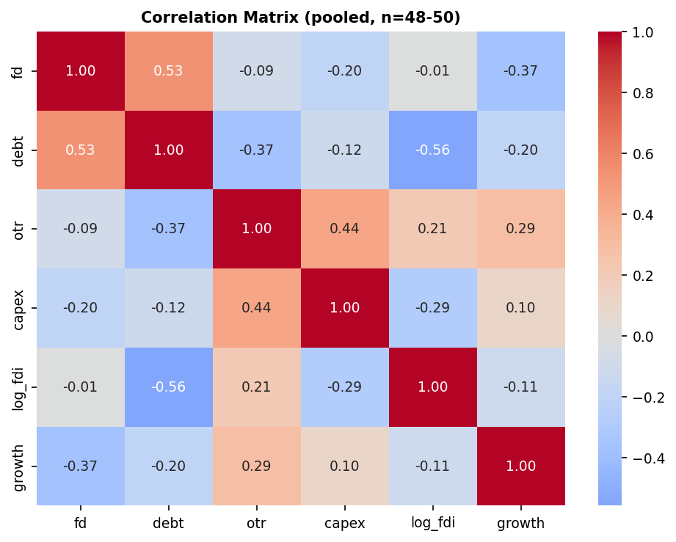
Figure 15. Correlation heatmap of fiscal regressors and outcome variables, colour-coded from the same matrix as the table above (red = positive, blue = negative).
The table below reports the within-state deficit and debt coefficients from Model 1 under three perturbations of the sample, to check whether the fixed-effects result is being driven by a single year or a single state. Dropping the COVID year (n = 39) leaves both coefficients stable in sign and significance (deficit 0.802, p = 0.017; debt 0.324, p = 0.002). Dropping Uttar Pradesh (n = 45) barely moves either estimate (deficit 0.532, p < 0.001; debt 0.366, p < 0.001), which matters because it shows the left-censoring in UP's FDI series is not driving the within-state result. Dropping Jharkhand (n = 43), by contrast, flips the deficit coefficient's sign and removes its significance entirely (-0.310, p = 0.141), while the debt coefficient survives, smaller but still significant (0.182, p = 0.015). Jharkhand alone is therefore responsible for a meaningful share of the within-state deficit-FDI pattern; Section 7.3 examines why. That pattern is not one the paper leans on in any case: the within-state deficit coefficient does not survive cluster-robust or bootstrap inference (Table 34), so its fragility across subsamples is consistent with the verdict recorded there rather than additional to it. Two further checks belong here because they answer questions the design invites. Lagging debt by one year, which is the cheapest response to the reverse-causality concern recorded as the fourth limitation in Section 8, leaves the pooled coefficient at -0.197 (p = 0.003, n = 39): investment follows the previous year's debt position about as closely as the contemporaneous one, which is what a signalling account would predict and is not what simultaneous determination would. And dropping FY 2019-20, the six-month window DPIIT's series opens with and the one cell in the panel that is not a full year, strengthens the pooled coefficient rather than weakening it, to -0.237 (p = 0.003, n = 39). Neither is reported as a headline result; both are reported because their absence would be the first thing a reader asks about.

Table 23. Robustness of Model 1 within-state coefficients across four subsamples: the full baseline, then each perturbation dropping one problematic year or state in turn.
Specification | n | fd_coef | fd_p | debt_coef | debt_p | otr_coef | otr_p | capex_coef | capex_p
Baseline (all data) | 48 | 0.566 | 0.0 | 0.353 | 0.0 | 0.107 | 0.684 | -0.173 | 0.571
Excl. COVID year (FY2020-21) | 39 | 0.802 | 0.017 | 0.324 | 0.002 | 0.535 | 0.26 | -0.207 | 0.48
Excl. Jharkhand | 43 | -0.31 | 0.141 | 0.182 | 0.015 | 0.019 | 0.922 | 0.414 | 0.084
Excl. Uttar Pradesh | 45 | 0.532 | 0.0 | 0.366 | 0.0 | 0.092 | 0.711 | -0.186 | 0.555
The table below reports the same robustness check for Model 2 (GSDP growth), since Table 23 covers only Model 1. Dropping Jharkhand collapses the fiscal-deficit coefficient from -2.172 (p = 0.031) to -0.424 (p = 0.459), the same fragility pattern documented for Model 1; dropping the COVID year has a similar, if smaller, effect. The debt coefficient is more stable, remaining significant at the 5 per cent level in three of the four perturbations. This is consistent with, and reinforces, Section 6.7's decision to base the growth finding on debt and own tax revenue rather than on the fiscal deficit once the wild cluster bootstrap is applied.
Table 23a. Robustness of Model 2 (GSDP growth) within-state coefficients across the same four subsamples as Table 23.
Specification | n | fd_coef | fd_p | debt_coef | debt_p | otr_coef | otr_p | capex_coef | capex_p
Baseline (all data) | 50 | -2.172 | 0.031 | 1.097 | 0.028 | 4.083 | 0.101 | -0.356 | 0.775
Excl. COVID year (FY2020-21) | 40 | -1.968 | 0.177 | 1.604 | 0.053 | 5.651 | 0.082 | -1.429 | 0.113
Excl. Jharkhand | 45 | -0.424 | 0.459 | 1.608 | 0.001 | 2.698 | 0.155 | 0.548 | 0.538
Excl. Uttar Pradesh | 45 | -5.078 | 0.001 | 1.477 | 0.001 | 2.520 | 0.003 | -0.202 | 0.921
Both models so far absorb time with a single dummy for FY 2020-21. That is a strong restriction, and the panel gives us a way to test it. A dummy removes the level of the pandemic year and nothing else, whereas the ten states share a whole time path: growth averages 7.2 per cent in FY 2019-20, -0.9 in FY 2020-21, then 19.5, 14.5 and 11.7 in the three years after, while average debt peaks at 31.7 per cent of GSDP in the pandemic year and settles around 28 thereafter, above its pre-pandemic 27.3. The FY 2021-22 rebound is therefore left in the error term by a COVID dummy, in a year when debt is still elevated. Replacing the dummy with a full set of year fixed effects absorbs the entire common path instead. The table below re-estimates both models that way. The COVID dummy is collinear with year effects and drops out by construction.

Table 23b. Within-state coefficients under a single COVID dummy against a full set of year fixed effects, both models. Cluster-robust and wild cluster bootstrap p-values are reported for the two-way specification, the bootstrap being the reference distribution this paper defers to at ten clusters.
Regressor | M1 one-way coef | M1 one-way p | M1 two-way coef | M1 two-way p (cluster / wild) | M2 one-way coef | M2 one-way p | M2 two-way coef | M2 two-way p (cluster / wild)
Fiscal deficit | +0.566 | 0.264 | +0.678 | 0.154 / 0.274 | -2.172 | 0.310 | +0.348 | 0.303 / 0.448
Debt-to-GSDP | +0.353 | 0.000 | +0.332 | 0.098 / 0.234 | +1.097 | 0.001 | -0.689 | 0.019 / 0.086
Own tax revenue | +0.107 | 0.810 | -0.262 | 0.632 / 0.565 | +4.083 | 0.045 | +0.896 | 0.636 / 0.611
Capital expenditure | -0.173 | 0.686 | -0.265 | 0.594 / 0.610 | -0.356 | 0.827 | -2.050 | 0.146 / 0.270
For Model 1 the consequence is a loss of precision rather than a change of story. The within-state debt coefficient barely moves, from +0.353 to +0.332, but its p-value rises to 0.098 under cluster-robust inference and 0.234 under the bootstrap. It stays positive in all ten leave-one-state-out refits and significant at 5 per cent in only one of them. Restricted to FY 2021-22 onward, once the pandemic year and its immediate rebound are outside the window, the same coefficient turns negative, at -0.452 with a bootstrap p of 0.075. That is the pattern Section 7.1 argues for, and it is the reason this paper places no weight on the positive within-state estimate.
For Model 2 the consequence is more serious and we report it plainly, because it revises a claim made in earlier drafts of this work. Under the COVID dummy, debt enters the growth equation at +1.097 and own tax revenue at +4.083, and both clear the bootstrap. Under year fixed effects, own tax revenue falls to +0.896 and is no longer distinguishable from zero (p = 0.61), while debt reverses sign to -0.689, cluster-robust p = 0.019 and bootstrap p = 0.086. The reversal is not fragile: debt is negative in all ten leave-one-state-out refits, ranging from -0.886 to -0.396, and significant at 5 per cent in eight of them. The positive debt-growth association reported under the COVID dummy is therefore an artefact of incomplete time controls, and specifically of assigning the FY 2021-22 rebound to the residual while debt was still elevated. The negative sign that replaces it points the way the prior literature does, but at a bootstrap p of 0.086 across fifty observations it is not a finding we claim either. What this panel supports is that its growth equation cannot identify a fiscal effect once common year shocks are removed, and Sections 6.7 and 8 are written accordingly. We note also that the 132-specification curve of Section 6.7 varies the estimator, the pandemic year, the controls, the transformation and the excluded state, but holds the time control fixed at a single dummy; Table 23b is the dimension it does not cover.

6.6 Machine-learning validation
The corrected specification (Section 5.2) restricts LASSO, Elastic Net and SHAP to the five time-varying fiscal regressors and estimates all three on the same 48 observations. With the penalty strength chosen by state-blocked cross-validation, LASSO settles at alpha = 0.106 and assigns debt-to-GSDP by far the largest standardised coefficient, -1.376, roughly two and a half times the size of the next-largest term, the fiscal deficit at +0.563, with capital expenditure a close third at -0.553. Elastic Net, at alpha = 0.131 and an l1-ratio of 0.7, agrees closely on the leading variable: debt -1.280, with capital expenditure second at -0.562 and fiscal deficit third at +0.488.
Table 24. LASSO and Elastic Net standardised coefficients under state-blocked cross-validation, five fiscal predictors, ranked by the absolute size of the LASSO coefficient. A blank or zero coefficient would mean a variable was eliminated by the penalty; all five survive here.
Variable | LASSO_coef (standardized) | LASSO_selected | ElasticNet_coef | ElasticNet_selected
Debt-to-GSDP | -1.3760 | YES | -1.2797 | YES
Fiscal Deficit | 0.5625 | YES | 0.4879 | YES
Capital Expenditure | -0.5525 | YES | -0.5621 | YES
COVID year | 0.1293 | YES | 0.1613 | YES
Own Tax Revenue | 0.0394 | YES | 0.0978 | YES

The choice of cross-validation scheme matters here and is worth stating explicitly. Under the row-wise leave-one-out scheme the same procedure selects alpha = 0.00106, a penalty two orders of magnitude lighter, under which the LASSO coefficients are barely distinguishable from unpenalised least squares and the debt coefficient is -1.571. Debt is the largest surviving coefficient under both. That the ranking is unchanged across a hundredfold range of penalty strength is a stronger statement than either fit alone.

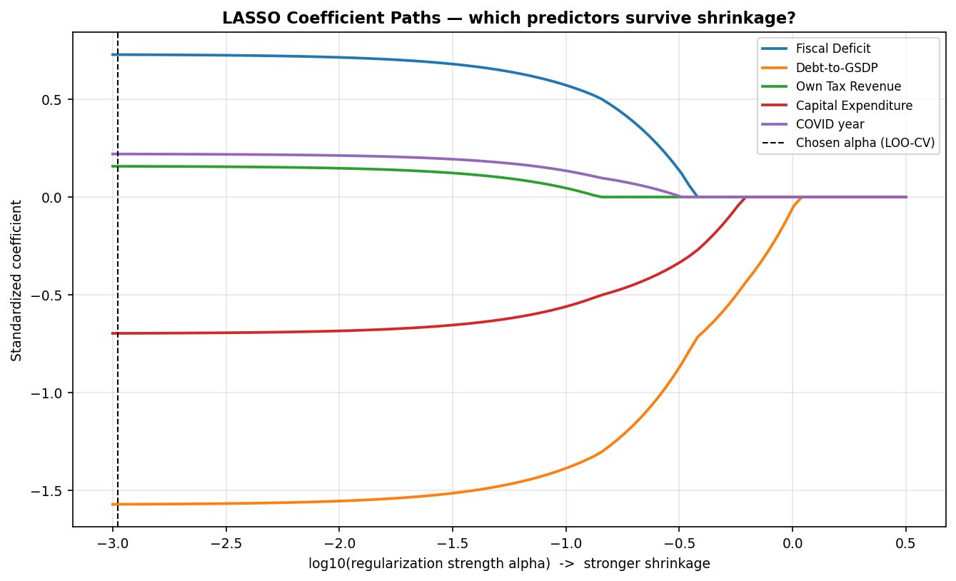
Figure 16. LASSO coefficient paths across the regularisation path, five fiscal predictors. Each line traces one variable's coefficient as the penalty strength increases (moving right); the vertical dashed line marks the cross-validated penalty actually used in Table 24.
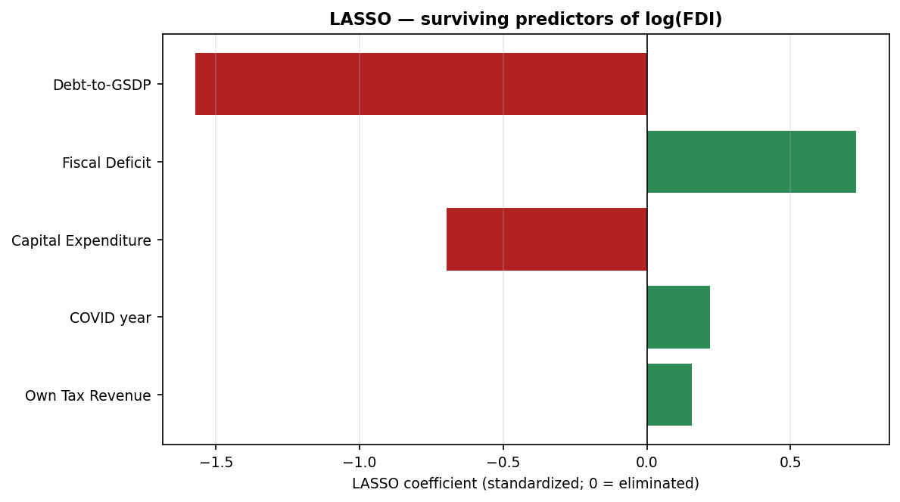
Figure 17. LASSO surviving coefficients at the cross-validated regularisation strength, five fiscal predictors, plotted as a bar for each variable's final coefficient.
Because the cross-validated penalty is light enough that all five regressors survive it, a table of which variables were selected is uninformative on its own. Two supplementary results address this. The entry order along the regularisation path identifies the variable that survives the harshest shrinkage. Debt-to-GSDP is the first to acquire a non-zero coefficient, at alpha = 1.016, well before capital expenditure at 0.609 and fiscal deficit at 0.375. Own tax revenue is last to enter, at 0.138. Read as a sequence, the path says that if the model were permitted only one fiscal regressor, that regressor would be debt.
Table 25. LASSO entry order along the regularisation path, five fiscal predictors. A higher entry alpha means the variable survives a stronger penalty.
Variable | Alpha at which the variable enters the path
Debt-to-GSDP | 1.0163
Capital Expenditure | 0.6085
Fiscal Deficit | 0.3749
COVID year | 0.3160
Own Tax Revenue | 0.1383

The stability-selection exercise, by contrast, does not separate the five variables, and we report that plainly. Refitting LASSO over a grid of penalties on 500 five-state subsamples, every variable is retained in at least 94 per cent of subsamples at the cross-validated penalty, and the harshest penalty at which a variable is still retained in 80 per cent of subsamples is 0.667 for capital expenditure, 0.556 for both own tax revenue and debt, 0.321 for fiscal deficit and 0.268 for the COVID dummy. Debt does not lead on this metric. The reading we take is that selection and magnitude are different questions at this sample size: with five weakly correlated regressors and no strong penalty, all five are easy to retain, and what distinguishes debt is the size of its coefficient and its position on the path, not the mere fact of its retention. Presenting only the selection frequencies would overstate the evidence in a direction that happens to favour our own conclusion, which is why both are shown.

Table 26. Stability selection across 500 subsamples of five of the ten states, five fiscal predictors.
Variable | Harshest alpha retained in 80% of subsamples | Selection probability at the CV alpha
Capital Expenditure | 0.6670 | 0.968
Own Tax Revenue | 0.5557 | 0.966
Debt-to-GSDP | 0.5557 | 0.960
Fiscal Deficit | 0.3213 | 0.960
COVID year | 0.2677 | 0.940
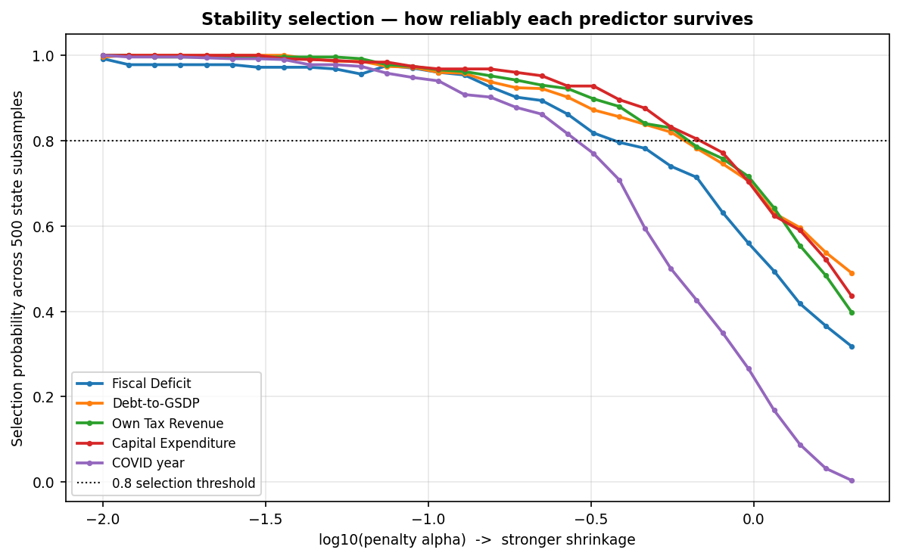
Figure 18. Selection probability against penalty strength across 500 five-state subsamples, five fiscal predictors. Each line traces how often a variable survives the LASSO penalty as that penalty strengthens (moving right); the dotted line marks the conventional 0.8 stability threshold.

SHAP values from the corrected random forest (out-of-bag R² = 0.402) rank debt-to-GSDP first among the five predictors by a wide margin: mean |SHAP| = 1.029, against 0.219 for fiscal deficit, 0.208 for own tax revenue, 0.136 for capital expenditure, and an effectively negligible 0.007 for the COVID dummy. These are contributions to the model's prediction, not causal effects or coefficient magnitudes; Section 8 states the paper's causal position for the study as a whole.

Table 27. SHAP importance, five fiscal predictors, random forest. Mean |SHAP| is the average, across all 48 observations, of the absolute contribution that variable made to the model's prediction for that observation; a higher value means the variable moves the predicted FDI further, in either direction.

Variable | Mean_|SHAP|
Debt-to-GSDP | 1.0287
Fiscal Deficit | 0.2185
Own Tax Revenue | 0.2081
Capital Expenditure | 0.1360
COVID year | 0.0068

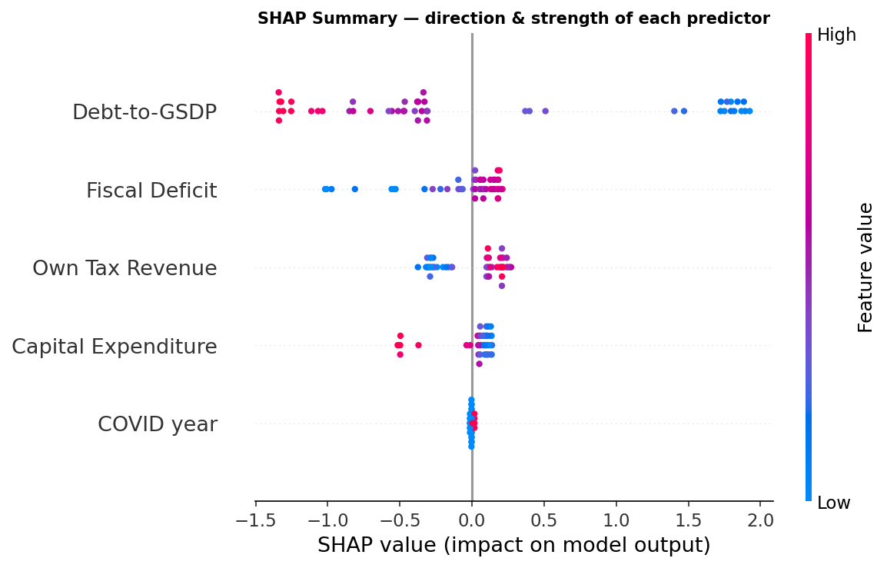
Figure 19. SHAP summary plot, five fiscal predictors. Each dot is a single state-year. Its horizontal position gives that observation's SHAP value, the pull it exerted on predicted log FDI, and its colour gives the observation's value on the variable itself (red high, blue low). In the debt row the red dots sit to the left, on the negative side: high debt pulls the model's predicted FDI downward.
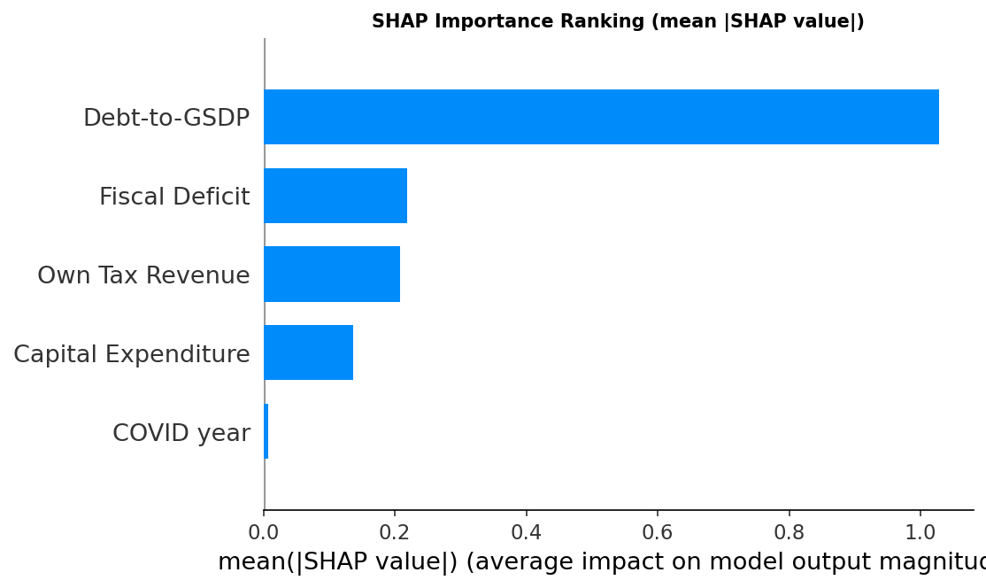
Figure 20. SHAP importance by mean absolute SHAP value, five fiscal predictors. The same ranking as Table 27, drawn as bars.
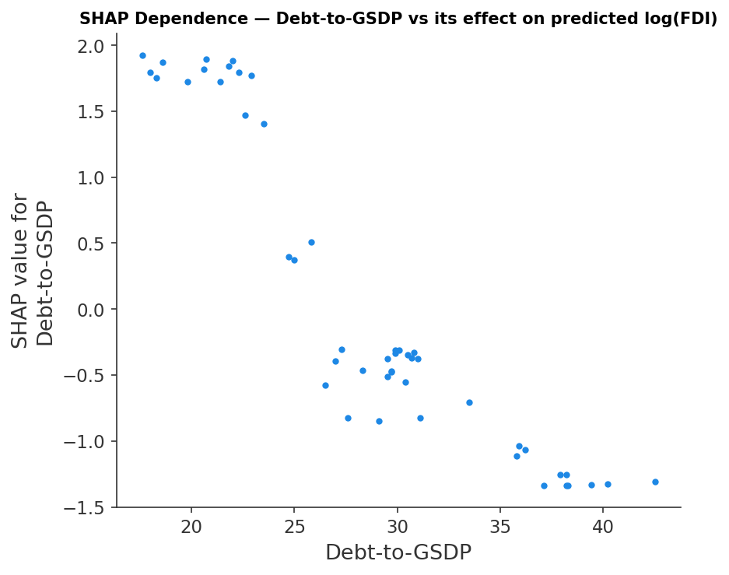
Figure 21. SHAP dependence plot for debt-to-GSDP. Horizontal position is the state-year's debt ratio and vertical position is that observation's SHAP value, so the plot traces the effect on predicted log FDI across the range of debt the panel actually covers.

Refitting the forest ten times, each time with one state's five observations removed entirely, and recomputing SHAP importances on each refit, debt-to-GSDP ranks first in all ten refits, with a rank standard deviation of zero. No single state, including the two anomalous cases discussed in Section 7.3, is responsible for its position.

Table 28. Rank of debt-to-GSDP by mean |SHAP| across ten leave-one-state-out refits of the random forest.
State left out of the refit | Rank of debt-to-GSDP by mean |SHAP|
Maharashtra | 1
Karnataka | 1
Gujarat | 1
Tamil Nadu | 1
Haryana | 1
Telangana | 1
Jharkhand | 1
Rajasthan | 1
West Bengal | 1
Uttar Pradesh | 1

Some variable must rank first, so the rank alone proves little. The null must respect the same structure the cross-validation does. Permuting log FDI across all forty-eight rows breaks the between-state persistence the real data carry and so makes the observed margin easier to beat than it should be; the null reported here therefore permutes whole states, moving each state's block of outcomes together, which is the design the state-blocked folds of Section 5.2 imply. Under that null, debt ranks first under a permuted outcome 38.1 per cent of the time, far above the 20 per cent a five-way coin flip would give, which confirms the concern: a tree ensemble does favour debt-to-GSDP on the basis of its distribution alone, irrespective of any relationship with FDI. The rank is therefore weak evidence and we do not lean on it. The margin is a different matter. The observed gap between the first- and second-ranked variable is 0.810 in mean absolute SHAP units, and a gap that large or larger arises in 3.8 per cent of state-block permutations (p = 0.038). For comparison, the row-wise permutation we ran first returns p = 0.004; the state-blocked figure is the honest one and it is the one reported throughout, since the row-wise null is anti-conservative for exactly the reason the cross-validation is blocked in the first place.
Table 29. Permutation null for the SHAP ranking, 500 draws.
Quantity | Value
Observed top-ranked variable | Debt-to-GSDP
Observed top-to-second mean |SHAP| gap | 0.8102
P(debt ranks first | states permuted) | 0.381
P(gap >= observed | states permuted) | 0.038
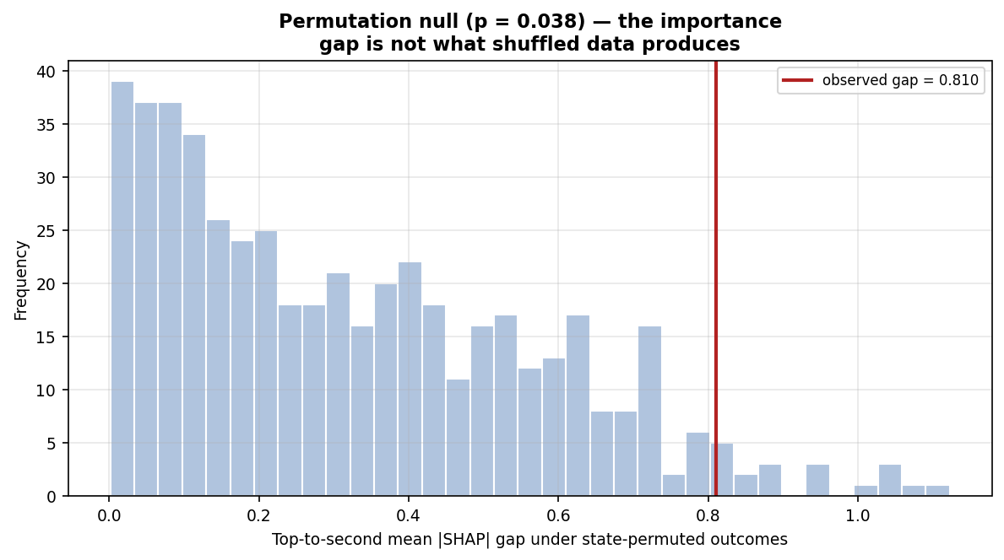
Figure 22. Null distribution of the gap between the first- and second-ranked variable by mean |SHAP|, across 500 permutations of the outcome. The vertical line marks the gap actually observed.

Fitting the same two methods to state-demeaned data, which reproduces the algebra of the fixed-effects estimator, tests whether the machine-learning branch is learning fiscal variation or merely learning which state an observation belongs to. It is learning fiscal variation, and it independently reproduces the sign reversal of Section 7.1. On demeaned data LASSO shrinks own tax revenue and capital expenditure to exactly zero and retains debt with a coefficient of +0.441, positive where the pooled fit gives -1.376, alongside fiscal deficit at +0.248 and the COVID dummy at -0.222. SHAP importances on the demeaned forest again place debt first, at 0.274 against 0.119 for fiscal deficit.
Table 30. Within-state (demeaned) LASSO coefficients and SHAP importance, against pooled SHAP importance, five fiscal predictors.
Variable | Within LASSO coef. | Within mean |SHAP| | Pooled mean |SHAP|
Debt-to-GSDP | 0.4411 | 0.2743 | 1.0287
Fiscal Deficit | 0.2476 | 0.1191 | 0.2185
Own Tax Revenue | 0.0000 | 0.0371 | 0.2081
Capital Expenditure | 0.0000 | 0.0310 | 0.1360
COVID year | -0.2222 | 0.0007 | 0.0068
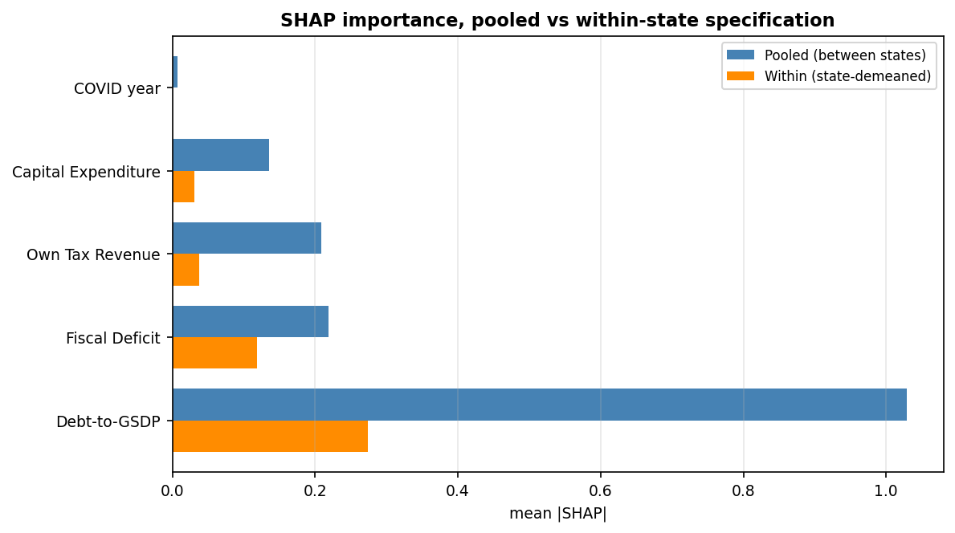
Figure 23. SHAP importance by mean absolute SHAP value, pooled specification against the state-demeaned (within) specification, five fiscal predictors.
Two things follow. First, debt is the dominant fiscal predictor in both dimensions, so its importance is not an artefact of cross-state level differences. Second, the sign reversal between the dimensions is reproduced by methods that share none of the fixed-effects estimator's distributional assumptions, which removes one available explanation for it. The reversal is a property of the data over this window, not of the linear panel estimator, and Section 7.1 interprets it accordingly.
Out-of-sample R-squared is modest under every scheme, which is what forty-eight observations should produce. The three columns differ substantially, and the differences are themselves a result.
Table 31. Out-of-sample R-squared under three cross-validation schemes, five fiscal predictors. Row-wise leave-one-out refits the model once per observation; leave-one-state-out refits it once per state; forward-chaining predicts each year from the years preceding it.
Model | Row-wise LOO | Leave-one-state-out | Forward-chaining by year
OLS (5 predictors) | 0.440 | 0.163 | 0.269
LASSO | 0.416 | 0.235 | 0.257
Random Forest | 0.395 | 0.085 | 0.235
Gradient Boosting | 0.509 | 0.112 | 0.241
The row-wise column retains four other years of the held-out state in the training sample and is inflated accordingly; the gap between it and the state-blocked column, roughly 0.28 for ordinary least squares and 0.31 for the random forest, measures how much of the apparent fit is state persistence rather than fiscal signal. Predicting a state never seen in training is the hardest of the three tasks and produces the lowest figures. Forward-chaining sits between them at 0.24 to 0.27. Two patterns are worth drawing out. The penalised linear model is the most robust across schemes and is the best performer under the state-blocked scheme at 0.235, while the two tree ensembles degrade sharply, to 0.085 and 0.112. Additional flexibility buys nothing out of sample here, which is what one would expect if the underlying relationship is close to linear once debt is in the model, and it supports reading the SHAP results as corroboration of the linear estimates rather than as evidence of a neglected non-linearity. None of these figures is a claim to predictive power. The exercise validates an in-sample ranking; it does not forecast.
None of the point estimates above comes with a sense of how much they would move under a different draw of the same ten states, so a cluster bootstrap was run on the leave-one-state-out figures: two hundred resamples of the ten states, drawn with replacement, each refitting every model and recomputing the leave-one-state-out R-squared. The resulting intervals are wide enough to include zero for every model, between eleven and twenty per cent of resamples in fact return a negative leave-one-state-out R-squared. This is the sharper way of saying what the point estimates already implied: forty-eight observations support a ranking of which method degrades least out of sample, not a claim that any of them predicts reliably.
Table 31a. Bootstrap 95 per cent confidence intervals for the leave-one-state-out out-of-sample R-squared of Table 31, two hundred state-cluster resamples.
Model | Point estimate | Bootstrap median | 95% CI (state-cluster bootstrap) | Share of draws ≤ 0
OLS (5 predictors) | 0.163 | 0.364 | [-0.815, 0.799] | 17.0%
LASSO | 0.235 | 0.328 | [-0.510, 0.806] | 20.5%
Random Forest | 0.085 | 0.339 | [-0.484, 0.815] | 11.0%
Gradient Boosting | 0.112 | 0.396 | [-1.152, 0.968] | 15.5%
Three methodologically independent approaches converge on debt-to-GSDP as the dominant fiscal predictor of cross-state FDI: a pooled panel regression, a regularised linear selector, and a non-linear tree-based explainer. The sign is negative in all three. Debt enters the regularisation path first, survives a hundredfold variation in penalty strength, ranks first on SHAP importance in all ten leave-one-state-out refits, does so by a margin that permuted whole states reproduce under four times in a hundred, and holds its rank when the data are demeaned so that only within-state variation remains. Together with the Spearman correlation of Section 6.2, this convergence is the strongest evidence the paper offers for H1 in its cross-state form, precisely because it does not rest on any single model's distributional assumptions, nor on treating one p = 0.007 result as sufficient in a panel this short. It should be read as support for one component of H1 rather than for the hypothesis as stated. H1 predicts that all four indicators move FDI in a particular direction; on this panel only debt does. Capital expenditure carries the opposite sign to the one predicted and is discussed in Section 7.2, own tax revenue is indistinguishable from zero in every specification, and the fiscal deficit is signed as predicted in the cross-state dimension but never precisely enough to claim. The hypothesis as written is therefore rejected for three of its four indicators and supported for the fourth, which is the one the rest of the paper is about. One qualification belongs with that list rather than in a footnote. Of the five methods, the Spearman correlation of Section 6.2 reaches significance only once Uttar Pradesh is excluded, and Section 7.3 shows that the exclusion cannot be justified as removing a pure censoring artefact, since scaling the state’s observed years leaves the correlation insignificant. That leg of the convergence is therefore conditional, and the argument should be read as resting on the four that are not: the pooled regression, LASSO, Elastic Net and SHAP importance.

6.7 Specification and diagnostic tests
The F-test for poolability rejects pooling in the FDI model: F(9,33) = 6.741, p < 0.0001. State effects are jointly significant and the fixed-effects specification is justified. In the growth model it does not: F(9,35) = 0.818, p = 0.603. We keep fixed effects there anyway, because the estimator stays consistent where random effects would be biased, and because the argument of Section 3 requires state-level controls. That is a modelling decision, not a verdict the test delivered, and we report it as one. The Hausman test returns nothing at all for the FDI model: the difference between the fixed- and random-effects covariance matrices is not positive definite, a routine outcome at ten entities. For the growth model it computes, at 6.319 on four degrees of freedom (p = 0.177), so random effects are not rejected there either. The four degrees of freedom are the four fiscal coefficients; the COVID dummy is excluded from the contrast because it varies only by year and carries no within-state information the two estimators could disagree about. One apparent tension in Table 32 is worth resolving. The Breusch-Pagan LM test reports no random-effects component (p = 0.529) while the poolability F strongly rejects the absence of entity effects on the same panel. The two are computed on different equations: the LM test is run on pooled residuals that already carry literacy and urbanisation, which absorb most of the cross-state variation an entity effect would otherwise pick up, whereas the poolability F compares fixed effects against a pooled fit without them. The tests are consistent once that is said.
The three tests bearing on the covariance estimator give a more mixed picture than the use of Driscoll-Kraay implies. In the FDI model, Pesaran's CD statistic is 0.019 (p = 0.985), so cross-sectional dependence does not show up. The Wooldridge test is reported here against its correct null. First-differencing an error that is serially uncorrelated in levels induces an AR(1) coefficient of exactly -0.5 by construction, so the hypothesis under test is that the first-difference autocorrelation equals -0.5, not that it equals zero. On that basis the FDI model returns -0.051 (p = 0.061), short of rejection at the 5 per cent level but not comfortably so, while the growth model returns -0.092 (p = 0.021) and does reject: serial correlation is present in the growth equation. Cross-sectional dependence in the growth model is unambiguous as well, CD = 8.397 (p < 0.0001), as it should be in a panel whose middle year is a shock common to every state. The modified Wald test rejects homoskedasticity across states in both models (p < 0.0001). Driscoll-Kraay is therefore clearly warranted for the growth model, which carries dependence, serial correlation and heteroskedasticity together. For the FDI model the heteroskedasticity is real, the cross-sectional dependence the estimator exists to absorb is not, and the serial correlation is borderline, so a cluster-robust estimator remains the more natural default there, and Table 33 reports the debt coefficient under both.
Table 32. Specification and diagnostic tests, both models. Tests that return no verdict are included.
Test | Model 1 (log FDI) | Model 2 (GSDP growth) | Reading
F-test for poolability | 6.741 (p < 0.0001) | 0.818 (p = 0.603) | State effects jointly significant in Model 1 only
Hausman, FE vs RE | Not computable | 6.319 (p = 0.177) | Inconclusive for Model 1; RE not rejected for Model 2
Breusch-Pagan LM, pooled vs RE | 0.397 (p = 0.529) | 2.569 (p = 0.109) | No random-effects component detected
Pesaran CD, cross-sectional dependence | 0.019 (p = 0.985) | 8.397 (p < 0.0001) | Dependence present in Model 2 only
Wooldridge, first-order serial correlation | -0.051 (p = 0.061) | -0.092 (p = 0.021) | H0: rho = -0.5. Serial correlation present in Model 2; Model 1 borderline, not rejected at 5%
Modified Wald, groupwise heteroskedasticity | 347.33 (p < 0.0001) | 184.58 (p < 0.0001) | Error variance differs by state; robust SEs justified
Ramsey RESET, functional form | 1.455 (p = 0.246) | — | No evidence of misspecification

That distinction matters, because Driscoll-Kraay does not behave conservatively at this panel length. Table 33 gives the within-state debt coefficient under three covariance estimators. The point estimate is identical by construction. The standard error is not: Driscoll-Kraay returns 0.042, cluster-robust 0.084, and the unadjusted estimator 0.106. A kernel estimator whose properties are asymptotic in T is being applied at T = 5, and it produces the tightest of the three intervals instead of the widest. The same numerical fragility leaves a negative robust F-statistic in the fixed-effects output. None of this changes the substantive conclusion. The coefficient stays significant under cluster-robust inference (p = 0.0002), and a bootstrap resampling whole states gives a 95 per cent interval of [+0.074, +0.522], which excludes zero. The cluster-robust column is the conservative reading of the within-state results in Section 6.3, and should be read as such.
Ramsey's RESET gives no evidence of functional-form misspecification (F = 1.455, p = 0.246). The logarithmic and inverse-hyperbolic-sine transformations of FDI are indistinguishable here, both returning a within R-squared of 0.429 against 0.108 for FDI in levels, so the choice of logarithms in Section 5.1 costs nothing and the results are not an artefact of it.
Table 33. Within-state debt coefficient in Model 1 under four approaches to inference. The point estimate is common to the first three by construction; only the standard error differs.
Covariance estimator | Debt coefficient | Standard error or interval | p-value
Driscoll-Kraay (kernel) | +0.353 | 0.042 | 0.0000
Cluster-robust by state | +0.353 | 0.084 | 0.0002
Unadjusted | +0.353 | 0.106 | 0.0021
Cluster bootstrap, 2,000 draws | +0.298 (mean) | 95% CI [+0.074, +0.522] | Interval excludes zero

Across 88 pooled specifications the debt coefficient is negative in every one, ranging from -0.269 to -0.087 with a median of -0.198, and significant at the 5 per cent level in 89 per cent of them. Across 44 fixed-effects specifications it is positive in every one, from +0.128 to +0.417 with a median of +0.338, significant in 95 per cent. Neither sign is a specification artefact. What separates them is the dimension of variation the estimator uses, and nothing else. That is as far as the argument of Section 7.1 can be pushed: the between-state and within-state results each survive every other choice available, and they still disagree.
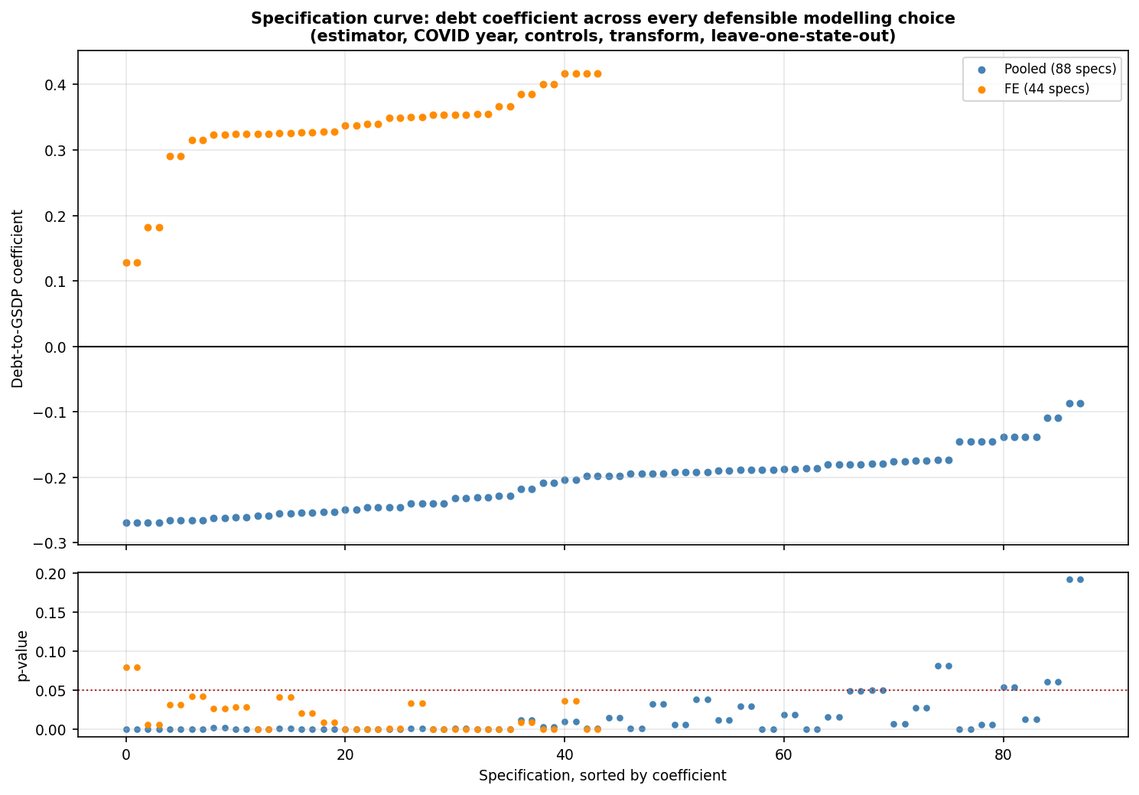
Figure 24. Specification curve for the debt-to-GSDP coefficient across 132 specifications, varying estimator, treatment of the pandemic year, inclusion of Census controls, the transformation of FDI, and the exclusion of each state in turn. Upper panel gives the coefficient, lower panel the p-value; the dotted line marks the 5 per cent level.

Neither the kernel nor the cluster-robust estimator stands on firm ground here. The first is asymptotic in the number of periods, of which there are five; the second in the number of clusters, of which there are ten. Where they disagree the wild cluster bootstrap settles it, and Table 34 reports it for every coefficient the paper uses. Two of its verdicts differ from what Driscoll-Kraay gives. Both are set out below.
The first concerns the growth equation. Under Driscoll-Kraay the fiscal deficit enters negatively at p = 0.031, which would replicate Trivedi and Rajmal (2011) and Panda and Sahay (2022) on newer audited data. It does not survive. Cluster-robust inference puts it at p = 0.310 and the bootstrap at p = 0.448. The coefficient is large but too imprecisely estimated, at fifty observations across ten states, to support a claim. Within the COVID-dummy specification, debt (+1.097, bootstrap p = 0.020) and own tax revenue (+4.083, bootstrap p = 0.028) do clear the bootstrap, and earlier drafts of this work read that as H2 holding through a channel we had not originally proposed. Table 23b withdraws that reading. Once the single COVID dummy is replaced by year fixed effects, own tax revenue is indistinguishable from zero and the debt coefficient reverses to -0.689, so the positive association was tracking the shape of the recovery rather than a fiscal mechanism. No specification of the growth equation survives that substitution with a fiscal effect we are willing to claim in either direction. H2 is not supported by this panel, and the deficit channel in particular is one it cannot speak to.
The second concerns the size of the paper's central result, though not its direction. The pooled debt-FDI coefficient is significant at p = 0.007 under cluster-robust inference and at p = 0.057 under the bootstrap: significant at 10 per cent, marginally short of 5. Two secondary results from the pooled model, literacy (p = 0.235) and capital expenditure (p = 0.095), survive at neither level and we do not rely on them. The evidence that never depended on a standard error is unchanged. Debt is negative in all 88 pooled specifications of the curve above; LASSO and Elastic Net rank it first by a wide margin; SHAP ranks it first in all ten leave-one-state-out refits; the permutation null, permuting whole states, puts the importance margin at p = 0.038. H1 rests on that convergence. The paper was designed to produce it, precisely so the claim would not hang on one p-value.
Table 34. Cluster-robust and wild cluster bootstrap p-values for every coefficient the paper relies on. The bootstrap imposes the null, uses Rademacher weights over the ten states, and is the appropriate reference distribution at this number of clusters.
Coefficient | Estimate | Cluster-robust p | Wild cluster bootstrap p | Significant at 5%
M1 pooled: debt | -0.176 | 0.007 | 0.057 | No
M1 pooled: literacy | +0.101 | 0.035 | 0.235 | No
M1 pooled: capital expenditure | -0.366 | 0.008 | 0.095 | No
M1 within: debt | +0.353 | 0.000 | 0.031 | Yes
M1 within: fiscal deficit | +0.566 | 0.264 | 0.836 | No
M2 within: fiscal deficit | -2.172 | 0.310 | 0.448 | No
M2 within: debt | +1.097 | 0.001 | 0.020 | Yes
M2 within: own tax revenue | +4.083 | 0.045 | 0.028 | Yes
M2 within: COVID dummy | -13.783 | 0.000 | 0.003 | Yes

The model choices behind Section 6 are defended three ways instead of one: by the formal tests where they are valid, including the two that return no verdict; by showing that the inference does not turn on which covariance estimator is used; and by a specification curve in which the cross-state result holds in all 88 specifications. No single test statistic could carry that weight at forty-eight observations. None is asked to.

7. Discussion

7.1 Why debt is negative between states and positive within them
The central puzzle in Section 6.3 is that debt enters Model 1 negative in the pooled cross-state specification and positive in the within-state fixed-effects specification, and that both are estimated precisely enough to take seriously: the pooled coefficient at p = 0.007 under cluster-robust inference and p = 0.057 under the wild cluster bootstrap of Section 6.7, the within-state coefficient at p = 0.031 under that same bootstrap. Both estimates are correct. They answer different questions. The pooled coefficient asks whether a state that persistently carries less debt than its peers attracts more FDI than they do. It does, and the magnitude, roughly 19 per cent more FDI per percentage point of lower debt-to-GSDP, lines up with the discipline ranking of Section 4.7. The two lowest-debt states in the panel, Gujarat and Maharashtra, rank first or second overall in almost every year; the highest-debt state, West Bengal, ranks last in all five. It lines up too with the Spearman correlation of Section 6.2, which turns significant (rho = 0.728, p = 0.026) once the one state whose FDI series is an accounting artefact rather than a genuine low outcome is set aside.
The fixed-effects coefficient asks a different question: when a state's own debt ratio rises above its usual level, does its FDI rise with it? Over this window it does, and not because borrowing attracts investors. Five years is a short series and one of them, FY 2020-21, is a shock common to every state. Deficits and debt rose everywhere at once while FDI fell everywhere; inflows then recovered through FY 2021-22 and FY 2022-23 while debt remained at its elevated pandemic level. Gujarat's FDI rose in FY 2020-21 and Karnataka's in FY 2021-22, both while debt stood above its pre-pandemic ratio. Debt and FDI therefore move together within states over this window for reasons that have little to do with either causing the other, and a five-year panel containing a shock of that size cannot separate them. The within-state estimate is best read as a description of the COVID window rather than as a behavioural relationship.
Because the two dimensions are the whole of the argument, it is worth estimating them inside one equation rather than inferring the contrast from two separate regressions. A Mundlak specification does this: each fiscal regressor enters twice, once as the state's five-year mean and once as the deviation of each year from that mean, so the between-state and within-state coefficients are identified jointly and can be tested against each other directly. It returns exactly the split the paper describes, and the difference between the two debt coefficients is a great deal more precisely estimated than either separate model conveys. A true between estimator, fitted to the ten state means alone, agrees with the pooled coefficient reported in Section 6.3.
Table 35. Debt coefficient in a Mundlak (correlated random effects) specification of Model 1, which separates within-state from between-state variation in a single equation, and in a between estimator fitted to the ten state means. Standard errors clustered by state.
Specification | Debt coefficient | Std. error | p-value | What it identifies
Mundlak: within-state deviation | +0.370 | 0.098 | 0.0002 | Year-to-year movement around a state's own mean
Mundlak: state-mean term | -0.256 | 0.064 | 0.0001 | Differences between states' average debt
Test of equality (within = between) | difference 0.626 | t = 4.65 | 0.017 | The two dimensions are formally distinguishable
Between estimator, ten state means | -0.237 | 0.072 | 0.0217 | Cross-state relationship estimated directly
The sign reversal is therefore not an artefact of comparing two estimators with different assumptions: it survives inside a single equation, and the hypothesis that the within-state and between-state debt coefficients are equal is rejected at p = 0.017 under the same wild cluster bootstrap the rest of the paper defers to, and at p = 0.000003 under a cluster-robust t that Section 6.7 argues is unreliable at ten clusters; the bootstrapped figure is the one we rely on. The between estimator puts the cross-state coefficient at -0.237 against the pooled -0.176 of Section 6.3, so the pooled specification is if anything conservative about the size of the relationship this paper reports. Section 6.1's variance decomposition explains why the two differ so sharply in precision: almost all of the variation in debt is cross-sectional, which leaves the within-state coefficient identified off very little, and Table 23b shows what happens to it once common year shocks are absorbed.
The practical reading we draw is that fiscal discipline works as a structural, between-state signal that investors use to compare states with one another. It is not a lever a single state can pull in one budget year to move its own inflows. A finance department that cuts its deficit by half a percentage point this year should not expect that action alone to shift next year's FDI number. A state that has held debt below 25 per cent of GSDP for five consecutive years is operating in a different competitive tier from one that has not, and the market appears to price that difference.

7.2 Capital expenditure's negative sign
Capital expenditure enters the FDI specification with a negative coefficient, -0.366, significant under cluster-robust inference (p = 0.008) though not under the wild cluster bootstrap of Section 6.7 (p = 0.095). The paper accordingly rests no claim on it. The sign is nonetheless the opposite of what the crowding-in channel of Section 2 predicts, and it is stable enough across the specification curve to be worth explaining rather than dismissed. Two features of the measure account for most of it.
The first is what the variable actually contains. Capital expenditure here is derived as the gross fiscal deficit minus the revenue deficit (Section 4.2), so it includes net lending alongside capital outlay. A state that lends heavily to its public sector undertakings records high capital expenditure without building any of the infrastructure an investor would notice. The measure is therefore a noisy proxy for the productive spending the crowding-in argument has in mind, and the noise is not distributed at random: it concentrates in exactly those states that route the most activity through their undertakings.
The second is that capital expenditure cannot be read independently of how it is financed. A rupee of capital spending funded from a low debt base is a different signal from the same rupee funded by fresh borrowing, and a single coefficient cannot distinguish the two. The SHAP dependence plot in Figure 25 shows the pattern directly. Across the range the panel mostly occupies, roughly 1 to 3 per cent of GSDP, capital expenditure contributes mildly positively to predicted FDI. Above about 3.5 per cent the contribution turns sharply negative, and the state-years in that region are predominantly mid- to high-debt ones. The negative coefficient is therefore not evidence that capital spending deters investment. It reflects the fact that in this panel the highest capital-expenditure ratios are recorded by states carrying the heaviest debt, so the variable is partly picking up the financing position that Section 7.1 shows investors respond to.
This is an interpretation the data support rather than a specification the data can identify. At forty-eight observations an explicit capital-expenditure-by-debt interaction term is not estimable with any useful precision, and none is reported. Separating capital outlay from net lending in the source accounts, which the Finance Accounts permit but at some cost in vintage consistency, is the change most likely to settle the question.
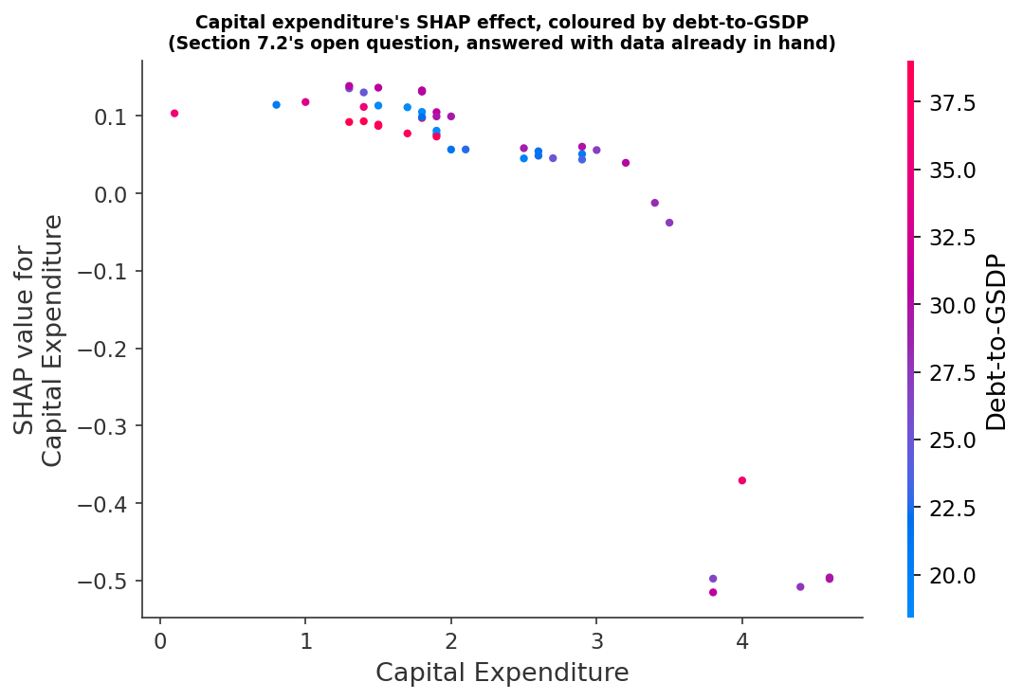
Figure 25. SHAP dependence plot for capital expenditure, coloured by debt-to-GSDP. Horizontal position is the state-year's capital expenditure ratio, vertical position is that observation's contribution to predicted log FDI, and colour is the same observation's debt ratio (red high, blue low).

7.3 The Jharkhand and Uttar Pradesh cases
Jharkhand shows that discipline does not by itself deliver investment. It sits mid-table on the composite ranking, sixth of ten on both constructions of it, with an average yearly rank of 5.7 in Table 16 and a five-year composite score of 4.75 in Table 15, yet its FDI is the most erratic in the panel: a substantial inflow in FY 2019-20, a much smaller one in FY 2020-21, and almost nothing from FY 2021-22 onward. Excluding it moves the within-state estimates more than excluding any other state (Section 6.5), which is why it is discussed separately rather than absorbed into the average. Its trajectory diverges sharply from Gujarat's or Karnataka's, and the reasons are specific rather than fiscal: political turnover, difficulties in the mining sector on which much of its investment case rests, and infrastructure that compares poorly with the states above it. Fiscal prudence appears necessary for a state to be considered; Jharkhand demonstrates that it is not sufficient for a state to be chosen.
Uttar Pradesh is the mirror case, and its anomaly is one of measurement rather than performance. DPIIT's series for the state begins only in FY 2021-22, so its first two cells are missing rather than zero. On fiscal discipline it ranks first of ten on both constructions: a composite score of 3.375 on the five-year averages of Table 15, and an average yearly rank of 2.0 in Table 16, ahead of Maharashtra at 2.3. Whether that censoring distorts the results was tested directly: dropping the state leaves the regression estimates substantially unchanged (Section 6.5), but it does move the Spearman correlation of Section 6.2 from insignificant to significant (rho = 0.728, p = 0.026). That pattern is what one would expect. A regression using forty-eight state-year observations absorbs two missing cells; a rank correlation that compresses each state to a single five-year total does not, because the missing years drag Uttar Pradesh's total down and its rank with it. That reasoning justifies treating Uttar Pradesh's total as incomparable; it does not establish that the state is only an artefact, and testing it directly shows that it is not. Scaling the three observed years to a five-year equivalent gives 12,923 crore, which still leaves Uttar Pradesh ninth of ten, ahead only of West Bengal, and the rank correlation computed with that imputation is rho = 0.359 (p = 0.309). Comparing all ten states only over FY 2021-22 to FY 2023-24, the window in which Uttar Pradesh is actually observed, gives rho = 0.231 (p = 0.521). Under both censoring-consistent treatments the correlation remains insignificant. Uttar Pradesh is therefore a genuine counterexample as well as a censored series: first on the discipline ranking and near the bottom on realised investment even after the missing years are allowed for. The significant rho = 0.728 reported in Section 6.2 depends on excluding it, and Section 6.6 records what that means for the convergence argument.

7.4 What the agglomeration rival hypothesis survives
Section 3 set out the rival explanation: foreign investment follows existing industrial clusters and metropolitan markets, and a state's fiscal position is largely incidental to where it goes. Nothing in this study refutes that hypothesis. The results are better read as locating fiscal discipline within it than as displacing it.
The machine-learning stage speaks most directly to the point, though not in the direction the first run suggested. That run included the two Census controls and ranked urbanisation as the dominant predictor, which would have been a striking vindication of the agglomeration account. It was not one. Urbanisation is fixed within a state across all five years, so the forest was using it to identify which state an observation came from, re-learning the state fixed effect rather than measuring any agglomeration mechanism. The result is an artefact of the panel's shape and carries no evidence about clustering in either direction, which is why Section 5.2 reports it as a diagnostic failure and Section 6.6 excludes both controls. It cannot be cited in support of the rival hypothesis, and it is not cited here. That leaves an obvious objection: excluding urbanisation means the machine-learning branch never had the chance to prefer agglomeration, so its convergence on debt is partly a consequence of what it was shown. We therefore reran the branch once with both Census controls restored and under the state-blocked cross-validation of Section 5.2, rather than the row-wise scheme the original seven-variable run used, and report it here as a comparison rather than only as a diagnosed failure. Given the chance, the two methods split. LASSO still ranks debt-to-GSDP first by a wide margin, at -0.930 against +0.486 for literacy and +0.251 for urbanisation, so the regularised linear selector prefers the fiscal variable even with the agglomeration proxies in front of it. The random forest still ranks urbanisation first, at 1.296 against 0.254 for debt, which is the fingerprinting problem restated rather than evidence about clustering, since urbanisation remains constant within a state across all five years and the forest has ten states to tell apart. The claim this paper rests on is the narrower one that survives both: the pooled regression retains literacy and urbanisation as controls and the debt coefficient survives their inclusion.
What the corrected analysis does show is that once attention is restricted to variation this panel can actually speak to, debt ranks first among the fiscal predictors in both the pooled and the state-demeaned specifications (Section 6.6). The pooled regression retains literacy and urbanisation as controls and the debt coefficient survives their inclusion, so the cross-state result is not merely a restatement of which states are already developed and urbanised.
The reading we take is that the two accounts operate at different levels rather than in competition. Structural advantages — location, port access, an established industrial base, the depth of a metropolitan labour market — determine which states are candidates for large inflows at all, and the ten states in this sample are precisely those that have already cleared that bar. Fiscal position then appears to sort investment among them. That is consistent with the between-state result of Section 7.1, and it is also why the finding should not be extrapolated: it describes how capital is allocated among states already in contention, not how a state enters contention in the first place. Section 8 returns to this as the study's principal limit on external validity. One further alternative explanation sits closer to this one than to the measurement notes of Section 8, and we state it here rather than there. DPIIT records equity inflows against the state in which the recipient company is registered, not the state in which the investment is deployed. That error is not classical: it concentrates in the states hosting corporate headquarters, which in this panel are Maharashtra, Karnataka and Gujarat, and those are also three of the lowest-debt states. A registered-office effect would therefore push the between-state coefficient in exactly the direction we report, and nothing in this design separates it from a fiscal signal. It is, alongside agglomeration, the alternative account we regard as most likely to survive scrutiny of the central result.

8. Conclusion, Policy Implications and Limitations
Foreign Direct Investment in India is more likely where a state holds its debt down relative to its own economy, but that relationship holds only between states, not within a single state from one year to the next. Gujarat and Maharashtra, which have kept debt low relative to GSDP throughout the panel, receive substantially more FDI than states that have not. Five methods agree on it, drawn from three families that share no distributional assumptions with one another: a parametric panel regression, a rank correlation, and regularised linear and tree-based machine-learning estimators. Within those families LASSO and Elastic Net are close relatives rather than separate tests, and we count them as one verdict. States carrying less debt attract more investment.
Within states over time, the picture is different and narrower than we first supposed, and narrower again than an intermediate draft of this paper reported. Under a specification that controls for the pandemic with a single dummy, higher debt and stronger own tax revenue both appear significantly associated with growth. Neither survives the substitution of that dummy for a full set of year fixed effects: own tax revenue goes to zero and debt reverses sign (Table 23b). The association was tracking the common shape of the post-pandemic recovery, in which every state's growth rebounded while debt stayed above its pre-pandemic level. The fiscal deficit fares no better: its coefficient is large and negative under the Driscoll-Kraay standard errors conventional in this literature, but it does not survive a wild cluster bootstrap appropriate to ten clusters. We therefore report H2 as unsupported. That is a departure from Trivedi and Rajmal (2011) and Panda and Sahay (2022), who find a deficit-growth effect on longer panels of more states; we read our result as a limit of a five-year panel of ten states in which ninety-eight per cent of the variation in growth is within states and almost all of it is common to them, rather than as a contradiction of theirs. The substantive finding that does hold is the distinction between dimensions in the investment equation: comparing states with one another, debt predicts FDI; following a single state across five years, it does not. Investors appear to price a state's standing fiscal position rather than any single year's budget arithmetic. Section 7.1 develops the point, and notes that a window containing the pandemic is the least favourable setting in which to test it.
State finance departments should weigh three things. First, the payoff is not immediate: a state building a reputation for discipline is making an investment that pays off over several years, not a single budget cycle, and should not expect a small debt reduction to move investment inflows right away. Second, of the available fiscal metrics, debt is the one this paper's evidence points to as easiest to communicate and verify, and it is the stock of debt rather than any single year's addition to it that appears to matter for investment. We attach no growth recommendation to any of the four indicators, because Section 6.5 shows this panel cannot identify a fiscal effect on growth once common year shocks are absorbed. Third, how capital expenditure is financed matters as much as its level: spending funded from existing revenue is a different signal to an investor than the same spending funded by fresh borrowing.
A state needs to understand what its own accounts are saying. For groups like the Finance Commission, NITI Aayog and investment-promotion bodies there is a lesson. Rankings of states by discipline are only useful if they can be connected to real outcomes, like investment and growth. Otherwise these rankings are numbers. It would be better to report these rankings alongside outcomes like how much investment a state receives or how fast it grows. This would make it possible to test and improve the rankings. We did this with our ranking, which is explained in detail so anyone can understand and challenge it. We also tested our ranking, against outcomes and reported the results even when they were not what we expected. Jharkhand is a caution against reading any ranking mechanically. It sits mid-table on discipline and near the bottom on realised investment, and its trajectory does real work in the within-state estimates. Discipline appears necessary; Jharkhand demonstrates that it is not sufficient. A state government that improves its fiscal position without addressing the sector-specific and region-specific frictions an investor also weighs, whether infrastructure gaps, land and clearance processes, or the particular investment cycle of a dominant industry, should not expect FDI to follow automatically. The reverse caution applies to Uttar Pradesh, whose apparent weakness on the investment side is an artefact of when DPIIT began reporting its series rather than a statement about the state.
Five limitations bound these conclusions, and the first is simply arithmetic. The panel is short: fifty state-year cells, forty-eight of them with a usable FDI observation. That is why the paper leans on convergent machine-learning and rank-correlation evidence instead of the regression p-values alone, and why instrument-heavy dynamic panel GMM was excluded by design at this N and T (Roodman, 2009). A short panel also means that any single influential year or state can move a coefficient materially, which is precisely what Section 6.5 documents for Jharkhand.
Second, the way FDI is recorded is imperfect. The DPIIT state-by-state series starts in October 2019, so FY 2019-20 covers only six months rather than a full year, and Uttar Pradesh is missing entirely until FY 2021-22; Section 6.5 addresses both directly and neither can be corrected retroactively. A further measurement problem affects the FDI series generally: equity inflows are recorded against the state where the recipient company is registered, not necessarily the state where the investment is actually deployed, which can inflate the recorded flows to states that host corporate headquarters.
Third, the debt measure used here is the on-budget figure from the CAG-audited finance accounts, and excludes off-budget borrowings and guarantees, estimated at roughly 14 to 15 per cent of GSDP for Telangana — large enough to change the picture of a state's real fiscal exposure. Because the paper's central result concerns debt, this is the limitation most likely to affect the size of the estimated effect, though not, ex ante, its direction: if off-budget exposure is concentrated in states that already carry high on-budget debt, including it would widen the gap and strengthen the result; if it is concentrated in low-debt states instead, it would narrow the gap and weaken it.
Fourth, association is all that a five-year panel of ten states can support. Reverse causality, in which anticipated investment changes a state's fiscal behaviour rather than the other way round, cannot be ruled out by this design. Nor can the sample speak to states outside the top ten. The ten states studied here are the ten that already receive almost all of India's FDI, so the result should be read as describing how investment is sorted among states that are already candidates for it, not as a claim that a low-FDI state can enter that group by consolidating its balance sheet alone. Section 7.4 argues that agglomeration and fiscal discipline plausibly operate at those two different levels, and nothing in this design can separate them fully.
Fifth, the design controls for a state's fixed structural position through entity fixed effects and, in the pooled specification, literacy and urbanisation, and Table 23b adds a full set of year effects that absorb whatever the ten states experience in common in a given year. What remains uncontrolled is the shock that varies by year and by state at once: an infrastructure project completed mid-panel, a shift in one state's labour-market conditions, a change in political leadership. Any such shock is left in the error term rather than modelled directly, and could in principle be correlated with both a state's fiscal choices and its FDI in a way neither state nor year effects can absorb.
It is worth stating what would change this conclusion, since a finding that cannot be overturned is not much of a finding. Three observations would do it. A longer panel in which the between-state debt coefficient loses significance once further post-pandemic years are added would indicate that the present result is a feature of the COVID window rather than a standing relationship. A debt measure extended to include off-budget guarantees that reversed the ranking of the high-debt and low-debt groups would undercut the interpretation even if the coefficient survived. And a specification in which a direct agglomeration measure, rather than the Census proxy used here, absorbed the debt effect entirely would support the rival hypothesis of Section 3 over the reading offered in Section 7.4.
Three extensions follow from those limits. A longer panel, once further post-pandemic years have been audited, would show whether the within-state debt coefficient settles at the between-state sign as FY 2020-21 loses weight in the estimation window. The present data already point that way: restricted to FY 2021-22 onward and estimated with year effects, the within-state coefficient is -0.452 with a bootstrap p of 0.075 (Section 6.5), but thirty observations is too thin a base to do more than motivate the test. Adding off-budget guarantees to the debt measure, and interacting capital expenditure with its financing source, are the two specification changes that Section 7.2 and the limitations above point to most directly. Beyond this sample, the natural test of external validity is to extend the panel below the top ten, where the variation in both fiscal position and investment is wider and the agglomeration floor is lower, and to ask whether the same convergence across methods survives outside the group of states that were always going to receive the capital.

Data and Code Availability
The complete dataset, analysis code, results and this manuscript are openly available at https://github.com/fbivinay/Fiscal-Discipline-and-Investment-Outcomes The repository contains the audited source series, the 50-row analysis panel used in every estimate reported here, all five analysis scripts, and the full set of tables and figures, so that each result can be reproduced from the raw inputs. It also retains the superseded seven-variable machine-learning run discussed in Section 5.2, so that the leakage diagnosis reported there can be verified rather than taken on trust.

References
Arellano, M., & Bond, S. (1991). Some tests of specification for panel data: Monte Carlo evidence and an application to employment equations. Review of Economic Studies, 58(2), 277-297. https://doi.org/10.2307/2297968
Athey, S., & Imbens, G. W. (2019). Machine learning methods that economists should know about. Annual Review of Economics, 11, 685-725. https://doi.org/10.1146/annurev-economics-080217-053433
Baltagi, B. H. (2021). Econometric analysis of panel data (6th ed.). Springer. https://doi.org/10.1007/978-3-030-53953-5
Barro, R. J. (1990). Government spending in a simple model of endogenous growth. Journal of Political Economy, 98(5, Pt. 2), S103-S125. https://doi.org/10.1086/261726
Blonigen, B. A. (2005). A review of the empirical literature on FDI determinants. Atlantic Economic Journal, 33(4), 383-403. https://doi.org/10.1007/s11293-005-2868-9
Borensztein, E., De Gregorio, J., & Lee, J.-W. (1998). How does foreign direct investment affect economic growth? Journal of International Economics, 45(1), 115-135. https://doi.org/10.1016/S0022-1996(97)00033-0
Breiman, L. (2001). Random forests. Machine Learning, 45(1), 5-32. https://doi.org/10.1023/A:1010933404324
Cameron, A. C., Gelbach, J. B., & Miller, D. L. (2008). Bootstrap-based improvements for inference with clustered errors. Review of Economics and Statistics, 90(3), 414-427. https://doi.org/10.1162/rest.90.3.414
Department for Promotion of Industry and Internal Trade (DPIIT). (2024). State-wise FDI equity inflows (from October 2019). Ministry of Commerce and Industry, Government of India. https://dpiit.gov.in
Driscoll, J. C., & Kraay, A. C. (1998). Consistent covariance matrix estimation with spatially dependent panel data. Review of Economics and Statistics, 80(4), 549-560. https://doi.org/10.1162/003465398557825
Drukker, D. M. (2003). Testing for serial correlation in linear panel-data models. Stata Journal, 3(2), 168-177. https://doi.org/10.1177/1536867X0300300206
Dunning, J. H. (1993). Multinational enterprises and the global economy. Addison-Wesley. https://archive.org/details/multinationalent0000dunn
Feld, L. P., Köhler, E. A., Palhuca, L., & Schaltegger, C. A. (2024). Fiscal federalism and foreign direct investment: An empirical analysis. The World Economy, 47(6), 2287-2331. https://doi.org/10.1111/twec.13547
Fischer, S. (1993). The role of macroeconomic factors in growth. Journal of Monetary Economics, 32(3), 485-512. https://doi.org/10.1016/0304-3932(93)90027-D
Government of India. (2025). Report of the Sixteenth Finance Commission, Volume II: Annexures. Ministry of Finance. https://indiabudget.gov.in/doc/16fcvol2.pdf
Hastie, T., Tibshirani, R., & Friedman, J. (2009). The elements of statistical learning: Data mining, inference, and prediction (2nd ed.). Springer. https://doi.org/10.1007/978-0-387-84858-7
Hausman, J. A. (1978). Specification tests in econometrics. Econometrica, 46(6), 1251-1271. https://doi.org/10.2307/1913827
International Monetary Fund. (2020). World economic outlook, April 2020: The great lockdown. IMF. https://www.imf.org/en/publications/weo/issues/2020/04/14/weo-april-2020
Lundberg, S. M., & Lee, S.-I. (2017). A unified approach to interpreting model predictions. Advances in Neural Information Processing Systems, 30, 4765-4774. https://arxiv.org/abs/1705.07874
Mahatekar, D. D. (2025). State-wise foreign direct investment (FDI) flows and economic impacts in India: A comparative study (2019-2024). JETIR, 12(10). https://www.jetir.org/papers/JETIR2510525.pdf
Meinshausen, N., & Bühlmann, P. (2010). Stability selection. Journal of the Royal Statistical Society: Series B (Statistical Methodology), 72(4), 417-473. https://doi.org/10.1111/j.1467-9868.2010.00740.x
Ministry of Statistics and Programme Implementation (MoSPI). (2024). State-wise Gross State Domestic Product, 2011-12 series. Government of India. https://mospi.gov.in
Misra, S., Gupta, K., & Trivedi, P. (2023). Sub-national government debt sustainability in India: An empirical analysis. Macroeconomics and Finance in Emerging Market Economies, 16(1), 57-79. https://doi.org/10.1080/17520843.2021.1948171
Mullainathan, S., & Spiess, J. (2017). Machine learning: An applied econometric approach. Journal of Economic Perspectives, 31(2), 87-106. https://doi.org/10.1257/jep.31.2.87
National Institute of Public Finance and Policy (NIPFP). (2024). How much debt is optimal for the major Indian states? Economic growth vs. debt sustainability (Working Paper No. 411). https://nipfp.org.in/media/documents/WP_411_2024.pdf
NITI Aayog. (2025). Fiscal Health Index 2025. Government of India. https://niti.gov.in
NITI Aayog. (2026). Fiscal Health Index 2026. Government of India. https://niti.gov.in
Oates, W. E. (1972). Fiscal federalism. Harcourt Brace Jovanovich. https://archive.org/details/fiscalfederalism0000oate
O'Brien, R. M. (2007). A caution regarding rules of thumb for variance inflation factors. Quality & Quantity, 41(5), 673-690. https://doi.org/10.1007/s11135-006-9018-6
Office of the Registrar General & Census Commissioner, India. (2011). Census of India 2011, primary census abstract. Ministry of Home Affairs, Government of India. https://censusindia.gov.in
Panda, M., & Sahay, S. (2022). Determinants of economic growth across states in India. In S. R. Hashim, R. Mukherji, & B. Mishra (Eds.), Perspectives on inclusive policies for development in India (pp. 133-152). Springer. https://doi.org/10.1007/978-981-19-0185-0_8
Pesaran, M. H. (2015). Testing weak cross-sectional dependence in large panels. Econometric Reviews, 34(6-10), 1089-1117. https://doi.org/10.1080/07474938.2014.956623
Rao, M. G., & Singh, N. (2005). The political economy of federalism in India. Oxford University Press. https://academic.oup.com/book/36234
Reserve Bank of India. (2024). State finances: A study of budgets, 2023-24. RBI. https://rbi.org.in
Roodman, D. (2009). How to do xtabond2: An introduction to difference and system GMM in Stata. Stata Journal, 9(1), 86-136. https://doi.org/10.1177/1536867X0900900106
Spearman, C. (1904). The proof and measurement of association between two things. American Journal of Psychology, 15(1), 72-101. https://doi.org/10.2307/1412159
Tibshirani, R. (1996). Regression shrinkage and selection via the lasso. Journal of the Royal Statistical Society, Series B, 58(1), 267-288. https://doi.org/10.1111/j.2517-6161.1996.tb02080.x
Tiebout, C. M. (1956). A pure theory of local expenditures. Journal of Political Economy, 64(5), 416-424. https://doi.org/10.1086/257839
Trivedi, P., & Rajmal. (2011). Growth effects of fiscal policy of Indian states. Millennial Asia, 2(2), 141-162. https://doi.org/10.1177/097639961100200201
Varian, H. R. (2014). Big data: New tricks for econometrics. Journal of Economic Perspectives, 28(2), 3-28. https://doi.org/10.1257/jep.28.2.3
Wooldridge, J. M. (2010). Econometric analysis of cross section and panel data (2nd ed.). MIT Press. https://mitpress.mit.edu/9780262232586/econometric-analysis-of-cross-section-and-panel-data/
Zou, H., & Hastie, T. (2005). Regularization and variable selection via the elastic net. Journal of the Royal Statistical Society, Series B, 67(2), 301-320. https://doi.org/10.1111/j.1467-9868.2005.00503.x

