**Introduction**

**Selenium IDE** is a portable software-testing tool for web applications It is open-source Firefox add-on, web developers and testers can download and use it without charge.

Not only supporting record & playback function, Selenium IDE also offers other features: scripting, debugging, reporting, etc. With the full set of most common functions, Selenium IDE is a complete tool for testers to save their time working on the testing project.



This Extension was the champion project of Katalon Studio Hackathons contest. Katalon Automation Recorder was developed to support users who no longer be able to record and playback automation tests using the obsolete Selenium IDE or users of popular open source frameworks looking for a handy recorder.

**Prerequisites**

Having installed katalon tool on Firefox browser

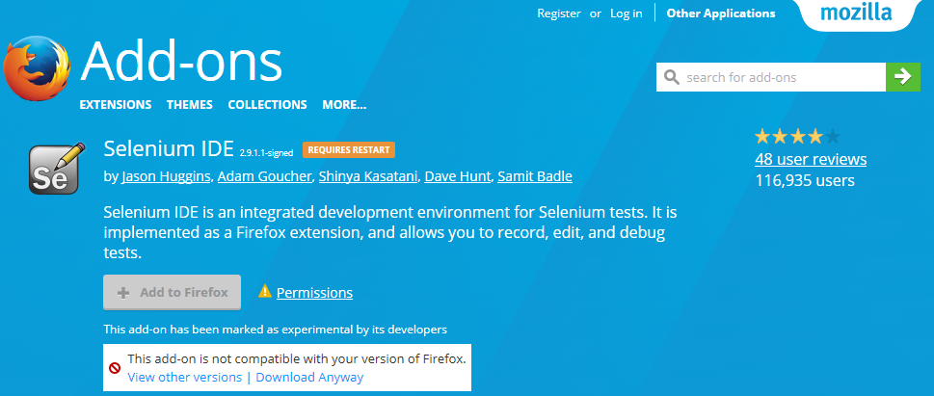

**How to install it ?**

**Katalon Automation Recorder**extension for [**Chrome**](https://chrome.google.com/webstore/detail/katalon-automation-record/ljdobmomdgdljniojadhoplhkpialdid?utm_source=chrome-ntp-icon)and [**Firefox**](https://addons.mozilla.org/en-US/firefox/addon/katalon-automation-record/) has been introduced by Katalon Studio team.

Firefox: <https://addons.mozilla.org/en-US/firefox/addon/katalon-automation-record/>



**How to record a new test case?**

1.-Open your Katalon add on



2.- Create a new test case and click  "OK"

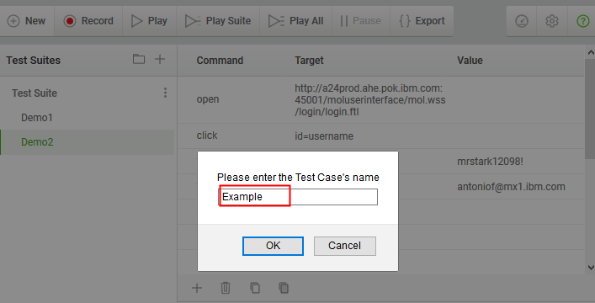

3.-Open your Web application that you want to start recording and test

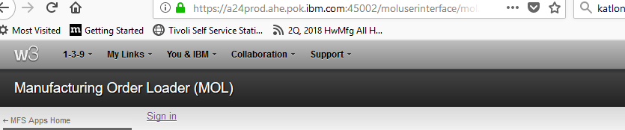

4.- start recording and start the magic

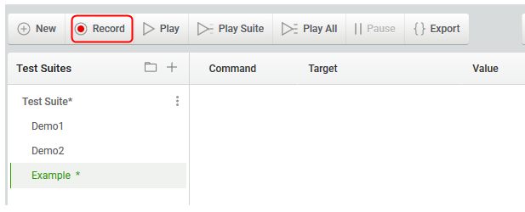

Steps recorded

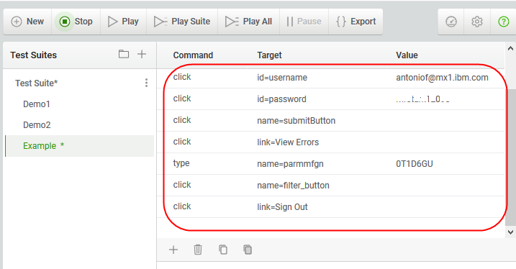

5.- Run your automated test case

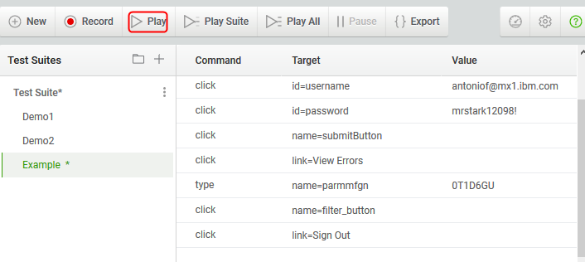

Successful execution

