YAML

NAME ANA 515 Assignment 2

2022

answer:1 the content of the data set is with respect to states. content are the columns 1) Number of drivers involved in fatal collisions per billion miles 2) Percentage of drivers involved in fatal collisions who were spending 3) percentage of drivers involved in fatal collisions who were alcohol-impaired 4) percentage of drivers involved in fatal collisions who were not distracted 5) percentage of drivers involved in fatal collisions who had not been involved in any previous accidents 6) Car Insurance premiums 7) losses incurred by insurance companies for collisions per insured driver

all the variables are giving us a discrete numerical values which mean the quantitative variables it was collected from the traffic police the data was saved in comma separated values(csv) format delimited the comma was used for delimiters and we normally used to excel to open a csv file. the data is not in binary format its a quantitative dataset.

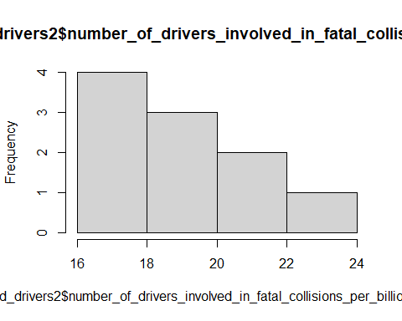

plot(bad_drivers2$car_insurance_premiums,bad_drivers2$number_of_drivers_involved_in_fatal_collisions_per_billion_miles)

