INITIATION OF COVERAGE · CAPSTONE US EQUITIES · 16 SEPTEMBER 2026
TER · Teradyne, Inc.
Test is the one part of semiconductor capital equipment whose share of the wallet is rising, and Teradyne is the cleanest way to own it: 70% AI-driven, the leader in memory test, a dual-sourcing wave running in its favour at the two largest compute pools, and a target model that the company is about to rewrite upward in February. We agree with all of that, and our earnings sit above the Street. We initiate at NEUTRAL with a $400 target because the price already pays for it: the probability-weighted return is roughly the cost of equity, the DCF does not cover the share price on any through-cycle margin, and 2027 is the year test lags wafer-fab equipment, on management's own arithmetic.

RATING  NEUTRAL | PRICE (09-16)  $341.15 | 12-MO TARGET  $400 (+17%) | MKT CAP / EV  $53.3bn / $52.8bn | CY28E EPS CAPSTONE / STREET  $15.99 / $14.77 | CY26E REV / EPS (CAPSTONE)  $5.13bn / $9.03

Investment summary
We initiate on Teradyne at NEUTRAL with a 12-month price target of $400 (+17%), 25x our CY28E EPS of $15.99. Teradyne is the number-two automated-test-equipment (ATE) vendor in a two-company market, the leader in memory test, and the company whose own numbers best describe why test is now growing faster than the fabs it serves: test equipment was about 4% of total semiconductor capex in 2023, 7% in 2025 and 8% in the first five months of 2026 (Greg Smith, Q2 CY26 call, 2026-07-29). Revenue doubled year on year in the June quarter, both halves of 2026 will be records, and the second half that the Street had modelled as an air pocket (-15% q/q) was guided down only 6%. Our base case lands within 1% of consensus on CY27 revenue and 2% above it on CY28, with EPS +4% and +8% above the Street on operating leverage that management has told us to expect. Our caution is the price, not the company. At $341 the stock trades on 30x Street CY27E and 23x CY28E after a 30% drawdown from the June peak; our bull case is worth $505 and our bear case $205, and the probability-weighted value of $378 is 11% above the price, which is roughly Teradyne's cost of equity (CAPM 10.9% on a 1.34 beta). The Bloomberg consensus target is $451 (13 Buy, 6 Hold, 0 Sell); our target sits at the low end of the published range ($390-550), alongside Morgan Stanley's $397 Equal-weight and TD Cowen's $400; BofA cut to $450 (31x CY28E) on 29 July and UBS's desk relayed $500 on 25 July.
Four things we believe that are not consensus. (1) The Street's revenue line is right and its earnings line is low: consensus carries CY28 operating margin at 36%; we carry 38% because management has said opex will grow at less than half the rate of revenue (CEO, GS Communacopia small group, 2026-09-09, per the GS compile of 2026-09-13) and the March-2026 quarter already ran at 37.5%. (2) 2027 is the year test lags the fab. Management has said the ATE share of capex 'could revert down to 6%, 7% or so' next year because fab tools are paid for a year before wafers appear; on our bridge the ATE TAM grows 18% in 2027 while wafer-fab equipment grows 30-43% (UBS $225bn, MS $223bn). Teradyne will look like a relative laggard against Lam, KLA and Applied in the 2027 prints while trading at a premium to them. (3) The share story is real but slow: the merchant-GPU path is '3-5 years toward roughly 30% of the compute portion' and the second hyperscaler ramps 'in 10/20/30-point increments' (CEO, GS Communacopia small group, 2026-09-09); IR trimmed UBS's 500bp 2026 share-gain arithmetic to 300-400bp (2026-08-03). We model +120bp in 2027 and +150bp in 2028. (4) Cash is about to become the debate: with no debt, $1.6bn of free cash flow in CY27 and $2.1bn in CY28, cash reaches $3.6bn by end-2028 at the current $400m-a-year buyback pace. Management is holding it as 'dry powder' for MLTP-sized deals; a return to the FY25 repurchase pace ($702m; FY24 $199m, FY23 $401m per the 10-Ks) would add ~0.5% a year to EPS versus our $400-450m, and $1bn a year ~1%.
What would make us Buyers (dated): the new target earnings model at the Q4 call in early February 2027 framing the ATE TAM at or above $20bn with mid-single-digit annual share gains (management's own words) and an operating-margin structure above 38%; a Q4-26 guide that holds the December quarter flat with September, which would put the 2027 'resurgence' on a higher base; evidence that the 2027 test-to-capex ratio is holding at 7.5% or better (the Advantest and Teradyne TAM slides in late January and July 2027); or a pullback toward $330, where the base case offers 21% and the probability-weighted return exceeds 15%. What would make us Sellers: a Q4 guide below $1.15bn, memory test orders rolling over (book-to-bill was 2.0 in June), a customer of the two that specify more than 10% of revenue moving a socket back to Advantest, or the ratio printing below 7% for 2027.
Capstone estimates vs the Street
US$m except per share | CY25A | CY26E Capstone | CY26E Street | CY27E Capstone | CY27E Street | CY28E Capstone / Street
Revenue | 3,190 | 5,126 | 5,066 | 6,220 | 6,237 | 7,694 / 7,543
y/y growth | +13% | 61% | 59% | 21% | 23% | 24% / 21%
of which Semiconductor Test | 2,524 | 4,320 | n/a | 5,295 | n/a | 6,639 / n/a
Non-GAAP gross margin | 58.2% | 59.5% | 59.4% | 59.5% | 59.5% | 60.2% / 59.7%
Non-GAAP operating margin | ~22% | 32.2% | 32.7% | 34.8% | 34.4% | 38.0% / 36.1%
Non-GAAP EPS | $3.97 | $9.03 | $8.84 | $11.92 | $11.45 | $15.99 / $14.77
Capstone vs Street |  | +2.1% |  | +4.1% |  | +8.3%
Free cash flow | 450 | 1,136 | n/a | 1,579 | n/a | 2,139 / n/a
Capex | 224 | 355 | 282 | 380 | 353 | 430 / 429
P/E at $341 | 86x | 37.8x | 38.6x | 28.6x | 29.8x | 21.3x / 23.1x
Sources: company 10-K FY25 (2026-02-19), 10-Q Q2 FY26 (2026-07-31), press release and call (2026-07-28/29); Bloomberg BEst consensus pulled 2026-09-16 (18 estimates for CY26-27, 11 for CY28; Teradyne's fiscal year is the calendar year). Blue cells = Capstone. Non-GAAP as the company defines it (excludes acquired-intangible amortisation, restructuring, ERP costs and equity-method amortisation; stock compensation is NOT excluded). Street operating margin = BEst EBIT / sales. CY25A operating margin is the revenue-weighted average of the four quarterly non-GAAP figures (20.5% / 15.1% / 20.4% / 29.0%).

TER · THE COMPANY SECTION 2 / 10
What Teradyne is, and how a mobile-test cyclical became an AI-test compounder
Three segments, one thesis: everything Teradyne sells is bought when a chip, a drive, a board or a rack has to be proven good before it ships. In 2026 more than 60% of that demand is AI.
Teradyne designs and builds the machines that test semiconductors and the systems they go into. Semiconductor Test (79% of FY25 revenue, 84% of the June quarter) sells system-on-chip testers (UltraFLEX and UltraFLEXplus, J750, Eagle), memory testers (Magnum, the platform behind its HBM and DRAM leadership) and Integrated System Test (IST: storage and system-level testers for hard drives, SSDs and complex compute) to foundries, OSATs, IDMs, memory makers and, increasingly, to the hyperscalers and fabless designers who specify the tester even when a subcontractor buys it. Product Test (11%) is a portfolio of defence and aerospace test, production board test (the new Omnyx platform aimed at AI server boards), LitePoint wireless test, Quantifi Photonics silicon-photonics instrumentation (acquired May 2025, $127m) and the MultiLane Test Products high-speed interconnect JV (75%, closed April 2026). Robotics (10%) is Universal Robots (cobots) and Mobile Industrial Robots (autonomous mobile robots), bought in 2015 and 2018, restructured in 2025 (about 400 employees) and now growing again with electronics manufacturing as its largest vertical (10-K FY25; 10-Q Q2 FY26; Q2 CY26 call).
The mix has been rebuilt in eighteen months. In 2023 Teradyne was a mobile-and-industrial test company waiting for a smartphone recovery; AI was a networking niche. AI-related demand was ~50% of revenue in the September-2025 quarter, >60% in December, ~70% in March 2026 and >60% in June (calls, 2025-10-29 to 2026-07-29). Compute is now 70% of SoC product revenue and grew ~600% year on year in the June quarter; memory test has printed three straight quarters above $200m with a book-to-bill over 2x; IST grew 2.5x quarter on quarter on hard-drive demand from 'all three major suppliers' (Q2 CY26 call). Revenue in 2026 will be roughly 1.4x the 2021 cyclical peak and EPS roughly 1.6x, on a share count 26% smaller than in 2015 (Exhibit 1). The company's own evergreen target model, published in February 2026 ($6bn revenue, 59-61% gross margin, $9.50-11.00 EPS on a $12-14bn ATE TAM), will be reached in 2026 on EPS and in 2027 on revenue, and management has said it will publish a new one at the Q4 call. One transaction distorts the FY24-FY25 comparison: in May 2024 Teradyne sold its Device Interface Solutions (DIS) business to Technoprobe for $85m as part of the 10% stake purchase, booking a $57.1m pre-tax gain in FY24 and giving up ~$55m of annual service revenue (10-K FY24; 10-K FY25).
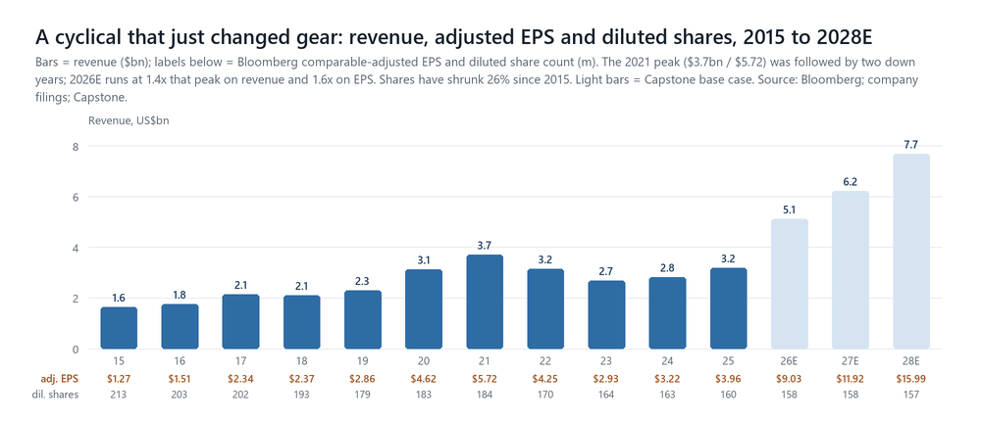
Exhibit 1. Bloomberg comparable-adjusted EPS to 2025; Capstone base case 2026-28. Calendar years.
Segments, customers and footprint
Segment | FY25 revenue $m | FY25 pre-tax $m | 1H26 revenue $m | What it is and what is moving
Semiconductor Test | 2,524 | 701 (27.8%) | 2,233 | SoC $1,890m / Memory $505m / IST $129m in FY25. Compute = 70% of SoC; memory record $212m in Q2 (HBM + DRAM + a NAND resurgence); IST +94% y/y on HDD. Two customers specified >10% of FY25 revenue (12%, 10%) and one direct purchaser took 19%.
Product Test | 358 | 61 (17.0%) | 187 | Defence/aerospace (the largest piece), production board test (Omnyx, shipping since Q2), LitePoint wireless (best Q2 in 3-4 years), Quantifi Photonics (PIC/CPO test), MLTP JV (copper interconnect). Highest gross margin of the three groups (IR, 2026-08-03).
Robotics | 308 | (99) loss | 191 | Universal Robots + MiR. FY25 -15% with a $99m pre-tax loss; 1H26 +33% y/y and 'nearly break even' after the 2025 restructuring; electronics manufacturing/semis the largest vertical (+50% q/q in Q2); a 'marquee' customer tripling revenue in 2026 and again in 2027; US plant opens later in 2026.
Source: 10-K FY25 Note V (segment income before taxes excludes corporate items); 10-Q Q2 FY26; Q2 CY26 call; GS Communacopia CEO small group (2026-09-09; GS compile 2026-09-13; management source). The marquee-customer tripling is one account, not the segment.
- Customers and concentration. The five largest direct customers were 44% of FY25 revenue (36% in 2024, 32% in 2023). Teradyne distinguishes the 'specifying' customer (the OEM, IDM or fabless designer who chooses the platform) from the 'purchasing' customer (usually an OSAT): in 2025 two specifiers drove 12% and 10% of revenue and one direct purchaser accounted for 19%, partly overlapping, and none is named (10-K FY25). The prior filings did name them: Samsung was 12.5% of 2024 revenue (direct plus OSAT sales, Semiconductor and Wireless Test) and Texas Instruments 10% of 2023 (10-K FY24). No customer is named on the calls; the wiki's attributions of the hyperscaler and merchant-GPU accounts to Amazon, Google and NVIDIA are sell-side inference (UBS, JPM), not company disclosure. Geography follows the OSATs: Taiwan 40%, Korea 20%, China 12%, United States 7% of June-quarter revenue (10-Q); 89% of FY25 revenue was outside the US.
- Footprint and balance sheet. About 6,600 employees, 2,200 in the US, with the largest offshore populations in the Philippines (19%), Denmark (10%, robotics), Costa Rica, China and Taiwan; manufacturing is largely outsourced to contract manufacturers, with a dual-source set-up Citi describes as having 'about 2x capacity headroom' (Citi, 2026-05-21). Cash and investments of $517m, no debt (the $200m drawn on the $750m revolver at December was repaid), a 10% stake in probe-card maker Technoprobe carried at $515m, and $617m left on the $2.0bn January-2023 buyback authorisation after $1.38bn used at an average $113.52 (10-Q Q2 FY26). H1 FY26 free cash flow was $579m (+150% y/y) on $734m of operating cash flow; the June quarter alone generated $378m.
- Management. Greg Smith (President and CEO since February 2023; the 10-K exhibit list carries his termination-benefits agreement dated 31 January 2023) and Michelle Turner (CFO since November 2025, succeeding Sanjay Mehta per the Q3 FY25 call; Amy McAndrews runs investor relations). The style is conservative on guidance (Section 8: ten of ten quarters at or above the midpoint) and explicit about what it does not know: 'we don't have meaningful commitment from customers around what they'll buy and when' (Smith, 2026-04-29, per the third-party call summary on file); on the test-to-capex ratio, 'the real answer is we don't know… I would plan for 7 to 9%' (McAndrews, 2026-08-03).

TER · THE SET-UP SECTION 3 / 10
The ATE market: a duopoly whose TAM is now written as a share of the fab
Two vendors, one denominator. The whole debate about Teradyne reduces to two numbers: the test share of semiconductor capex, and Teradyne's share of test.
The structure. Automated test is a two-company market. Advantest (6857 JP) is number one, with SoC tester share 'in the high-60% range' in 2025 (Advantest Q3 FY-Mar-26 call, 2026-01-28) and NVIDIA disclosed for the first time as a 20.2% customer in its FY-Mar-26 securities report (per an X relay of the Japanese filing, not read directly; the arithmetic ties to the reported top line); Teradyne is number two, with total test share of roughly 37% 'up just a touch, but still basically flat' in 2026 on UBS's arithmetic put to management on the July call (Arcuri, 2026-07-29). Cohu, SPEA and a set of Chinese entrants (AccoTEST, Hoson, Grand Tech) are the tail. The two leaders split the market by heritage: Advantest at the GPU and HPC leaders through its NVIDIA franchise and the Verigy acquisition, Teradyne at mobile (Apple, per channel checks), networking (very high share at both large networking silicon vendors, sole-sourced at one), memory (HBM and DRAM leadership, roughly 50% of HBM test on TD Cowen's estimate) and, since 2024, at the first hyperscaler's custom silicon, where it now has about 70% share (CEO, GS Communacopia small group, 2026-09-09). The Taiwan supply-chain view a year ago was that GPU test 'stays Advantest', Teradyne being 'best for mobile' (StoneX / John Su, 2025-08-20); the two companies' 2026 calls describe a different market, in which the customers themselves are forcing dual sourcing.
The denominator. Both companies now frame the ATE TAM off semiconductor capex rather than off unit volumes. Teradyne's version: test equipment was 'down near 4% of the total CapEx' in 2023, 7% in 2025 and 8% in the first five months of 2026; it should 'settle somewhere in the 7% to 9% range… could settle down in the 7% to 8%, but it could go up to 9%', and 'after more than a decade of semi-cap equipment outgrowing the test TAM, the trend reversed in 2024' (Smith, 2026-07-29). The WFE version of the ratio is UBS's, not the company's: 'the Semi Test TAM has averaged a median of ~8% of WFE spend' (Arcuri via Ruple, 2026-07-25), and it was Arcuri who told IR on the fireside that the ratio has 'historically been 8%… now snapped back'; McAndrews' answer was 'the real answer is we don't know… I would plan for 7 to 9%' (2026-08-03). BofA reached the same band from outside: 'ATE intensity likely sustaining at 7%-8%… a $14bn+ ATE TAM as early as FY27E' on ~$200bn of WFE (Arya, 2026-07-29). Two caveats travel with the ratio. First, the denominators differ: management says 'total semi-CapEx' on the call and never adopted 'WFE'; we nevertheless treat the ratio as ATE-to-WFE because Smith's own end-point, 'as WFE CapEx approaches $250 billion… ATE TAM to reach or exceed $20 billion', is an 8%-of-WFE statement, and because that is the basis UBS and BofA publish on. Second, UBS's older framing (test TAM at ~1% of semiconductor revenue against ~15% for WFE, 2026-04-20) is a different ratio on a different base; both circulate and they are not interchangeable.
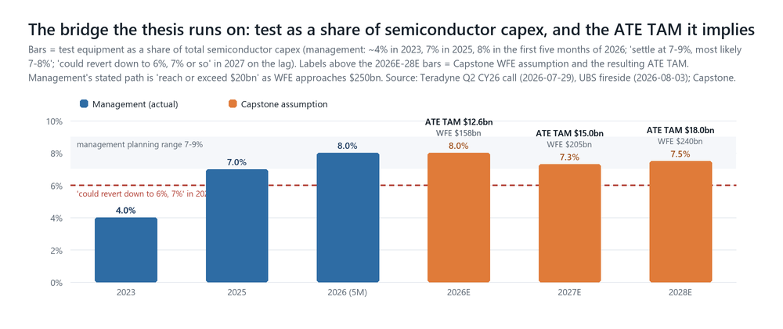
Exhibit 2. Management ratios as stated; WFE assumptions are Capstone's (CY27 $205bn, CY28 $240bn) against a wiki canonical range of $180-215bn for CY27 and a house top of $260bn for CY28. Street CY27 marks: UBS $225bn (2026-09-01), MS $223bn, Mizuho >$190bn, KLA's CFO citing a Street consensus 'in and around the $190 billion range', Bernstein $175bn, SEMI $175bn, Gartner $166bn; CY28: GS $281bn, UBS $275bn, MS $254bn (fifth raise of 2026), Bernstein $198bn. Our $205bn sits above the management-endorsed consensus and below the two most recent raises.
The TAM ladder, with bases kept apart. Teradyne's slide puts the 2026 ATE TAM at $12-14bn (Arcuri reading it on the call, 2026-07-29), with memory about one-fifth of the total ('the SOC TAM is 5x the size of the memory TAM', Smith); UBS separately estimates the SoC component at $11-12bn (Arcuri, 2026-08-03, not confirmed by IR, who confirmed only the ~$1bn networking figure). Advantest's raised TAM the night before was 'kind of in the right zip code' but excludes burn-in, so the two are not like for like. For 2027 the upper end of Teradyne's TAM range is $16-17bn (Arcuri reading the slide on the call); management's stated end-point is a path 'to reach or exceed $20 billion' as WFE approaches $250bn. Our bridge is the same arithmetic with explicit inputs: 8.0% of $158bn in 2026 ($12.6bn), 7.3% of $205bn in 2027 ($15.0bn, +18%) and 7.5% of $240bn in 2028 ($18.0bn, +20%). The 2027 dip in the ratio is management's own lag argument, not ours; it is the single most important modelling choice in this document and the one the bulls do not make (Exhibit 2).
Source · date | Number | What it measures and why it is not comparable
Teradyne, Q2 CY26 call, 2026-07-29 | ATE ~4% (2023) → 7% (2025) → 8% (Jan-May 2026) of semi capex; settle 7-9%; ATE TAM 'reach or exceed $20bn' at ~$250bn WFE | Company ratio, company-defined denominator; includes burn-in and IST. The 6-7% 2027 reversion is the same source.
Teradyne IR, UBS fireside, 2026-08-03 | Plan on 7-9% of WFE ('the real answer is we don't know'); the 'historically 8%… snapped back' framing is Arcuri's question, not IR's answer; networking TAM ~$1bn in 2026 confirmed ('Yes, it is'); SoC $11-12bn is UBS's estimate, not confirmed | Planning range on a denominator UBS supplied. Networking hit Teradyne's own '$800m+ by 2028' two years early.
Advantest, Q1 FY-Mar-27 results, 2026-07-28 | SoC and memory TAM raised; SoC capacity 5,000 → 10,000 testers/yr pulled forward (GS small group 2026-09-09); tester ASP +10-15%/yr | Excludes burn-in. Advantest guided to gain SoC share and lose memory share; Teradyne agreed only on memory.
BofA (Arya), 2026-07-28 / 07-29 | 7-8% of WFE → '$14bn+ ATE TAM as early as FY27E' on ~$200bn WFE; TER ~$8bn revenue / ~$18 EPS power at $250bn WFE (07-28) and ~$11bn / ~$23 'in a $300bn WFE environment' (07-29) | Sell-side derivation from Teradyne's outlook; the $8bn needs ~40% share of an 8% ratio. PO cut to $450 (31x CY28E) from $525 on 07-29.
UBS (Arcuri), 2026-04-20 / 05-28 | Test TAM ~1% of semiconductor revenue vs ~15% for WFE; NVDA tester TAM $3-4bn by 2028, TER share target 30-70%; C28 revenue ~$7.4bn / EPS ~$15 | Revenue-based ratio, not capex-based; the NVDA figure is one account's tester spend, not a market.
TD Cowen (Sankar), 2026-07-09 | CY26 GPU test TAM $2.5bn+; TER ~50% of HBM test; GPU test revenue ~$50m in CY26; SiPho SAM $50-100m | Sub-market sizes inside the SoC TAM; pre-print, so the $50m GPU figure predates the shipped first order.
Jefferies (Garrigan), AEHR initiation 2026-08-13 | High-power wafer-level burn-in SAM $626m (2026) → $2.0bn (2030) | An adjacent insertion where 'neither Teradyne nor Advantest has established a meaningful position'; a coverage gap, not a share loss; not additive to the ATE TAM above.
Never blend the bases: a share of WFE is not a share of semiconductor revenue, and a customer's tester budget is not a market TAM.

TER · PILLAR 1 SECTION 4 / 10
Test intensity: why more transistors per wafer became more testers per fab
The mechanism is physical and it is the part of the thesis we trust most. The part we trust least is the year-to-year ratio.
The mechanism, in management's framing. Two forces lift test spend faster than wafer output. The first is volume: WFE approaching $250bn by the end of the decade drives '5% to 10% annual growth in 300-millimeter wafer production and 15% to 20% CAGR in total transistor production', and 'every transistor must be tested… a given process node yields roughly the same transistor count per wafer regardless of device type', so non-memory transistor output is 'a reasonable first-order predictor of the SOC TAM' and bit production the predictor for memory. The second is advanced packaging: 'as accelerators, CPUs and networking devices pack in more chiplets, memories and eventually CPO, a single latent defect has a greater impact on final device yield, raising test intensity per die in multi-chip packages' (Smith, 2026-07-29). An independent author states the same thing as an equation: tester demand = unit volume x number of test insertions x test time per insertion / parallelism, and for AI accelerators all three numerator terms rise while parallelism falls with die size, so 'even if shipment volume is much smaller than mobile chips, tester demand can be larger'; the system-level test insertion is an insurance premium of $200-500 per chip against a late-stage failure that 'can exceed $50K', so 'even a failure rate of 0.5% makes 100% SLT economically rational' (DAMNANG, 2026-04-29; independent Substack, not a broker).
The corroboration from the rest of the test chain is unusually broad. Cohu's compute-systems orders rose 150% year on year with its long-term HPC pipeline raised to $850m (Jefferies · Garrigan/Curtis, Cohu 2Q26, 2026-07-31, per the wiki ingest of that note); Chroma claims more than 50% of CPO test insertion 3 and 100% of insertion 4, and reports that AMD's GPU test time 'could be 2-3x that of NVIDIA's GPU' at similar power, a direct per-unit multiplier (JPM · Tsai, 2026-07-30); Hon Precision's large-package thermal handlers carry a 20-25% price premium with customer thermal roadmaps at ~10kW for 2027-28 (JPM · Huang/Tsai, 2026-07-30); JPM Asia describes advanced thermal control migrating from final test to chip probe because power per reticle during probing 'could be up to 5x on N2 versus on N5P' and known-good die matter more when CoWoS, HBM and substrates are all scarce (JPM · Huang/Tsai, 2026-08-26, which names Advantest and TEL, not Teradyne); ADI, which sells the analog content inside the testers, reported ATE up more than 50% year on year at record levels (UBS read-across, 2026-08-19, with Barclays noting the growth rate decelerated). Advantest's own decomposition of its earnings set-up is 'market growth, higher test intensity, share and pricing', with tester ASPs up 10-15% a year for two years (Advantest management, GS Communacopia small group, 2026-09-09).
The two counter-arguments, and why they matter for 2027 specifically. First, the ratio is a lagging indicator dressed as a leading one. Management's own words: 'when people buy fab equipment, the money changes hands about a year before the wafers start coming out… our lead times are in the 16-weekish range. So it's three quarters on from when the revenue for the fab equipment has happened to when the revenue for the test equipment happens'; hence 8% in 2026 'could revert down to 6%, 7% or so' in 2027 (Smith, 2026-07-29). With WFE forecast up 30-43% in 2027, the ATE TAM can grow 15-20% and the ratio still falls; that is our base case and it is where Teradyne underperforms Lam and Applied on printed growth. Second, content per accelerator is not rising every generation: Morgan Stanley's Greater China semis team checked that initial Rubin final-test time is 'flattish vs Blackwell', which the MS Asia desk read as evidence of tester scarcity forcing customers to ration test time rather than as falling intensity (Amerian, 2026-08-14, sales commentary). Both readings are live; the resolution is whether 2027 test TAM prints closer to +10% or +25% as WFE accelerates. Our read: the level shift is real (the 2024 reversal, the dual-sourcing wave and the multi-die physics are not cyclical facts), the slope in any given year is not knowable from outside, and the stock's multiple currently assumes the slope.

TER · PILLAR 2 SECTION 5 / 10
Share: the dual-sourcing ladder, the lead-time weapon, and what 'roughly 30%' actually means
Customers are forcing the second source into existence. Teradyne has told us the mechanics, the ceiling at a mature account and the slope. The Street models the ceiling; we model the slope.
The ladder. 'Dual vendor strategies are emerging at the largest compute customers' (prepared remarks) because, as Smith put it in the Q&A, 'they want to be sure that they're going to be able to get the capacity that they need when they need that capacity.' The qualification 'runs through four phases: an opportunity to compete, developing a working solution, correlation, and then a production ramp. If successful, it takes nine to 12 months from the start to the ramp. After the initial dual-sourced part ramps, we enter a fast follower phase where additional parts are converted and ramped… During the fast follower phase, we expect market share to grow incrementally from zero up to about 30%.' Standing at the July call: 'one compute customer in the mature dual vendor phase, one in fast follower, and one in qualification prior to ramp'; the first merchant-GPU order (received Q1) shipped in Q2, correlation was completed at a second hyperscaler (the transcript reads 'also in Q3, we completed correlation'; on a 29 July call that most plausibly means early in the September quarter, and we flag the timing), and 'the next surge for these customers is expected to be in the first half of 2027' (Smith, 2026-07-29). The CEO put numbers on the three accounts at Goldman's conference: at hyperscaler #1 'share rose to roughly 70% after a successful dual-source ramp'; at the merchant-compute account Teradyne is 'qualified as a second vendor… expects meaningful volume on additional parts beginning in 2027' with 'a 3-5 year share-gain path toward roughly 30% of the compute portion of that account'; at hyperscaler #2 'the first part is being released and meaningful production share is expected in 2027, likely ramping more gradually in 10/20/30-point increments'; and 'each large hyperscaler can represent hundreds of millions to roughly $1bn of annual ATE TAM' (GS Communacopia small group, 2026-09-09, per the GS compile of 2026-09-13; management source). So the ~30% is the fast-follower way-station, and 70% is what a mature account looks like; the slope, however, is years.
The weapon is availability, not technology. 'Our tester's capable of testing both ARM-based and x86 as is our competitor's… it's not a technical thing' (McAndrews, 2026-08-03). Per Arcuri on the 3 August fireside, Advantest had said 'last night' that it is 'seeing visibility that now extends like 12 months' (a sell-side paraphrase; no Advantest source is on file); Teradyne's reply: 'we certainly don't have orders 12 months out… you're right, we are using our supply chain to try and gain share… right now we're in the 10 to 20 week lead time' (McAndrews, 2026-08-03). A supply-availability share shift is faster to win and just as fast to lose: if Advantest's capacity pull-forward (10,000 SoC testers a year, target brought forward; Advantest management at GS Communacopia, 2026-09-09) normalises its lead times, the argument weakens. It also has a price: TD Cowen notes front-end vendors are raising prices 10-20% while 'back-end (TER) is not raising prices' (2026-07-09), and Advantest reports ASPs up 10-15% a year; Teradyne's gross margin is the cost of the strategy.
How much share, and when. UBS built roughly 500bp of aggregate 2026 share gain (800-900bp in memory, 400bp in SoC); IR's answer was 'your numbers are a little bit heavier than what we see… more like 3 to 400 basis points in totality', weighted to memory because compute starts from 'such a low share point', and a 'couple hundred basis points' is a reasonable 2027 bogey ('Yes, we do') (2026-08-03). On the call itself the CEO had conceded 2026 SoC share is 'probably going to be pretty flat, maybe a slight incremental gain', with 'the effective share change in 2027… gradual… socket-by-socket' (2026-07-29). The CEO's framing at Goldman: 'satisfied with mid-single-digit annual share gains on top of strong market growth' (GS Communacopia small group, 2026-09-09). We model +120bp in 2027 and +150bp in 2028 on our TAM basis; the bull case carries +200bp a year; UBS's May 2026 arithmetic implies more. Two structural tailwinds sit behind the sockets: Advantest itself now says hyperscaler custom silicon 'may become the largest incremental tester pool' with the ASIC-versus-GPU crossover pulled in from 2-3 years to 'roughly one year' (Advantest management, 2026-09-09), i.e. the pool where Teradyne has 70% at one account and a 2027 ramp at another becomes the biggest pool; and server CPUs shifting toward Arm favour Teradyne's historical relationships, with an x86 wedge at 'the second largest GPU maker' and at Intel, which management expects to 're-enter commercial ATE in 2027 at small scale' and become 'more meaningful in 2028+' because 'we don't think that they're investing much in their own internal platform' (2026-08-03; 2026-09-09).
The risk on the other side of the same accounts. Teradyne has 'very, very, very high share' at both large networking silicon customers and is sole-sourced at one; the ~$1bn networking TAM of 2026 arrived two years ahead of Teradyne's own '$800m+ by 2028'. Asked whether the dual-sourcing being run at Teradyne on the compute side of one account would run against it in networking, IR was candid: 'we're paranoid, we're defending our share there… we'd be happy to trade half of the share in networking for half of the share in the other part of the account… net it means more share for us', and had not checked 'in about a quarter' whether the reciprocal qualification is under way (2026-08-03). We carry it as an unmonitored risk to the highest-share business Teradyne has.

TER · PILLAR 3 SECTION 6 / 10
Memory, and the engines beyond the tester: IST, Product Test, Robotics, CPO
Memory is the leg where Teradyne leads and the Street worries; the rest is small in the model and large in the multiple.
Memory: leadership, a reversal, and an unanswered arithmetic. Memory test was $61m in the June-2025 quarter and a record $212m in June 2026 (third straight quarter above $200m), with the 2026 memory TAM 'likely to be more than 40% larger than 2025', book-to-bill 'over 2x' (IR: 2.0), and demand strong in HBM, in DDR ('stronger now than we thought it would be in January', pulled by agentic-AI CPUs and SOCAMM/LPDDR) and, newly, in NAND ('we're actually getting pull from our customers for more NAND capacity'); a quarter earlier the company expected second-half memory to be down, 'and it's the opposite' (Smith 2026-07-29; McAndrews 2026-08-03). Teradyne expects single-digit-point memory share gains in 2026 and Advantest guided to lose memory share, which the Teradyne CEO 'agreed with'. The wins are specific: HBM4 wafer-sort performance test at a major DRAM maker (first DRAM wafer-sort win there) and post-stack singulated-die test, with 'some HBM suppliers introducing additional test insertions on the singulated stack' (calls 1Q-2Q 2025, via DAMNANG 2026-04-29). The arithmetic the company would not answer is Morgan Stanley's: memory test running ~62% year on year against DRAM/NAND bit growth nearer 30%, when 'memory has had years in the past when strong growth (2020, 2024) was followed by digestion' (Brett/Moore, 2026-07-28); Smith took the question offline, then argued memory test has 'two flywheels' (bit growth, served by cheaper equipment, and technology transitions HBM3→HBM4, DDR5→DDR6, next-generation flash). The de-spec debate cuts the other way for test, per management: 'lower HBM stack heights can be positive for tester TAM because the same DRAM wafer pool creates more HBM stacks requiring performance test', with 2027 HBM 'expected to grow rather than enter a digestion phase' (CEO, 2026-09-09). We carry memory growing with the SoC TAM, per management, and treat the 2027 memory TAM print as the test that settles MS's question.
IST and hard drives: small, and a read-through the drive makers should notice. IST revenue was $67m in June, +94% year on year and 2.5x quarter on quarter, 'driven by AI-related HDD storage demand from all three major suppliers' against '>20% annual exabyte growth'. Asked whether that is areal density or units, IR said 'I think it's both. Higher density needs longer test times, but obviously units would be a driver as well' (2026-08-03), which sits awkwardly with the drive makers' own no-unit-growth story. System-level test for compute and mobile was 'a little bit quieter to start the year'.
Product Test and the optical option. The group grew 26% year on year and 33% quarter on quarter in June across defence/aerospace, board test (Omnyx shipping to AI server builders), wireless and MLTP. CPO test is sized by management at '$300 million to $700 million by 2028', with 2027 'aiming towards more of the low side… in the $200 million range' because CPO port forecasts 'are all over the map'; management's technical position is that insertion 2 cannot be skipped ('the lens assembly is a critical part of the optical path'). Teradyne's optical angle is indirect: it screens the electrical side (SerDes, drivers, TIAs) of dies containing optical devices, with Quantifi instrumentation being integrated into UltraFLEXplus and the Photon 100 platform for wafer-level photonics (DAMNANG 2026-03-21; UBS CPO call 2026-05-04). SIG's optical checks describe CPO test as lacking standard methodologies, with PIC testing taking '>10 minutes per die versus seconds' on systems 'costing millions', and prefer Keysight rather than Teradyne as the test name (Hosseini, 'Optical Update', 2026-09-09). We carry ~$200m of CPO-related revenue in 2027 inside Product Test and Semi Test and do not model the $700m end.
Robotics: from problem child to attach story. The 2025 restructuring (about 400 employees, breakeven lowered) and a pivot to electronics manufacturing and logistics have produced four consecutive quarters of growth, +33% in 1H26 and 'nearly break even'; the CEO now frames the segment as 'positioned to essentially grow in proportion with the rest of the company', pulled by the same data-centre build-out (assembly automation, board test, rack-level test) and by 'a lot of common customers now across all three of our groups' (2026-07-29; 2026-08-03). Morgan Stanley's humanoids universe rates Teradyne Underweight and puts it third in its Humanoid 100 performance table (+207% since inclusion, as of 2026-07-27), which tells you the market has priced the robotics option in the multiple rather than in the segment. We carry Robotics as a revenue line only, $460m in 2027 and $530m in 2028 (+16% / +15%), with no segment P&L: at the segment's own 'nearly break even', it contributes little to EPS and considerably more to the narrative. It also carries $416m of goodwill, singled out as a critical audit matter in the FY25 10-K, on a segment that lost $99m pre-tax in FY25.

TER · THE DEBATES SECTION 7 / 10
Six debates, scored: where the evidence is, and what resolves each one
Bull and bear side by side, scored on evidentiary standing rather than rhetoric. Three are management-quantified, two are arithmetic, one is a multiple.
Debate | Bull evidence | Bear evidence | Status | Our call · what resolves it
1. Is 8% of capex a new level or a cyclical spike? | 4% → 7% → 8% (2023-1H26) with a physical mechanism (multi-die yield, KGD, power per reticle 5x N5P→N2); 'trend reversed in 2024'; BofA lands on 7-8% independently; Advantest reports ASP +10-15%/yr and pulls capacity forward; ADI ATE +50% y/y at record. | Management itself: the ratio 'could revert down to 6%, 7% or so' in 2027 on the WFE→wafer lag; Rubin final-test time 'flattish vs Blackwell' (MS Chan via Amerian 08-14); TSMC pushing cross-generation tool fungibility; test-time rationing in a shortage looks like intensity but is not. | Level: strong. Slope: unknowable. Two derivations agree on 7-8%; nobody has 2027 data. | We model 8.0% / 7.3% / 7.5% (2026-28). Resolves with the CY27 TAM slides (Advantest late Jan-27, Teradyne early Feb-27) against WFE; a print below 7% is the bear case, above 7.5% the bull.
2. Share at compute: how fast is 'roughly 30%'? | Hyperscaler #1 at ~70% after dual-source; merchant-GPU order shipped Q2, second hyperscaler correlated; 'each large hyperscaler = hundreds of millions to ~$1bn of ATE TAM'; Advantest pulls the ASIC-vs-GPU crossover to ~1 year, i.e. Teradyne's strong pool becomes the biggest; lead times 10-20 weeks vs Advantest's 12 months. | CEO: 2026 SoC share 'pretty flat'; IR trims UBS's 500bp to 300-400bp; merchant path '3-5 years toward roughly 30%'; hyperscaler #2 in '10/20/30-point increments'; Advantest has 20.2% of sales at NVIDIA and calls dual sourcing 'structurally limited' by switching costs; StoneX: TSMC qual for AI test 'very difficult'. | Management-quantified on both ends. Ceiling proven at one account; slope is years. | +120bp (2027) / +150bp (2028) on our TAM basis. Resolves in the 1H27 compute surge (are additional merchant parts and hyperscaler #2 in the Q1/Q2-27 numbers?) and in Advantest's own SoC share commentary.
3. Memory: two flywheels or a 2020/2024-style digestion? | Record $212m, book-to-bill 2.0, 2026 TAM +40%+, NAND inflected, DDR surprising up on agentic CPUs/SOCAMM; HBM4 wafer-sort and singulated-stack insertions won; Advantest concedes memory share loss; capacity adds planned 'out into 2027'; lower stack heights = more stacks to test. | MS: ~62% y/y memory test vs ~30% bit growth; 'digestion' followed 2020 and 2024; Smith took the question offline; MS Europe has DRAM pricing near a second-derivative peak and the cycle late-cycle by 4Q26; ONTO/BESI numbers already cut on HBM de-spec. | Direction with management, arithmetic with the bear. Near-term booked; 2027 unproven. | Memory grows with the SoC TAM in our base (management's framing); the bear case has 2027 memory test flat. Resolves with the 2027 memory TAM guide in February and HBM4/HBM4E stack decisions (Rubin Ultra configuration).
4. Concentration and visibility: is 2027 booked or modelled? | Dual sourcing is customer-driven ('they want to be sure they get the capacity'); networking sole-sourced at one of two accounts; memory orders now placed 'a little bit longer'; the WFE correlation is 'strong over kind of three to five-year periods'. | Five customers = 44% of revenue; two specifiers 12%/10%, one purchaser 19%; Taiwan+Korea+China 72%; lead times 10-20 weeks by choice; 'not at all correlated when you're down to a quarter level'; MS: 'visibility on tester demand more than 6 months out would be unprecedented' (07-28) - confirmed by the transcript. | MS is right and management agrees. 2027 is a model, not a backlog. | We treat 2027 as WFE-derived and give it the consensus quarterly shape. The Q4-26 guide (late Oct) is the first hard read on 1H27; the compute surge is 'expected', not booked.
5. Margins: 59% → '60% or higher', or mix and pricing erosion? | GM 57.3% → 60.9% record in Q1-26; IR: '60% or higher over the mid-term', new model in February; product test carries the highest GM; memory 'kind of at parity' with SoC; opex to grow at less than half of revenue. | Q1-26 had undisclosed one-time benefits ('for competitive reasons'); 2H steps down on mix, volume and new-product cost curves; memory 'a strain… into 2027'; TER 'not raising prices' while front-end raises 10-20% (TD Cowen); input-cost inflation cost Chroma 3ppt of GM (JPM 07-30). | Arithmetic, mostly ours. GM debate is worth ~$5 of target; opex is worth $14. | GM 59.5% → 60.2%, opex +10%/+11%: operating margin 35% / 38% vs Street 34% / 36%. That gap is why our EPS is above consensus. Resolves quarter by quarter; the February model is the venue.
6. What multiple does a test company deserve? | Structural TAM growth (test outgrowing WFE), duopoly, net cash, ROIC of 17-20% through the last downcycle (17.3% in 2023) and 27-39% at the 2021-22 peak (Bloomberg); the 2021-26 blended forward P/E mean is 28x; GS pays 37x normalized, BofA 31x CY28E; test peers trade 26-28x on FY2 and 20-24x on FY3 (Advantest 21.6x, CAMT 23.4x, FORM 23.9x, COHU 20.3x). | 2016-25 blended forward mean 21.7x (median 20.4x); in June the stock traded 52x blended forward on 79x trailing (weekly, 19 June) and has de-rated to 32x while blended-forward EPS rose 26%; MS: the only zero-return base case in its ten-name screen; positioning screens negative (Barclays 09-01); 2027 relative growth lags the front end. | The actual disagreement with the Street. Earnings are not the argument; the multiple is. | 25x CY28E = $400. Between the through-cycle and AI-era regimes, ~20% premium to front-end peers on the same year and in line with the test peers on FY3, below the 30x the stock trades on Street CY27E. Resolves as the ratio debate resolves; a February model with $18+ 'earnings power' re-rates the stock toward the bull case.
All quotes attributed to management, broker or analyst and dated in the text. DAMNANG is an independent author (Substack), not a broker, and carries no rating or target; MS Asia (Amerian) and BofA (Fenske) desk notes are sales commentary, not research; GS Communacopia material is management speaking, relayed by the analyst, with no GS rating attached.

TER · ESTIMATES SECTION 8 / 10
Our model: anchored to the guide, built on the TAM-times-share bridge, checked against what we can observe
Every input is tagged by how grounded it is. The below-the-line constants are back-solved from the guided EPS; nine guardrails test the output.
Guidance track record: 10 of 10 at or above the midpoint, 5 of 10 above the top on revenue, 7 of 10 on EPS
Quarter | Revenue guide → actual | vs midpoint | Non-GAAP EPS guide → actual | vs top end | Note
Q1 FY24 | $540-590m → $600m | +6.2% (above top) | $0.22-0.38 → $0.51 | +0.13 | cycle trough; memory test $-
Q2 FY24 | $665-725m → $730m | +5.0% (above top) | $0.64-0.84 → $0.86 | +0.02 | compute/networking (VIP) begins
Q3 FY24 | $680-740m → $737m | +3.8% | $0.66-0.86 → $0.90 | +0.04 | AI ~10-15% of revenue
Q4 FY24 | $710-760m → $753m | +2.4% | $0.80-0.97 → $0.95 | -0.02 | Technoprobe stake closed May-24
Q1 FY25 | $660-700m → $686m | +0.9% | $0.58-0.68 → $0.75 | +0.07 | tariff scare; stock $74 in April
Q2 FY25 | $610-680m → $652m | +1.1% | $0.41-0.64 → $0.57 | -0.07 | memory timing trough ($61m)
Q3 FY25 | $710-770m → $769m | +3.9% | $0.69-0.87 → $0.85 | -0.02 | memory +110% q/q; CFO transition
Q4 FY25 | $920-1,000m → $1,083m | +12.8% (above top) | $1.20-1.46 → $1.80 | +0.34 | the inflection: +41% q/q; 'evergreen' model published
Q1 FY26 | $1,150-1,250m → $1,282m | +6.8% (above top) | $1.89-2.25 → $2.56 | +0.31 | record; stock -8% on a sequentially lower Q2 guide
Q2 FY26 | $1,150-1,250m → $1,329m | +10.7% (above top) | $1.86-2.15 → $2.47 | +0.32 | record; H2 re-cut to 50-52% H1 weighting
Q3 FY26 | $1,200-1,300m → ? | cons $1,244m | $1.85-2.15 → ? | cons $1.99 | reports ~late October 2026
Source: company press releases 2024-01-31 to 2026-07-28 (guidance ranges and reported figures); Capstone arithmetic. Mean revenue beat vs the midpoint +5.4% over ten quarters, +8.6% over the last four; mean EPS beat vs the midpoint $+0.22 (last four $+0.37). Applied to the Q3 FY26 midpoints that implies $1,317-1,357m of revenue and $2.22-2.37 of EPS against consensus of $1,244m / $1.99, i.e. the Street is positioned for the midpoint, not for the pattern. We keep the base case at $1,270m / $2.05 because the 2H was re-based upward only eight weeks ago; the bull case uses the pattern (Exhibit 3).
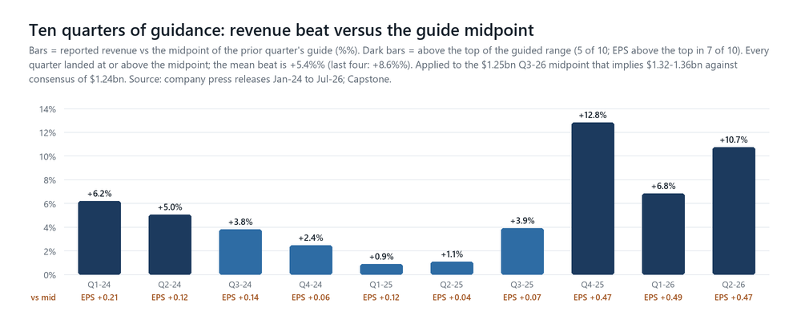
Exhibit 3. Company press releases; Capstone.
The quarterly build (base case; Exhibit 4 plots it against the consensus ladder)
US$m | Q3-26E | Q4-26E | Q1-27E | Q2-27E | Q3-27E | Q4-27E | Q1-28E | Q2-28E | Q3-28E | Q4-28E
Revenue | 1,270 | 1,245 | 1,474 | 1,617 | 1,592 | 1,536 | 1,808 | 1,993 | 1,970 | 1,923
q/q | -4.4% | -2.0% | +18.4% | +9.7% | -1.5% | -3.5% | +17.7% | +10.2% | -1.2% | -2.3%
Street consensus revenue | 1,244 | 1,236 | 1,418 | 1,596 | 1,606 | 1,575 | 1,811 | 2,011 | 1,902 | 1,770
Gross margin | 58.6% | 58.5% | 59.0% | 59.5% | 59.7% | 59.8% | 60.0% | 60.2% | 60.3% | 60.3%
Opex | 375 | 377 | 372 | 383 | 388 | 395 | 413 | 425 | 430 | 439
Opex % of revenue | 29.5% | 30.3% | 25.2% | 23.7% | 24.3% | 25.7% | 22.9% | 21.3% | 21.8% | 22.8%
Operating income | 370 | 352 | 498 | 579 | 563 | 523 | 672 | 774 | 757 | 721
Operating margin | 29.1% | 28.2% | 33.8% | 35.8% | 35.4% | 34.1% | 37.1% | 38.9% | 38.5% | 37.5%
Net income (tax 15-15.5%, +$5m other, +$5.5m Technoprobe) | 324 | 309 | 433 | 502 | 488 | 455 | 577 | 664 | 650 | 619
Diluted shares (m) | 158.0 | 157.8 | 157.7 | 157.6 | 157.5 | 157.3 | 157.2 | 157.0 | 156.9 | 156.8
EPS (non-GAAP) | $2.05 | $1.96 | $2.74 | $3.19 | $3.10 | $2.89 | $3.67 | $4.23 | $4.14 | $3.95
Street consensus EPS | $1.99 | $1.94 | $2.48 | $2.97 | $2.95 | $2.76 | $3.49 | $4.05 | $3.68 | $3.25
Blue = Capstone. Calendar quarters (Teradyne's fiscal year is the calendar year). Sums: CY26 $5,126m / EPS $9.03 (H1 actual $2,611m / $5.02 + our H2); CY27 $6,220m / $11.92; CY28 $7,694m / $15.99. Street from the Bloomberg BEst quarterly ladder (14 estimates for the next four quarters, 6 for 2028), 2026-09-16. Annual free cash flow: CY26 $1,136m, CY27 $1,579m, CY28 $2,139m; cash at end-CY28 $3,589m after $400-450m a year of buybacks and ~$85m of dividends.
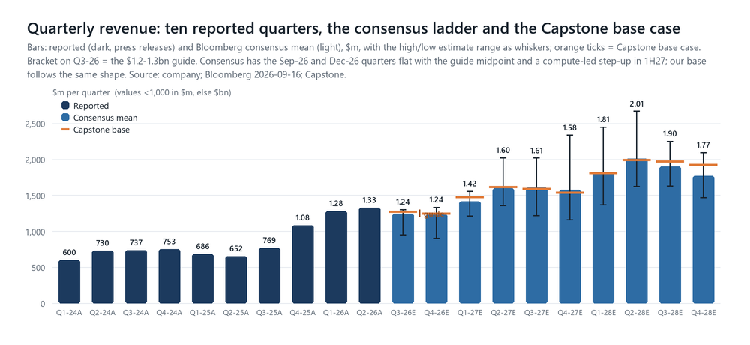
Exhibit 4. Company press releases; Bloomberg BEst quarterly ladder 2026-09-16; Capstone base case (orange ticks).
The bridge behind the revenue line: WFE x test ratio x Teradyne share
 | 2025A | 2026E | 2027E | 2028E | Grounding
WFE, US$bn | — | 158 | 205 | 240 | PARTIAL: UBS $158bn CY26 baseline; wiki canonical CY27 $180-215bn (UBS $225bn, MS $223bn, KLA-cited Street consensus ~$190bn, Bernstein $175bn); CY28 house top $260bn (GS $281bn, UBS $275bn, MS $254bn, Bernstein $198bn)
ATE share of WFE | 7.0% | 8.0% | 7.3% | 7.5% | PARTIAL: management 7% (2025) / 8% (Jan-May 2026); 'settle 7-9%, most likely 7-8%'; 2027 dip is the lag caveat
ATE TAM, US$bn | — | 12.6 | 15.0 | 18.0 | Derived; management: 'path to reach or exceed $20bn' at ~$250bn WFE; TER slide upper end $16-17bn for 2027
Teradyne Semi Test share | — | 34.2% | 35.4% | 36.9% | ESTIMATE: +120bp / +150bp vs IR's 300-400bp (2026) and 'couple hundred bp' (2027) bogeys; UBS ~37% on an Advantest-derived TAM
Semiconductor Test revenue | 2,524 | 4,320 | 5,295 | 6,639 | H1 FY26 actual $2,233m; H2 = total less Product Test and Robotics
of which SoC (indicative) | 1,890 | 3,205 | 3,900 | 4,950 | ESTIMATE overlay; FY25 from the 10-K product-line table; H1 FY26 SoC $1,725m
of which Memory (indicative) | 505 | 885 | 1,150 | 1,400 | ESTIMATE overlay; H1 FY26 $415m; 2026 TAM +40%+; grows with SoC thereafter
of which IST (indicative) | 129 | 230 | 245 | 290 | ESTIMATE overlay; H1 FY26 $94m; HDD-driven 2H
Product Test revenue | 358 | 410 | 465 | 525 | ESTIMATE: H1 $187m; +13%/yr on Omnyx, MLTP, ~$200m CPO-related in 2027
Robotics revenue | 308 | 396 | 460 | 530 | ESTIMATE: H1 $191m (+33%); 'in proportion with the rest of the company'
Total revenue | 3,190 | 5,126 | 6,220 | 7,694 | vs Street 5,066 / 6,237 / 7,543
The sub-segment split is an overlay that does not change the totals; Teradyne discloses SoC/Memory/IST annually (10-K) and on the calls, not by quarter in the filings. The 2025 WFE, TAM and share cells are deliberately blank: management's 7% for 2025 is quoted against 'total CapEx', a denominator we do not have on a consistent basis, so the 2026 share level (34%) is our anchor and only the 2027-28 gains are scored against IR's 'couple hundred bps' bogey; the 2026 300-400bp bogey cannot be tested on this basis.
How the inputs are grounded, and how the constants were calibrated
Input | Grounding | Source and value
Q3 FY26 revenue $1,200-1,300m, GM 58-59%, opex 29-30% of sales, OpM 28-30%, EPS $1.85-2.15 | HARD | Guidance, Michelle Turner, Q2 CY26 call 2026-07-29 and press release 2026-07-28. We use $1,270m (+1.6% on the midpoint), 58.6%, 29.5%.
H1 FY26 = 50-52% of FY26 revenue; Q4 opex 'comparable to Q3' | HARD | Turner, 2026-07-29. Implies FY26 $5.02-5.22bn; our $5.13bn (Q4 $1,245m) puts H1 at 50.9%.
Below-the-line: +$5m/qtr other income, +$5.5m/qtr Technoprobe, tax 15% (15.5% in 2028), 158.0m diluted shares | ANCHOR | Tax: the FY25 and FY24 effective rates were 12.1% and 9.8% (10-K), the Q2 FY26 rate 15.1% and the Q4 FY25 guide 14.5%; we sit at the top of that range, and each 2pp is $9 of target, more than the gross-margin debate. Shares back-solved on the guided P&L: $1,250m x 29% = $362.5m OI, +$5m, x 0.85, +$5.5m = $318m / $2.00 = 159m shares vs 157.7m reported diluted in Q2 (buybacks offset awards). Q2 FY26 GAAP ETR 15.1%; interest and other +$5.8m; equity-method line -$1.9m GAAP plus the $7.6m amortisation add-back.
WFE $158bn / $205bn / $240bn | PARTIAL | UBS 2026-09-01 baseline for 2026; 2027-28 inside the wiki's canonical ranges, below UBS ($225bn / $275bn) and MS ($223bn / $254bn), above Bernstein ($175bn / $198bn) and above the ~$190bn CY27 Street consensus KLA's CFO cited; $20bn of 2028 WFE is worth $45 of target.
ATE share of WFE 8.0% / 7.3% / 7.5% | PARTIAL | Management's stated series (4% / 7% / 8%) and range (7-9%, most likely 7-8%); the 2027 dip follows the CEO's lag argument. Every 50bp on 2028 is worth ~$36 of target.
Share +120bp (2027) / +150bp (2028) | ESTIMATE | IR: 300-400bp aggregate in 2026 (trimmed from UBS's 500bp), 'a couple hundred' in 2027; CEO: 'mid-single-digit annual share gains'. Our 2026 level (34%) is lower than UBS's 37% because our TAM denominator is larger (8% of WFE vs Advantest's ex-burn-in TAM).
Gross margin 59.5% (2027) → 60.2% (2028) | PARTIAL | FY26 'right around 59%' (Turner); '60% or higher over the mid-term' (McAndrews); new model in February. Street 59.5% / 59.7%.
Opex +10% / +11% a year | PARTIAL | 'OpEx growth target less than half of revenue growth over time' (CEO, GS Communacopia small group, 2026-09-09); FY26 opex ~$1.40bn (H1 $647m + Q3-Q4 at 29.5-30%). Decomposed: FY25 opex was 31.0% of revenue (E&D $454m = 14.2%, S&M $367m = 11.5%, G&A $169m = 5.3%; 10-K Note V); our path takes total opex to 27.3% (CY26), 24.8% (CY27) and 22.2% (CY28), i.e. R&D dollars +12% a year and SG&A +8-9% against revenue +21-24%. R&D intensity was 11.5% of revenue at the 2021 peak, 16.3% in 2024 and 15.8% in 2025 (Bloomberg basis); our path takes it back toward ~10% by 2028, i.e. peak-cycle intensity. This 880bp of total-opex intensity compression is the load-bearing input for the EPS gap to the Street; if opex grows with revenue, CY28E EPS is $15.4 and the target $386.
Buybacks $150m (2H26), $400m, $450m; dividend $0.13/qtr | ESTIMATE | H1 FY26 buyback $74m at $341.89; $617m left on the authorisation; management 'building cash' for MLTP-sized M&A. Diluted shares 158.0m → 156.8m by Q4-28.
Capex $355m / $380m / $430m; D&A $136m / $150m / $175m; SBC ~$90-105m; working capital 15% of incremental revenue | PARTIAL | H1 FY26 capex $155m ('increased $26m from last quarter'); FY25 $224m (7% of revenue); BEst $282m / $353m / $429m; H1 FCF/NI conversion 73%.
Multiple 25x CY28E EPS | PARTIAL | Midpoint of Teradyne's two P/E regimes (blended forward, weekly: 2016-25 mean 21.7x; 2021-26 mean 28.2x); ~20% premium to KLAC (20.3x), LRCX (19.1x), ASML (20.7x) and Advantest (21.6x) on their FY3 EPS; below the 30x the stock trades on Street CY27E. Blended-forward at the Sep-27 horizon: 26.7x.
DCF: Ke 10%, g 3%, OM fading from 38% to 30% by 2035, SBC charged, capex 5% of revenue, tax 15.5% | ESTIMATE | House template convention (Ke 10%, g 3%). CAPM on Teradyne's 1.34 Bloomberg beta gives 10.9%. Terminal margin 30% is above the FY17-25 non-GAAP average (~24%) and below the CY28 peak; the grid shows the alternatives.
Guardrails: does the model agree with what we can observe?
- I1 input check: Q3 FY26 EPS reproduced from the guided P&L: $2.05 on $1270m / 58.6% GM / opex 29.5% / tax 15% / 158.0m shares vs $2.00 guide mid — input check (calibration): reproduces the midpoint within $0.05
- I2 input check: FY26 shape vs the '50-52% in H1' framing: H1 $2,611m = 50.9% of our FY26 $5,126m — input restated: inside the 50-52% band
- G1 implied TER share of the ATE TAM (Semi Test / [WFE x ratio]): 34.2% (2026) -> 35.4% -> 36.9% — PASS vs UBS's ~37% 'basically flat' 2026 mark on the call (different TAM basis, Advantest's ex-burn-in) and IR's 300-400bp 2026 / 'couple hundred bps' 2027 bogey; our 2026 level is lower because our TAM denominator (8% of $158bn WFE) is larger than the Advantest-derived $12bn
- G2 implied ATE TAM path: $12.6bn -> $15.0bn (+18%) -> $18.0bn (+20%) — PASS vs management's 'path to reach or exceed $20bn' as WFE approaches $250bn (ours: $18bn at $240bn) and TER's own 2027 TAM slide 'upper end $16-17bn' (Arcuri on the call); CY27 TAM growth (+19%) trails UBS's +43% WFE because the ratio dips, per management's own lag caveat
- G3 CY27 / CY28 revenue growth vs the evergreen model and management's words: +21% / +24%; CY27 EPS $11.92 vs the evergreen model's $9.50-11 at $6bn — PASS: 'a resurgence in growth in 2027' (CFO 07-29) and the target model being reached 'at an accelerated pace'; our CY27 revenue of $6.2bn is the model's $6bn a year early
- G4 Q3 FY26 vs the guidance track record: our $1270m vs track-record-implied $1317m (10-qtr mean beat) / $1357m (last 4); consensus $1,244m — CHECK: we sit deliberately at the low end of the pattern because the 2H guide was just re-based upward; the pattern says the Street is not positioned for a top-end print
- G5 opex growth vs 'less than half of revenue growth': opex +10% / +11% vs revenue +21% / +24% — PASS at the ceiling of management's framing (CEO, GS Communacopia small group 2026-09-09, per the 09-13 compile); this is the input that puts our EPS above the Street
- G6 operating margin vs the reported peak: CY27 34.8% / CY28 38.0% vs Q1 FY26 record 37.5% and Street CY28 36.1% — CHECK: CY28 at 38% assumes the Q1 FY26 structure recurs at 1.5x the revenue; the Street stops at 36%
- G7 free cash flow conversion: CY27 FCF $1,579m = 84% of non-GAAP NI; CY28 85% — PASS vs FY25 (71%) and H1 FY26 (73%); capex $380m/$430m vs BEst $353m/$429m
- G8 CY28 vs BofA's '$8bn / $18 earnings power in a $250bn WFE world': Capstone $7.69bn / $15.99 at $240bn WFE — PASS/CHECK: BofA's frame needs ~40% share of an 8%-of-WFE TAM; we carry 36.6% of 7.5% -- the gap is the share and ratio debate, not the WFE
Sensitivity: what actually moves the target
Flexing one input at a time around the base case, at a constant 25x on CY28E EPS. The finding: the WFE denominator and the test ratio are worth far more than anything Teradyne controls. Twenty billion dollars of 2028 WFE moves the target by $45; half a point of test ratio by $36; the whole share debate (50bp vs 250bp a year) spans $58. Gross margin, the input the Street argues about most, is worth $5 either way; opex, our load-bearing assumption, $14. The multiple alone spans $288 (18x) to $528 (33x). The rating therefore lives in the 22-28x band, which is exactly where the two regimes of the stock's own history sit.
Input flexed (base case otherwise) | CY27E EPS | CY28E EPS | PT at 25x | vs base | Multiple alone
CY28 WFE $220bn (Bernstein-to-SEMI end of the range) | $11.92 | $14.20 | $355 | -45 | 18x = $288
CY28 WFE $254bn (MS, fifth raise of 2026) | $11.92 | $17.25 | $431 | +31 | 20x = $320
CY28 WFE $275bn (UBS 2026-09-01) | $11.92 | $19.13 | $478 | +78 | 22x = $352
ATE share of WFE 7.0% in CY28 (vs 7.5%) | $11.92 | $14.56 | $364 | -36 | 25x = $400
ATE share of WFE 8.0% in CY28 (top of the 2026 run-rate) | $11.92 | $17.43 | $436 | +36 | 28x = $448
CY27 ratio dips to 6.5% (management's 'could revert to 6-7%') | $10.06 | $15.99 | $400 | +0 | 30x = $480
Share gain +50bp/yr (vs +120/+150bp) | $11.58 | $15.00 | $375 | -25 | 31x = $496
Share gain +250bp/yr (UBS-type) | $12.55 | $17.33 | $433 | +34 | 33x = $528
Gross margin -50bp every quarter CY27-28 | $11.75 | $15.78 | $395 | -5
Gross margin +50bp every quarter | $12.09 | $16.20 | $405 | +5
Opex growth +3pp/yr (13%/14%) | $11.67 | $15.43 | $386 | -14
Opex growth -3pp/yr (7%/8%) | $12.17 | $16.53 | $413 | +14
Tax rate +2pp | $11.64 | $15.62 | $390 | -9
Base CY28E EPS $15.99; PT $400 (25x, rounded to $5). Right-hand column: the same base EPS at 18x to 33x. The 2027 ratio flex changes CY27 (not CY28) because the 2028 share and TAM are set independently. Capstone arithmetic.
A note on the house model in the wiki. The Teradyne page has carried house EPS of $5.46 (2026E) and $6.90 (2027E) from the Capstone semicap peer model (ASML_Peers_SemiCap v16, 2026-06-15), described there as 'below consensus, more cautious on ATE'. That line was overtaken by the June-quarter print: Teradyne earned $5.02 in the first half alone and guided the September quarter to $2.00. This initiation replaces it. The wiki's house table has been re-based to these numbers (CY26E $9.03, CY27E $11.92, CY28E $15.99) with the prior values moved to the page Changelog, per the thesis-drift rule; the peer workbook itself has not been modified.

TER · VALUATION SECTION 9 / 10
Fairly valued on our base case; the bull case is the Street's case
Primary frame: P/E on CY28E EPS at the 12-month horizon. Cross-checks: CY27E P/E, the stock's own two regimes, semicap peers, and a template-convention DCF that does not get there.
Price target $400 = 25x our CY28E EPS of $15.99 (rounded to $5), which is also 33.6x our CY27E EPS and 26.7x the blended twelve-month-forward EPS the market will be looking at in September 2027. At $341 the stock trades on 28.6x our CY27E and 21.3x our CY28E (29.8x / 23.1x on Street numbers), and 32.0x Bloomberg's blended twelve-month-forward EPS ($10.65, BEst 2026-09-11). The price context matters. The stock rose from ~$74 (April 2025) to $484 (daily close, 30 June 2026: ~56x blended forward, ~66x CY26E) and has given back 30% while blended-forward EPS rose 26% and CY27 consensus from $10.04 (May) to $11.45 (August): the de-rating has happened, from ~56x to 32x. We choose 25x on CY28 rather than something lower because (i) Teradyne's blended forward P/E has lived in two regimes, a 21.7x mean from 2016 to 2025 and a 28.2x mean since 2021, and 25x is the midpoint; (ii) on the same forward year the front-end leaders trade on 19-21x (LRCX 19.1x, KLAC 20.3x, ASML 20.7x) and Advantest on 21.6x, so 25x is a ~20% premium for a company whose end-market is growing faster than theirs and whose share is rising; (iii) the sell-side struck its own targets at 31-37x (BofA 31x CY28E, cut from 41x on 29 July 'after recent semicap multiple compression and in line with… Advantest at a similar 31x CY28E'; GS 37x normalized $12.50), so our 25x is the low multiple on the Street and we say so. We choose it rather than something higher because 2027 is the year test lags the fab on management's own arithmetic, because five customers are 44% of revenue and lead times are 10-20 weeks by design, and because the DCF, on any through-cycle margin, is below the share price. Our multiple is the source of our caution; our earnings are above the Street.
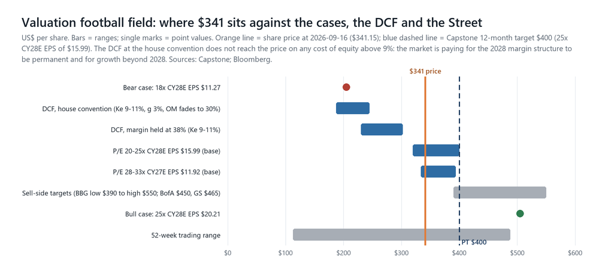
Exhibit 5. Capstone estimates; Bloomberg 2026-09-16. Sell-side range: BBG low $390 / high $550. Published marks: GS $465 (Buy, 07-05), BofA $450 (Buy, cut from $525 on 07-29), TD Cowen $400 (Buy, 07-09), MS $397 (Equal-weight, 08-19); UBS $500 is a 07-25 sector-sales relay of Arcuri's Buy (formal published PT of record $200, 2025-12-22) and is not a rated mark. Scenario values rounded to $5.
Scenarios
Case | What has to be true | CY28E rev / EPS | Multiple | Value | vs $341 | Weight
Bull $505 | WFE at the house top ($220bn / $260bn), the test ratio holds 7.5% in 2027 and 7.7% in 2028, share +200bp a year (hyperscaler #2 and the merchant account both ramp on schedule, memory share keeps rising), GM 60.1% / 60.7%, opex +12%. ATE TAM $20.0bn in 2028, Teradyne at 39%. Revenue CY27 $7.1bn (+14% vs Street), CY28 $9.0bn, at the Street high ($9.3bn). Broadly BofA's 07-28 '$8bn / $18 earnings power at $250bn WFE' frame (its 07-29 note adds ~$11bn / ~$23 at $300bn); also the case a February model at $20bn TAM would validate. | $9.0bn / $20.21 | 25x | $505 | +48% | 25%
Base $400 | Management's trajectory: Q3 at the guide, Q4 flat, a 2027 'resurgence' of +21% as WFE-driven TAM growth (+18%) meets +120bp of share, +24% in 2028; GM to 60%, opex at half the rate of revenue; FCF $1.6bn / $2.1bn; cash $3.6bn by end-2028 with buybacks at $400-450m a year. Within 2% of Street revenue, 4% / 8% above Street EPS. | $7.7bn / $15.99 | 25x | $400 | +17% | 50%
Bear $205 | The lag bites: the test ratio reverts to 6.5% in 2027 on $200bn of WFE (ATE TAM +3%), share +100bp, memory test flat as bit growth catches up with the 2026 build, GM 58% on mix and pricing, opex +8%. Revenue CY27 $5.3bn (-15% vs Street), CY28 $6.3bn; the multiple compresses to the 2016-25 lower quartile. MS's bear is $274 (-32% off its 12-Aug $402.74 reference, -20% against $341); Octahedron's short thesis (07-15) is this case's narrative. | $6.3bn / $11.27 | 18x | $205 | -40% | 25%
Probability-weighted | 0.25 x 505 + 0.50 x 400 + 0.25 x 205 |  |  | $378 | +11%
The skew is positive (+48% / -40%) and the probability-weighted expected return of +11% is about the cost of equity, which is the definition of a Neutral: we would not chase it here, and we would not short a company with no debt, a booked second half, a 2.0 memory book-to-bill and a model update coming that is almost certainly higher. The bull case is not exotic; it is the Street's case and roughly what the stock discounted at $484 in June. The bear case requires the 2027 lag to arrive in full and memory to digest, which is what happened in 2022-23 after the 2021 peak. Exhibit 6 shows what the price implies: base-case CY28 earnings on ~21x, or bull-case CY28 earnings on ~17x. Below ~$330 the base case offers more than 20% and the expected value more than 15%; that is where we would move to Buy on unchanged estimates.
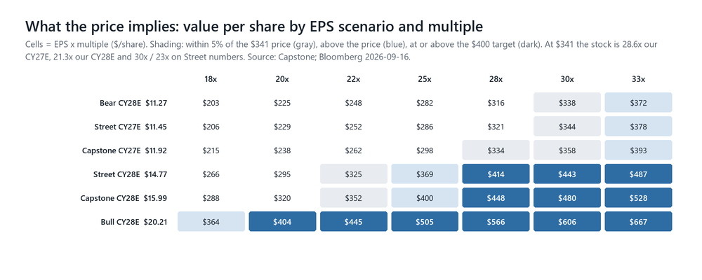
Exhibit 6. Capstone estimates; Bloomberg consensus.
DCF cross-check: the market is paying for duration
On the base-case cash-flow path (CY27 revenue $6.2bn growing to ~$12.5bn by CY35 as growth fades from +13% to +3%; operating margin peaking at 38% in CY28 and fading to 30% by CY35; stock compensation charged; capex 5% of revenue; working capital 15% of incremental revenue; 15.5% tax; $884m of net cash at end-2026 plus the $515m Technoprobe stake added back; Ke 10%, terminal growth 3%) the DCF gives $197 per share at end-2026, $212 rolled to our twelve-month horizon, with the terminal value 56% of enterprise value. Holding the 38% margin flat forever lifts it to $259; at Ke 9% with the flat margin, $302; the bull operating path with a flat margin reaches $348. None reaches the share price. We do not read that as a sell signal; we read it as a statement of what the market is paying for: a growth runway well beyond 2028 (the ≥$20bn ATE TAM path and the '$300bn+ WFE doable' bias UBS and Bernstein now carry for 2029), and a permanently higher margin structure. Those may both be right; they are not something a semicap cyclical earns on a through-cycle DCF, and it is the reason we do not round the target up.
Base-case DCF, $/share (rolled to Sep-27) | Ke 9% | Ke 10% (house) | Ke 10.9% (CAPM, beta 1.34) | Ke 12% | Note
OM fades 38% → 26% (FY17-25 average +2pt) | $216 | $188 | $169 | $151 | the cyclical's DCF
OM fades to 30% (base) | $244 | $212 | $189 | $168 | template convention
OM fades to 34% | $273 | $235 | $210 | $185
OM held at 38% (CY28 level) | $302 | $259 | $230 | $203 | what $341 needs, plus growth beyond 2035
Terminal growth 3% throughout; 157.6m diluted shares; SBC charged; net cash and the Technoprobe stake added. Bull path DCF: $266 with the fade, $348 flat; bear path $134. Ke 10% / g 3% is the house Template DCF convention; the CAPM column uses Rf 4.2% + 1.34 x 5.0% ERP.
What the Street is doing, and what it is not
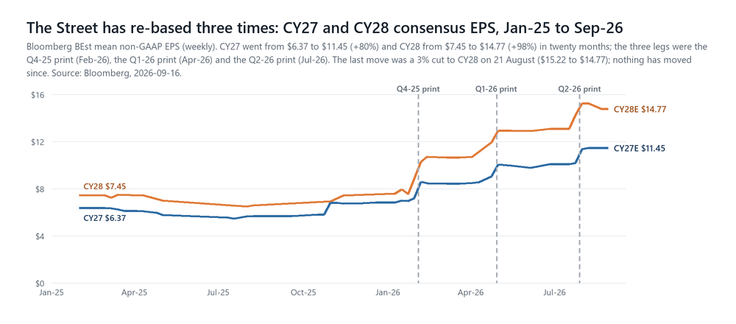
Exhibit 7. Bloomberg BEst, calendar years, weekly, 2026-09-16.
Consensus CY27 EPS has risen 80% in twenty months and CY28 has doubled; each leg was a print (Exhibit 7); the last move was a 3% cut to CY28 on 21 August (from $15.22 to $14.77) and nothing has moved since. Nineteen analysts cover the name, 13 at Buy and 6 at Hold with none at Sell, and a mean target of $451 (Bloomberg). The published targets are narrower and centred higher than the wiki had them: GS $465, BofA $450 (cut from $525 on 29 July, 31x CY28E), TD Cowen $400, MS $397, with the Bloomberg range $390-550 and UBS's desk relaying $500 (Arcuri, 25 July; the formal UBS mark of record is still $200 from December). UBS's latest sector note lists Teradyne among the names that 'declined initially following earnings given elevated expectations' and does not include it in the names it continues to favour (AMD, MU, LRCX, ENTG, TXN) (Arcuri, SemiBytes, 2026-09-08). What separates them is not 2027 revenue but how much of the test-intensity step-up each treats as structural. Morgan Stanley's is the most informative seat: Equal-weight at fair value (-1% base, +33% bull, -32% bear), the only zero-return base case in its ten-name semicap screen, with Teradyne classified 'Significant' rather than 'Core to Thesis' for AI (MS, 2026-08-19). The positioning read is negative: Teradyne sat on Barclays' relative-underperformance streak screen (-7 days vs SMH) on 1 September, the week after MS flagged the second-largest week of hedge-fund supply in semicaps in twelve months; a buy-side LP call in July named it a short idea with 'a really big TAM looking out to 2030' but 'might not have much to show' over the next four quarters (Octahedron, 2026-07-15). Our Neutral is not a call that the Street is wrong on earnings; it is a call that the Street's earnings are already in the price, and that the argument that would move the multiple resolves in February.
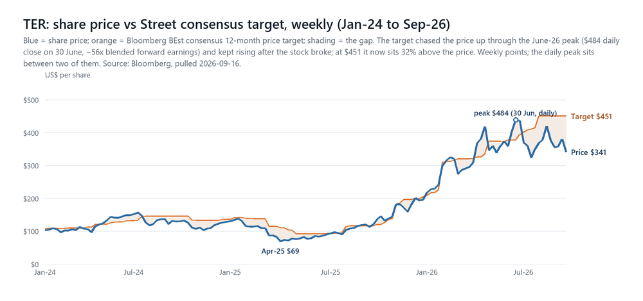
Exhibit 8. Bloomberg, weekly, 2026-09-16. Price series = Friday closes; the 30 June daily peak of $484 sits between two weekly points.
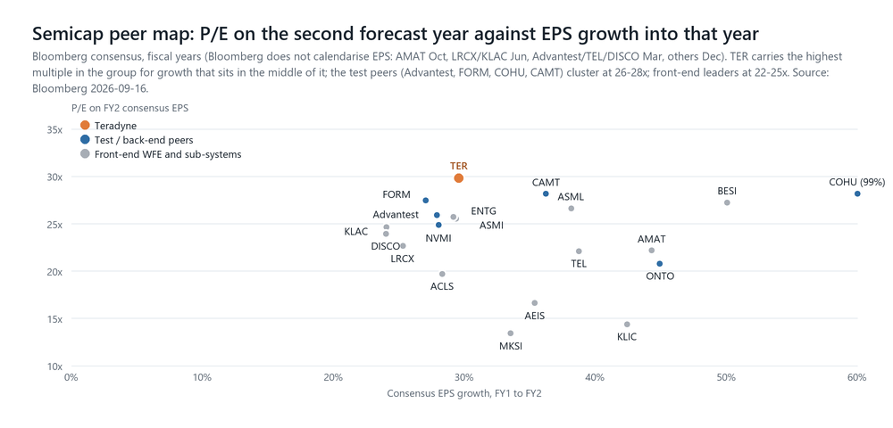
Exhibit 9. Bloomberg consensus, fiscal years, 2026-09-16. AEHR (61x) omitted. TER is the highest multiple in the group; its consensus EPS growth into FY2 (+30%) is mid-pack.

TER · RISKS AND CATALYSTS SECTION 10 / 10
What could make us wrong, in both directions, and when we find out
Dated tests beat opinions. The two that matter most are the late-October Q4 guide and the early-February target model.
Risks to our Neutral: the ways the bull case arrives
- The February model. Management pre-announced a new target earnings model at the Q4 call; the callbacks clustered on 'how quickly can the ATE TAM get to $20 billion and what do we look like when it's at that level'. A model at ≥$20bn TAM with ~40% share and a >38% operating margin is BofA's $8bn / $18 frame (BofA's 07-29 note goes further: ~$11bn / ~$23 at $300bn WFE) and would re-rate the stock toward $500.
- The ratio holds. If the test share of capex does not dip in 2027 (Advantest's TAM raise in late January would be the first read), our CY27 TAM grows 30% rather than 18% and the stock's relative-growth problem versus the front end disappears.
- Faster sockets. Additional merchant-GPU parts in 1H27, hyperscaler #2 releasing more than the first part, a memory share gain in the high single digits, Intel's re-entry to merchant ATE arriving in 2027 rather than 2028; each is a 2027 EPS event.
- Capital return. $617m left on the authorisation and $3.6bn of cash by end-2028 on our numbers; a return to the FY25 repurchase pace ($702m; FY24 $199m, FY23 $401m per the 10-Ks) adds ~0.5% a year to EPS versus our $400-450m, $1bn a year ~1%, and would signal that M&A is not the priority.
- Optical and robotics options land. CPO test toward the $700m end of the 2028 range, Omnyx and MLTP scaling with rack shipments, the robotics marquee customer tripling again; small in the model, large in the multiple.
Risks to the stock: the ways the bear case arrives
- The lag. Management's own scenario: the ratio 'could revert down to 6%, 7% or so' in 2027 while WFE grows 30-43%. Teradyne would print +5-10% growth into a front-end complex printing +30%, on a premium multiple.
- Concentration. Five customers are 44% of revenue; two specify more than 10% each and one buys 19%; Taiwan, Korea and China are 72%. A socket moving back to Advantest, an OSAT capex pause or a program slip shows up within 10-20 weeks, which is the company's lead time by design.
- Memory digestion. ~62% growth against ~30% bit growth (MS) with 2020 and 2024 as precedents; if HBM4 stack decisions (Rubin Ultra 8/12-Hi) reduce insertions rather than multiply stacks, the 'positive for test' argument fails.
- Advantest's response. Capacity to 10,000 SoC testers a year pulled forward, ASPs up 10-15% a year, and a stated view that dual sourcing is 'structurally limited' by switching costs. If its lead times normalise, Teradyne's availability weapon dulls; if it prices to defend, Teradyne's 'not raising prices' becomes a margin cost.
- Margins. Undisclosed one-time benefits in Q1-26, new-product cost curves, input-cost inflation (Chroma lost 3ppt of GM), memory 'a strain into 2027', and a $25.8m FY25 inventory provision 'due to downward revisions to previously forecasted demand levels' (10-K). Our EPS advantage over the Street is opex leverage; if opex grows with revenue, CY28E EPS is $15.4 and the target $386.
- China and export controls. China is 12% of revenue; Teradyne notes competitors are 'not always under the same restrictions'; Chinese ATE entrants (AccoTEST, Hoson, Grand Tech) are on TD Cowen's map; the auto/industrial power-test recovery is partly China.
- Housekeeping risks. The $750m revolver expires 10 December 2026 (renewal is routine); the Technoprobe stake ($515m carrying) marks with Italian small-cap tape; the ERP implementation and three integrations (Quantifi, TestInsight, MLTP) run concurrently; Robotics has lost money in each of the last three years (-$54m / -$78m / -$99m pre-tax, FY23-25), was restructured twice (2024, 2025) and carries $416m of goodwill that the auditor flagged as a critical audit matter (10-K FY25); the model's 15-15.5% tax rate sits above the 12.1% (FY25) and 9.8% (FY24) effective rates, and a return to those rates is upside, not risk.
Catalyst calendar
Date | Event and what to look for
13-14 Oct 2026 | SEMICON West, San Francisco: BofA group meetings with Teradyne (Arya); Bernstein meetings the same days. First management contact since the 11 September quiet period began.
~late Oct 2026 | Q3 FY26 print: the Q4 guide is the event (flat with Q3 = the 2027 base is higher; below $1.15bn = the bear's first datapoint); memory book-to-bill; any 2027 framing; merchant-GPU and hyperscaler #2 conversion into guided revenue; buyback pace.
~late Oct 2026 | Advantest Q2 FY-Mar-27: SoC/memory TAM, capacity, lead-time commentary; Susquehanna hosts Advantest 22 September.
Nov-Dec 2026 | Rubin Ultra HBM configuration freeze (stack height → test insertions); revolver renewal; NAND capacity announcements (Teradyne's 'pull for more NAND capacity').
late Jan 2027 | ASML Q4 / SEMI WFE marks set the 2027 denominator; Advantest Q3 FY-Mar-27 with a first 2027 SoC TAM.
~2 Feb 2027 | Q4 FY26 print and the NEW TARGET EARNINGS MODEL: TAM frame (≥$20bn?), share ambition (mid-single-digit annual gains), gross-margin model (60%+), operating leverage. The most likely single re-rating event on the name.
1H CY27 | The 'next surge' in compute: additional merchant-GPU parts, hyperscaler #2 ramping in 10/20/30-point increments; Q1-27 guide in February and Q2-27 guide in April are where it either appears or does not.
Mar 2027 (OFC) | CPO test insertion standards and port forecasts: is 2027 CPO tracking the $200m low end?
2027 | Intel merchant ATE re-entry 'at small scale'; CY27 memory TAM against bit growth (MS's test); the 2027 test-to-WFE ratio, which settles Debate 1.
2028 | CPO $300-700m; hyperscaler #2 toward 30%+; the ≥$20bn TAM year on management's own path.

TER · APPENDIX A APPENDIX A
The Street map: every published view in the corpus, dated
Nineteen analysts on Bloomberg, 13 Buy / 6 Hold / 0 Sell, mean target $451. The published marks below are those in the Capstone corpus; several houses are on the call but not in it.
Broker · analyst | Rating | PT (basis) | Date | One-line thesis / key numbers
BofA · Vivek Arya | Buy | $450 (31x CY28E; cut from $525, which was 41x) | 2026-07-28 / 07-29 | First take (07-28): ATE buy rate inflecting from ~1% of semi revenue; NVDA dual-source (UltraFLEXplus qualified, fast-follower, ~30% near-term ceiling); ~$8bn sales / ~$18 pf-EPS power at $250bn WFE. PO change (07-29): FY27E raised 15%/17% to $6.3bn / $11.41; 'ATE intensity likely sustaining at 7%-8%… a $14bn+ ATE TAM as early as FY27E'; ~$11bn / ~$23 power at $300bn WFE; 2026 SoC share 'flat to slightly higher before a more visible 2027'; PO cut 'after recent semicap multiple compression' to Advantest's 31x. Hosts TER at SEMICON West 13-14 Oct.
Goldman Sachs · James Schneider | Buy | $465 (37x normalized EPS $12.50; from $350) | 2026-07-05 / 07-28 | Bullish on merchant-GPU test share gains vs Advantest's NVIDIA incumbency; 'strong quarter and guidance likely clears an elevated bar'; key downside risk = delay/failure of the merchant-GPU insertion.
UBS · Timothy Arcuri | Buy | $500 (07-25 sector-sales relay, from $440 on 05-31; formal published PT of record $200, 2025-12-22) | 2026-05-28 / 07-25 / 08-03 / 09-08 | TER is a TAM story: test ~1% of semi revenue vs 15% WFE; 'the Semi Test TAM has averaged a median of ~8% of WFE spend' (07-25); NVDA tester TAM $3-4bn by C28 with TER at 30-70%; C28 revenue ~$7.4bn / EPS ~$15 (05-28); ~500bp 2026 share gain (trimmed by IR to 300-400bp). Hosted the 08-03 IR fireside. 09-08 SemiBytes: TER among the SPE names that 'declined initially following earnings'; UBS 'continue[s] to favor AMD, MU, LRCX, ENTG, and TXN'. Desk relays carry no rating or PT of record.
TD Cowen · Krish Sankar | Buy | $400 (48x CY27E EPS $8.40; SOTP 47x ATE / 50x robotics) | 2026-07-09 | Pre-print: SoC test in mobile digestion, CSP/GPU emerging; CY26 GPU test TAM $2.5bn+ (TER ~$50m); TER ~50% of HBM test; TER 'not raising prices' vs front-end +10-20%; EPS de-risked; robotics profitability 'in question'.
Morgan Stanley · Shane Brett / Joseph Moore | Equal-weight | $397 (from $387) | 2026-07-28 / 08-19 | 'Constructive but unconvinced': base -1%, bull +33%, bear -32%; memory 62% y/y vs 30% bit growth; 'visibility on tester demand more than 6 months out would be unprecedented'; TER 'in between' the 2027-peak and need-2028 buckets; 'Significant', not 'Core to Thesis'.
Citi · Atif Malik | Buy | n/a in corpus | 2026-05-13 / 05-21 | 70% of revenue AI-driven; ATE durable double-digit growth through 2030; GPU share ~3-year path to 30%; VIPs to $800m 'faster than 2028'; CPO TAM $100m → $300-700m (2028) → >$1bn (2030); dual-source manufacturing with ~2x headroom.
Susquehanna · Mehdi Hosseini | Positive | n/a ($357-372 refs) | 2026-09-08 / 09-09 | Optical Update (09-09): CPO/NPO test has no standard methodologies; KGD critical; PIC insertion-1 test >10 minutes per die; prefers Keysight as the test name. On the Q2 call asked about insertion consolidation and robotics.
JPMorgan · Samik Chatterjee | Neutral | $193.37 (Dec-25; no active mark in the corpus) | 2025-12-15 / 2026-06-12 | VIP-ASIC TAM durability + NVDA dual-source the 2026 watchpoints; robotics sub-breakeven; by June 'sounding a bit better about memory', Google qual ~end-3Q, Intel an out-year option. No post-print JPM mark on TER is in the corpus or the mailbox; the December target is 57% of the current price and should be read as absent, not as the Street low.
Jefferies · Kevin Garrigan (AEHR initiation) | NR on TER | — | 2026-08-13 | 'Neither Teradyne nor Advantest has established a meaningful position in high-power wafer-level burn-in'; SAM $626m → $2.0bn (2030). Read-through only.
StoneX · John Su (channel) | n/a | — | 2025-08-20 | GPU/HPC test stays Advantest ('better for HPC because of very large dies'); Teradyne 'best for mobile' / Apple InFO; TSMC second-source qualification 'very difficult'. The pre-dual-sourcing view.
Octahedron (fund LP call) | short idea | — | 2026-07-15 | 'A really big TAM looking out to 2030… but over the next four quarters might not have much to show'; fund view, not a rating.
Bloomberg consensus | 13 Buy / 6 Hold / 0 Sell | $451 mean ($390-550) | 2026-09-16 | CY26E $5.07bn / $8.84; CY27E $6.24bn / $11.45 (hi $14.24 / lo $9.00); CY28E $7.54bn / $14.77 (11 estimates; hi $18.95 / lo $10.60); one CY29 estimate at $8.75bn / $18.45.
Independent authors cited (never brokers, no ratings or targets): DAMNANG (Substack). Desk/sales commentary cited as such: BofA TMT specialist sales (Fenske), MS Asia IED (Amerian), UBS sector sales (Ruple). Management-source compiles: GS Communacopia + Technology 2026 (conference 09-08 to 09-10; Teradyne broadcast and CEO small group 09-09; GS full-summary compile dated 09-13), relayed by the analyst with no GS rating attached. Cantor (CJ Muse) asked on the call; no published view in the corpus.

TER · APPENDIX B APPENDIX B
Ten quarters of reported numbers (non-GAAP unless stated)
The series the model is anchored to. Segment revenue from the press releases; the SoC/Memory/IST split from the calls where given.
Quarter | Revenue $m | y/y | GM | OPM | EPS | Semi Test $m | Prod. Test / Robotics $m | SoC / Memory / IST $m and colour
Q1 FY24 | 600 | -3% | 56.6%* | 14.8% | $0.51 | 412 | 100† / 88 | trough; System Test $75m + Wireless $25m
Q2 FY24 | 730 | +7% | 58.3%* | 21.9% | $0.86 | 543 | 97† / 90 | compute/networking VIP programs begin
Q3 FY24 | 737 | +5% | 59.2%* | 22.4% | $0.90 | 543 | 106† / 89 | AI ~10-15% of revenue
Q4 FY24 | 753 | +12% | 59.4%* | 21.7% | $0.95 | 561 | 94† / 98 | FY24 $2,820m / $3.22
Q1 FY25 | 686 | +14% | 60.6% | 20.5% | $0.75 | 543 | 74 / 69 | Product Test segment formed (Mar-25)
Q2 FY25 | 652 | -11% | 57.3% | 15.1% | $0.57 | 492 | 85 / 75 | 397 / 61 / 34; AI ~20% of SoC; Quantifi closed
Q3 FY25 | 769 | +4% | 58.5% | 20.4% | $0.85 | 606 | 88 / 75 | 440 / 128 / 38; ~50% of revenue AI
Q4 FY25 | 1,083 | +44% | 57.2%* | 29.0% | $1.80 | 883 | 110 / 89 | ~650 / 206 / ~27 (SoC, IST derived); >60% AI
Q1 FY26 | 1,282 | +87% | 60.9% | 37.5% | $2.56 | 1,111 | 80 / 91 | 882 / 203 / 27; ~70% AI; record on every line
Q2 FY26 | 1,329 | +104% | 59.8% | 33.7% | $2.47 | 1,122 | 107 / 100 | 843 / 212 / 67; compute 70% of SoC, +~600% y/y
FY25 | 3,190 | +13% | 58.2% | ~22% | $3.97 | 2,524 | 358 / 308 | 1,890 / 505 / 129 (10-K product lines)
1H FY26 | 2,611 | +95% | 60.3% | 35.6% | $5.02 | 2,233 | 187 / 191 | 1,725 / 415 / 94; FCF $579m
Sources: company press releases (revenue, non-GAAP EPS, non-GAAP operating margin, segment revenue), 10-K FY25 (product lines), calls (SoC/Memory/IST). * = Bloomberg GAAP gross margin where the press release reconciliation is not in the corpus; Q4 FY25 GM is the Bloomberg GAAP figure (guide was 57-58%). † = System Test + Wireless Test under the pre-2025 segment structure (Product Test was formed in March 2025 and IST moved into Semiconductor Test). Q4 FY25 SoC and IST are derived from the Semi Test total and the disclosed memory figure.
Appendix C: balance sheet and cash flow (US$m)
Line | FY24 | FY25 | Jun-26 / 1H26 | Comment
Cash from operations | 672 | 674 | 734 (1H) | 1H26 already above any full year; receivables +$302m in H1 on the revenue step-up
Capex | (198) | (224) | (155) (1H) | Q2 $91m, 'increased $26m from last quarter'; 7% of FY25 revenue; BEst FY26 $282m
Free cash flow | 474 | 450 | 579 (1H) | Q2 $378m; conversion 73% of non-GAAP NI in 1H; Capstone CY26E $1,136m
Buybacks / dividends | (199) / (76) | (702) / (76) | (74) / (41) (1H) | FY23 $401m; 0.2m shares at $341.89 in 1H26; $1,383m used of the $2.0bn Jan-2023 authorisation ($617m left); $0.13/qtr
Acquisitions / divestitures | (524) Technoprobe 10%; +85 DIS sale | (145) Quantifi + AET | (166) MLTP JV + TestInsight | DIS (device-interface) business sold to Technoprobe for $85m in May-24, $57.1m pre-tax gain, ~$55m of annual service revenue given up; 'dry powder for accretive M&A' inside the wafer-to-datacentre strategy
Cash and investments | 724 | 448 | 517 | cash 350 + short-term 5 + long-term marketable 162
Debt | 0 | 200 (revolver) | 0 | $750m revolver, expires 2026-12-10; $350m drawn and $550m repaid in 1H26
Accounts receivable | n/a | 787 | 1,110 | 76 days of revenue; the swing item in 1H cash flow
Inventories | n/a | 380 | 403 | 68 days of COGS; 'inventory investment increased in support of future sales'
Deferred revenue and customer advances | n/a | 204 | 257 | current 194 + long-term 63
Equity-method investment (Technoprobe) | n/a | 537 | 515 | 10% of Technoprobe; $7.6m/qtr amortisation excluded from non-GAAP
Goodwill + intangibles | n/a | 572 | 766 | MLTP goodwill $83m + intangibles $44m (10-year life)
Total equity | n/a | 2,796 | 3,473 | incl. $36m non-controlling interest (MultiLane's 25% of MLTP)
Shares outstanding (m) | 163.3 dil. | 159.7 dil. | 156.3 (07-27) | diluted 157.7m in Q2; count -26% since 2015
Source: 10-K FY25 and 10-K FY24 (cash-flow statements, MD&A liquidity section, share-repurchase disclosures), 10-Q Q2 FY26 and the 2026-07-28 press release (condensed statements).

TER · APPENDIX D APPENDIX D
How management's language moved over five quarters
Seven themes, quarter by quarter, paraphrased from the calls. Only the Q2 FY26 column rests on a verbatim (Bloomberg) transcript; the four earlier columns are built from third-party bullet summaries of the calls (Motley Fool / Insider Monkey) and carry that caveat. The latest column is bold; the direction of travel is the point.
Theme | Q2 FY25 (2025-07-30) | Q3 FY25 (2025-10-29) | Q4 FY25 (2026-02-03) | Q1 FY26 (2026-04-29) | Q2 FY26 (2026-07-29)
AI mix | AI compute ~20% of SoC; 'AI + verticalization the primary near-term growth drivers' | ~50% of revenue AI-driven; ~60% guided for Q4 | >60% of Q4 revenue; ~70% guided for Q1 | ~70% of revenue; 'three AI waves' framed (general-purpose, inference-optimised, edge) | >60% of revenue; compute 70% of SoC product revenue, +~600% y/y; 'wafer to AI data center' strategy delivering
Compute / dual-sourcing | 'Significant growth Q3 over Q2 and Q4 over Q3' in compute expected | Merchant-GPU design wins NOT in guide; demand 'incredibly concentrated' (~2 customers); hyperscalers moving to dual-sourcing | Evergreen model: $6bn / 59-61% GM / $9.50-11 EPS on a $12-14bn ATE TAM | First multi-system merchant-GPU production orders; 'low-double-digit share sufficient' for $6bn | Order shipped; second hyperscaler correlated; four-phase ladder, 9-12 months to ramp, fast-follower 0→~30%; one mature / one fast-follower / one in qual; next surge 1H27
Memory | $61m, timing-related decline; recovery expected in 2H; HBM4 singulated-die win 'important growth driver' | $128m (+110% q/q); ~75% DRAM / 25% flash; Magnum 7H HBM3E/HBM4; singulated-stack insertion ramping | Record $206m (+61% q/q) | $203m; HBM + DRAM strength | Record $212m; book-to-bill >2x; 2026 TAM +40%+; DDR the surprise; NAND 'pull from customers'; 'two flywheels'; MS's bit-growth question taken offline
Year shape / visibility | Mobile seasonality 'no longer dictates revenue' | Q4 guided $920m-1.0bn; 2028 EPS target $7.00-9.50 reiterated | FY26 framed 60/40 H1-weighted ('the inverse of 2025') | 55-60% H1; 'we don't have meaningful commitment from customers around what they'll buy and when' | Re-cut to 50-52% H1 (FY26 ≈ $5.0-5.2bn); 2027 'resurgence'; confidence rests on the WFE correlation ('strong over 3-5 years, not at all at a quarter level'); ~16-week lead times
Gross margin | 57.3% | 58.5% (above guide); Q4 guided 57-58% incl. one-time supply-chain costs | Within guide; target model 59-61% | Record 60.9% (+370bp q/q) | 59.8%; Q3 guided 58-59%; FY 'right around 59%'; memory 'a strain… into 2027'; ±400bp quarterly swing, ±200bp annual band
Robotics | $75m (+9% q/q); 'plan of record' customer win for later 2026; new US plant | $75m flat; UR $62m / MiR $13m | $89m; third straight growth quarter | $91m (+32% y/y); fourth straight growth quarter | $100m (+33% y/y); electronics/semis +50% q/q and now the largest vertical; 'grow in proportion with the rest of the company'; US 32% of sales
Test intensity / TAM | — | Chiplets require upstream test to manage scrap; DC tolerance for latent defects 'very, very low' | ATE TAM $12-14bn in the model | 'Three AI waves'; CPO $300-700m mid-term TAM, ~$100m today | Test 4% → 7% → 8% of semi capex; settle 7-9% (most likely 7-8%); 'could revert to 6-7%' in 2027; ATE TAM path ≥$20bn at ~$250bn WFE; 'test is now outpacing fab equipment'
Source: earnings-call transcripts and summaries on file (Q2 FY25 to Q2 FY26); paraphrased. The Q3 FY25 call also marked the CFO transition (Sanjay Mehta to Michelle Turner, effective 2025-11-03).
Appendix E: Teradyne vs Advantest, the duopoly on one page
Axis | Teradyne (TER) | Advantest (6857 JP) | Source
Position | #2; total test share ~37% 'basically flat' in 2026 (UBS arithmetic on the call); leader in memory/HBM test (~50% of HBM test per TD Cowen) | #1; SoC tester share 'high-60% range' in 2025; sole/dominant at NVIDIA GPU test; NVIDIA = 20.2% of FY-Mar-26 sales (securities report) | TER call 07-29; Advantest Q3 FY-Mar-26 call; @QQ_Timmy 08-01 relaying the filing (not read directly)
Compute pools | Hyperscaler #1 ~70% share; merchant account 2nd vendor, 3-5 yrs to ~30% of compute; hyperscaler #2 ramping 10/20/30 pts in 2027; networking very high share, sole-source at one | GPU incumbency; 'dual sourcing structurally limited' by switching costs; expects ASIC pool to overtake GPU within ~1 year (was 2-3) | GS Communacopia small groups 09-09, per the 09-13 compile (management)
Memory | Records three straight quarters; book-to-bill 2.0; single-digit share gains expected; HBM4 wafer-sort and singulated-stack wins | Guided to lose memory share (TER 'agreed'); memory test on high-performance DRAM and non-volatile | TER call 07-29; IR 08-03; Advantest 07-28
Lead times / capacity | 10-20 weeks, 'stay under six months'; 'using our supply chain to try and gain share'; dual-source manufacturing ~2x headroom (Citi) | Visibility 'now extends like 12 months' (Arcuri's paraphrase of an Advantest IR call 'last night', 08-03); 5,000 → 10,000 SoC testers/yr target pulled forward, further expansion considered | IR 08-03; GS 09-09; Citi 05-21
Pricing | 'Not raising prices' (TD Cowen 07-09); GM 59-60% | Tester ASP +10-15%/yr for 1-2 years; GM ~67-68%; FY-Mar-27 op margin guided flat | TD Cowen; GS 09-09; BBG
TAM basis | Includes burn-in and IST; ratio-to-capex framing (8%); path to ≥$20bn | Excludes burn-in; TAM raised 07-28, 'in the right zip code' per TER | TER call 07-29
Growth (consensus) | CY26 +59% / CY27 +23% / CY28 +21% revenue; EPS +30% into CY27 | CY26 +35% / CY27 +40% / CY28 +23% revenue (¥); EPS +28% into FY2 | Bloomberg 09-16
Valuation | 32.0x blended forward (BEst 09-11 EPS $10.65 at $341); 29.8x CY27E / 23.1x CY28E (Street); mean PT $451 (13/6/0) | 29.5x blended forward (¥1,041.6 at ¥30,700); 25.9x FY2 / 21.6x FY3; JPM OW ¥41,000, Bernstein OP ¥45,800, MS OW ¥36,000 (pre-print) | Bloomberg 09-16; ADVANTEST wiki page
Shared bear | Concentration (top-5 44%), 10-20 week visibility, 2027 ratio lag, memory digestion | NVIDIA concentration, China 20-25% of revenue, flat-margin guide, HBM de-spec ('process control most vulnerable', MS) | 10-K FY25; Advantest calls; MS 09-08
Who prefers whom | GS names TER the merchant-GPU challenger and the share-gainer; BofA Buy $450 at 31x, 'in line with… Advantest'; UBS Buy on TAM; MS EW at fair value | MS Asia desk: 'own an agnostic winner like Advantest'; JPM top pick; Bernstein OP; the 'toll booth' argument | GS 07-05; Amerian 08-14; JPM 09-09
Pair logic: the duopoly grows with the same TAM; Teradyne is the share-gainer at a similar multiple on FY3 (23x vs 22x) but a higher one on FY2 (30x vs 26x) because its 2027 growth is lower; BofA now strikes its TER target at Advantest's 31x CY28E. A long TER / short 6857 pair is a bet on the dual-sourcing slope; a long 6857 / short TER pair is a bet on 2027 test-time rationing and the GPU pool. We hold neither.
Appendix G: sources and basis notes
- Company primary sources: 10-K FY25 (2026-02-19), 10-Qs Q1 FY25 to Q2 FY26 (latest 2026-07-31), earnings press releases 2024-01-31 to 2026-07-28 (EDGAR), the Q2 CY26 earnings call (Bloomberg final transcript, 2026-07-29), third-party bullet summaries (Motley Fool / Insider Monkey, fetched 2026-06-19) of the Q2 FY25 to Q1 FY26 calls, which are not verbatim transcripts and are quoted as such, the UBS-hosted IR fireside with Amy McAndrews (2026-08-03, machine transcript), and the Goldman Sachs Communacopia 2026 sessions (2026-09-09 broadcast; 2026-09-13 CEO small group, both management speaking).
- Market data: Bloomberg terminal pulls on 2026-09-16 (price, consensus by quarter and year, target-price and rating history, blended-forward P/E history 2010-2026, peer consensus). Teradyne's fiscal year is the calendar year, so no calendarisation is needed for Teradyne; peer P/Es are on fiscal years as noted. The CY26 Street EPS of $8.84 is Bloomberg's annual line (18 estimates); the quarterly ladder sums to $8.96 because the annual line lags the post-print quarterly refresh.
- Broker and independent sources: Outlook mailbox checked for post-print marks on 2026-09-16 (BofA PO change 07-29, UBS sector-sales relay 07-25, UBS SemiBytes 09-08, GS Communacopia takeaways 09-09); otherwise as dated in the text and in the Capstone wiki page for TER (Debate, intra-quarter log, Changelog), the ADVANTEST page, the semicap-WFE theme page and the assumptions ledger (WFE canonical ranges). Where a source is a machine transcript, a desk relay or a management compile rather than a published note, the text says so.
- Basis rules applied: non-GAAP as the company defines it (SBC not excluded); ATE-to-WFE ratio never mixed with the test-to-semiconductor-revenue ratio; TAM bases (Advantest ex-burn-in vs Teradyne) kept apart; no customer named as a company disclosure unless the company named it; GW bases not used in this document.
- Analyst: Felipe Monteiro, Capstone US Equities. Internal research, not investment advice. Estimates are Capstone's own; the prior wiki house line (semicap peer model, 2026-06-15) is superseded by Section 8.

