Maximum Mean Discrepancy in High-Dimensional Biology

Frederick Boehm1,✉

08 May, 2021

Text of abstract

1 University of Massachusetts Medical School

✉ Correspondence: [Frederick Boehm <[frederick.boehm@gmail.com](mailto:frederick.boehm@gmail.com)>](mailto:frederick.boehm@gmail.com)

Keywords: keyword 1; keyword 2; keyword 3

Highlights: These are the highlights.

# 1 Specific Aims

**Aim 1: Examine statistical and mathematical properties of MMD.**

**Aim 2: Apply MMD to high-dimensional biological data**

**Aim 3: Create an R package that implements MMD methods**

# 2 Background and Significance

The last twenty years have seen an explosion in the volume and dimensionality of molecular biology data. Following the sequencing of the human genome, technologies such as DNA sequencing, RNA sequencing, and single-cell RNA sequencing proliferated. The new experimental designs and high dimension of modern biological data require parallel development of new statistical methods and computational tools for their analysis. Maximum mean discrepancy (MMD) is a new statistical tool with novel mathematical properties (Borgwardt et al., 2006; Gretton et al., 2012, 2009, 2006). We propose to explore its mathematical and statistical properties and to apply MMD methods in the analysis of high-dimensional biological data.

MMD is a statistical method for determining whether two high-dimensional samples arise from distinct distributions. Throughout this document, we use the term “sample” to refer to measurements on a collection of subjects from a single group. In introductory statistics courses, one often studies Student’s t-test (Student, 1908) when discerning whether two samples come from the same distribution. Implicit to the t-test are the assumptions that the two samples arise from normally distributions with a single, common variance parameter.

# 3 Approach

# 4 Methods

# 5 Results

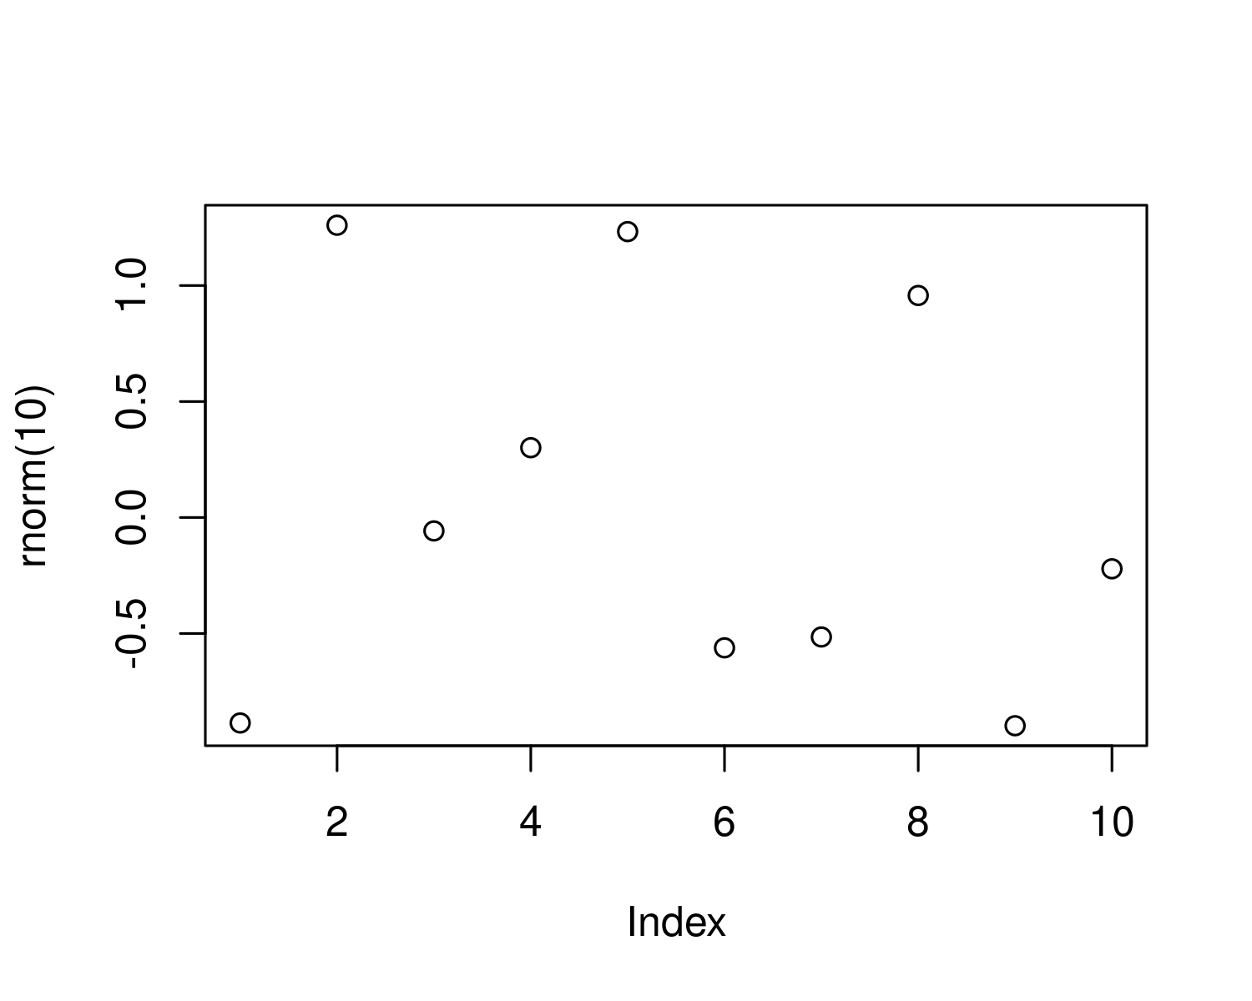

Figure 5.1: A plot of random numbers

Figure 5.1 shows how we can have a caption and cross-reference for a plot

Here is an example of inline code 3.14 in the middle of a sentence.

# 6 Discussion

# 7 Conclusion

# 8 Acknowledgements

# 9 References

Borgwardt, K.M., Gretton, A., Rasch, M.J., Kriegel, H.-P., Schölkopf, B., Smola, A.J., 2006. Integrating structured biological data by kernel maximum mean discrepancy. Bioinformatics 22, e49–e57.

Gretton, A., Borgwardt, K.M., Rasch, M.J., Schölkopf, B., Smola, A., 2012. A kernel two-sample test. The Journal of Machine Learning Research 13, 723–773.

Gretton, A., Borgwardt, K., Rasch, M., Schölkopf, B., Smola, A., 2006. A kernel method for the two-sample-problem. Advances in neural information processing systems 19, 513–520.

Gretton, A., Fukumizu, K., Harchaoui, Z., Sriperumbudur, B.K., 2009. A fast, consistent kernel two-sample test., in: NIPS. pp. 673–681.

Student, 1908. The probable error of a mean. Biometrika 1–25.

### 9.0.1 Colophon

This report was generated on 2021-05-08 15:09:19 using the following computational environment and dependencies:

#> ─ Session info ───────────────────────────────────────────────────────────────  
#> setting value   
#> version R version 4.0.4 (2021-02-15)  
#> os Ubuntu 21.04   
#> system x86_64, linux-gnu   
#> ui X11   
#> language (EN)   
#> collate en_US.UTF-8   
#> ctype en_US.UTF-8   
#> tz America/New_York   
#> date 2021-05-08   
#>   
#> ─ Packages ───────────────────────────────────────────────────────────────────  
#> package * version date lib source   
#> assertthat 0.2.1 2019-03-21 [1] CRAN (R 4.0.1)   
#> bookdown 0.21 2020-10-13 [1] CRAN (R 4.0.3)   
#> cachem 1.0.4 2021-02-13 [1] CRAN (R 4.0.3)   
#> callr 3.5.1 2020-10-13 [1] CRAN (R 4.0.3)   
#> cli 2.3.1 2021-02-23 [1] CRAN (R 4.0.3)   
#> crayon 1.4.1 2021-02-08 [1] CRAN (R 4.0.3)   
#> desc 1.2.0 2018-05-01 [1] CRAN (R 4.0.1)   
#> devtools 2.3.2 2020-09-18 [1] CRAN (R 4.0.3)   
#> digest 0.6.27 2020-10-24 [1] CRAN (R 4.0.3)   
#> ellipsis 0.3.1 2020-05-15 [1] CRAN (R 4.0.1)   
#> evaluate 0.14 2019-05-28 [1] CRAN (R 4.0.1)   
#> fastmap 1.1.0 2021-01-25 [1] CRAN (R 4.0.3)   
#> fs 1.5.0 2020-07-31 [1] CRAN (R 4.0.3)   
#> glue 1.4.2 2020-08-27 [1] CRAN (R 4.0.3)   
#> highr 0.8 2019-03-20 [1] CRAN (R 4.0.1)   
#> htmltools 0.5.1.1 2021-01-22 [1] CRAN (R 4.0.3)   
#> knitr 1.31 2021-01-27 [1] CRAN (R 4.0.3)   
#> lifecycle 1.0.0 2021-02-15 [1] CRAN (R 4.0.3)   
#> magrittr 2.0.1 2020-11-17 [1] CRAN (R 4.0.3)   
#> memoise 2.0.0 2021-01-26 [1] CRAN (R 4.0.3)   
#> pkgbuild 1.2.0 2020-12-15 [1] CRAN (R 4.0.3)   
#> pkgload 1.2.0 2021-02-23 [1] CRAN (R 4.0.3)   
#> prettyunits 1.1.1 2020-01-24 [1] CRAN (R 4.0.1)   
#> processx 3.4.5 2020-11-30 [1] CRAN (R 4.0.3)   
#> ps 1.5.0 2020-12-05 [1] CRAN (R 4.0.3)   
#> purrr 0.3.4 2020-04-17 [1] CRAN (R 4.0.1)   
#> R6 2.5.0 2020-10-28 [1] CRAN (R 4.0.3)   
#> remotes 2.2.0 2020-07-21 [1] CRAN (R 4.0.3)   
#> rlang 0.4.10.9000 2021-03-31 [1] Github (r-lib/rlang@2b9f2b3)   
#> rmarkdown 2.7 2021-02-19 [1] CRAN (R 4.0.3)   
#> rprojroot 2.0.2 2020-11-15 [1] CRAN (R 4.0.3)   
#> sessioninfo 1.1.1 2018-11-05 [1] CRAN (R 4.0.1)   
#> stringi 1.5.3 2020-09-09 [1] CRAN (R 4.0.3)   
#> stringr 1.4.0 2019-02-10 [1] CRAN (R 4.0.1)   
#> testthat 3.0.2 2021-02-14 [1] CRAN (R 4.0.3)   
#> usethis 2.0.1.9000 2021-02-15 [1] Github (r-lib/usethis@aaf79d8)  
#> withr 2.4.1 2021-01-26 [1] CRAN (R 4.0.3)   
#> xfun 0.22 2021-03-11 [1] CRAN (R 4.0.3)   
#> yaml 2.2.1 2020-02-01 [1] CRAN (R 4.0.1)   
#>   
#> [1] /home/fred/R/x86_64-pc-linux-gnu-library/4.0  
#> [2] /usr/local/lib/R/site-library  
#> [3] /usr/lib/R/site-library  
#> [4] /usr/lib/R/library

The current Git commit details are:

#> Local: main /home/fred/work/professional-development/mmdproject  
#> Remote: main @ origin (https://github.com/fboehm/mmdproject.git)  
#> Head: [04db879] 2021-04-29: merged