**USING THE PHYSICAL LIFE CALCULATOR**

Following is a copy of the Physical Life Calculator input/output template. If you have any doubt about a question (i.e., what is a greenfield site?) refer to the explanatory comments following the template.

**Completion Instructions**

In the top field (under PHYSICAL LIFE CALCULATOR) write the building name and address.

In the next field write a 3-line descriptive comment specific to the building siting, occupancy and integrity characteristics. Something like this:

2-Story frame construction. Stable soil conditions (or comment if other). Owner-occupied (or tenant-occupied) year-round (comment if seasonal). Comment if there is onsite video or professional security surveillance. Comment if fire sprinklered. Comment if very high quality (luxury) construction.

Mark each question with a Y or N. If you don’t know an answer, leave it blank.

Note: 1 kilometer is 3,281 feet. 500mm is about 20 inches. 10 m2 is about 108 square feet.

Answers to the 30 Yes/No questions characterize the building environmental context, its occupational profile, and its structural integrity. The questions indicated with (#) are double weighted, and blank spaces are ignored.

**Background**

This tool was developed by Craig Langston, Professor of Construction and Facilities Management, Bond University, Queensland, Australia, as a component in his study of building obsolescence culminating in his 2011 conference paper entitled, **“*Estimating the useful life of buildings*”**.

Professor Langston explains that his physical life calculator algorithm assumes a base life of 100 years, and then adds or deducts points (years) according to the responses to questions. It is similar in concept to the Living to 100 Life Expectancy Calculator (see http://www.livingto100.com) that predicts human life span based on extensive medical and empirical data. Some conservatism is applied to the estimate and the forecast is rounded down to one of the following outcomes: 25, 50, 75, 100, 150, 200, 250 or 300 years. The template is unsuitable for temporary structures or for iconic monuments, both of which require specialist judgment.

The Calculator does not replace expert opinion, but it informs expert judgement.

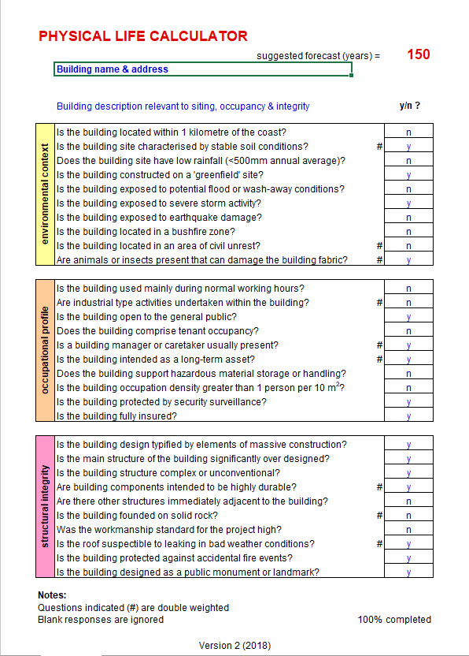

Environmental Context

Is the building located within 1 kilometer of the coast?

A kilometer is about .6214 statute miles (3,281 feet) and a mile is about 1.609 kilometers. This question factors for corrosion, erosion, storm severity and other characteristics associated with a marine exposure.

Is the building site characterized by stable soil conditions?

Is this building on soft ground, or is there on-going soil movement that might affect the building integrity? A “No” here can be offset later by a “Yes” about whether the building is on solid rock which is the same as an intact in-ground piling foundation.

Does the building site have low rainfall (<500mm annual average)?

Is the annual average rainfall less than 20-inches.

Is the building constructed on a “greenfield site”?

A greenfield site is one where there was no building before.

Is the building exposed to potential flood or wash-away conditions?

If the building is in a designated floodway or flood zone, then the answer is “Yes”. Also, “Yes” if there is a history of the building flooding.

Is the building exposed to severe storm activity?

Hurricane, typhoon, tornado, etc.

Is the building exposed to earthquake damage?

Is it in a known earthquake zone? Also answer this question “Yes” if exposed to volcanic or other, similar risks.

Is the building located in a bushfire zone?

Is wildfire likely to burn through the surrounding area?

Is the building located in an area of civil unrest?

Civil unrest means riots, war, etc.

Are animals or insects present that can damage the building fabric?

What eats or gnaws buildings? Termites, carpenter ants, carpenter bees, porcupines, bears, etc.

Occupational Profile

Is the building used mainly during normal working hours?

For a building occupied more than 12 hours a day the answer is probably “No”.

Are industrial type activities undertaken within the building?

Heavy live loads, heavy vibrations, hot/cold extremes, etc.

Is the building open to the general public?

Residential uses are usually “No”. Government buildings and most retail uses are “Yes”.

Does the building comprise tenant occupancy?

If the building is tenant-occupied or if it is intended for tenant occupancy, then the answer is probably “Yes”.

Is a building manager or caretaker usually present?

This question is about whether there is someone regularly present who has access to the building interior, and who is personally responsible for the building. If there is paid professional management, then answer “Yes”. If it is single-unit residential occupied only part of the year, then probably “No”.

Is the building intended as a long-term asset?

Probably “No” for inexpensive agricultural buildings, small accessory structures, and the like.

Does the building support hazardous material storage or handling?

Many industrial uses will answer “Yes”. Also, Yes for fuel farms, fertilizer storage, and other tank farms.

Is the building occupation density greater than 1 person per 10 m²?

That is, greater than about 108 square feet. Things happen to buildings when the occupational density is very high. For most residential uses the answer will be “No”. For offices, restaurants, theatres, motels, flop houses, etc., the answer might be “Yes”.

Is the building protected by security surveillance?

Is there a video surveillance system, or on-patrol security?

Is the building fully insured?

This speaks to the interest of an insurance company to minimize its risk, and the questions posed by the lack of insurance. Leave blank if unknown or uncertain. Mortgaged buildings are usually insured, and government-owned buildings often are not.

Structural Integrity

Is the building design typified by elements of massive construction?

Think stone or solid concrete walls and floors.

Is the main structure of the building significantly over designed?

Possible for any building type, especially if designed for additional stories or super durability.

Is the building structure complex or unconventional?

Moving roofs or walls, complex curves, untried materials, or construction techniques?

Are the building components intended to be highly durable?

Long-lived components, properly assembled, lead to long physical life.

Are there other structures immediately adjacent to the building?

This is about proximity risk. If walls touch, or if there is a common wall, then the answer is “Yes”. If building separation distance precludes side access for firefighting, then consider a “Yes”. This question is also related to neighboring basements.

Is the building founded on solid rock?

Also “Yes” if the building is constructed on engineered, in-ground pilings and grade beams.

Was the workmanship standard for the project high?

This is a question about high quality construction. So, luxury hotels and residences will be “Yes”, most buildings will be “No”.

Is the roof susceptible to leaking in bad weather conditions?

This is about a new roof that leaks or a roof design with a history of leaking. A good example is a glass roof, or a roof design type that nearly always leaks. This is not about a well-designed, but worn out roof.

Is the building protected against accidental fire events?

Is there an active fire suppression system?

Is the building designed as a public monument or landmark?

Is the building designed to last “forever”?