MArine Engines

By

Insert Your Name

Presented to

Instructor’s Name, Course

Institution Name, Location

Date Due

**1. Describe how the number of lifeboats carried on a vessel is determined and outline the action of a marine surveyor in determining if the engine of a lifeboat has been tested regularly and is in good working order.**

The number of lifeboats carried on a vessel is determined by the aggregate capacity of the vessel. Any vessel should carry sufficient lifeboats that can accommodate all the people onboard. Additionally, the vessel must have/carry liferafts that can accommodate 50 percent of the people onboard. This ensures the safety of the persons in case of any accident (International Maritime Organization, 2004).

Marine engineers determine if the engine of a lifeboat is regularly tested and is in good working order by testing it, checking records onboard of maintenance, grease on wire falls, and whether the indicator shows a safe situation. Additionally, marine engineers check other substances that limit the efficiency of the lifeboat’s engine such as excessive rust or paints. Reviewing the reports of inspections, repairs, servicing, and maintenance, which should always be update and onboard, gives the engineer a glimpse of the condition of the engine. Further, an examination of the engine and propulsion system, the condition of the engine in terms of loose and fixed parts, and the components directly connected to the engine determines whether the boat is in good condition.

**2. Describe how the capacity of lifeboats is determined.**

The capacity of lifeboats is determined by size, shape, and the carrying capacity of the vessel they are intended to be used in. The size determines the number of persons that can board the lifeboat. Additionally, the design in terms of shape determines the arrangement of people inside, thus playing a significant role in determining its capacity. Most importantly, lifeboats are sometimes designed for specific vessels. In such cases, the capacity of the vessel and the number of the lifeboats required for the vessel determines the lifeboat capacity. The lifeboat is, therefore, constructed to meet the specific demand.

**3. State the type or types of fire extinguishers that should be found in the accommodation of a ship.**

* Water Extinguisher
* Soda-Acid Extinguishers
* Foam Extinguishers – mechanical and chemical
* Carbon dioxide extinguishers, and
* Dry-powder extinguishers (Anderson, 2014)

**4. Explain five main properties of fuel oil that affect the performance of marine engines and which chemical properties have an effect on the environment?**

**Fuel Properties**

* Viscosity – the viscosity of marine fuel oils influences its use and is purchased based on the limiting viscosity due to engine-related restrictions. The viscosity does not significantly have quality implications but influences the quality of combustion in marine engines. A high viscosity fuel causes improper atomization and subsequently, incomplete combustion. As such, it is important to use fuel of the right viscosity range. Providing high temperature using a fuel-oil heater is critical for lowering the viscosity (American Bureau of Shipping, 2011).
* Asphaltenes/carbon residue - is defined as the measure of fuel’s tendency to form carbon or asphaltenes deposits in the course of combustion. Fuels rich in carbon are more difficult to combust and mainly cause the formation of soot/carbon deposits. These deposits cause a significant abrasive wear causing engine inefficiency. Asphaltenes are insoluble in hot heptane and petroleum naphtha but soluble in hot benzene and carbon disulfide. Their formation in marine engines causes delay in ignition, engine fouling, and abrasive wear (American Bureau of Shipping, 2011; Vermeire, 2012).
* Specific gravity - is the ratio of weight of a particular volume of a product at 15 oC to the weight equal to that of water at the same temperature. That various standard fuel/water separation techniques use the difference in density of the substances. Engines’ effectiveness if affected when the specific gravity of the fuel approaches 1.0 making centrifugation less effective. This leaves water elements in the fuel affecting the marine engines, which use water-free fuels significantly. According to Vermeire (2012), the high specific gravity shows a heavily cracked aromatic fuel that combusts poorly causing abnormal liner wear. Further, the deposits of carbon and asphaltenes cause slow burning and high b.p. constituents which result in changes in the rate of releasing heat and high thermal loading. These among other effects cause scuffing, engine deposits, and cylinder wear.
* Compatibility – occurs when heavy fuels with high content of asphaltene are mixed with lower fractions predominant with aliphatic hydrocarbons. Mixing of the fuel oils causes asphaltenes’ precipitation. Incompatibility of fuel oils causes rapid strainer and excessive sludge, which result in injection pump sticking, exhaust valve and injector deposits, and deposits on the turbocharger turbine of the diesel engine. The removal of the incompatible oil and deposits is time-consuming and expensive while failure to remove them causes inefficiency.
* Heating value – the heat contained/released during the combustion of heavy fuel oils influences diesel engine performance greatly. Therefore, the consideration of the heating values of a marine fuel oil is of critical importance. A change in the heating value indicated by a change in the heat content is revealed through increased brake specific fuel rate measured in pounds per brake horsepower/hour and causes a decrease in the overall engine efficiency. More fuel of lower heat content should be burnt to ensure fixed power output (American Bureau of Shipping, 2011).

**Chemical properties**

* Sulfur – this element is found in all crude oils in varying concentrations and forms. Distillation of crude oil concentrates derivatives of sulfur in the heavier fractions leaving the lighter fractions with lower sulfur contents. The type of engine determines the extent to which the sulfur is tolerated. The release of sulfur into the environment in form of sulfur dioxide pollutes the environment by causing acid rain.
* The carbon content – marine fuel oils contain a high carbon content whose combustion causes the release of carbon monoxide and carbon dioxide, which are greenhouse gases, and which cause the greenhouse effect. The effect causes increased global temperatures, melting icecaps, rising sea levels, and environmental diseases such as skin cancer among other.
* The flash point of the marine fuel oils contributes significantly towards environmental pollution. The characteristic influences the ignition and combustion of fuels. Fuels with high flash points are likely to show semi-combustion leading to the release of greenhouse gases and carbon into the environment. The gases such as CO and CO2 have a great impact on the environment.
* Heavy metals – crude and heavy fuel oils used in ships and marine engines in general have higher levels of carbon and heavy metals. The release of the heavy metals into water bodies affect marine life by causing overgrowth of marine plants, which cause a depletion of oxygen in the water, causing the loss of marine fauna.
* Vanadium – crude oil contains considerable amounts of vanadium. Accidental spillage of the oil causes toxic effects in the environment that last for long-term. Additionally, the release of the element into the environment causes the development of particulates/aerosols which influence the environment significantly (American Bureau of Shipping, 2011; Vermeire, 2012)

**5. If you have been instructed to carry out a condition survey for a handy size bulker, suffering from heavy weather damage resulting in the partial flooding of No,1 hold, list the following:**

**a) The structural items you would check and form of damage you would look for to assess the condition freeboard deck forward and outboard of No 1 hatch, including your assessment of the need for repairs (10%)**

The examination of the decks places emphasis on areas of possibly increased corrosion or stress concentration. These include:

* Hatch corners
* Deckhouses
* Hatch coamings and other discontinuities of the structure

Attention is further directed towards the examination of the end and side openings and the related inner and shell doors. The purpose is the determination of the water-tightness and weather-tightness of the decks and their damage stability (International Maritime Organization, 2009).

**b) The structural items you would check and the form of damage you would look for on the No 1 hatch coamings and No 1 hatch covers.**

The examination of deck erections such as deckhouses and hatch coamings is critical during a survey. The examination focuses on the connections of the equipment, and the attachments to the structural elements that carry the load. The greatest attention is directed towards the end and side openings and other related parts such as the inner doors and the shell. The survey of hatch covers checks the satisfactory of the mechanical operations. It highlights damages occurring on the stowage, rubber gaskets, securing in open condition, wires, locking and the efficiency of sealing in closed position, the hydraulic and power components, and the link drives and chains. Survey of hatch coaming targets the identification of faults in sealing arrangements, stiffeners, and the hatch cover plating. Also, the survey measures or inspects the thickness of coaming (International Maritime Organization, 2009; DNV, 2014).

**c) The structural items you would check and the form of damage you would look for in the No 1 cargo hold side shell structure, transverse bulkheads structure and upper wing tanks structure. (10%)**

**Cargo hold side shell structure**

* Side shell frames
* End brackets
* The transverse bulkhead and the lower stool
* Hopper tank, double tank bottom, girder, and the watertight bulkhead.

**Transverse bulkheads structure**

* Upper stool
* Topside tank
* Lower stool
* Hopper side tank, and double bottom.

**Upper wing tank structure**

* Internal frames
* Topside tanks and the ballast hold

**Forms of damage**

Survey includes thickness measurement, testing, and focuses on ensuring the effectiveness of the structural integrity remains. It aims to uncover corrosion, significant deformation, damages, fractures, and any other form of structural deterioration.

**6. Describe four benefits of incorporating turbochargers in 2-stroke slow- speed engines, and list four potential safety hazards arising from their operation?**

The integration of turbochargers into the 2-stroke slow-speed engines improves the endurance strength and allows a higher circumferential speed and pressure ratios. For instance, exhaust gas turbochargers for the slow-speed engines record pressure ratios exceeding five which is obtained through titanium impellers that allow even higher circumferential speeds (Hiereth & Prenninger, 2012).

The benefits of incorporating the turbochargers to the slow-speed engines include:

* A considerably higher boost pressure level, which enables the achievement of high-mean effective pressure values.
* The high mean efficiency pressure levels allows an improvement of the circumferential speed thus making the engines more effective.
* The integration of the turbochargers causes improved charging efficiency. They ensure that even at unchanged charge pressure there is continued and effective charging. The turbochargers improve the efficiencies of the turbine and compressor, which in the single-stage decrease with increasing pressure ratio.
* The intercooler allows an increment of the total efficiency. As such, the incorporation of turbochargers to the 2-stroke slow-speed engines is of critical importance for enhanced general efficiency of the engines (Hiereth & Prenninger, 2012).

**Potential Safety Hazards arising from Incorporating Turbochargers in 2-stroke Slow-Speed Engines**

* Turbochargers that operate outside their operational range produce less air flow
* Inefficient air flow causes scavenge air pressure reduction
* The reduction of the scavenge air pressure causes partial combustion leading to deposits of contaminants, which reduce engine efficiency (Hiereth & Prenninger, 2012).
* Poor fuel injection into the engine causes fouling of the exhaust systems.

**7. Explain five benefits which variable pitch propellers have over fixed pitch propellers.**

* The variable pitch propellers operate with higher efficiency in astern conditions. The efficiency boosts the general effectiveness of the system, allowing higher productivity
* The variable pitch propeller is more effective in cases of emergency or where there is a need for faster response in terms of speed change. While this is the case, the fixed pitch propellers offer a significant challenge where there is a need for faster response of speed change. This makes the controllable pitch propeller technology more effective.
* The propellers generates the thrust needed for a change of speed. The application of the variable pitch propeller allows the achievement of the needed speed without necessarily changing the speed of the main engine. The fixed pitch propeller lacks this ability and thus has a lesser operational efficiency as compared to the variable pitch propeller.
* The application of the variable propellers makes it usable in the astern and forward operation of the ship and reduces the weight significantly in comparison with the fixed pitch propellers.
* The application of the variable pitch propeller allows forward and astern operational efficiency and a change in both directions without having to change the rotational direction of the engine. The variable propeller works on the lift-generated principle influenced by the functionality of the aerofoil blade section (Carlton, 2012).

**8. How can impure boiler water damage boilers and what can be done to avoid such undesired consequences?**

Impure water causes internal incrustation. Marine boilers are fed with salty impure water containing various substances such as salt, flint, Sulphur, lime, and other solid particles which accumulate causing making the boilers internally incrusted. Constant examination and cleaning of the boilers is critical for preventing adverse impacts and consequences. Additionally, surface condensation, using condensed water which does not contain the impurities prevents undesired consequences (A & C Society, 2012).

**9. What are the main safety risks associated with the operation of the starting air compressors and system onboard a vessel?**

Operating starting air compressors while onboard a vessel poses various safety risks. Risks include:

* Explosions caused by the pressurized air which is mainly under high pressure.
* Excessive heat makes causes the impurities in the high-pressure air to reach ignition temperature resulting in fires.
* Explosions/fires damages other critical components causing further catastrophic impacts (TPUB, 2016).

**10. Describe three different pump designs and indicate applications in which each different design is better suited.**

**Diaphragm pumps**

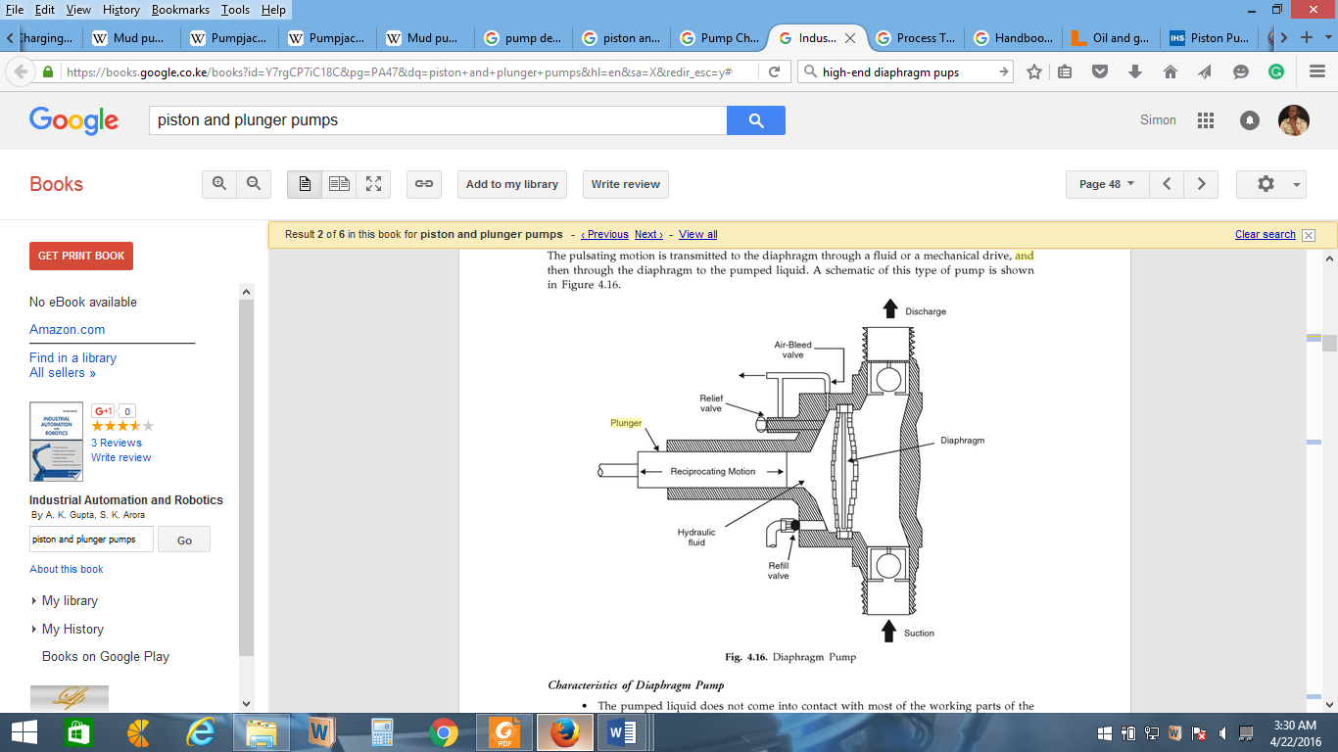(Gupta & Arora, 2013)

* Its various applications include chemical injection – adding different chemical additives to prevent undesirable processes/conditions. The injected substances prevent/manage corrosion, mineral scaling, improve water/oil separation, and prevent asphaltene and paraffin precipitation among others (Volk, 2014).
* Highly flexible
* Remove slurries of hydrocarbons from gas platforms
* Absorption of humidity in gas terminals
* Mainly used for low/medium flows with medium/high pressures

**Plunger pumps**

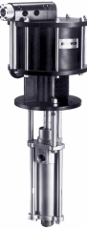 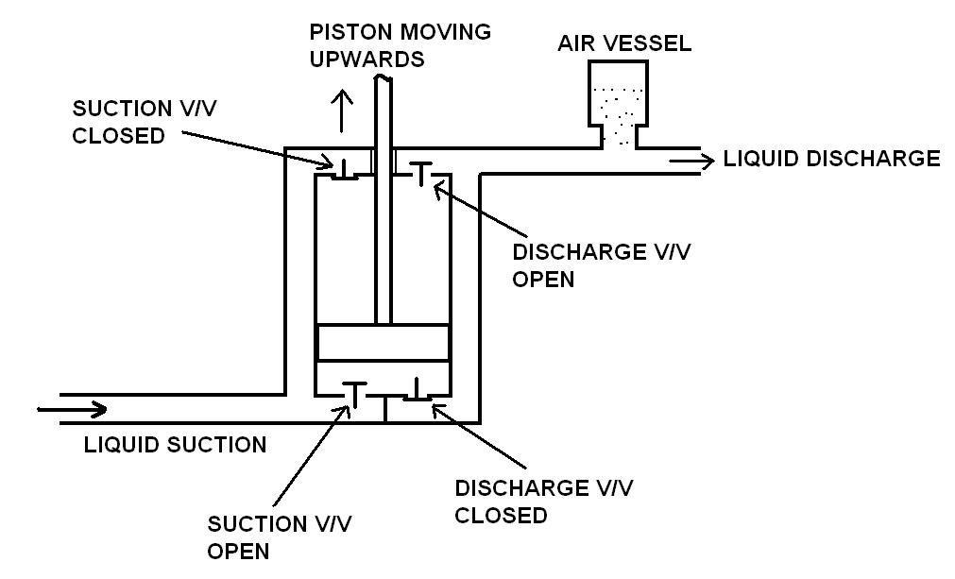

Source: http://www.globalspec.com/learnmore/flow_transfer_control/pumps/piston_plunger_pumps

* Expand and contract cavities to move fluids
* Are reciprocating pumps whose cavities contract and expand in an up/down and back/forth motion.
* Applied where high pressure ranges are required (they operate under a wide pressure range)
* Used for moving slurries, viscous fluids, and abrasives.

(Nesbitt, 2006)

**Piston pumps**



Source; http://engineering.stackexchange.com/questions/200/what-are-characteristic-values-for-a-piston-pump

* Expand and contract cavities to move fluids
* Cavities expand and contract back/forth and up/down.
* Used for moving slurries, viscous fluids, and abrasives
* Applicable in chemical, petrochemical, and in gas and oil production industries.

(Nesbitt, 2006: Thomas, 2013)

Bibliography

A & C Society, 2012. *Archives and Collections Society.* [Online]   
Available at: http://navalmarinearchive.com/research/salt_in_marine_boilers.html  
[Accessed 22 April 2016].

American Bureau of Shipping, 2011. *Heavy fuel oil.* [Online]   
Available at: https://www.eagle.org/eagleExternalPortalWEB/ShowProperty/BEA%20Repository/Rules&Guides/Current/31_HeavyFuelOil/Pub31_HeavyFuelOil  
[Accessed 21 April 2016].

Anderson, B., 2014. *The Adlard Coles book of the international certificate of competence.* London: Adlard Coles Nautical.

Carlton, J. S., 2012. *Marine propellers and propulsion.* Amsterdam: Elsevier.

DNV, 2014. *Rules for classification of self-elevating units.* [Online]   
Available at: https://rules.dnvgl.com/docs/pdf/DNV/codes/docs/2014-10/OSS-104.pdf  
[Accessed 14 April 2016].

Gupta, A. K. & Arora, S. K., 2013. *Industrial Automation and Robotics.* New York: Laxmi Publications.

Hiereth, H. & Prenninger, P., 2012. *Charging the Internal Combustion Engine.* New York: Springer.

International Maritime Organization, 2004. *Survey of life-saving appliances and arrangements : course + compendium.* London: International Maritime Organization.

International Maritime Organization, 2009. *Code for the Construction and Equipment of Mobile Offshore Drilling Units.* London: International Maritime Organization - Publication.

Nesbitt, B., 2006. *Handbook of Pumps and Pumping: Pumping Manual International.* Burlington, MA: Elsevier in association with Roles & Associates.

Thomas, C. E., 2013. *Process Technology Equipment and Systems.* New York: Cengage Learning.

TPUB, 2016. *Safety precautions.* [Online]   
Available at: http://firecontrolman.tpub.com/14104/css/14104_207.htm  
[Accessed 22 April 2016].

Vermeire, M. B., 2012. *Everything you need to know about marine fuels.* Ghent, Belgium: Chevron Global Marine Products.

Volk, M., 2014. *Pump Characteristics and Applications.* 3rd Edition ed. New York: CRC Press.