Marketing Strategy

Name

Institution

Course

Instructor

Date

**Marketing Strategy**

The rate at which technology is changing in the contemporary society is impressive considering the application of such technology to different areas of life. Most individual and organizational functions have been automated, with the further development of the computer being important in facilitating increased productivity and positive life. The smartphone has turn out to be an integral part of life considering the various features that it presents in relation to the social connectedness and organization of small daily activities among individuals. With social networking being an increasingly important function for both individuals and organizations, smartphones provide such an option of connectivity apart from text messaging and phone calls (Lu, 2012). There are also other advanced connection services that increase the experience of individuals, including skype and Viber.

Smartphones are also highly efficient considering the fact that they work as miniature computers (Lu, 2012). Individuals can synchronize them with their various accounts including their email accounts, allowing them to carry out both their professional and personal functions while on the move. The factorability of smartphones has also made life easier for both business professionals and personal users as its allows them to store important files of data on the phones, and to install applications that they can use to inform their day to day decisions. For instance, there are applications that provide individuals with updates on the best places to park, available taxis, health care service providers within their reach, and trends in the stock market, among others vital information that is important in making day to day decisions (Lu, 2012). One of the smartphones that has made its mark on the list of phones that should be owned LG. Nevertheless, the brand has continued to diminish in terms of its popularity and success in the market, an aspect that could be attributed to its positioning.

The positioning of smartphones is a highly important component of marketing as it allows an organization to narrow down its target customer and thus to reduce competition. To effectively position a product, it is important to clearly understand its current position (Boone & Kurtz, 2015). To have a clear understanding of the current position of LG in the market, it is integral to develop a perceptual map, from which one can be able to determine an underexploited area that holds potential and to reposition the brand in such an area.

Business

Personal

Exciting, Trendy

Reliable, Family









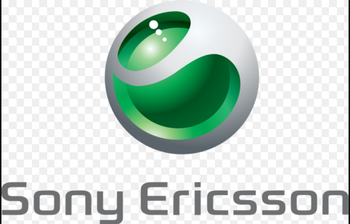

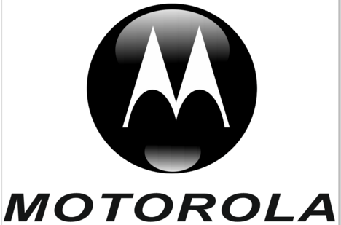



According to the perceptual map below, LG has positioned itself as a smartphone that is reliable for family and personal use. The growth of generation X, a new generation of young people has a great impact on the decisions that are made by organizations, including LG. This generation is more attracted towards trendy devices with features that allow them to take care of both their professional and personal lives on the same device. Business professionals have increasingly ventured into smartphones for the management of their businesses and the organization of all the functions within business organizations including Human Resource Management. As such, considering the fact that none of the brands is exclusively trendy and business oriented, positioning the LG smartphone in such a perspective, as shown below, is likely to increase its sales among business professionals and organizations.



Business

Personal

Exciting, Trendy

Reliable, Family

















References

Boone, L. E., & Kurtz, D. L. (2015). *Contemporary Marketing.* Stamford: Cengage Learning.

Lu, Z. (2012). *Learning with Mobile Technologies, Handheld Devices, and Smart Phones.* Hershey: IGI Global.