**HAPPYLAND GARDEN CENTER**

By:

(Name)

Presented to

(Instructor, Course)

(Institution, Location)

Date:

**Micro-Operations Analysis**

**Value Chain Model**

The value chain provides one of the highly important models in the analysis of the competitiveness of any business organization. Porter developed the value chain to help managers understand and hence exploit the activities from which value is created and built. The value chain comprises of primary activities and support activities, all of which define the value provided by the organization (D'heur, 2015, p. 25).

*Primary activities*

Inbound Logistics

The inbound logistics for Happyland Garden Center involves ordering the right amounts of each product at the season’s beginning. These has been a major problem for the organizations with various challenges being faced in terms of projecting the right amounts to procure (Rainer & Cegielski, 2010, p. 48). Poor decisions made at times lead to losses. Case in point, if some of the non-perishable products like barbecues are ordered in large amounts for the spring season when they are in high demand, the company is forced to offer discounts during winter, when demand is low, thus incurring losses.

Operations

Happyland Garden Center operates from one location about a half a mile away from the Happyland village in the Cotswold, United Kingdom (UK). The garden center has experienced tremendous growth over the past years and provides consumers with a wide array of products including gardening requisites. In addition, the center has a restaurant that offers consumers with various meal preferences. The garden center operates all days around the year except on Christmas day.

Outbound logistics

There are no intermediaries in selling the products offered by Happyland as the center directly interacts with the consumers. The company has employed individuals who work in different areas selling the products offered and rendering services directly to consumers.

Marketing and sales

Happyland has not invested much in marketing but has instead invested in high quality products and services, with meeting the consumer needs being its major motive. Nevertheless, the organization also uses celebrity endorsement to promote its products as they insist that they have been able to attract television based ‘personality gardeners’ to pay special visits to the center, hence attracting consumers. The center banks on its reputation and word of mouth for its success in attracting more customers.

Services

Proficiency in services is one of the approaches that Happyland uses to promote loyalty among its consumers. The availability of family areas with toys allows individuals with toddlers to wait in the ques while their children have fun, saving them the trouble of looking out for them. Nevertheless, the center faces a major problem with staffing as they experience long queues that at times drive some customers away.

*Support activities*

Firm infrastructure

Infrastructure includes all the departments within the organization such as the management, legal, and finance, among others, which are important in making it operational (Sand, 2010, p. 102). Happyland has well established stores and a restaurant, which are complimented with a large parking area that can handle up to 350 customers and a family area with toys for children to play with. This allows them to effectively handle the large flow of customers into the area.

Human resource management

The committed workforce at Happyland could be considered as it major attribute towards its growth and success. The organization has employed a high number of employees ranging from permanent, to part-time, to casual workers, who are called to duty according how busy the center is. This is to ensure that there are always enough employees to cater for the needs of the customers within the organization. Hiring part-time, causal and permanent workers has also allowed the organization to achieve a proper mix of skills and expertise necessary to achieve customer satisfaction.

Technology development

Happyland has invested little in technology, utilizing only the necessary technology required for storage of its products, stocking, and transportation of the products across the organization. Considering the problem faced by the organization in terms of congestion leading to long queues and frustrated customers, it should consider embracing online business such as online shopping of some of its products and invest in delivery vehicles and teams.

Procurement

Happyland gets its products from different areas across the globe. Nevertheless, it faces a major challenge in controlling the inventory, especially when it comes to making the right decision on the right amount of products to order, considering the fact that some shift in terms of demand from time to time, while others have a short shelf life, hence need to be sold quickly.

**Input-Process-Output (IPO) Model**

It is without question that the business process within any organization involves a subset of processes. With the execution of various tasks within the business organization, economic resources are consumed, which are generically referred to as ‘inputs’ (Müller-Christ, 2011). Such resources are categorized into two, which include monetary resources and human resources. The money resources are outlaid to facilitate the acquisition of purchased-in resources. All these resources are highly important in ensuring that the business process is well discharged. When graphically presented, inputs, processes, and outputs offer a conceptual view of an organization’s operations. The IPO model presents a chronological flow of things, in which an organization uses available resources to facilitate certain processes that produce given outputs, which are then delivered to the marketplace (Müller-Christ, 2011).

Inputs

Processes

Outputs

Inputs

Inputs include all the materials, ideas and resources that are included into the business process with the aim of obtaining certain outcomes (Madu & Kuei, 2012, p. 137). It is important to note that for inputs to be established, it is important to consider the kind of outputs that are expected. In the case of Happyland, the inputs include its rich employee representation, vast spread of product, and fresh and high quality products obtained from highly established suppliers. The employees provide the organization with the skills that are required to effectively market its products and attract more consumers to the center, an aspect that has greatly promoted the organizations sales.

Process

The process part of the IPO model involves the various approaches upheld in the transformation of the resources (inputs) into outputs or results defined buy the organization’s goals and objectives (Catlin-Legutko & Klingler, 2012, p. 66). Happyland has invested in various products, some of which are indoor products while others are outdoor products. Most of their products are finished and packaged products that bare only displayed and sold to the consumers. For such products, the processes involved include storage and proper marketing initiatives that ensure that consumer awareness is created. Nevertheless, for the agricultural products, the processes involve designing of the various display gardens and proper planting of the plants while employing the various products sold by the center to exhibit their effectiveness. The HappyDay restaurant also involves various processes, which include preparation of the various food products and serving of the customers.

Outputs

The outputs include the results of the business processes, or what was meant to be achieved through exploitation of the inputs (Madu & Kuei, 2012, p. 154). This may range from the tangible results to the intangible results of business processes. Some of the outputs that result from the processes at Happyland include the displayed products, the food at the restaurant, and the outdoor agricultural product displays. Such outcomes present what is being offered to the consumer as a result of the efforts put in place and hence underlie the profitability of the center.

**Happy land Mind Map**

Mind maps are important tools of organizational analysis as they allow for visual representation and development of information on various concepts within the organization (D'heur, 2015, p. 92). Images are used to draw a clear distinction between the various concepts being represented in the mind map it is important to note that organizations cane be able to identify operational hitches and strategic failures through mind maps as they are able to track the various business processes that go about within then organization and to note the specific area that need improvement. This section involves development of a mind map showing the general operational environment at Happyland Garden Center. It is important to note that Happyland has invested in various areas of its business that ensure its success. The management have been keen on expanding their scope, allowing for dealing in a wide range of products, including indoor and outdoor products, and a restaurant. The developed mind map revolves around the management role at Happyland.



Happyland GARDEN Center

Adequate staff to handle consumer flow throughout the year

Indoor and Outdoor staff



Technology



HappyDay restaurant staff

Inadequate staff assigned to handle the queues

Customer Frustration and Customer walk-away

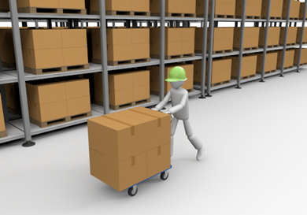

Inventory Control

Staffing Issues



Difficulties in establishing the quantity of perishable and non-perishable products to order

Management

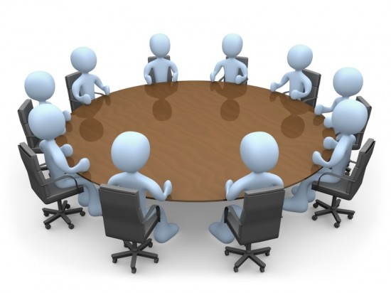

Low utilization of new technology and promotion of innovation

Finance Department monitors cash flow and ensures that profitability is achieved across the organization. They are in charge of functions such as pricing



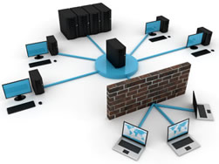

Infrastructure

Proper development of stores to allow for easy customer navigation and expansion of parking area

One of the important role of the management at Happyland involves staffing. It is important to note that the human resource forms an important part of an organization’s success as they are involved in the transformation of the other resources into outputs. As such, ensuring a proper working environment is important in motivating employees and hence facilitating increased productivity and innovation. Happyland’s management has invested heavily in staffing, utilizing permanent, part-time, and casual workers. Nevertheless, the restaurant sector of the business has been less effective in handling the high flow of consumers throughout the organization. It is clear that the restaurant experiences long queues, which increase even more during the weekends and the management has not done much to change the situation in terms of hiring more employees and increasing the tellers in the restaurant to handle the customers. The manager, Christine, reports of cases where customers have been forced to leave because they could not bear to wait for the long queue. On the other hand, the indoor businesses and the outdoor businesses have been well staffed, ensuring that the number of staff who report to duty fluctuates with the changes in consumer visits.

Another important function of the management lies within its finance department. The finance department manages financial capital within the organization, ensuring that finances are well allocated to the various functions within the organization. Happyland has experienced profits over the past few years, an aspect that could be partly attributed to the organization’s finance department. The ability of the department to manage a positive cash flow has allowed the organization to achieve an increase in its profit margin. The organization’s competitive pricing has also been a major source of attraction for customers, an aspect that could explain the growing number of consumers flowing into the center. This has forced the organization to effectively invest in its infrastructure, which can be observed in the center’s expansion of the parking area to allow for increased accommodation of customers within the premise.

**Recommendations**

It is clear that the major problem facing the organization lies within its service provision, whereby most of the customers are frustrated because of the long wait they have to endure in order to purchase items, especially food from the restaurants. This could be attributed to understaffing in the restaurant. Despite the high number of customers served by the restaurant, it has only twelve workers, who are overwhelmed with the high number of customers. Another issue noted is the limited capacity of the restaurant, such that some of the regular customers are forced to book seats using their belongings, while new customers are likely to miss out. As such, this paper recommends that the management should expand its HappyDay restaurant infrastructure to allow for accommodation of more customers. Increasing the serving personnel within the restaurant would increase the number of queues and reduce their sizes, hence encourage more customers into the restaurant, based on the understanding that they will not have to wait for long to be served. In addition, expanding the facility would allow for accommodation of more customers, thus increasing sales and profitability.

References

Catlin-Legutko, C. & Klingler, S., 2012. *Organizational Management.* Lanham: Altamira Press.

D'heur, M., 2015. *Sustainable Value Chain Management: Delivering Sustainability Through the Core Business.* London: Springer.

Madu, C. N. & Kuei, C.-H., 2012. *Handbook of Sustainability Management.* New Jersey: World Scientific.

Müller-Christ, G., 2011. *Sustainable Management: Coping with the Dilemmas of Resource-Oriented Management.* Bremen: Springer.

Rainer, R. K. & Cegielski, C. G., 2010. *Introduction to Information Systems: Enabling and Transforming Business.* New York: John Wiley & Sons.

Sand, C., 2010. *The Packaging Value Chain.* Philladephia: DEStech Publications, Inc..