Hunter McHugh

Library Inc.

Library Information Management System

Bookify

APPROVAL PAGE

Joey Kitson, Client

Library Inc

This document is to receive the approval of the client, *Joey Kitson*, and the project manager, *Hunter McHugh*, for the proposed project. By signing this document, both parties acknowledge they have read the document in its entirety and agree to the plans in this document. If the proposed plan is accepted, date and sign below to move forward with the proposed project outlined in this document.

|  |  |  |  |
| --- | --- | --- | --- |
| Approver Title | Approver Name | Signature | Date |
| Client | Joey Kitson, Library Inc |  | 2022.01.30 |
| Project Manager | Hunter McHugh | Hunter McHugh | 2021.01.30 |

Document Tracking

|  |  |  |  |  |
| --- | --- | --- | --- | --- |
| Version | Document Name | Date | Author | Comments |
| 0.1 | 2a_DRAFT_CIS-2245 System Analysis and Design Doc.docx | 2022.24.01 | Hunter McHugh | Outline |
| 0.12 | 2a_DRAFT_CIS-2245 System Analysis and Design Doc.docx | 2022.04.01 | Hunter McHugh | Initial draft cleaned up |
| 1.0 | CIS-2245 System Analysis and Design Doc | 2022.14.02 | Hunter McHugh | Final doc. |

1 Management Summary 7

2 System Overview 8

System Statement 8

System Deliverables 10

2.1.1 Deliverables 10

2.1.2 Non-deliverables 10

System Assumptions 10

System Constraints 10

System Key Requirements 11

2.1.3 Inputs 11

2.1.4 Outputs 11

2.1.5 Data 11

2.1.6 Process 12

2.1.7 Security 12

3 Analysis: System Modeling 13

System Event Table 13

System Domain Class Diagram 17

Use Case 1: Create a Customer Account 18

3.1.1 Use Case Diagram: Create a Customer Account 18

3.1.2 Fully Developed Use Case Description: Create a Customer Account 19

3.1.3 System Sequence Diagram: Create a Customer Account 20

Use Case 2: Add a Book to Collection 21

3.1.4 Use Case Diagram: Add a Book to Collection 21

3.1.5 Fully Developed Use Case Description: Add a Book to Collection 22

3.1.6 System Sequence Diagram: Add a Book to Collection 23

Use Case 3: View Book Collection 24

3.1.7 Use Case Diagram: View Book Collection 24

3.1.8 Fully Developed Use Case Description: View Book Collection 25

3.1.9 System Sequence Diagram: View Book Collection 26

Use Case 4: Weekly Most Popular Book List 27

3.1.10 Use Case Diagram: Weekly Most Popular Book List 27

3.1.11 Fully Developed Use Case Description: Weekly Most Popular Book List 28

3.1.12 System Sequence Diagram: Weekly Most Popular Book List 29

Use Case 5: Weekly Subscription Report 30

3.1.13 Use Case Diagram - Weekly Subscription Report 30

3.1.14 Fully Developed Use Case: Weekly Subscriptions Report 31

3.1.15 System Sequence Diagram: Create Weekly Subscriptions Report 32

Use Case 6: Daily Overdue Accounts Report 33

3.1.16 Use Case Diagram: Daily Overdue Accounts Report 33

3.1.17 Full Developed Use Case Description: Daily Overdue Accounts Report 34

3.1.18 System Sequence Diagram: Daily Overdue Accounts Report 35

4 Design: System Components Details 36

Design Class Diagram 36

System Design 37

Use Case 1: Create a Customer Account 37

4.1.1 Detailed Sequence Diagram: Create a Customer Account 37

Use Case 2: Add a book to Collection 38

4.1.2 Detailed Sequence Diagram: Add a book to Collection 38

Use Case 3: View Book Collection 39

4.1.3 Detailed Sequence Diagram: View Book Collection 39

Use Case 4: Create Weekly Most Popular Book List Report 40

4.1.4 Detailed Sequence Diagram: Weekly Most Popular Book List Report 40

Use Case 5: Weekly Subscription Report 41

4.1.5 Detailed Sequence Diagram: Weekly Subscriptions Report 41

Use Case 6: Daily Overdue Accounts Report 42

4.1.6 Detailed Sequence Diagram: Daily Overdue Accounts Report 42

Package Diagram of the Patient Scheduling System 43

Output Design 44

Use Case 4: Weekly Most Popular Book List 44

4.1.7 Report Analysis Form: Weekly Most Popular Book List 44

Use Case 5: Weekly Subscriptions Report 46

4.1.8 Report Analysis Form: Weekly Subscriptions Report 46

Use Case 6: Daily Overdue Accounts Report 48

4.1.9 Report Analysis Form: Daily Overdue Accounts Report 48

Input Design 51

Use Case 1: Create a Customer Account 51

Use Case 2: Add a Book to Collection 53

Use Case 3: View Book Collection 55

5 Database Design 57

Entity Relationship Diagram for LIMS 57

Database Data Dictionary 58

Support Processing Design 62

Support Forms 62

Policies or Procedures 62

6 Environmental Requirements 63

7 Implementation Requirements 64

8 Appendix A 66

# Management Summary

Bookify is a book subscription service that lets customers access a wide range of digital books and add them to their collection. As long as a customers’ subscription is active, they will have access to their books. This document will describe in detail the overall system and analysis design for the Library Book Management System (LIMS) that drives the Bookify platform.

The LIMS system will allow customers to create new accounts, search for books in the system and add them to their collection. In the same system, authorized users (employees) will have more granular access to book data, add, update, and delete new books, view publisher details, and create reports.

The LIMS platform will be a web-based system with a clean, simple design that will make it enjoyable for customers and easy for employees to interact with the site. The main subsystems in LIMS include:

* Customer subsystem
* Employee subsystem
* Book subsystem (including collections)
* Billing Account subsystem

**Key Recommendations:**  
The system will have the highest level of security possible to ensure customer confidentiality. Training employee to abide by the rules laid out within these documents is crucial to the successful implementation of ILIMS.

Secondly, though LIMS will save time and money in the long run for Library Inc, additional upgrades including automating several reporting features should be considered in the future.

# System Overview

## System Statement

The LIMS system contains several subsystems that will contribute to the overall system flow. Details of each subsystem are described below:

* Customer subsystem
* Employee subsystem
* Book subsystem
* Billing Account subsystem

**Customers:**The customer subsystem lets new users create an account so they can use LIMS. Customers can create, update, and delete their accounts. Customers can view all details about their accounts. Authorized users (employees) can access customer accounts if technical or billing support is required. Only users with valid credentials can access customer data. A customer can update their billing information from the customer subsystem.

**Book:**  
The book subsystem is the main Bookify subsystem that manages all functions related to digital books in the system. Customers can search for books, view information about books, and give books ratings. Authorized users can update book details, add, or view publisher details, and add new books to the system. When a book from the inventory is added into a customer collection, the book information is updated in the book inventory.

**Employee:**  
The employee subsystem is responsible for all functions related to creating and managing employees of Bookify. Employees will all have dedicated login credentials and employee roles that will dictate what they have access to in LIMs. For example, the different access levels can include the ability to modify books, manage customer data or manage other employee information.

**Billing (Account):**The subsystem takes care of the customer billing and payment subscriptions. The billing subsystem can track new customer payment type, payment details and subscription information. Only authorized employee users can access the customer billing information (e.g., technical support).

## System Deliverables

### Deliverables

* PHP web application of LIMS
* Database setup and SQL script with all information required for LIMS
* Documentation for installation, training, and configuration
* User manual
* Customer subsystem
* Book subsystem
* Employee subsystem
* Billing subsystem

### Non-deliverables

* Hardware needed to run the system
  + A server capable of running a Linux virtual machine (VM) to host the Apache/ PHP/ MySQL stack (LAMP).

## System Assumptions

* LIMS will be a cohesive system that allows for functionality between all subsystems in LIMS.
* Other departments will keep export requirements consistent for efficient data management.

## System Constraints

* LIMS must be ready by March 1st to allow time for testing and deployment on March 15th, 2022.

## System Key Requirements

### Inputs

* Customer functions (create, read, update, delete [CRUD])
* Customer billing functions (CRUD)
* Employee functions (CRUD)
* Book functions (CRUD)
* Collection functions (CRUD)
* Lookup Tables
  + Collection Item

### Outputs

* **Reports**
  + Weekly subscription report
  + Most popular book weekly report
  + Overdue accounts report
* **Exports**
  + Weekly subscription report (for head office)

### Data

* Customer data
* Customer billing data
* Book data
* Collection data
* Employee data
* Publisher data
* Lookup table data

### Process

* A customer can create one subscription account (customer billing account). One account is connected to one customer by their email.

A customer with a subscription, can add books to their collection. A customer can add many books to one collection. A customer can have many collections.

* An employee has one employee role. The employee role determines the actions they can perform in LIMS.
* An authorized employee can make changes to the book data in LIMS and can access customer information if required.
* When a customer billing account is overdue, they will automatically receive an email to update their account.
* Reports will be reviewed as required to improve the system and customer experience.
* Monthly export of system data to a secure location.

### Security

All LIMS data information will be kept hidden unless it is absolutely required for business functions. Only the data required to perform the function will be accessed by the appropriate user dictated by their customer status or employee role.

* **Identity management:**
  + Identity management
    - UserID/ password
    - Authorized users only see information relevant to their position.
* Editing any data in LIMS is restricted to authorized users.
* **Outputs:**
  + Reports
    - All report will only show relevant customer information.

# Analysis: System Modeling

## System Event Table

Any event that requires a system response can be considered a use case. All the LIMS use cases are listed in Table. 1.

Table 1. The System Event Table for LIMS.

|  |  |  |  |  |  |
| --- | --- | --- | --- | --- | --- |
| EVENT | TRIGGER | SOURCE | USE CASE | RESPONSE | DESTINATION |
| Customer | | | | | |
| Create a customer account | Customer wants to create account | Customer | Create a new customer account | New customer account created | Customer |
| Update customer account | Customer wants to update account details | Customer | Update account details | Customer account details are updated | Customer |
| Disable customer account | Customer has overdue billing account | System Trigger | Disable a customer account | Account is disabled | Customer |
| Delete customer account | Customer wants to delete account | Customer | Delete a customer account | Account is deleted | Customer |
| Books | | | | | |
| Create (add) a new book to system | Employee adds book to system | Employee | Add a new book | A new book is added to system | Employee |
| Update a book in the system | Employee updates a book in system | Employee | Update a book | An existing book is updated | Employee |
| View all books in the system | Employee views all books in system | Employee | View all books | All books displayed | Employee |
| Delete a book in the system | Employee deletes book from system | Employee | Delete an existing book | An existing book is deleted | Employee |
| Add a new book rating | Customer wants to add book rating | Customer | Add a new book rating | A rating is added to a book | Customer |
| Update a book rating | Customer wants to update a book rating | Customer | Update a book rating | A rating is updated for a book | Customer |
| Delete a book rating | Customer wants to delete a book rating | Customer | Delete a book rating | A rating is deleted for a book | Customer |
| Disable a book | Employee disables a book from system (but not delete) | Employee | Disable existing book | Existing book is disabled | Employee |
| Create a collection | Customer creates a new book collection | Customer | Create new collection | Collection is created | Customer |
| View all collections | Customer views all collections | Customer | View all collections | All collections are viewed | Customer |
| Update a collection (name) | Customer updates a collection name/ description | Customer | Update a collection | Collection (name/ description) is updated | Customer |
| Delete a collection | Customer removes a collection | Customer | Delete existing collection | Collection is deleted | Customer |
| Add a Book to Collection | Customer wants to add a book to collection | Customer | Add a new book to collection | Book is added to a collection | Customer |
| View all books in a collection | Customer views all books in one collection | Customer | View all books in a collection | All books in a collection are viewed | Customer |
| Removes book in a collection | Customer removes a book from their collection | Customer | Remove book from collection | Book is removed from collection | Customer |
| Billing | | | | | |
| Add billing information | Customer adds billing information to account | Customer | Add new billing information in account | Billing account is created | Customer |
| Update billing information | Customer updates billing information to account | Customer | Update billing information in account | Billing information is updated | Customer |
| View billing information | Customer views their billing information | Customer | View billing information for account | Billing information is viewed (onscreen) | Customer |
| Delete billing information | Customer deletes billing information | Customer | Delete billing information (all customers must have billing information) | Billing information is deleted …. | Customer |
| Employees | | | | | |
| Add new employee | A new employee is hired | Employee | Create new employee account | New employee account is created | Employee |
| View all employees |  |  |  |  |  |
| Update employees | Employee wants to update information | Employee | Update an existing employee account | Employee account is updated | Employee |
| Disable employee account | Employee has left the company | Employee | Disable an employee account (not delete) | Employee account is disabled | Employee |
| Add a new publisher to system | Employee adds new publisher | Employee | Create new publisher | New publisher is added to system | Employee |
| View/ Read all publishers |  | Employee |  |  | Employee |
| Update a publisher | Employee wants to update publisher information | Employee | Update an existing publisher | Publisher is updated in system | Employee |
| Remove a publisher (but not from the system) | Employee wants to disable a publisher | Employee | Disable an existing publisher | Publisher is disabled | Employee |
| Remove a publisher completely | Employee wants to delete a publisher | Employee | Delete an existing publisher | Publisher is deleted | Employee |
| Reports | | | | | |
| Weekly subscription report | Weekly | Employee | Create subscription report | New report created | Employee |
| Weekly most popular book list | Weekly | Employee | Create most popular book list | New report created | Employee |
| Weekly overdue billing accounts | Weekly | Employee | Create overdue billing accounts report | New report created | Employee |

## System Domain Class Diagram

Figure 1. The complete domain class diagram for LIMS at Bookify.

## Use Case 1: Create a Customer Account

### Use Case Diagram: Create a Customer Account

Figure 2. The use case diagram for the create a customer account use case with the LIMS.

### Fully Developed Use Case Description: Create a Customer Account

Table 2. Fully developed use case description for the create a customer account use case with the LIMS.

|  |  |  |
| --- | --- | --- |
| Use case name: | Create a Customer Account | |
| Scenario: | Customer wants to create a playlist within Bookify | |
| Triggering event: | Customer opens Create Account screen | |
| Brief description: | Library Inc’s web interface has an amazing “Book Playlist” system that requires user account creation to use | |
| Actors: | Customer | |
| Related use cases: | Create Collection | |
| Stakeholders: | Customer, Employee | |
| Preconditions: | Email must exist  Password must follow security standards | |
| Postconditions: | Account Created | |
| Flow of activities: | Actor | System |
| 1. Customer goes onto website and clicks create login  2. Customer enters account information  3. Customer enters address details  4. Customer enters card info | 1.1. Session is created  2.1 Account details confirmed  3.1 Address details confirmed  4.1 Card information confirmed  5. Account Created |
| Exception conditions: | 1.1 Site Outage  2.1 Invalid customer details  3.1 Invalid address details  4.1 invalid card details | |

### System Sequence Diagram: Create a Customer Account

Figure 3. A system sequence diagram depicting the sequence when a new patient appointment is created in LIMS.

## Use Case 2: Add a Book to Collection

When a customer wants to add a book to their collection, they can search for the book they want. When the customer clicks “add”, the book will be added to their account as long they have an active subscription.

### Use Case Diagram: Add a Book to Collection

Figure 4. The use case diagram for the add a book to collection use case in LIMS.

### Fully Developed Use Case Description: Add a Book to Collection

Table 3. Fully developed use case description for “add a book to collection” in LIMS.

|  |  |  |
| --- | --- | --- |
| Use case name: | Add a Book to Collection | |
| Scenario: | A customer wants to add a book from the database to their collection | |
| Triggering event: | Customer clicks “add book” button | |
| Brief description: | A customer adds a book from the database to their account collection. The customer must be signed in and the book must be available in the database. | |
| Actors: | Customer | |
| Related use cases: | Customer login, customer searches for a book, customer views all books | |
| Stakeholders: | Customer | |
| Preconditions: | Customer must have a valid account  Book must be available in the database | |
| Postconditions: | Book is added to customer account’s collection | |
| Flow of activities: | Actor | System |
| 1. Customer views list of all available books  2. Customer selects book and view details  3. Customer clicks “add” button  4. Customer receives confirmation and returns to view all books page. | Available book list is displayed  2.1 Book details displayed  3.1 Book is added to customer collection  Confirmation screen, return to view all books list  4.2 Collection and book inventory updated |
| Exception conditions: | 1.1 Customer does not have a valid account  2.1 Book is unavailable  3.1 System down (maintenance, power outage etc.) | |

### System Sequence Diagram: Add a Book to Collection

Figure 5. A system sequence diagram depicting the sequence when a customer wants to add a new book to their collection in LIMS.

## Use Case 3: View Book Collection

The view book collection use case is triggered when a customer requests to view his/her collection. After a user is logged in, they can go to the “My Collection” section on the website where they will find the list of books that they have added to their collection. If the user does not have any books on his/her collection the system will show an appropriate message.

### Use Case Diagram: View Book Collection

Figure 6. The use case diagram for the cancel a patient appointment use case with LIMS.

### Fully Developed Use Case Description: View Book Collection

Table 4. The fully developed use case description when a customer views his/her collection.

|  |  |  |
| --- | --- | --- |
| Use case name: | View Book Collection | |
| Scenario: | Customer views their book collection | |
| Triggering event: | Customer request to view their collection on the website | |
| Brief description: | A customer logs into his/her account and goes to the “My Collection” section on the website to view their book collection. | |
| Actors: | Customer | |
| Related use cases: | Add a Book to Collection | |
| Stakeholders: | Customer | |
| Preconditions: | Customer account must exist in the system.  Customer must have at least one book on their collection, otherwise they will just see an appropriate message. | |
| Postconditions: | Customer access his/her collection | |
| Flow of activities: | Actor | System |
| 1. Customer logs into his/her account. 2. Customer goes to the “My Collection” section on the website. | 1.1 System utilizes security protocols to authenticate the customer’s credentials.  2.1 After the customer is logged in, they can access their book collection by going to the “My Collection” section on the website, if there are no books on their collection the system will show an appropriate message. |
| Exception conditions: | Customer does not have an account or cannot access it.  If the customer has no books on their collection, then the system will show an appropriate message. | |

### System Sequence Diagram: View Book Collection

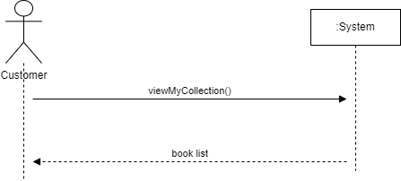

Figure 7. A system sequence diagram depicting the sequence when a new patient appointment is cancelled in LIMS.

## Use Case 4: Weekly Most Popular Book List

The Weekly Most Popular Book List use case is for a weekly report of the most popular book through how many people have that book in their playlist and are reading it right now.

### Use Case Diagram: Weekly Most Popular Book List

Figure 8. The use case diagram for the create call list for next day appointment use case in LIMS.

### Fully Developed Use Case Description: Weekly Most Popular Book List

Table 5. The fully developed use case description documenting the Most Popular Book List for an amount of time

|  |  |  |
| --- | --- | --- |
| Use case name: | Most Popular Book List | |
| Scenario: | Employee would like to create list of the top 3 most popular books for last week | |
| Triggering event: | First workday of the week begins | |
| Brief description: | Employee would like to create list of the top 3 most popular books for last week to allow users to get new recommendations, runs by how many accounts the book is in | |
| Actors: | Employee | |
| Related use cases: | Add a Book to Collection | |
| Stakeholders: | Employee | |
| Preconditions: | Books must be in users accounts | |
| Postconditions: | Book list confirmed | |
| Flow of activities: | Actor | System |
| 1. Employee comes into work  2. Employee logs into computer and signs into email | 1. Book list created at start of week  2.1 System emails employee with list of most popular books |
| Exception conditions: | 1. Books are not listed in accounts | |

### System Sequence Diagram: Weekly Most Popular Book List

Figure 9. The system sequence diagram for the most popular book list of the week in LIMS

## Use Case 5: Weekly Subscription Report

### Use Case Diagram - Weekly Subscription Report

Once a week the system will create an automated weekly subscription report to keep track of the progress of the company and our products. Only authorized users will have access to these reports on the website.

Figure 10. The use case diagram displaying the Weekly Subscriptions Report in LIMS.

### Fully Developed Use Case: Weekly Subscriptions Report

Table 6.The fully developed use case description documenting the case to access the weekly subscription report.

|  |  |  |
| --- | --- | --- |
| Use case name: | Weekly Subscription Report | |
| Scenario: | An employee accesses the weekly subscription report | |
| Triggering event: | View weekly subscription report | |
| Brief description: | The view weekly subscriptions report will be generated automatically by the system. Authorized employees will have access to this report once they login on the “Stats” section of the website. | |
| Actors: | Employee, System | |
| Related use cases: | N/A | |
| Stakeholders: | Employee | |
| Preconditions: | Employee account must exist in the system.  Employee must be authenticated to access this report. | |
| Postconditions: | Employee accesses the report | |
| Flow of activities: | Actor | System |
|  | 1. Employee logs into his/her Account. 2. Employee goes to the “Stats” section on the website. | 1.1 System utilizes security protocols to authenticate the employee’s credentials.  2.1 After the employee is logged in, he/she can access the report on the “Stats” section on the website, if there are no subscriptions for the current week the system will show an appropriate message. |
| Exception conditions: | Employee does not have an account or cannot access it.  If there are no subscriptions for the current week then the system will show an appropriate message. | |

### Table Description automatically generatedSystem Sequence Diagram: Create Weekly Subscriptions Report

Figure 11. The system sequence diagram for the Weekly Subscriptions Report in LIMS.

## Use Case 6: Daily Overdue Accounts Report

### Use Case Diagram: Daily Overdue Accounts Report

The daily overdue accounts report is a summary of accounts where the customer’s payment information has expired. The system will generate an email sent to the customer that their payment details need to be updated before they can continue using their account.

Figure 12. The use case diagram for creating daily overdue reports in LIMS.

### Full Developed Use Case Description: Daily Overdue Accounts Report

|  |  |  |
| --- | --- | --- |
| Use case name: | Create Daily Overdue Accounts Report | |
| Scenario: | If a customer’s payment information is expired, the customer should receive an email to update their payment information | |
| Triggering event: | Credit card expiry date in the customer payment account is expired for the selected day. | |
| Brief description: | Every customer must have a paid account with a valid payment method. When the payment method is expired, the customer should be prompted by email to update their payment info. | |
| Actors: | Employee | |
| Related use cases: | View customer account, view customer payment account, view billing information | |
| Stakeholders: | Employee, Customer | |
| Preconditions: | Successful employee authentication | |
| Postconditions: | Daily Overdue Accounts Report created | |
| Flow of activities: | Actor | System |
| 1. Employee clicks on “Create daily overdue accounts report”  2. Employee selects dates for report  3. Employee clicks “send email notification” button | 1.1. System prompts date selection  2.1. System displays accounts that have overdue payment information that have not already received a notification.  3.1. Auto-created email is sent to customers to update their payment information |
| Exception conditions: |  | |

### System Sequence Diagram: Daily Overdue Accounts Report

Figure 13. Daily Overdue Accounts Report system sequence diagram in LIMS.

# Design: System Components Details

## Design Class Diagram

Figure 14. The entire design class diagram of LIMS showing the required classes, attributes, and their datatype.

## System Design

## Use Case 1: Create a Customer Account

### Detailed Sequence Diagram: Create a Customer Account

Figure 15. The detailed sequence diagram for the create a customer account use case in the LIMS.

## Use Case 2: Add a book to Collection

This sequence diagram shows the system interaction when a customer wants to add a new book to their collection.

### Detailed Sequence Diagram: Add a book to Collection

Figure 16. The detailed sequence diagram for adding a new book to the collection in LIMS.

## Use Case 3: View Book Collection

### Detailed Sequence Diagram: View Book Collection

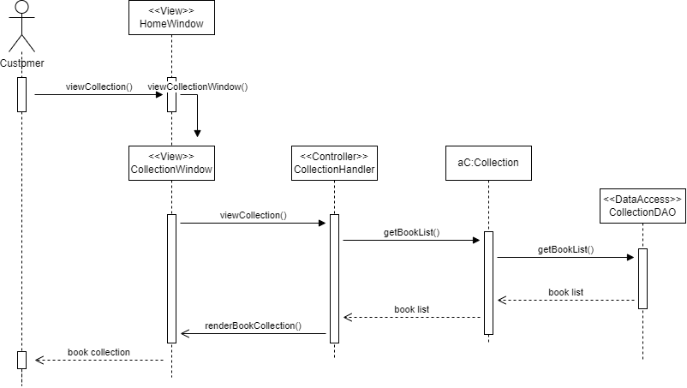

Figure 17. A detailed sequence diagram describing the events that take place when an appointment is deleted.

## Use Case 4: Create Weekly Most Popular Book List Report

### Detailed Sequence Diagram: Weekly Most Popular Book List Report

Figure 18. A detailed sequence diagram describing the events that take place when the beginning of the week comes around and the most popular book for the week is given in a report

## Use Case 5: Weekly Subscription Report

The detailed sequence diagram shown below describes the interaction of an employee who wants to access the weekly subscriptions report and the system.

### Detailed Sequence Diagram: Weekly Subscriptions Report

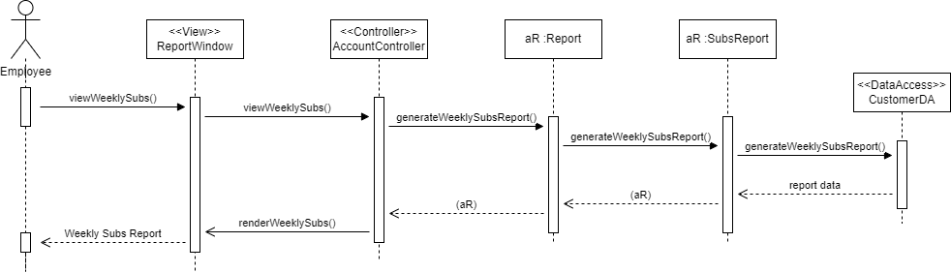

Figure 19. This sequence diagram for the appointment reminder report use case.

## Use Case 6: Daily Overdue Accounts Report

### Detailed Sequence Diagram: Daily Overdue Accounts Report

Figure 20. Detailed sequence diagram to create a report list of all the daily overdue accounts.

## Package Diagram of the Patient Scheduling System

Figure 21. The package diagram for LIMS.

## Output Design

## Use Case 4: Weekly Most Popular Book List

### Report Analysis Form: Weekly Most Popular Book List

**SYSTEM DOCUMENTATION**

NAME OF SYSTEM DATE PAGE 1 OF 2

Library Information February 1st, 2022

Management System

ANALYST PURPOSE OF DOCUMENTATION

Team Bookify Generates a list of the top 3 most popular books in a week

|  |  |  |
| --- | --- | --- |
| FIELD | FIELD TYPE | FIELD LENGTH |
| Book ID | Numeric | 5 |
| Author First | String | 20 |
| Author Last | String | 20 |
| Title | String | 20 |
| Genre | String | 20 |
| Collection Id | Numeric | 7 |
| Book Title | String | 20 |

COMMENTS

Week at top of page

SORT SEQUENCE

Detail lines are in order by most popular book

TOTALS REQUIRED

Amount of collections each book is in

MEDIA

The report is generated digitally through an excel doc and received via on screen or printed copy

FREQUENCY

The report is printed Weekly (Workdays).

DISTRIBUTION

The report is generated digitally and printed for one Employee who will list the most popular books for the week.

This mock-up will output the most popular books for the given week, looking through each collection to gather the book in the most collections.

ATTACHMENTS

Mock-up report is attached

Bookify – Most Popular Book List

Report for December 10, 2021

|  |  |  |  |
| --- | --- | --- | --- |
| **Book Title** | **Author First + Last** | **Genre** | **Number of Playlists In** |
| **Title** | **Name Name** | **Genre** | **13245** |
|  |  |  |  |

## Use Case 5: Weekly Subscriptions Report

### Report Analysis Form: Weekly Subscriptions Report

**SYSTEM DOCUMENTATION**

|  |  |  |  |  |  |
| --- | --- | --- | --- | --- | --- |
| **NAME OF SYSTEM** |  | **DATE** | | **PAGE 1 OF 2** | |
| Library Information Management System |  | February 1st, 2022 | |  |  |
| **ANALYST** |  | **PURPOSE OF DOCUMENTATION** | | |  |
| Team Bookify |  | Report – Weekly Subscriptions Report | | | |
| FIELD | FIELD TYPE | | FIELD LENGTH | | |
| User ID | Numeric | | 5 | | |
| User First Name | String | | 20 | | |
| User Last Name | String | | 20 | | |
| Subscription Date | Date/Time | | 20 | | |

COMMENTS   
Week at top of the document.

SORT SEQUENCE   
Detail lines are ordered from the most recent to the last subscription of the current week.

TOTALS REQUIRED   
The total number of subscribers for the current week.

MEDIA  
The report is generated digitally through an excel doc and received via on screen or printed copy.

FREQUENCY   
The report is printed Weekly (Workdays).

DISTRIBUTION   
The report is generated digitally and printed for one Employee who will list the subscribers for the week. This mock-up will output the weekly subscribers for the given week.

ATTACHMENTS   
Mock-up report is attached.

Bookify – Weekly Subscriptions

Report for February 1st, 2022

|  |  |  |
| --- | --- | --- |
| **User ID** | **Username** | **Subscription Date** |
| **12345** | **Name Name** | **2022-02-01** |
|  |  |  |

## Use Case 6: Daily Overdue Accounts Report

### Report Analysis Form: Daily Overdue Accounts Report

**SYSTEM DOCUMENTATION**

|  |  |  |
| --- | --- | --- |
| NAME OF SYSTEM | DATE | PAGE 1 of 3 |
| LIMS | January 28th, 2022 |  |
| ANALYST | PURPOSE OF DOCUMENTATION | |
| Jennifer Whittaker | Generates a list of customers with expired payment account information. Customers need to update their payment information to use their account. | |

|  |  |  |
| --- | --- | --- |
| FIELD | FIELD TYPE | FIELD LENGTH |
| Customer ID | Numeric | 6 |
| Customer Email | String | 20 |
| Payment Method | String | 3 |
| Payment Expiry Date | Date/Time | 20 |

COMMENTS  
A report that is automatically generated each morning. An automated email is sent to user accounts with a link to update their payment information.

SORT SEQUENCE   
Customer ID

TOTALS REQUIRED  
Total number of accounts (count of customerId)

MEDIA  
An automated email for customers (see attachment).

FREQUENCY  
The report is queried daily, and automated emails are sent as necessary.

DISTRIBUTION   
No distribution to management required. Customer receives email.

ATTACHMENTS   
See the following page.

|  |  |  |  |  |  |  |  |  |  |  |  |  |  |  |  |  |
| --- | --- | --- | --- | --- | --- | --- | --- | --- | --- | --- | --- | --- | --- | --- | --- | --- |
|   **Daily Overdue Accounts Report**   |  |  |  |  | | --- | --- | --- | --- | | Customer ID | Customer Email | Payment Method | Payment Expiry Date | | 12234-6 | oneTruWizard@hogwarts.com | MasterCard | 01/28/2022 | | 16234-6 | lightReading@hogwarts.com | Visa | 01/28/2022 | | 15234-6 | anotherRedHead@hogwarts.com | MasterCard | 01/28/2022 |   Page 1 of 1 |

Figure 22. Daily Overdue Accounts Report generated automatically.

From: Bookify notice@bookify.com  
To: Hermione Granger lightReading@hogwarts.com  
Subject: Your account needs attention!

Figure 23. An automatically generated email when a customer's payment account method has expired. The button will direct the customer to their account so they can update their account.

## Input Design

## Use Case 1: Create a Customer Account

Figure 24. This is the login screen that a user is presented with when accessing the site. You can click create an account to create an account.

Figure 25. After clicking create an account, the user can create an account from this screen.

## Use Case 2: Add a Book to Collection

Figure 26. After the user sees the book they want to add to their book collection from the book list they will click on the Add Book button (or can click View Details to see further details and then add the book.).

Figure 27. After a user adds a book, they will get a confirmation that their book was added to their collection. They will have the option to return to the book list or view their collection.

Figure 28. If the user returns to the book list, they will see a notification that their book was added successfully and a link to View Collection.

## Use Case 3: View Book Collection

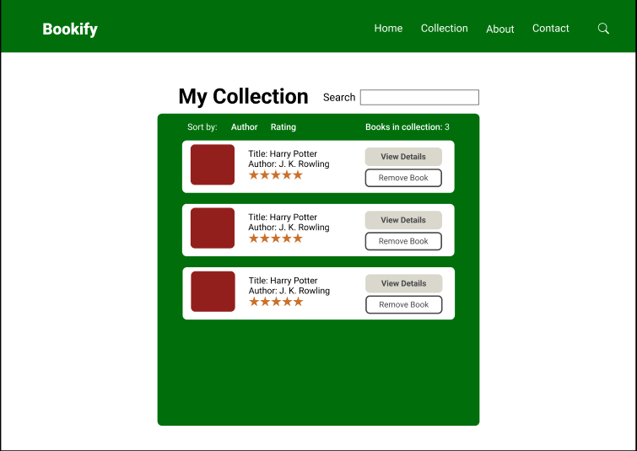

Figure 29. When a customer goes to the “Collection” section of the website he/she will see a list of the books that were added to the collection previously.

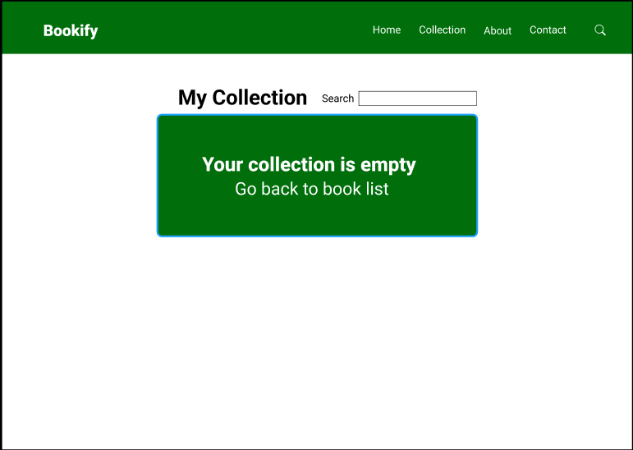

Figure 30. If there are no books on the customer’s collection the system will show the message shown above.

# Database Design

## Entity Relationship Diagram for LIMS

Figure 33. The Entity Relationship Diagram for LIMS at Bookify.

## Database Data Dictionary

**Customer Table**

Table 7. Customer table data dictionary

|  |  |  |  |  |  |
| --- | --- | --- | --- | --- | --- |
| Constraint | Field Name | Captions | Data Type | Field Size | Description |
| PK | customerId | Customer ID | Integer | 6 | Customer ID |
|  | addressId | Address ID | Integer | 6 | Address ID |
|  | email | Customer Email | Varchar | 50 | Customer Email |
|  | phone | Customer Phone | Varchar | 50 | Customer Phone |
|  | firstName | Customer First Name | Varchar | 100 | Customer First Name |
|  | lastName | Customer Last Name | Varchar | 100 | Customer Last Name |

**Address Table**

Table 8. Address table data dictionary

|  |  |  |  |  |  |
| --- | --- | --- | --- | --- | --- |
| Constraint | Field Name | Captions | Data Type | Field Size | Description |
| PK | addressId | Address ID | Integer | 6 | Address ID |
|  | street1 | Street Number | Varchar | 100 | Address street number |
|  | street2 | Street Name | Varchar | 100 | Address street name |
|  | city | Address City | Varchar | 100 | Address city |
|  | province | Address Province | Varchar | 2 | Address province |
|  | postalCode | Address Postal Code | Varchar | 6 | Address postal code |
|  | County | Address County | Varchar | 50 | Address County |

Account Table

Table 9. Account table data dictionary

|  |  |  |  |  |  |
| --- | --- | --- | --- | --- | --- |
| Constraint | Field Name | Captions | Data Type | Field Size | Description |
| PK | accountId | Account ID | Integer | 6 | Account ID |
| FK | billingId | Billing ID | Integer | 6 | Billing ID |
|  | username | Username | Varchar | 50 | Username |
|  | password | Password | Varchar | 20 | Password |
|  | accountType | Account Type | Varchar | 50 | Account Type |

Billing Table

Table 10. Billing account table data dictionary

|  |  |  |  |  |  |
| --- | --- | --- | --- | --- | --- |
| Constraint | Field Name | Captions | Data Type | Field Size | Description |
| PK | billingID | Billing ID | Integer | 6 | Billing ID |
|  | billingType | Billing Type ID | Varchar | 50 | Billing Type |

**Employee Table**

Table 13. Employee table data dictionary

|  |  |  |  |  |  |
| --- | --- | --- | --- | --- | --- |
| Constraint | Field Name | Captions | Data Type | Field Size | Description |
| PK | accountId | Account ID | Integer | 6 | Account ID |
|  | employeeName | Employee Name | Varchar | 100 | Employee name |
|  | employeeRole | Employee Role | Varchar | 50 | Employee Role |
|  | employeeEmail | Employee Email | Varchar | 50 | Employee email |
|  | employeePhone | Employee phone number | Varchar | 50 | Employee phone number |

**Collection Table**

Table 15.Collection table data dictionary

|  |  |  |  |  |  |
| --- | --- | --- | --- | --- | --- |
| Constraint | Field Name | Captions | Data Type | Field Size | Description |
| PK | bookId | Rating Id | Integer | 6 | 12345 |
|  | author | Author Name | Varchar | 10 | Author Name |
|  | title | Book Title | Varchar | 100 | Book Title |
| FK | publisherId | Publisher Id | Integer | 6 | Publisher Id foreign key |
|  | genre | Book genre | Varchar | 100 | Book genre |

**Book Table**

Table 16. Book table data dictionary

|  |  |  |  |  |  |
| --- | --- | --- | --- | --- | --- |
| Constraint | Field Name | Captions | Data Type | Field Size | Description |
| PK | bookId | Rating Id | Integer | 6 | 12345 |
|  | author | Author Name | Varchar | 10 | Author Name |
|  | rating | Book Rating | Integer | 1 | Customer book rating |
|  | title | Book Title | Varchar | 100 | Book Title |
| FK | publisherId | Publisher Id | Integer | 6 | Publisher Id foreign key |
|  | genre | Book genre | Varchar | 100 | Book genre |
|  | description | Description | Varchar | 500 | Book description |
|  | releaseDate | Release Date | Date/Time |  | Book release date |

**Book Rating Table**

Table 17. Book Rating table data dictionary

|  |  |  |  |  |  |
| --- | --- | --- | --- | --- | --- |
| Constraint | Field Name | Captions | Data Type | Field Size | Description |
| PK | ratingId | Rating Id | Integer | 6 | 12345 |
| FK | bookId | Book Id | Varchar | 10 | Book Id foreign key |
|  | rating | Book Rating | Integer | 1 | Customer book rating |

**Publisher Table**

Table 18. Publisher table data dictionary

|  |  |  |  |  |  |
| --- | --- | --- | --- | --- | --- |
| Constraint | Field Name | Captions | Data Type | Field Size | Description |
| PK | publisherId | Publisher Id | Integer | 6 | 12345 |
|  | companyName | Publisher Name | Varchar | 100 | Publisher Name |
|  | address | Publisher Address | Varchar | 100 | Publisher Address |
|  | Phone | Publisher Phone | Varchar | 10 | Publisher Phone Number |

## Support Processing Design

## Support Forms

* A sample of the report analysis form is included in Appendix A.

## Policies or Procedures

* All employees will be given overview training of LIMS.
* Dedicated training and a user manual will be created for authorized users who will have daily access to LIMS.
* System documentation will be created that includes the hardware, software, and architecture requirements for LIMS.
* Authorized users will have dedicated credentials and will not share credentials with others.
* Only data that is relevant to the current view will be shown to the user. Every attempt will be made to uphold data integrity and privacy.
* Backups of LIMS will be performed regularly. The backup will be encrypted and stored in a secure location off the main network.

# Environmental Requirements

**Hardware**

* Server meeting system requirement for PHP and Maria DB.
* Dedicated secure router separating the internal network from the outside network

**Software**

* Server - PHP 7.0, Maria DB, and Apache to host the application
* LIMS (in house application).

**Facility Additions/Modifications**

* The customer and employee subsystems are currently in the same system but will be later updated to separate them for security purposes.

**Employee**

* After the system is operational and employee are trained, routine maintenance could be handled by office employee.

# Implementation Requirements

The implementation of LIMS will require several related steps. These steps are described in greater detail below.

**Data conversion/ Data entry**

* LIMS is a new system that does not have any prior data conversion needs. New data will be entered by authorized employee users only.

**Security**

* All customers and employees will be given be given login credentials.
* Only authorized employee will have access to view or modify customer or book data in LIMS.
* All printed reports will have only the required information to protect data privacy.
* Reports can only be printed by authorized users who are logged in.

**Training**

* All employees will be given overview training of the new system and the changes that will take place because of the new system implementation.
* Dedicated employee training for authorized users will take place and a user manual will be created.

**Post-implementation Review**

* The current contract does not include post-implementation review however feedback can be forwarded to Library Inc.

**System Changeover**

* It is anticipated that the new system will take approximately four months (12 weeks) to implement assuming the hired IT programmers finish implementation and testing within timeframe.
* As there was previously no database system for LIMS, the system changeover will be directly deployed.

# Appendix A

**SYSTEM DOCUMENTATION**

NAME OF SYSTEM DATE PAGE 1 OF 2

ANALYST PURPOSE OF DOCUMENTATION

|  |  |  |
| --- | --- | --- |
| FIELD | FIELD TYPE | FIELD LENGTH |
|  |  |  |
|  |  |  |
|  |  |  |
|  |  |  |
|  |  |  |
|  |  |  |
|  |  |  |

COMMENTS   
Information about report design.

SORT SEQUENCE   
How the report will be sorted or organized.

TOTALS REQUIRED   
Any calculations required to complete the form

MEDIA  
How the report will be distributed (digital, print)

FREQUENCY  
How often the report will be created.

DISTRIBUTION  
Who the report will be distributed to.

ATTACHMENTS  
Attach an example of the report to the form.