Machine Learning Projekt: Netflix

# Einleitung

# Hauptteil

## Projektmanagement

### Projektziele

### Wirtschaftsinformatische Aspekte

## Datenanalyse

### Daten Exploration

library(ggplot2)  
  
dim(netflix_titles)

## [1] 6234 12

head(netflix_titles)

## # A tibble: 6 x 12  
## show_id type title director cast country date_added release_year rating duration listed_in description   
## <dbl> <chr> <chr> <chr> <chr> <chr> <chr> <dbl> <chr> <chr> <chr> <chr>   
## 1 81145628 Movie Norm of the North: King Sized Adventure Richard Finn, Tim Maltby Alan Marriott, Andrew Toth, Brian Dobson, Cole Howard, Jennifer Cameron, Jonathan Holmes, Lee Tockar, Lisa Durupt, Maya Kay, Michael Dobson United States, India, South Korea, China September 9, 2019 2019 TV-PG 90 min Children & Family Movies, Comedies "Before planning an awesome wedding for his grandfather, a polar bear king must take back a stolen artifact from an evil archaeologist first."   
## 2 80117401 Movie Jandino: Whatever it Takes <NA> Jandino Asporaat United Kingdom September 9, 2016 2016 TV-MA 94 min Stand-Up Comedy "Jandino Asporaat riffs on the challenges of raising kids and serenades the audience with a rousing rendition of \"Sex on Fire\" in his comedy show."   
## 3 70234439 TV Show Transformers Prime <NA> Peter Cullen, Sumalee Montano, Frank Welker, Jeffrey Combs, Kevin Michael Richardson, Tania Gunadi, Josh Keaton, Steve Blum, Andy Pessoa, Ernie Hudson, Daran Norris, Will Friedle United States September 8, 2018 2013 TV-Y7-FV 1 Season Kids' TV "With the help of three human allies, the Autobots once again protect Earth from the onslaught of the Decepticons and their leader, Megatron."   
## 4 80058654 TV Show Transformers: Robots in Disguise <NA> Will Friedle, Darren Criss, Constance Zimmer, Khary Payton, Mitchell Whitfield, Stuart Allan, Ted McGinley, Peter Cullen United States September 8, 2018 2016 TV-Y7 1 Season Kids' TV "When a prison ship crash unleashes hundreds of Decepticons on Earth, Bumblebee leads a new Autobot force to protect humankind."   
## 5 80125979 Movie #realityhigh Fernando Lebrija Nesta Cooper, Kate Walsh, John Michael Higgins, Keith Powers, Alicia Sanz, Jake Borelli, Kid Ink, Yousef Erakat, Rebekah Graf, Anne Winters, Peter Gilroy, Patrick Davis United States September 8, 2017 2017 TV-14 99 min Comedies "When nerdy high schooler Dani finally attracts the interest of her longtime crush, she lands in the cross hairs of his ex, a social media celebrity."  
## 6 80163890 TV Show Apaches <NA> Alberto Ammann, Eloy Azorín, Verónica Echegui, Lucía Jiménez, Claudia Traisac Spain September 8, 2017 2016 TV-MA 1 Season Crime TV Shows, International TV Shows, Spanish-Language TV Shows "A young journalist is forced into a life of crime to save his father and family in this series based on the novel by Miguel Sáez Carral."

tail(netflix_titles)

## # A tibble: 6 x 12  
## show_id type title director cast country date_added release_year rating duration listed_in description   
## <dbl> <chr> <chr> <chr> <chr> <chr> <chr> <dbl> <chr> <chr> <chr> <chr>   
## 1 80159925 TV Show Kikoriki <NA> Igor Dmitriev <NA> <NA> 2010 TV-Y 2 Seasons Kids' TV A wacky rabbit and his gang of animal pals have fun solving problems, sharing stories and exploring their sometimes magical, always special world.   
## 2 80000063 TV Show Red vs. Blue <NA> Burnie Burns, Jason Saldaña, Gustavo Sorola, Geoff Lazer Ramsey, Joel Heyman, Matt Hullum, Dan Godwin, Kathleen Zuelch, Yomary Cruz, Nathan Zellner United States <NA> 2015 NR 13 Seasons TV Action & Adventure, TV Comedies, TV Sci-Fi & Fantasy This parody of first-person shooter games, military life and science-fiction films centers on a civil war fought in the middle of a desolate canyon.   
## 3 70286564 TV Show Maron <NA> Marc Maron, Judd Hirsch, Josh Brener, Nora Zehetner, Andy Kindler United States <NA> 2016 TV-MA 4 Seasons TV Comedies Marc Maron stars as Marc Maron, who interviews fellow comedians for his popular podcast, only to reveal more about his own neuroses and relationships.  
## 4 80116008 Movie Little Baby Bum: Nursery Rhyme Friends <NA> <NA> <NA> <NA> 2016 <NA> 60 min Movies Nursery rhymes and original music for children accompanied by bright, playful animation engage and educate about numbers, shapes, colors and more.   
## 5 70281022 TV Show A Young Doctor's Notebook and Other Stories <NA> Daniel Radcliffe, Jon Hamm, Adam Godley, Christopher Godwin, Rosie Cavaliero, Vicki Pepperdine, Margaret Clunie, Tim Steed, Shaun Pye United Kingdom <NA> 2013 TV-MA 2 Seasons British TV Shows, TV Comedies, TV Dramas Set during the Russian Revolution, this comic miniseries is based on a doctor's memories of his early career working in an out-of-the-way village.   
## 6 70153404 TV Show Friends <NA> Jennifer Aniston, Courteney Cox, Lisa Kudrow, Matt LeBlanc, Matthew Perry, David Schwimmer United States <NA> 2003 TV-14 10 Seasons Classic & Cult TV, TV Comedies This hit sitcom follows the merry misadventures of six 20-something pals as they navigate the pitfalls of work, life and love in 1990s Manhattan.

summary(netflix_titles)

## show_id type title director cast country date_added release_year rating duration listed_in description   
## Min. : 247747 Length:6234 Length:6234 Length:6234 Length:6234 Length:6234 Length:6234 Min. :1925 Length:6234 Length:6234 Length:6234 Length:6234   
## 1st Qu.:80035802 Class :character Class :character Class :character Class :character Class :character Class :character 1st Qu.:2013 Class :character Class :character Class :character Class :character   
## Median :80163367 Mode :character Mode :character Mode :character Mode :character Mode :character Mode :character Median :2016 Mode :character Mode :character Mode :character Mode :character   
## Mean :76703679 Mean :2013   
## 3rd Qu.:80244889 3rd Qu.:2018   
## Max. :81235729 Max. :2020

netflixDatatypes <- netflix_titles  
netflixDatatypes$type <- as.factor(netflixDatatypes$type)  
  
ggplot(netflixDatatypes, aes(release_year))+  
 geom_histogram(col="black", alpha=.4)+  
 labs(title="Histogramm: Erscheinungsjahr")+  
 theme_classic()

## `stat_bin()` using `bins = 30`. Pick better value with `binwidth`.

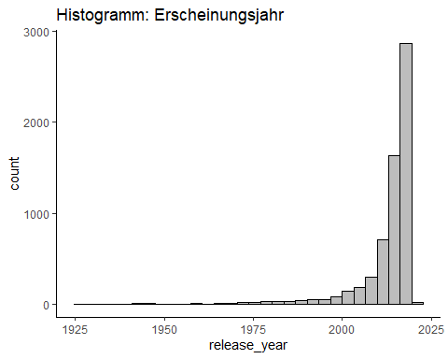

ggplot(netflixDatatypes, aes(type))+  
 geom_bar(col="blue", fill="blue", alpha=.4)+  
 labs(title="Barchart: Film/TV Show")+  
 theme_classic()

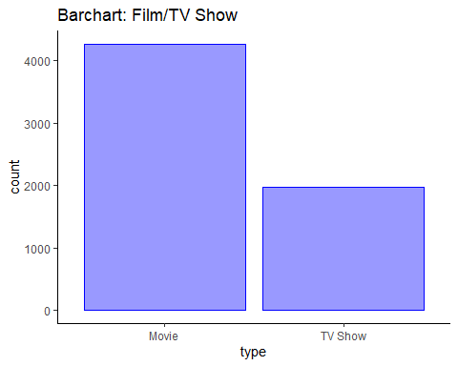

### Machine Learning Algorithmen

### Ergebnisse

# Fazit